Abstract and Conclusion
The processes and tests applied in the intermediate validation of the MIO_SHAi2C product
SW_OPER_MIO_SHAi2C_00000000T000000_99999999T999999_0501
and the conclusions on the product quality drawn herefrom are described in this document.
This product contains the representation of a model of the magnetic field of Earth’s ionosphere (“MIO” part of product name) using spherical harmonic coefficients (“SHA” part of product name). The model is estimated from Swarm and ground observatory data using the Comprehensive Inversion (CI) scheme within the Swarm Level 2 Processing system (“2C” part of product name). Operational Swarm Level 1b data version 0505/06, covering the period from 2013-11-25 to 2018-12-31 are used for the model estimation and the product is considered valid at all times (“00000000T000000_99999999T999999” part of product name). This is version 0501 of the product (last part of product name), i.e. baseline 05 indicating 5th year CI production, first, minor version. The format of the product is described in “Product Specification for L2 Products and Auxiliary Products”, doc. no. SW-DS-DTU-GS-0001.
The assessment of the SW_OPER_MIO_SHAi2C_00000000T000000_99999999T999999_0501 product shows structures in good agreement with ionospheric field models.
The DTU SIL’s opinion is that the MIO_SHAi2C product is successfully validated and therefore suitable for release.

Table of Contents
1 Intermediate Validation Report of MIO_SHAi2C 5
1.1 Input data products 5
1.2 Model Parameterization and Data Selection 5
1.3 Output Products 5
1.4 Validation Results 6
1.4.1 Equivalent Current Function 6
1.4.2 Statistics of Model Residuals 14
1.5 Criteria 15
2 Additional Information 16
2.1 Model Configuration and Data Selection Parameters 16
2.2 Comments from Scientists in the Loop 17
2.2.1 Derivation of Model 17
2.2.2 Conclusion 17

Table of Figures
Figure 1-1: Equivalent current function, CIY5, March equinox 7
Figure 1-2: Equivalent current function, CM5, March equinox 8
Figure 1-3: Equivalent current function, CIY5, June solstice 9
Figure 1-4: Equivalent current function, CM5, June solstice 10
Figure 1-5: Equivalent current function, CIY5, September equinox 11
Figure 1-6: Equivalent current function, CM5, September equinox 12
Figure 1-7: Equivalent current function, CIY5, December solstice 13
Figure 1-8: Equivalent current function, CM5, December solstice 14
Table of Tables

Table 1-1: Input data products 5
Table 1-2: Statistics of model residuals 15
Table 1-3: Validation criteria 15
Table 2-1: Model Configuration 17

Abbreviations
Acronym | Description
CI | Comprehensive Inversion
CMB | Core-Mantle Boundary
MIO | Magnetic Ionospheric field
QD | Quasi Dipole
SHA | Spherical Harmonic Analysis
SIL | Scientist in the Loop
VAL | Validation

References

[Sabaka et.al., GJI, 2015] CM5, a pre-Swarm comprehensive geomagnetic field model derived from over 12 yr of CHAMP, Ørsted, SAC-C and observatory data; Sabaka, Terence J.; Olsen, Nils; Tyler, Robert H.; Kuvshinov, Alexey; in journal: Geophysical Journal International (ISSN: 0956-540X), vol: 200, issue: 3, pages: 1596-1626 (2015) , doi: 10.1093/gji/ggu493.
[Sabaka et.al., GRL, 2016] Extracting Ocean-Generated Tidal Magnetic Signals from Swarm Data through Satellite Gradiometry; Sabaka, Terence J. ; Tyler, Robert H. ; Olsen, Nils in journal: Geophysical Research Letters (ISSN: 0094-8276) (2016), doi: 10.1002/2016GL068180.
[Sabaka et.al., EPS, 2018] A Comprehensive Model of Earth's Magnetic Field Determined From 4 Years of Swarm Satellite Observation; Sabaka, Terence J. ; Tøffner-Clausen, Lars; Olsen, Nils; Finlay, Christopher C. , in Earth, Planets and Space, vol: 70, issue: 1 (2018), doi: 10.1186/s40623-018-0896-3.

Intermediate Validation Report of MIO_SHAi2C

Input data products
The following input data products were used for the estimation of the MIO_SHAi2C ionospheric field model
Products | Type | Period | Comment
SW_OPER_Q3D_CI_i2__00000000T000000_99999999T999999_0101 | Q-matrix of Earth’s electrical conductivity (1-D mantle + oceans) | - | Used for computing induced part of ionospheric field
SW_OPER_AUX_OBS_2__20130101T000000_20131231T235959_0117  SW_OPER_AUX_OBS_2__20140101T000000_20141231T235959_0117 SW_OPER_AUX_OBS_2__20150101T000000_20151231T235959_0117  SW_OPER_AUX_OBS_2__20160101T000000_20161231T235959_0117  SW_OPER_AUX_OBS_2__20170101T000000_20171231T235959_0117  SW_OPER_AUX_OBS_2__20180101T000000_20181231T235959_0117 | Observatory hourly mean values | 2013-11-25  –  2018-10-31 | A total of 163 observatories are included
SW_OPER_AUX_DST_2__19980101T013000_20190115T233000_0001  SW_OPER_AUX_F10_2__20060101T000000_20190115T000000_0001  SW_OPER_AUX_KP__2__19990101T023000_20190117T133000_0001 | Indices | As indicated by the file names
SW_OPER_MAGA_LR_1B_yyyymmddTh1m1s1_yyyymmddTh2m2s2_vvvv  SW_OPER_MAGB_LR_1B_yyyymmddTh1m1s1_yyyymmddTh2m2s2_vvvv  SW_OPER_MAGC_LR_1B_yyyymmddTh1m1s1_yyyymmddTh2m2s2_vvvv | Swarm magnetic data, 1 Hz | 2013-11-25  -  2018-12-31 | Decimated to 30 second sampling  vvvv = 0505 or 0506
Table 1-1: Input data products

Model Parameterization and Data Selection
See Section 2.1.

Output Products
The products of this validation report are:
Swarm Level 2 Magnetic ionospheric field Product:
SW_OPER_MIO_SHAi2C_00000000T000000_99999999T999999_0501
Swarm Level 2 Intermediate Validation Product:
SW_OPER_MIO_VALi2C_00000000T000000_99999999T999999_0501

Validation Results
The tests were conducted between 2019-01-15 and 2019-02-10.
This 5th year CI L2 production, denoted CIY5, is very similar in methodology and results as last year’s production (CIY4) which is thoroughly described in [Sabaka et.al., EPS, 2018]. The following contains the results of the tests performed on the ionospheric field output product.

Equivalent Current Function
The figures on the following pages show the equivalent current function of the primary ionospheric currents for the MIO_SHAi2C product and for the CM5 model [Sabaka et.al., GJI, 2015] for four different epochs, for the equinoxes and the solstices. Each plot shows the current system for four different UT times, morning (06h), noon, evening (18h), and midnight. The blue line indicates the magnetic dip equator, which gives an indication of the separation between northern and southern current functions. Also shown are the 55°N and 55°S magnetic quasi dipole latitudes in red corresponding to the transition of the use of vector field information. The current function is shown as iso-lines with 10 kA separation.

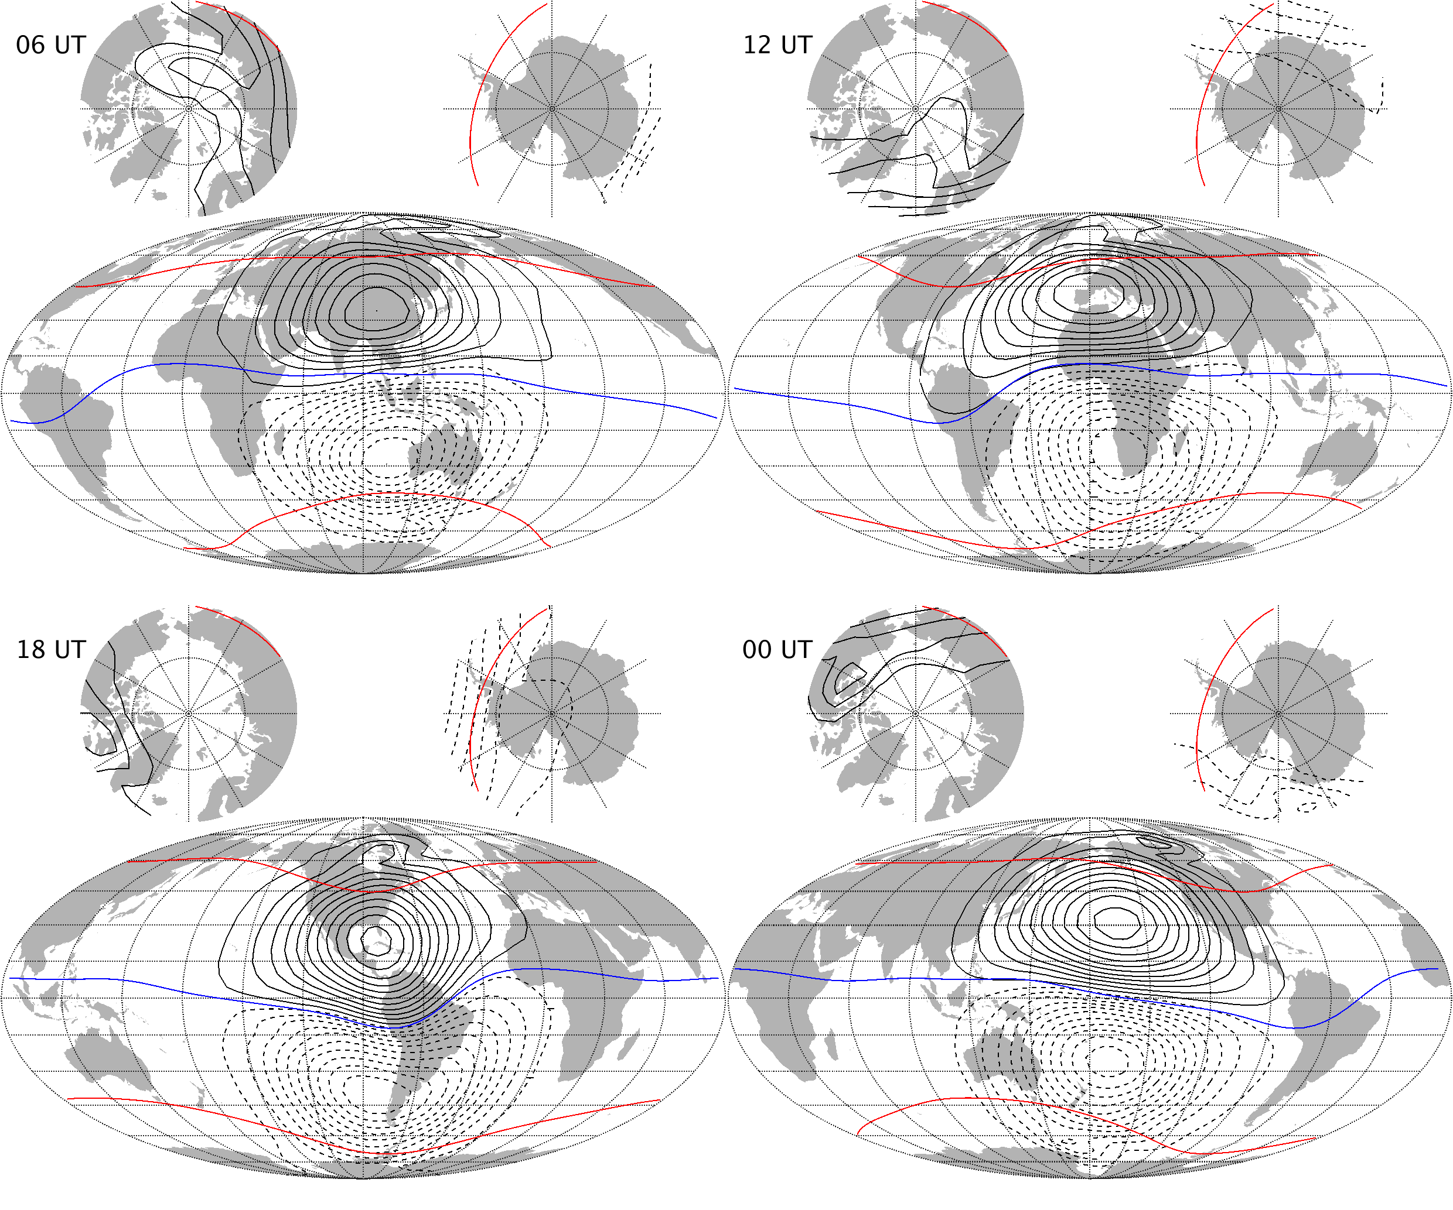Figure 1-1: Equivalent current function, CIY5, March equinox
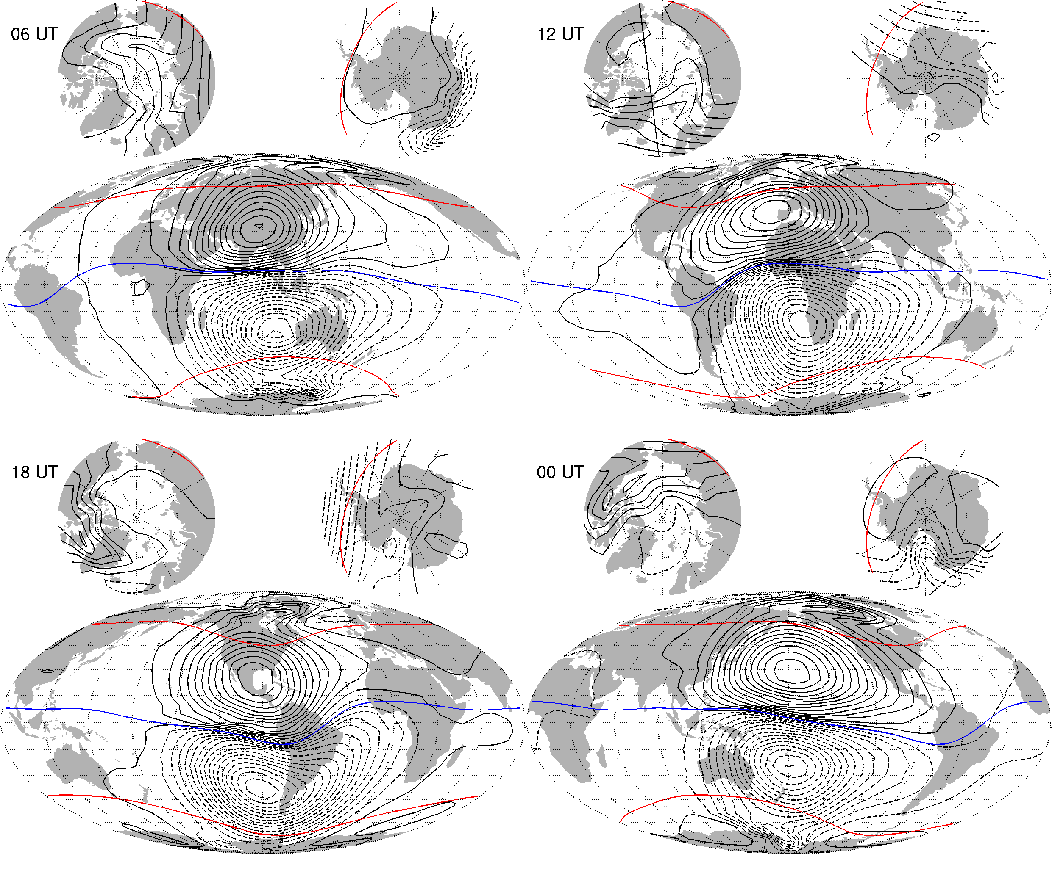
Figure 1-2: Equivalent current function, CM5, March equinox

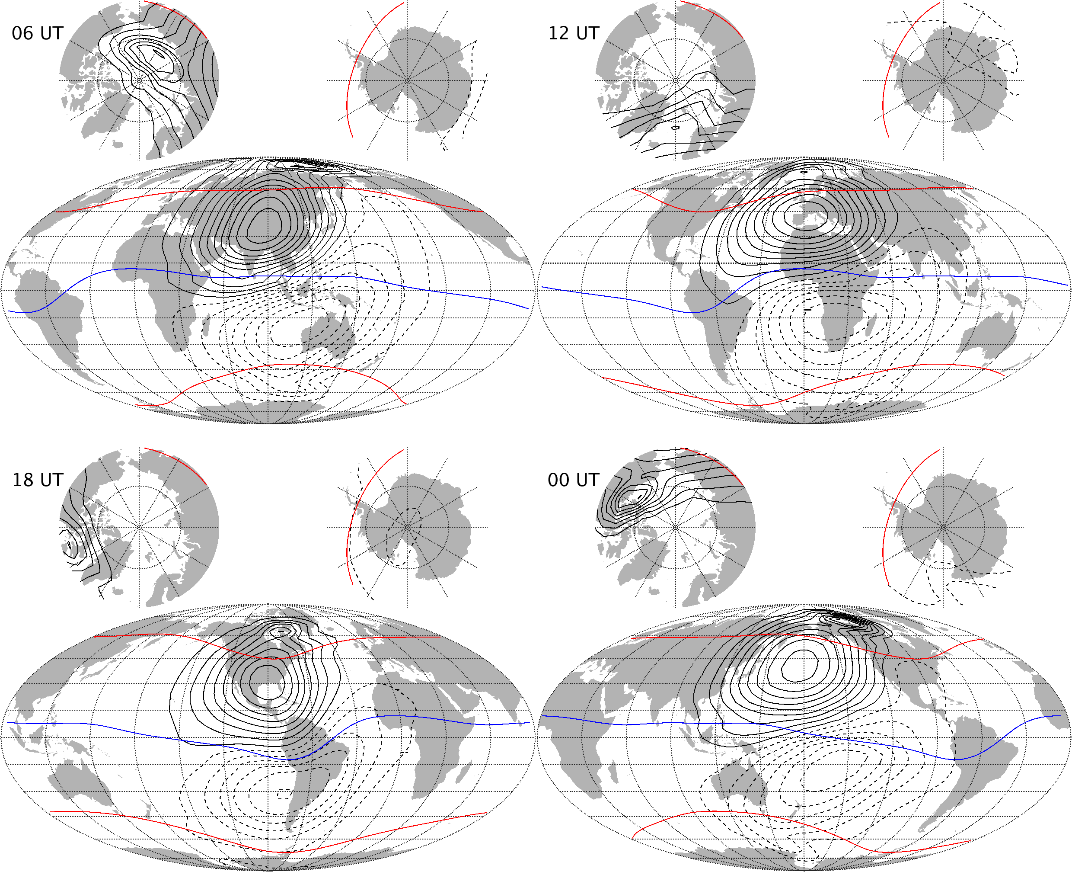
Figure 1-3: Equivalent current function, CIY5, June solstice
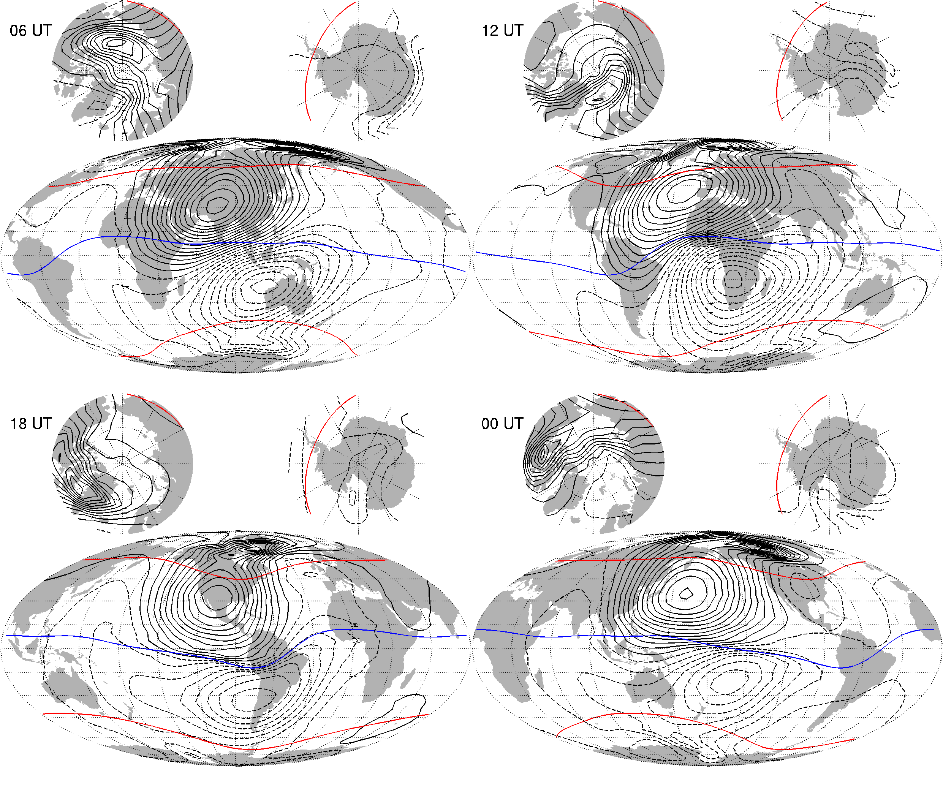
Figure 1-4: Equivalent current function, CM5, June solstice
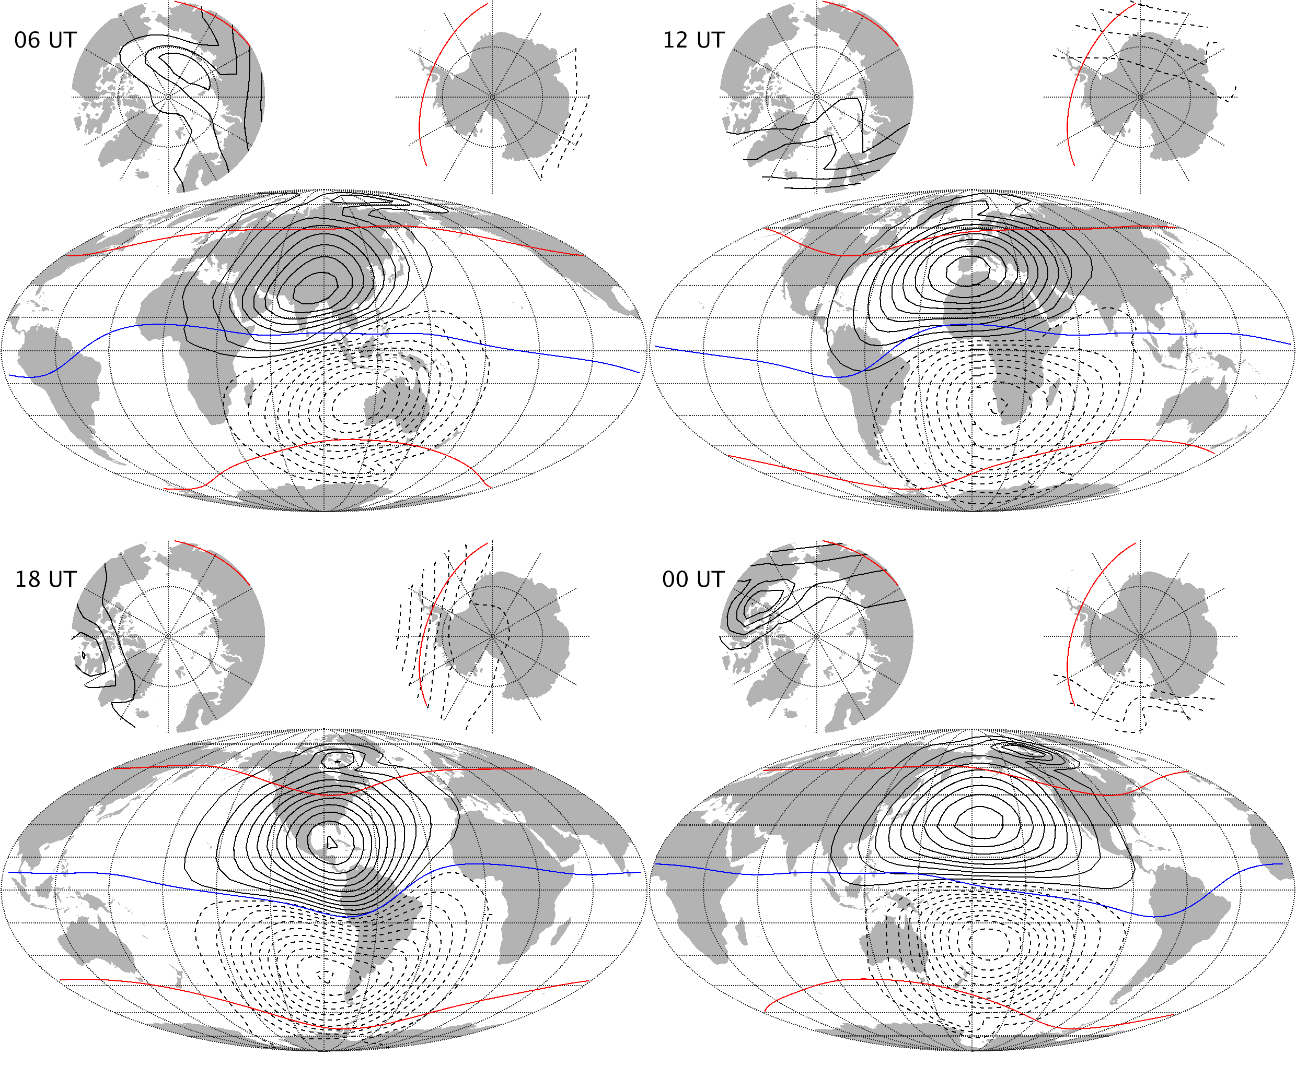
Figure 1-5: Equivalent current function, CIY5, September equinox

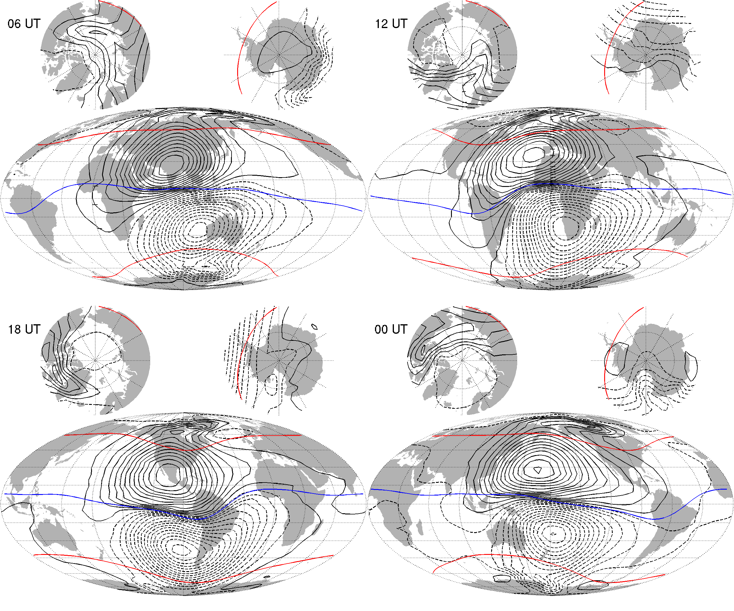
Figure 1-6: Equivalent current function, CM5, September equinox
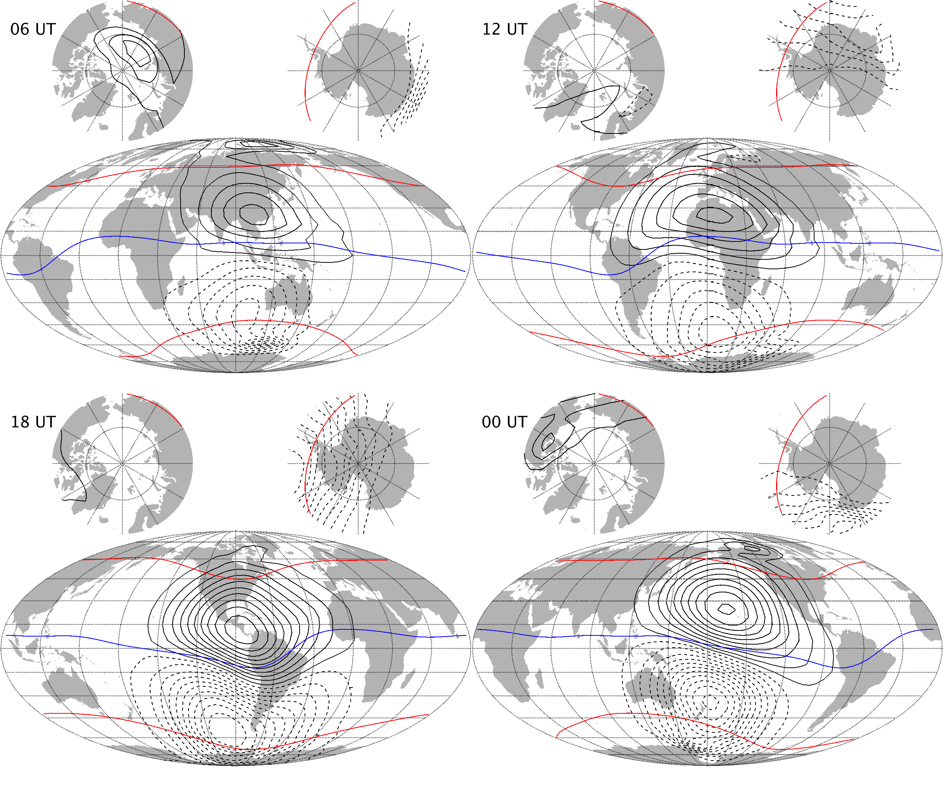
Figure 1-7: Equivalent current function, CIY5, December solstice

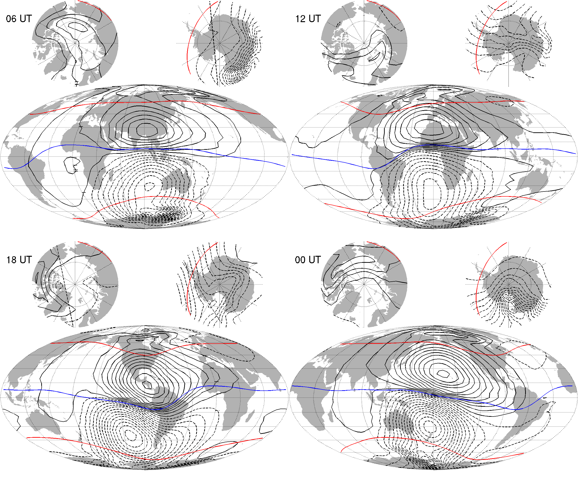Figure 1-8: Equivalent current function, CM5, December solstice

Statistics of Model Residuals
The statistics of the data residuals obtained by the CIY5 modelling is given in Table 1-3 below. Grey cells indicate data from night side, white cells indicate data from sunlit regions. Crossed cells indicate data which are not used in the inversion process. “Field” indicate the pure vector and scalar measurements, whereas “NS diff” and “EW diff” indicate the North-South (along-track) respectively East-West differences. The standard deviations (of the residuals between the observations and the estimated model) of the differences are quite impressive; the standard deviations of the direct field measurements from the satellites are also remarkably. Note in addition the almost perfect similarity between Swarm A and C (side-by-side flying pair) and North-South differences for all three satellites. Swarm B shows slightly higher residuals in the horizontal and scalar Field components (B_{θ}, B_{φ}, and F) at low and mid latitudes and slightly lower residuals at high latitudes likely due to its higher altitude.
Swarm/  Obs. |  | Geomagnetic quasi-dipole latitude
 |  | Low, ≤ 10° |  |  |  | Mid, ]10°..55°] |  |  |  | High, > 55°
 |  | Standard deviations of data residuals, Huber weighted, [nT]
 |  | σ(B_{r}) | σ(B_{θ}) | σ(B_{φ}) | σ(F) | σ(B_{r}) | σ(B_{θ}) | σ(B_{φ}) | σ(F) | σ(B_{r}) | σ(B_{θ}) | σ(B_{φ}) | σ(F)
A | Field | 1.63 | 1.92 | 1.66 | 2.41 | 1.65 | 2.09 | 2.07 | 1.78 |  |  |  | 5.62
 | NS diff | 0.31 | 0.18 | 0.32 | 0.16 | 0.24 | 0.28 | 0.35 | 0.18 |  |  |  | 0.93
 |  | 0.89 | 0.76 | 0.79 | 0.68 | 0.49 | 0.53 | 0.82 | 0.31 |  |  |  | 1.05
B | Field | 1.64 | 2.49 | 1.98 | 3.29 | 1.88 | 2.55 | 2.26 | 2.33 |  |  |  | 5.44
 | NS diff | 0.30 | 0.18 | 0.30 | 0.16 | 0.24 | 0.28 | 0.34 | 0.19 |  |  |  | 0.83
 |  | 0.80 | 0.67 | 0.72 | 0.60 | 0.47 | 0.52 | 0.80 | 0.29 |  |  |  | 0.95
C | Field | 1.64 | 1.87 | 1.64 | 2.38 | 1.65 | 2.08 | 2.07 | 1.78 |  |  |  | 5.62
 | NS diff | 0.32 | 0.18 | 0.32 | 0.16 | 0.25 | 0.29 | 0.35 | 0.18 |  |  |  | 0.93
 |  | 0.90 | 0.76 | 0.78 | 0.68 | 0.49 | 0.54 | 0.82 | 0.31 |  |  |  | 1.05
A-C | EW diff | 0.55 | 0.40 | 0.74 | 0.36 | 0.38 | 0.44 | 0.75 | 0.32 |  |  |  | 0.55
 |  | 1.22 | 0.63 | 1.79 | 0.51 | 0.70 | 0.75 | 1.50 | 0.44 |  |  |  | 0.59
Magnetic observatories |  | 3.99 | 4.01 | 4.50 | n.c. | 3.44 | 3.87 | 4.31 | n.c. | 13.23 | 12.83 | 10.41 | n.c.
 |  | 11.41 | 13.43 | 9.39 | n.c. | 5.31 | 6.75 | 7.97 | n.c. | 16.26 | 17.37 | 15.07 | n.c.
Table 1-2: Statistics of model residuals

Criteria
Table 1-4 below summarizes the criteria used to check the validity of the MIO_SHAi2C product:
Input | Test | Criteria | Pass?
Observations | Residual statistics | Standard deviation of vector data below 7 nT. | Ok
Alternative model | Comparison with model | CI model agrees with alternative model | Ok
Table 1-3: Validation criteria

Additional Information

Model Configuration and Data Selection Parameters
The MIO_SHAi2C product is obtained as a comprehensive co-estimation of the core, lithosphere, ionosphere, and magnetosphere field contributions including induced contributions similar to the method described in [Sabaka et.al., GRL, 2016]. The complete model configuration used is given in Table 2-1 below; the MIO_SHAi2C product is the green part:
Model Part | Maximum  Degree/Order | Temporal  Characteristics | Comment
Core | 18/18 | Order 5 B-spline with knots every 6 months | Damping of the mean-square, second and third time derivatives of B_{r} at the core-mantle boundary (CMB, at 3480 km radius) with enhanced damping of zonal terms up to degree 9.
Lithosphere | 120/120 | Static | Degree 19-120 purely determined by North-South differences from all satellites and East-West differences of lower pair satellite (A and C).  Damping of B_{r} at Erath’s surface for degrees 91 and above to reduce noise
Ionosphere | 45/5  (quasi dipole  coordinates) | Annual, semi-annual, 24-, 12-, 8- and 6- hours periodicity | Spherical harmonic expansion in quasi-dipole (QD) frame, underlying dipole SH n_{max} = 60, m_{max} = 12. Scaling by 3-months averages of F10.7 plus induction via a priori 3-D conductivity model (“1-D mantle + oceans”) and infinite conductor at CMB.  Regularisation of:  - Mean-square current density J in the E-region within the night-side sector (magnetic local times 21:00 through 05:00; peak damping at 01:00)  - Mean-square of the surface Laplacian of J multiplied by a factor of sin⁸(2θ) over all local times, where θ is co-latitude.
Magnetosphere,  external | 3/1 | One hour bins
Magnetosphere,  induced | 3/3 | One hour bins
M2 Tidal | 18/18 | Periodicity: 12.42060122 hr, phase fixed with respect to 00:00:00, 1999 January 1 GMT
Table 2-1: Model Configuration
The data selection criteria are:
- Coarse agreement with CHAOS-6 field model: ΔB_{c} ≤ 500 nT for all components c=r,ϑ,φ, and ΔF ≤ 100 nT.
- Kp ≤ 3⁰ for gradient data, Kp ≤ 2⁻ for field data
- Time-derivative of Dst: |dDst/dt| ≤ 3 nT/hour
- 30 second sampling period for satellite data, NS gradient data computed from 15 second differences
- core and tidal fields determined from night-side data only, i.e. with Sun ≥ 10° below the horizon

Comments from Scientists in the Loop

Derivation of Model
The final Comprehensive Inversion model using five years of Swarm data shows good agreement with alternative models and exhibits very good data residual statistics (Table 1-3).

Conclusion
The estimated model is assessed to be of good quality with very good agreement with the general structures of the ionospheric field.

