Arctic Sea Level

during the altimetry era

A. Carret¹, J. Johannessen², O. Andersen³, M. Ablain⁴,

P. Prandi⁴, A. Blazquez¹, A. Cazenave¹

1. LEGOS, Université de Toulouse, CNES, CNRS, IRD, UPS, Toulouse, France.
2. NERSC, Bergen, Norway
3. DTU, Denmark

4. CLS, Ramonville St Agne, France

Special Issue of Surveys in Geophysics on

‘Integrative study of sea level and components’

April 2016
Abstract

1.Introduction
Over the recent decades, the Arctic region has warmed at a rate about twice the
rest of the globe (IPCC AR5). This primarily results from human-induced climate change, with strong amplification of anthropogenic warming in this region. Feedback mechanisms mostly result from decreasing albedo due to sea ice melting (REF). But the Arctic region is also affected but a number of other global warming-related phenomena: Greenland ice sheet mass loss (e.g., Shepherd et al., 2012, Velicogna et al., 2014), Alaskan glacier melting (Gardner et al., (2013), permafrost melting with potential release of carbon dioxide and methane (REF), snow cover extent decrease (IPCC AR5), decrease of Arctic lakes ice cover (Kouraev et al., XX), drying of Siberian lakes (Smith , 2012), etc.
Studies about Artic sea level have been limited so far because of lack of data. Thus most studies have been dedicated to investigate Arctic sea level along the Russian and Norwegian coastlines (Proshutinsky et al. 2001, 2004, 2007a, 2011; Henry et al., 2013). The situation changed recently with the availability of satellite altimetry data from ERS-1&2 and Envisat satellites covering the Arctic Ocean up to 82°N. The area covered by the altimetry data is affected by seasonal or permanent sea ice so that until recently altimetry data in the Arctic were largely unused. However new efforts in developing dedicated reprocessing Cheng et al., 2015 reprocessed ERS-1/2/Envisat satellite altimetry to develop an improved 20-year sea level dataset for the Arctic Ocean. They have developed both an along-track dataset and three-day gridded sea level anomaly maps from September 1992 to April 2012. A major improvement in data coverage was gained by tailoring the standard altimetry editing criteria to Arctic conditions. The new reprocessed data has significant increased data coverage with between 4 and 10 times the amount of data in regions such as the Beaufort Gyre region compared with standard altimetry products. This has allowed for a more accurate estimation of sea level changes from satellite altimetry in the Arctic Ocean. In the mean time a new sea level product over the Arctic has been provided from a joint effort between CLS and PML (Plymouth Laboratory, UK). PIERRE, MICHAEL: DISCUSS BRIEFLY
In this paper, we analyze and compare these improved altimetry-based sea level grids over the Arctic region. Using an ocean reanalysis and GRACE space gravimetry data for estimating steric and ocean mass components, we also study the sea level budget over the last decade. Finally we compare the observations with CMIP5 coupled climate mod

2. Sea level during the altimetry era

2.1. Data description
2.1.1 New altimetry-based sea level data
We used two new altimetry datasets produced by CLS/PML and DTU, and based on dedicated retracking and/or reprocessing of Arctic altimetry waveforms. The DTU dataset was built using data ERS 1 and 2, ENVISAT and Cryosat-2 satellites and spanned the 1992 to 2012 period. The CLS dataset included only ENVISAT data. Both are referenced to the MSS DTU13 and extracted for the period from 2002 to 2010. Both consist in gridded datasets every month for DTU and every week for CLS. Resolution is of 2° for CLS and 0,5° for DTU. The common spatial coverage is 66°N up to 80°N. TO BE EXPANDED BY OLE AND PIERRE
2.2.2 Steric data
To estimate the steric contribution to Arctic sea level, we used temperature and salinity data coming from the ORAP5 reanalysis (REF). Assimilated data are coming from the EN3 database and surface forcing fields from ERA-Interim atmospheric reanalysis. Data can be downloaded at https://reanalyses.org/ocean/overview-current-reanalyses. We computed steric sea level since 1979, integrating density anomalies from the surface down to the sea loor. We also computed halosteric sea level using a temperature climatology which we obtained by averaging monthly data from 1979 to 2013. We compute thermosteric sea level in the same way except for using a climatology for the salinity. Data consists of monthly grids of 0,25 degree of resolution.
2.2.3 GRACE-based ocean mass data
Direct estimation of the Arctic ocean mass component is possible since 2002 thanks to the GRACE space gravimetry mission. Different versions of this product corresponding to distinct data processing are available. We used three of these monthly products : the GRACE Tellus solution (REF) available at http://grace.jpl.nasa.gov/data/get-data/monthly-mass-grids-ocean/ ; the GRACE MASCONS solution (REF) available at http://grace.jpl.nasa.gov/data/get-data/jpl_global_mascons/ and a new product developed at LEGOS (Blazquez et al., 2016). The processing of Tellus data is based on the RL05 spherical harmonics from CSR, JPL and GFZ. Processing steps of the MASCONS product are described in Watkins et al. (2015). It relies on the Level-1 GRACE observations, processed at JPL. Both products include the C20 and degree 1 coefficients. Both implement a GIA correction based on Peltier (19xx). The Tellus solution uses a destripping filter, a 500 km wide Gaussian filter and a land hydrology leakage correction For the MASCONS solution, we use a version which applies a Coastline Resolution Improvement filter.
The LEGOS solution is based on a forward modeling approach (TO BE EXPANDED BY ALEJANDRO)

2.2.4 Processing

Seasonal cycles were also removed and a six-month running mean filter applied at each grid mesh of all data sets

3. Sea level during altimetry era

3.1 Altimetry-based sea level over the 2002-2010 time span : trends and EOF decomposition
We first compare the two gridded altimetry datasets, choosing a common space and time coverage : 66°N up to 80°N over the ENVISAT era from 11/2002 to 08/2010. On Fig.1 the spatial trend patterns are represented for each dataset. We initially note similarities with strong patterns of increasing trends along the Greenland coasts and in the Beaufort gyre area and decreasing trends in the Kara and Laptev seas. However important differences concern the extent of the increasing trend pattern over the Beaufort gyre: the amplitude is larger and the increasing trend spreads out over a much bigger area for the CLS dataset. Moreover the decreasing trend pattern in the Bering Strait and above east Siberia is more pronounced in the CLS map. The residual trend map is also shown on Fig.1 (right hand side panel). Differences are mainly located over the Beaufort gyre. They can reach more than 10 mm/yr. This illustrate the difficulties for satellite altimetry in the Arctic Ocean and substantial differences will be related to the fact that the two datasets have different statio and temporal coverage. Seasonal sea-ice means that only a fraction of the data will be available in the interior of the Arctic Ocean compared to the ice-free regions in the North Atlantic Ocean (se Cheng, 2012) cover lowers the amount of DTU data to It illustrates the difficulties of retracking data because of sea ice which according to the period of the year can cover large regions OLE, PIERRE, MICHAEL : Can you comment?

a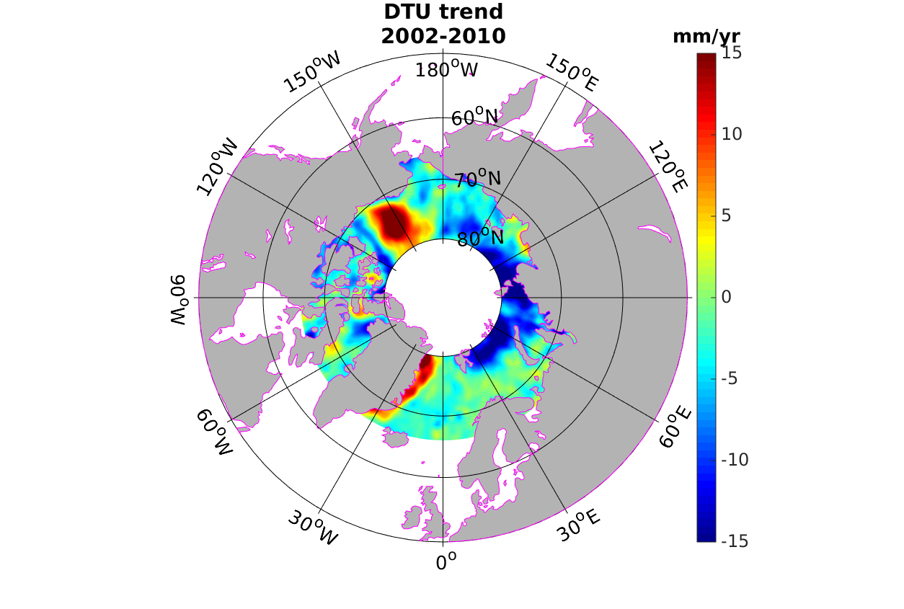 | b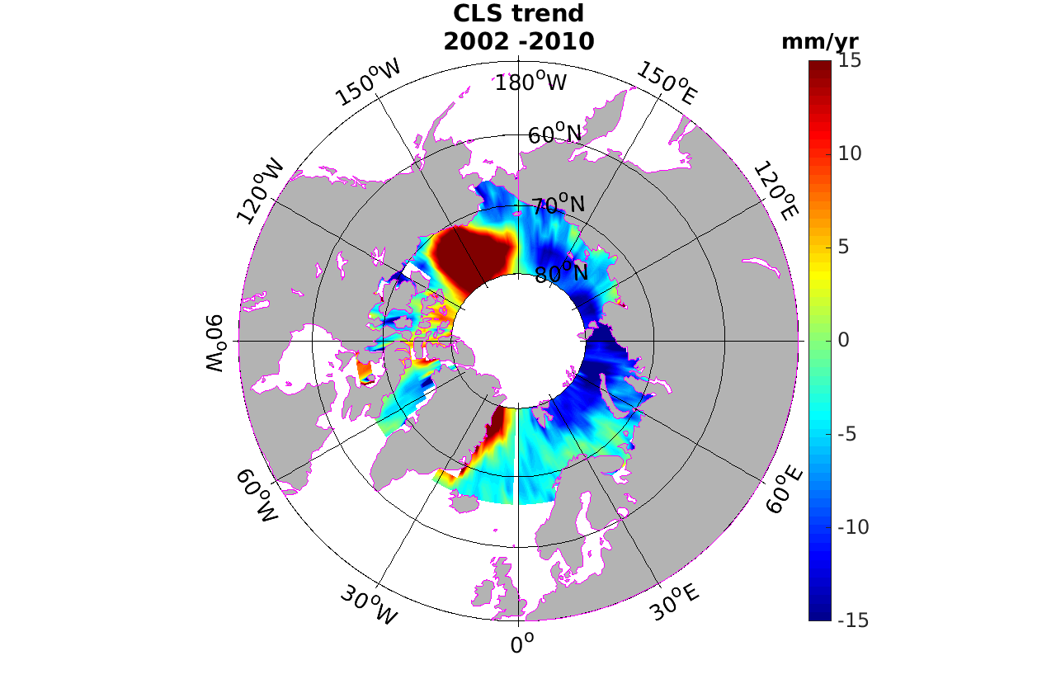 | c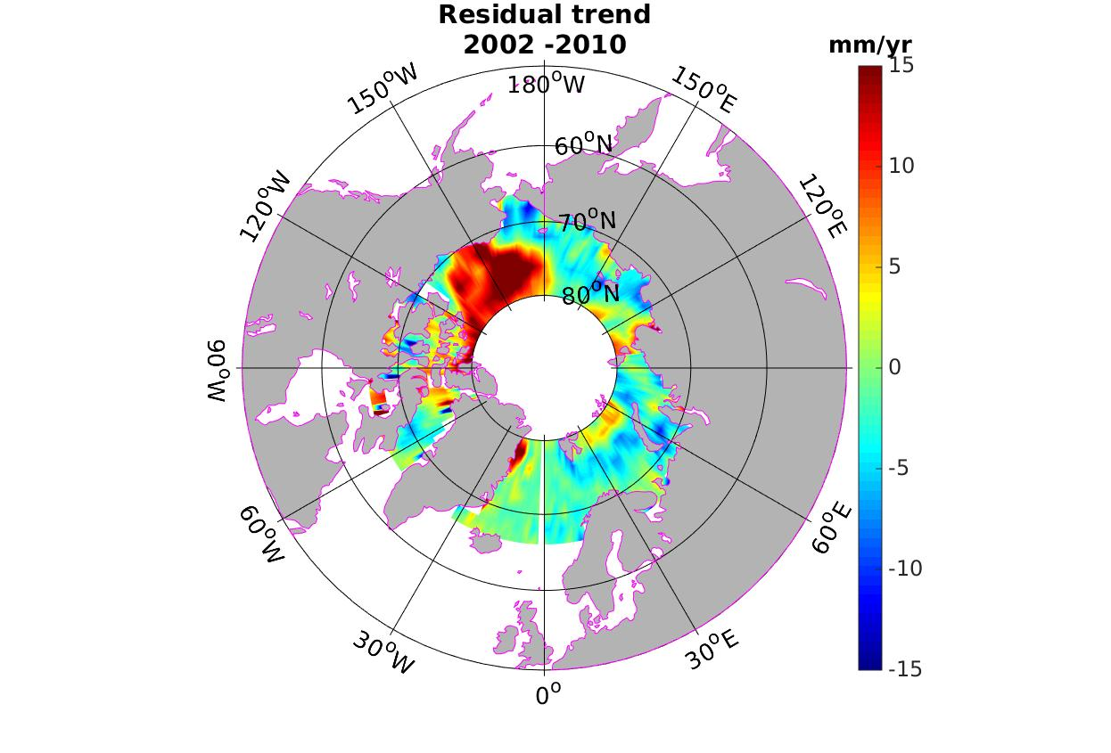
Figure 1: Spatial trend patterns in a) DTU and b) CLS altimetry based sea level for the 2002-2010 period. c) Residual map (CLS-DTU)

Using an EOF (Empirical Orthogonal Functions) analysis, we extracted the dominant modes of variability of the Arctic sea level signal. In Fig.2 are plotted the first 3 spatial and temporal modes for the CLS/PML and DTU datasets. The DTU mode 1 and CLS/PML mode 2 (10 % of the total variance) are highly correlated temporally (see Fig.2 bottom panel). Spatial modes show similar patterns along the Greenland coastlines and above Siberia, although with a higher signal for DTU, but do not agree over the Beaufort gyre. The amplitude of the spatial pattern over this region is more pronounced for CLS.
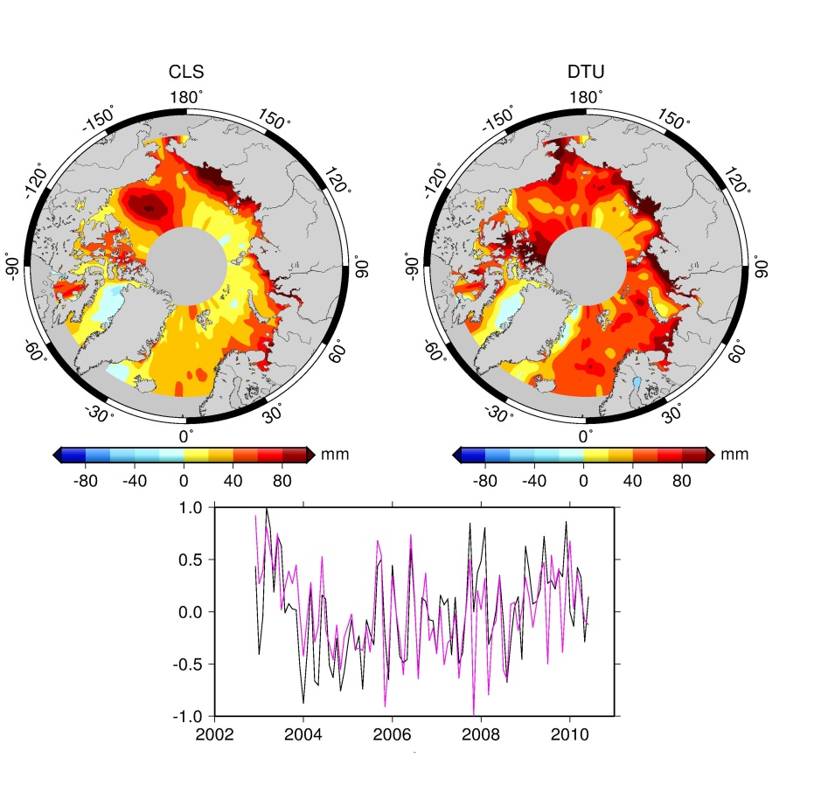

Fig.2: Modes 1 and 2 of CLS/PML and DTU altimetry grids over 2002-2010 (upper panels);

Bottom panel : associated temporal curves (CLS/PML : pink; DTU: black)

3.2 Steric and mass trends during the 2002-2010 period
We analyzed steric data to look for similar patterns which could explain the regional trends observed by altimetry. As the ORAP5 reanalysis covers the whole Arctic region, we selected the area spanning from 66°N to 80°N to be in agreement with the altimetry. Fig.3 shows the steric trend patterns and the decomposition into the halosteric and thermosteric contributions. Regarding first the steric trend patterns, we notice a strong agreement with altimetry in the Beaufort gyre region and along the Greenland coastlines. Sea level change seems to have a dominant steric origin in these regions. Trend patterns along Siberia and north of Norway are not really similar to altimetry-based sea level patterns but it may reflect the non-steric sea level contribution. Concerning the differences observed with altimetry, especially over the Beaufort gyre, steric trend patterns look closer to the CLS/PML trend map. Thermosteric trends are quite weak almost everywhere except in the Norwegian and Greenland seas. In most regions the positive steric component is balanced by the negative halosteric trends. These weak thermosteric trends are in agreement with Yin et al. (2010) and result from weaker thermal expansion coefficient expected in low temperatures environments. In the Arctic, the spatial trends in sea level thus mainly come from halosteric component. This is particularly the case along the Greenland coastlines and the Beaufort gyre region, indicating a decrease of salinity. DISCUSS MORRISON ET AL PAPER HERE
a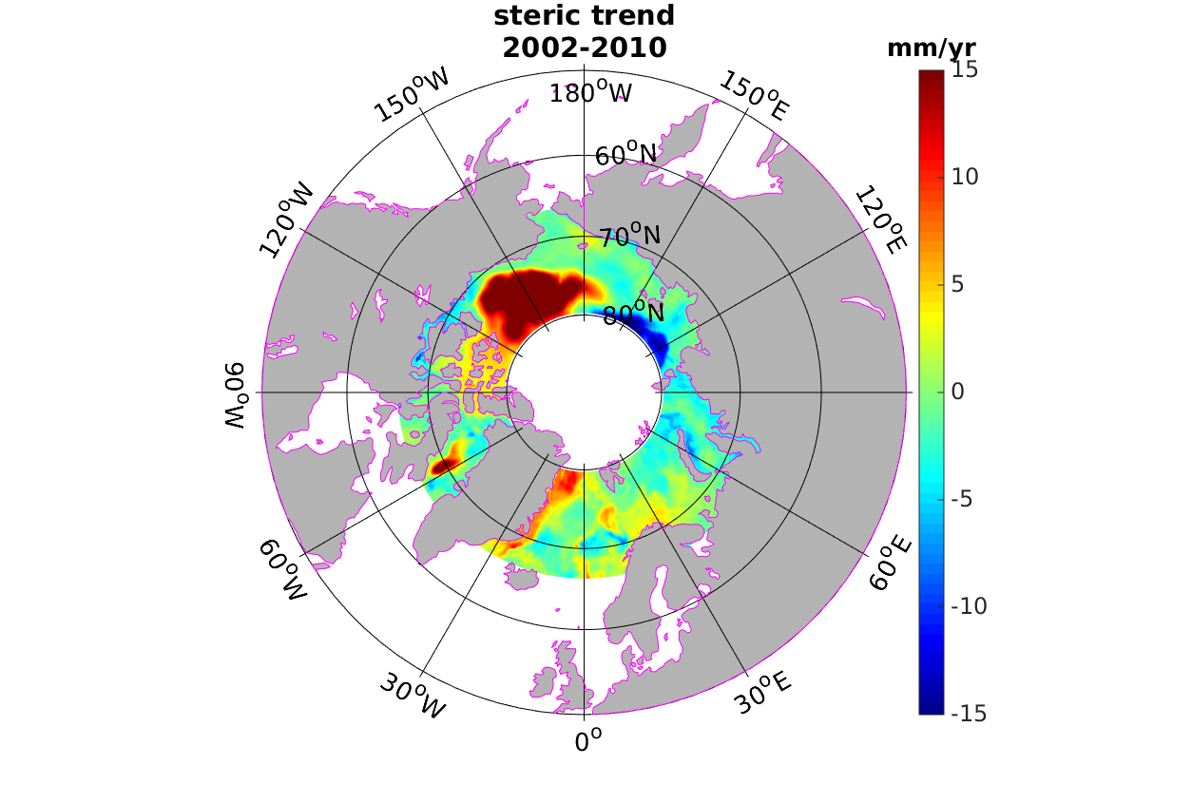 | b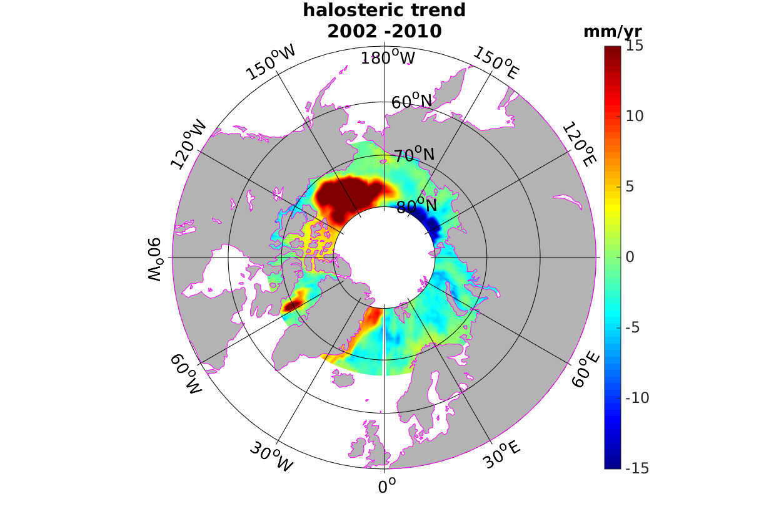 | c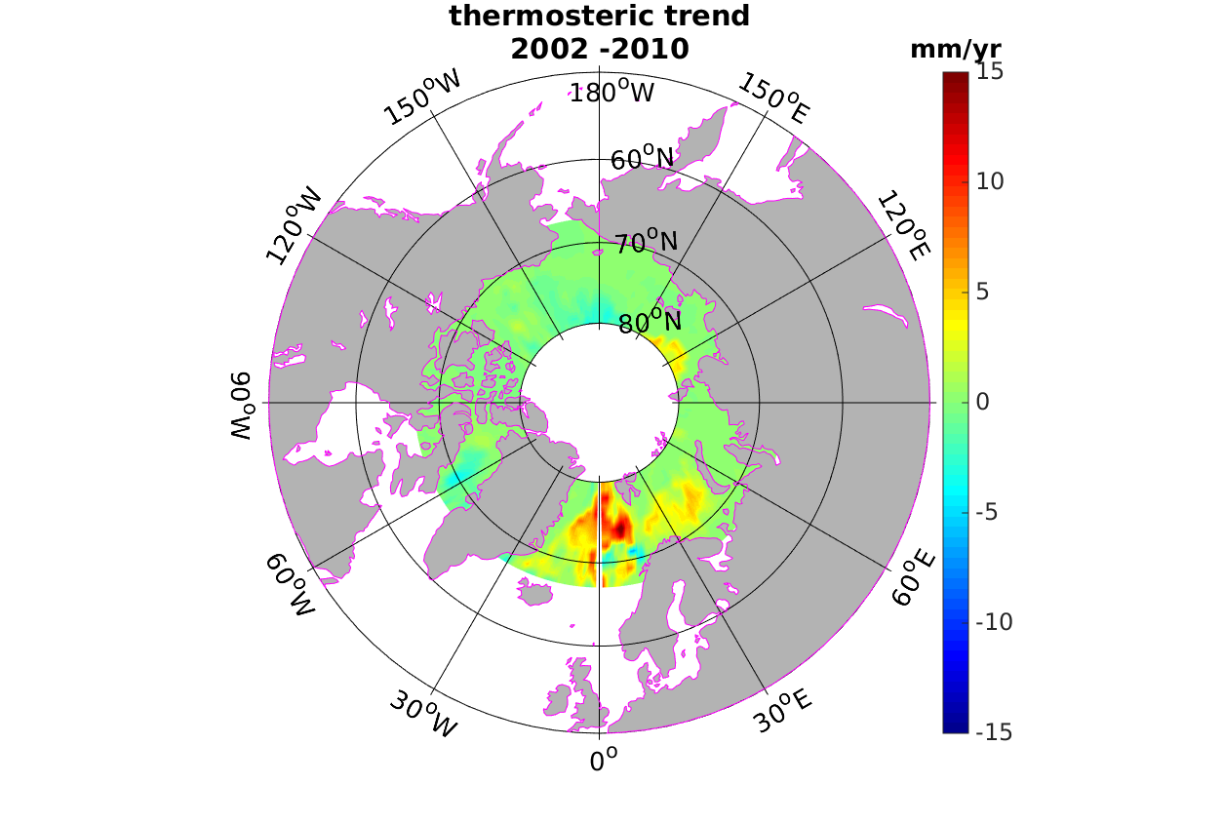
Figure 3 : Spatial trend patterns of a) steric, b) halosteric, c) thermosteric sea level in Arctic over 2002-2010

To illustrate how non-steric effects account for trend patterns, in Fig.4 is presented the trend map of altimetry-based sea level minus the steric component. From 120°W to 180°E, the DTU and CLS trends are quite similar: we find the same patterns along Greenland and Siberia coastlines, especially near 150°E where the positive trend pattern has a similar extent and amplitude for both datasets. However over the Beaufort gyre region residual trends are higher for the CLS/PML data. Regarding absolute values, non-steric signal is strong along the Greenland coastlines and over the Beaufort gyre corresponding to regions where the halosteric trend signal is important. One should bear in mind that these maps are reflecting differences in trend and not trend of the differences and so may be flawed by uncertainties on the trends.
a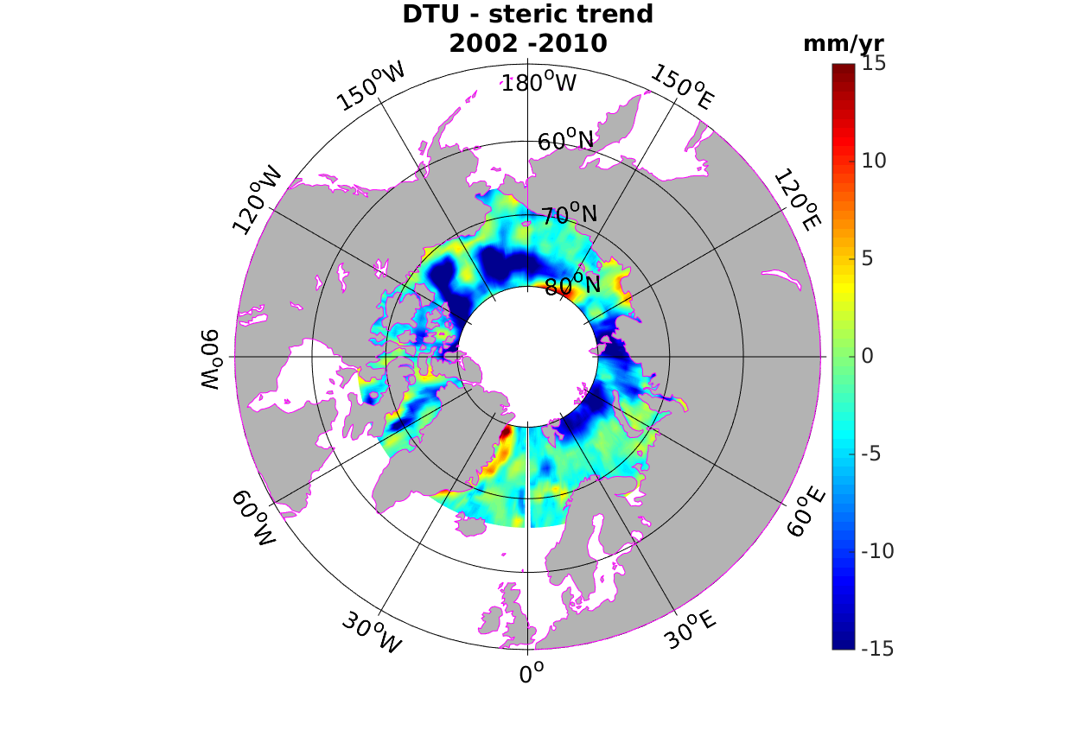 | b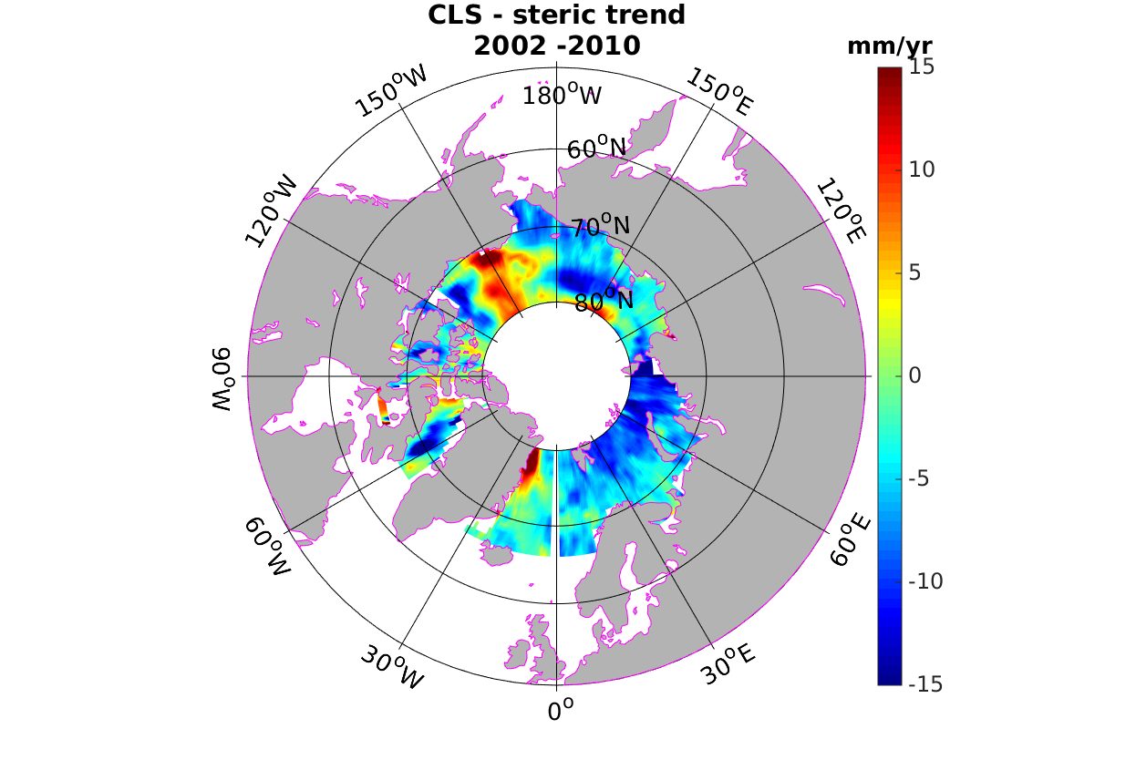
Figure 4: Observed trend patterns from a) DTU and b) CLS/PML altimetry minus steric sea level

To further analyze these residuals, we now focus on GRACE-based sea level trends. Trend patterns of the three GRACE products are shown in Fig.5. Comparing the 3 GRACE-based Arctic ocean mass trends, we note that results much differ from one solution to another. The closer solution to the residual map (i.e., altimetry minus steric trends) seems to be the LEGOS solution TO BE DISCUSSED BY ALEJANDRO

a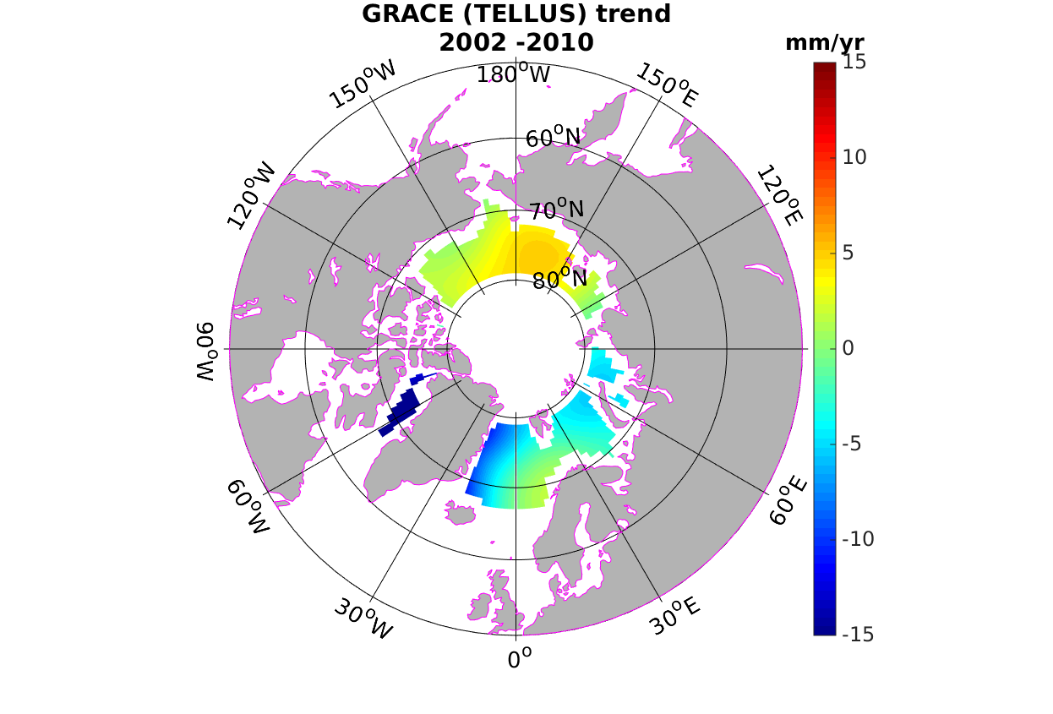 | b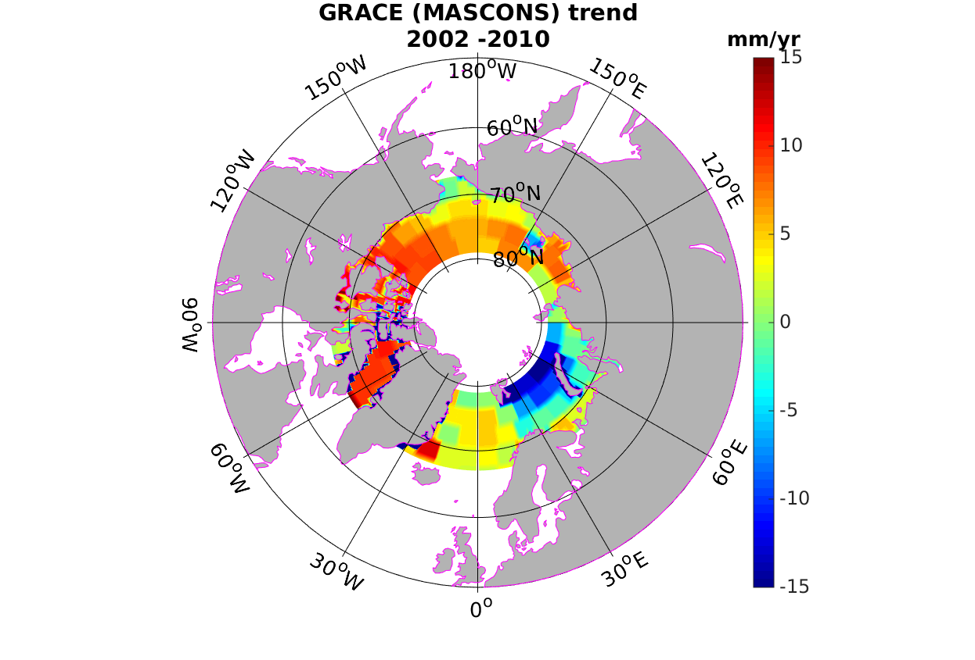 | c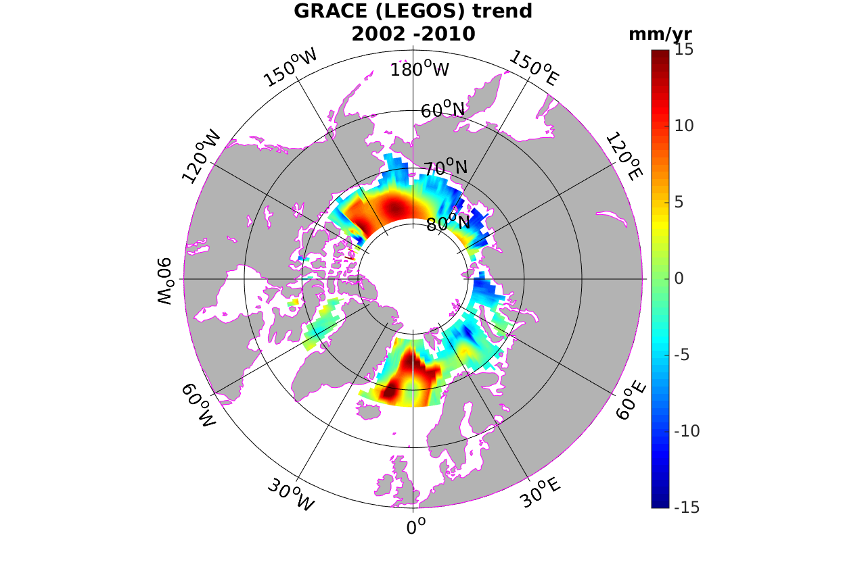
Fig.5: GRACE trend patterns for a) TELLUS, b) MASCONS and c) LEGOS solutions during 2002- 2010

3.3 Regional averages and interannual variability
This section is dedicated to the interannual variability in regional averages. For each time step we averaged altimetric and steric data in Arctic (66°N-80°N). We weighted every point by the latitude cosine. Time series of altimetry-based and steric sea level are shown in Fig.6. The two altimetry-based sea level curves agree well (correlation coefficient of 0.81). These are correlated with the temporal EOF modes seen on Fig.2.
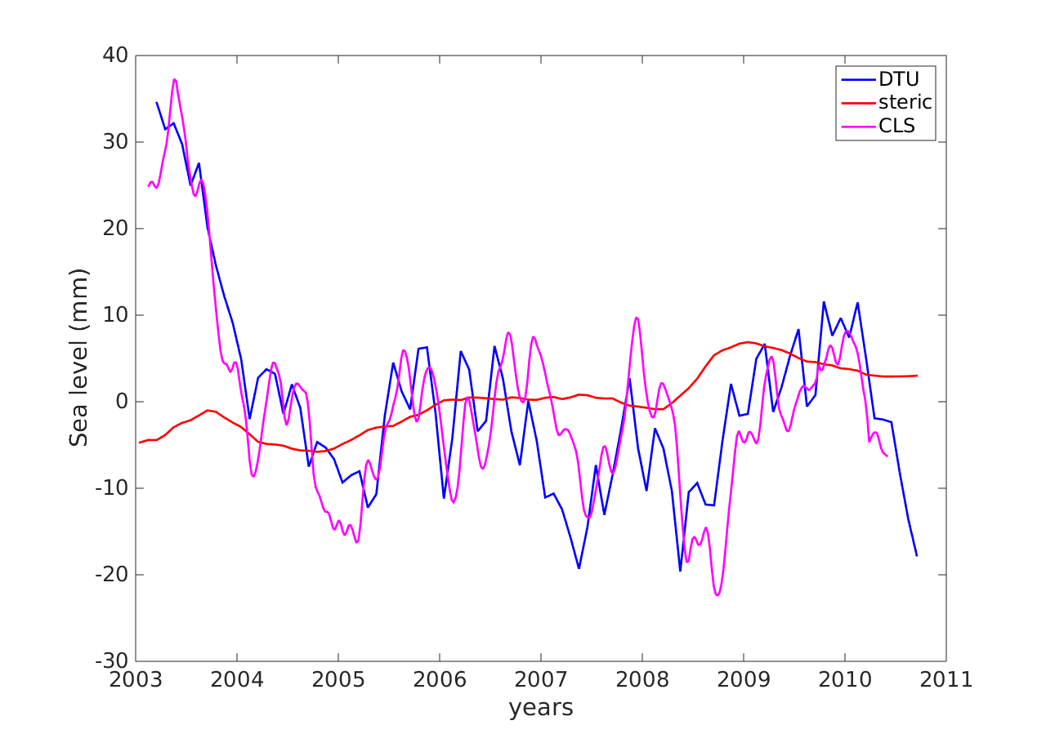

Fig. 6 : DTU (blue curve) and CLS (pink curve)-based sea level. Data are averaged for each time step. The steric sea level from ORAP5 reanalysis is superimposed (red curve).

In terms of regional average the steric component is weak compared to altimetry-based sea level. Strong trend patterns seen in Fig.3 offset each other, leading to a small steric contribution. This suggests that in terms of regional averages, most of the sea level contribution comes from mass variations.

4. Sea level budget during the altimetric era

4.1 Comparison between altimetry-based sea level and sum of steric plus GRACE-based mass contributions over the 2002-2010 time span
Over 2002-2010, GRACE data are available. We use this opportunity to compare time series from the 3 GRACE datasets to altimetry-based sea level corrected for the steric component. As we mentioned previously the steric component in Arctic is weak suggesting a dominant mass contribution. The regionally averaged GRACE and altimetry time series are shown in Fig.5 for each GRACE dataset. The averaged altimetry-based sea level corrected for steric effects and the GRACE-based mass component for the 3 solutions (TELLUS, MASCONS and LEGOS) are represented. The TELLUS solution agrees very well with CLS/PML sea level (correlation of 0.81). The correlation with DTU data is a little lower (0.71). The LEGOS solution is a little less in agreement but remains significant (correlation of 0,76 with CLS/PML and 0,62 with DTU). The MASCONS solution is poorly correlated with the two altimetry-based sea level time series (correlation of 0.34 for CLS and 0.18 for DTU) but this mainly comes for the early part of the period (2003-2005) and to a lesser extent during year 2009.

a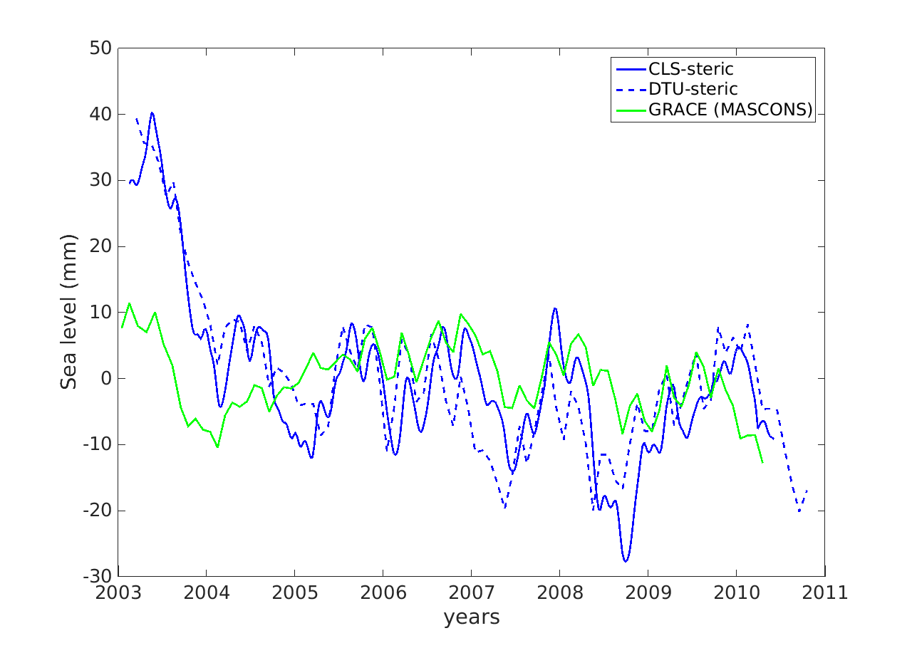 | b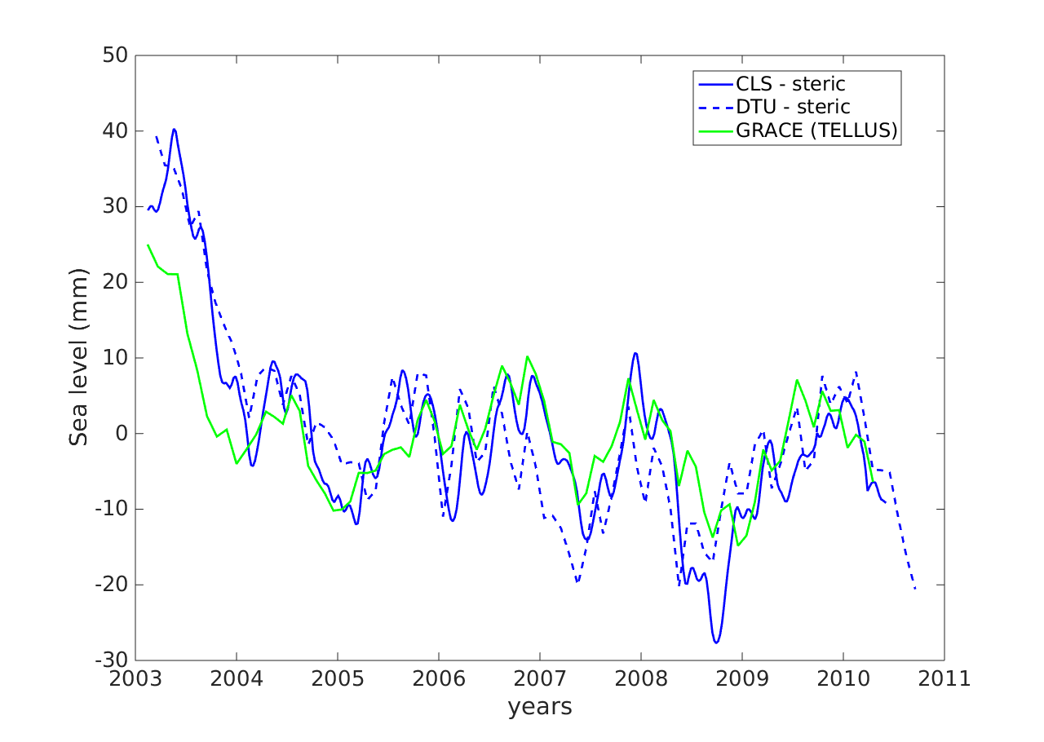 | c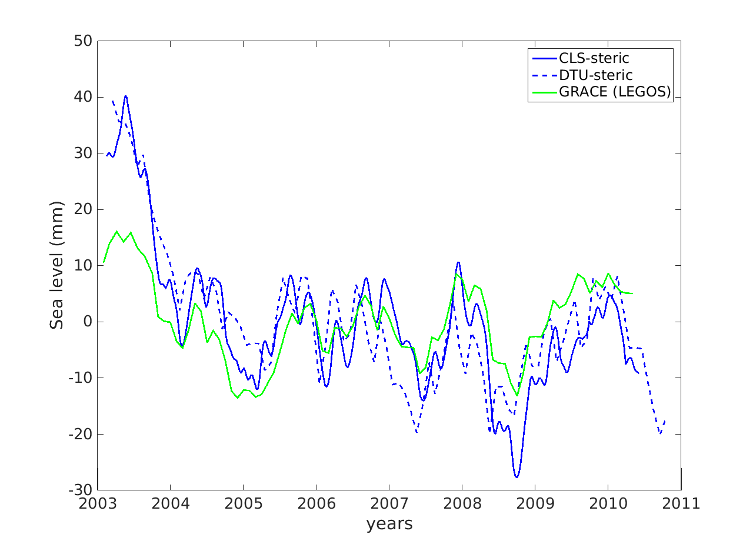
Figure 7 : Averaged altimetry-based sea level for CLS (blue curve) and DTU (blue-dashed curve). GRACE-based ocean mass component (green curve) for a) MASCONS data, b) TELLUS data, c) LEGOS data

4.2 Analysis by sectors over 2002-2010
In order to refine this regional average analysis, we divided the Arctic region into three sectors, covering Siberia seas, Greenland and the Beaufort gyre areas where most discrepancies are concentrated. These sub-regions can be seen in Fig.8 (left hand side panel) . For each sector we compared time series of averaged altimetry-based sea level (after removing the steric component) to the different GRACE products.
Fig.8 (right hand side panel) shows averaged altimetry-based sea level for DTU and CLS and GRACE-based mass component for two solutions (TELLUS and MASCONS) for different regions. In the Greenland sector, the GRACE TELLUS-based mass component (in red) agrees well with the averaged altimetry-based sea level in Greenland (in black). However this does not work as well in other sectors, i.e., the Beaufort gyre sector where the sea level budget is not closed with these data sets. In the Siberia sector, the agreement looks quite reasonable. We conclude that the main differences observed in the total average curves (Fig.7) comes from the Beaufort gyre region.
a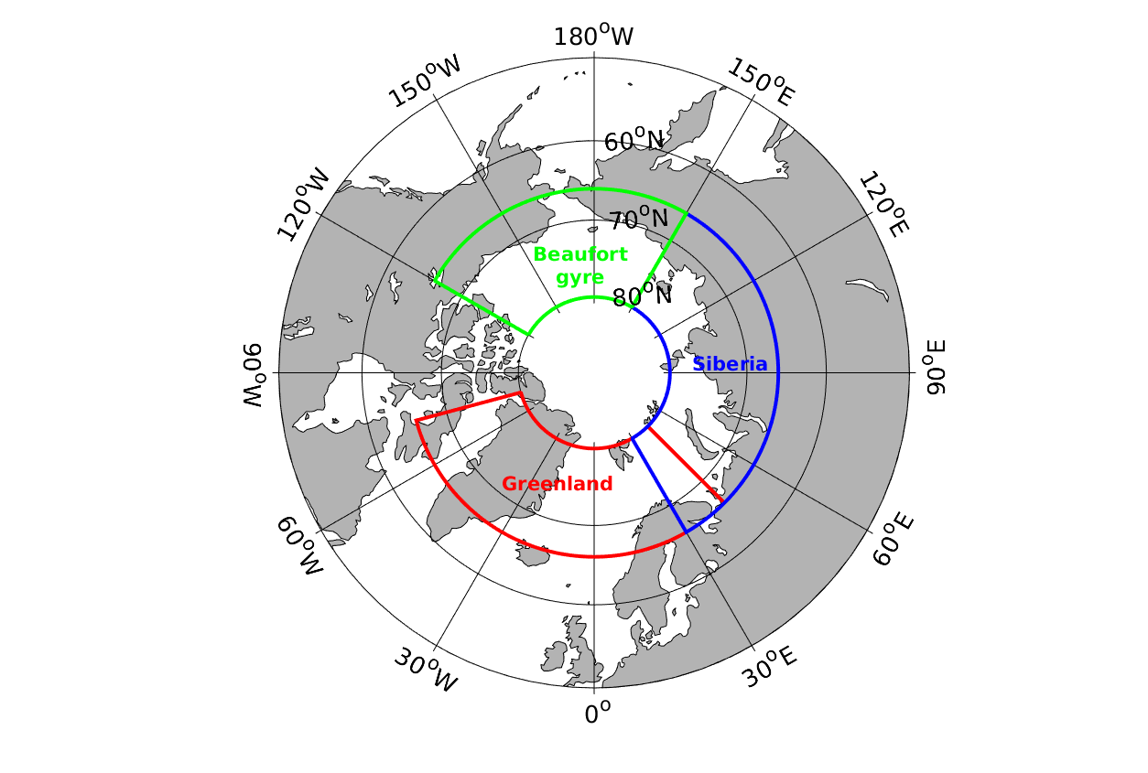 | b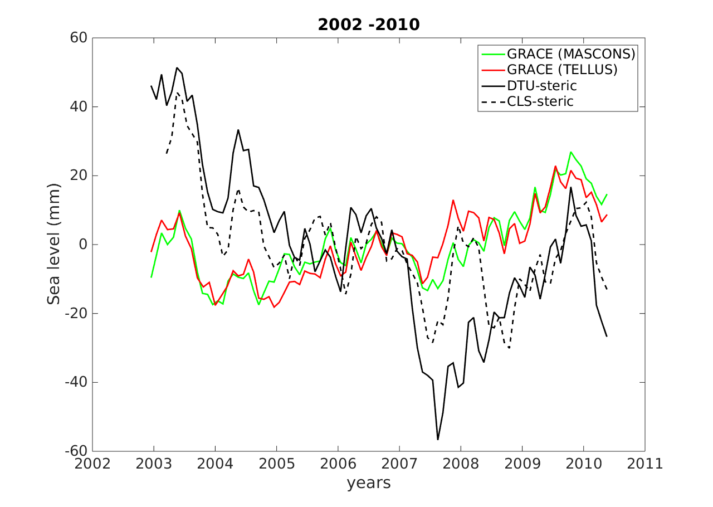
c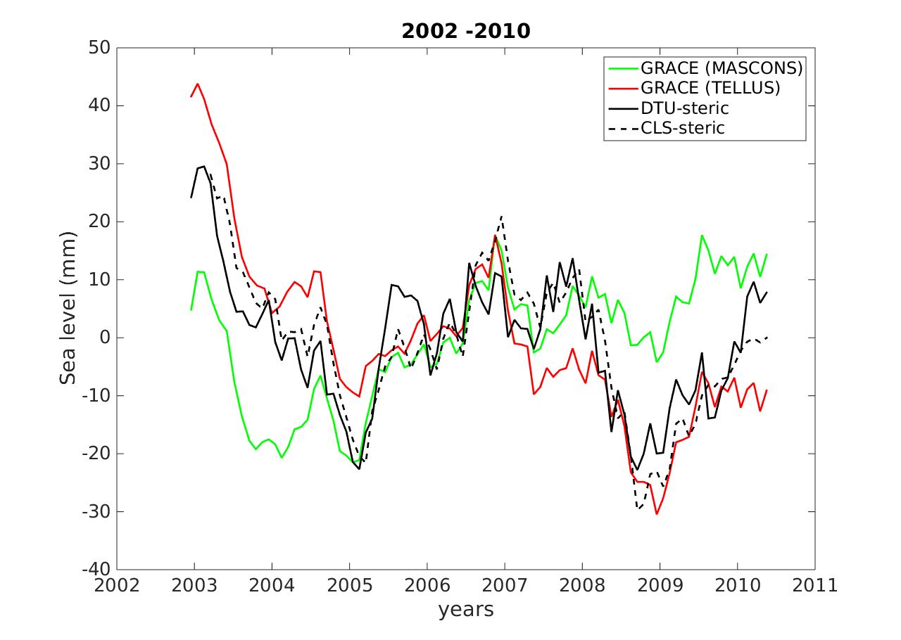 | d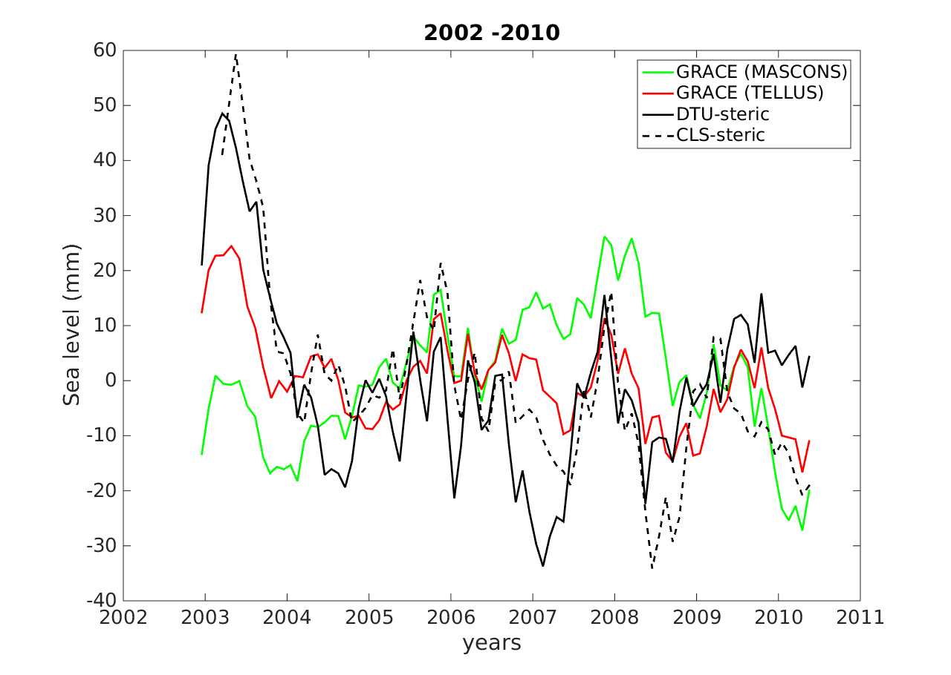
Figure 8 : a) Geographic division of Arctic. Altimetry-based sea level for DTU (black curve) and CLS (black dashed curve) averaged on b) Beaufort gyre ; c) Greenland ; d) Siberia. The steric component is removed. GRACE-based mass components are represented in green for the MASCONS solution and in red for the TELLUS solution.

We computed the root mean square errors (RMSE) between the two altimetry-based sea level corrected for steric effects and the two of the GRACE products (TELLUS and MASCONS). Results are shown in Fig.9. Highest RMSE are almost always found in the Beaufort gyre region while lower RMSE are always found in Greenland. The MASCONS solution displays higher RMSE than the TELLUS product. The weaker RMSE are obtained using CLS and TELLUS data

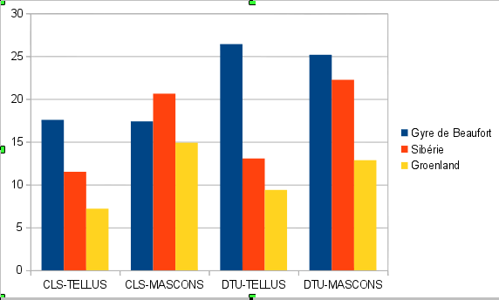Fig.9: Root mean square errors of altimetry corrected for steric effects minus GRACE-based mass component in three sub-regions

4.3 Arctic sea level over 1993-2010
The Arctic sea level was also computed over the 1992-2010 time span. For this period only the DTU and ORAP5 datasets are available. In Fig.10 spatial trend patterns are shown for in the DTU-based sea level and ORAP5 steric data. In contrast to Fig.1 which presents spatial trend patterns in DTU altimetry-based sea level for 2002-2010, Fig.10 shows positive rates almost everywhere. This illustrates the fact that the Arctic is frequently dominated by local inter-annual signal but, on a longer time span, on average Arctic sea level is increasing as illustrated in Fig.11. Fig.11 shows however that strong interannual variability is superimposed to the positive trend. In Fig.10, the increasing trend patterns along the Greenland coastlines seen over 2002-2010 are no more visible. This may indicate recent changes in this region. In contrast, the increasing trend pattern in the Beaufort gyre area is still there. As for the shorter time span, the Beaufort gyre trends are essentially steric in origin. Except for this region, the steric trend map shows weak rates, poorly correlated with the altimetry trend patterns seen north of Norway, Sweden and Finland on the DTU trend map.
The steric sea level also displays a dominant halosteric component, e.g. in the Beaufort gyre region. Since direct estimate of the mass component is not possible before 2002, we estimated it by computing the residual trend patterns (Fig.10, right hand side panel). In fact the residual trend map represents, in addition to mass redistribution all other non steric components, including atmospheric loading effect, fresh water input, etc.). The residual map shows positive trends almost everywhere. If attributed to mass redistribution alone, this implies rising trends in the whole Arctic for the mass component. The strongest signals are located in the Greenland and Norwegian seas.
a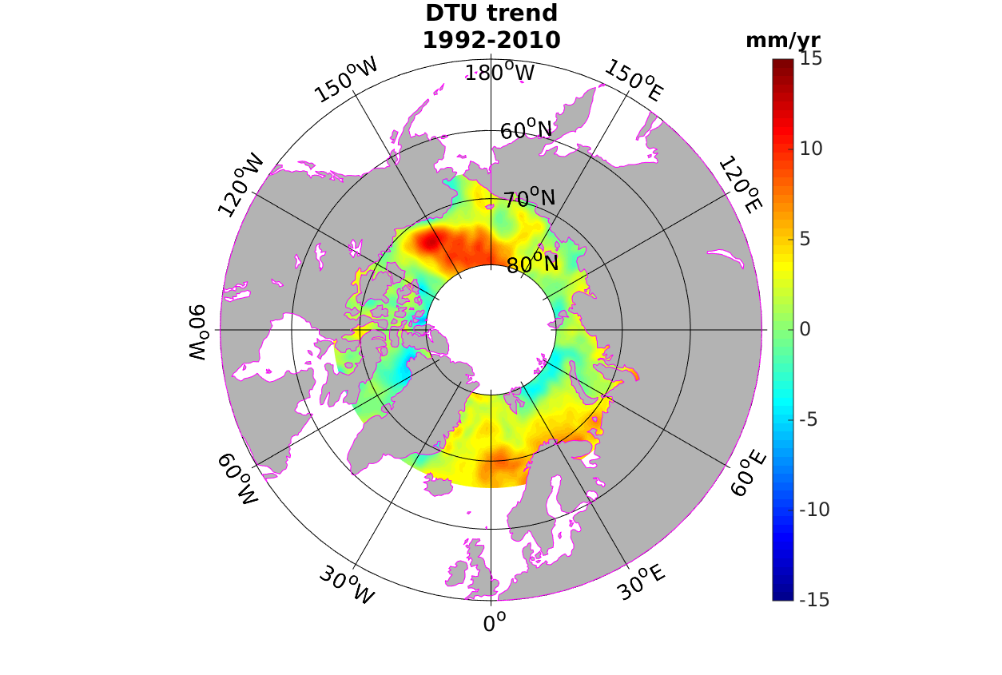 | b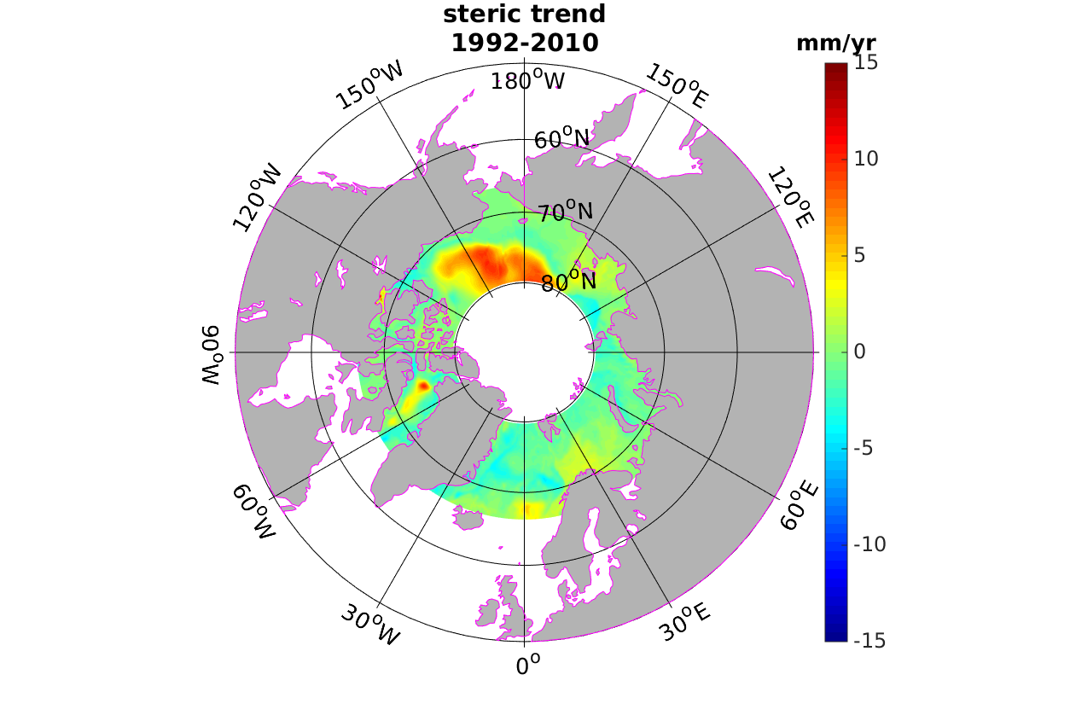 | c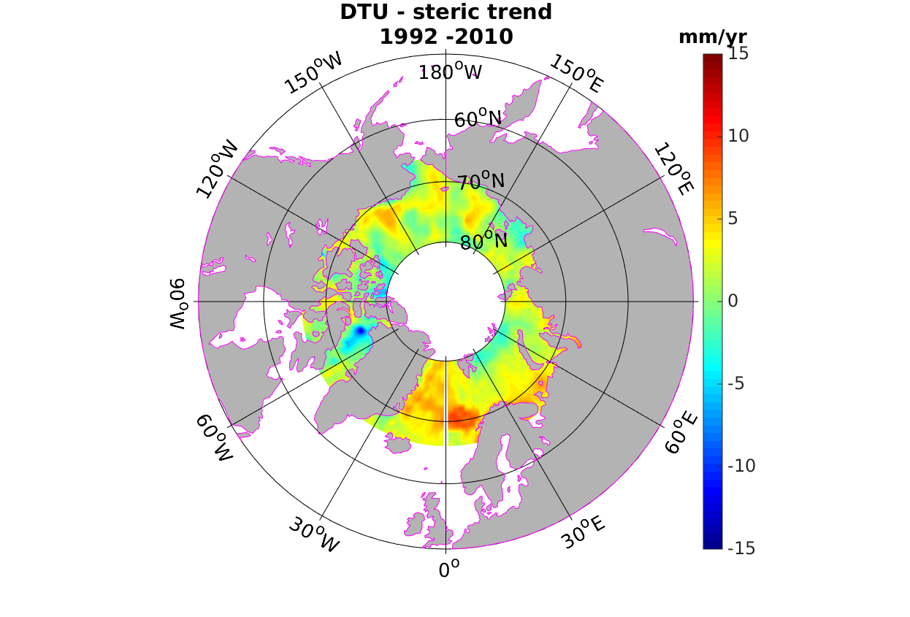
Figure 10 : Spatial trend patterns in a) DTU-based sea level, b) steric sea level. c) Residual map (DTU-steric)

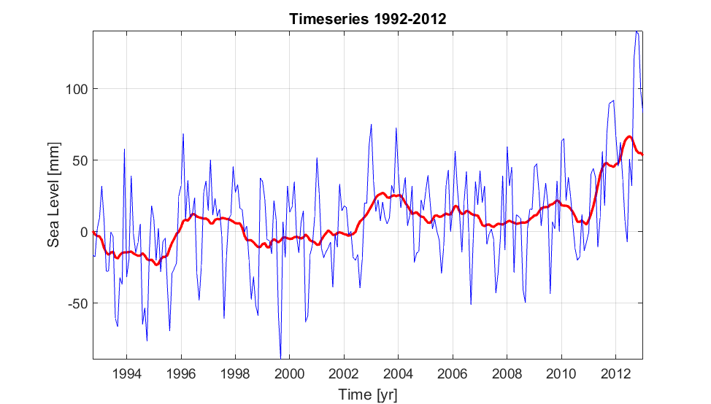
Figure 11. DTU based average sea level curve for the Arctic for the 1993-2012 period. Blue is the monthly average and red is a running annual mean.
In the regional averages shown in Fig.11, the steric contribution is still small. The DTU time series clearly shows an upward trend with some peaks starting in 1996 and 2002. Over the entire period, the altimetric sea level trend amounts to 2.23 mm/yr.

5. Coastal sea level from tide gauges data (Norwegian and Siberian sectors)
This section is an update of the Henry et al. (2014) study. We considered Revised Local Reference dataset from Permanent Service for Mean Sea Level available at http://www.psmsl.org/data/obtaining/. We used the tide gauges records from stations selected in Henry et al. (2014) consisting in 11 stations localized along Norwegian coast, 48 along Siberia and 3 Island tide gauges. As in Henry et al. (2014), we divided Russian tide gauges into 2 sets of data according to the continuity of records. The end time of the tide gauges series is 2013 for most cases but some Russian stations ended before. Following Henry et al. (2014), we linearly interpolated time series if data presented gaps during less than 3 years then we removed annual and semi-annual cycles and smoothed data with a running mean filter.
We corrected time series from GIA using Geruo A and J. Wahr (2013) model with the deglaciation history ICE-5G and mantle viscosity structure VM2. GIA rates fall between -3,07 mm/yr and 1,17 mm/yr with higher values along the Greenland coastlines and smaller values mainly along Norwegian coastlines. In order to correct for the inverse barometer (IB) effect we downloaded surface pressure data from http://www.esrl.noaa.gov/psd/data/gridded/data.ncep.reanalysis.derived.surface.html. Data are available as monthly grids and we chose the nearest grid point for each tide gauge to compute the IB correction. On average IB trends are of 0,15 mm/yr.
In Fig.12 are presented the tide gauge-based sea level time series corrected for IB effect and GIA for each region : Norwegian Sea, Russian 1 and Russian 2 sectors. All datasets show increase since 1980 and although there are some short periods of decrease (for example in 1995 or in 2009), the mean sea level is rising even more after these dates. This update of Henry et al. (2014) ‘s work shows an increasing trend since 2009. Since the beginning of tide gauges records, we found trends of 1.5 mm/yr for the entire Arctic, 0.6 mm/yr for the Norwegian sector, 2.2 mm/yr for the first Russian sector, 2.1 mm/yr for the second Russian sector.

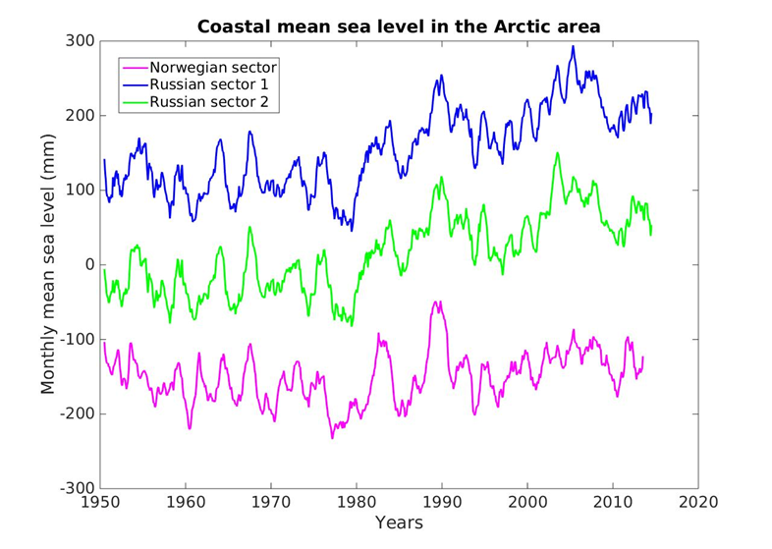

Fig.12: Coastal sea level from tide gauge data for the Norwegian, Russian 1 and Russian 2 sectors
We also looked at the mean coastal sea level (CMSL) averaging all tide gauge records of the 3 sectors region and superimposed it to the Arctic Oscillation (AO) index ( Fig.13). Except between 2002 and 2008 the AO is significantly correlated with tide gauge-based sea level. Over the whole period the correlation coefficient is 0.61.
In order to have an estimation of the coastal sea level budget, we interpolated GRACE and ORAP5 steric data at the tide gauges stations. We considered the nearest grid point of each station. In the whole Arctic region the steric component is weak but for some tide gauges it explains much of the interannual variability ( Fig.14). We added GRACE-based sea level to the steric component also using the three GRACE products available (Fig.15). Unlike the altimetric comparison discussed above, at the coast, we find better correlation with the MASCONS product. It may be due to improvement of the land leakage filter developed in this solution leading to better results near the coasts. The tide gauge series and the GRACE plus steric based sea level give similar results until 2013 where the times series diverge.
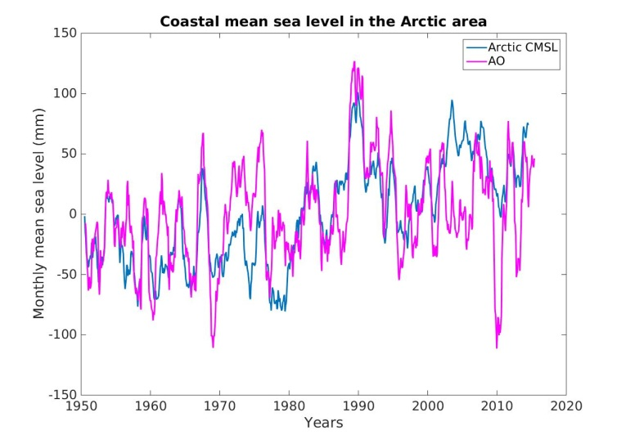

Fig.13: Mean coastal sea level in the Arctic between 1950 and 2014. The AO index is superimposed.
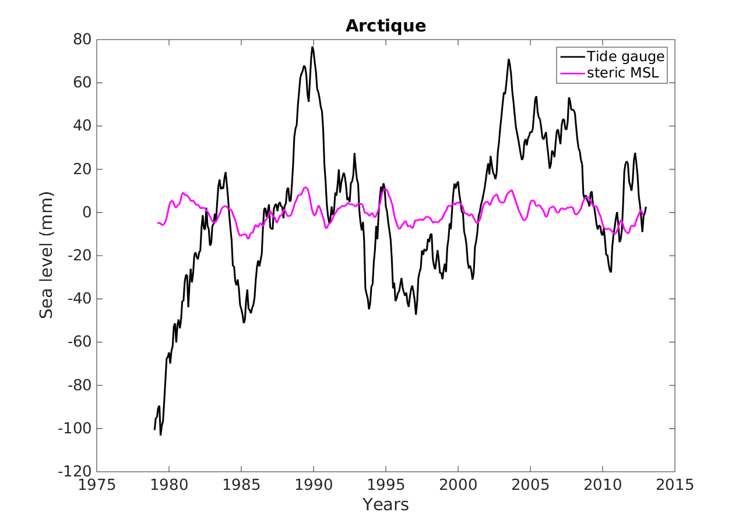Fig.14 : CMSL at Arctic tide gauges (black curve) and steric component interpolated at the stations (pink curve) | Figure 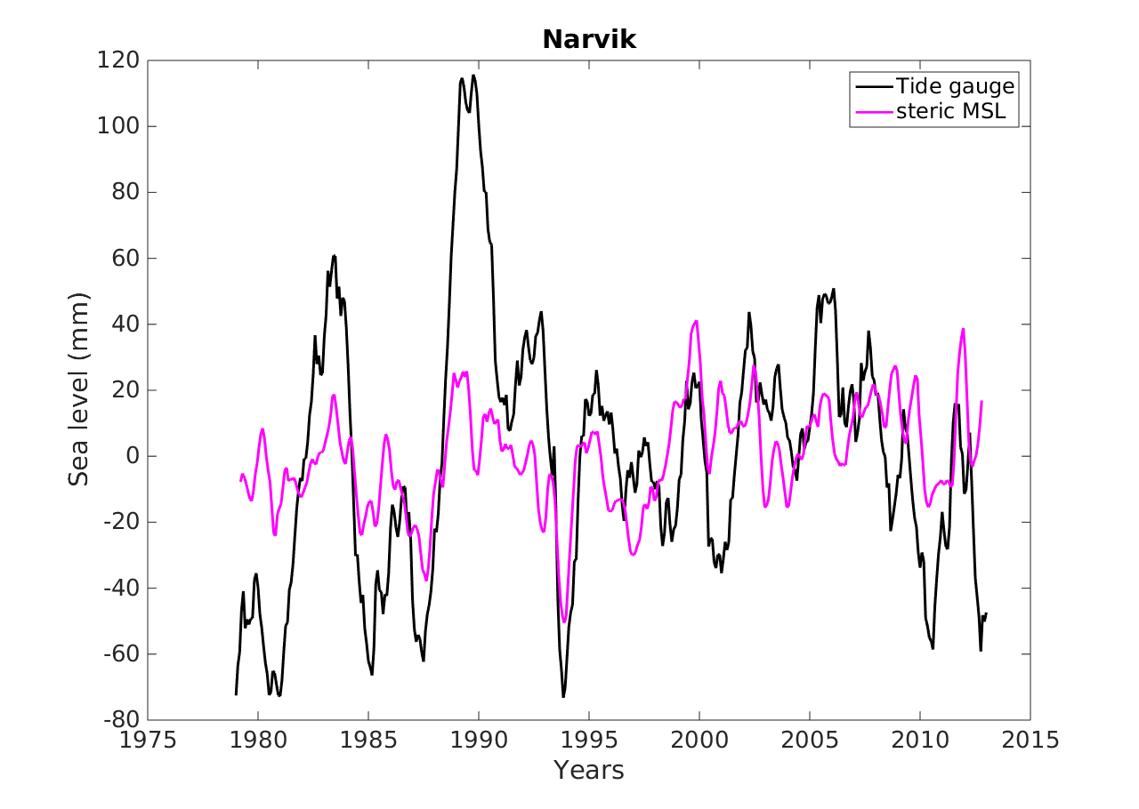15 : CMSL (in black) and steric sea level (in pink) at Narvik station

a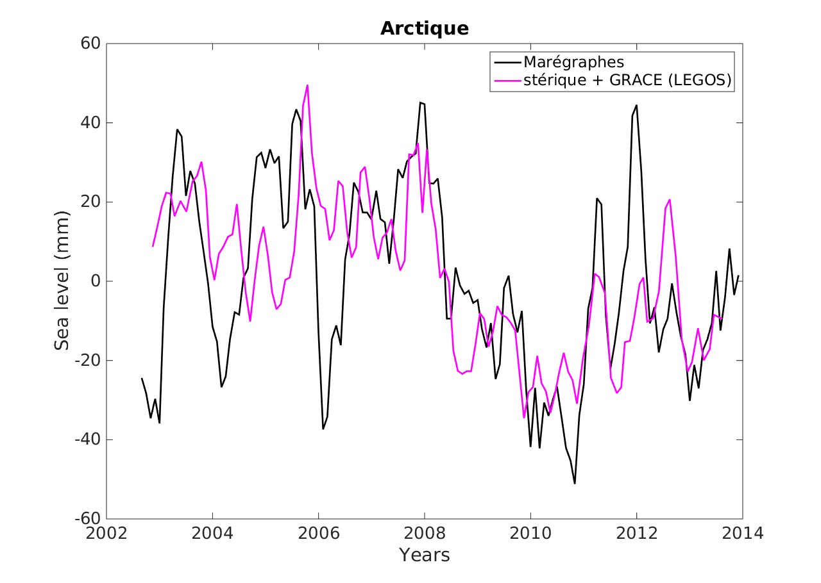 | b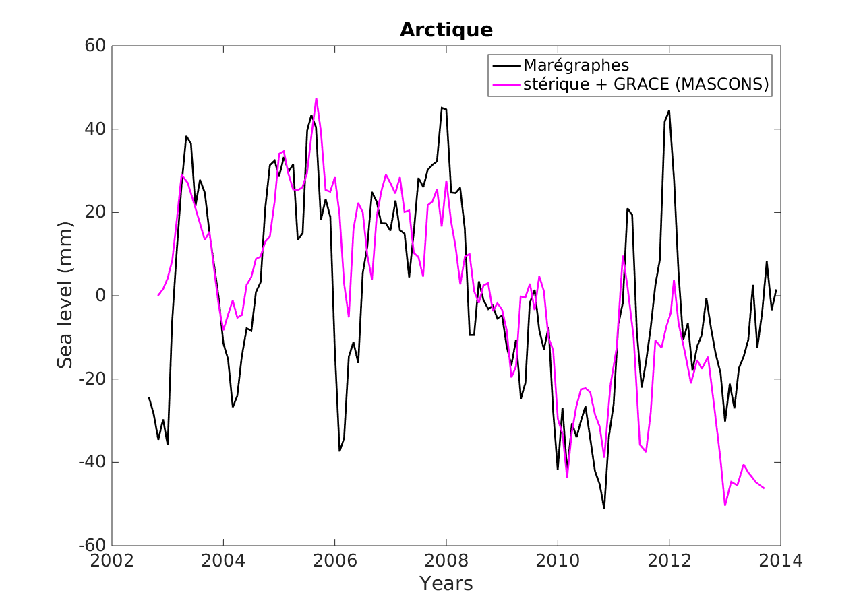 | c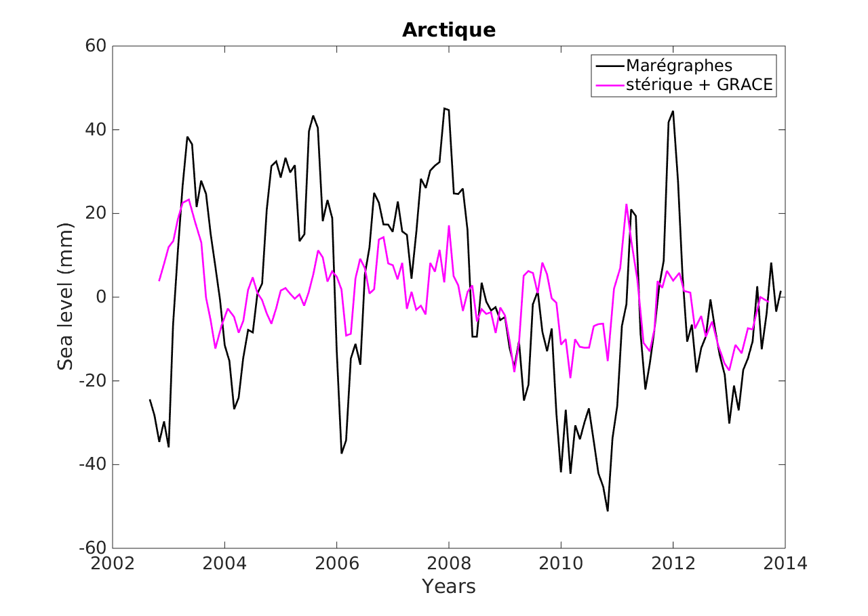
Figure 16 : CMSL and interpolated steric + GRACE a) LEGOS-based, b) MASCONS-based, c) TELLUS-based sea level at arctic stations

CONCLUSION OF THIS SECTION: TBD

6. CMIP5 models on the Arctic; comparison with data during the altimetry era

6.1 CMIP5 model description
We used CMIP5 models for comparison with altimetry based sea level over the Arctic region. This paper considers 20 models coming from 11 institutions, with different versions of some models (see Table 1). We focused on three variables : Sea Surface Height Above Geoid, steric and thermosteric sea level in the whole water column. We used historical runs from 1850 to 2005 and extended them until 2010 using the RCP8.5 experiment. All gridded fields are projected on a 1x1° map. Data are also corrected for model drift using pre-industrial control runs. The drift removed for each grid cell is quadratic for the sea surface height above geoid and is computed for a 150-year time span beginning when the control run is branched to the historical run. In contrast steric and thermosteric variables are corrected for a linear drift computed for the whole pre-industrial experiment time span. We compared both methods and did not find significant differences.
Table 1
Institution | Model name | Components changing according to the version
CSIRO-BOM | ACCESS1-0 | Land surface ; Atmosphere
 | ACCESS1-3
Canadian Center for Climate Modelling | CanESM2
NCAR | CCSM4
Centre National de Recherches Météorologiques and Centre Européen de Recherche et Formation Avancées en Calcul Scientifique | CNRM-CM5
NOAA | GFDL-CM3 | Atmosphere ; Aerosol ; Atmospheric chemistry; Ocean biogeochemistry
 | GFDL-ESM2M
University of Tokyo, National Institute for Environmental Studies, Japan Agency for Marine Earth Science and Technology | MIROC5 | Atmosphere ; Ocean ; Ocean biogeochemistry ; Atmospheric chemistry
 | MIROC-ESM
 | MIROC-ESM-CHEM
Max Planck Institute for Meteorology | MPI-ESM-LR | Ocean and atmosphere resolution
 | MPI-ESM-MR
Meteorological Research Institute | MRI-CGCM3
Norwegian Climate Center | Nor-ESM1-ME | Ocean biogeochemistry
 | NorESM1-M
UK Met Office | HadGEM2-CC | Carbon cycle
 | HadGEM2-ES | Earth system
IPSL | IPSL-CM5A-LR  IPSL-CM5A-MR | Resolution
Table 1: Models used, their institution and the components differing from one version to another

6.2 Sea level in Arctic during altimetry era using CMIP5 models

For the 2002-2010 time span, we computed spatial trends for each models. Trend patterns maps are shown in Fig.17.
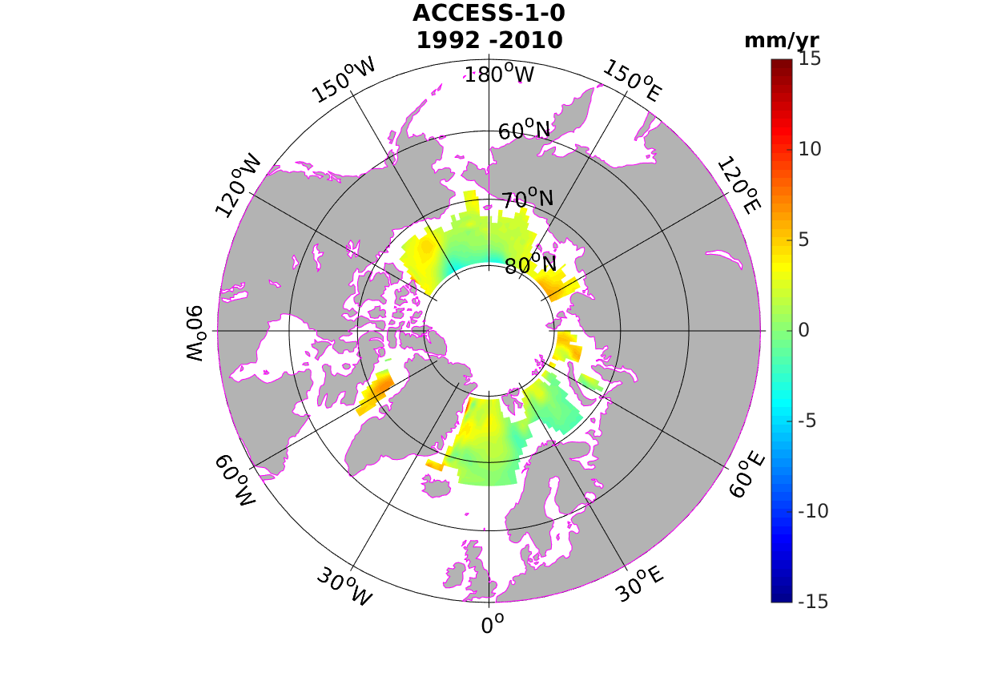 | 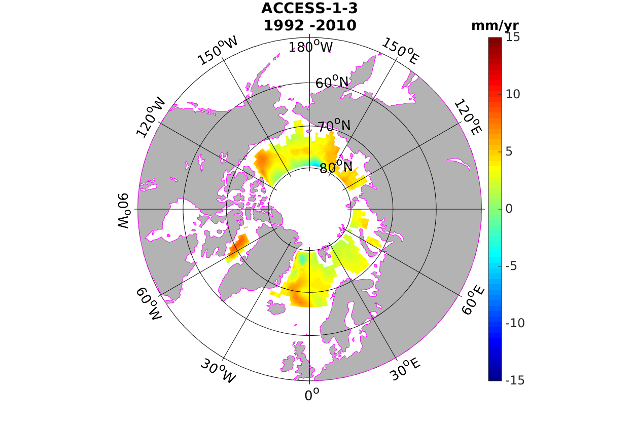 | 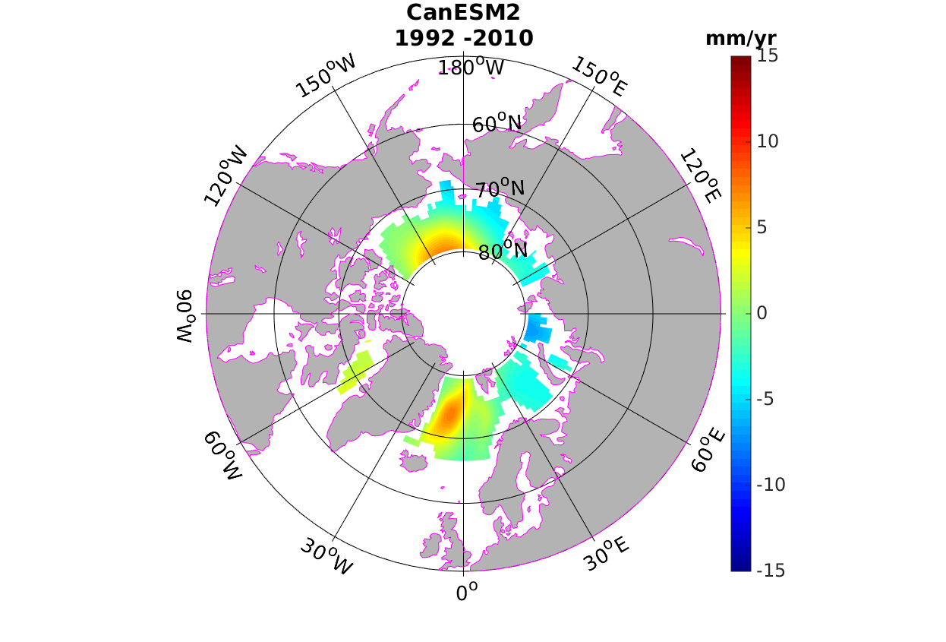 | 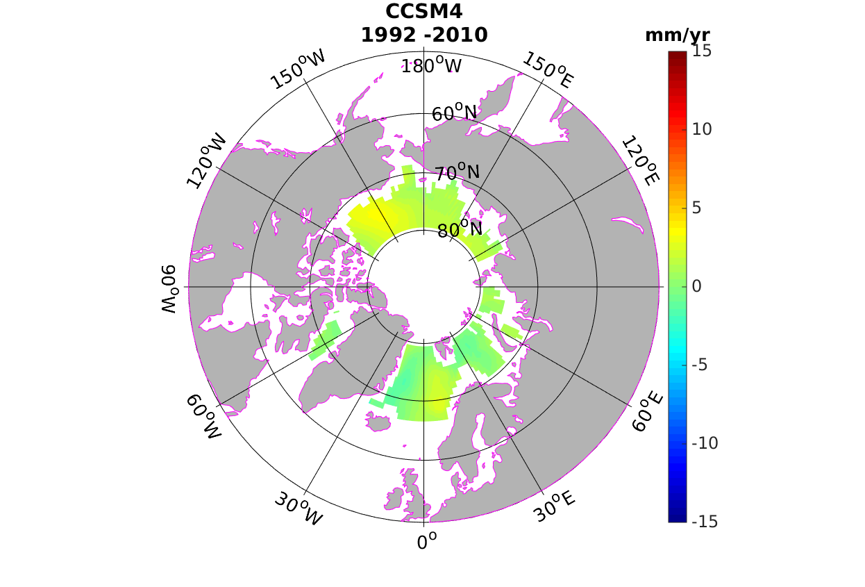
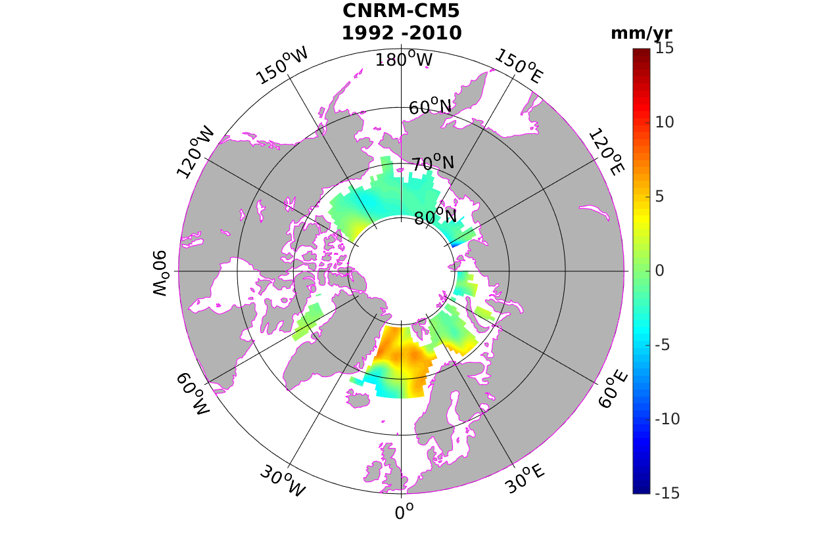 | 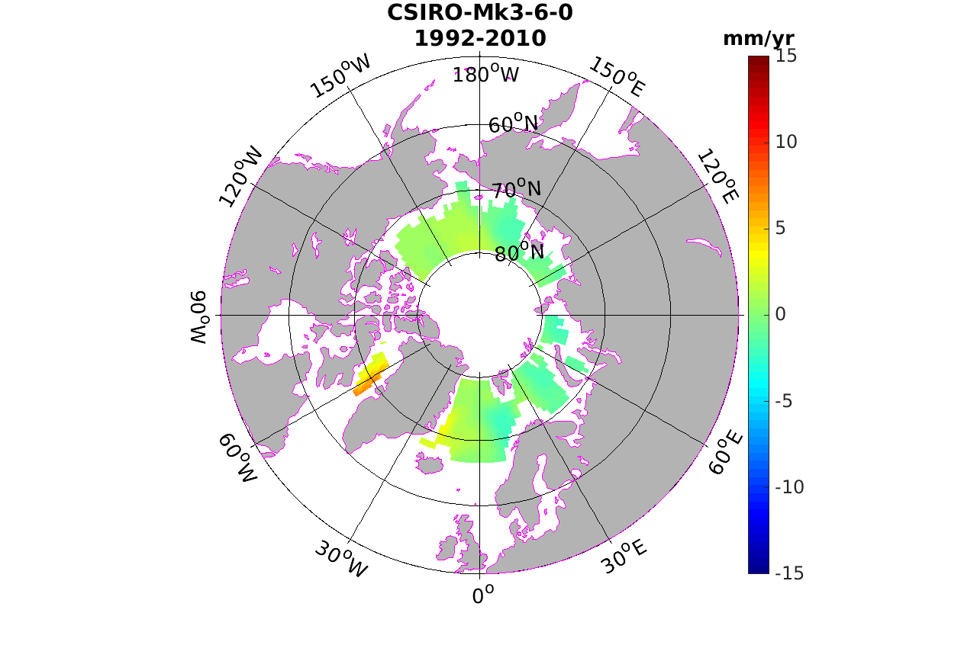 | 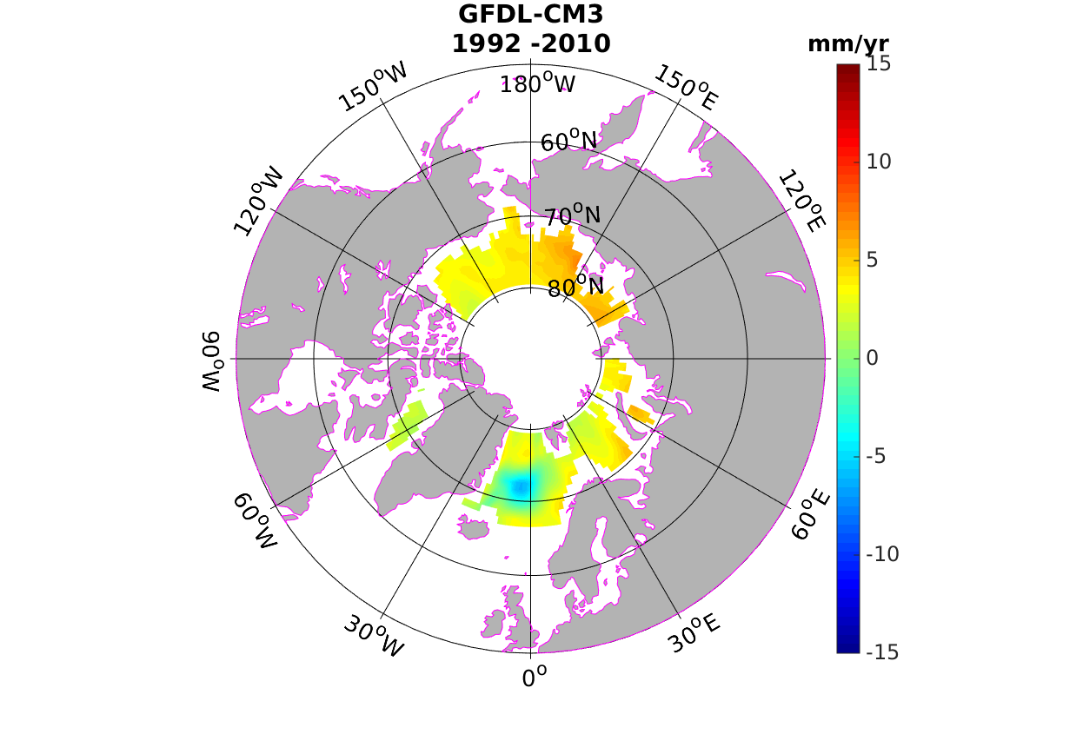 | 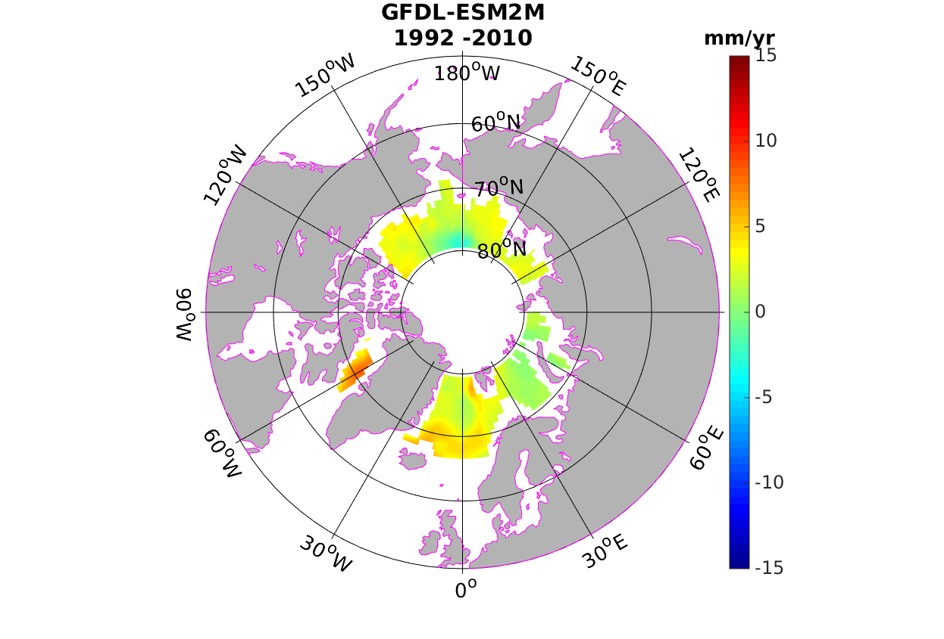
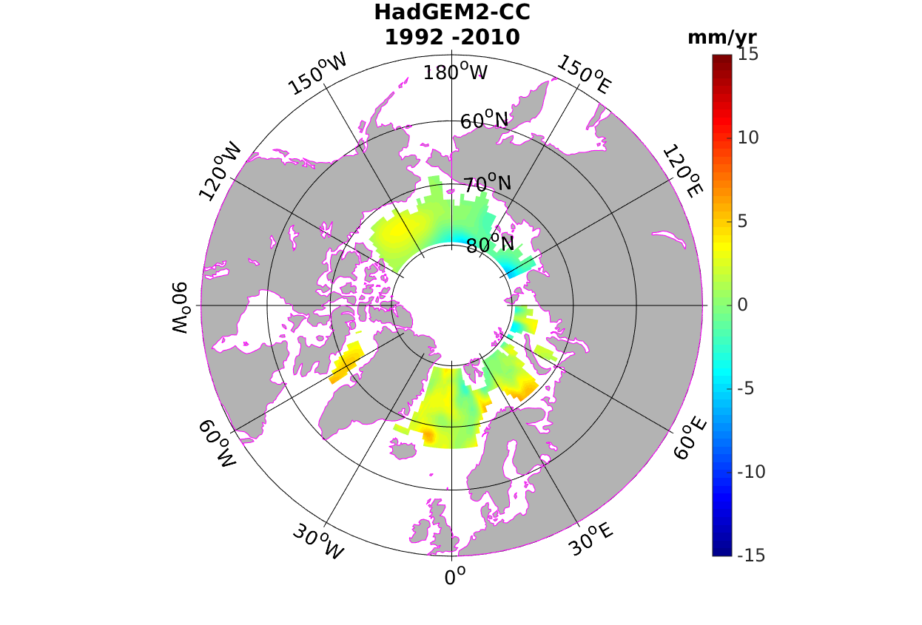 | 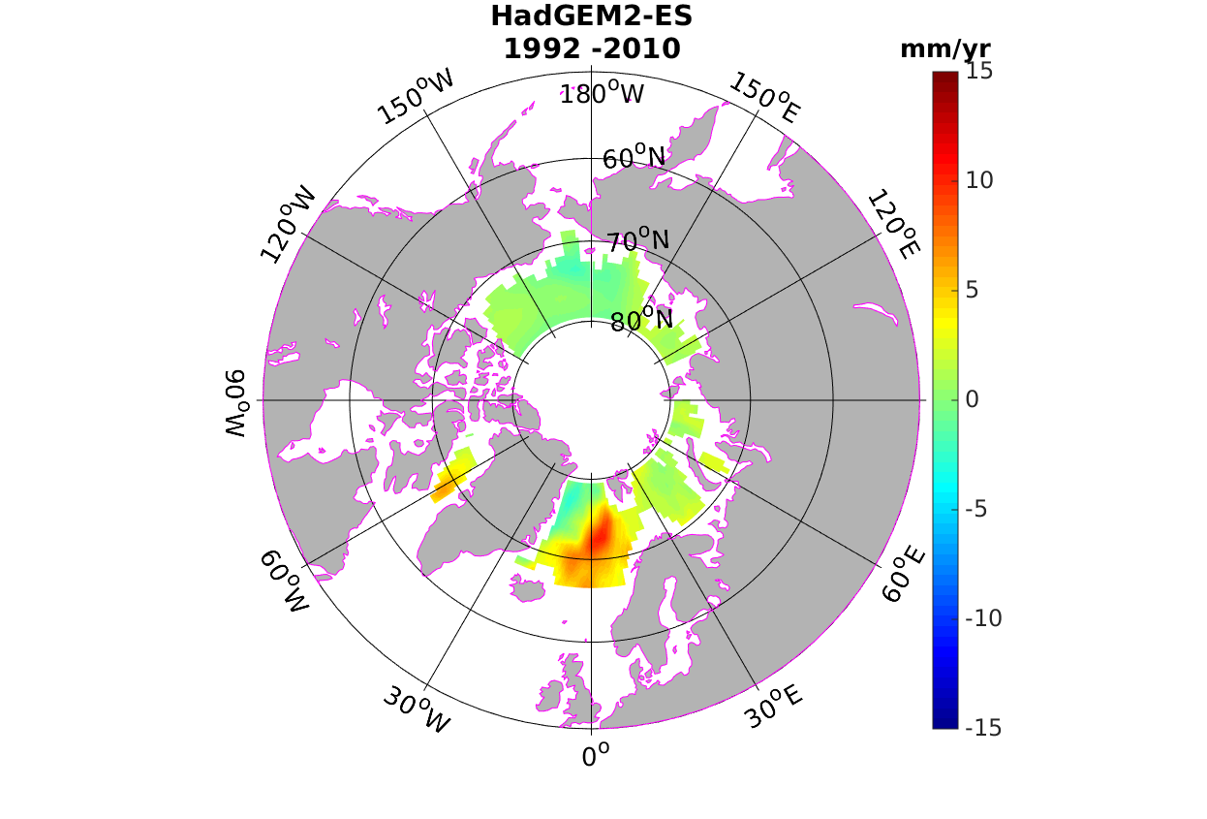 | 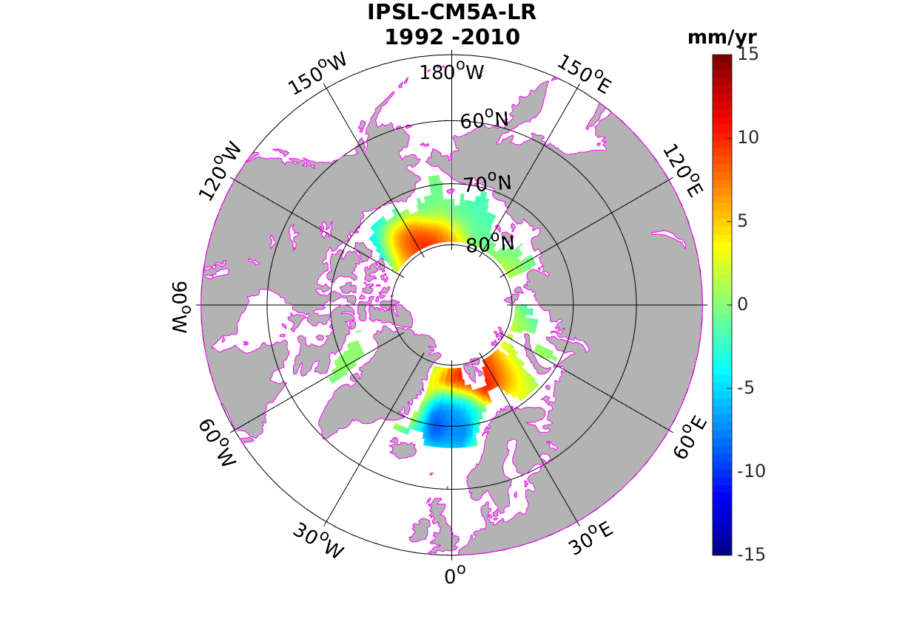 | 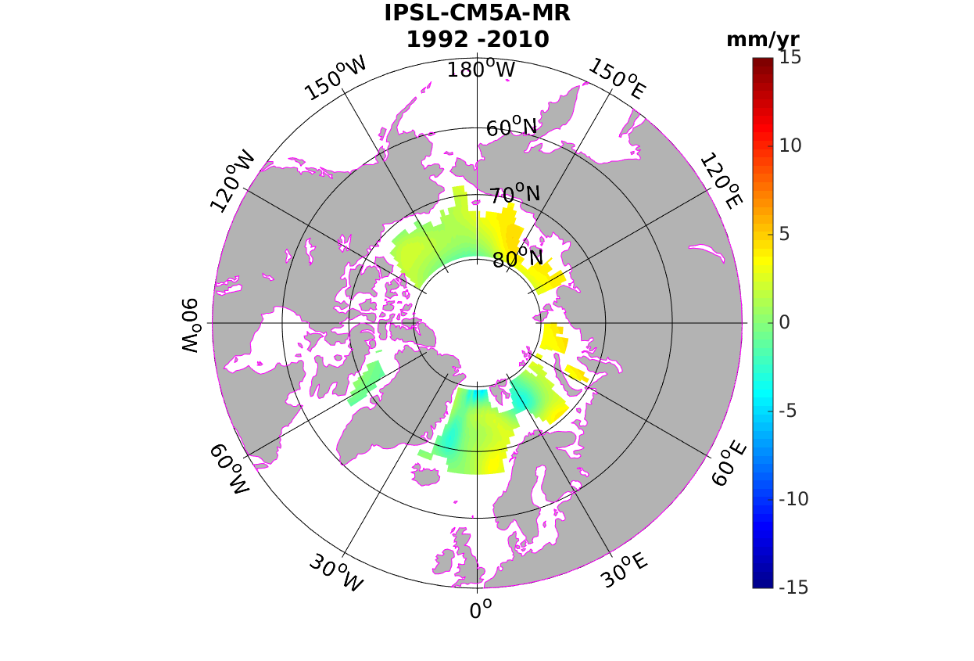
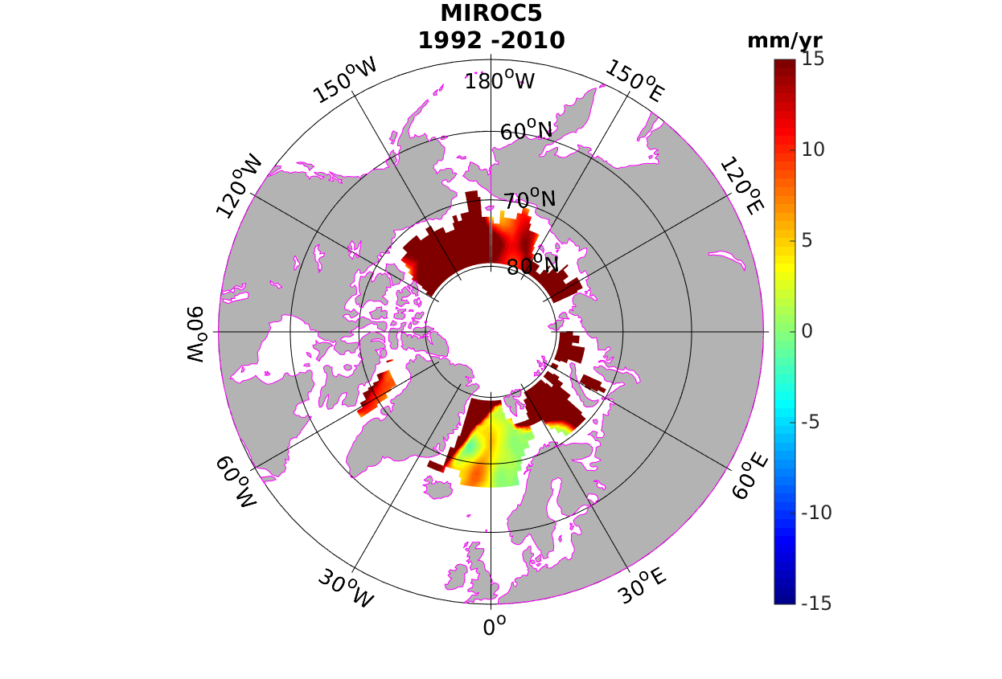 | 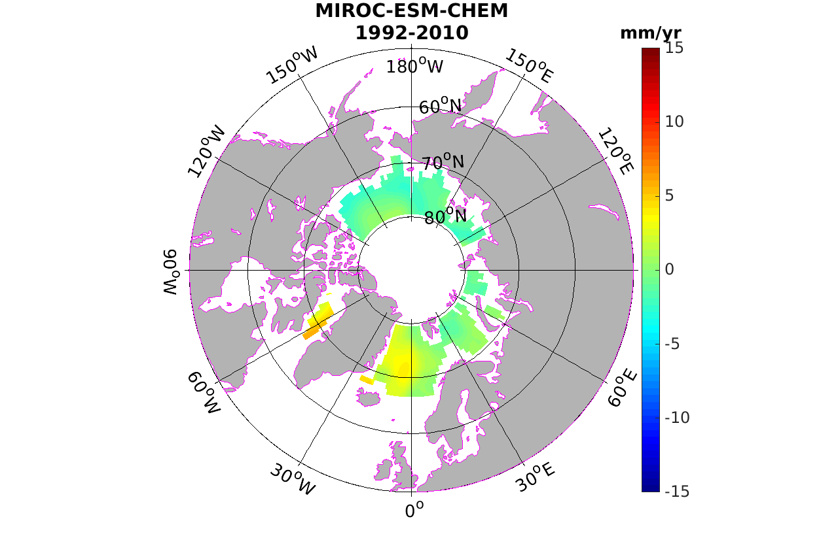 | 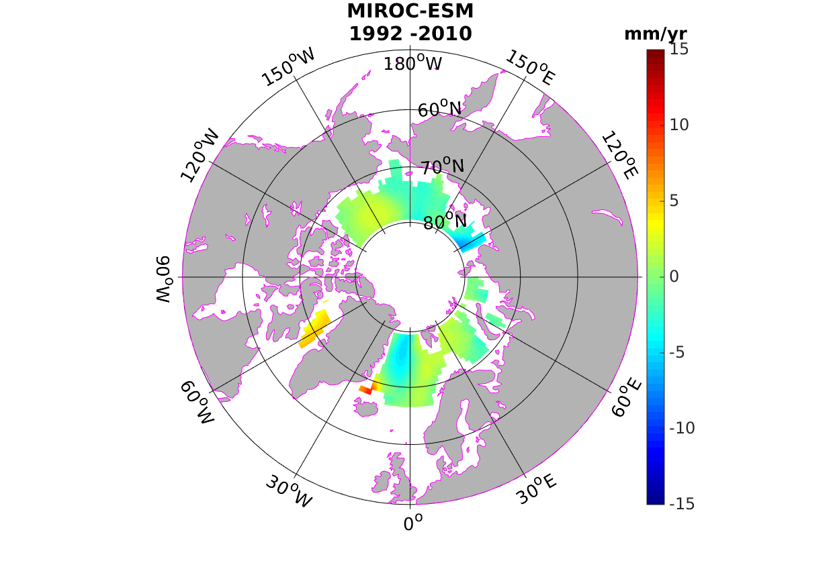 | 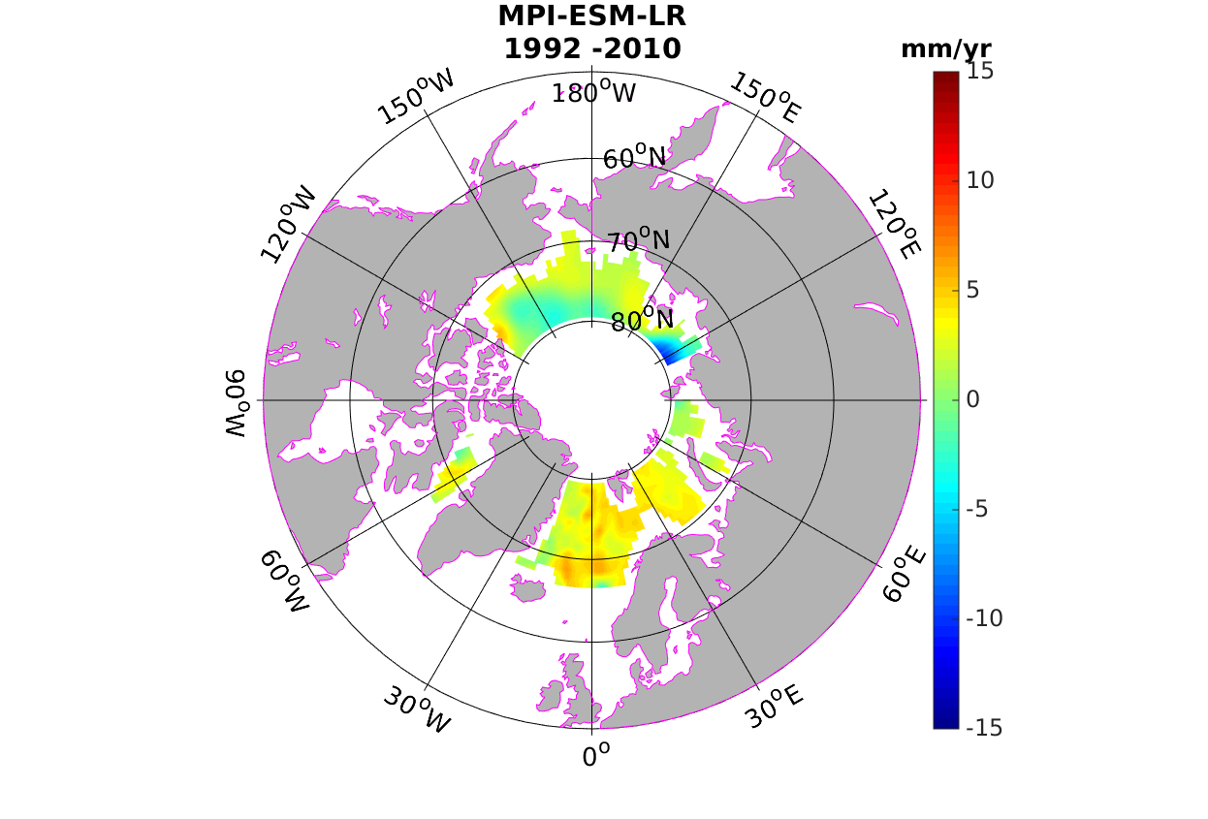
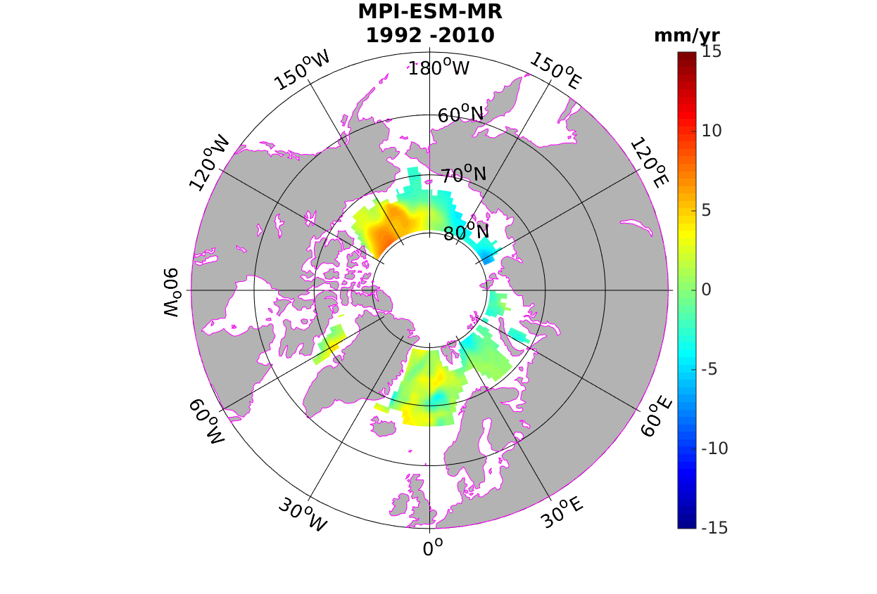 | 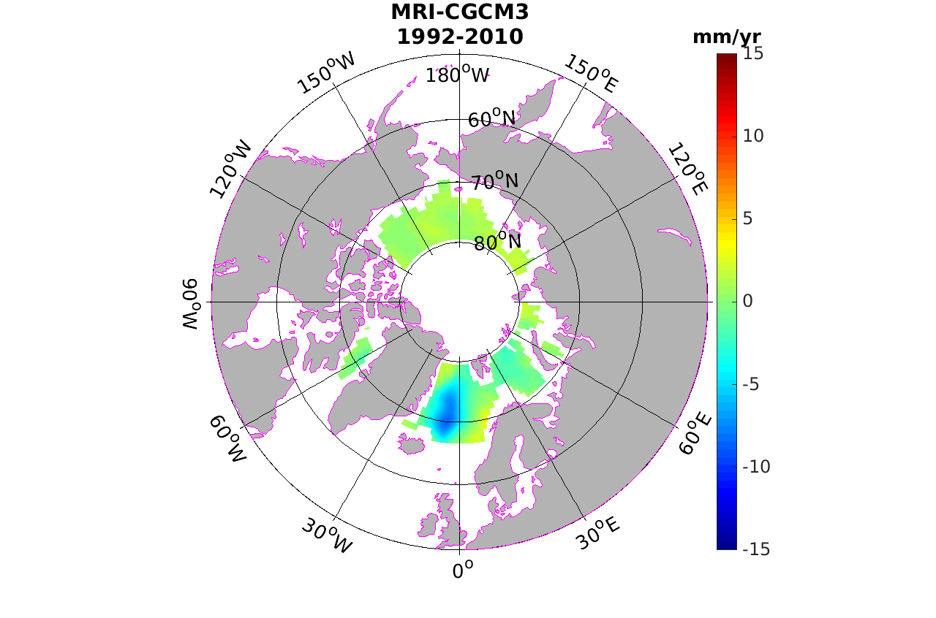 | 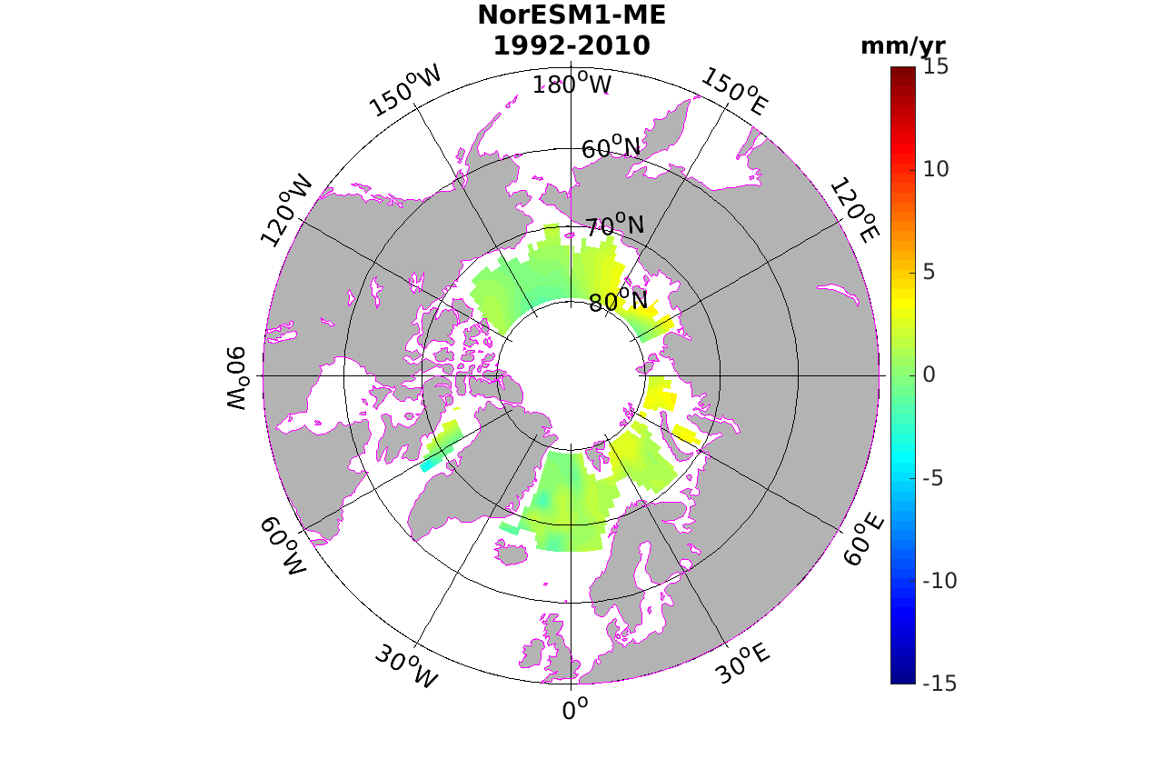 | 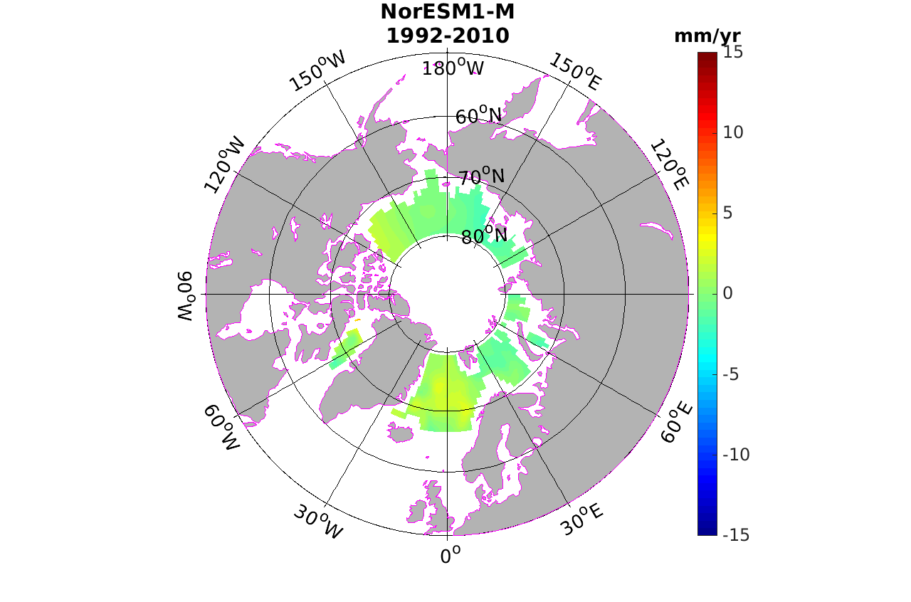
Figure 17: Trend pattern of sea surface height for 20 CMIP5 models during the 1992-2010 period

Results highly differ between models and even from one version of a given model to another. The increasing trend pattern over the Beaufort gyre seen on altimetry maps is not reproduced by all models. Thus we selected those models showing patterns similar to altimetry in this particular region. As another selection criterion, we retained models for which the steric trend map displays lower RMSE wrt the ORAP5 steric trend map. This approach led us to select 6 models: MPI-ESM-MR, MIROC-ESM, NorESM1-ME, CSIRO-Mk3-6-0, CCSM4 and GFDL-CM3. Fig.18 presents the ensemble mean trend map for the six selected models. We also considered the steric and thermosteric maps, also provided by the six models. The steric map is strongly similar to the ensemble mean of sea surface height map (see Fig.18, right panel) although it shows higher amplitudes especially in the Greenland and Norwegian Seas. The thermosteric component significantly contributes in these regions while it displays weaker signal elsewhere. This confirms the conclusion drawn above from inspection of altimetric and ORAP5 maps, suggesting dominant halosteric contribution in the Arctic region.

a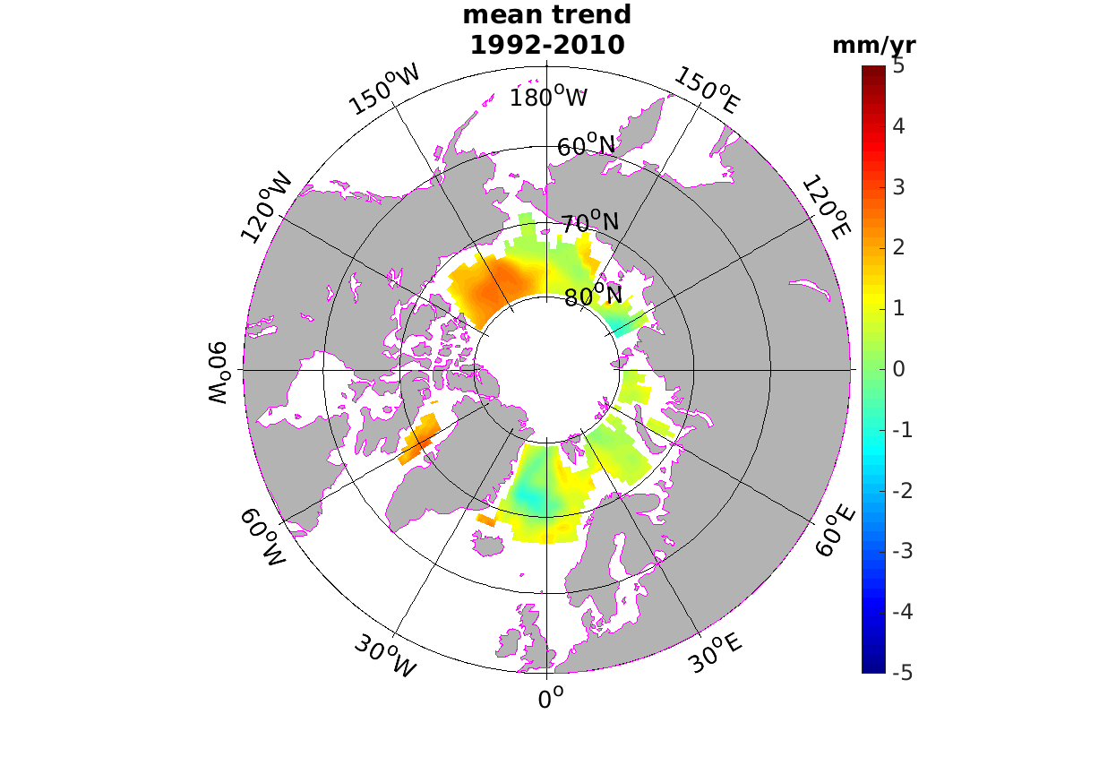 | b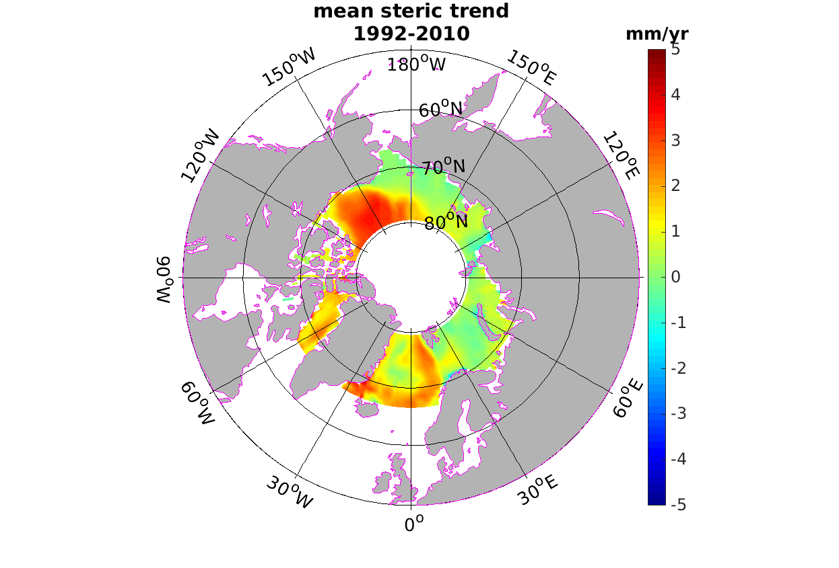 | c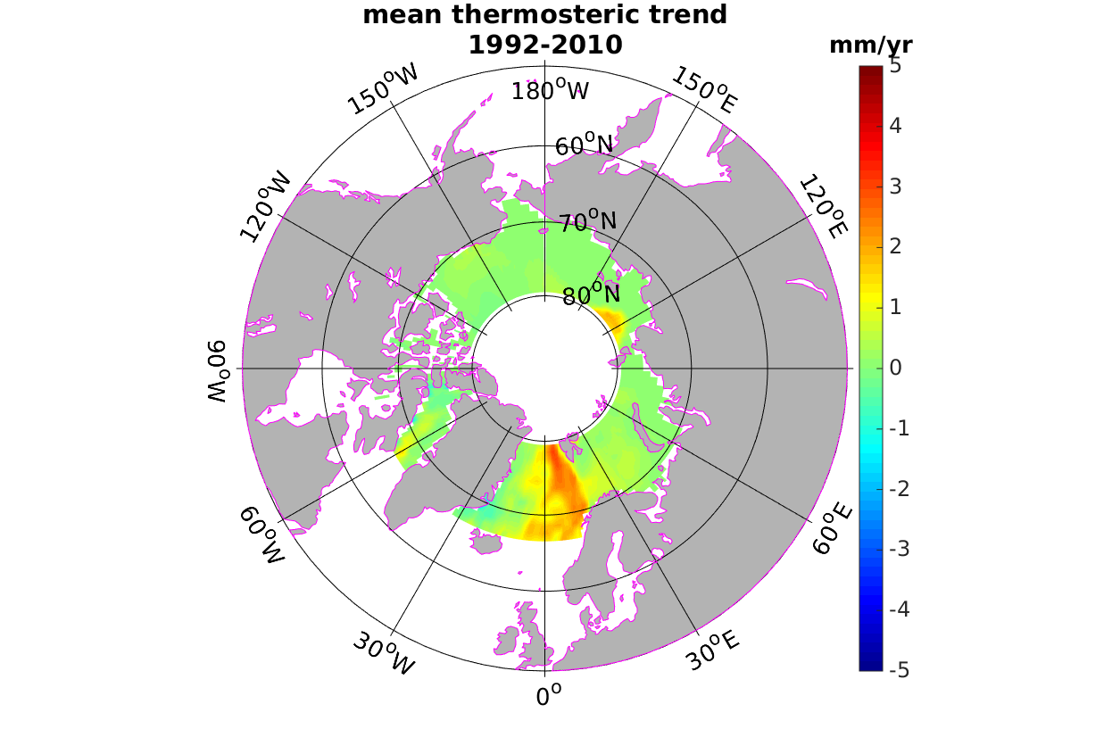
Figure18 : a) Ensemble mean sea level ; b) ensemble mean steric sea level ; c) ensemble mean thermosteric sea level trend pattern maps using a selection of 6 models

TO BE COMPLETED BY JOHNNY WITH SPECIFIC DISCUSSION BASED ON THE NORESM MODEL

8. Discussion 2 pages

9. Conclusion & perspectives 1 page

References
Cheng Y., Andersen O. and Knudsen P. (2015) An improved 20-Year Arctic Ocean Altimetric Sea Level Data Record, Marine Geodesy, 38:2, 146-162, DOI:10.1080/01490419.2014.954087

Gardner, A. S., et al. (2013), A reconciled estimate of glacier contributions to sea level rise, 2003-2009, Science, 340, 852–857, doi:10.1126/science.1234532.

Geruo A and Wahr

Henry, O., P. Prandi, W.Llovel, A. Cazenave, S. Jevrejeva, D. Stammer, B. Meyssignac, and N. Koldunov (2013), Tide gauge-based sea level variations since 1950 along the Norwegian and Russian coasts of the Arctic Ocean : Contribution of the steric and mass components, J. Geophys. Res., 117, C06023, doi:10.1029/2011JC007706.

Koldunov et al., JGR 2014
Morrison J., Kwok R., Peralta-Ferriz C, M. Alkire., I. Rigor, R Andersen et al., (2012) Changing Arctic Ocean freshwater pathways, Nature, 481, 66-70, doi:10.1038/nature10705

Peralta-Ferriz C. , J. H. Morison, J. M. Wallace, J. A. Bonin, J. Zhang, Arctic Ocean Circulation Patterns Revealed by GRACE, Journal of Climate, 27, doi:10.1175/JCLI-D-13-00013.1
Prandi P., M. Ablain, A. Cazenave & N. Picot (2012) A New Estimation of Mean Sea Level in the Arctic Ocean from Satellite Altimetry, Marine Geodesy, 35:sup1, 61-81, DOI:10.1080/01490419,2012.718222
Proshutinsky, A., V. Pavlov, and R. H. Bourke (2001), Sea level rise in the
Arctic Ocean, Geophys. Res. Lett., 28(11), 2237–2240, doi:10.1029/
2000GL012760.

Proshutinsky, A., I. M. Ashik, E. N. Dvorkin, S. Häkkinen, R. A. Krishfield,
and W. R. Peltier (2004), Secular sea level change in the Russian sector of
the Arctic Ocean, J. Geophys. Res., 109, C03042, doi:10.1029/
2003JC002007.

Proshutinsky, A., et al. (2011), The Arctic (Ocean), Bull. Am. Meteorol.
Soc., 92(6), supplement, S145–S148.
Shepherd, A., et al. (2012), A reconciled estimate of ice-sheet mass balance, Science, 338(6111), 1183–1189, doi:10.1126/science.1228102.

Smith, L. C., Y. Sheng, G. M. MacDonald, and L. D. Hinzman (2005), Dis- 893
appearing Arctic lakes, Science, 308, 1429, doi:10.1126/science.1108142.
Velicogna I., Sutterley T.C., and M.R. van den Broeke (2014) Regional acceleration in icemass loss from Greenland and Antarctica using GRACE time-variable gravity data, Geophys. Res. Lett., doi: 10.1002/2014GL061052.

Volkov, D. L., and F. W. Landerer (2013), Nonseasonal fluctuations of the Arctic Ocean mass observed by the GRACE satellites, J. Geophys. Res. Oceans, 118, 6451-6460, doi:10,1002/2013JC009341
Yin J. , S. M. Griffies, R. J. Stouffer (2010) Spatial Variability of Sea Level Rise in Twenty-First Century Projections, Journal of Climate, 23, doi:10.1175/2010JCLI3533,1

