DTU16 Mean Sea Surface
for The Baltic

Date 21 November 2017.

Report and data prepared for
FAMOS

Prepared by
Ole Baltazar Andersen
DTU space.
Elektrovej bldg 328.
Office 104.
2800 Kongens Lyngby , Denmark
Mail: oa@space.dtu.dk

summary
This short note introduced the DTU16 Mean sea surface which can be used as a vertical Offshore Reference Frame has been computed relatively to reference ellipsoid WGS84/GRS80 in the non-tidal tide system (correspondent to tide system used for GPS processing)

The computation have been performed for the European Region corresponding to 45N to 70N latitude by 20W to 31E longitude and the computation have been performed on 1 minute resolution.

For reference, it should be noted, that the DTU16Mean Sea Surface is identical to the DTU16LAT (DTU16 Lowest Astronomical Tide) inside the Baltic Sea. This is because the Baltic is considered tide free and hence the Lowest Astronomical Tide is zero

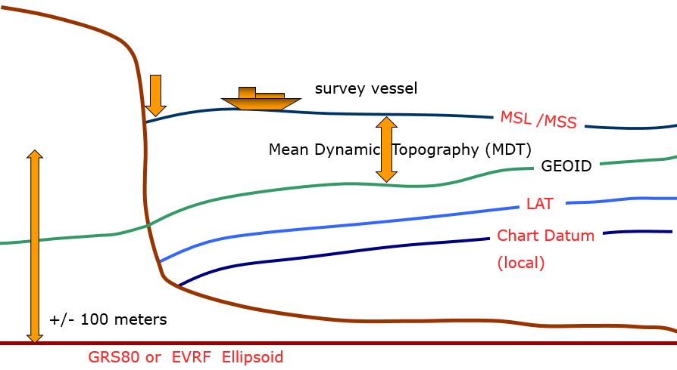
Figure 1.0: Sketch of the DTU16 MSS relative to the GRS80 ellipsoid

Development of the Mean Sea Surface.
The mean sea surface is computed using 20 years of altimetric radar observations of the sea level for the region using the method and model described in detail in Andersen and Knudsen, 2008. The physical resolution of this model is 1/60 degree corresponding to 1 minute. The Mean sea surface is given in meters relative to the GRS80/WGS84 Ellipsoid.
The reason for computing a new FAMOS MSS for the Baltic Sea lies in the fact that ESA recently launched the Cryosat-2 satellite which is providing observations with higher precision compared to previous for the Baltic.
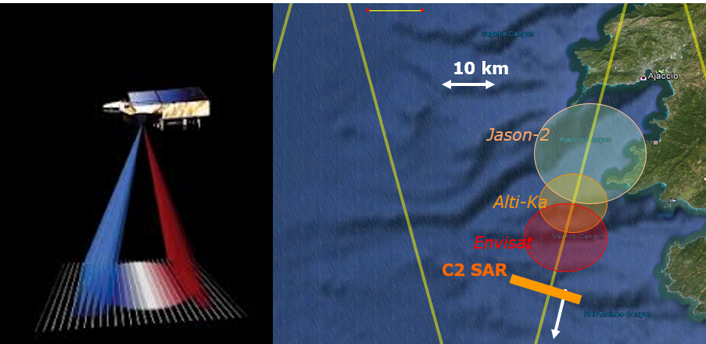
Figure 2. The SAR scanning operating model of Cryosat-2 in the Baltic Sea. The associated foot print (right) figure compared with footprints of conventional satellites like ENVISAT,SARAL/ALtiKa and Jason-2

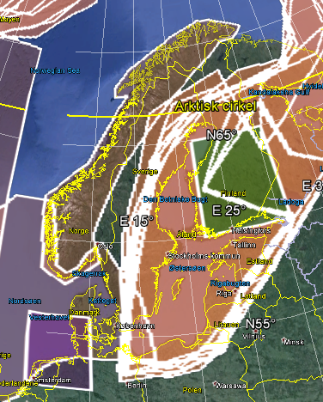
Figure 2. The Cryosat-2 SAR mode employed in the Baltic Sea.
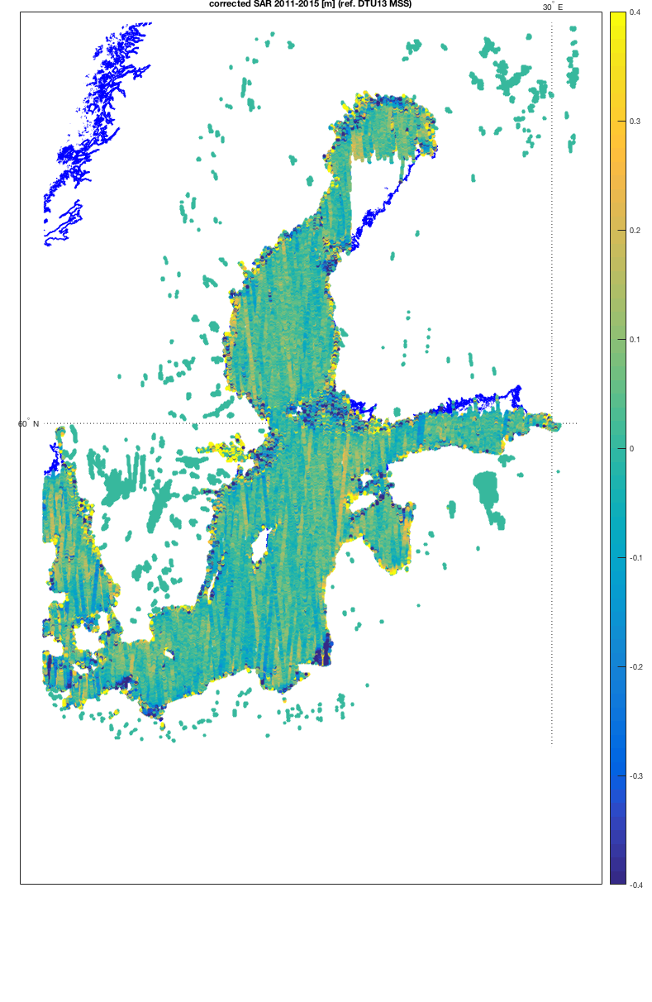
Figure 4. The Cryosat-2 SAR altimetry data available for computation of the DTU16MSS. The values are given relative to the previous DTU15MSS. Large differences can be seen along the coast and an the regions with many island “skærgården”.

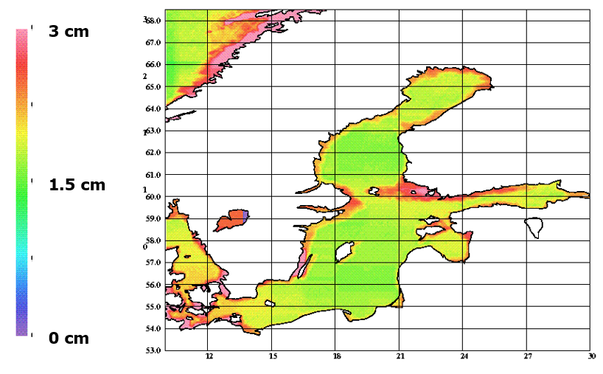
Figure 5. The interpolation error of the DTU MSS in the FAMOS region.
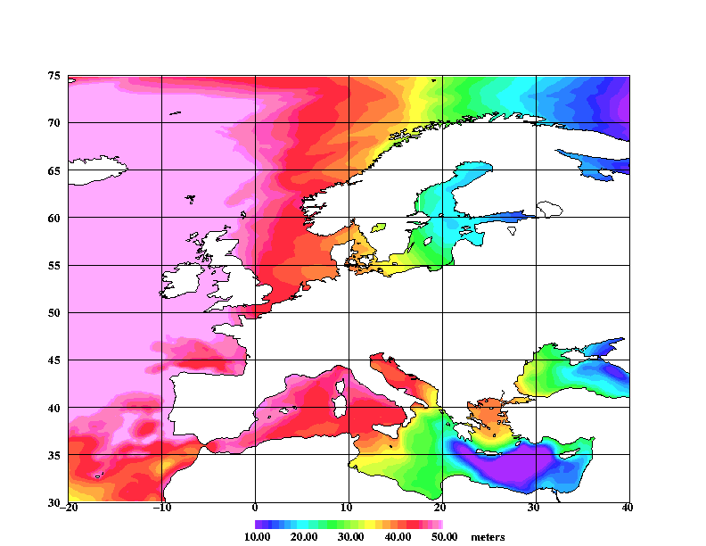
Figure 1.2 Mean Sea Surface model relative to GRS80/WGS84 for the greater FAMOS European Region

The Reference Ellipsoid

The DTU16MSS is given relative to the GRS80 / WGS reference Ellipsoid is the currently best fitting mathematical model used to describe the shape of the Earth.

Se documentation at http://en.wikipedia.org/wiki/GRS_80
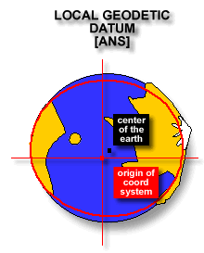
Figure 1.3. The geodetic model of the Earth represented by i.e., the GRS80

Tide System

The DTU16 Mean sea surface is given in the Tide free or NON-TIDAL system to be consistent with GPS observations.

Geoid heights (and mean sea surface heights) differ depending on what tidal system is implemented to deal with the permanent tide effects. In the MEAN TIDE system, the effects of the permanent tides are included in the definition of the geoid. In the ZERO TIDE system, the effects of the permanent tides are removed from the gravity field definition. In the TIDE FREE or NON-TIDAL system, not only the effects of the permanent tides are removed but the response of the Earth to that absence is also taken into account.. GPS is processed in the NON-TIDAL system.

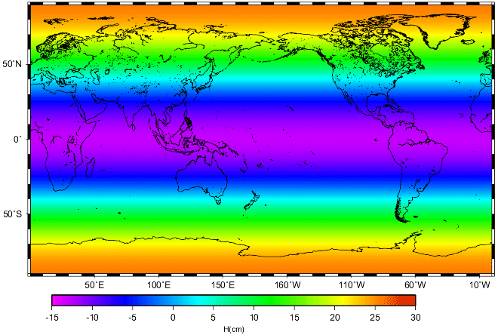
Figure 1.5. Difference between the Mean Tide and Non Tide system.

Files and Formats
One file is available to FAMOS via ftp to ftp.space.dtu.dk/pub/Altimetry/FAMOS:

DTU16MSS_TideFree_WGS84_Noib_Baltic.xyz.zip

This represent the DTU16MSS for FAMOS region on a 1 minute resolution.

Spatial extend is 53 N to 67 N and 8.00833333 W to 31.0083333333E

Upon reading the file into the software the grid can be reshaped back in to a 841 x 1381 cell grid.
Normal gravsoft file format is also available within the same location.

File Format

The files contain the following information on each line corresponding to each cell in the 1 minute resolution mesh expanded by the latitude range and longitude range

The grid is written out as points from Northwest to southeast in a scanning file format where the upper row is shown first.

Example: 4 59.9500 15.6500 43.8390 64.1221

Where each line contain:
Running index (line number).
Latitude (decimal degree),
Longitude (decimal degree),
The MSS in geodetic coordinates (meters). Given relative to WGS84/GRS80 ellipsoid
Depth (meters) – GEBCO Bathymetry. Depth is positive. Zero/negative on land.

If wanted the data can be re-shaped into a grid which should contain 841 x 1381 cells (west/east x north/south)

Notice that the VORF extends onto land (but becomes increasingly in-accurate in order to enable interpolation in coastal regions.

References

DTU10 mean sea surface and mean dynamic topography models [Preview]

O. B. Andersen and P. Knudsen
J. Geophys. Res., 114, C11001, doi:10.1029/2008JC005179, 2009

