**Chapter 9**

**The high latitude seas and Arctic Ocean**

Johnny A. Johannessen1 and Ole B. Andersen2

(1) NERSC, Norway

(2) DTU, Denmark

Contents

9.1 Introduction. 1

9.1 Satellite Altimetry in the Arctic 4

9.2 Mapping the sea ice thickness in the Arctic Ocean 6

9.3 Sea level change 7

9.3.1 The Seasonal cycle 8

9.3.3 Secular and long term changes 9

9.3.3.1 The Altimetry era 9

9.3.3.2 Sea level change since 1950 10

9.3.4 Arctic Sea level budget 11

9.3.5 Atmospheric pressure variations 13

9.3.6 The Polar gap and accuracy estimates 13

9.4 Mean dynamic topography 14

9.5 Absolute dynamic topography and ocean circulation 15

6. Reanalyses 21

7. Conclusions and future directions 21

References 21

# 9.1 Introduction.

Changes in the dynamic topography and ocean circulation between the northern Atlantic Ocean and the Arctic Ocean result from variations in the atmospheric forcing field and convective overturning combined with changes in freshwater runoff and their pathways, mean sea level, sea ice deformation and water mass transformation. The ocean circulation in this region has been subject to investigations since Helland-Hansen and Nansen (1909). In general, it can be characterized by four regional circulation regimes and cross-regional exchanges and volume transports, namely the Northeast Atlantic, the Labrador Sea and Canadian archipelago, the Nordic and Barents Seas and the Arctic Ocean, as illustrated in Fig. 9.1.

Accurate knowledge of the ocean transport variability together with understanding of the water mass transformations within and across these regions is highly needed to quantify changes in the overturning circulation with acceptable uncertainty. The Atlantic meridional overturning circulation is, among other factors, influenced by: variations in the upper ocean and sea ice interaction; ice sheet mass changes and their effect on the regional sea-level change; changes in freshwater fluxes and pathways; and variability in the large-scale atmospheric pressure field. For instance, changes in the pathways of the freshwater from the Eurasian runoff forced by shifts in the Arctic Oscillation can lead to increased trapping of freshwater in the Arctic Ocean as presented by Morison et al. (2012) that, in turn, may alter the thermohaline circulation in the sub-Arctic Seas.

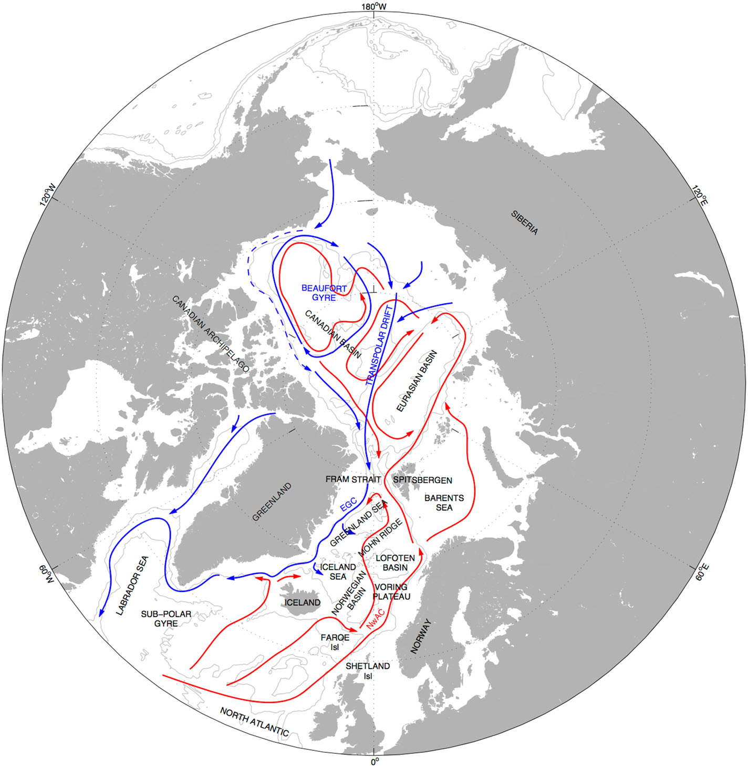

***Figure 9.1****. General circulation in the upper ocean of the Arctic Ocean, Nordic Seas, and North Atlantic from Furevik and Nilsen (2005). Red arrows represent the warmer Atlantic Waters, which reside in the surface in the Nordic Seas and submerged in the Arctic Ocean. Blue arrows represent Polar Water, residing in the surface. Bottom contours marked by the 1000 and 3000 m are outlining the shelves and basins.*

The **Arctic Ocean** is the smallest and shallowest of the world's five major [oceans](https://en.wikipedia.org/wiki/Ocean" \o "Ocean).  It covers roughly 4.2 percent of the worlds ocean and holds roughly 1.2 percent of the volume of water on the Earth as the average depth of the Arctic Ocean is only 1300 meters.

The International Hydrographic Organization (IHO) recognizes the Arctic Ocean as an ocean, although some oceanographers call it the Arctic Sea. The oceanographic classification of the Arctic as a sea refers to the fact that the Arctic can be considered as a Mediterranean type of sea with limited pathways and water exchange with the larger oceans to the south. The four major pathways include : the Fram Strait between Greenland and Svalbard; the Bearing Strait between Russia and USA; the Canadian Archipelago region and Nares Strait; and the northeastern Barents.

There is a growing concern how the Arctic region responds to climate change. There is evidence that the Polar Ocean is undergoing rapid climate change resulting from processes including a reduction of sea ice extent [e.g., IPCC, [2013](http://onlinelibrary.wiley.com/doi/10.1002/2015JC011579/full" \l "jgrc21773-bib-0022" \o "Link to bibliographic citation); Kwok et al., 2009; Stroeve et al., [2012](http://onlinelibrary.wiley.com/doi/10.1002/2015JC011579/full" \l "jgrc21773-bib-0057" \o "Link to bibliographic citation)].

The Arctic Ocean currently stores around 84,000 km3 of freshwater in its surface layer [Serreze et al., [**2006**](http://onlinelibrary.wiley.com/doi/10.1002/2015JC011579/full#jgrc21773-bib-0054)] and this number seems to be increasing. Measurements from ships and moorings have shown that the deep Arctic basins, in particular the Canada Basin, accumulated up to 10,000 km3 of freshwater during the 1990s and 2000s [Proshutinsky et al., 2009; Krishﬁeld et al., 2014; Rabe et al., 2014]. This was confirmed from satellite altimetry by Giles et al. [[**2012**](http://onlinelibrary.wiley.com/doi/10.1002/2015JC011579/full#jgrc21773-bib-0018)] who demonstrated that the Beaufort Gyre accumulated 800 ± 200 km3 of freshwater per year during the 2000’s .

The freshwater storage in the Arctic is important to monitor as enhancement of Arctic freshwater outflow will mainly occur through the Fram and Nares Straits and may be able to disrupt the North Atlantic Meridional Overturning Circulation [Manabe and Stouffer, [**1995**](http://onlinelibrary.wiley.com/doi/10.1002/2015JC011579/full#jgrc21773-bib-0033)]. Such enhanced freshwater outflow has been linked to the North Atlantic “Great Salinity Anomalies” of the 1970s, 1980s, and 1990s [Dickson et al., [**1988**](http://onlinelibrary.wiley.com/doi/10.1002/2015JC011579/full#jgrc21773-bib-0010);  Belkin, [**2004**](http://onlinelibrary.wiley.com/doi/10.1002/2015JC011579/full#jgrc21773-bib-0005)]. The “Great Salinity Anomaly” of the 1970s consisted of only ∼2000 km3 excess liquid and solid freshwater export to the North Atlantic [Häkkinen, [**1993**](http://onlinelibrary.wiley.com/doi/10.1002/2015JC011579/full#jgrc21773-bib-0020)]. Hence, monitoring the balance and/or sea level budget of the Arctic Ocean freshwater fluxes is climatically important.

Sea surface height (SSH) is an essential climate variable and global indicator [IPCC, [**2013**](http://onlinelibrary.wiley.com/doi/10.1002/2015JC011579/full#jgrc21773-bib-0022)**; GCOS….**] and an important parameter in the mapping of freshwater storage. However, it is poorly observed in the Arctic. A reasonable amount of tide gauge data (more than 100) is available along the Norwegian and Russian coasts since 1950. Unfortunately a substantial part of the Russian gauges were dis-continued with the collapse of the Soviet Union in the early 1990’s. A substantial problem with many of the Arctic tide gauges is their location in river-mouths and even inside rivers. E.g., the tide gauge Antipaiuta (69°N,76°E) in the PSMAL (Holgate, 2013) is located inside the Ob River eustaria nearly 900 km from the open Arctic Ocean. Eight of the nine largest rivers contributing freshwater to the Arctic Ocean are located in the Russian sector with the Siberian rivers; Yenisei, Ob, and Lena each provide up to 600 km3 of water per year and the Canadian-sector Mackenzie River provides of the order of 340 km3 per year (Aagaard and Carmack, 1989).

Most published research on Arctic sea level extends cautiously from these gauges as no other gauges of length longer than several decades exists in the Arctic. Consequently a very careful editing of the tide gauges is required to isolate the sea level signal which is of oceanographic origin (Proshutinsky, Volkov, Henry et al,, 2012; Svendsen et al., 2014, 2016)

UPGRADE REF…..

## 9.1 Satellite Altimetry in the Arctic

The inclination of the CNES/NASA TOPEX/Poseidon and Jason satellites limits the coverage to 66° N, which means that these satellites does not cover the Arctic Ocean with regular routine sea level observations. The European Space Agency satellites ERS-1, ERS-2 and Envisat with an inclination of 82˚N , on the other hand, fundamental in deriving a long altimetric SSH record for the Arctic Ocean as these have been providing altimetry regularly since 1991 (Prandi et al., 2012). In this way they cover 78 % of the Arctic Ocean.

However the standard processing of satellite radar altimetry breaks down in the presence of sea ice and as scuh they do not provide regular routine monitoring of the Arctic sea level .

The presence of sea ice affects the number and quality of the altimetric observations in various ways. Sea ice affects the returned radar echo or waveform recorded by the satellite or even prevents it from reflecting of the sea surface. The waveform can become highly complex and i.e. have multiple peaks resulting from scattering from the ice within the footprint, but it can also be very specular if returned by still water within leads. In any case, the waveform does not resemble a normal open ocean Brown waveform for conventional altimeters and is subsequently often discarded by the Space Agency processing schemes.

Indirectly, the ice contaminates the radiometer observations and hence the ability to provide accurate range corrections. Finally several range corrections are missing and/or are less accurate in the Arctic Ocean. As an example the tides are less accurate in the Arctic than elsewhere (Stammer et al., 2014).

Consequently the most conventional studies of the high latitude and Arctic SSH have been limited to the open ocean [e.g., Prandi et al., 2012, Henry et al., 2012]

In the northern part of the Atlantic Ocean and in the Barents sea nearly 100 % of conventional altimetric data for the 1991-2010 period is available. However this number rapidly decreases when moving into the interior of the Arctic Ocean where an average between 5 and 10 % is available. This is illustrated in Figure 9.X.2 by the percent of available data along the ERS-1/ERS-2/ENVISAT reference tracks in the RADS standard edited dataset SLA during the 1993-2010 period (from Cheng and Andersen (2011).

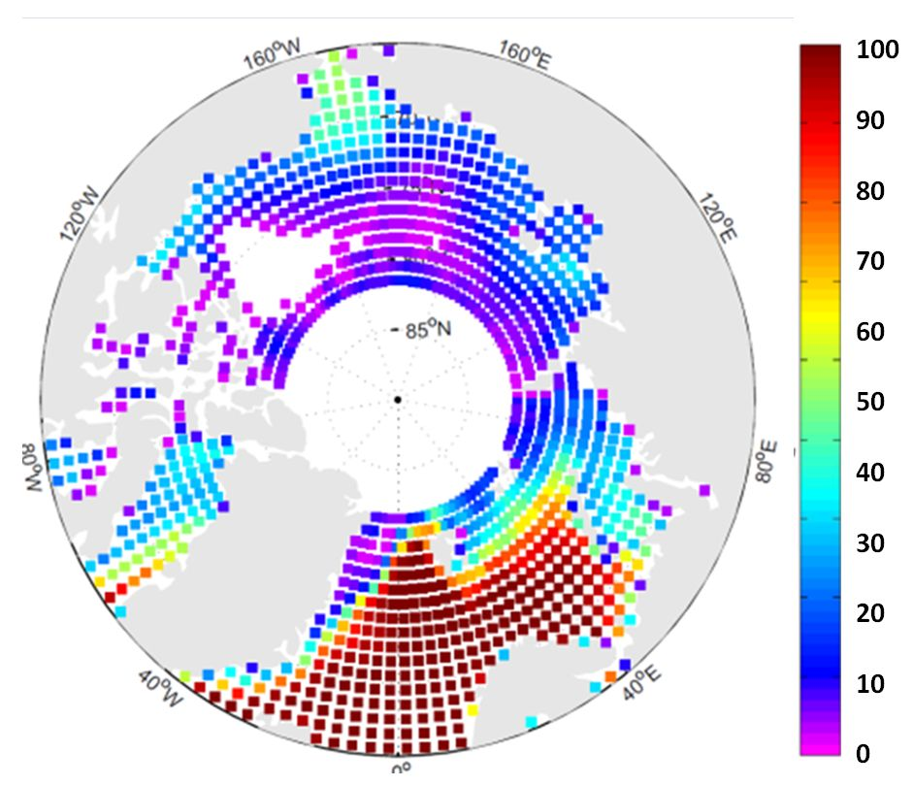

***Figure 9.X.2****. Percent of available data along the ERS-1/ERS-2/ENVISAT reference tracks in the RADS standard edited dataset SLA during the 1993-2010 period.*

In order to increase the number and quality of SSH observations in ice affected regions, several new altimeter satellites have been operated over the last 15 years such as ICESat, CryoSat-2, Sentinel-3A and SARAL.

ICESat has provided 17 monthly epoch of laser altimetry up to 86°N between 2003 and 2009 and will likely be continued by ICESat-2 in 2018. The higher resolution (footprint: 50–70 m) and precision of the lidar (shot-to-shot repeatability of ∼2–3 cm) onboard ICESat [Zwally et al., [**2002**](http://onlinelibrary.wiley.com/doi/10.1002/2015JC011357/full#jgrc21558-bib-0040)] allowed unambiguous identification of open water between ice-floes (of water or thin ice) and therefore importantly supplied a new source of SSH observations in the Arctic Ocean [Kwok et al., [**2004**](http://onlinelibrary.wiley.com/doi/10.1002/2015JC011357/full#jgrc21558-bib-0020)].

The CryoSat-2 mission [Wingham et al., [**2006**](http://onlinelibrary.wiley.com/doi/10.1002/2015JC011357/full#jgrc21558-bib-0038)] is a new generation Earth Explorer mission which acquires the SSH by the single frequency (Ku) Synthetic Aperture Radar (SAR) Interferometric Radar ALtimeter (SIRAL). With an inclination of 92° the instrument covers 95% of the Arctic Ocean while operating in three different modes. These are conventional or low resolution mode (LRM); Synthetic Aperture Radar mode (SAR) in which a delay Doppler modulation to slice the radar footprint into a number of along-track slices and finally the interferometric Synthetic Aperture Radar Mode (SAR-in) in which two receiving antenna chains onboard Cryosat-2 are applied enabling a detection of the cross-track angle to the prime scatter in the footprint. This SAR-in mode has proven to be particularly useful in the Arctic Ocean (Laxon et al., 2013) as well as for coastal regions (i.e., Abulaitijiang and Andersen, 2015) where the satellite can detect coastal sea level even when the satellite is flying in-land close to the coast.

Whereas conventional or LRM observations has a footprint of roughly 100 km2, the SAR and SAR-in modes have a footprint of roughly 4 km2 which means that far fewer observations are affected in the presence of sea ice. This enables the instrument to track sea level in leads and polynyas in the ice covered regions. The delay Doppler modulation of the altimeter signal create a synthesized footprint which is nominally 0.31 km by 1.67 km in the along- and across- track directions (Martin-Puig et al., 2013). Similarly multiple-looks of returns from the surface are used to reduce noise due to radar speckle [Bouzinac, [**2013**](http://onlinelibrary.wiley.com/doi/10.1002/2015JC011357/full#jgrc21558-bib-0006)].

Cryosat-2 operates in all 3 modes over the Arctic Ocean following a sophisticated mask which changes with time depending on ice-coverage. The detection of sea level within leads and polynyas from Cryosat-2 still requires careful examination of the full waveforms (so-called Level-1B data) and considerable effort by the user.

The Sentinel-3A satellite that was launched in 2016 carries a dual frequency (Ku and C band) SRAL instrument. SRAL is similar to the SIRAL onboard Cryosat-2, but does not have the interferometric capabilities as Cryosat-2. On the other hand it has a microwave radiometer for atmospheric corrections. This satellite will be the first-ever satellite to operate in high resolution SAR mode everywhere including the Arctic Ocean up to 81°N in the future.

Since 2013 the French-Indian SARAL or **S**atellite with **AR**gos and **AL**tiKa was launched in the same orbit as ENVISAT to continue the altimetric record and to test a new Ka band instrument which has much smaller footprint. ALTIKA will measure ocean surface topography with an accuracy of 8 mm, against 2.5 cm on average using conventional altimeters, and with a spatial resolution of 2 km using a higher temporal sampling.

Altogether the continuity of altimetry satellites in principle provides a data record for the Arctic Ocean which by 2016 reaches 25 years.

Returning to the conventional satellites ERS-1/ERS-2 and ENVISAT, there are basically two routes to increase the number of SSH observations in the Arctic Ocean. One is the use of more robust radar waveform retrackers tailored to Arctic conditions; the other is a re-evaluation of existing datasets consisting of fine-tuning/tailoring the editing and re-processing of the data within the Arctic Ocean.

Retracking of the ERS-2 data was applied by Peacock and Laxon (2004) who developed a robust retracker to extract the sea surface height (SSH) in partly ice-covered areas for the Envisat near 10 years period. More recently Armitage et al., (2016) retracked the ENVISAT data using the same method developed for ERS-2. At CLS/PML a more sophisticated system in which the data are first classified by ocean surface type in order to separate frozen ocean areas from open water corresponding leads or polynyas and subsequently using new retracking algorithm for each class.

Cheng and Andersen (2013) realized that standard editing criteria applied by AVISO; PODAAC and in RADS are all fine-tuned for the SLA retrieval in the global oceans. By a combination of replacing range and geophysical corrections and fine-tuning editing criteria in the Arctic Ocean, they retrieved between four and ten times as many SLA observations in large part of the interior of the Arctic Ocean without degrading the quality of the data. Hereby they could derive a time-series of Arctic SSH anomalies for 20 years. This has recently been updated to a 25 years time-series (Andersen and Piccioni 2016) taking into account 5 additional years of retracked Cryosat-2 SAR altimetry. In the following this 25 years dataset called DTU-SSH will be used for various analysis.

# 9.2 Mapping the sea ice thickness in the Arctic Ocean

  - sea ice freeboard height from altimetry

- inverting to sea thickness

- uncertainty estimation

- estimation of sea ice volume (in combination with extent and concentration)

The key approach to derive sea ice thickness estimation in the Arctic Ocean is by

satellite altimetry. The caveat is that the uncertainty estimation is challenging and that the existence of in-situ observations of snow depth, snow density and sea ice thickness are sparse.

The first comprehensive estimate of changes in sea ice thickness from altimetry was published by Laxon et al. (2003). Exploring radar altimeter measurements from ERS-1/2 and Envisat from the 1990s, they found a strong inter-annual variability in sea ice thickness, and circumpolar thinning of Arctic sea ice. Moreover, Kwok et al. (2009) found a decline in Arctic sea ice thickness of 0.18 m/yr between 2003 and 2008 based on analyses of laser altimeter measurements from NASA’s ICESat. At the end of the ICESat period in 2008, a winter thickness of 1.89 m was reported, being 1.75 m lower than the mean sea ice thickness from the 80’s based on submarine data in the central Arctic (Kwok and Untersteiner, 2011). In comparison, Hendricks et al. (2013) derived a mean sea ice thickness of 1.87 m in the central Arctic in winter 2012/2013 (October - March) using CryoSat-2 data.

The freeboard, the part of the ice above the water level is obtained by using the elevation over leads as the instantaneous sea surface height and then calculating the difference between the sea surface height and ice floes (Zwally et al., 2002; Kwok et al., 2007; Hendricks et al., 2013). The elevation measurements from leads and ice floes are distinguished by the shape of the waveform based on the pulse peakiness structure. After retracking the range and applying necessary corrections (e.g. Doppler range, the ionospheric, the dry tropospheric and the modelled wet tropospheric, ocean tide, long-period tide, loading tide, earth tide, pole tide and inverse barometer corrections), and filters (removal of complex waveforms, failed re-tracking and echoes that yielded elevations more than 2 m from the mean dynamic sea surface height) the local sea level at ice floe locations is interpolated from nearby lead elevations. The freeboard is then calculated as the difference of radar altimetry measured ice floe elevation and the local sea level. As the freeboard measurement is known to be noisy, it is necessary to average several measurements. While the radar altimeter signal is assumed to be reflected from the snow and ice interface (Beaven et al., 1995), thus providing the ice freeboard, the laser signal is reflected from the air-snow interface, and hence provides the snow plus the ice freeboard. Assuming hydrostatic equilibrium, the freeboard can be converted into an estimate of sea ice thickness based on given knowledge of the sea ice density as well as the snow depth and snow density.

During the last three decades the sea ice area in the Arctic Ocean has shown a distinct decline. The largest reductions are found for the month of September when the annual minimum sea ice area is reached. Decline in sea ice area and thickness also result in a reduction of sea ice volume. Based

on data from the laser altimeter on board ICESat, Kwok et al. (2009) found a net loss of 5400 km3 in October-November and 3500 km3 in February-March during the ICESat period from 2003 to 2008. Recent results, exploring new data from CryoSat-2, report a further decline in Arctic sea ice volume (Laxon et al.,2013). The average sea ice volume in October-November for 2010 and 2011 was estimated to be 7560 km3, i.e. 64% of the 2003-2008 mean value estimated from ICESat (Kwok et al., 2009). However, all these findings are associated with large uncertainties.

# 9.3 Sea level change

Most of the Arctic Ocean is covered with sea ice which varies in extend and thickness on annual and interannual scales with a distinct decrease in ice coverage during the recent decades as mentioned above.

Armitage et al (2016) performed an EOF analysis of monthly retracked ENVISAT data to inspect the dominant model of seasonal and nonseasonal Artic SSH variability. They first computed the EOF on the full SSH and concluded that the leading two model account for 62.6% of the variance. They next removed the mean seasonal cycle and re-performed the EOF analysis on the non-seasonal SSH variability. The result is shown in Figure 9.3.X1

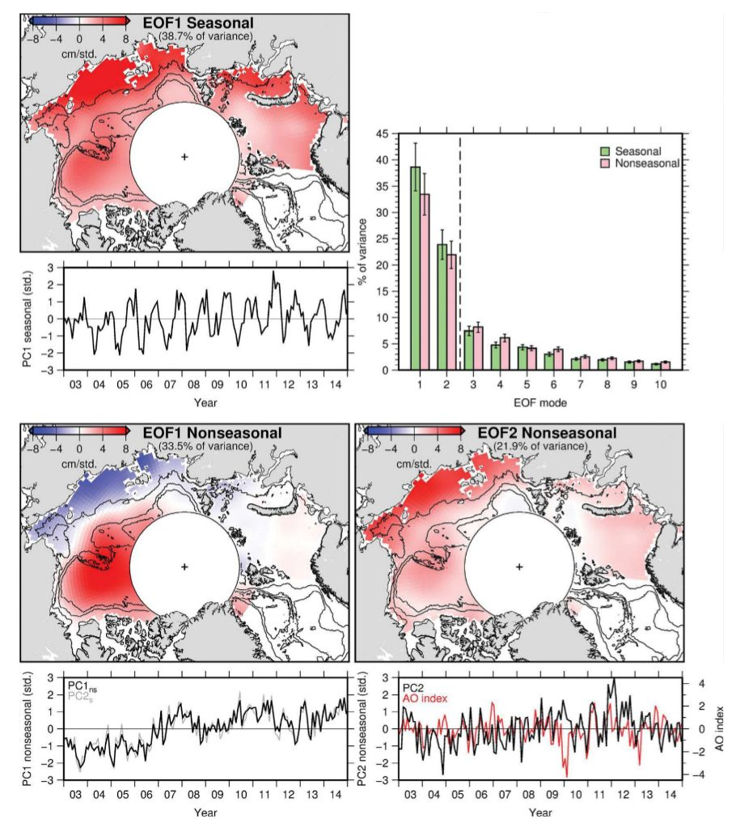

***Figure 9.3.X1****. The dominant modes of seasonal and non-seasonal Arctic SSH from Envisat. The leading seasonal EOF is shown in the upper left figure. The leading two EOF of the de-seasonalised SSH field is shown in the lower two figures. The AO is superimposed on the second non-seasonal EOF. Also contours of bathymetry is shown in the pictures. The upper left figure shows the variance explained by the first seasonal and first non-seasonal mode.*

GET PERMISSION FROM ARMITAGE...

## 9.3.1 The Seasonal cycle

Arctic SSH variability is dominated by the seasonal cycle and the SSH time series in e.g. figure 9.3.2.1 illustrate this. The Seasonal variation is in this case derived from the 20 year SSH from the DTU-SSH dataset augmented with estimation from Cryosat-2 north of 82°N.

The seasonal cycle has a near uniform phase throughout the Arctic Ocean with maximum in October-December and a minimum in May-June (Fig 9.3.1.X2 upper right). The largest amplitudes are found on the Siberian shelf where amplitudes reaching 10 cm can be seen from satellite altimetry. This amplitude decreases toward the interior of the Arctic Ocean to a few cm.

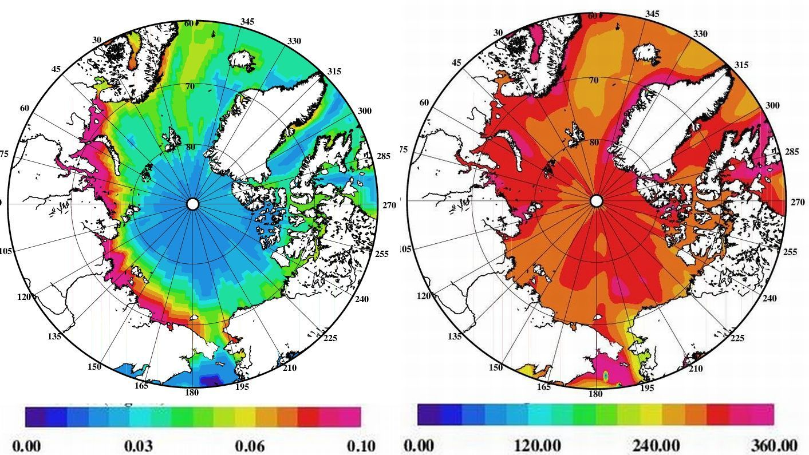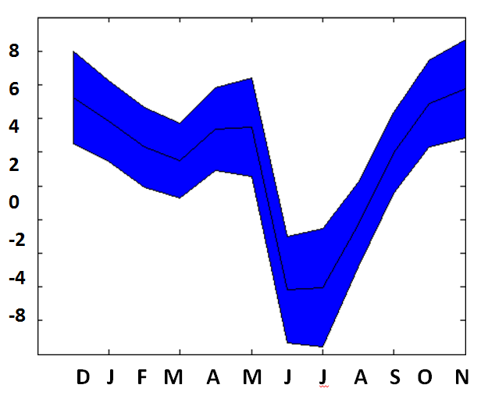

***Figure 9.3.1.X2****. The seasonal SSH signal in the Arctic Ocean derived from satellite altimetry with the amplitude (left), phase (center) and basin average with the associated uncertainty estimate.*

The basin-averaged mean Arctic SSH seasonal cycle shows a broad maximum of 4 cm between October–January, and a minimum of -4 cm in May-July, and a relatively small, intermediate peak in April. Smaller smaller intermediate peak have been seen in ocean mass and have been linked to the annual cycle of river runoff [Peralta-Ferrizand Morison , 2010].

The form of the SSH seasonal cycle from altimetry is similar to that observed by tide gauges [Proshutinsky et al., 2004; Richteret al., 2012], although the amplitude is somewhat smaller. The explanation for this is the fact that the tide gauge includes the inverse barometer effects, which are corrected for in altimetry. The difference is explored in more detail in section 9.3.5

The large annual signal in the Arctic ocean provide a problem for tidal modelling using satellite altimetry. The problem being that diurnal constituents K1 and P1 have alias periods of exactly one year (365 days) when observed by sun-syncrounous satellites. This makes them inseparable from the seasonal cycle and each other. Similarly the semidiurnal constituent K2 tidal constituent has an alias period of 183 days, which makes it inseparable from the semiannual signal (Ssa). Although this signal generally has a much smaller amplitude in the Arctic it adds to modify the highs and lows in the annual variation due to e.g., the large fluxes of freshwater in and out of the Arctic Ocean.

## 9.3.3 Secular and long term changes

### 9.3.3.1 The altimetry era

To investigate the Arctic sea level trend in the region between 66°N and 82°N, the DTU Version 3 sea level dataset has been used to compute the monthly mean sea level, which was filtered with a 1-year moving average. Figure 9.3.4 shows the linear sea level trend over the last 23 years. From 2011 the monthly measurements (blue curve) register slightly higher annual fluctuations, which correspond to the fact that CRYOSAT-2 has more observations during leads in the winter period compared with conventional altimetry from ERS-1/ERS-2 and ENVISAT. The regional sea level trend computed over the period 1993-2015 indicates an increase of 2.2 ± 1.1 mm/y, which is relatively consistent with the results obtained by Svendsen (2015).

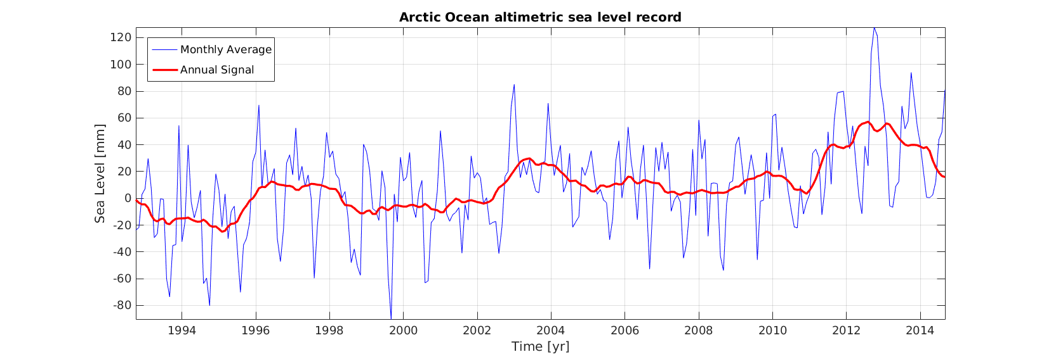

***Figure 9.3.4.4.X1****: Regional sea level variations over 1993-2015. Monthly values (blue curve) are averaged with a 13-month moving mean (red curve).*

A detailed view of spatial pattern of the linear sea level trend for period 1993-2015 is presented in Figure 3.4.4.X2 with a resolution of 0.5°x0.5°.

The trend pattern is dominated by a significant positive trend in the area of the Beaufort Sea, where an increase of almost 15mm/y is registered. This is due to the Beaufort Gyre, a wind driven phenomenon that leads to freshwater accumulation (Rabe et al., 2011; Giles et al., 2012). In the northern part of the North Atlantic we observe regional sea level trend of 3-5 mm/years, which is comparable to what is seen by i.e., Nerem et al. (2010). Very close to the coast of Greenland the high sea level trend is questionable and can be attributed to the fact that few data exist during the ERS-1/ERS-2/ENVISAT period due to heavy sea ice coverage whereas in the same area Cryosat-2 provides a very narrow strip of SAR-in data.

Throughout most parts of the Russian Sector of the Arctic Ocean we only observe a relative small sea level trend of the order of 0-5 mm/year. This has to be further confirmed using tide gauges data in the region.

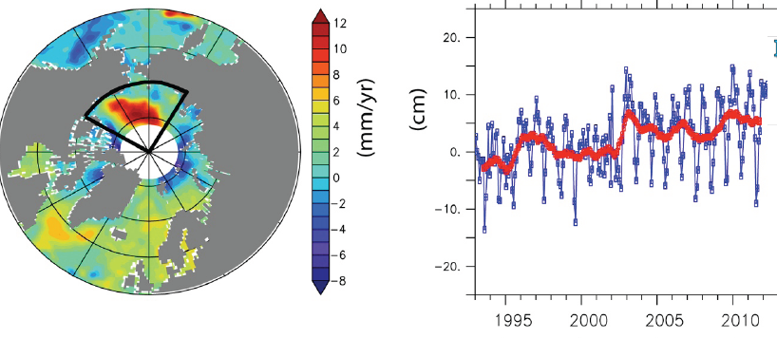

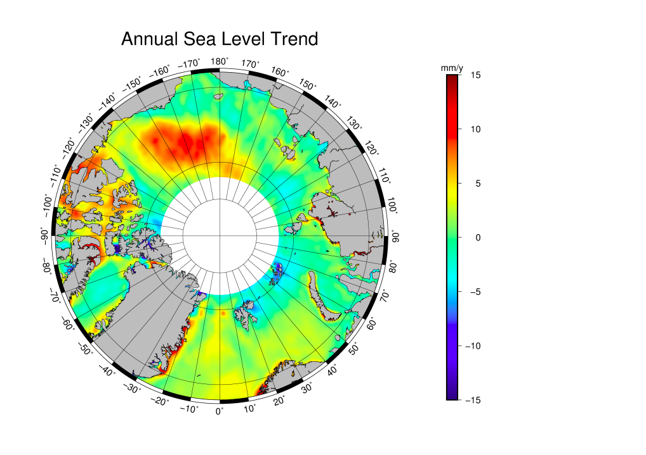

### 9.3.3.2 Sea level change since 1950

Proshutinsky et al. [[**2004**](http://onlinelibrary.wiley.com/doi/10.1002/2015JC011579/full#jgrc21773-bib-0046)] have used tide gauges to estimate secular sea level change in the Siberian Arctic of 1.85 mm/yr between 1954 and 1989, and Richter et al. [[**2012**](http://onlinelibrary.wiley.com/doi/10.1002/2015JC011579/full#jgrc21773-bib-0050)] estimate trends of 1.3–2.3 mm/yr along the Norwegian coast between 1960 and 2010.

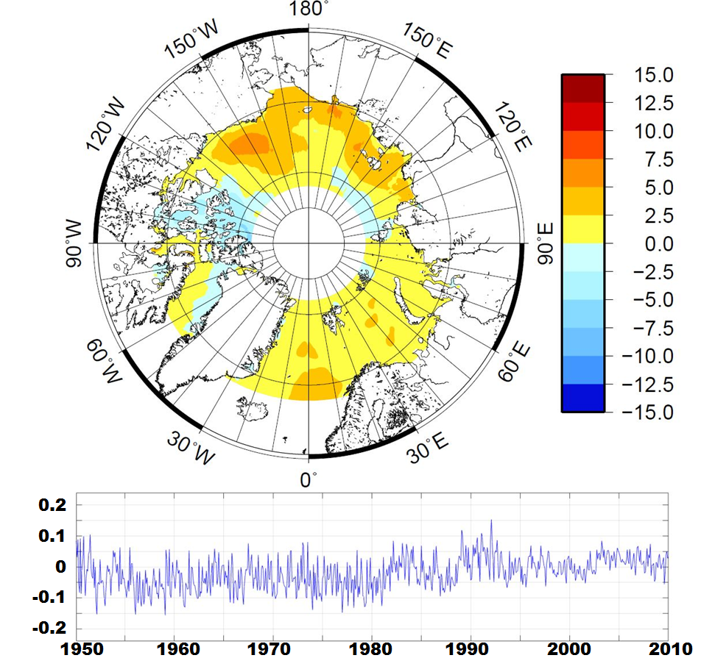

Reconstructing historical Arctic sea level is a considerable challenge, due to the relatively small amount of usable data. In a recent paper by Svendsen et al., 2016, the datum-fit sea level reconstruction method (Ray and Douglas) produces very stable Arctic linear sea level trend of around 1.5 +/-0.3mm/y for the period 1950 to 2010, between 68ºN and 82ºN. This value is also in good agreement with the global mean trend of 1.8+/- 0.3 mm/y for 1950–2000, as found by Church et al. (2004). Generally, the datum-fit method proved far more stable results than the method by Church and White in which monthly differences were cumulated.

## 9.3.4 Arctic Sea level budget

The sea level budget equation in its most simple form reads:

$$ΔS_{sl}=ΔS_{mass}+ΔS_{steric}$$

Where ΔSsl is the observed sea level, ΔSmass is the ocean mass variation and ΔSsteric is the steric component. Smaller contributions due to inflow and outflow from the Arctic Ocean as well as sea level pressure variations with time should be accounted in the overall sea level budget. However, as a first estimate these contributions can be neglected.

Here a first attempt on regional basin scale for the Arctic ocean is evaluated by comparing the updated sea level record with GRACE EWT values combined with the NOAA steric heights during the overlapping period 2003-2015. GRACE ocean mass variations are processed without accounting for the atmospheric pressure component. This correction is therefore applied using the ECMWF ERA-Interim model, and integrated according to Wunsch and Stammer (1997).

It is important to notice that in this first attempt on sea level budget closure several crude assumptions are made as the prime purpose of the study is to perform a validation of the observed change in altimetry sea level over the period 2003-2015. First, it must be considered that there is a spatial limitation due to satellite coverage, and the central part of the Arctic Ocean (above 82°N) is not included. Secondly, the budget contains data from the Northern area of the Atlantic Ocean, which exchanges water with other parts of the Atlantic Ocean.

The NOAA halosteric data for the period 2003-2015 is only provided with an interval of 5 years, whicle the thermosteric component has a step of 3 months. In order to make these consistent with the other datasets the steric values are interpolated over GRACE time coordinates with a cubic function and subsequently added to the EWT measurements.

Table 9.1 shows the linear trend of the different components. For period 2003-2015 the altimetric record measures a sea level rise of 2.4 mm/y, while GRACE EWT registers an increase of 2.8 mm/y. The dominating contributor to the steric component is the halosteric level, which shows a significant increase of 0.8 mm/y whereas the thermosteric variations are of -0.2 mm/y. The linear trend computed from the sum of EWT with the steric contribution is of 3.4 mm/y. In general the budget closes at around 1 mm/year. This is believed to be an acceptable result from this first attempt to perform a sea level budget closure also taking into account that investigation considering the limitations described above.

|  |  |
| --- | --- |
|  | **Linear trend** |
| Altimetry | 2.4 mm/y |
| GRACE | 2.8 mm/y |
| Thermosteric | -0.2 mm/y |
| Halosteric | 0.8 mm/y |
| Total steric | 0.6 mm/y |
| GRACE + steric | 3.4 mm/y |

*Table 9.1: Trend of sea level budget elements.*

In figure 9.3.4X1 the monthly sea level contributions filtered with a 1-year moving average are shown. It is very interesting that the large anomaly in sea level seen in 2012 and continuing into 2013 is found in both GRACE (green curve) and steric sea level (blue). The event is likely connected with the recording melting in the Arctic Region as also seen on Greenland (Kahn et al., 2015). General agreement can be observed in the annual estimates between the altimetric records (black) and the GRACE-steric combination (red).



***Figure 9.3.4X1****: Filtered monthly sea level contributions seen from Altimetry (black) and EWT from GRACE (green), steric contribution (blue), and the sum of GRACE ocean mass with steric height (red). All values are in centimeters.*

## 9.3.5 Atmospheric pressure variations

The comparison between satellite altimetry and coastal tidegauges on annual timescales revealed that altimetry has smaller amplitudes compared with the tide gauges.

This is largely because tide gauge SSH include the correction for atmospheric pressure via the inverse barometer (and long-period tidal effects).

Particularly the inverse barometer correction removes the hydrostatic response to surface pressure variations which are considerable in the Arctic Ocean. Welsh demonstrated that the annual variation in SSH pressure.

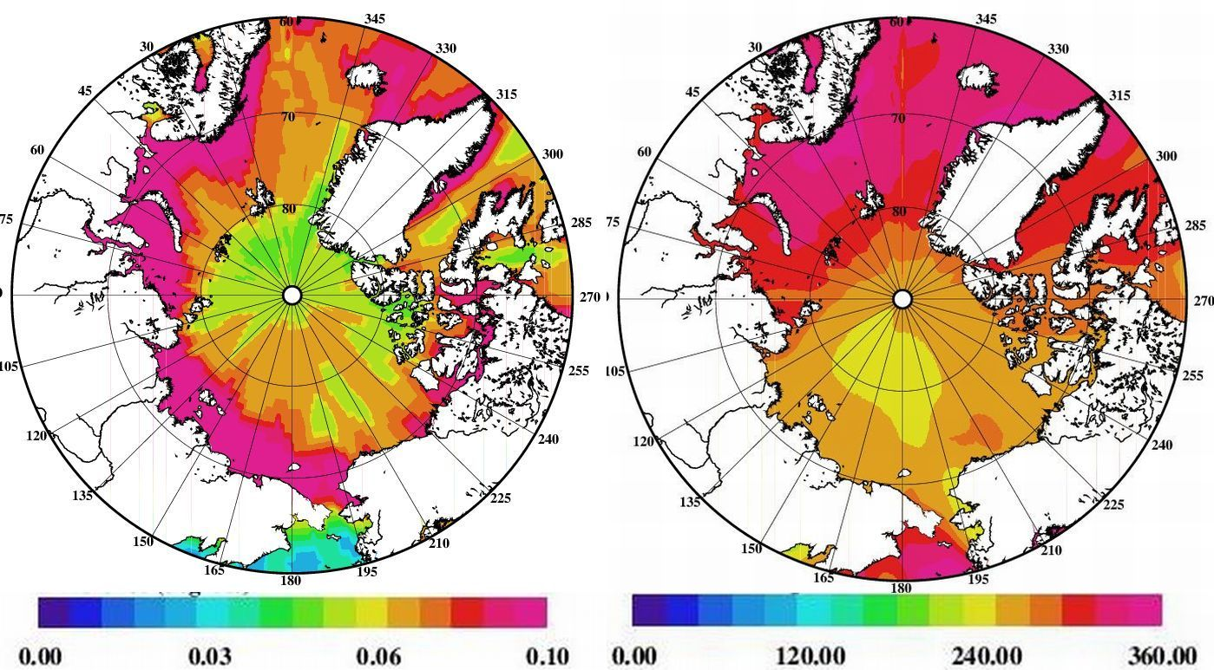

OA

Look how different this is to Figure where IB is applied.

Avaiting analysis of IB

## 9.3.6 The Polar gap and accuracy estimates

In practice, 27% of the Arctic is not sampled by the ERS-1/ERS-2/Envisat timeseries so to ensure compatibility over the whole time series, the other timeseries (GRACE and steric) have been truncated at 81.5°N.

However, there are now over 4 years of CryoSat-2 altimetry data up to 88°N with which to assess whether the monthly mean DOT calculated up to 81.5°N is representative of the whole basin.

First, the mean DOT within our defined boundary was calculated between November 2010 and December 2014 both north and south of 81.5°N to determine whether variations north of 81.5°N are coherent with variations in the rest of the study area. The seasonal cycle has a similar magnitude and phase north and south of 81.5°N and there is a static offset of ∼10 cm. The static offset simply reflects the fact the Beaufort Gyre lies in the region south of 81.5°N.

MORE - Ole

# 9.4 Absolut dynamic topography and ocean circulation

The dynamic topography can be interpreted in terms of influences from the water mass properties, ocean currents, ocean-atmosphere fluxes, and near surface winds. The time mean of the dynamic ocean topography is called the Mean Dynamic Topography (MDT). This reflects the long-term dynamically driven departure of the sea surface height (SSH) from the geoid which is represented by the mean sea surface (MSS). Hence the time-mean ocean geostrophic current is estimated from the corresponding slope of the MDT (= MSS - hgeoid)

The MDT is derived with respect to the temporal averaging period over which the associated MSS is derived from satellite altimetry. The time-mean used to calculate surface geostrophic currents and ocean transports is particularly sensitive to geoid residuals, since accurate models of the gravitational field are required to separate the marine geoid and oceanographic signals.

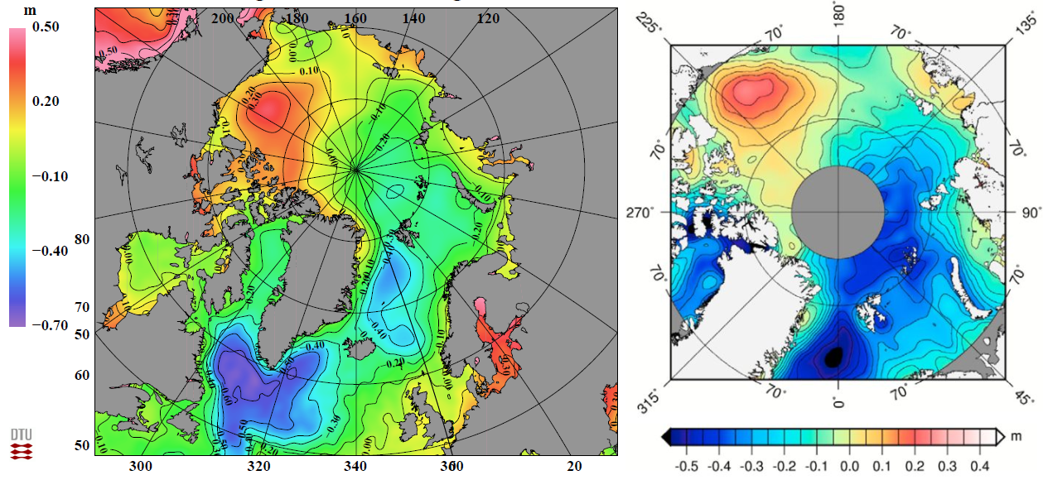

***Figure 9.4****. Two independent MDT models for the Arctic Ocean. The left is the DTU15MDT derived from the DTU15MSS and the EIGEN6-C4 geoid model and the right side is the MDT by Farrell derived from ICESat. The grey sector centered at the Pole marks lack ofcoverage.*

The GOCO03s geoid is calculated up to spherical harmonic degree/order 250 implying that it should be able to resolve features with wavelength of order 80 km. By inspecting transects of the MDT, it was determined that the Gaussian convolution filter used to smooth the monthly DOT grids successfully removes undulations due to short wavelength noise in the geoid model. The main features of the Arctic MDT (DTU15MDT) derived from the new DTU15MSS and the EIGEN6-C4 (Figure 9.4) are, as expected, consistent with Johannessen et al., (2014) and clearly reveals the presence of: a high in the Beaufort Sea associated with the anticyclonic Beaufort Gyre; a large-scale slope in topography from the Amerasian Basin to the Eurasian Basin associated with both the Beaufort Gyre and transpolar current; a low in the Norwegian and Greenland Seas associated with the cyclonic circulation; the expression of a sloping MDT in the northeast Atlantic consistent with the North Atlantic Current and its extension to the Norwegian North Atlantic Current; and a distinct low in the Sub-Polar gyre connected with the circulation in the north Atlantic and Labrador Sea. The result is also agreeing qualitatively well with previous results from satellite altimetry [Kwok and Morison, 2011; Farrell et al., 2012; Giles et al., 2012; Kwok and Morison, 2015] as well as from ocean models [e.g., Koldunov et al., 2014; Proshutinsky et al., 2015]. Moreover, in the Nordic Seas, the spatial pattern in the MDT agrees well with the spatial pattern in the mean steric height derived from hydrographic data (Nilsen et al. 2008) for the period 1950–2010 as shown by Johannessen et al., (2014).

In the recent work by Kwok and Morison (2015), the time-mean dynamic topography (MDT) from ICESat [Kwok and Morison, 2011], CS-2, DOT2008A [Andersen and Knudsen, 2009, Pavlis et al, 2012], and DTU13MDT [Andersen et al., 2015] are compared primarily for the Arctic Ocean (Figure 9.5). The MDTs are smoothed with a 250 km Gaussian averaging-kernel to reduce the noise in the sea surface measurements and the contribution of residual geoid errors at shorter wavelengths. The ICESat and CS-2 MDTs are from different epochs with potential biases between the two instruments. However, their spatial patterns are mostly the same with a well defined dome in the Canada Basin located to the Beaufort Sea and an east-west gradient across the Amerasian and Eurasian Basins. This is also in agreement with the findings reported by Johannessen et al., (2014). In contrast, the DOT2008A MDT display a very different structure whereby the Beaufort dome is closer to a ridge extending along the Canadian Arctic Archipelago. The DTU13MDT that incorporates both ICESat and CS-2 SSHs, on the other hand, shows a more defined Beaufort dome.

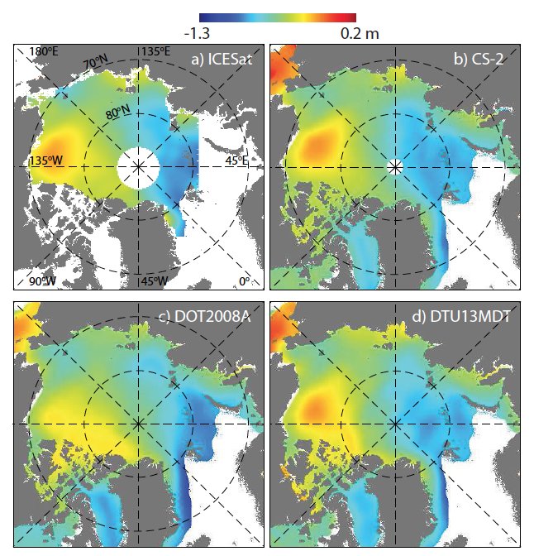

***Figure 9.5.*** *Mean dynamic topography of the ice-covered Arctic Ocean. (a) ICESat (Mean of Feb-Mar, 2003-2008) [Kwok and Morison, 2011], (b) CryoSat-2 (2011-2014). (c) DOT2008A. (d) DTU13MDT All fields have been smoothed with a 250-km Gaussian kernel.*

# 9.5 Absolute dynamic topography and ocean circulation

  - trends and variability in SSH

- seasonal and annual variability in ocean circulation and transport

  - assessment

**Surface circulation**

There are two main pathways by which the Arctic Ocean connects with the global ocean circulation (Figure 9.1), notably the Pacific-Arctic and the Atlantic-Arctic gateways (Rudels and Friedrich 2000). The Pacific-Arctic gateway is the narrow (~ 85km wide), shallow (~ 50m deep) Bering Strait, through which about 0.8Sv (1Sv=106m3/s) of water enters the Arctic. Properties of this inflow vary significantly seasonally, from about 0.4Sv, -1.9ºC, and 33 psu in winter to about 1.2Sv, greater than 2 ºC, and less than 31.9 psu in summer (Woodgate *et al.* 2005a). The Atlantic-Arctic gateway is through both the Fram Strait (~ 350km wide, ~ 2700m deep) and the Barents Sea (mostly via St Anna Trough, ~ 200km wide, ~ 600m deep). The Atlantic inflow is generally saltier (greater than 34 psu), warmer (greater than 0ºC), and about 10 times greater in volume than the Pacific inflow (Beszczynska-Möller *et al*. 2011). The Fram Strait inflow is about 7Sv (also seasonally varying) (Fahrbach *et al.* 2001), although complex recirculations in the strait return around half of that immediately to the south (Rudels *et al.* 2000b). The Barents Sea inflow is around 1Sv in summer and 3Sv in winter, and has been substantially modified during transit of the Barents Sea (Schauer *et al.* 2002a).

The other inputs to the Arctic are volumetrically small: Eurasian and Russian rivers (~ 0.1Sv) and precipitation minus evaporation (~ 0.06Sv). However, together they contribute roughly two-thirds of the freshwater entering the Arctic Ocean, the remaining third coming from the Pacific inflow (Aagaard and Carmack 1989, Serreze *et al.* 2006).

Outflows from the Arctic are all to the Atlantic, via either the western side of the Fram Strait (~ 9Sv, Fahrbach, *et al.* 2001), or via the complex channels of the Canadian Archipelago (~ 1-2Sv, Melling *et al.* 2008).

All these flow estimates are approximate, with uncertainties typically about 25%. See Beszczynska-Möller *et al*. (2011) for a review.

Within the Arctic Ocean the circulation is characterized by the eastward flowing Atlantic water in the Eurasian basin, the transpolar drift from the Siberian shelf region to the Fram Strait and the Beaufort Gyre in the Canadian Basin as illustrated in Figure 9.1. The distinct development and presence of the dome in the Beaufort Gyre from 2003 to 2014 is primarily connected and influenced by the ocean circulation in the Arctic Ocean. For the period 2005 to 2009 Koldunov et al., (2014) suggest that an anomalous transport (referenced to the 1970-2000 mean transport) in the upper ocean driven by dominant negative anomalies in the Ekman pumping directed fresh Siberian, Alaskan and Canadian Archipelago shelf and upper slope waters into the Beaufort Gyre as shown in Figure 9.6. This led to a convergence of low salinity water and subsequent increase of the steric height and hence formation of the dome as expressed in the MDTs in Figure 9.5 and Figure 9.6.

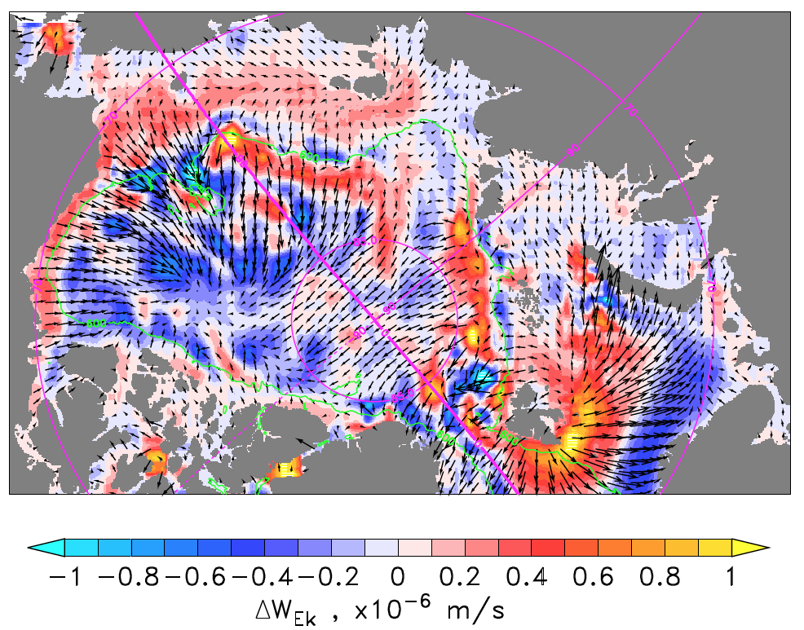

***Figure 9.6.*** *Ekman pumping anomaly (2005-2009 average minus 1970-2000 average) with the respective anomaly of Ekman transports superimposed (largest vector = 0.2 m2 s−1) computed from the ATL12 wind stress. The isobath shown corresponds to 600 m depth.*

Within the Greenland-Island-Norwegian (GIN) Seas the mean surface geostrophic velocities (Figure 9.7) are computed from the GOCE MDT for the period 1993-2009 in consistence with the period for the construction of the DTU MSS data, whereby:

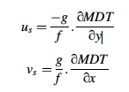

where *us* and *vs* are components of the surface geostrophic velocity, *g* is the acceleration due to gravity, *f* is the Coriolis parameter, and *x* and *y* are the zonal and meridiornal directions. The large-scale cyclonic surface circulation regime is well reproduced with the inflowing Atlantic Water to the Norwegian Sea reaching nearly 0.2 m/s. Moreover, the broadening of the NwAC over the Vøring Plateau and in the Lofoten Basin is noticed.

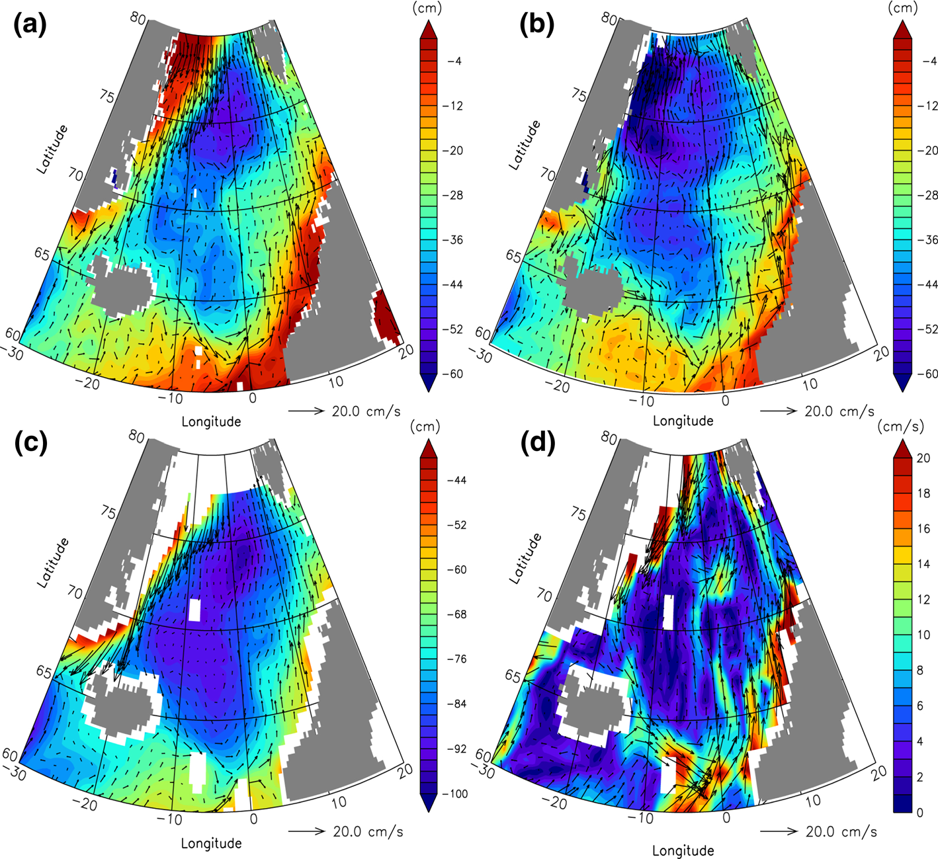

***Figure 9.7.*** *Mean surface geostrophic velocities vectors superimposed on the mean dynamic topography (MDT) derived from a GOCE, b CNES_CLS09, c Maximenko et al. (2009), and d mean surface velocity vectors derived from the climatology of the global surface drifter data. Color scale indicates the MDT in cm for (a) to (c) and speed in cm/s for (d). Current-vector scale shown in the lower right corner. (Courtesy Johannessen et al.,2014.)*

For a more detailed study the seasonal mean velocities are estimated whereby the ADT is determined as the sum of MDT and altimeter-based monthly mean sea level anomaly (SLA) data referenced to the time period 1993-2009. The main expected features are revealed by the mean velocities, notably (i) the two branch northward flowing West Spitsbergen Current (WSC) around 8°E and 15°E and (ii) the strong southbound EGC at 10°W. The branches are strongest in wintertime in consistence with velocity retrievals and transport estimates reported by Mork and Skagseth, (2005).

**Volume transport**

Lastly, we analyze the changes in the top-50 m horizontal freshwater fluxes (the fresh water F is defined as F = (34.8g/kg−salinity)/(35g/kg)) in the period 2005-2009 (period with large positive trend in SSH). Again, an anomaly is computed relative to the 1970- 2000 mean, shown in Fig. 14 together with the long-term average. The mean distribution Fig. 14 shows the well-known surface anticyclonic circulation in the Amerasian basin around the central Beaufort Gyre and the Transpolar Drift linking the Pacific inflow to the Fram bottom) a strengthening of the Beaufort Sea circulation is evident. The core of the anticyclonic circulation seems to elongate towards the western side of the Chukchi Plateau. Freshwater transport to the central Eurasian Basin from the Kara Sea can be also seen. In the shelf areas of the Laptev and East Siberian Seas a consistent freshwater circulation changes towards the east is seen, but there without any obvious connection to the central Amerasian basin. At a first glance, this seems to indicate that no clear connection can be established between the freshwater pool over the shelf due to river run-off and the accumulation in the central Amerasian basin. However, as seen in Fig. 13, Ekman transport anomalies from the Siberian shelf areas towards the Beaufort gyre were found to exist, suggesting that a contribution by lateral advection of river water could be possible. We claim however, from the agreement shown before regarding the reconstructed salinity, which the Ekman pumping accounts for the majority of the freshwater change in the central Amerasian basin. An interesting additional feature is the decrease and, at places, the reversal in freshwater transport through the Canadian Archipelago, which was identified by Ko¨hl and Serra [2014] as the main mechanism for explaining decadal variability of the total freshwater content in the Arctic. They found that the pattern of SSH change similar to EOF1 in Fig. 6 drives freshwater content changes in the Arctic via the associated changes in SSH difference to the North Atlantic.

By combining the GOCE derived MDT and altimetric sea level anomalies (SLA) with the comprehensive hydrographic data base an estimate of the mean and variable transport of Atlantic Water (salinity >35) entering the Nordic seas was obtained for the period 1993 – 2011 at a spatial resolution of 100 km (Johannessen et al., (2014). Using 44 CTD-sections for the Island-Faroe Ridge (IFR), 84 CTD-sections for the Faroe-Shetland Channel (FSC) and 76 CTD-sections taken along the Svinøy section the baroclinic velocity structures in the Atlantic Water were estimated across these sections. Combined with the barotropic velocity values the absolute velocities are then retrieved, and when multiplied to the area covered by the Atlantic Water estimates of the corresponding volume transports of Atlantic Water across the 3 sections are obtained.

|  |  |  |  |  |  |  |  |
| --- | --- | --- | --- | --- | --- | --- | --- |
| **Source** | **Data** | **Period** | **IFR [Sv]** | **FSC [Sv]** | **Svinøy [Sv]** | | |
| **NwAFC** | **NwASC** | **Total** |
| Johannessen et al., (2014) | GOCE + Altim. + hydr. | 1993-2011 | 3.5 | 4.1 | 3.0 | 3.9 | 6.9 |
| Mork and Skagseth (2010) | Altim. + hydr. | 1993-2009 |  |  | 1.7 | 3.4 | 5.1 |
| Skagseth et al. (2008) | current meter | 1995-2006 |  |  |  | 4.3 |  |
| Orvik and Skagseth (2005) | curr. meters | 1995-1999 |  |  |  | 4.2 |  |
| Orvik and Skagseth (2003) | curr. meters | 1998-2000 |  |  |  | 4.4 |  |
| Orvik et al. (2001) | curr. meters + ADCP  + hydr. | 1995-1999 |  |  | 3.4 | 4.2 | 7.6 |
| Berx et al. (2013) | Altm.+ADCP+hydro | 1995-2009 | 3.5 |  |  |  |  |
| Østerhus et al. (2005) | Bottom ADCP + hydr. | 1999-2001 | 3.8 | 3.8 |  |  |  |
| Hansen et al. (2010) | Bottom ADCP + hydr. | 1997-2008 | 3.5 |  |  |  |  |
| Hansen et al. (2003) | Bottom ADCP + hydr. | 1997-2001 | 3.5 |  |  |  |  |
| Sandø et al. (2012) | MICOM model | 1994-2007 | 4.7* | 4.7 |  |  |  |
| Johannessen et al., (2014) | MICOM model | 1993-2007 | 3.5 | 6.9 | 3.5 | 5.0 | 8.5 |
| Johannessen et al., (2014) | ATL model | 1993-2007 | 3.5 | 4.2 | 3.5 | 4.7 | 8.2 |

***Table 9.2.*** *Comparison of volume transport estimates from combined GOCE, altimetry and in-situ to previous studies as well as estimates from simulation models for the Island-Faroe Ridge (IFR), Faroe-Shetland Channel (FSC), NwAFC, NwASC in the Svinøy Section and the total Svinøy Section. (* only from 1997-2007.)*

A comparison of the volume transport estimates from the combined use of GOCE, altimetry and in-situ to earlier studies as well as estimates from model simulations for the Island-Faroe Ridge (IFR), Faroe-Shetland Channel (FSC), and the Svinøy Section are given in Table 9.2 (Johannessen et al., 2014).The mean inflows of Atlantic Water across the Iceland Faroe Ridge and through the Faroe-Shetland Channel are estimated to approximately 3.5 Sv and 4.1 Sv respectively (1 Sv = 106 m3s-1). Moreover, the mean transport of the two branches of Atlantic Water crossing the Svinøy section, e.g. the Norwegian Atlantic Slope Current (NwASC) and the Norwegian Atlantic Front Current (NwAFC) is respectively 3.0 Sv and 3.9 Sv. In view of the different integration periods these transports compares reasonably well with earlier reported observed as well as simulated transport values with a few exceptions. On the other hand, the total combined GOCE-, altimeter- and hydrographic-based transport estimates across the Svinøy section is about 20% lower than the simulated transports (e.g. 6.9 Sv versus 8.5 and 8.2 Sv). According to Johannessen et al., (2014) this is partly related to the definition and choice of layers for the transport estimations.

In order to further assess these transport values it is highly necessary to provide additional uncertainty estimates. For instance, the spread in mean transport estimates imply significant differences in the mean northward advection of heat and salt to the Nordic Seas and Arctic Ocean. This, in turn, may affect both the evaporation-precipitation fluxes and convective overturning in the Norwegian and Greenland Seas. Further studies are therefore needed to investigate the accuracies of these transport estimates.

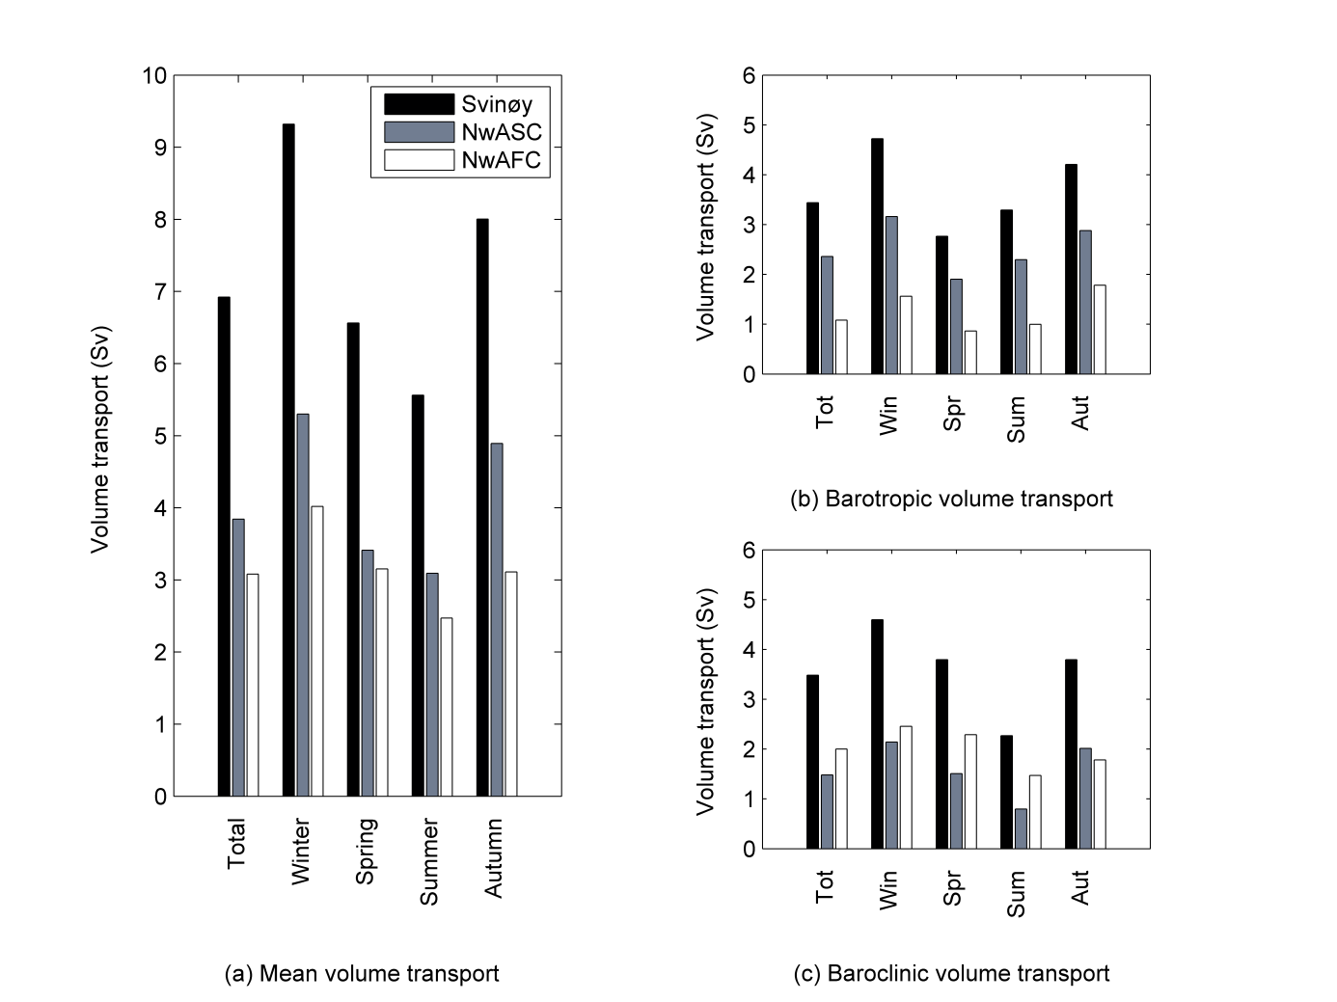

***Figure 9.8.*** *Mean annual and mean seasonal total volume transport estimates for the Svinøy section (black) compared to the mean transports of the NwASC (grey) and the NwAFC (white) for the period 1993-2011 based on combined use of GOCE, altimetry and in-situ hydrography data.*

Taking benefit of the temporal variability observed in the SLA and hydrographic data the mean and seasonal cycle in the transport of the inflowing Atlantic Water for the period 1993 to 2009 can also be estimated and inter-compared as shown in Figure 9.8 for the Svinøy section. The mean seasonal variability reveals a pattern with largest transports (9.3 Sv) in winter compared to the summer transport minimum (5.4 Sv). Moreover, the mean seasonal NwASC transport always exceeds the mean seasonal NwAFC transport, while the latter display a narrower range of seasonal variability in the volume transport. This suggests that the seasonal changes of the transport across the Svinøy section are predominantly controlled by seasonal changes in the transport of the NwASC.

Altogether, these GOCE-based estimates combined with altimeter-based SLA and in-situ hydrographic data are providing new and promising abilities to examine the seasonal transport variability (total as well as barotropic and baroclinic components) across key selected regions. As such, it is also providing an important tool for validations of model circulation and transports between the Northeast Atlantic Ocean and the Nordic Seas and Arctic Ocean.

# 7. Conclusions and future directions

  - future directions (what will newer, higher resolution altimeters, such as Ka-band altimeters and SWOT, offer us that has not been possible previously from altimetry?)

JOHNNY and OLE.