Cyclone Larry:
Severe Tropical Cyclone Larry passed the tropical north Queensland coast near Innisfail on Monday 20 March 2006. Figure 1 shows the Moderate Resolution Imaging Spectroradiometer (MODIS) on NASA’s Aqua satellite acquired this photo-like image on March 19, 2006. The tropical cyclone low developed over the eastern Coral Sea and reached cyclone intensity during the early hours of 18 March and continued on a general westerly course towards the Queensland coast. Larry rapidly strengthened in the following 48 hours reaching hurricane-force intensity at 1200 UTC 18 March and peaking at 56 m/s (110 knots) at 12:00 UTC 19 March as it marched gradually westwards towards the coast (Figure 2).
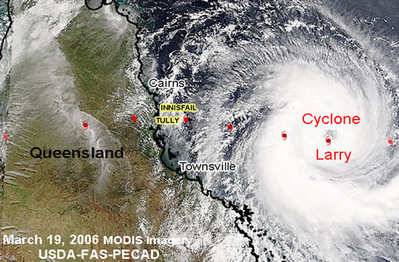
Figure 1. Satellite acquired image of Larry on March 19, 2006.

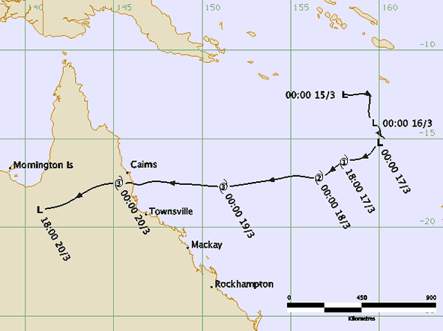
Figure 2. The track of Larry
Two altimetric ground tracks/passes have been selected during the period of the cyclone Larry (Figure 3). The mean sea level (since 1992) and standard deviation have been computed at each along-track point. For each pass, a point, where the SLA reaches the maximum during the cyclone Larry, is chosen. The SLA time series is plotted. The along-track SLA profiles have also been analysed for two tracks.
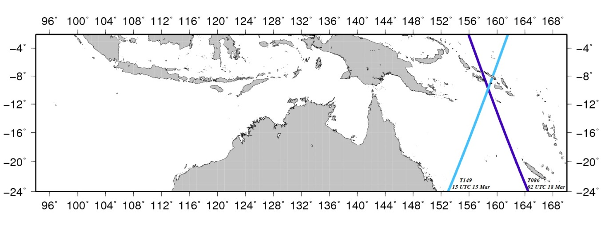
Figure 3. Selected altimetric ground tracks 149 and 086 during the cyclone Larry period.

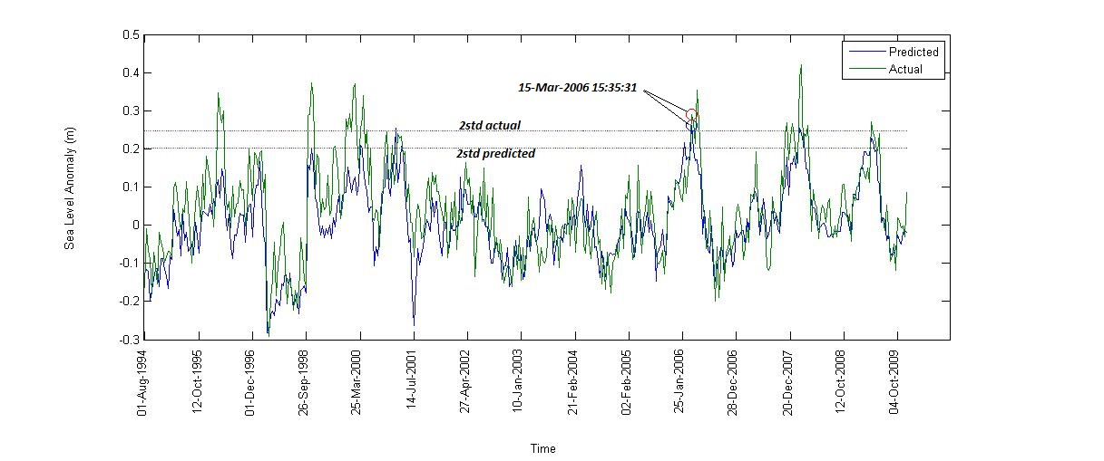
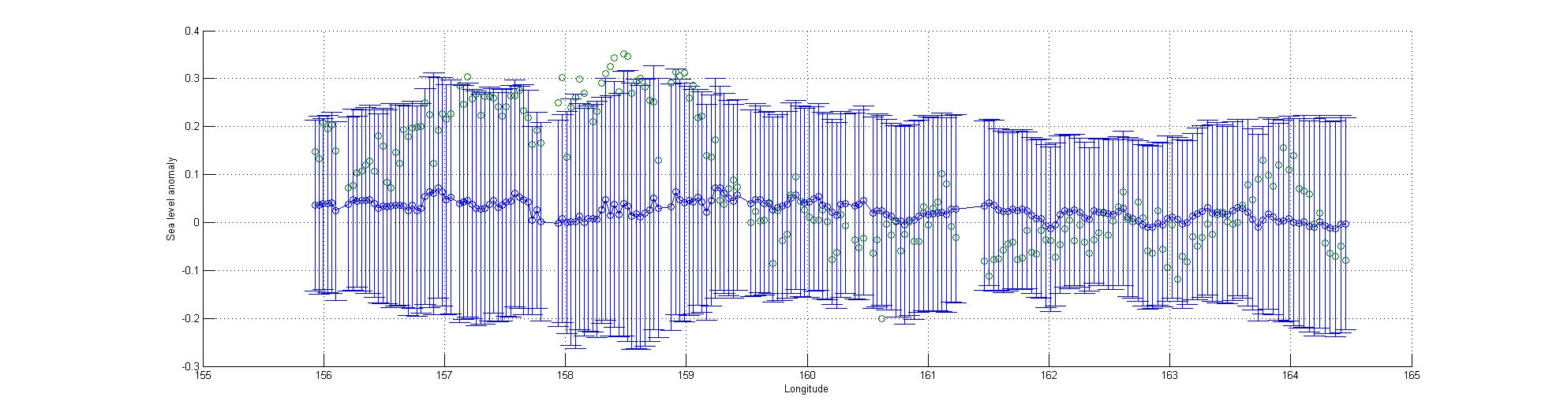
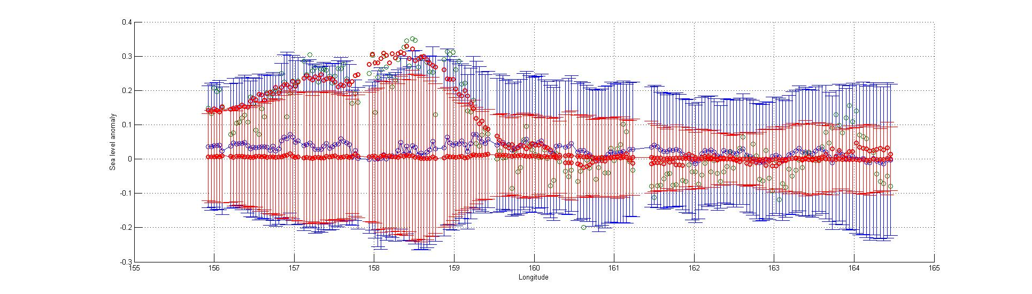
Figure 4. (Top): The measured (green) and predicted by the multi regression method (blue) SLA time series for a normal point (10.1629°S, 158.8757°E) along track 86. The 2 times standard deviations (both related to measured and predicted) are shown as horizontal lines, suggesting that they both capture the sea level variations caused by the cyclone Larry. (Mid): Along-track SLAs (green) and 2 times stds (blue bar) with respect to the mean sea level (blue circle) during the cyclone Larry around UTC15:00 on 15 March 2006 (units in m), indicating that SLAs are > 2σ. (Bottom): The same as mid Figure, but adding predicted mean (red circle) and 2σ (red bar) into the figure. It shows that both measured and predicted SLAs are > 2σ over the area, where the track crosses the cyclone.

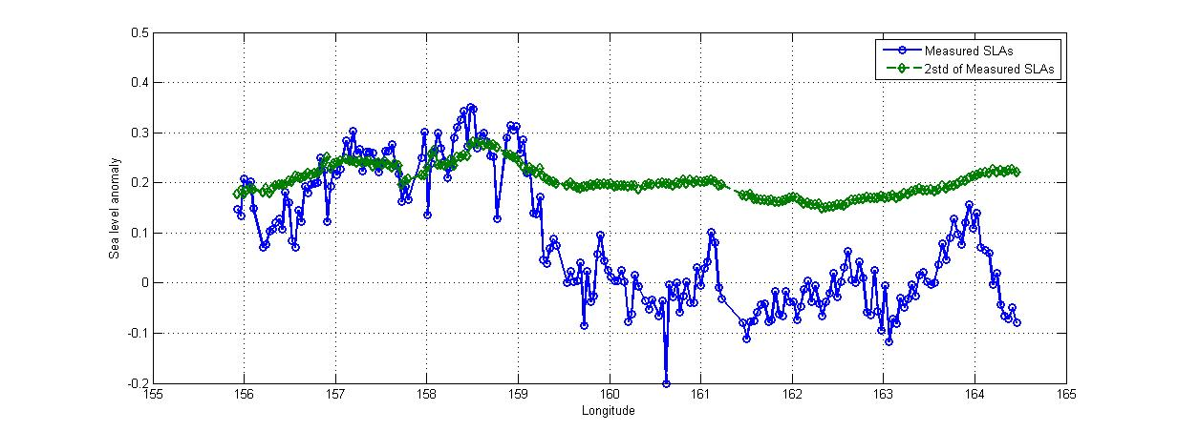
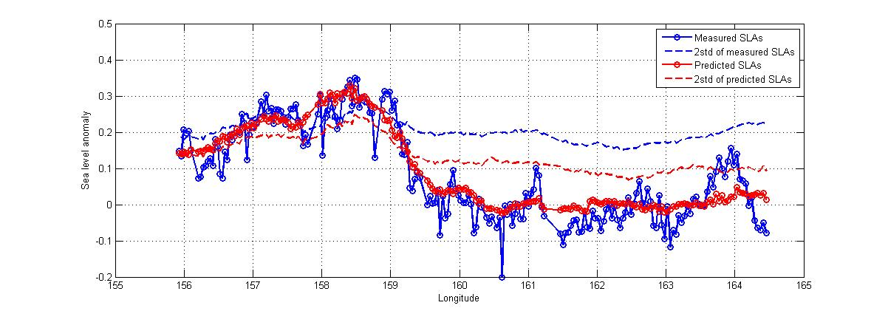
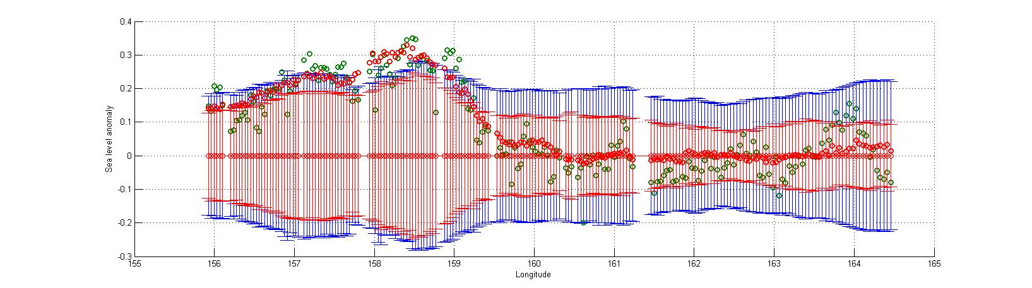
Figure 4. (Top): Along- track measured SLAs (blue) and the 2 times standard deviations (green), demonstrating that SLAs are > 2σ during the cyclone Larry. (Mid): The measured (blue) and predicted by the multi regression method (red) SLA time series at each normal points along track 86 and the 2 times standard deviations (both related to measured and predicted) are shown as dashed blue and red lines respectively, suggesting that they both capture the sea level variations caused by the cyclone Larry. (Bottom): Along-track SLAs (green) and 2 times stds (blue bar), along with predicted SLAs (red circle) and 2σ (red bar), all with respect to the zero, indicating that both measured and predicted SLAs are > 2σ during the cyclone Larry around UTC15:00 on 15 March 2006 (units in m).

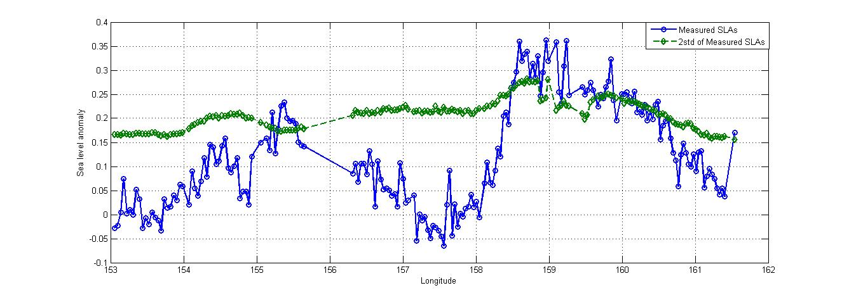
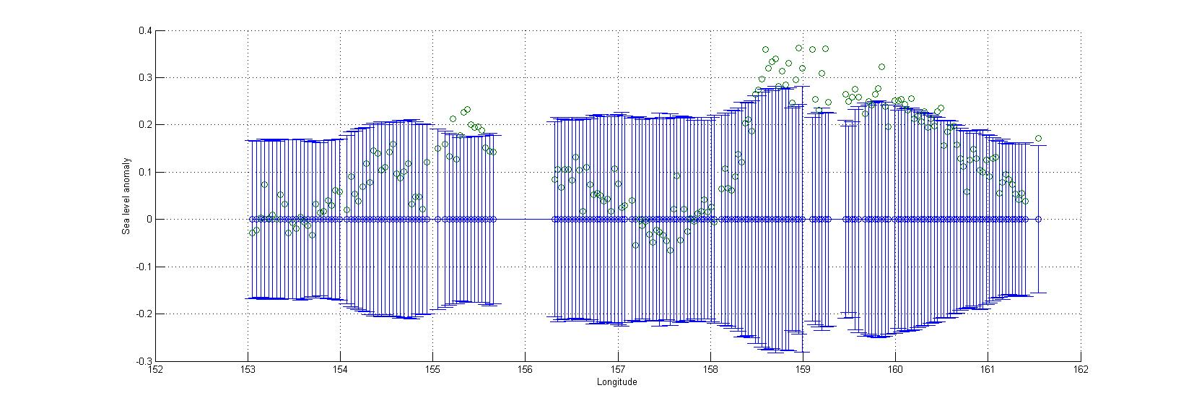
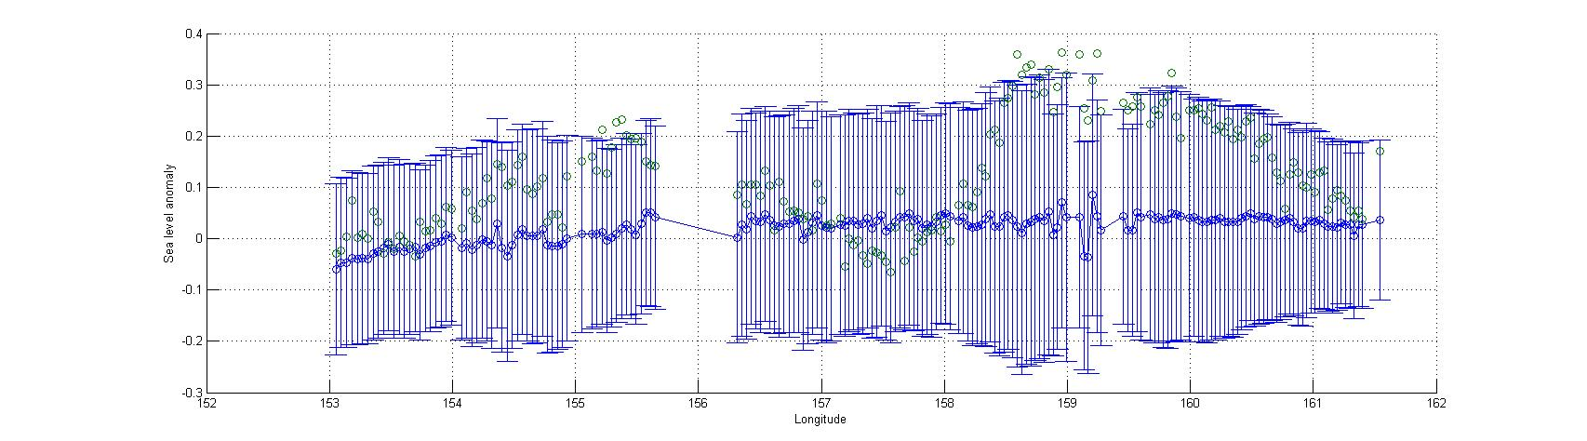
Figure 7. (Top): Along- track SLAs (blue) and the 2 times standard deviations (green), demonstrating that SLAs are > 2σ during the cyclone Larry. (Mid): Along-track SLAs (green) and 2 times stds (blue bars), all with respect to the zero during the cyclone Larry around 02 UTC on 18 March 2006, indicating that SLAs are > 2σ. (Bottom): The same as mid Figure, but the error bars (blue bars) are with respect to the mean sea level (blue circle), indicating that in both cases SLAs are > 2σ (units in m).

