ESA CryoVEx/ICESat-2 2019
  - Airborne and in situ field campaign - Data Acquisition Report

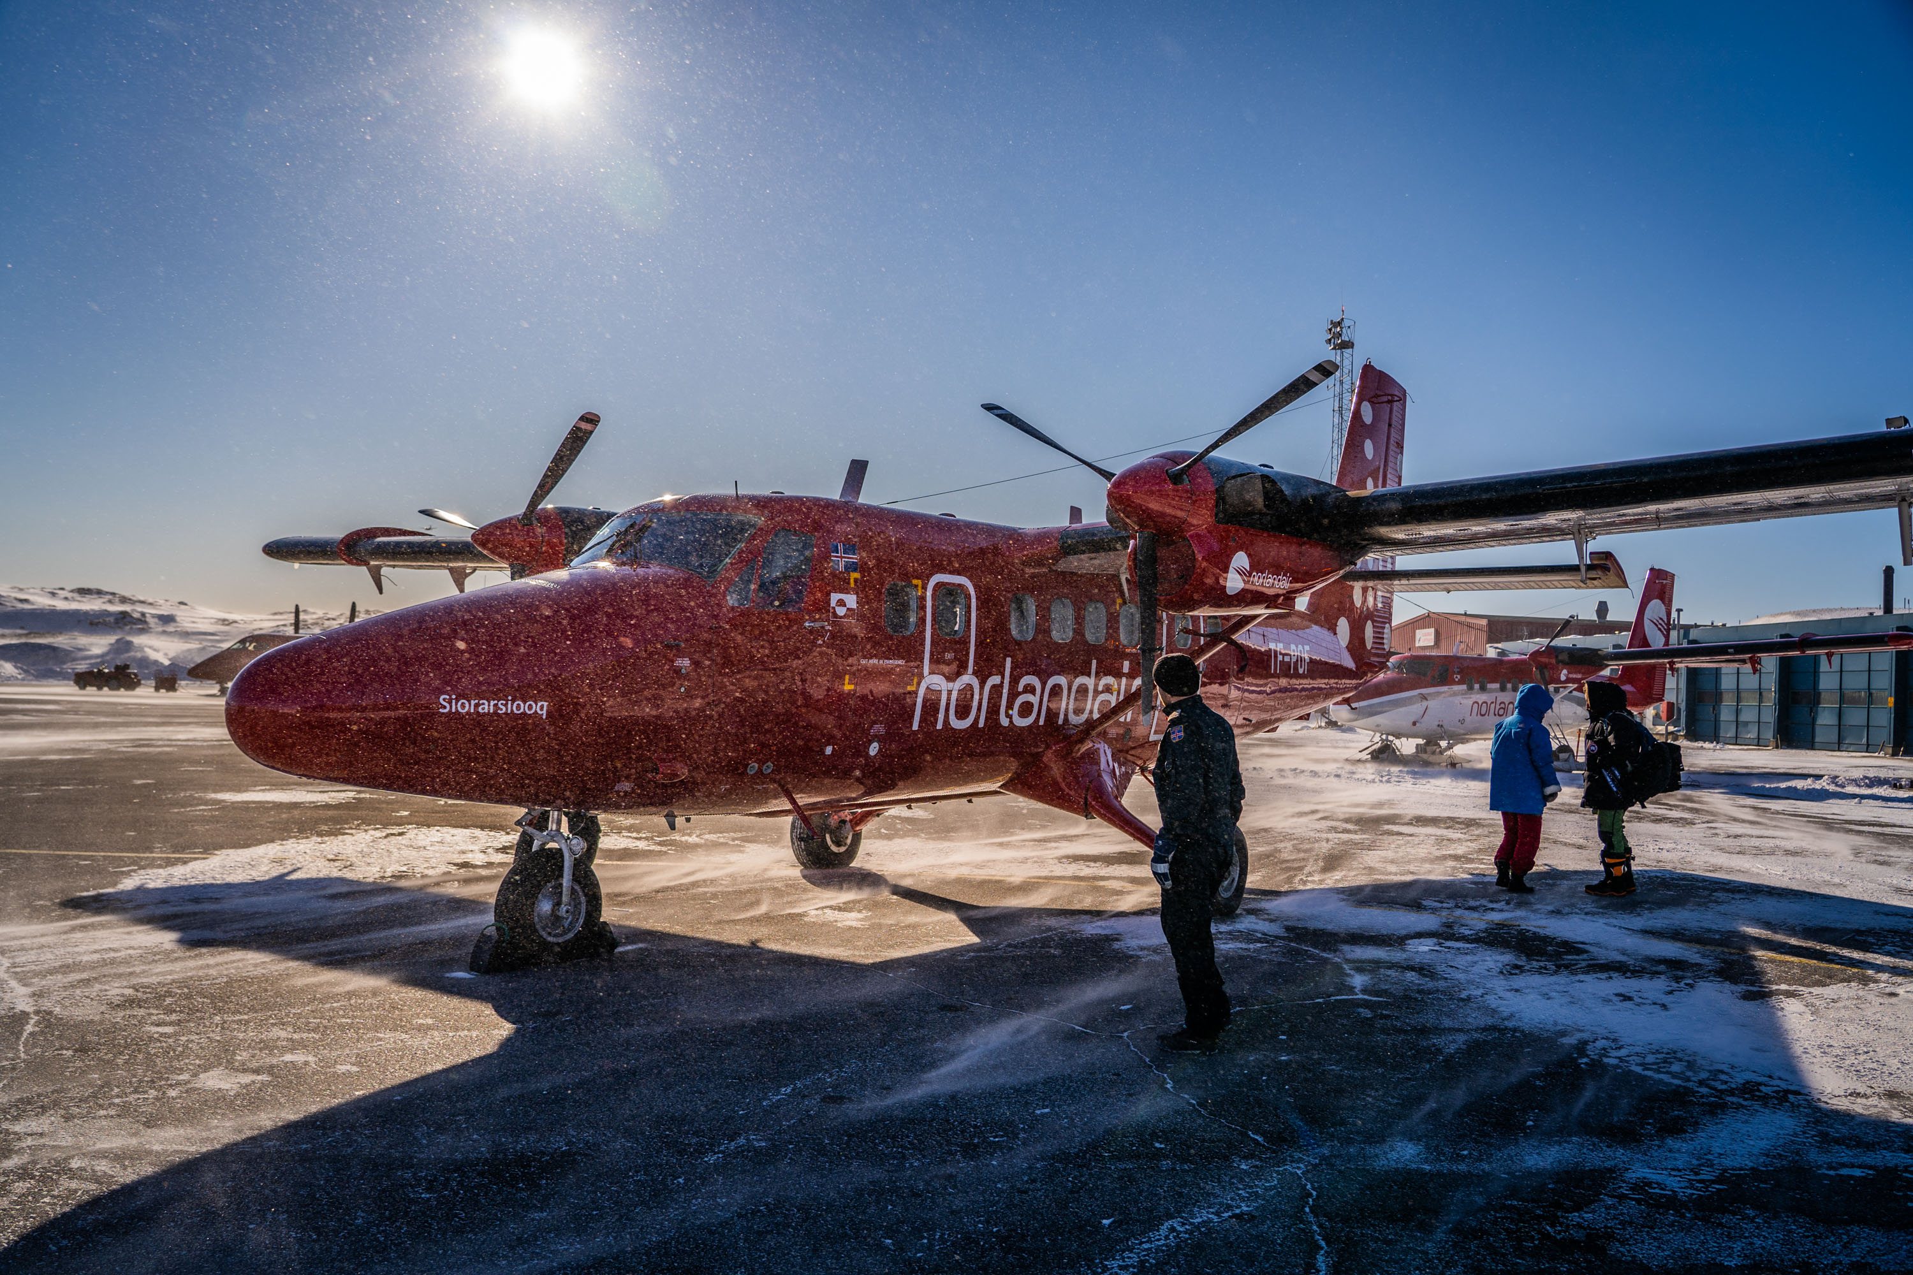

  - H. Skourup¹, A. Di Bella¹, A. Coccia², A. Shepherd³, A. Hogg³, S. B. Simonsen¹,
  - I. Otosaka³, A. Lemos³, F. Rodriguez-Morales⁴, R. Forsberg¹ and T. Casal⁵

  - ¹ DTU Space, Technical University of Denmark, Kgs. Lyngby, Denmark
  - ² MetaSensing BV, Noordwijk, The Netherlands
  - ³ CPOM, University of Leeds, LS2 9JT, UK
  - ⁴ CRESIS, University of Kansas, USA
  - ⁵ ESA ESTEC, NL

  - July, 2019

ESA contract report
Version: 1.0
Contract number: 4000120131/17/NL/FF/mg (CCN1)
Contractor: DTU Space
Authors: H. Skourup, A. Di Bella, A. Coccia, R. Forsberg and T. Casal
ESA technical officer: Tânia Casal

Front page: Norlandair Twin Otters to support the airborne and in situ work. Credits: EU team.

Contents

1 Introduction 4
2 Summary of operation 5
2.1 Day to day 8
3 Hardware installation 9
4 Overview of acquired data 13
5 Data handling 16
5.1 GPS and INS data 16
5.2 Airborne Laser Scanner (ALS) 17
5.3 ASIRAS 18
5.4 KAREN 18
5.5 Calibration and absolute heights of ASIRAS and KAREN 22
5.6 Camera 23
6 The EGIG line 24
6.1 In situ observations 24
7 Priority flights 25
8 Conclusion 27
9 References 28
10 APPENDIX Operator logs 29
11 APPENDIX Overview acquired ALS data 35
12 APPENDIX Overview of acquired ASIRAS data 36
13 APPENDIX Overview of acquired KAREN data 37

Introduction

The ESA CryoVEx/ICESat-2 campaign 2019 is the first CryoVEx campaign since the launch of NASA ICESat-2 in September 2019, and aims at cross-validating ESA CryoSat-2 and NASA ICESat-2 missions over sea ice and land ice in the Arctic. The campaign also extends the observations of dual-frequency (Ka/Ku-band) airborne observations, first flown in CryoVEx/KAREN 2016 fall campaign, to exploit the concept for future polar satellite missions. The airborne observations were coordinated with large scale in situ work along the EGIG line of the Greenland Ice Sheet.

The campaign involved operations with ESA’s Ku-band radar (ASIRAS), Dutch Company MetaSensing’s Ka-band radar (KAREN) and laser scanner using chartered Twin Otter (TF-POF) from Norlandair, Iceland. Three sea ice flights were flown in the Arctic Ocean out of Station Nord including 2 near coincident underflights of ICESat-2 and 1 of CryoSat-2, see Figure 1. A direct underflight of CryoSat- 2 was flown in Baffin Bay on route from Thule AB to Ilulissat. Transit flights crossing the Greenland Ice Sheet provides cross-overs of all altimeter missions (CryoSat-2, ICESat-2, Sentinel-3 and SARAL/AltiKa).

Unfortunately a planned coincident flight with Alfred Wegener Institute for Polar and Marine Research (AWI) airborne program called “IceBird” carrying a snow radar for independent measurements was not possible due to bad weather in CFS Alert. For similar reasons, a dedicated flight following ground tracks of CryoSat-2 and ICESat-2 over the Greenland ice sheet, was not possible.

This report outlines the airborne and in situ field operations conducted during March 23 – April 4, 2019. The campaign was coordinated by National Space Institute, Technical University of Denmark (DTU Space) in collaboration with MetaSensing. In addition to Danish/Dutch airborne team, ground validation was carried out by scientists from the University of Leads (UK), University of Kansas (US), and DTU Space.

The primary purpose of the project is:
- Cross-validation of ESA CryoSat-2 and NASA ICESat-2 missions over land- and sea ice
- To fly dual frequency (Ka/Ku-band) radar altimeters together with laser to study penetration depths in support of future satellite missions
- Coordinated flight with extended in situ work on land ice (EGIG-line)

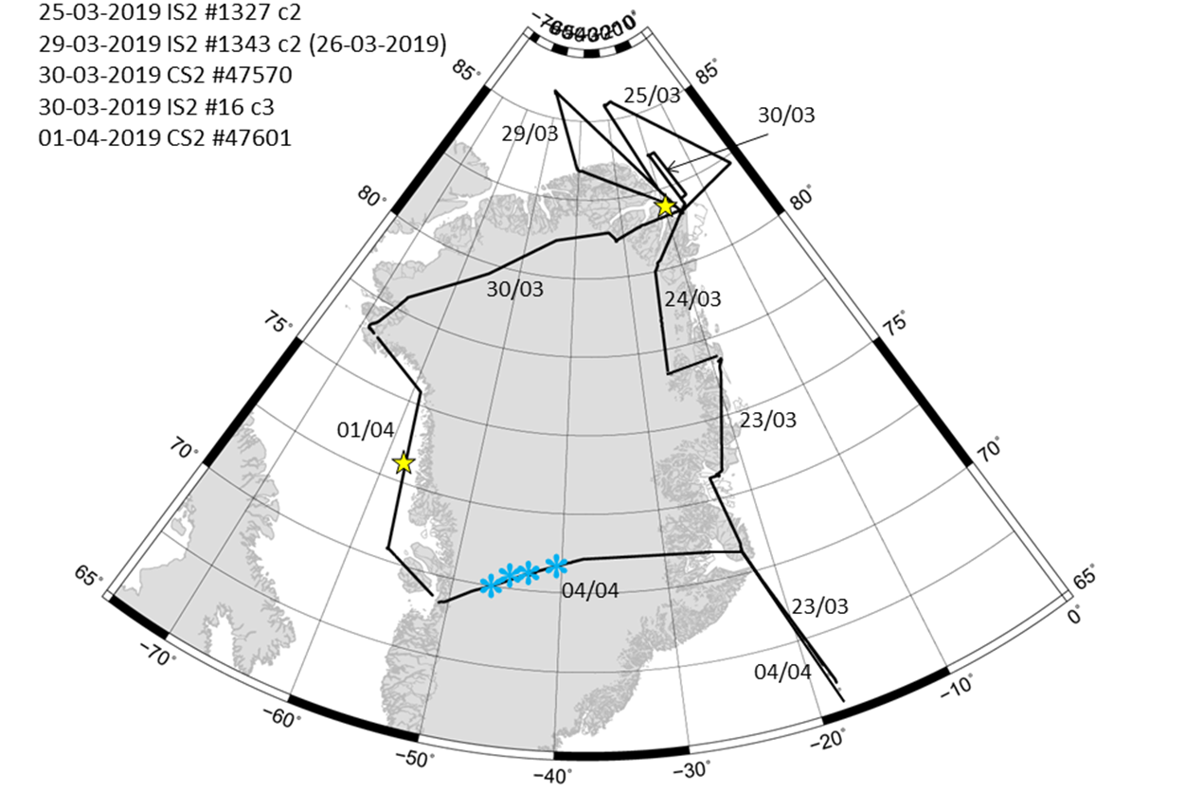

Figure 1: Overview of the flight tracks from the CryoVEx/ICESat-2 2019 airborne campaign. Yellow stars marks satellite passage time on the day of flight and blue snowflakes mark the in situ sites.

Summary of operation

The CryoVEx/ICESat- 2 2019 airborne campaign, basically circumnavigated Greenland north of 70°N, see flight lines in Figure 1, with about 30 flight hours.

The campaign took place March 23 – April 4, 2019. The Norlandair Twin Otter (reg: TF-POF), which is the same aircraft as used throughout previous CryoVEx campaigns, was chartered. The instrument installation and test flights took place in Akureyri, Iceland, March 21-23, following the general instrument certification for the aircraft obtained in 2006 (Hvidegaard and Stenseng, 2006). Unfortunately the weather was not favorable, and included quite a few weather days where it was not possible to fly. Station Nord was experiencing snow and white out, whereas weather days in Ilulissat was due to heavy cross-winds on the runway, and rain followed by freezing.

The coincident flight with AWI Polar-6 was originally planned out of Station Nord. Due to restrictions flying directly from Svalbard to Station Nord, this had to be cancelled in advance. As an alternative the team tried to do a coincident underflight of ICESat-2 while Polar-6 was based in CFS Alert and CryoVEx team was based in Station Nord. Due to weather it was not succeeded.
Luckily, the weather was favorable and all planned flights were achieved within the estimated time.

The flight altitude during survey is typically 300 m agl, limited by the range of the laser scanner, and the nominal ground speed is 135 knots. The aircraft is equipped with an extra ferry tank permitting longer flights (5-6 hrs), and an autopilot for better navigation accuracy. In good conditions the across-track accuracy is down to a few meters using a custom-made navigation system connected to geodetic GPS receivers. Calibration flights of the instruments over buildings and runways were performed whenever possible. For a more detailed description see Section 5.3 and 5.4.

The airborne science team consisted of Henriette Skourup (HSK), Alessandro Di Bella (ADIA) from DTU Space, Alex Coccia (AC) from MetaSensing, and Tânia Casal (ESA). The in situ team consisted of Andy Shepard, Anna Hoggs, Ines Otosaka, … Adriano, Fernando, Sebastian B. Simonsen.

An overview of the flights is found in Table 1 and 2 along with a detailed “day-to-day”-report in Section 2.1. Operator logs and detailed plots of flight tracks are provided in Appendix 10.

Table 1: Overview of CryoVEx/ICESat-2 2019 flights

Date | DOY | Flight | Track | Take off UTC | Landing | Airborne | Airborne | Survey operator
 |  |  |  |  | UTC |  | accumulated [dd:hh:mm]
23-03-2019 | 82 | a | AEY test flight | 13:10 | 13:50 | 00:40 | 00:00:40 | HSK/ADB/AC
23-03-2019 | 82 | b | AEY-CNP | 15:06 | 17:10 | 02:04 | 00:02:44 | No Survey
23-03-2019 | 82 | c | CNP-DMH | 17:38 | 20:18 | 02:40 | 00:05:24 | No Survey
24-03-2019 | 83 | a | DMH-STN | 15:39 | 18:56 | 03:17 | 00:08:41 | HSK/ADB/AC
25-03-2019 | 84 | a | STN-ICESAT(1327)-F2-F1-CAL-STN | 08:06 | 13:35 | 05:29 | 00:14:10 | HSK/ADB/AC
29-03-2019 | 88 |  | STN-ICESAT(1343)-STN | 16:10 | 21:25 | 05:15 | 00:19:25 | HSK/ADB/AC
30-03-2019 | 89 | a | STN-CS2()-IS2(16)-STN | 08:10 | 10:24 | 02:14 | 00:21:39 | HSK/ADB/AC
30-03-2019 | 89 | b | STN-HAGF2-NORT6-NORT1-TAB | 11:03 | 16:04 | 05:01 | 01:02:40 | HSK/ADB/AC
01-04-2019 | 91 | a | TAB-CS2(47570)-JAV | 12:45 | 17:15 | 04:30 | 01:07:10 | HSK/ADB/AC
04-04-2019 | 94 | a | JAV-EGIG-CNP | 16:13 | 20:58 | 04:45 | 01:11:55 | HSK/ADB/AC
04-04-2019 | 94 | b | CNP-AEY |  |  |  |  | No Survey
Total |  |  |  |  |  |  | 30h 28min

Day to day

The airborne part of CryoVEx/ICESat-2 2019 campaign progressed as follows:

March 20 HSK, ADIA Copenhagen -> Akureyri
March 21-22 Installation, Norlandair Hangar. Power rack cannot start up using 220V only aircraft power 28V. Prep new metal …. Tânia stuck in Rekjavik
March 23 Tânia arrives in the morning. Test flight at noon. Akureyri -> Danmarkshavn via Constable Pynt. Too low clouds to measure Walterhausen glacier and ice sheet
March 24 Standby in the morning. ETD 15.00 Danmarkshavn to Station Nord. Directly west to intercept line WALTH2 – NE2. Measure on the ice sheet to Station Nord. Some drift on the surface.
March 25 Clear sky, -32C, calm. Flight ICESat-2 # 1327 almost on the line outside STN at the IS2 passage time. Measure northern (F2-F1) and eastern part (F1-STN) of triangle. AWI Polar-6 arrive at CFS Alert.
March 26-27 grounded due to snow and low visibility. Polar-6 grounded due to weather. The icebridge in Nares Strait collapsed and open water outside the station.
March 28 -30C, no snow, … Weather improved STN. Predictions area for planned coincident flight with AWI looks bad with snow and low clouds. AWI next … cancelled the flight of the day
March 29 Delaying flight to 1600 UTC to wait for Polar-6. Flight along ICESat-2 track #1343 … AWI had to cancel due to weather.
March 30 Clear sky, -30C at STN. Flying a short flight following CS2 #47570 and IS2 #16 out of station nord. Passage times outside the … TAB open within flight hours of Operation Northern Falcon (Ilusion) 1100-1700 UTC. Flight STN to TAB following Hagen Glacier and NORT6-1. Arriving TAB. (Opening of TAB 1.600 USD/hour). In situ team at T35. No heating of the iMAR 110V, TO in hangar.
March 31 Day off due to closure of the airport. In situ team survey T9 and T12.
April 1 TAB to JAV following CS2 track #47601. Change power supply for screen to pilots. Were at position … by the passage time of CS2 (14:48 UTC). Skipped Disko Island flight due to time and low clouds in the region. The afternoon flight planned for the EGIG line was cancelled due to heavy cross-winds at the runway (already marginal for the landing)
April 2-3 No flying due to weather. April 2 windy, rain and +5C - risk of icing. April 3 snow and windy.
April 4 Snow and wind in the morning. EGIG line T1-T41 in the afternoon in clear conditions at the ice sheet. In situ team at T21 with corner reflectors. Five overflights of the site en route CNP. Arrive at midnight local. Deinstall the instruments 4 hours.
April 5 SSIM, ADIA and HSK AEY-CPH

Hardware installation

The hardware installation in the Norlandair Twin Otter (TF‐POF) consisted of the following instruments:

- MetaSensing Ka-band radar altimeter KAREN
- ESA Ku‐band interferometric radar ASIRAS
- DTU Space Airborne Laser Scanner (ALS) of the type Riegl LMS Q‐240i‐60
- Three geodetic dual‐frequency GPS receivers of type Javad Delta (AIR1-4), where AIR4/AIR3 was used to support ASIRAS time tagging
- An Inertial navigation system (INS) of the type Honeywell H‐764G
- An Inertial navigation system (INS) of the type iMAR
- An integrated NovaTel GPS-INS system to support KAREN
- Cameras (GoPro3 and GoPro7) for vertical and slant looking images
The KAREN sensor was for the first time successfully tested during CryoVEx/KAREN 2016 fall campaign (Skourup et al., 2017a). Since then, the horn antennas, have been replaced with new Microstrip patch array antennas, see Figure 2.

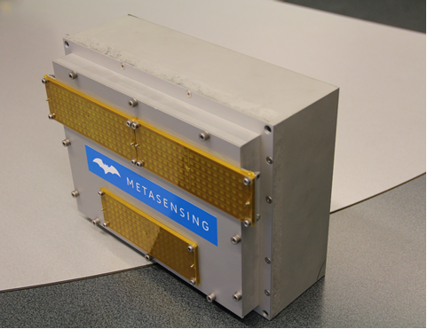
Figure 2: KAREN Radio Frequency (RF) enclosure with updated microstrip patch antennas.

The installation was similar to CryoVEx/KAREN 2017 campaign (Skourup et al., 2019). To avoid shadow effects from the hull of the aircraft the ALS was tilted slightly backwards. The Ka-band altimeter was fitted into the rear ASIRAS rack. A dedicated GPS-INS is used by the Ka-band altimeter for post processing, and it is installed in the rack together with the control unit.

The installation of the ASIRAS system was identical to the setup used throughout the previous CryoVEx campaigns (e.g. Skourup et al., 2013). Due to problems with PC2 during previous campaigns, ASIRAS had been modified before the campaign to rely on only PC1, leaving it with only option to measure in Low Altitude Mode (LAM). A Javad Delta receiver AIR4/AIR3 was used to support ASIRAS. The bottom view of the aircraft is shown in Figure 4, with the external ASIRAS antennas at Ku band, and the KAREN sensor at Ka band contained in the hatch.

Three geodetic dual-frequency GPS receivers (AIR1, AIR2 and AIR3/AIR4), mounted to log precise aircraft positioning, were connected to two separate GPS antennas (“front” and “rear”) through antenna beam splitters. The GPS antennas are permanently installed on TF-POF. Information about the antenna constellation is provided below:

Front antenna:
- AIR2
- AIR3 from 24-03-2019
- AIR4 until 23-03-2019

Rear antenna:
- AIR1

The logging rates of the AIR2 and AIR3 were 1 Hz, whereas AIR1 and AIR4 (has not been downloaded as it broke) was logging at 2 Hz. The higher logging rate for AIR1 was chosen to obtain a higher precision for the on-board navigation system. AIR4 was also used to support ASIRAS time tagging. Offsets between GPS antennas and ASIRAS/ALS reference points are given in Table 2.

To record the attitude (pitch, roll and heading) of the aircraft, two inertial navigation systems (INS) were used. The primary unit is a medium grade INS of type Honeywell H-764G. This unit collects data both in a free-inertial and a GPS-aided mode at 50 Hz. Specified accuracy levels in roll and pitch are better than 0.1˚, and usual accuracy is higher than this. A new super-precise INS strap-down unit purchased from iMAR, which has the potential to measure the gravity field, was installed in the cabin next to the front operator seat, see Figure 3. The Honeywell INS was connected to the rear antenna. The iMAR was connected to the front GPS antenna. The setup of the instruments in the aircraft is shown in Figure 3 and pictures of the various instruments are shown in Figure 4-7.

Table 2: The dx, dy and dz offsets for the lever arm from the GPS antennas to the origin of the laser scanner, the back centre of the ASIRAS antenna (see arrow Figure 3), and the KAREN reference point.
To laser scanner | dx (m) | dy (m) | dz (m)
from front GPS antenna | - 3.60 | + 0.49 | + 1.58
from front GPS antenna | + 0.10 | - 0.38 | + 1.42
to ASIRAS antenna | dx (m) | dy (m) | dz (m)
from front GPS antenna | -3.37 | +0.47 | +2.005
from rear GPS antenna | +0.33 | -0.40 | +1.845
to KAREN reference point | dx (m) | dy (m) | dz (m)
from front GPS antenna | -3.71 | +0.47 | +1.82
from rear GPS antenna | -0.01 | -0.40 | +1.66

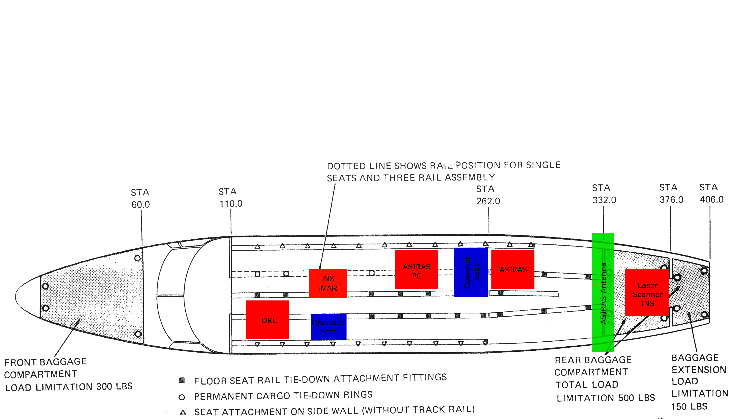
Reference point for antenna offset measurements
y
x
The Ka-band radar antenna, are mounted alongside the laser scanner.
The Ka-band radar system is added to the rear-ASIRAS rack
Figure 3: Overview of instrument setup in the TF-POF Twin Otter aircraft

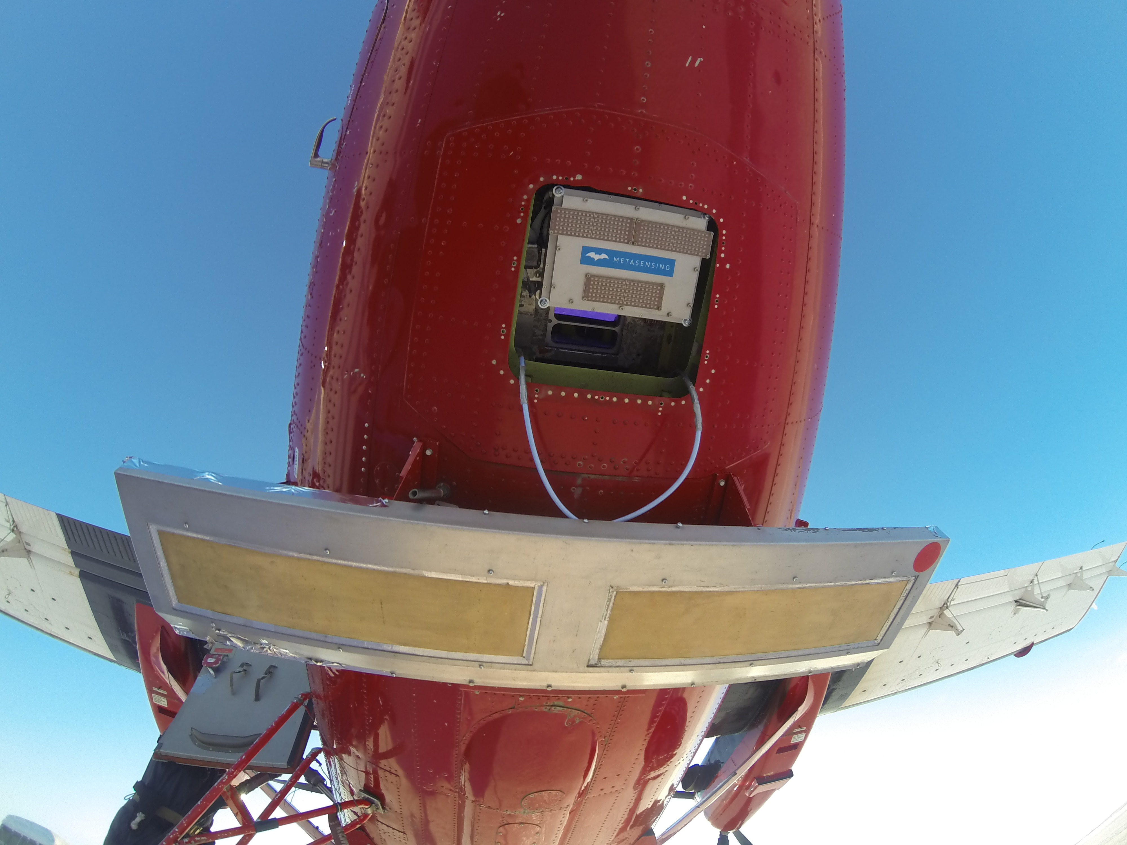
Figure 4: Bottom view of the Norlandair Twin-Otter TF-POF showing KAREN and ASIRAS antennas together with ALS and GoPro camera.

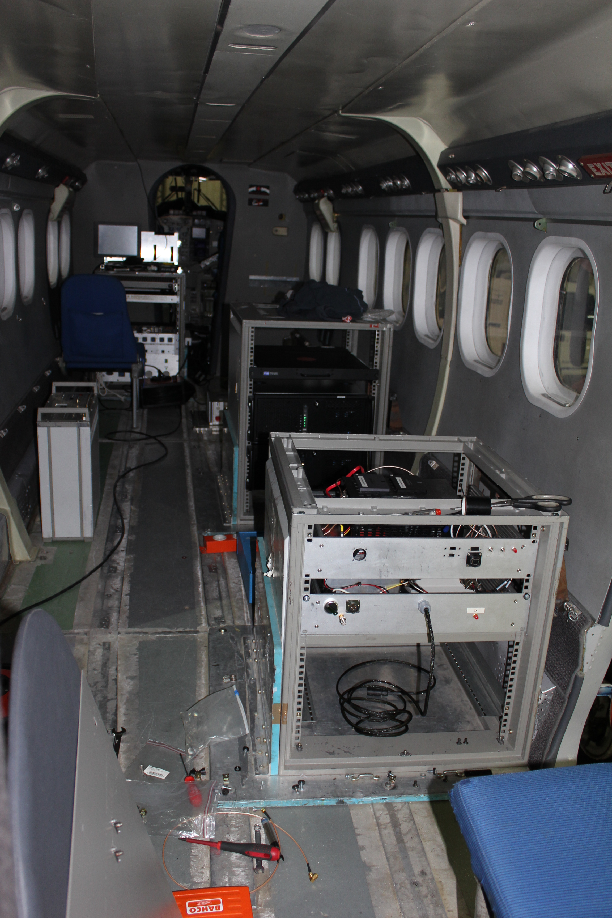
Figure 5: View of cabin in aircraft; Left picture: Rack with Ka-band altimeter (front right), rack for ALS, GPS and INS (rear left). Right picture: iMAR strap-down INS, grey box attached to the floor (lower right).

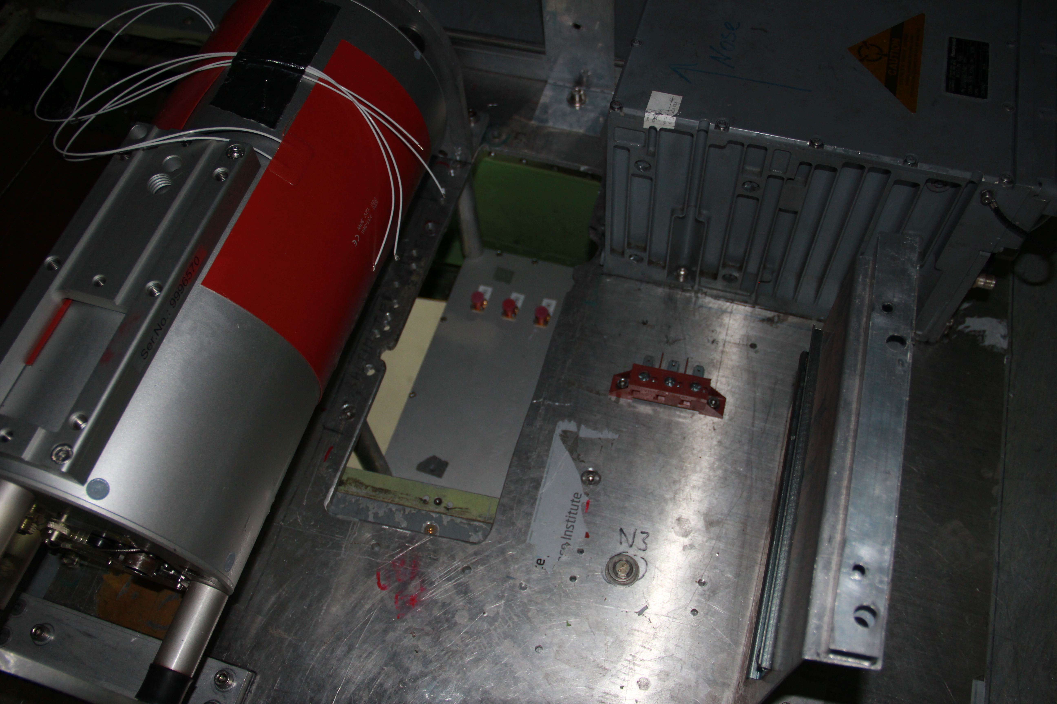
Figure 6: The mount-plate seen from above. The ALS is seen in the lower part of the image just below the Ka-band RF module. The EGI is seen in the upper left corner.

Figure 7: Detail of the KAREN sensor: the new patch antennas allow for a compact installation. Part of the ALS is seen below the KAREN sensor as a bluish window and the GoPro camera to the left. Photo: A. Coccia.

Overview of acquired data

Data from the various instruments were acquired where feasible, considering the limited height range of the ALS system and the weather. An overview of all acquired data is listed in Table 3.

The sampling frequency of the KAREN sensor was set to 25 MHz corresponding to one sampling each ~30cm on the ground. The high sampling frequency results in a large amount of 360 GB of raw data per hour, plus a few MB of navigation data (dedicated GPS/IMU module). Acquisitions have been manually started and stopped by the operator according to the area which was flown; data sets of typically ~10 minutes or ~20 minutes duration have been logged. At the end of the campaign the raw data amount is ~6 TB. During the flight and at the end of each acquisition day a quick data look was performed on randomly selected dataset to assess the quality and eventually adjusting the Pulse Repetition Frequency (PRF) according to the flight altitude.

As described in Section 3, ASIRAS could only measure in in Low Altitude Mode (LAM), due to the decoupling of PC2. This allows flight at an altitude of 300 m, which is within the operational range of the ALS system and a relative low data volume of about 28 GB per hour. A total of 567 GB raw ASIRAS data were collected during the CryoVEx/ICESat-2 2019 campaign. The data were stored on hard discs as ASIRAS level 0 raw data in the modified compressed format (Cullen, 2010).

In general, the ALS worked well. During all flights the last pulse option was used, to avoid internal reflections of the aircraft fuselage due to the limited space. The data volume obtained by the ALS is about 250-300 MB per hour, which is a relative small amount, when compared to the ASIRAS data volume. During the campaign a total of 32.8 GB ALS data was acquired.

The airborne GPS units logged data internally in the receivers during flight, which were downloaded upon landing on laptop PCs. The GPS reference stations listed in Tables 3 are described in further detail in Section 5.1.

Despite the limited space in the instrument bay, it possible to mount a nadir-looking GoPro camera next to the KAREN sensor, however with limited field of view. Additional slant looking GoPro was mounted on a rear window in the cabin. These images were only acquired for sea ice flights. For a more detailed description of images, see Section 5.5.

Table 3: Data acquisition overview from CryoVEx/ICESat-2 2019 campaign
Date | DOY | AIR1 | AIR2 | AIR3 | AIR4 | EGI H-764G | iMAR | ALS | GPS  REF1 | KAREN | ASIRAS | Nadir GoPro | Sidelooking GoPro | Log | Remarks
23-03-2019 | 82a | X | X | - | X | X¹ |  | X | X | X |  |  |  | X
23-03-2019 | 82b | X |  | - | X | - |  |  | - |  |  |  |  | X | No Survey
23-03-2019 | 82c | X | X | - |  | X² |  |  | - |  |  |  |  | X | No Survey
24-03-2019 | 83 | X | X |  |  | X² |  | X | - | X | X |  |  | X
25-03-2019 | 84 | X | X | X | - | X³ |  | X | X⁴ | X | X |  |  | X
29-03-2019 | 88 | X | X | X | - | X |  | X | X | X | X |  |  | X
30-03-2019 | 89a | X | X | X | - | X |  | X | X | X | X |  |  | X
30-03-2019 | 89b | X⁵ | X | X | - | X |  | X | - | X | X |  |  | X
01-04-2019 | 91 | X | X | X | - | X |  | X | - | X | X |  |  | X
04-04-2019 | 94a | X |  | X | - | X² |  | X | - | X | X
04-04-2019 | 94b |  |  | - | - |  |  |  |  |  |  |  |  |  | No Survey
1) Stopped before on ground, probably due to loss of satellites, as the rear antenna cable was out of order
2) In DASIN(dx) or ASIN(dx) or DACOS(dx) or ACOS(dx), DABS(dx).gt.1.0 (dx=-0.1683593620398824d+01). Error occurs at or near line 239 of _MAIN__
3) Screen froze, restart EGI at the beginning of the flight (GAP 8.1741972-8.2612325)
4) Stopped before end of flight at 11:44:59 UTC (On ground 13:35:00)
5) Started 11:15:07.0000 take off 11:03 ?!?
AIR4 was not downloaded as it broke

Data handling

The data processing is shared between MetaSensing (MS), the Alfred Wegener Institute (AWI) and DTU Space. Both KAREN and ASIRAS data are processed using GPS and INS data supplied by DTU Space to ensure a consistent baseline, which is possible as all the instruments are flown on the same platform. GPS differential positioning and combined INS-GPS integration is performed at DTU Space followed by processing of laser distance measurement into elevation above a reference ellipsoid. The KAREN data is primarily processed by MS with input and expert knowledge from AWI. The ASIRAS data was processed by AWI using standard procedures.

GPS and INS data

The exact position of the aircraft is found from kinematic solutions of the GPS data obtained by the GPS receivers installed in the aircraft, see Chapter 3. Two methods can be used for post-processing of GPS data, differential (DIF) processing and precise point positioning (PPP). Whereas the first method uses information from reference stations in the processing procedure, the PPP method is only based on precise information of satellite clock and orbit errors.

A Javad Maxor Receiver (REF1) with internal antenna and logging rate 1 Hz were used as base station. The base station was mounted on DTU Space small tripods (vertical height 12 cm). However, the reference points were generally not marked, and thus the reference stations were not placed at the exact same position for the different flights, and a reference point has to be calculated for each flight. The post-processing of GPS data for both campaigns has just been finalized at DTU Space.

The position and attitude information (pitch, roll and heading) is measured with the Honeywell (H-764G) and iMAR inertial navigation systems. A dedicated GPS-INS is used by the Ka-band altimeter for post-processing.

Airborne Laser Scanner (ALS)

The RIEGL LMS Q‐240i‐60 laser scanner uses 4 rotating mirrors, which results in parallel scan lines on the surface with a maximum scan-angle of 60˚. The ALS operates with wavelength 904 nm, which is expected to reflect on the air-snow surface. The pulse repetition frequency is 10,000 Hz and the ALS scans 40 lines per second, thus the data rate is 251 pulses per line. This corresponds to a horizontal resolution of 0.7 m x 0.7 m at a flight height of 300 m and a ground speed of 250 kph. The across-track swath width is roughly equal to the flight height, and the vertical accuracy is in the order of 10 cm depending primarily on uncertainties in the kinematic GPS-solutions.

The raw logged files with start /stop times are listed in Appendix 11. The ALS data were pre-processed during the campaign to ensure a high quality and to prevent any problems with the instruments.

Calibration of ALS misalignment angles between ALS and INS can be estimated from successive overflights from different directions of the same building, where the position of the corners is known with high precision from GPS measurements. For this purpose buildings in Akureyri and at Station Nord have been measured, see example of overflight of calibration building (called Ebbes Koldhal) in Figure 8. Calibration maneuvers were carried out, as listed below:

• 23-03-2019 DOY 82 Akureyri, Iceland
• 25-03-2019 DOY 84 Station Nord, Greenland
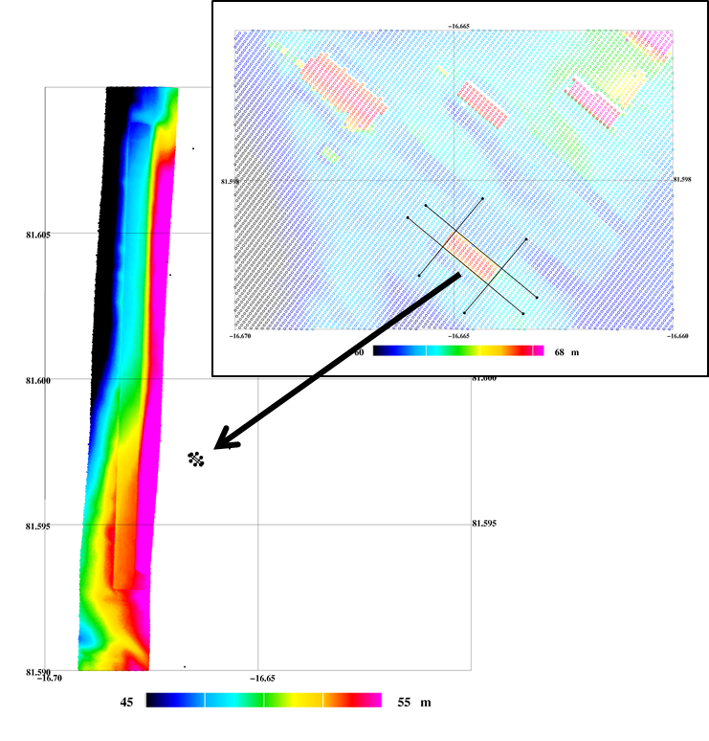
Figure 8: Map of the calibration building and runway at Station Nord measured by ALS on March 25, 2019

ASIRAS

The ASIRAS radar operates at 13.5 GHz with footprint size 10 m across-track and 3 m along-track at a standard flight height of 300 m. The range resolution for ASIRAS is 0.1098m. ASIRAS specifications are provided in Table 4.

An overview of the acquired ASIRAS log-files together with start/stop times, range window and number of pulses are listed in Appendix 12. The raw data has been shipped to AWI for further processing, and GPS/INS data solutions for priority flights March 25 and April 4 (Section 7) are ready and provided to AWI.

Table 4: Specifications of ASIRAS and KAREN at 300m flight altitude above the surface
Instrument | Frequecy (GHz) | Footprint size |  | Range resolution (m)
 |  | Along-track (m) | Across-track (m)
ASIRAS | 13.5 | 3 | 10 | 0.1098
KAREN | 34.525 | 5 | 12 | 0.1650

KAREN

The KAREN airborne instrument is an interferometric frequency modulated continuous wave (FMCW) SAR altimeter working at the Ka-band with central frequency of 34.525 GHz. The sensor operates with FMCW radar modulation in interferometric mode (SARIn), with one transmitting antenna and two receiving antennas. Radiation characteristics of the patch antennas include a gain of 22 dBi and a 3dB aperture of 15° x 4.6° (along track and cross track). The processed multi-looked data corresponds to an along- and across-track footprint size of 5 m (100 looks) and 12 m, when flying at 300 m AGL, respectively. The vertical resolution is 0.1650 m when transmitting 600 MHz of bandwidth (tunable). KAREN specifics are provided in Table 4.
An overview of the acquired data is provided in Appendix 13. The name of each file represents the date and starting time of the acquisition. For each acquisition the file size and some additional notes are given, such as duration of acquisition, altitude of the aircraft during the acquisition and area of interest.
Figure 9 shows some plots generated in-flight during acquisitions for quick-data analysis purposes: raw data, Range Doppler maps and backscattering profiles, for both receiving channels, together with a coherency map are given.

During the campaign, an anomaly has been found on one of the two sampling channels. Within each acquisition after some time one ADC randomly introduced some “out of range” samples (see Figure 10). These were the cause for some deteriorating quality of the data (see Figure 11).

The issue has been solved in the processing phase, by introducing an extra step with respect to the standard processing chain. The aim is to “filter out” the samples out of range in the faulty channel and substituting them with an interpolated value. A comparison analysis on the data collected by the two separate channels showed good results after the correction step has been implemented (see Figure 12).

In Figure 13 an example of KAREN processed profile is given as a reference, acquired on the 25th of March 2019.

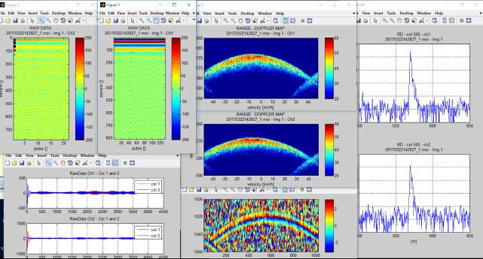
Figure 9: Plots generated during flight for quick check

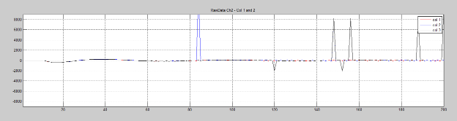
Figure 10: Example of misbehavior of the ADC during one acquisition: out of range samples are arbitrarily introduced in the raw data of channel 2.

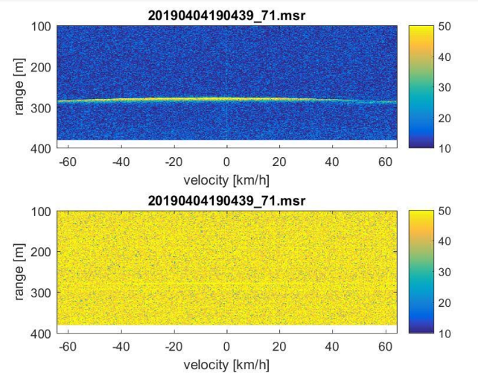
Figure 11: Example of RD maps processed for the two RX channels of KAREN. Top: channel 1 showing the expected behavior. Bottom: channel 2, where the ADC issue was present, showing much higher noise level.

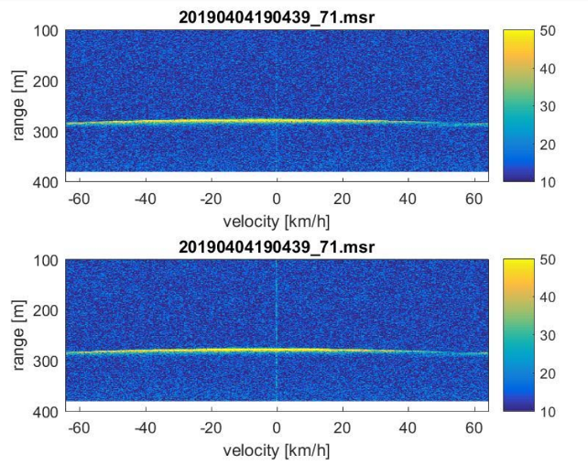
Figure 12: Example of RD maps processed for the two RX channels of KAREN after the filtering of ch2 data. Top: channel 1 Bottom channel 2, both showing the expected behavior.

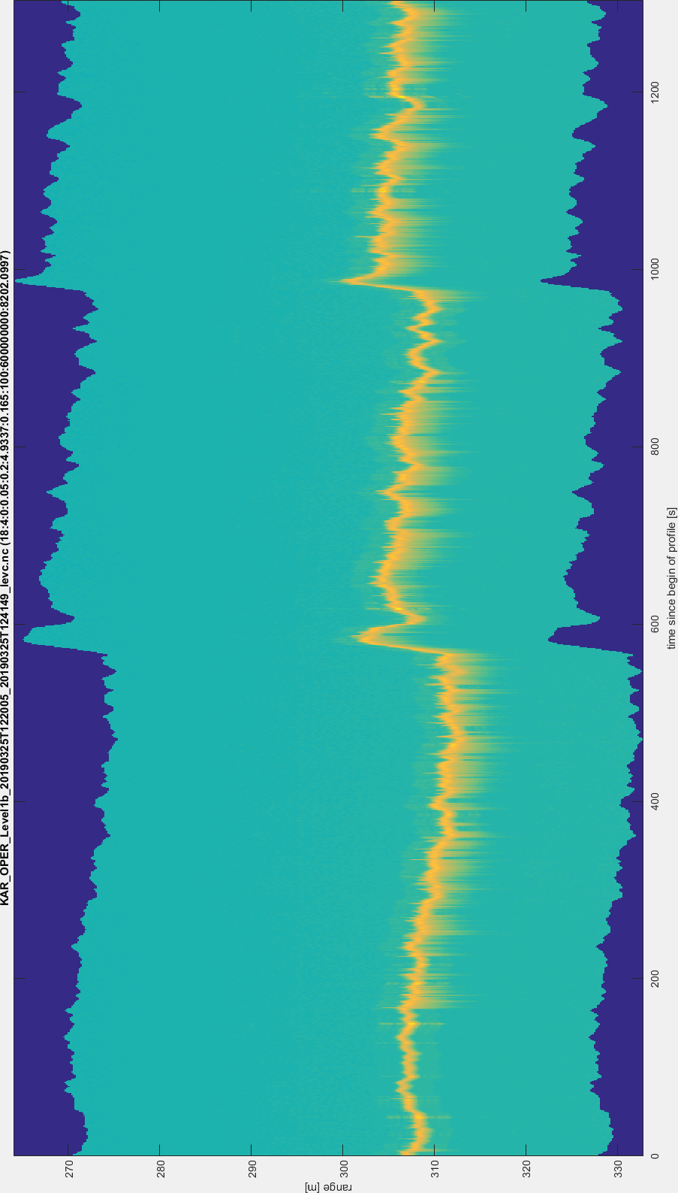
Figure 13: Example of processed waveform from KAREN data, namely KAR_OPER_Level1b_20190325T122005_20190325T124149_levc.nc.

Calibration and absolute heights of ASIRAS and KAREN

To obtain absolute surface heights from ASIRAS and KAREN an offset needs to be applied to account for internal delays in cables and electronics, see Sections 5.4.1 and 5.5.1. As the offset is dependent on the choice of retracker it has not been applied in the final Level 1b processing. The offset is estimated by comparing ASIRAS and KAREN surface heights to surface heights obtained by ALS over a surface, where both the radar and the laser are known to reflect at the same surface. Such measurements are typically obtained by overflights of runways. Different biases apply for the different aircraft installations, see Section 3.

The runway overflights performed during CryoVEx/ICESat-2 2019 campaign is listed below:

- 25-03-2019 DOY 84 Station Nord
- 04-04-2019 DOY 94 Ilulissat, Greenland

Camera

To complement the analysis of KAREN, ASIRAS and ALS data over sea ice high resolution images are collected along the flights. A nadir looking GoPro3 camera was installed in the baggage compartment with limited field of view due to the limited space. A slant looking images were obtained using a GoPro7 camera. The camera was mounted in the rear starboard window in the cabin. During ESA CIMR campaign in March it was found that GoPro7 was more prone to cold temperatures. Both cameras were remote controlled and time tagged using the internal camera clock. By combining the time tag of the images with GPS data the images can be geo-located along the flight lines. An overview of the properties of the cameras is given in Table 5 and examples are shown in Figure 14.

GoPro3, nadir photos
- 23-30/03/2019 → Pics time = UTC+1
- 1-4/04/2019 → Pics time = UTC+2
GoPro7, off-nadir photos (right side w.r.t. flight direction)
- Pics time = UTC

Table 5: Overview of camera types and settings.

Camera type | View | Interval (sec) | Resolution (pixels) | Image size (MB) | Software program | Format
GoPro 3 | Nadir-looking | 5/2 | 2592x1944 | ~1.5 | Alessandro ? | JPEG
GoPro 7 | Slant-looking | 5 | 3000x4000 | ~2.2 | Alessandro ? | JPEG

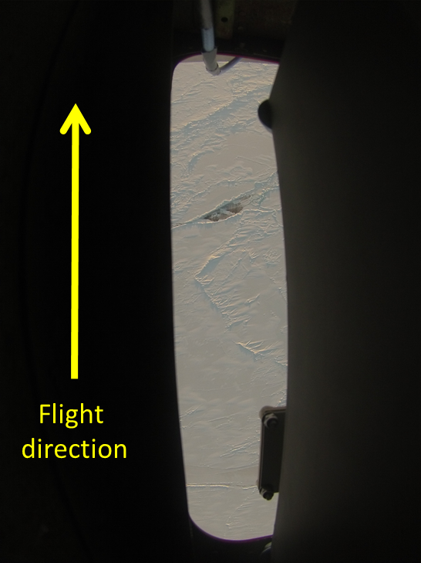 | 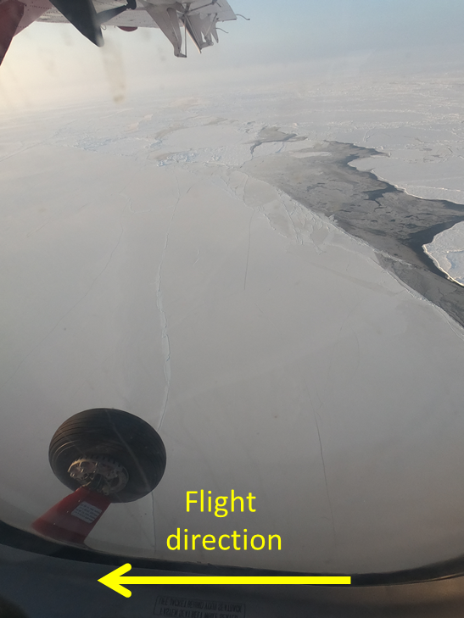
Figure 14: Examples of nadir looking image from GoPro3 (left) and slant-looking image from GoPro7 (right) taking during flight on March 25, 2019.

The EGIG line
The CryoVEx April 2019 land ice field team visited 4 field sites along the EGIG line in Greenland. The overall aim was to sample different snow conditions on the Greenland ice sheet, namely the dry snow zone, the percolation zone, and the ablation zone. The science experiments conducted aim at informing how different snow conditions affect the altimeter echo. These in-situ measurements will help the validation and interpretation of airborne data collected by DTU Space and space-borne altimeters (CryoSat-2, IceSat-2, Sentinel-3 and AltiKa) flying over the EGIG line.

In situ observations
A map of the field sites is shown in Figure 15 below.

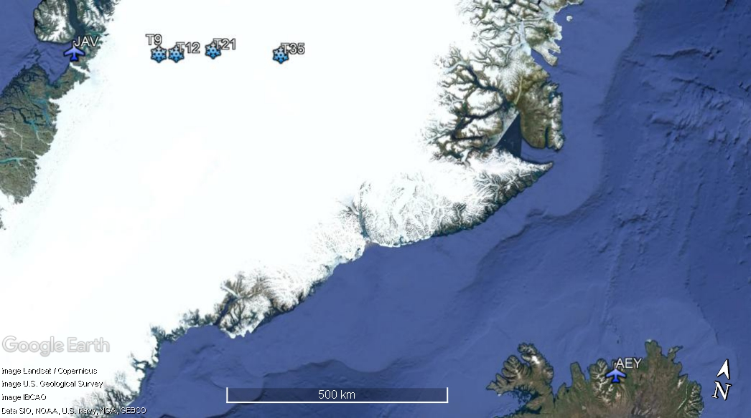
Figure 15: Locations of Airports () and locations on the EGIG-line ().
The information listed below provides a general schedule for the land ice field campaign in Spring 2019 on the Greenland ice sheet (Table 6).

Table 6: Overall schedule of the 2019 campaign
Date | Travel plan
28/03/2019 | IO and AH Leeds to AEY
29/03/2019 | Equipment preparation
30/03/2019 | Flight AEY-CNP-T35-JAV, AS Brussels to JAV, AL CPH to JAV
31/03/2019 | Flight JAV–T12–T9-JAV
01/04/2019 | Bad weather in JAV
02/04/2019 | Bad weather in JAV, AS returns to Leeds
03/04/2019 | Bad weather in JAV
04/04/2019 | Flight JAV-T21-CNP-AEY, IO and AH return to Leeds

The following locations (Table 7) were visited during the field campaign and the experiments conducted at each site are listed in Table 8.

Table 7: Overview of CryoVeX 2019 EGIG site locations
Site | Date | Base station start (UTC) | Base Station stop (UTC) | Latitude  [deg. N] | Longitude  [deg. W]
T9 | 31/03/2019 | 13:49 | 15:35 | 70 01.144N | 46 18.405W
T12 | 31/03/2019 | 11:54 | 13:30 | 70 10.419N | 45 20.761W
T21 | 04/04/2019 | 15:00 | 16:20 | 70 32.611N | 43 01.519W
T35 | 30/03/2019 | 16:15 | 18:00 | 70 57.03N | 39 21.72W

Table 8: Overview of acquired data at the T-sites
Date | Site | GPS | Core | Radar | Magnaprobe | Overflight reflectors
March 30th | T35 | X | X | X | X | -
March 31st | T12 | X | X | X | X | -
March 31st | T9 | X | X | X | X | -
April 4th | T21 | X | X | X | X | X

- Firn cores
Four shallow firn cores to directly measure the density of the top ~3 metres of snow were collected during the 2019 Spring campaign.
A coring system with a drill barrel of 9 cm diameter was used to extract ice cores down to ~6 m to obtain snow density and stratigraphy. Once extracted, the ice cores were stored in an ice core box and were taken to Ilulissat where detailed stratigraphy analysis of the ice cores was performed by illuminating the ice cores and taking photographs to identify the snow and ice layers.

- Magnaprobe
To measure the depth of the first ice layers and investigate the spatial variability of the snow conditions around each sites, snow depth measurements were recorded using the magna probe lent by the Norwegian Polar Institute. The magna probe records the snow depth, GPS position and time of the measurement and can measure a depth up to 120 cm. An example of the data collected is shown on Figure 16.

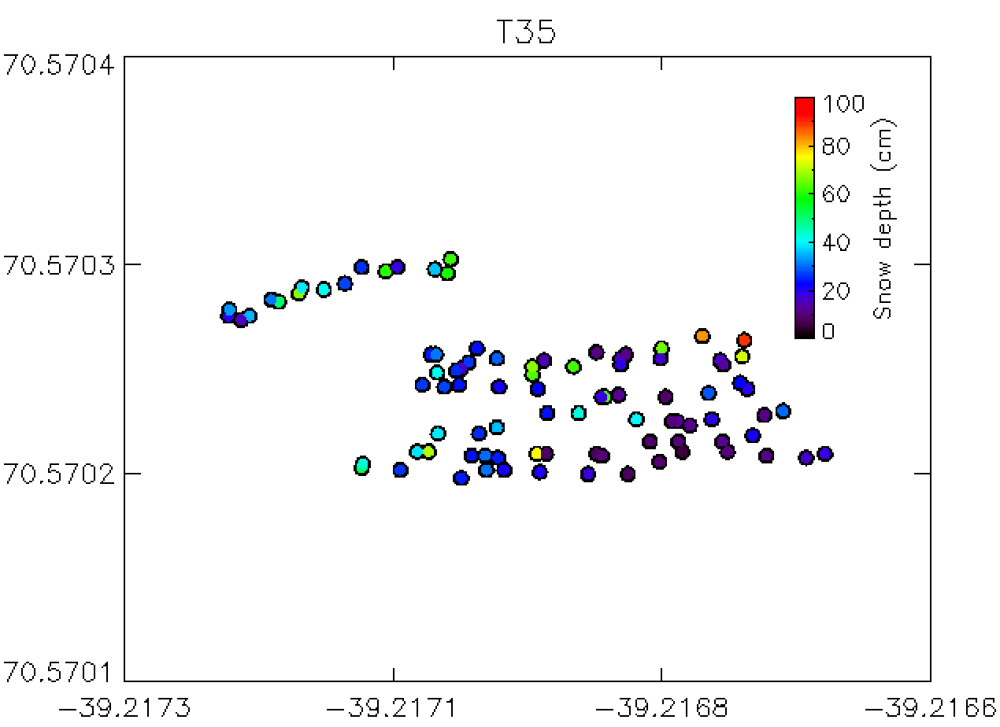
Figure 16: Snow depth measurements recorded with the magna probe at T35

- Radar

Static radar measurements were acquired at each site at both Ka and Ku-band using a radar built by CReSIS and a kinematic test was carried out at T21 over ~1.2 km.

- Corner reflectors
Three corner reflectors (one for Karen and two for ASIRAS) made in aluminum by MetaSensing were laid out on the snow surface to act as a strong surface scattering horizon. Figure 17 below shows the setup of the corner reflectors.
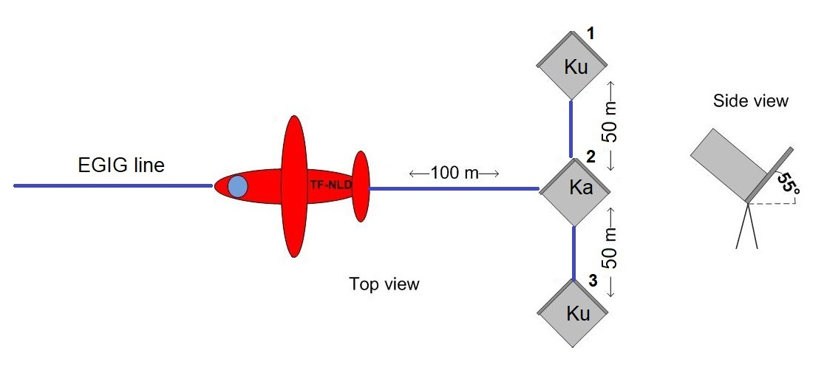
Figure 17: Setup for the corner reflectors overflight
We set the metal plate corner reflectors out at T12 on 4th April 2019. The corner reflector for Ka-band was fixed on a tripod while the two Ku corner reflectors were laid out on the snow. The height above the snow surface at which the corner reflectors were placed is given in Table 9.
Table 9: Corner reflectors site information
Number | Height above snow surface (cm)
1 | -7
2 | +114
3 | +4.5

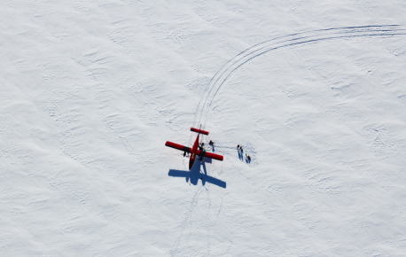
Figure 18: Ground team at work during acquisition over the EGIG line.

Priority flights

Flights on acquired on the EGIG line flight on April 4 and ICESat-2 underflight on March 25 following ICESat-2 orbit #1327 cycle 2 has been given priority to be quickly processed. Both flights include runway overpasses (see Section 5.5). INS and GPS data have been delivered to support KAREN and ASIRAS processing, and first look of ALS data is provided in Figure 15 and 16.

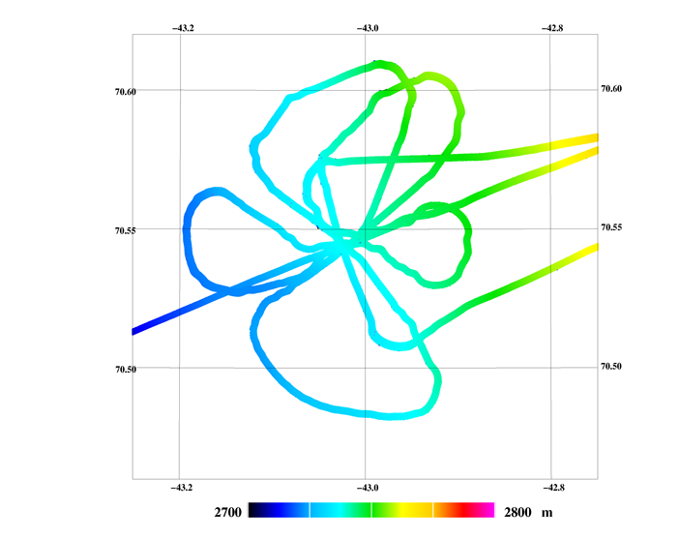
Figure 19: ALS elevations at T21 crossing corner reflectors several times (left) and ground team Twin Otter as seen by the nadir looking GoPro3. Acquired on April 4, 2019.

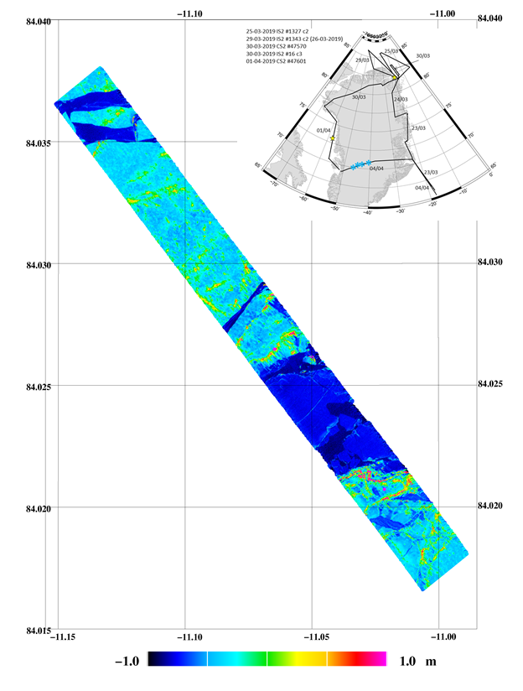
Figure 20: ALS with respect to DTU15 MSS over sea ice following ICESat-2 orbit #1327 cycle 2, acquired on March 25, 2019.

Conclusion

The CryoVEx/ICESat-2 2019 Arctic campaign has for the first time collected data along ICESat-2 ground tracks. Two near-coincident ICESat-2 tracks and two CryoSat-2 ground tracks over sea ice in the Wandel Sea north of Station Nord and in the Baffin Bay were underflown representing different sea ice types and settings. The flights were coordinated with large scale in situ work along the EGIG line on the Greenland Ice Sheet. Due to weather it was not possible to make direct underflights over the Greenland Ice Sheet, but the EGIG line is unique as it has several crossings of multiple altimetry missions including ICESat-2, CryoSat-2, Sentinel-3 and SARAL/AltiKa.

During the campaign data was acquired with MetaSensing’s Ka-band radar KAREN, ESA’s Ku-band radar (ASIRAS) and high-resolution near-infrared airborne Laser Scanner (ALS). Combined GPS and INS post-processed data has been delivered for the priority flights (March 25 and April 4) to support further processing of KAREN, ASIRAS and ALS. First results of post-processed ALS data are of high quality. The consequences of a small issue found during the campaign in one of the two sampling channels of the KAREN instrument have been minimized in the processing phase, at the end the data quality is not different for the two channels.

Despite several weather days the CryoVEx/ICESat-2 2019 campaign was successfully concluded and the data adds unique measurements to validate ICESat-2 and CryoSat-2. The results will assist on-going calibration and validation activities and support decision-making of future dual frequency satellite missions.

References

Cullen, R.: CryoVEx Airborne Data Products Description, Issue 2.6.1, ESA, Ref. CS-LI-ESA-GS-0371, 2010
Hvidegaard, S. M., H. Skourup, J. Wilkinson, R. Ladkin, and R. Forsberg: ICE-ARC airborne campaign 2015 - Data collection and processing report, June 2017.
Hvidegaard, S. M. and L. Stenseng: Test of ASIRAS installation in Air Greenland Twin-Otter. Field Report, National Space Center, 2006
H. Skourup, S. B. Simonsen, A. Coccia, and R. Forsberg: ESA CryoVEx/KAREN 2016 campaign - Airborne field campaign with Ku/Ka-band radar, and laser scanner. Data Acquisition Report, National Space Institute (DTU Space), Technical University of Denmark, February 2017

APPENDIX Operator logs

DOY 082, March 23, 2019: Test flight, CAL AEY

ALS:
EGI aligned
1308 Start taxi
132855 Start scan file
1332 Building overflight N-> S
1335 Building overflight E-> W
1344 Building overflight N-> S
KAREN problems finding satellites
1350 On ground

ASIRAS:
Test on ground ASIRAS (no HPA)

1311 Take off
iMAR looks OK
only GoPro3 at 2s interval
No ASIRAS
1352 Landing

DOY 082, March 23, 2019: AEY-CNP, CNP-DMH

ALS:
1506 Take off AEY
No surveying
AIR2 no satellites
Switch AIR2/AIR4 on rear splitter
1710 On ground CNP

1738 Take off CNP
Running GPS, EGI and iMAR
Very low clouds Walterhausen Glacier – no go
2018 On ground DMH

ASIRAS:
No ASIRAS or
No GoPro

DOY 083, March 24, 2019: DMH-GrIS -STN

ALS:
Before flight changed rear GPS antenna ta splitter cable
AIR4 not working, power connector in GPS broken
AIR3 setup to support ASIRAS

iMAR not logging for 10 min before flight
1539 Take off DMH
1633 on the line (WALTH2-NE2)
163815 New scanner file
1640 ASIRAS logging
173509 New scanner file, set to last pulse TS1
180730 New scanner file, over land
1856 On ground STN

ASIRAS:
Start up with no ASIRAS as AIR4 supporting ASIRAS is not working properly.
Found a difference between PC1 and UTC time (ASIRAS UTC time = ASIRAS PC1 time + 1h 7m 56s). Below, UTC time is used

1535 Take off
iMAR position LED always yellow/red, maybe not aligned for long enough? Or is it expected due to high latitudes?
Only GoPro3 (2s interval)
ASIRAS no calibration
1641 start A190324_00 (ASIRAS)
1739 start 01
1856 Landing

DOY 084, March 25, 2019: STN-IS2(1327c2)-F2-F1-CAL-STN

ALS:
Start up system using ground power
0806 Take off
New scanner file
Navigation system not ok
0810 ICESat-2 passage time
INS frozen – reboot, OK
0848 Navigation system ok
Suspect the power supply to be broken
0903 Some small refrozen leads
091015 New scanner file
0926 Poor visibility N84
Many leads
Strong headwinds
100909 New scanner file
1012 N85° 25 break track
Go to F2
1013 Teardrop
1020 F2
Low thin clouds
1033 Big lead with thin ice
1045 Huge area of thin ice
111100 New scanner file
1216 EOL F1
121615 New scanner file
1259 Crossing icedivide
Rubble field
1308 New scanner file
1316 Runway overflight N -> S
1319 Runway overflight S -> N
1324 Building overflight W-> E
1328 Building overflight S-> N
1335 On ground

ASIRAS:
Found a difference between PC1 and UTC time (ASIRAS UTC time = ASIRAS PC1 time + 1h 7m 58s). Below, UTC time is used

IS2+CS2 sea ice flight

0806 Take off
iMAR position led always yellow/red
Start GoPro3 at 5s interval
ASIRAS no calibration
0815 start A190325_00 (ASIRAS)
0918 start 01
1018 GoPro3 switched back to 2s interval
1018 GoPro7 turned on to 2s interval (found a way to mount it
inside)
1019 start 02
1121 start 03
1221 start 04 (end of record there should be the runaway
overflight)
1319 start 05 (short record, probably not useful)
iMAR files seem to be named from "000" to "007",
instead of date and time, something with the GPS (ask Tim)
1335 Landing

DOY 088, March 29, 2019: STN-IS2(1343c2)-STN

ALS:
1543 Turn on engine
Power off when switching from 1 -> 2 engines
Restart system
1604 Taxi
1610? Take off Station Nord
No measurements on route STN-WP1
174200 New scanner file
1744 WP1
Scanner set to TS1
1747 New scanner file
1759 Transition zone
1801 WP2
1804 The first leads
1817 WP3, some haze
@N85 04.10 clear sky
1833 WP4
1852 WP5, 85N
Teardrop
Measuring WP5-STN
190000 New scanner file
193000 New scanner file
2020 85% battery blinking, “OK” not green
2026 New scanner file
2033 Rubble fields
2044 Land
2058 Fjord ice/sea ice
2125 On ground STN
Stop scanner
Battery dead before download finished

ASIRAS:
ASIRAS UTC time = ASIRAS PC1 time + 5s. Below, UTC time is used

1600 Take off
iMAR position led always yellow/red
1739 Start both GoPros at 2s interval
1740 ASIRAS LAM calibration (_00)
1747 start A190329_00 (ASIRAS)
1855 start 01
1954 start 02
2054 start 03
2119 stop recording
iMAR files back to be named date and time
? Landing

DOY 089, March 30, 2019: STN-IS2(16c3)-CS2(47570)-STN

ALS:
Power system turned off even though ALS, heater and iMAR was switched off
0807 Taxi
0810? Take off
TS1
0819 New scanner file
On CryoSat line
0835 On line IS1-IS2
0844 IS2
0915 Break the line
091700 New scanner file
0920 Crossing line CS2-CS3
@ N83 38.29
0923 On line CS2-CS3
1001 Rubble fields
1015 CS3
1022 Stop scanner
1024 On ground STN

ASIRAS:
ASIRAS UTC time = ASIRAS PC1 time + 6s. Below, UTC time is used

0800 Take off
iMAR position led always yellow/red
0821 Start GoPro3 at 2s interval
0822 ASIRAS LAM calibration (_00)
0824 start A190330_00 (ASIRAS)
0828 Start GoPro7 at 5s interval, internal GPS option enabled
0916 turn back, tear drop towards second line
0923 start 01
0945 iMAR message "status of IMU invalid has changed" (x2)
0948 PC1 crash, restarted (coincident with Alex switching off
Karen, although shouldn’t be related)
0951 start 02
1016 stop recording
1017 Landing LAM calibration (_01)
1022 stop GoPro3
1025 stop GoPro7
1025 Landing
1030 GPS off right after landing, rack battery didn't work!
1030 iMAR stop recording, as no GPS available

DOY 089, March 30, 2019: STN-HAGF2-NORT6-NORT1-TAB

ALS:
1054 System on
1101 Taxi
1103 Take off
113800 New scanner file
1144 HAGF2
1207 NORT6
Teardrop
1210 NORT6 crossing
1219 NORT5 close to nunatak
1221 Land
123700 New scanner file
1306 NORT4
Drifting snow on surface
133900 New scanner file
1411 NORT3
1433 NORT2
144100 New scanner file
1507 85% Battery blinking on power rack
1522 NORT1
1529 Of the ice, stop survey
1604 On ground TAB

ASIRAS:
1105 Take off
iMAR position led always yellow/red
No GoPros, land ice
1140 ASIRAS LAM calibration (_02)
1141 start A190330_03 (ASIRAS)
1141 No GPS signal for ASIRAS, check software and cables,
ASIRAS and PC1 restarted (found out it was a faulty cable connection)
03 and 04 records not valid
1154 start 05
1256 start 06
1402 start 07
1508 start 08
1528 start 09 (very short and out of range window,
probably not valid)
1530 Landing LAM calibration (_03)
1531 ASIRAS off
? Landing
? GPS off right after landing, pilot suddenly shut off power
and rack battery didn't work!
? iMAR stop recording, as no GPS available

DOY 091, April 1, 2019: TAB-CS2(47601)-JAV

ALS:
1230 Engine on
1239 Taxi
1245 Take off
134915 New scanner file
1351 CS1
1418 First thin leads
1421 Frost flowers
1426 Huge area of thin ice
1439 CS2
144230 New scanner file
1448 CS2 passing @ N73° 16 W57° 52
1530 CS3
1534 Snow
1538 Climbing ~600m
1546 Descending ~300m
154800 New scanner file
1610 Break the line @ N70° 22
Right turn
1612 Crossing the line C3-C4
1613 Inbound JAV
1614 Stop surveying
1715 On ground JAV

ASIRAS:
ASIRAS UTC time = ASIRAS PC1 time + 8s. Below, UTC time is used

1220 Start iMAR logging, but PC went in stand-by (no aircraft power available and power rack battery down + could not get in the aircraft due to refueling operations)
1230 iMAR GPS on, logging should be good from here on
1245 Take off
iMAR position led switches between green, yellow and red
1348 ASIRAS LAM calibration (_00)
1351 start A190401_00 (ASIRAS)
13:53 Start GoPro7 at 5s interval, internal GPS option enabled
13:54 Start GoPro3 at 2s interval
14:54 start 01
15:30 start thick clouds
15:37 climbing to ~700m
15:54 start 02
16:09 stop recording
16:10 Landing LAM calibration (_01)
16:24 stop GoPro7
16:25 stop GoPro3
17:15 Landing

DOY 094, April 4, 2019: JAV-EGIG(T1-T41)-CNP

ALS:
In situ team on ground at T21, Corner reflectors 5 crossings

1550 Engine on
1620 Taxi
1613 Take off
161530 New scanner file
1628 Runway overflight SW-NE
On route T1
163730 New scanner file
1702 T1
Off the line by 2.5km
Aligning for T9
1720 T9, on the line
In situ team landed @T21
1729 T12
1736 T15
173800 New scanner file
1741 T17
1747 T19
1752 T21, in situ site
1755 Crossing CR
1759 Crossing CR
1804 Crossing CR
1809 Crossing CR, tail 2 nose
1813 Crossing CR
1827 T21 en route T35
1849 Speed increased to 150kn
1856 No GPS signal rear antenna
Loose connection in splitter
1858 GPS signal rear splitter OK
1859 T35
A bit off track, aligning
1911 T41
Stop surveying
On ground

ASIRAS:
ASIRAS UTC time = ASIRAS PC1 time + 15s. Below, UTC time is used

1600 start iMAR logging
1610 Take off
iMAR position led mostly green
No ASIRAS calibration
1615 start A190404_00 (ASIRAS)
1628 stop ASIRAS (local flight)
1632 start 01 (transition water/ice)
1635-41 sudden steep topography variations (out of range window several times + 2s of saturation)
1642 Karen starts logging
1729 start 02
1752 start maneuvers to align for overflight
1752 Start GoPro3 at 0.5s interval (T21, ground team overflight in G0041880-1917)
1803 Start GoPro7 video (T21, got a tiny piece of NLC and ground team, ~25s)
Second pass, manual video (got a tiny piece of NLC and ground team, ~40s)
? overflight is ~4km off track, check record 02. Aircraft turned back to survey again
1827 start 03 (right before getting on the right track for overflight)
1913 Landing LAM calibration (_00)
? Landing
No power at landing, only 5 minutes iMAR post-processing

DOY 094, April 4, 2019: CNP-AEY

No surveying

APPENDIX Overview acquired ALS data

 | DOY | File name | Start (dechr) | Stop (chr) | Comments
18-03-2017 | 082 | 082_130800.2dd  082_132900.2dd | 13.13393  13.47513 | 13.34241  13.74312 | Calibration AEY
18-03-2017 | 083 | 083_163815.2dd  083_173500.2dd  083_180730.2dd | 16.63725  17.58337  18.12506 | 17.56607  18.03125  18.52612
18-03-2017 | 084 | 084_081020.2dd  084_091115.2dd  084_100900.2dd  084_111100.2dd  084_121615.2dd  084_130800.2dd | 08.18467  09.17064  10.14981  11.18313  12.27060  13.13315 | 09.15750  10.12831  11.17075  12.26000  13.12330  13.48232 | Calibration STN
18-03-2017 | 088 | 088_174200.2dd  088_174700.2dd  088_190030.2dd  088_193000.2dd  088_202600.2dd | 17.70006  17.78340  19.00819  19.50008  20.43347 | 17.74628  18.99878  19.48661  20.40989  21.42017 | No data
18-03-2017 | 089 | 089_081930.2dd  089_091700.2dd  089_113800.2dd  089_123700.2dd  089_133900.2dd  089_144100.2dd | 08.32522  09.28340  11.63339  12.61676  13.65005  14.68342 | 09.27402  10.37259  12.60863  13.64059  14.67297  15.52387
18-03-2017 | 091 | 091_134915.2dd  091_144230.2dd  091_154800.2dd | 13.82088  14.70840  15.80007 | 14.69705  15.78888  16.23511
18-03-2017 | 094 | 094_161530.2dd  094_163730.2dd  094_173800.2dd | 16.25835  16.62507  17.63343 | 16.56138  17.62186  19.24944 | Runway JAV

APPENDIX Overview of acquired ASIRAS data

Date | File name | Start time (UTC) | End time (UTC) | Range window (m) |  | # Pulses
23-03-2019 | A190323_00.log | 13:17:34 | 13:18:06 | 90.00 |  | 75000
24-03-2019 | A190324_00.log  A190324_01.log | 16:41:53  17:40:35 | 17:40:35  18:00:37 | 90.00  90.00 |  | 8799942  2999980
25-03-2019 | A190325_00.log  A190325_01.log  A190325_02.log  A190325_03.log  A190325_04.log  A190325_05.log | 08:15:29  09:17:08  10:18:59  11:21:51  12:21:07  13:19:13 | 09:17:08  10:18:59  11:21:50  12:21:07  13:19:12  13:21:59 | 90.00  90.00  90.00  90.00  90.00  90.00 |  | 9242443  9272439  9422439  8884942  8709943  412498
29-03-2019 | A190329_00.log  A190329_01.log  A190329_02.log  A190329_03.log | 17:47:56  18:55:11  19:54:25  20:54:06 | 18:55:11  19:54:25  20:54:06  21:19:37 | 90.00  90.00  90.00  90.00 |  | 10084933  8879940  8947439  3822474
30-03-2019 | A190330_00.log  A190330_01.log  A190330_02.log  A190330_03.log**  A190330_04.log**  A190330_05.log  A190330_06.log  A190330_07.log  A190330_08.log  A190330_09.log | 08:24:06  09:23:55  09:50:36  11:44:08  11:47:16  11:53:44  12:56:17  14:03:00  15:08:58  15:28:56 | 09:23:54  09:43:55*  10:15:56  11:47:16*  11:47:16*  12:56:16  14:02:59  15:08:58  15:27:54  15:29:04 |  | 90.00  90.00  90.00  90.00  90.00  90.00  90.00  90.00  90.00  90.00 | 8964945  ?  3797475  0  0  9374939  10002433  9892433  2834981  15000
01-04-2019 | A190401_00.log  A190401_01.log  A190401_02.log | 13:51:37  14:54:40  15:54:50 | 14:54:39  15:54:50  16:09:54 |  | 90.00  90.00  90.00 | 9449939  9022440  2254986
04-04-2019 | A190404_00.log  A190404_01.log  A190404_02.log  A190404_03.log | 16:15:54  16:32:38  17:29:08  18:27:11 | 16:28:52  17:29:07  18:27:10  19:11:26 |  | 90.00  90.00  90.00  90.00 | 1942488  8467445  8702441  6634955
* measurement log file corrupted, time retrieved from file
** record corrupted, no available data

APPENDIX Overview of acquired KAREN data

Table 10 - Acquisition overview of the 23rd of March 2019 over Akureyri.
# | Bw [MHz] | Notes
20190323133143 | 600 | Calibration tracks over the airport
20190323133558
20190323134335

Table 11 - Acquisition overview of the 24th of March 2019, transfer flight to Station Nord.
# | Bw [MHz] | Notes
20190324164403 | 600 | Short
20190324164609 |  | 10 mins
20190324165706 |  | 10 mins
20190324171040 |  | 20 mins
20190324173457 |  | Short
20190324173556 |  | 20 mins
20190324175658 |  | 3 mins

Table 12 - Acquisition overview of the 25th of March 2019, local flight over sea ice from Station Nord.
# | Bw [MHz] | Notes
20190325081555 | 600
20190325082323
20190325083531 |  | 10 mins
20190325084603 |  | 10 mins
20190325085627 |  | 5 mins
20190325090113 |  | 30 mins
20190325093228 |  | 30 mins
20190325100411 |  | 8 mins
20190325102531 |  | 20 mins
20190325104635 |  | 10 mins
20190325105733 |  | 33 mins
20190325113140 |  | 20 mins
20190325115426
20190325122005 |  | 20 mins
20190325124937 |  | 17 mins
20190325131551 |  | Calibration track over runway

Table 13 - Acquisition overview of the 29^{h} of March 2019, local flight over sea ice from Station Nord.
# | Bw [MHz] | Notes
20190329170349 | 300 | HAM mode at ~1700 m AGL
20190329170614 | 200
20190329170930 | 200
20190329171401 | 300
20190329172505 | 150
20190329174802 | 600 | 15 mins
20190329180406 |  | 20 mins
20190329182434 |  | 20 mins
20190329184443 |  | 8 mins
20190329185521 |  | Short
20190329185808 |  | Crossing line
20190329190056 |  | 10 mins
20190329191152 |  | 10 mins
20190329193435 |  | 20 mins
20190329200121 |  | 30 mins
20190329203754 |  | 10 mins
20190329205852 |  | 10 mins

Table 14 - Acquisition overview of the 30th of March 2019, local flight over sea ice from Station Nord.
# | Bw [MHz] | Notes
20190330082709 | 600 | 5 mins
20190330083206 |  | 30 mins
20190330090441 |  | 12 mins
20190330092421 |  | 10 mins
20190330093425 |  | Short
20190330094951 |  | 8 mins
20190330095940 |  | 15 mins

Table 15 - Acquisition overview of the 30th of March 2019, transfer flight to Thule AB.
# | Bw [MHz] | Notes
20190330114422 | 600 | 24 mins
20190330121050
20190330121238 |  | 5 mins
20190330121726 |  | Short
20190330121951 |  | 33 mins
20190330130011 |  | 5 mins
20190330130714 |  | 30 mins
20190330133814 |  | 10 mins
20190330134851 |  | 20 mins
20190330140847 |  | 12 mins
20190330142019 |  | 20 mins
20190330143058 |  | 10 mins
20190330145253 |  | 20 mins
20190330151424 |  | 10 mins
Table 16 - Acquisition overview of the 1st of April 2019, transfer flight to Ilulissat.
# | Bw [MHz] | Notes
20190401135314 | 600 | 20 mins
20190401141331 |  | 10 mins
20190401142336 |  | 21 mins
20190401144442 |  | 10 mins (satellite overpass)
20190401145456 |  | 10 mins
20190401150508 |  | 20 mins
20190401152531 |  | 15 mins, AC climbing for weather conditions
20190401154011 |  | Short
20190401154332 |  | Short
20190401154635 |  | 20 mins
20190401160719 |  | Short

Table 17 - Acquisition overview of the 4th of April 2019, EGIG line to Constable point.
# | Bw [MHz] | Notes
20190404161623 | 600
20190404161949 |  | Satellite overpass
20190404163219
20190404164359 |  | 10 mins
20190404165949 |  | 10 mins – T1
20190404171004 |  | 3 mins
20190404171259 |  | T9 - 10 mins
20190404172323 |  | 5 mins
20190404172843 |  | 20 mins – T12
20190404174840
20190404175505 |  | Passes over survey team on ground
20190404575919
20190404180347
20190404180852
20190404181230
20190404181321
20190404182726 |  | 30 mins
20190404190039 |  | Short
20190404190439 |  | Short

