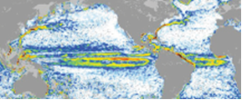

GOCE++ Dynamic Topography at the coast and tide gauge unification
GOCE ++ DYCOT

TITLE.

D6 – Technical Note describing the work performed in WP3000.

Authors

Ole B. Andersen,
Rory Bingham
Luciana Fenoglio
Chris W Hughes

ESTEC Ref: ITT AO/1-8194/15/NL/FF/gp "GOCE++ Dynamic Topography at the coast and tide gauge unification”- Coordinator: Ole B. Andersen (DTU)

DOCUMENT CHANGE LOG
Rev. | Date | Sections modified | Comments | Changed by
1 | 23-02-2017 | All | Draft | Ole B. Andersen
2 | 26-02-2017 | WP3100  References |  | Chris W. Hughes
3 | 07-03-2017 | WP3300 |  | Luciana Fenoglio

Contents
Dynamic Topography along the coast Introduction 3
WP3100 Dynamic Topography along the coast 4
3.1.1 Tide gauge variations and comparison with altimetry. 4
3.1.2 Ocean model mean dynamic topography characterization. 11
3.1.3 Case study of MDT derived from tide gauges in Australia 14
3.1.4 Initial results for a global tide gauge MDT calculation. 18
3.1.5 A proposed method to determine a coastal MDT using tide gauge data. 20
WP3200 Mean Dynamic Topography and GOCE 23
3.2.1 Coastal MDT omission error 23
3.3.2 Geoid and MSS errors 43
3.2.3. Geodetic coastal MDT 51
WP3300 Coastal Altimetry and MSS accuracy 69
3.3.1 Comparative assessment of coastal and geodetic MDT along the coast of Norway. 69
3.3.2 Enhanced coastal MDT using Cryosat-2 SARin in Norway 72
3.3.3 Enhanced coastal MDT using Cryosat-2 LRM data in Australia 74
3.3.4 Comparative assessment of coastal and open ocean SAR and PLRM Altimetry from CryoSat-2. 79
References 87

Dynamic Topography along the coast Introduction

This technical report summarizes the work on Work package 3 within GOCE+++ and report on determination of Dynamic Topography along the coast and at global tide gauges.

A novel method based on the ESA GUT project to determine MDT along the coast from the newest GOCE release will be tested, and compared with strategies using combined GOCE/GRACE/in-situ gravity. An investigation into the MSS error along the coast from altimetry will be performed. Relative offsets between tide gauge records will be sought

WP3100 DT along coast
WP3200 MDT and GOCE
WP3300 Coastal altimetry

The work performed within WP3400 (Connecting Tide Gauges) and WP3500 (Sea Level Trend) will be reported in Deliverable D7.

WP3100 Dynamic Topography along the coast

The aim of this work package is to use a combination of ocean model analyses and comparisons between tide gauge and satellite altimeter data to assess the nature of coastal dynamic topography variations and make recommendations concerning how to incorporate tide gauge measurements into a global mean dynamic topography estimate. We also make tide gauge estimates for one of our chosen areas (Australia) using a variety of geoids, and an initial global estimate using a single geoid. Finally, we produce a recommended methodology to apply once the parallel developments are complete.

The work undertaken in this work package falls into four subsections, described in more detail below. These are
- Tide gauge variations and comparison with altimetry.
- Ocean model mean dynamic topography characterization.
- Case study of MDT derived from tide gauges in Australia.
- Initial results for a global tide gauge MDT calculation.
Following these subsections we end with a synthesis subsection in which we summarize what has been learnt and make recommendations for the final stage of the project.

3.1.1 Tide gauge variations and comparison with altimetry.

In this subsection we focus not on the MDT but on the time-dependent variations. There are two reasons for looking at these. First, we need to know whether the tide gauge dynamic topography is representative of a large region or is a purely local measurement (this can be as a result of the position of the tide gauge, for example up a river or in a semi-enclosed bay, or it may simply be that the tide gauge data are poor quality). Second, as an alternative to using ocean models, we can use long-term variations at tide gauges as a proxy for the mean dynamic topography in order to investigate natural scales of variability along the coast. This is imperfect, as it is not clear that the nature of the variability at accessible time scales (in practice interannual to just about decadal) represents the same physics as that which is responsible for spatial variations in MDT, but it is nonetheless a useful guide.

In order to assess the relationship between tide gauges and altimetry we consider all tide gauges in the Permanent Service for Mean Sea Level (PSMSL) Revised Local Reference (RLR) dataset (http://www.psmsl.org). We identify all tide gauges (a total of 1007 sites) with data overlapping the precise satellite altimetry period 1993 to present (in practice to the end of 2015). Using monthly mean values, we apply an inverse barometer correction to make the resulting time series compatible with satellite altimetry. This is determined either from the ERA-Interim reanalysis product (http://www.ecmwf.int/en/elibrary/8174-era-interim-archive-version-20), monthly mean sea level pressure on a ¼ degree grid, interpolated to tide gauge locations, or the Dynamic Atmosphere Correction (DAC), which is a barotropic ocean model forced by atmospheric pressure and wind stress from the same meteorological analysis, reverting to simple inverse barometer correction at periods longer than 20 days. Although this does not mean that monthly mean values in the DAC are precisely equivalent to the simple IB correction, we find that they are extremely similar with both DAC and IB analyses explaining very similar fractions of the variance of the tide gauge data. For this reason, we will focus only on the DAC-corrected product, which is also the product used to correct the altimetry data.

For each tide gauge we seek the altimeter record (from the AVISO gridded absolute dynamic topography) within 300 km which, when supplemented by a trend, annual and semiannual cycle, explains the largest fraction of variance in the tide gauge record. All subsequent diagnostics are shown with DAC correction applied, seasonal cycle removed, and a trend added to the altimetry to make it match the tide gauge trend. Plotting the tide gauge and altimetry data together gives a good feel for the variability and its representativeness of the open ocean. Clearly it is not practical to show all these plots (though all have been inspected), but a few are shown here as examples.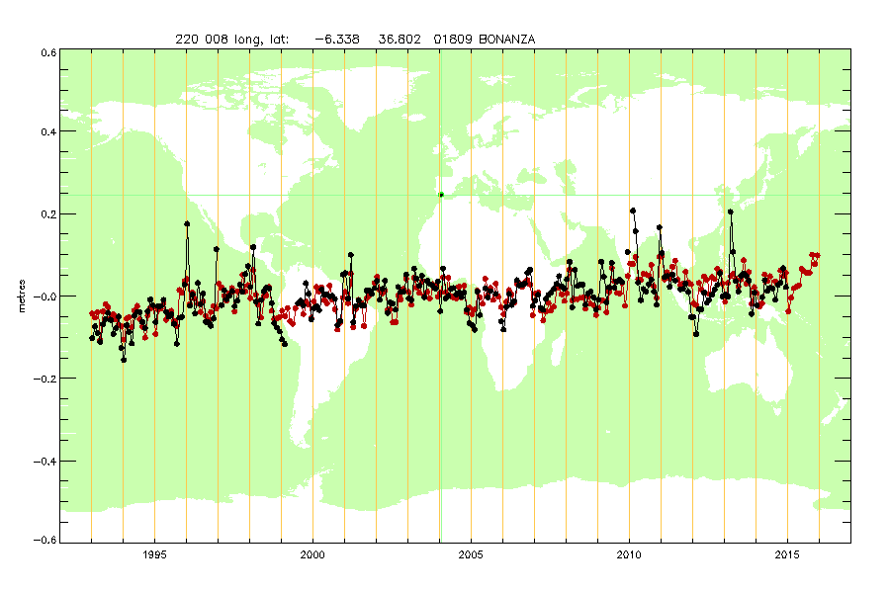
Figure 1: Monthly mean sea level record from tide gauge (black) and from altimetry (red), after removing DAC correction and seasonal cycle, and adding a trend to the altimetry to match the tide gauge trend. The tide gauge name (PSMSL) is Bonanza, shown as a green dot on the map, and altimetry is taken from the point marked by the black spot.
The Bonanza tide gauge (Fig. 1) shows a typical example, with good but not excellent agreement with the altimetry. In contrast, the next tide gauge in the list (Sevilla-Esclusa) shown in Fig. 2 shows much higher variability, and much poorer agreement with satellite altimetry. On closer inspection the reason becomes obvious: the gauge is more than 70 km from the sea along a rather narrow river, so is unlikely to be representative of the open ocean (Bonanza is at the mouth of the same river).

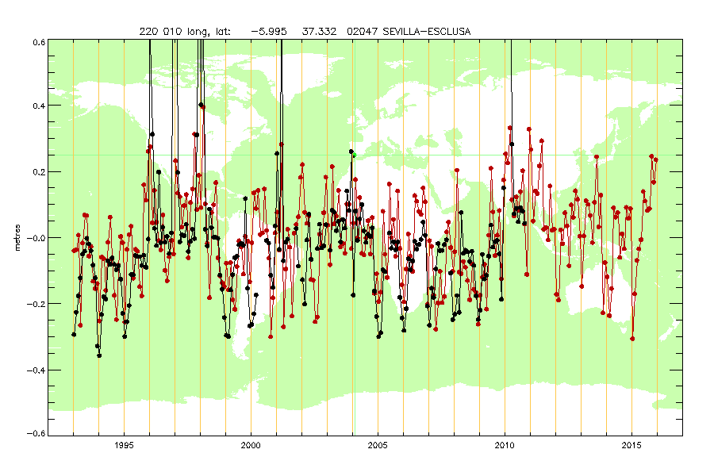
Figure 2: Same as Figure 1, but showing the Sevilla-Esclusa tide gauge and best correlated altimetry (scaled).
Another, rather different example is found in Japan. A series of gauges along the east coast of Japan show rather similar and small variability, the last in this sequence being Aburatsubo (Figure 3). The next tide gauge, Kaminato II (Figure 4) shows much greater variability. Unlike Sevilla-Esclusa, however, Kaminato II agrees well with the altimetry dataset. Again, closer inspection reveals the reason. Kaminato II is on a small island which is sufficiently far offshore that the Kuroshio current meanders to either side of the island, producing very large sea level jumps (around 0.8 m) as it crosses the island. Some other islands show related behaviour, whereas others are sufficiently close to the mainland coast that they behave almost as if they were part of the mainland.

These comparisons highlight the value of comparing with altimetry, and this is certainly valuable qualitative information to help understand particular cases. However, if we are to incorporate tide gauge data into an MDT estimate, we need a quantitative overview of the tide gauge/altimetry comparison. To this end, we calculate two quantities for each tide gauge: percent variance explained by altimetry (Figure 5), and standard deviation of the residual after the altimetry has been subtracted from the tide gauge (Figure 6). The former is a measure of how representative the tide gauge record is of nearby ocean (though it should be borne in mind that disagreement can in some places be a result of poor altimetry data in the coastal zone). The latter is an upper limit on the tide gauge error for a single month of measurement (one standard deviation), with 5-year mean values expected to be better by an amount that depends on the spectral content of the variability (the best possible would be a factor of $\sqrt{60}≈7.75$).

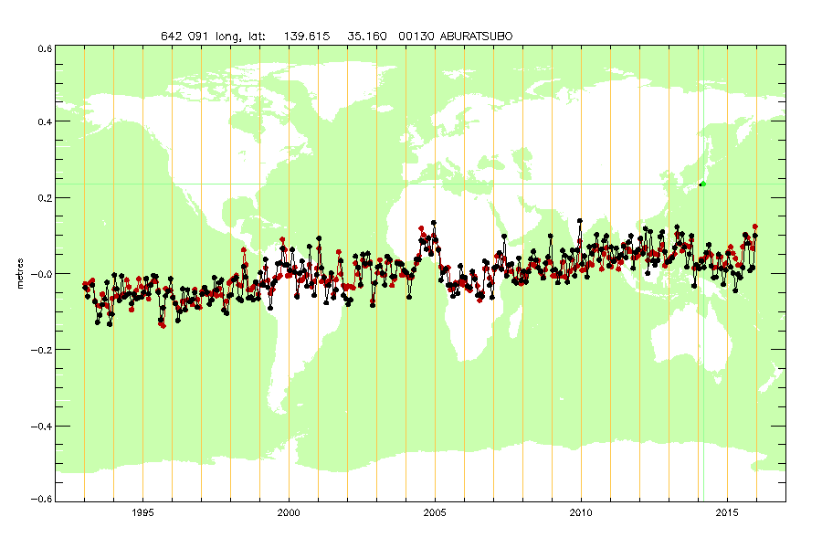
Figure 3: Same as Figure 1, but for Aburatsubo tide gauge in Japan.
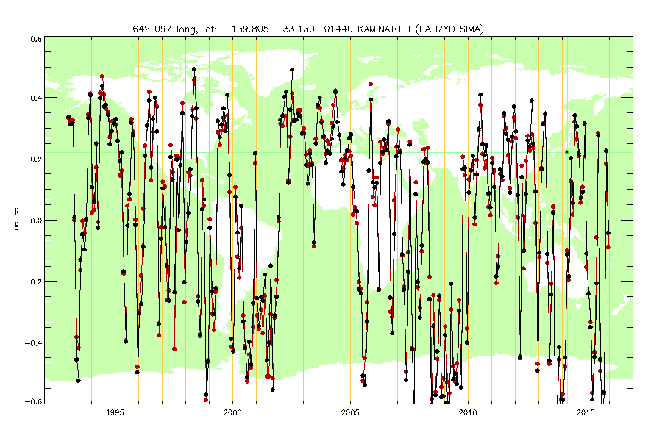
Figure 4: Same as Figure 1, but for Kaminato II tide gauge.
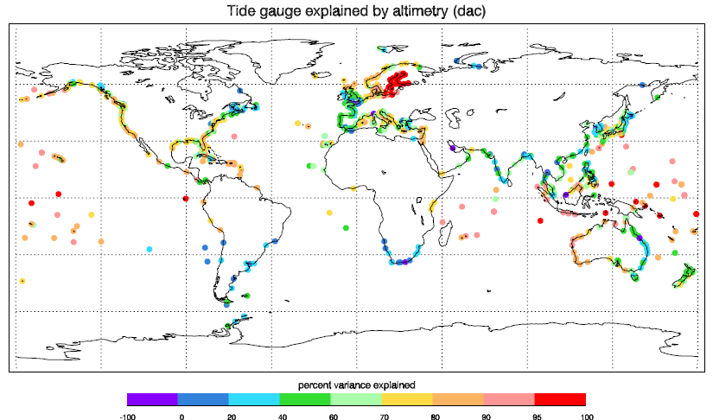
Figure 5: Percent variance of tide gauge data explained by satellite altimetry
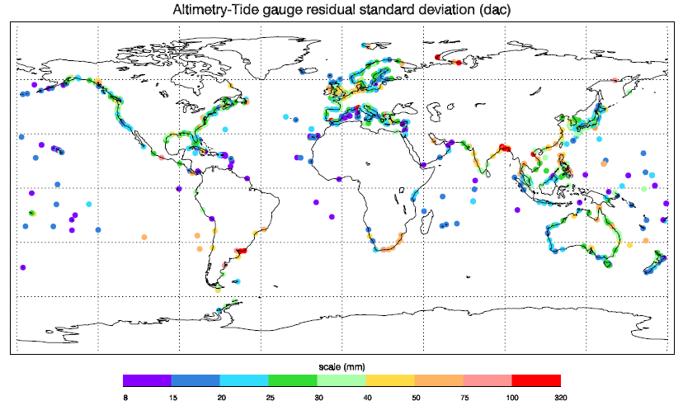
Figure 6: Residual standard deviation at each tide gauge after DAC correction, seasonal cycle, trend and open ocean (altimetry) signal have been accounted for.
Some features are worth highlighting in these figures. The very high variance explained in the Baltic results in a residual standard deviation of less than 40 mm despite the high initial variance in this region. Many tropical islands also very high variance explained and very low residual standard deviations (often less than 15 mm). Sevilla-Esclusa stands out as having a very high residual variability, and Kaminato II has very high variance explained, but still significant residual variability (> 75 mm).
Some other regions of high residual variability also have clear explanations. Genova II (NW Italy) is a clear error in the tide gauge data (this has been reported to PSMSL and has subsequently been corrected). Two points in Siberia are associated with extremely gappy altimeter records, and the cluster in the northern Bay of Bengal include some tide gauges which are far from the ocean (Calcutta, Tribeni), and others (e.g. Cox’s Bazaar) for which there is no obvious explanation (although the PSMSL documentation does show a history of difficulties for that tide gauge). There is no obvious reason for the disagreement in the broad River Plate estuary (Uruguay) or in Hon Ngu (Vietnam).

Low explained variance and fairly high residuals (> 50 mm) are also apparent on the east coast of South Africa, where the strong, narrow Agulhas western boundary current flows very close to the coast. This may be a case of limitations in the ability to map the altimetry data sufficiently close to the coast, though tide gauge problems may also be an issue. Similarly, the variance explained is systematically higher in Western Australia than on the east coast, where the East Australian Current flows close to the coast, and residuals are also higher on the east coast (> 50 mm at Mackay, but generally 25-40 mm).

The reasonable explanations found in most cases show that this comparison can be used to derive a measure of “quality” for each tide gauge. It is important to recognize, however, that we are using the term only in the sense of the tide gauge being representative of the broader ocean, so that it is meaningful to use it as part of an along-coast extrapolation/interpolation. In some cases the tide gauges will not be representative of the ocean because of data quality problems. In other cases, the data are of good quality, but are representing a very local process.

A second method of assessing the tide gauges is to look at the coherence of variability from one tide gauge to another. This accounts for the possibility that there may be signals which are coherent along the coastline, but quite different from those a short distance offshore (as in those western boundary currents which are pressed close to the coast).

Since this study does not require the coexistence of altimetry data, it can use tide gauge data from further into the past. Here we use a start date of 1979 (the limit of the ERA-Interim dataset). This longer time series also allows more focus on long time scales, accordingly we look at running annual averages rather than monthly mean values.

To look at along-coast coherence, we use the PSMSL coastline and station numbers to order the tide gauges. This is not a perfect ordering, though it does generally follow the global coastline in a logical order starting in Siberia, then passing round Europe, Africa, Asia, Indonesia, Australia, Pacific Islands, and the American continent (north to south along the west coast, then north again on the east coast), as shown in Figure 7.

In order to account for the imperfect ordering, we calculate correlations between each tide gauge and the 10 gauges surrounding it in order. Figure 8 shows all of these correlations (dots), and the best for each gauge (black line), together with the separation in that best case (red line, right hand scale).

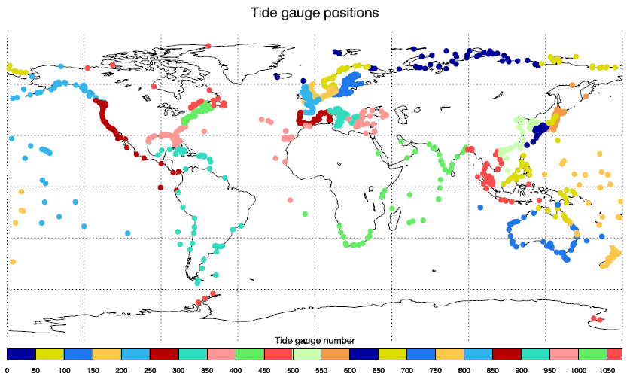Figure 7: Position of tide gauges ordered by PSMSL coastline and station number. The ordering starts with Arctic Russia, then follows the European, Africa, Asian, Indonesian and Australian coasts, then Pacific islands, then Pacific Americas, then Atlantic Americas, ending with Greenland and Antarctica.
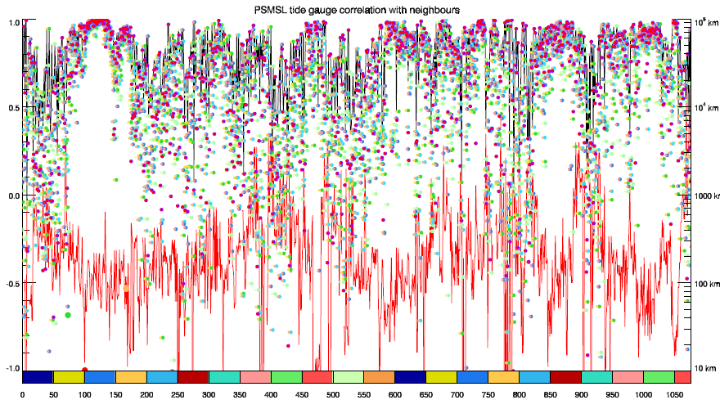
Figure 8: Correlation between running annual means of tide gauge records and their 10 neighbours (dots). Black line shows the best of these at each tide gauge. Red line shows the corresponding separation (right hand scale).
These correlations reveal a highly heterogeneous picture. There are patches of very high correlation, e.g. in the Baltic (around gauge number 100-150), parts of Japan (around 600), and much of the US and Canadian coasts (around 850 and 950-1050), as well as quite high correlations throughout much of Europe (about 60-390), and these generally correspond to closely spaced tide gauges, but there are also examples of high correlations with very distant spacing, and of low correlations between closely-spaced pairs of gauges. Again, this is indicative of instances of highly local variability interspersed among strongly-correlated regions.

Australia (around 690-750) is an interesting example. Although the strongest correlations are limited to the later end of this range, corresponding to Western Australia, there are still many strong correlations toward the earlier end of the range where the East Australian Current plays a role, suggesting a significant coherence along this eastern coast despite the very short length scales in the offshore direction.

3.1.2 Ocean model mean dynamic topography characterization.

We have gathered together estimates of the MDT from 7 ocean models at resolutions varying from 1 degree to 1/12 degree as described in report WP1300D2 of this project. Annual means have been calculated for the years 1993 up to the last year available in the model run (between 2007 and 2015 depending on the model). In addition, the 5-year mean for our standard reference period (2003-2007 inclusive) has been calculated, and that is the product we will consider here.

Spatial-and-time-mean values in these models are effectively meaningless and, although there may be some interest in the time variation of the spatial means, this is generally unreliable and unhelpful to retain when comparing between models and comparing models with observations. Accordingly, the spatial mean is removed for each field which has global ocean coverage (excluding isolated seas such as the Caspian Sea, which is masked out).

Some fields do not have global coverage, for example lacking an Arctic. In these cases, rather than remove the spatial mean over a different domain (which would introduce a significant bias), the spatial mean of the difference relative to one of the complete models (ECCO2) is subtracted. Removing the “mean” in this way requires the models to be on the same grid, so this step is performed after the regridding step described below.

All models are regridded onto a common grid at 1/8 degree resolution in latitude and longitude (grid cells are centred on the point 1/16 of a degree from the prime meridian and poles, and at 1/8 degree steps from that point). In order to retain as much as possible of the effect of model resolution, this regridding is performed in a manner which ensures that all coastal ocean points on the 1/8 degree grid are derived only from model coastal points, unless there is no model land within a model grid spacing of the true coast (e.g. in the case of islands which are not resolved by the model).

In more detail, the regridding is performed in two steps. All interior (i.e. non-coastal) points on the 1/8 degree grid are filled by bilinear interpolation from the model native grid. For this step, the model data are expanded with a one grid-point fringe of extra ocean data over land points, filled with the average of neighbouring ocean MDT values.
In the second step, coastal values at 1/8 degree are calculated. This is done by eliminating all non-coastal data from the model, then expanding the coastal strip of model data in both directions by averaging neighbouring values, with care taken not to import values from the opposite side of any land bridges. Bilinear interpolation of this expanded coastal strip is then used to fill all coastal values on the 1/8 degree grid. This method guarantees that the information at the regridded coast all comes from the model coast, an important consideration given the strong dynamical constraints on MDT slopes along the coast.

Having calculated these MDTs on a standard grid, we now need to assess how they can be used to help constrain coastal MDT variations derived from observations. Conventionally, this would be done by calculating lagged autocorrelation functions along the coast as input to an interpolation algorithm. Here, though, the heterogeneity of the dynamics precludes the use of a single autocorrelation function for the whole coast – it must be a different function at each position. Such an autocorrelation function could, in principle, be calculated from a sufficiently large ensemble of models, but there is too little variation in patterns in our ensemble even if we were willing to treat the coarse resolution models as equivalent to the finest resolution models.

Instead of calculating a true autocorrelation function, we calculate a proxy for such a function by looking at how far one has to travel from each coastal point in order to find an MDT which differs from the reference point by some threshold value. We choose thresholds of 1, 2, 4 and 8 cm as representative of the expected size of measurement error. This allows us to calculate such distances for each model. We calculate the distances in two ways. In the first case we find the distance to any point beyond the threshold, and in the second case we allow only coastal points. Distances in the second case are therefore constrained to be at least as large as in the first case.

Figure 9 shows the resulting distances plotted as ellipses surrounding each coastal grid point, for the case of the NEMO12b model, and with a threshold of 2 cm. Pink ellipses represent case 1, and are plotted on top of the blue ellipses of case 2 (the elliptical shape approximately accounts for the latitude-dependent distortion of zonal distances on the latitude-longitude projection used).

The result is quite informative concerning the natural length scales of coastal MDT variability. In general, it shows that alongshore variations (blue) have longer characteristic length scales than offshore variations (pink), (they must be at least as long, but are often much longer). This is particularly clear for the western coasts of South America and South Africa. On the east coasts of South Africa and Australia, both scales are short but the offshore scale is reduced to a single grid point, indicating the value of the coherence in the alongshore direction.

The US east coast is particularly interesting, as there are two pinch points in the alongshore length scale. The first, half way up Florida, is the expected position of the Gulf Stream-related step. The second, a little north of Cape Hatteras, is suggestive of a few points with a locally different MDT, rather than a sustained step in MDT.

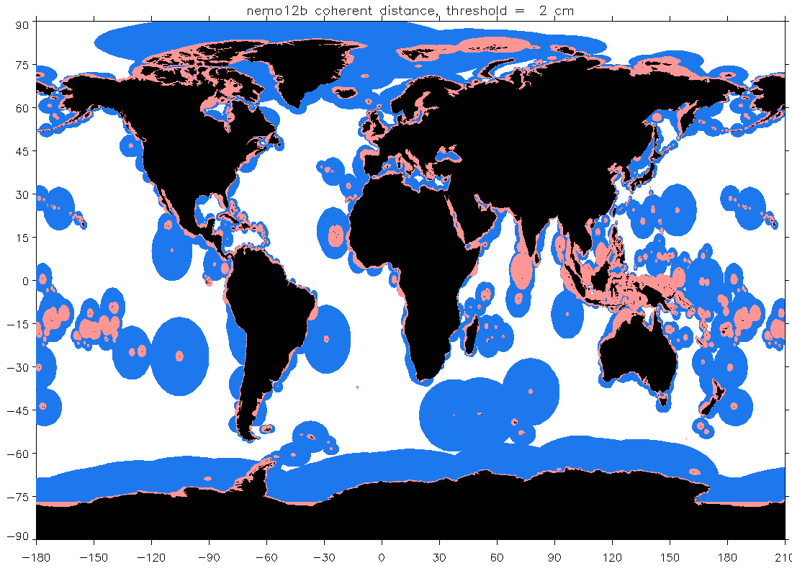
Figure 9: Coherence distances to a threshold of 2 cm MDT change (see text for description) for the NEMO12b model. Distances along the coast are shown in blue, and distances in arbitrary directions (indicative of the offshore scale) in pink.
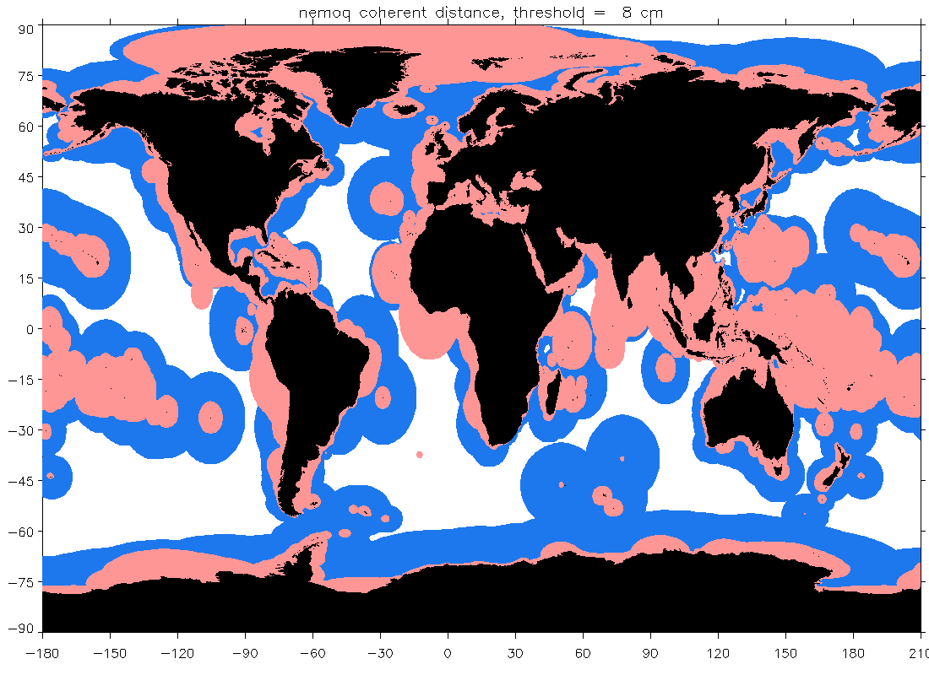
Figure 10: Coherence distances to a threshold of 8 cm MDT change (see text for description) for the NEMO12b model. Distances along the coast are shown in blue, and distances in arbitrary directions (indicative of the offshore scale) in pink.
Figure 10 shows the same as Figure 9, but with a threshold of 8 cm. For the most part this expands all the scales as might be expected, but it is interesting to see how the offshore scale remains at only 1 grid point for eastern Australia and South Africa. This highlights the need to resolve a very narrow coastal strip in these regions, suggesting that tide gauge measurements may be particularly valuable in these regions.
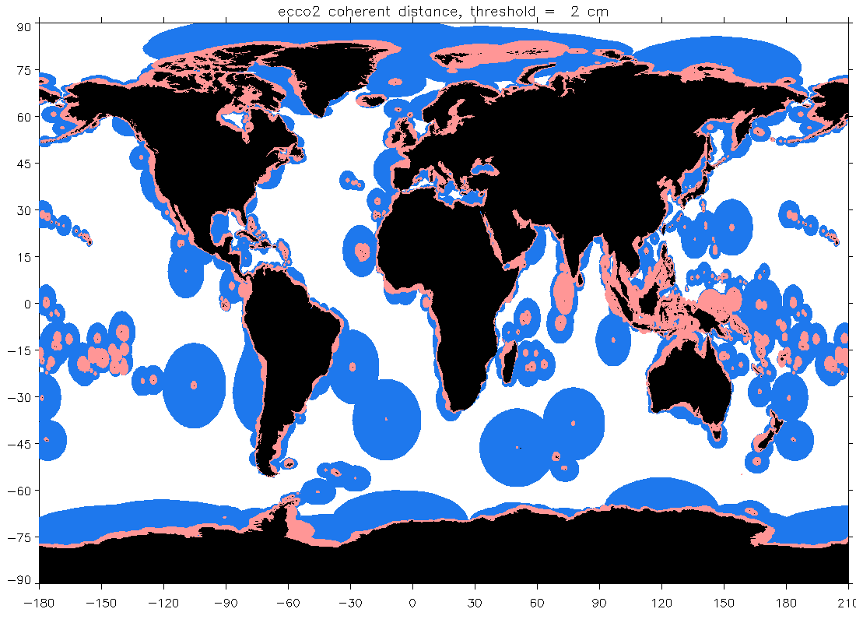
Figure 11: Coherence distances to a threshold of 2 cm MDT change (see text for description) for the ECCO2 model. Distances along the coast are shown in blue, and distances in arbitrary directions (indicative of the offshore scale) in pink.
Finally, Figure 11 reverts to the 2 cm threshold, but now for the ECCO2 model (this has approximately 18 km resolution, in comparison to the 9 km or less of NEMO12b). It is reassuring to see the similarity of many features between these very different models, which suggests that this lower resolution result is also valuable (the value of the 1 degree models is much more questionable, as they often cannot resolve the length scales derived from these finer resolution models).

3.1.3 Case study of MDT derived from tide gauges in Australia

As an initial test of newly-acquired data, we have focused on one of the project’s selected regions: Australia. The main results summarized here are documented in more detail in Filmer et al. (2017), a paper submitted to the Journal of Geophysical Research.

Vertical coordinates of 32 tide gauges have been identified using collocated GPS measurements. The positions of these tide gauges are shown in Figure 12.

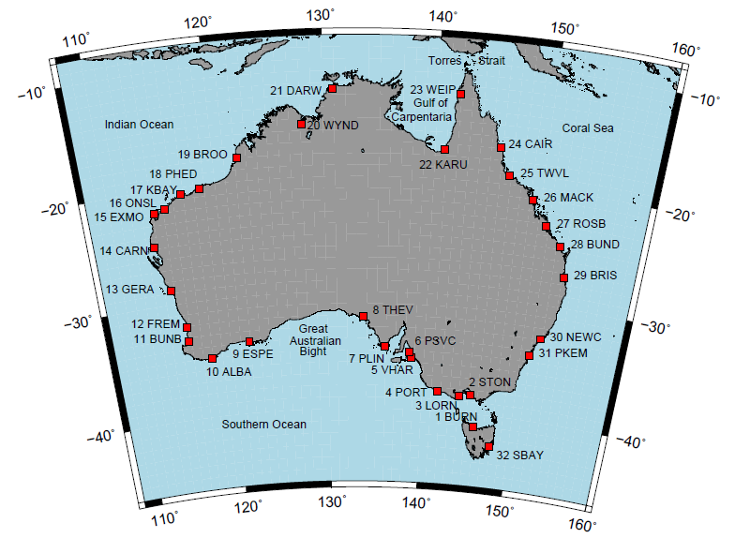
Figure 12: Positions of 32 tide gauges at which a calculation of MDT is possible, together with numbering system and abbreviated names.
The focus here is on variations in MDT around the coast, so in all plots, the mean value has been set to the same constant value. The standard reference period of 2003-2007 inclusive has been used, but tide gauge measurements for other periods have also been investigated and they show that values averaged over our reference period are typically within 20-30 mm of the 19-year mean (1993-2011 inclusive), with a standard deviation of 12 mm (other 5-year periods produce larger differences, with a greatest difference at any one tide gauge of 93 mm).

MDTs from a wide range of ocean models have been collated, together with the latest AVISO absolute dynamic topography and an MDT derived from the CARS climatology (a purely steric sea level computed where the ocean depth is 2000 m or greater, and extrapolated to the coast). These MDTs, all averaged over the standard 5-year reference period, are shown in Figure 13. The typical range among models is about 100 mm at any one tide gauge, and the models also show a similar degree of smoothness between nearby tide gauge positions. The obvious exception is in the Gulf of Carpentaria (gauges 22, Karumba and 23, Weipa), where the model spread is notably larger.

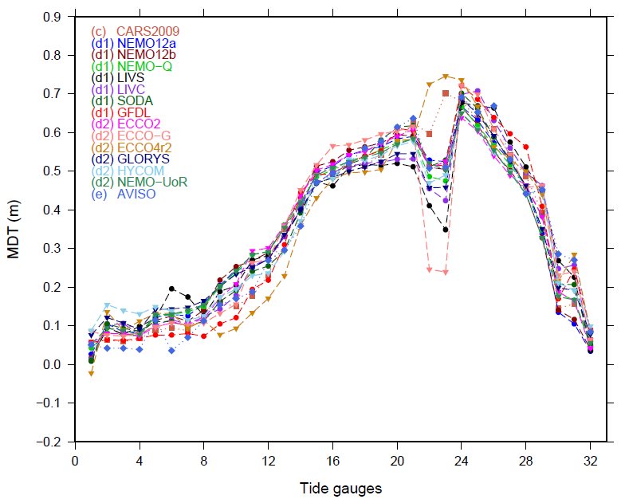
Figure 13: MDTs at Australian tide gauges from the CARS climatology (squares), ocean models independent of geodetic measurements (d1, circles), models incorporating geodetic measurements (d2, inverted triangles), and the AVISO MDT (diamonds).
The Gulf of Carpentaria is part of a broad, shallow shelf region where large sea level signals result from local wind stresses. It is very distant from the nearest CARS data point, and close to the Torres Strait, which is extremely shallow (a sill depth of 7 m, and shallower than that for much of its width). Two of the ocean models (ECCO-G and LIVC) actually have land bridges across the Strait, and it seems clear that the models are sensitive to the details of friction/barriers in the Strait and probably also to the applied wind stresses in this region.

In order to calculate MDT from the tide gauge data, the geoid at the tide gauge or GPS position is required. Here, we use three different geoids: EGM2008 (Pavlis et al., 2012; 2013), the Australian AUSGeoid09 (AGQG2009, Featherstone et al., 2009), and the TUM13 geoid (Fecher et al., 2015) supplemented with EGM2008 beyond degree 720. The resulting MDT values are shown (stars) in Figure 14. In addition, the figure repeats some curves from Figure 13, and adds an MDT determined from the TUM13 geoid and DTU10 mean sea surface (after correction to the standard reference period).

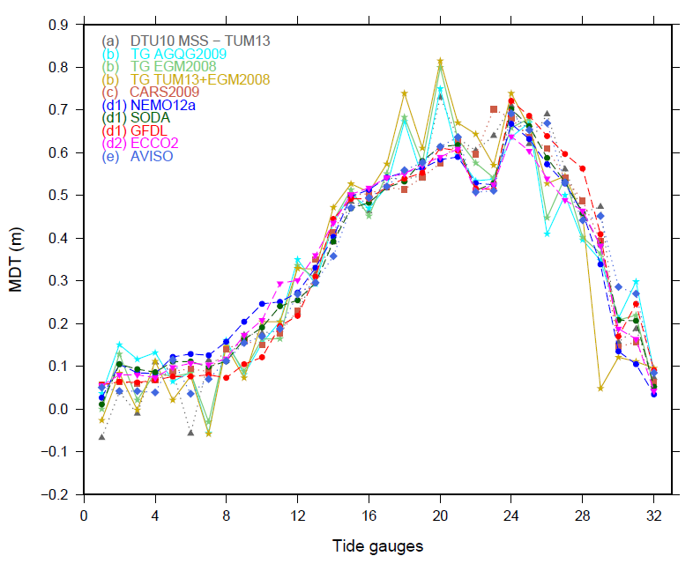
Figure 14: MDTs at Australian tide gauges as measured by tide gauges in combination with GPS and geoid data (stars), and by subtracting a geoid from the mean sea surface determined from altimetry (triangles). Some of the curves from Figure 13 are also repeated for context.
It is clear that the tide gauge results agree in general pattern with the models, but that the curves based on the tide gauges are much more jagged. Differences from the model curves have standard deviations of 70-80 mm (100 mm for TUM13, the difference clearly being mainly due to the discordant value at gauge 29, Brisbane, which should be investigated further).

Generally, the DTU10-TUM13 result is smoother and closer to the model results than the tide gauge results, although there are exceptions such as at gauge 6 (Port Stanvac), and gauge 20 (Wyndham). Wyndham is interesting in that it agrees with the tide gauge result. This may indicate a genuine MDT signal which is unresolved by the ocean models, since Wyndham is in a narrow estuary far from the coast, though that would imply that the DTU10 mean sea surface is also good in this region. The idea that the MDT at this gauge is decoupled from the nearby ocean value is consistent with the increased residual variability seen at this gauge (Figure 6), although that is still only between 40 and 50 mm for monthly mean values. Alternatively, the agreement on the size of the spike may be a result of common geoid errors, though this would imply that those errors are at degrees below 720 rather than at the highest degrees, which is unusual.

In the case of Port Stanvac, investigation of the mean sea surface has shown that it does not have data close to the coast in this region, as a result of limitations in the tidal model used, a deficiency which can be rectified in the latest mean sea surface.

Another gauge showing a spike is number 26 (Mackay) which has also been noted as having higher residual variability than other gauges, though there is no obvious reason for this (it is behind the Great Barrier Reef, but so are Townsville and Cairns, which both have lower residual variability).

Other large spikes are at gauges 7 (Port Lincoln) and 18 (Port Hedland). Although these are in a bay and an inlet respectively, this is not unusual and they do not show particularly high residual variability. Overall, although the oceanographic information suggests that some of the spikes may be at places with increased importance of local dynamics, the most likely explanation for spikes of this size must be errors in the small-scale geoid, though the case of Wyndham remains an interesting exception where the smallest scales of the geoid cannot be the issue, and local ocean dynamics is more likely to be an issue than elsewhere.

A final point worth making concerning this analysis is that the combination of good agreement with models at many positions, and large disagreements at others, is suggestive of an error distribution which is not a normal distribution, but has significantly broader tails. This is a plausible result of either geoid errors, which can have quite different sizes in different regions, or of blunders in deriving the tide gauge coordinates. Although every effort is made to avoid the latter, the complexity of the audit trail required to correctly identify tide gauge coordinates from a wide range of measurement types, levelling campaigns, and multiple tide gauge datums, means that occasional blunders are almost inevitable. In deriving a coastal MDT incorporating tide gauge data, statistically robust method must be used which makes it possible to reject clearly anomalous measurements.

3.1.4 Initial results for a global tide gauge MDT calculation.

Mean ellipsoidal heights of sea level have been calculated at 301 tide gauge positions using a combination of tide gauge measurements, datum information, and GNSS positioning data. The 5-year means are inverse-barometer corrected, and any large gaps have been filled using the nearby best-fitting altimetry data as used in Figures 1-6 (with trends and annual cycles removed and replaced based on valid tide gauge data). The resulting heights, calculated in the Tide-Free system as us usual in GNSS processing, have been converted to the Mean Tide system for comparison with models and altimetric measurements.

As an initial test of MDT calculation, the Eigen6-c4 geoid has been calculated at each tide gauge position using the full degree 2190 spherical harmonic expansion, again translated into the Mean Tide system. The resulting MDT values are plotted in Figure 15 (circles). The background to this figure is the Aviso MDT for the same period, with a mean value shifted so that the median difference at tide gauge positions is zero.
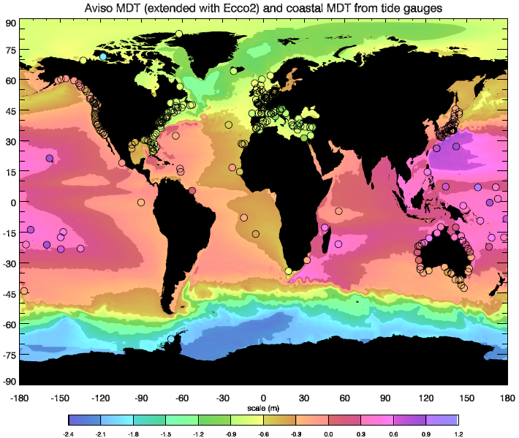
Figure 15: MDT at tide gauges (circles) using the Eigen6-c4 geoid, against a background of the Aviso MDT for the same period (extended with the Ecco2 model MDT over ice-covered regions, the Black Sea and the Baltic). Model and Aviso mean values have been changed so that the median difference at tide gauges is zero.
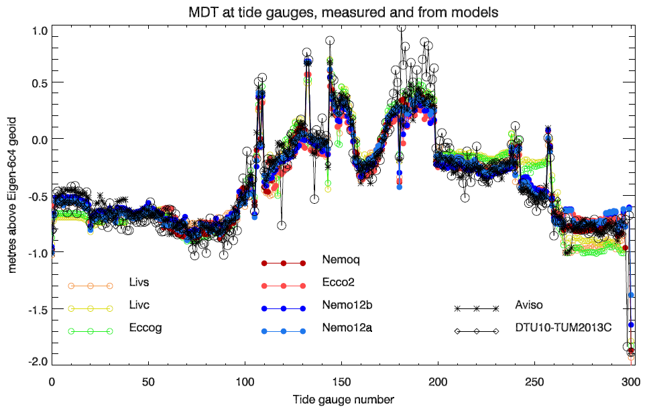
Figure 16: MDT at tide gauges as in Figure 15 (black circles), compared with the nearest coastal point from a variety of models. Tide gauge ordering is as in Figure 7.
At high latitudes, and in the Black Sea and Baltic, the Aviso data are missing. In these regions, the map shows the Ecco2 model MDT with a similar datum shift to match the median tide gauge values.

It is clear that the broad pattern of the MDT is captured well, with particularly good agreement along the continental and Japanese coastlines, including the small number of African points. Many Pacific islands appear to be too high in the tide gauge MDTs, a systematic bias likely to be a result of the similar small scale geoid structures on these large seamounts. Arctic and Antarctic tide gauges also agree well with the Aviso/Ecco2 values, with the exception of Ulukhaktok (formerly Holman) tide gauge on Victoria Island (just north of the Canadian mainland), for which the tide gauge value appears to be too low by about 1 m.

A better sense of the level of agreement is given by Figure 16, which compares the tide gauge MDT with all seven ocean models, and also the Aviso MDT and an MDT derived from the DTU10 mean sea surface and the TUM2013C geoid. Here, the high bias of Pacific island gauges (180-198) is particularly clear. Otherwise, the conclusions are generally similar to the case of Australia: large scale patterns are good, but the tide gauges show more “jitter” in MDT values (spikes which occur in both tide gauge and model MDTs result from sudden changes in position, e.g. to a distant island).

Root-Mean-Square differences are between about 14 cm and 18 cm depending on the field used, with the data-based MTDs and the finer resolution models coming out better, though the comparisons are not fair at this stage as not all tide gauges are represented in all fields (e.g. the data-based fields and coarse resolution models lack Arctic data). The spikiness, and the Pacific island bias, again suggest a non-Gaussian distribution.

The model curves clearly form two groups, with the coarse resolution models (Livs, Livc, Eccog) generally agreeing with each other, and differing from the finer resolution models which tend to follow the data better. A particularly clear example of this is in the Gulf of Mexico (244-254) and along the Atlantic coast of the US and Canada (260-295).

We stress that these are only preliminary results, with a single geoid, and no attempt to check for procedural errors following this initial calculation. The results are encouraging, but need to be investigated in more detail before concrete conclusions can be drawn.

3.1.5 A proposed method to determine a coastal MDT using tide gauge data.

The above analyses present a consistent, but complex picture of how tide gauges represent the MDT. Here we offer a recipe for using this information to produce a coastal MDT while taking errors into account.

A priori errors on the tide gauge MDT are unknown. The patchwork of information which constitutes the extension of geoid models beyond the satellite-resolved range up to degree ~200 makes it very difficult to assess the errors due to this unresolved range (expected to be about 30 cm RMS on a global mean, if no additional data are used, but in reality very dependent on region, and significantly smaller than 30 cm if good use has been made of auxiliary data). What we do know is that the spatial decorrelation scales of these errors are very short, so the jaggedness of the MDT estimate at tide gauges is likely to be dominated by this error source. The first stage is therefore to estimate this error from the data. In order to do this, we will subtract the best-correlated ocean model MDT from the raw tide gauge MDT, then subtract a large-scale correction from that residual, to account for any global scale biases in the ocean model, and treat the final differences as a measure of error, from which we should be able to produce a quite robust PDF given the 301 tide gauges available. The Australia study is consistent with previous assessments in the North Atlantic in suggesting that this error is likely to be in the range 5-8 cm RMS.

Such an error means that a single tide gauge measurement is unlikely to produce an improved MDT in most coastal locations – the omission error in the MDT is smaller than that in the geoid, so nearby altimetry should produce at least as good an estimate. The potential strength of tide gauges will therefore be in their combination, particularly along coastlines where the MDT changes rapidly offshore (such as eastern Australia). This combination requires that the tide gauges be representative of a broad stretch of coastline, and will rely on being able to supply an autocovariance function for the MDT along that coastline. We will use the above diagnostics to calculate such an autocovariance function (naturally, this will only be possible along extended coastlines; this method cannot be applied to small islands).

We will start by producing a single autocovariance function based on the longest coastlines and the (false) assumption of spatial homogeneity. The distances displayed in Figures 9-11 then represent a means of refining this autocovariance function locally, by forcing the initial curve to fit through the 4 points (1², 2², 4² and 8² cm² drops from the autocovariance at lag 0, at the respective distances). The most conservative values from all models will be used (alleviating the difficulties with low resolution cases. This will be further refined using the tide gauge cross-correlations shown in Figure 8 (in this case used in combination with variances to ensure that the autocovariance function drops at least as quickly as the tide gauge data imply. This will provide a means of interpolating and smoothing the tide gauge data along the coastlines. All of this will be done against a baseline “first guess” made from a mean of the model data, and a signal size estimated from the variance between model predictions.

The smoothing/interpolation will use a Wiener filter applied at each point along the coast. In addition to the expected signal autocovariance, this also needs an error estimate for each tide gauge. This will be calculated by a sum in quadrature of the estimated geoid error and the “representativeness error” which we will calculate from the difference between tide gauge and altimetry, after temporal smoothing (again, just a running annual mean, to give a conservative estimate). The assumption will be that these errors are not correlated in space.

The result will be a tide-gauge derived MDT along the entire coastline (for the 1/8 degree grid), together with error estimates. In the case of small islands, there will be no benefit from averaging or smoothing, so these will be dominated by the geoid and representativeness errors. However, there has been no use at this stage of satellite altimetry data. The final stage will be to combine this first estimate with a satellite altimetry-based global field. For this, we will again use the model data to estimate the spatial distributions around each point for which the MDT is within 1, 2, 4 and 8 cm of that at the tide gauge position, to provide weightings for the altimetry in this range. An error estimate for the altimetry will be needed, and this will be a combination of the mean sea surface error and geoid error. The latter will need to be estimated based on the lower of geoid power and satellite commission error, ignoring auxiliary data, since the spatial averaging of the altimetry is the reason for any improvement over the point values at tide gauges.

WP3200 Mean Dynamic Topography and GOCE

While many studies have now demonstrated the contribution GOCE has made to the determination of the open ocean MDT, there has been relatively little work focusing on the MDT where it meets the land. The objective of this work package is to assess our ability to compute a coastal MDT (CMDT) using the latest GOCE gravity models. We begin in section 3.2.1 with an assessment of the signal content of the CMDT as represented by a high resolution ocean model. From this, a model of CMDT omission error is derived. In section 3.2.2 the CMDT omission error is compared with the formal geoid errors from a representative range of gravity models, thereby establishing a likely upper limit (assuming the formal errors to be accurate) on the resolution that can be obtained by the geodetic approach. The impact of mean sea surface (MSS) errors are also considered. CMDTs derived from the range of gravity models are compared with model and GPS based CMDT estimates in section 3.2.3, providing an additional means of validating the formal errors and their relationship with the CMDT omission errors. The MSS is found to be the dominant source of error in the CMDT, which can be attributed to the limitations of altimetry in the coastal zone. This error is much greater than that suggested by the formal MSS errors. As the basis for further refinement, a relatively simple two-stage screening and filtering method is shown to dramatically improve the CMDT while preserving some oceanographically significant differences between the observations and the model.

3.2.1 Coastal MDT omission error

One of the novel features of the GOCE mission was the provision of formal error variance-covariance information. However, the rigorous exploitation of errors must take into account their magnitude in relation to the signal. Thus we begin by considering the magnitude of the coastal MDT (CMDT) signal as a function of degree and order, since the errors are also given in this form. Another, equivalent, way of framing this is as an examination of MDT omission error (MOE). If we take the MDT expressed as a series of spherical harmonic coefficients, then the MDT at a particular point can be calculated to some d/o=L. As L is increased, the MOE is reduced. However, the geoid (and MSS) commission error (GCE) grows as L is increased. If at some d/o=L_{opt} the GCE exceeds the MOE, then there is nothing to be gained by increasing L further, unless a filter can be devised that suppresses the GCE while not attenuating the MDT signal. As we shall see this is particularly challenging given the relative magnitudes of the residual MDT signal and GCE beyond d/o=250.

In this section we examine the first component of this balance, namely the MOE. To do this we take an MDT from a high resolution ocean model (the 1/12th of a degree OCCAM12 model). The MDT is extended to fill land areas to produce a smooth global field without discontinuities at land/sea boundaries. From this global field a set of spherical harmonic coefficients up to d/o=2190 was calculated. The complete set of 1600 tide gauge locations were mapped to the nearest ocean points on the model grid and at these points the MDT was calculated from the spherical harmonic coefficients as a function of d/o up to L=2190. These MDT vectors were subtracted from the original MDT values to give a set of residuals which give the MOE. Figure 17a, which shows the RMS MOE calculated over the 1600 TG locations (red), demonstrates that initially the MOE declines rapidly with d/o, reaching 1 cm at just over d/o=250. Subsequent reductions in MOE are harder to obtain, with errors falling to 0.5 cm at d/o=500 and 2 mm at d/o=2000. Figure 17b (red) expresses the MOE in terms of the fraction of signal recovered for a given d/o. At d/o=200 more than 90% of the MDT signal has been recovered, while at d/o=500 over 95% of the signal has been recovered. The RMS MOE was also calculated separately for the TGs within the five study regions. Although the statistics are not as robust, all show roughly the same behaviour. There is, however, quite a wide variation in the d/o at which the error falls below 1 cm, ranging from just under d/o=150 for Australia (blue) to just under d/o=400 for South America (magenta), reflecting the relative mean magnitude of the CMDT for these regions. In terms of skill, for the Northeast Atlantic, Southern Africa and the Pacific islands more 90% of the signal can be recovered with d/o=150, while for South America and Australia more terms are required to recover 90% of the signal.
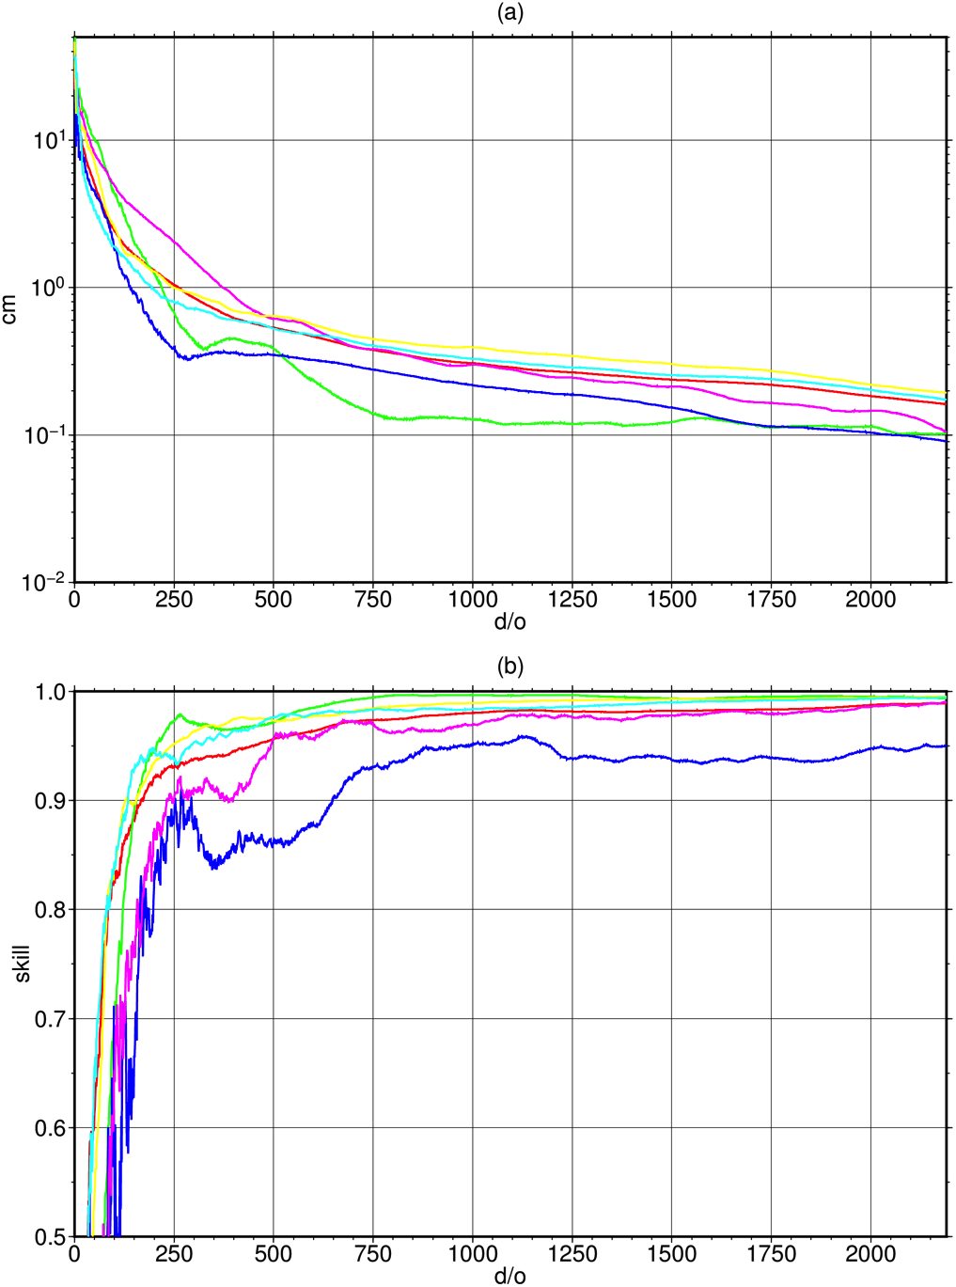
Figure 17. (a) The RMS residual between the original MDT and the truncated MDT as a function of d/o of truncation computed for the global set of tide gauge locations (red) and for sub-sets corresponding to the five study regions: the Northeast Atlantic (cyan), Australia (blue), Agulhas (green), South America (magenta) and the Pacific Islands (yellow). (b) Repeating (a) but expressed as fraction of signal recovered.
Figure 18 shows the d/o required to reduce the MOE at each location by 1 cm, 0.5 cm and 1 mm. In most locations the MOE can be reduced to 1 cm by expansion to d/o<200 and in many places to d/o<100. Similarly in many places the error can be reduced to 5 mm by expansion to d/o<300 and to 1 mm by expansion to d/o<800. However, there are some regions that stand out as requiring higher d/o expansions to reduce the MOE to a given level. Notable among these are the TG locations around Japan and Florida; two places where very strong currents – the Kuroshio and the Gulf Stream – come close to shore. Figure 19 shows the d/o required to reduce the MOE at each location by 10%, 5% and 1%. For most locations the MOE falls to less than 10% of the signal magnitude for d/o<200 and in many places for d/o<100, less than 5% for d/o<200 and less than 1% for d/o<800.

Figures 20 and 21 consider the absolute and relative errors, respectively, for three specific truncations: d/o=300, corresponding the maximum d/o for the final GOCE models (approximately so for GTIM5 where the maximum d/o=280); d/o=720 corresponding to the maximum d/o for the GOCO05C model, and d/o=2190 corresponding to the maximum d/o of the combined models EGM2008 and EIGEN-6C4, that will be considered further below. Even at d/o=300 the MOE at the majority of TG locations is less than 3 mm, with many locations achieving an accuracy better than 1 mm. There are relatively few locations, including the aforementioned regions around Japan and Florida, where the MOE exceeds 1 cm at d/o=300. At most location this amounts to a error of just a few percent, with the error exceeding 10% of the signal in a handful of locations. At d/o=720 the MOE at the majority of TG locations is less than 1 mm, or 1% of the signal, with many locations achieving an accuracy better than 0.5 mm, and relatively few locations where the MOE exceeds 5 mm. Finally, at d/o=2190, most locations have a MOE of less that 0.3 mm, with relatively few exceeding 1 mm or 1% of the signal.

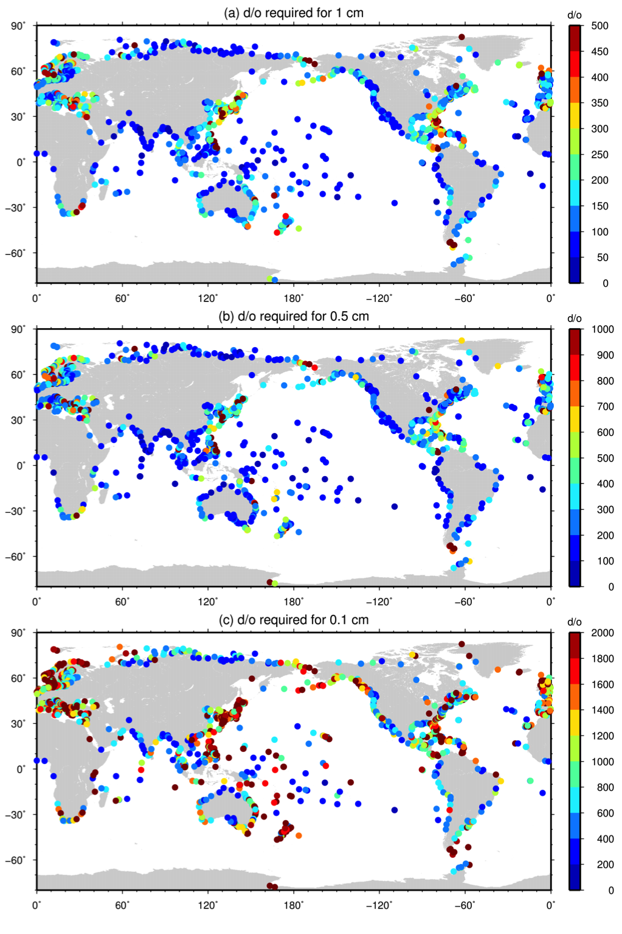
Figure 18. The d/o required to reduce the omission error at each tide gauge location to (a) 1 cm, (b) 0.5 cm and (c) 1 mm.

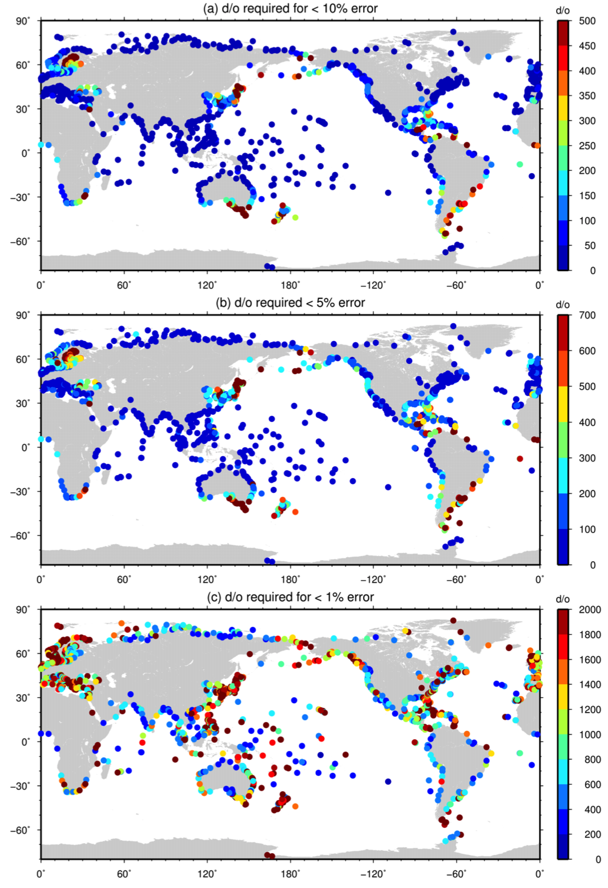
Figure 19. The d/o required to reduce the MDT omission error to (a) 10%, (b) 5% and (c) 1%.
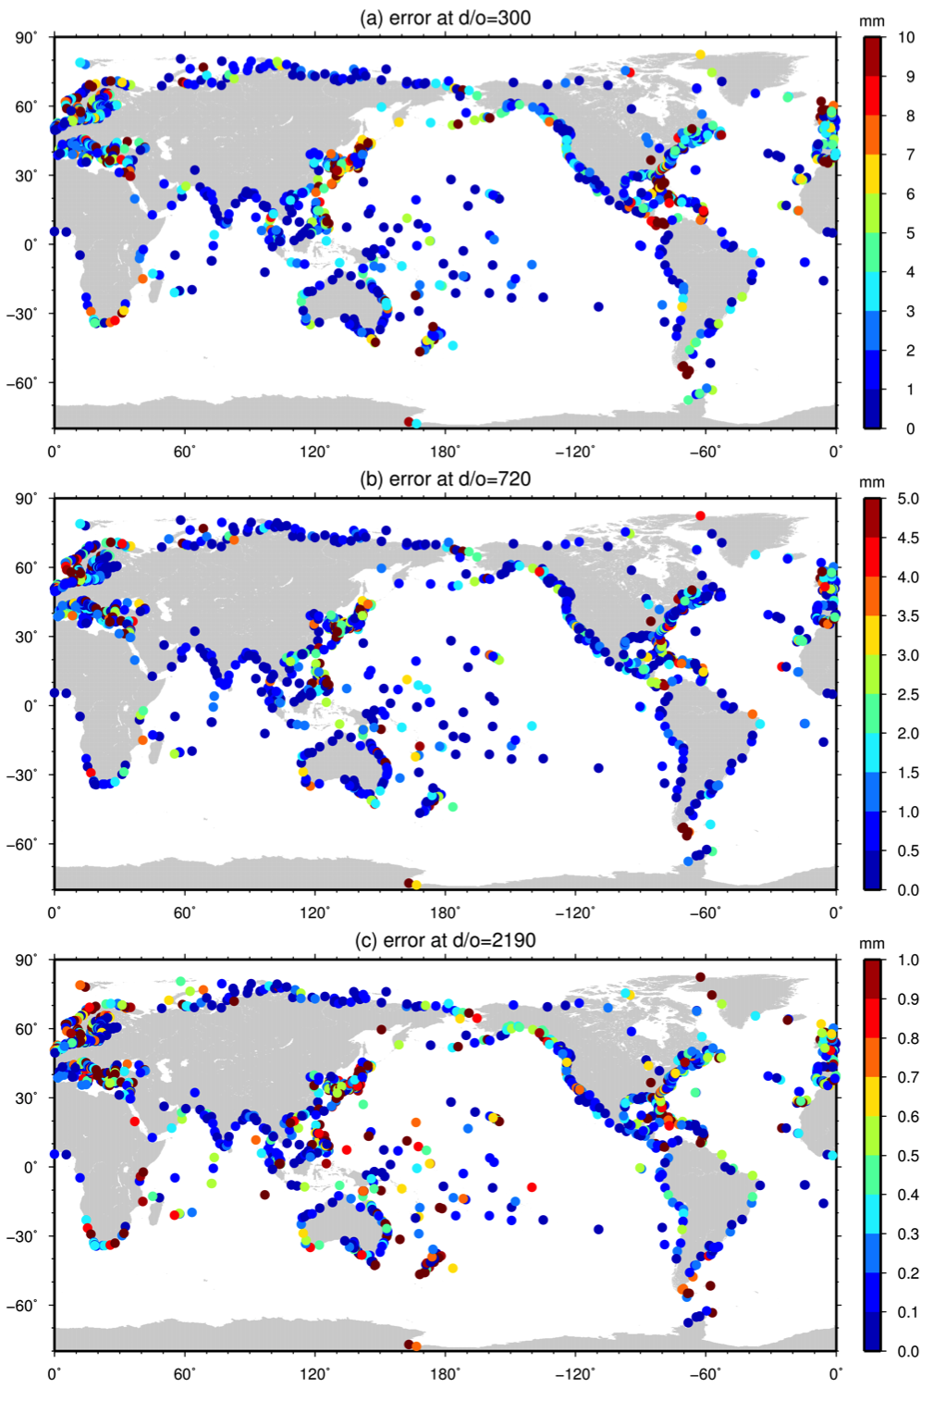
Figure 20. The MDT omission error at tide gauge locations for truncations at d/o (a) 300, (b) 720 and (c) 2190.
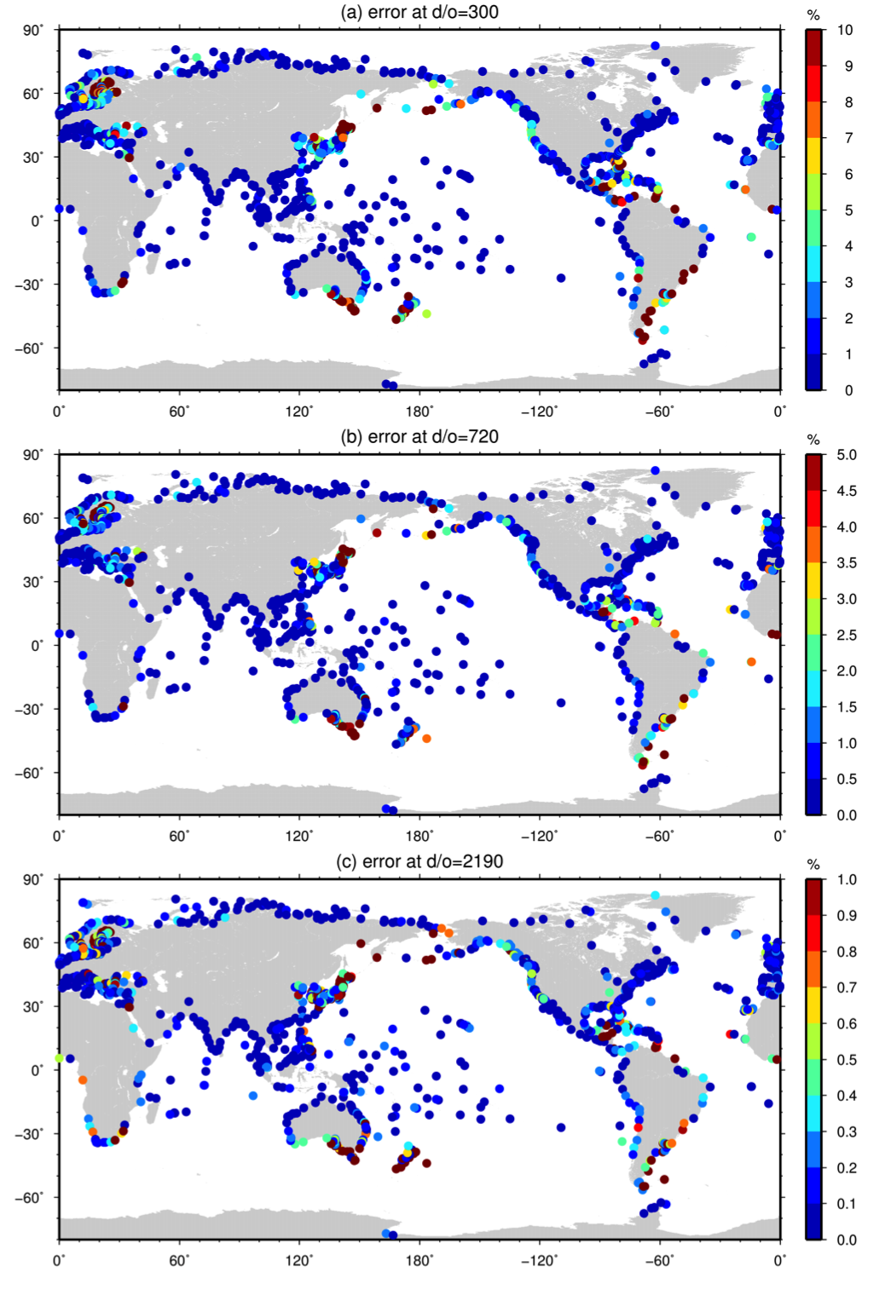
Figure 21. The relative MDT omission error at tide gauge locations for truncations at d/o (a) 300, (b) 720 and (c) 2190.

As identifying individual locations in the global maps is difficult, in Figures 22 to 31 we consider the MOE in each of the 5 study regions. Figure 22 shows that for the majority of the TG locations with the Northeast Atlantic region the MOE falls to less than 1 cm for d/o=200. There are many locations, however, where the MOE is slower to decline and more spherical harmonic terms are required to reduce the error to less than 1 cm. These locations are generally clustered in the eastern North Sea, the North western reaches of the British Isles, along the Spanish Mediterranean coast and the eastern Mediterranean. This may be an artefact of the convoluted nature of the coastline in these regions which may introduce to noise into the spherical harmonic transformations. In the majority of locations the MOE falls to less than 0.5 cm for d/o=400 and in many places for d/o<300. In the majority of locations to achieve a MOE of less than 1 mm requires substantially more spherical harmonic terms. In the majority of locations the MOE falls to less than 1 mm for d/o<1200, but in many locations even expansion to 2190 is insufficient to reduce the error to 1 mm. Figure 23 confirms that at d/o=300 the MOE is generally less than 4 mm and less than 2 mm in many locations. Only in a relatively few locations does the error at d/o=300 exceed 1 cm. At d/o=720 the MOE fall to less than 1.5 mm at most locations, with relatively few locations exceeding 5 mm. Finally, at d/o=2190 the error is less that 1 mm at the majority of locations.

Figure 24 shows that for the majority of the Australian TG locations the MOE falls to less than 1 cm for d/o=200, with several more requiring d/o=250. Only five TG locations, three on the east coast and two Tasmanian locations, require substantially more terms. Given their proximity to locations where less terms are required this most likely reflects some noise in the calculation rather than a true difference in the character in the CMDT at these locations. At the majority of locations the error falls to less the 5 mm for d/o<300, with a handful, excluding the anomalous locations previously mentioned, requiring expansions to d/o>300. Finally for most Australian TGs the MOE falls below 1 mm for d/o<800. Many require more than this. However, 1 mm MOE can be achieved for all within the upper limit of 2190. Figure 25 confirms that at d/o=300 the MOE is less than 5 mm at almost all Australian TG locations, exceeding 1 cm at only two locations. At d/o=720 the error is less than 2 mm at nearly all locations, exceeding 5 mm at only 4 locations. Finally at d/o=2190 the error is less than 1 mm at most TG locations.

Figure 26 shows that for nearly all of the TG locations within the Southern African region an expansion to d/o=200 reduces the error to less than 1 cm. The three anomalous locations along the eastern coast may reflect their close proximity to the Agulhas Current and the MDT gradient associated with it. At the majority of locations the MOE falls below 5 mm for d/o=300, with a handful, including two of the aforementioned locations, requiring expansions up to d/o=700 and one location requiring in excess of d/o=1000 to reduce the error to below 0.5 mm. All locations can achieve a MOE of less than 1 mm for d/o<2190. Figure 27 confirms that at d/o=300 the error is, with the exception of one location, less that 1 cm, with the majority having a MOE of less than 4 mm, while at d/o=720 most have an error of less than 1 mm and all less than 4.5 mm. At d/o=2190 the majority of TG locations have a MOE of less than 1mm.

Figure 28 shows that for almost all of the South America TG locations the MOE falls to less that 1 cm for d/o<200, to less than 0.5 cm for d/o<300 and 1 mm for d/o=800. The Patagonia locations are anomalous, requiring a much higher d/o to reduce the MOE to a given level. This may reflect their proximity to the ACC and/or the convoluted nature of the coastline here. Figure 29 confirms that at d/o=300 almost all TG locations have a MOE of less than 4 mm, the exceptions being the aforementioned Patagonian locations where for four the error exceeds 1 cm. At d/o=720 the error is generally less than 1.5 mm, with the only the Patagonian locations exceeding 5 mm, and less than 0.5 mm at d/o=2190.

Figure 30 shows that the Pacific Island TG locations generally require fewer terms to achieve a given MOE, with the majority achieving an accuracy better than 1 cm for d/o<100 and better than 0.5 cm for d/o<200. This to be expected given that these locations do not lie close to any strong boundary currents. The majority of locations achieve an accuracy better than 1 mm for d/o=800, with many achieving this accuracy with substantially less terms. Figure 31 confirms this picture, with the majority of TG locations have a MOE of less than 3 mm at d/o=300, 2 mm at d/o=720 and 1 mm at d/o=2190.

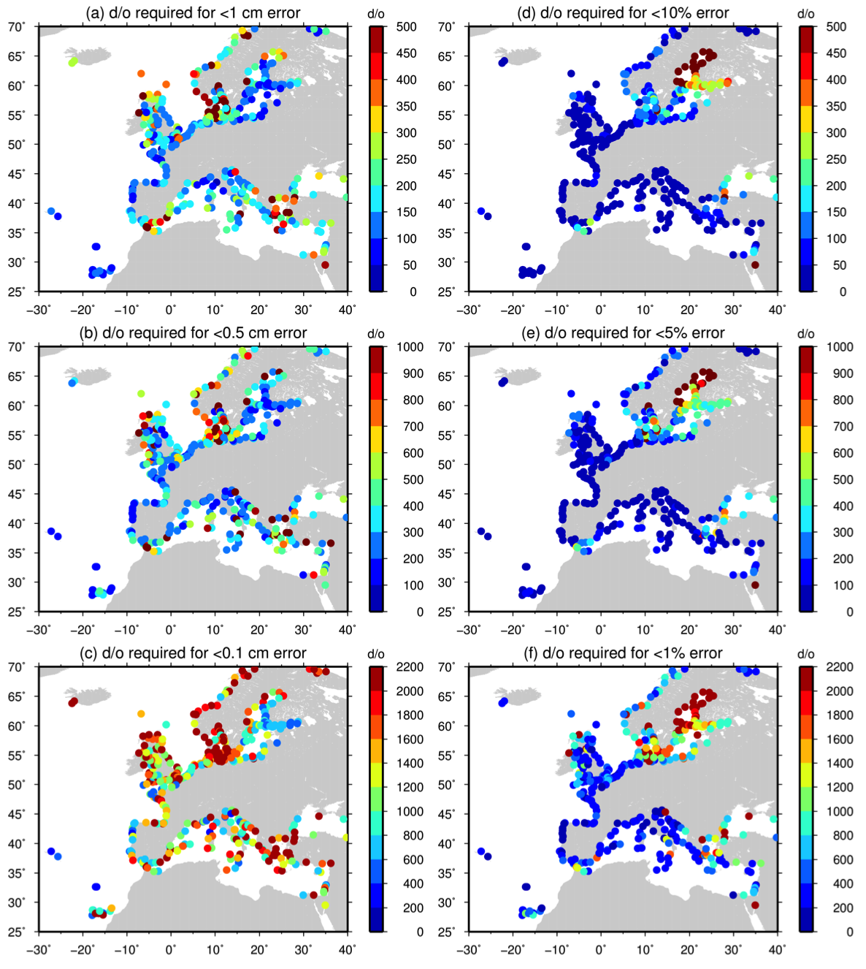

Figure 22. The d/o required at Northeast Atlantic tide gauge locations to reduce the MDT omission error to (a) 1 cm, (b) 0.5 cm, (c) 1 mm, (d) 10%, (e) 5% and (f) 1%.

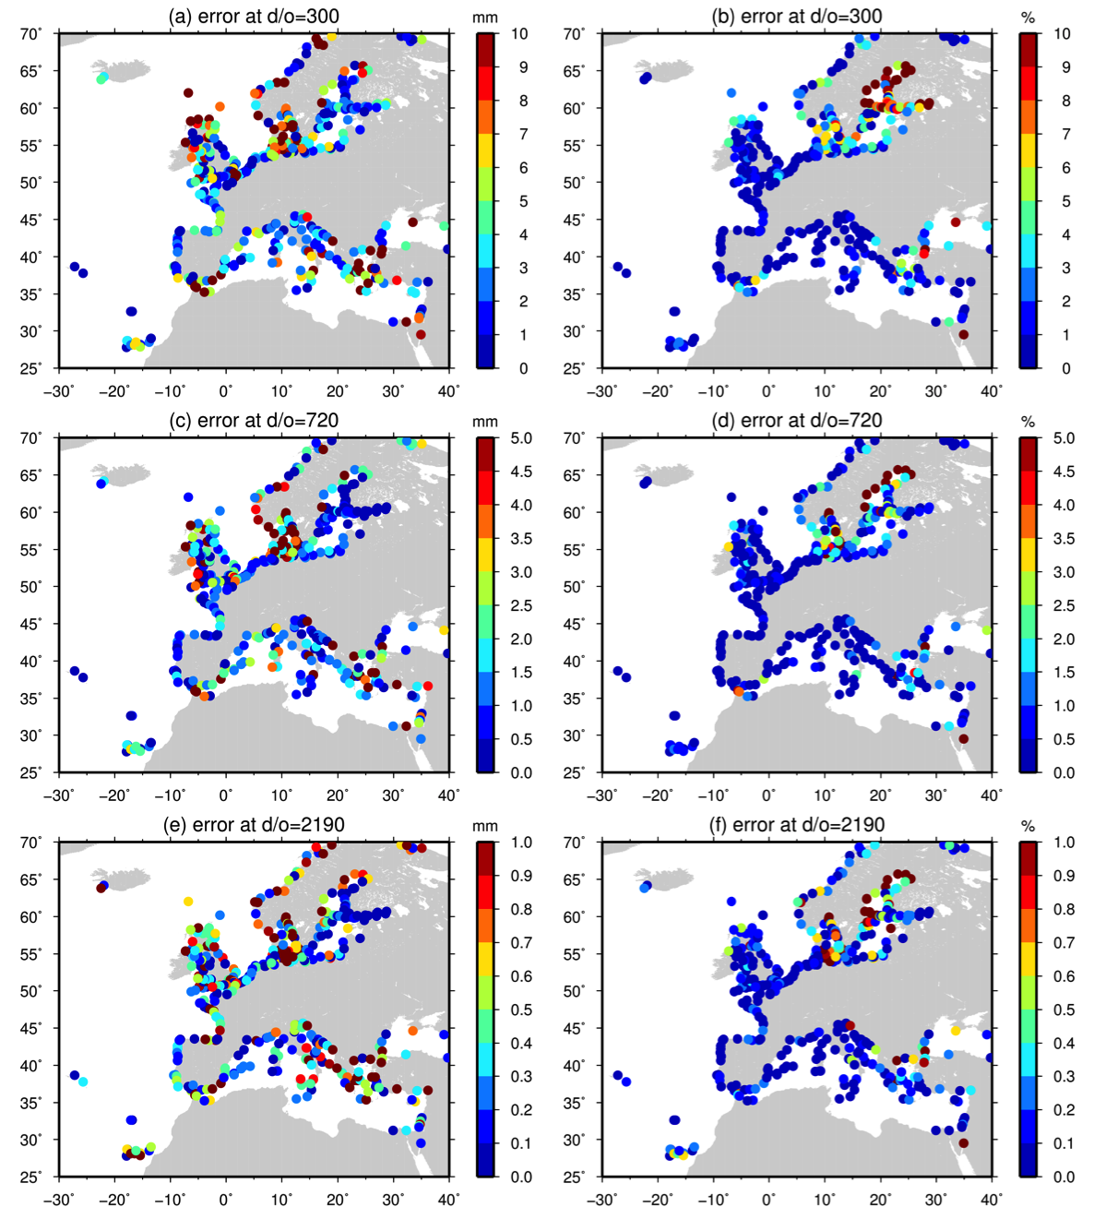

Figure 23 The absolute (left) and relative (right) MDT omission error at Northeast Atlantic tide gauge locations for truncations at d/o (a,b) 300, (c,d) 720 and (e,f) 2190.

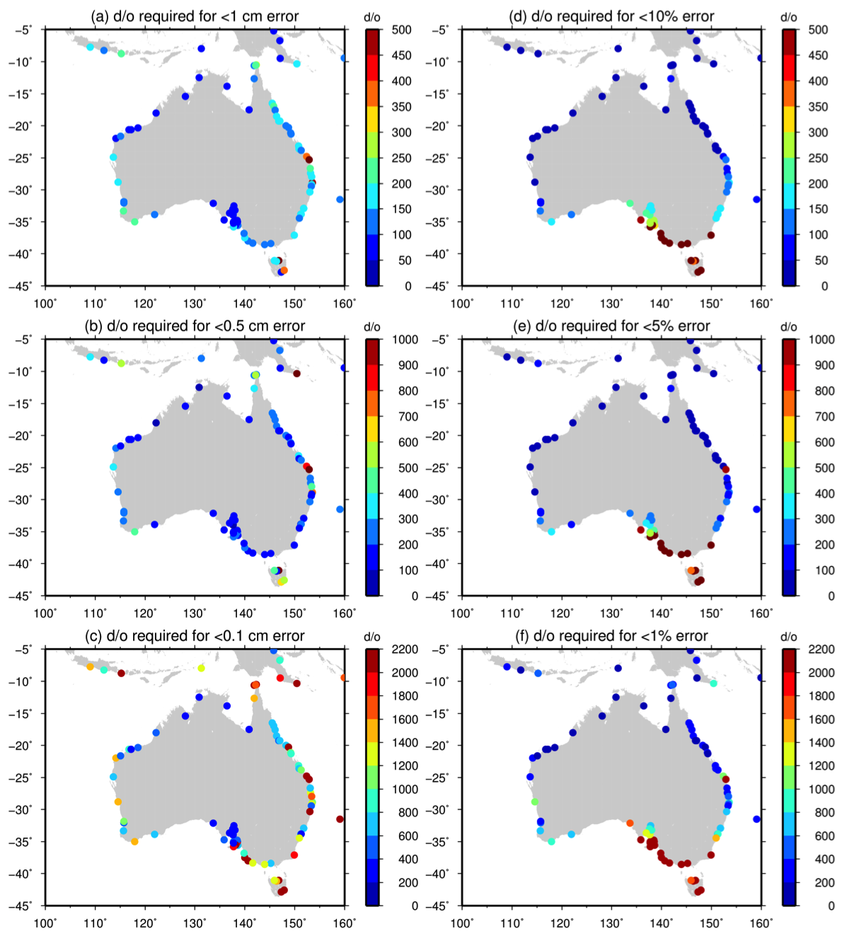

Figure 24. The d/o required at Australian tide gauge locations to reduce the MDT omission error to (a) 1 cm, (b) 0.5 cm, (c) 1 mm, (d) 10%, (e) 5% and (f) 1%.

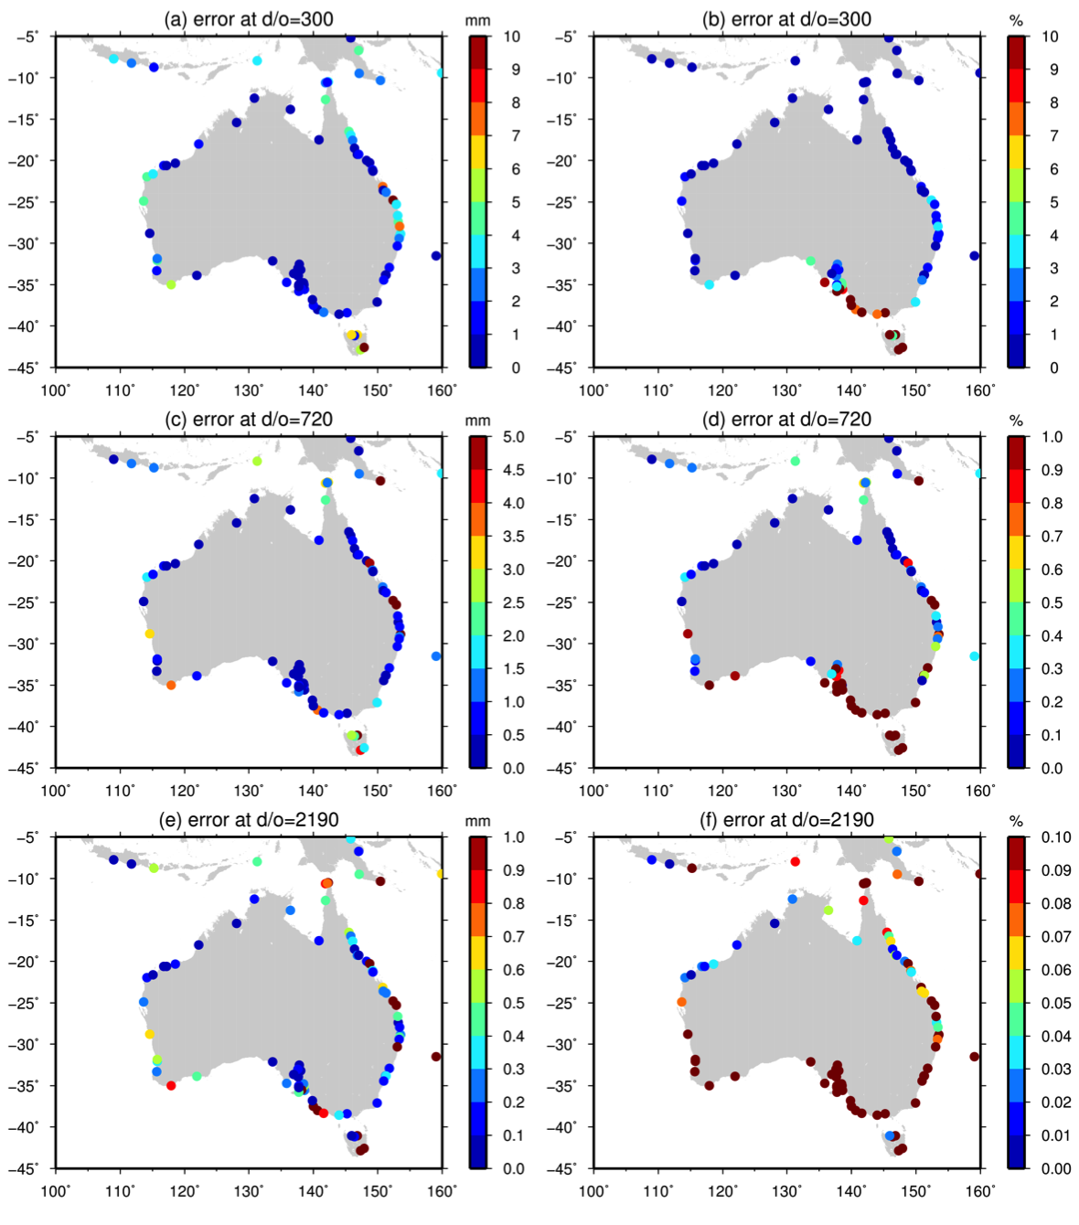

Figure 25. The absolute (left) and relative (right) MDT omission error at Australian tide gauge locations for truncations at d/o (a,b) 300, (c,d) 720 and (e,f) 2190.

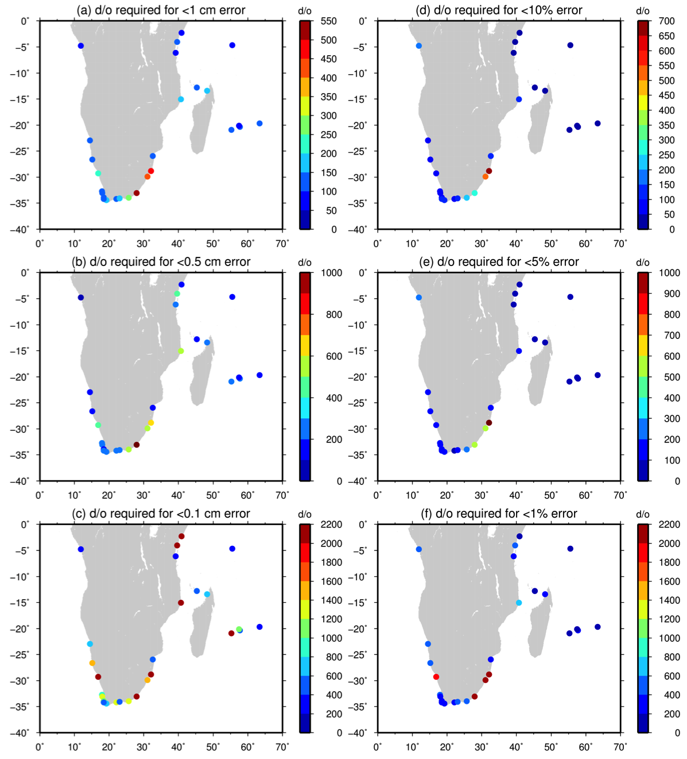

Figure 26. The d/o required at Southern Africa tide gauge locations to reduce the MDT omission error to (a) 1 cm, (b) 0.5 cm, (c) 1 mm, (d) 10%, (e) 5% and (f) 1%.

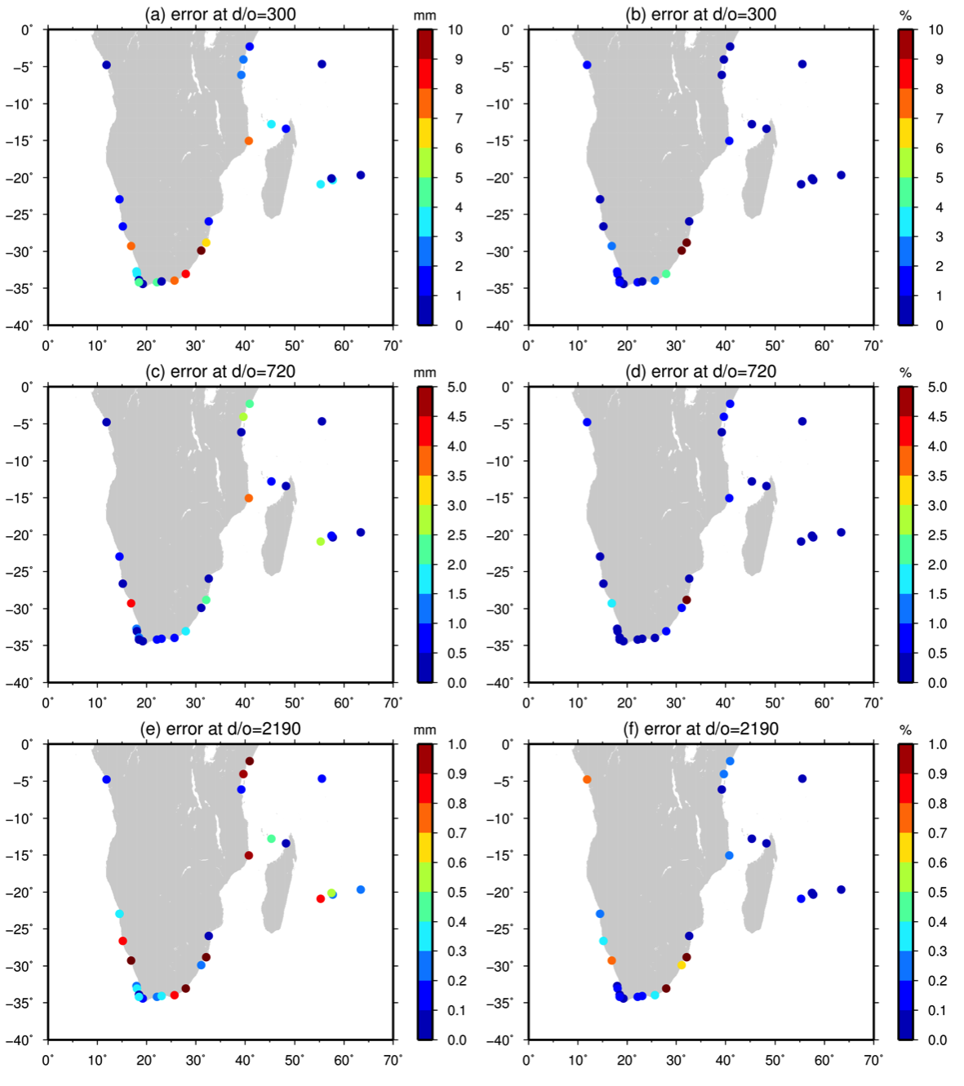
Figure 27. The absolute (left) and relative (right) MDT omission error at Southern African tide gauge locations for truncations at d/o (a,b) 300, (c,d) 720 and (e,f) 2190.

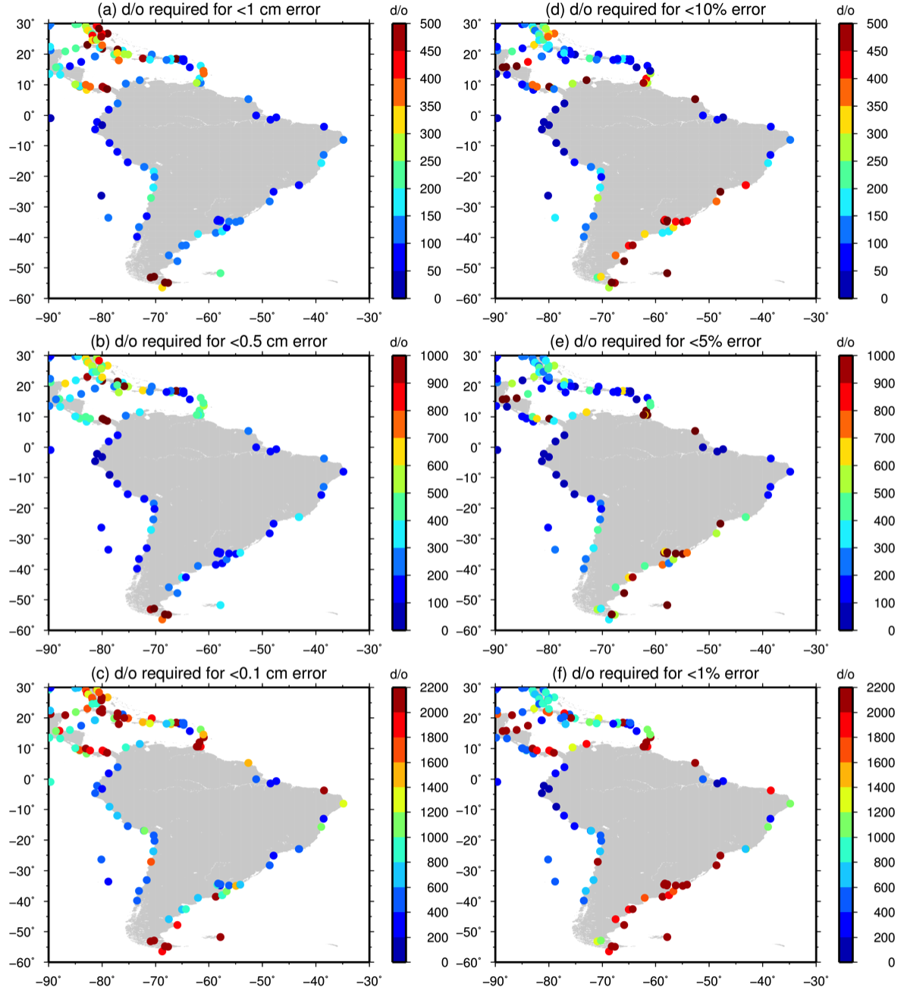

Figure 28. The d/o required at South American tide gauge locations to reduce the MDT omission error to (a) 1 cm, (b) 0.5 cm, (c) 1 mm, (d) 10%, (e) 5% and (f) 1%.

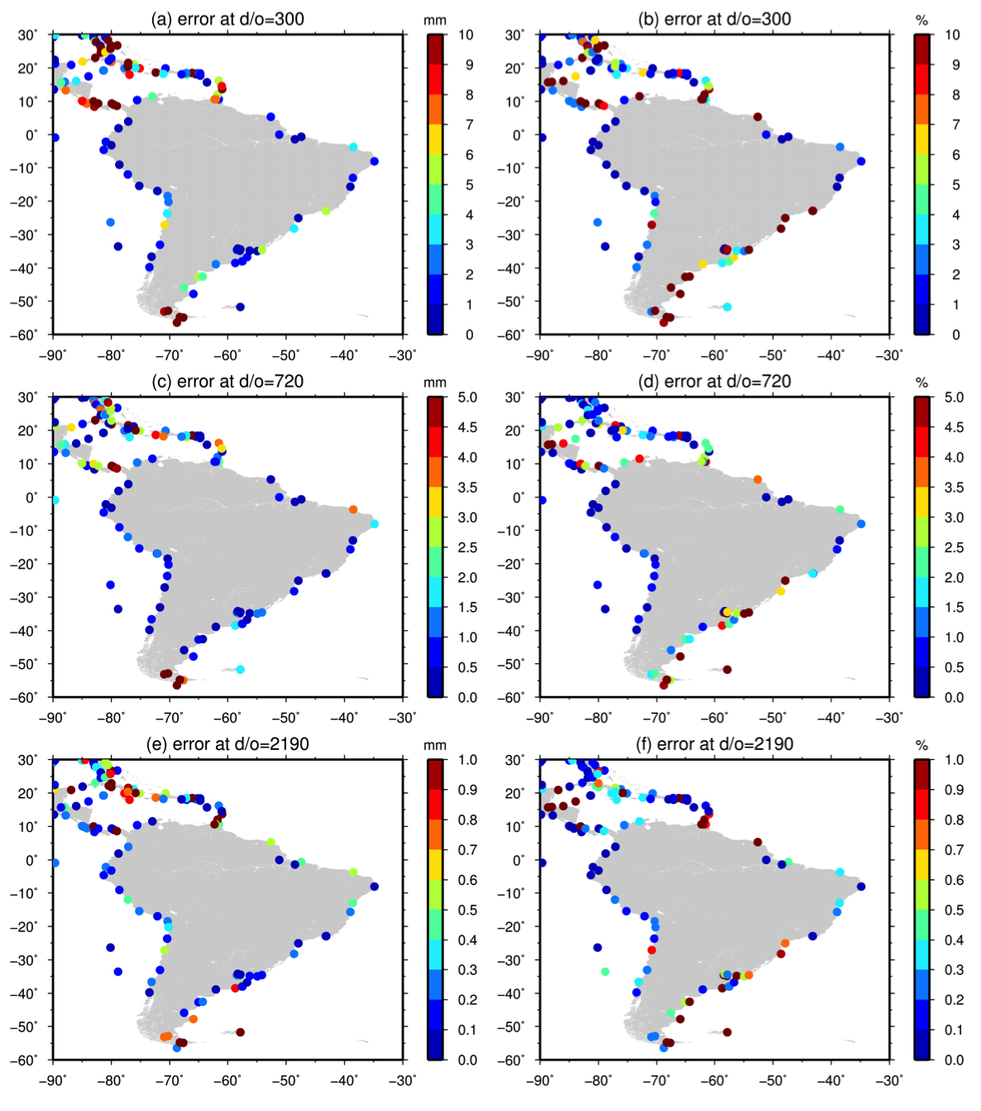
Figure 29. The absolute (left) and relative (right) MDT omission error at South American tide gauge locations for truncations at d/o (a,b) 300, (c,d) 720 and (e,f) 2190.

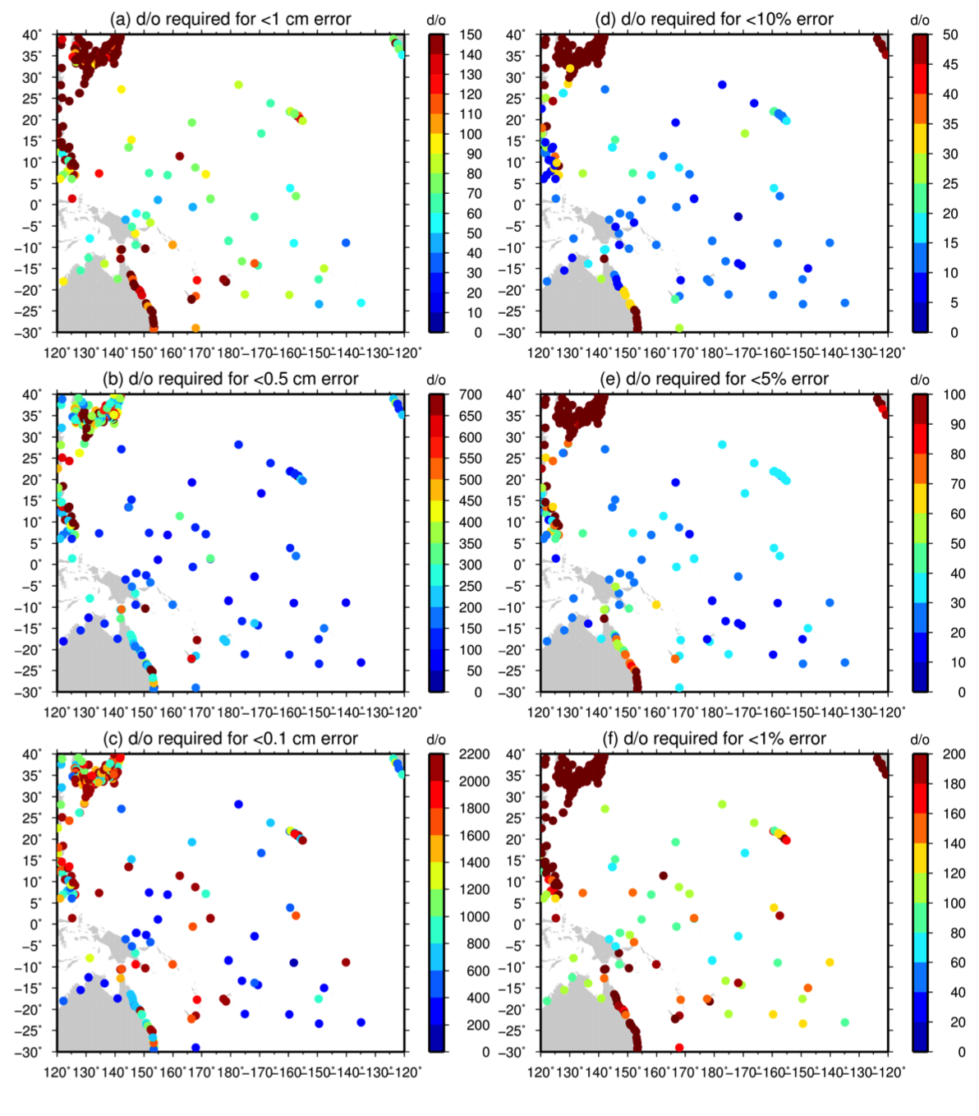
Figure 30. The d/o required at Western Pacific Island tide gauge locations to reduce the MDT omission error to (a) 1 cm, (b) 0.5 cm, (c) 1 mm, (d) 10%, (e) 5% and (f) 1%.

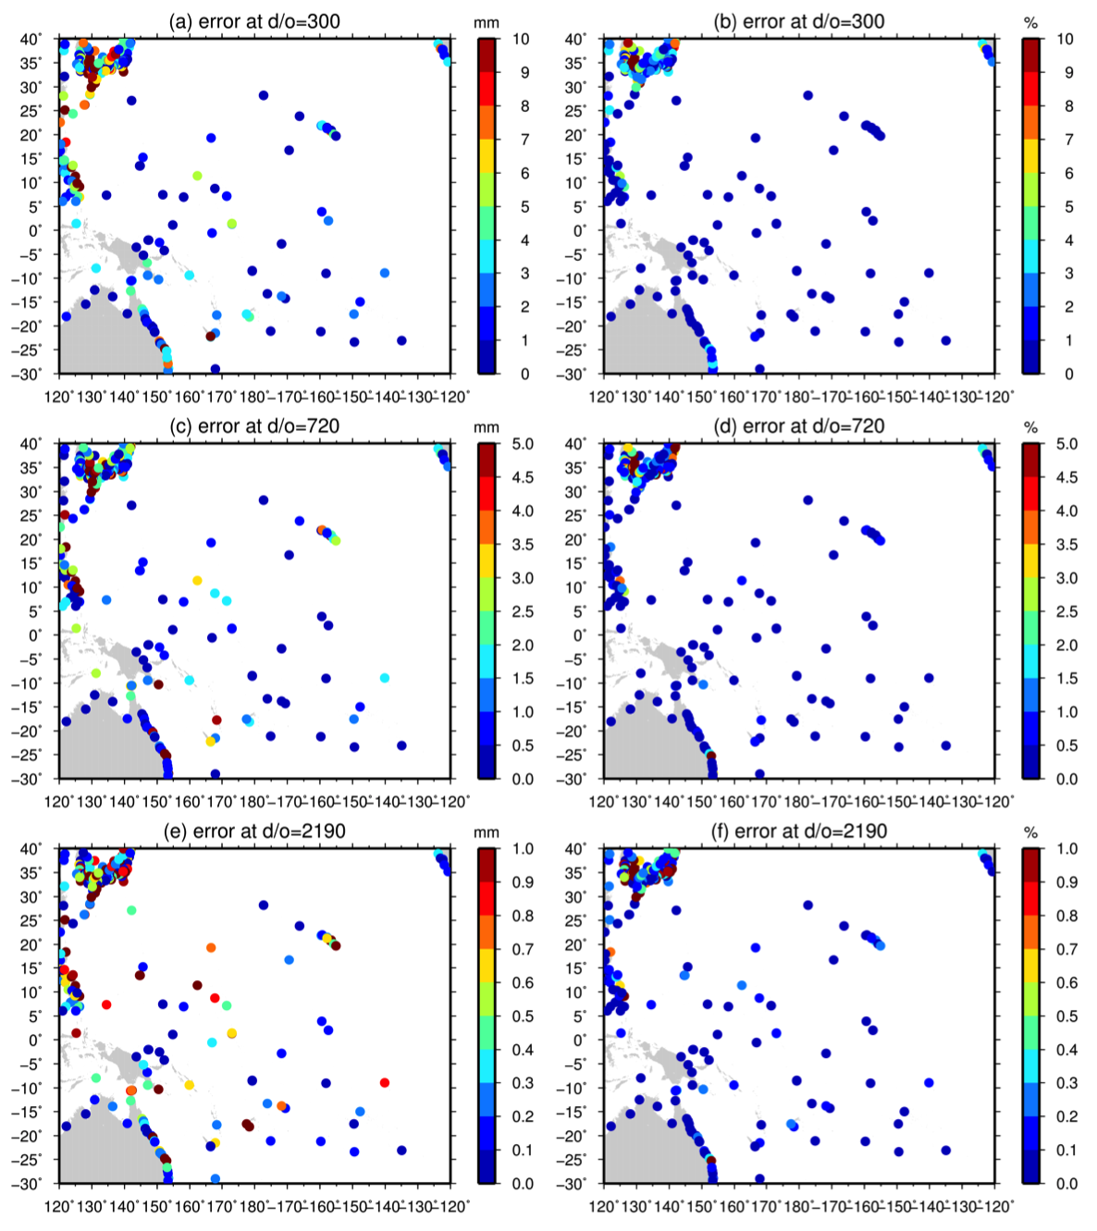
Figure 31. The absolute (left) and relative (right) MDT omission error at Western Pacific Island tide gauge locations for truncations at d/o (a,b) 300, (c,d) 720 and (e,f) 2190.

3.3.2 Geoid and MSS errors

Having examined MDT omission error (MOE) we now consider the geoid commission error (GCE) and the relative magnitude of the two. For this analysis we consider a range of earth gravity models (EGMs): the final pure GOCE model GTIM5 (maximum d/o=280); a recent satellite only solution combining GOCE, GRACE and Lageos data – GOCO05S (maximum d/o=28); and three EGMs combining satellite and in-situ data - GOCO05C (maximum d/o=720); EIGEN-6C4 (maximum d/o=2190) and the pre-GOCE model EGM2008 (maximum d/o=2190). For these five models cumulative formal geoid errors where computed as a function of d/o at each of the 1600 tide gauge locations from the spherical harmonic coefficient standard deviations.

Figure 32 shows the formal GCE for each of the EGMs averaged over the 1600 tide gauge locations. Taken at face value the formal errors show a clear improvement between EGM2008 (cyan) and EIGEN-6C4 (red), for which GOCE data can, in part, be credited. The relative contributions from GRACE and GOCE can partly be discerned by comparing the error curve for the GOCE only model (GTIM5; magenta) with that for the combined satellite only model (GOCO05S; green). EIGEN-6C4 is most accurate model (or at least as accurate) across all spatial scales, while EGM2008 is only more accurate than the satellite only models for d/o>250 and the GOCO05C model for d/o>400. It is worth bearing in mind, however, that as shown by Bingham et al. (2014) these formal errors may not be a true picture of the actual geoid error.

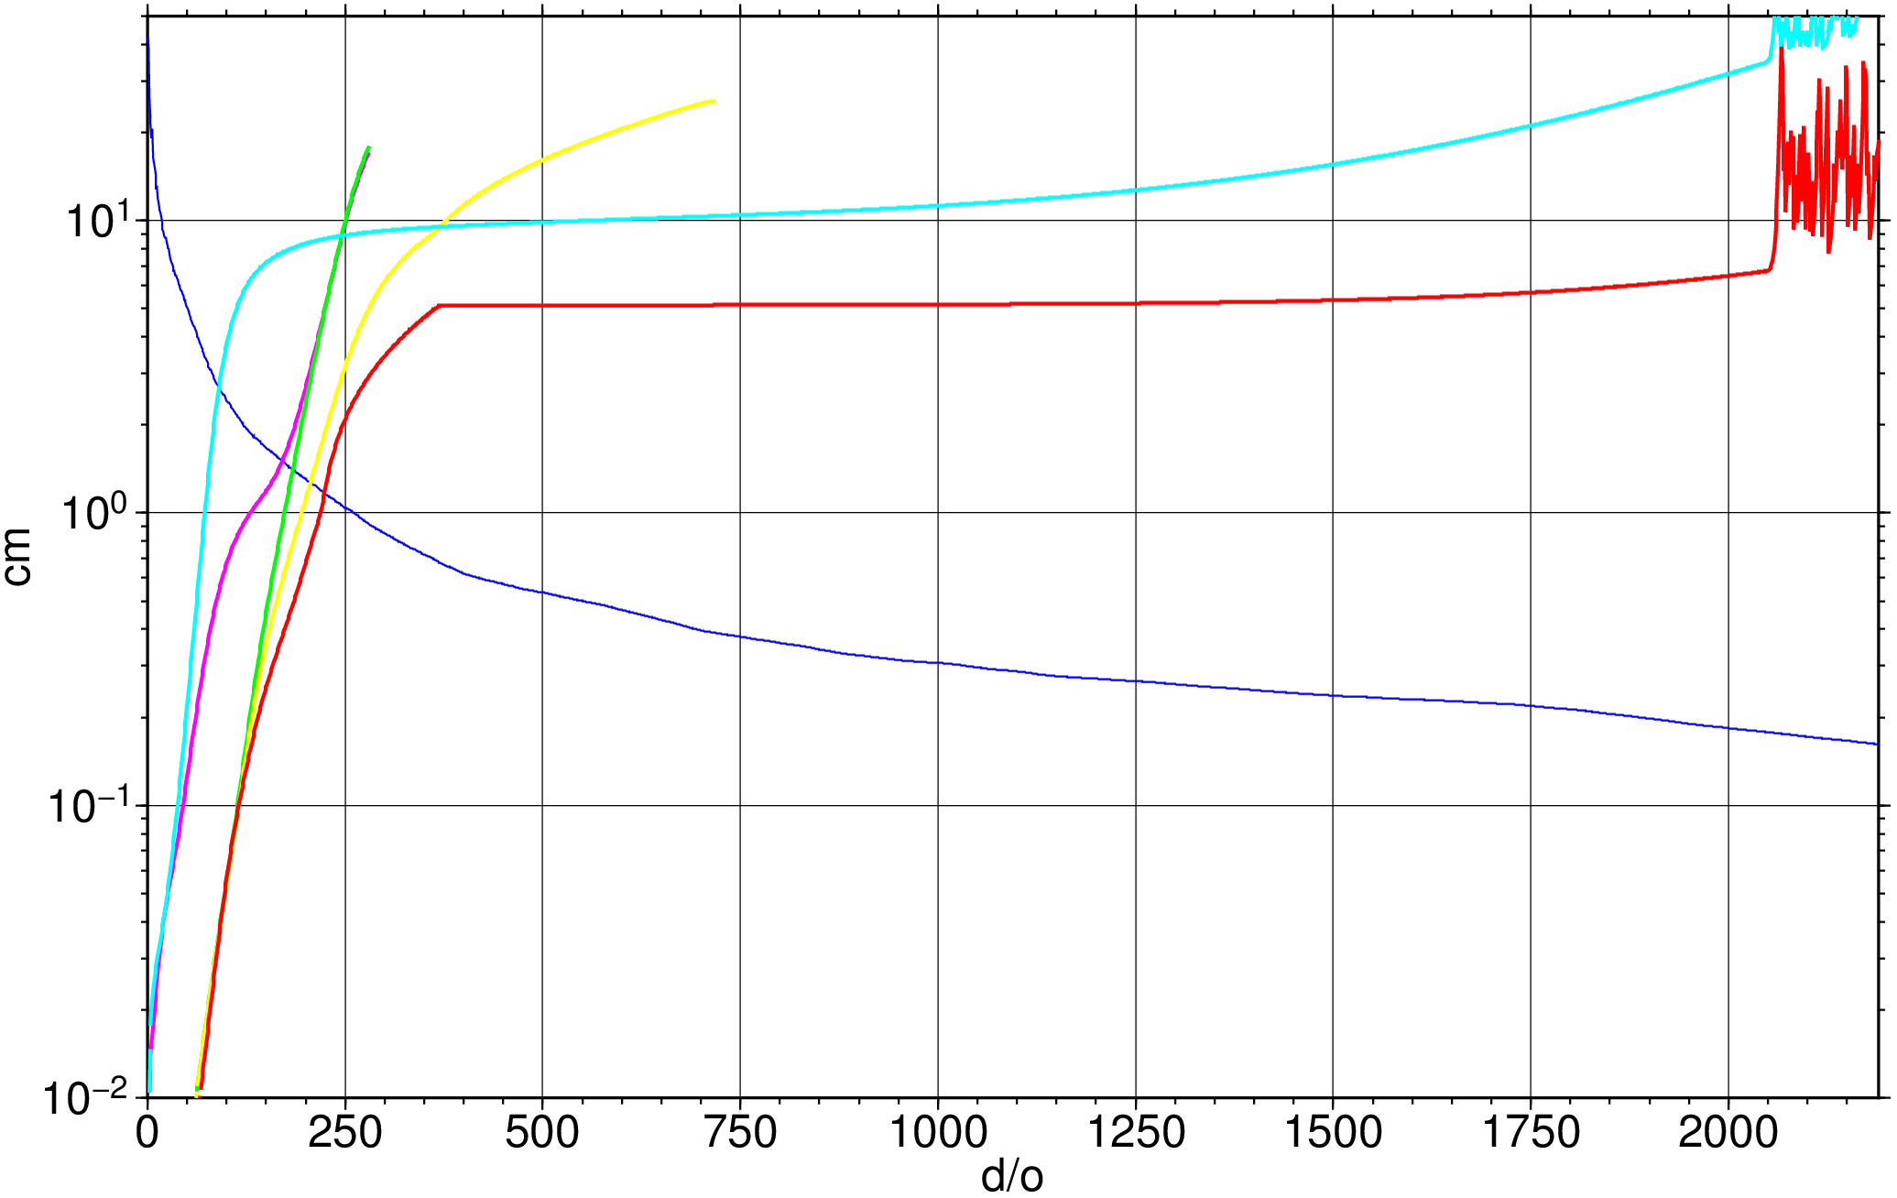
Figure 32. Formal geoid commission error averaged over the 1600 tide gauge locations regions for GTIM5 (magenta), GOCO05S (green), GOCO05C (yellow), EIGEN-6c4 (red) and EGM2008 (cyan) and the TG averaged MDT omission error.

For the purposes of the present investigation, we are interested in the cross-over point between the GCE and MOE, as represented by the blue curve in Figure 32. For all EGMs this occurs for d/o<250 suggesting that although there is signal content in the CMDT for d/o>250 the growth of GCE may mean that little signal can be recovered beyond d/o=250. However, the analysis of the previous section suggests that for most locations most of the CMDT signal can be recovered with d/o=250, with little residual signal (MOE) to be recovered. To enable their clearer identification, Figure 33a repeats Figure 32 but zooming in on the cross-over points. The best case is given by EIGEN-6c4 where the cross-over occurs for just greater than d/o=220, where the DCE and MOE are just over 1 cm. The worst case is given by EGM2008 where the cross-over occurs at d/o=90, where the DCE and MOE are just over 25 cm. Intermediate are GTIM5 (d/o= 170; errors ~16 cm), GOCO05S (d/o=180; errors ~15 cm) and GOCO05C (d/o=210; errors ~12 cm).

The remaining panels of Figure 33 show similar curves but with errors computed separately for the five study regions. The ordering of the cross-over points remains the same for each region but the values and ranges change. The lowest cross-overs occur for Australia – d/o=190, error 6 mm for EIGEN-6C4 – and the highest cross-overs occur for South America – d/o=260, errors = 20 cm for EIGEN-6CE.

The GCE/MOE cross-over points at each of the TG locations for each of the models are shown in Figures 34 and 35, while the corresponding errors at the cross-over points are shown in Figures 36 and 37. Figure 34a shows that for GTIM5 that the majority of locations the cross-over point is less than d/o=180, with many places having a cross-over of d/o<90. As shown in Figure 36a the error at the cross-over point is generally less than 1 cm, with relatively few locations where the error exceeds 2 cm. A marked improvement can be seen for GOCO05S (Figures 34b and 36b) with the cross-over points noticeably higher, although generally not exceeding d/o=180, and with the error at the cross-over point generally less than 0.5 cm and fewer locations exceeding 2 cm. Further, but not as dramatic, improvements are apparent for GOCO05C (Figures 34c and 36c) with the cross-overs at many locations now in the next d/o colour interval and the error exceeding 2 cm in fewer locations. As expected, additional improvements are apparent for EIGEN-6C4 (Figures 35a and 37a) with the cross-overs at many locations now exceeding d/o=210 and the error exceeding 2 cm at only a few locations and generally much less than 1cm. Finally, we see a dramatic difference between EIGEN-6C4 and EGM2008 (Figures 35b and 37b) with the cross-over point at all most all locations now d/o<90 and errors exceeding 2 cm in many locations.

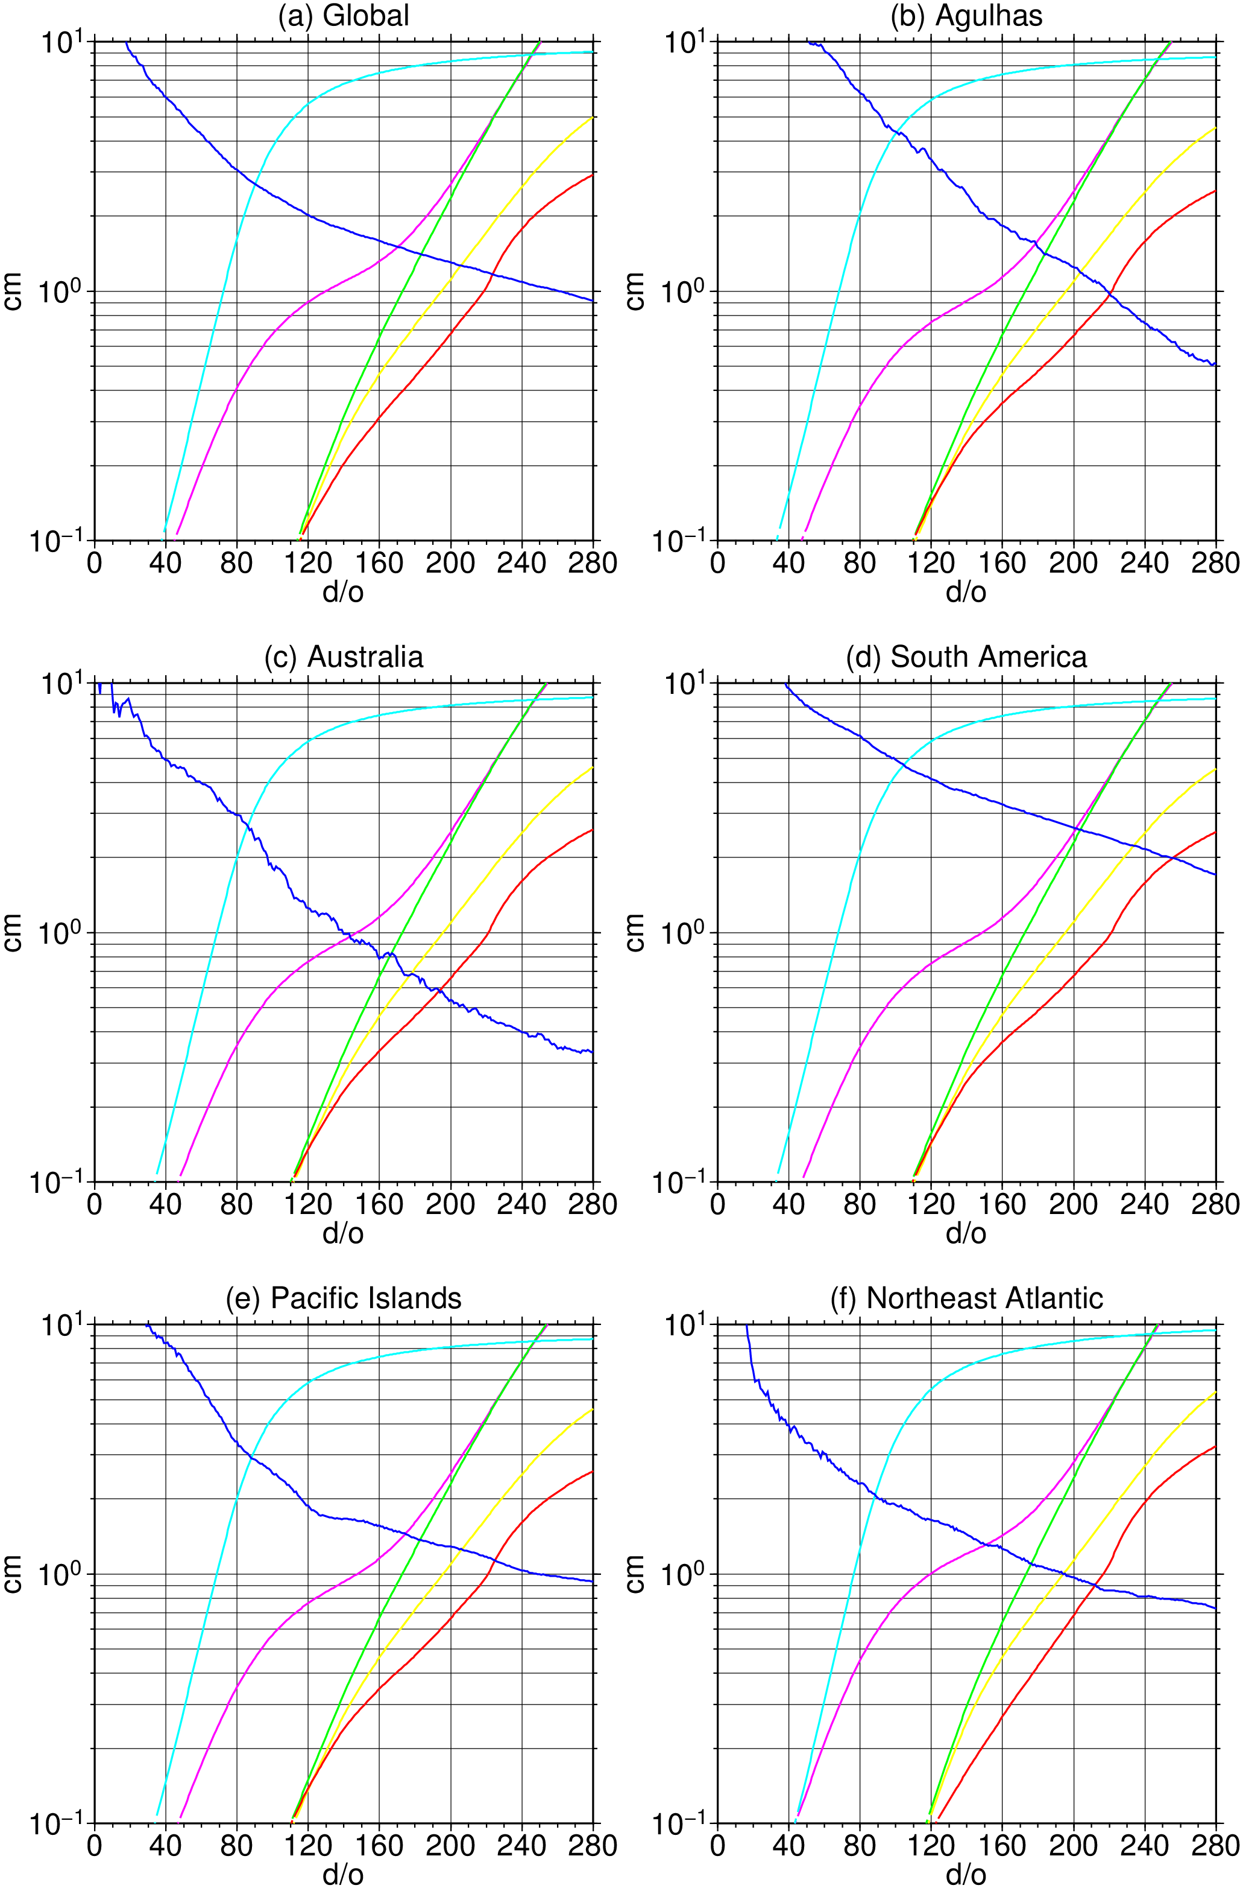
Figure 33. A comparison between MDT omission error (MOE; blue) and formal geoid commission error (GCE) globally and for the five study regions for GTIM5 (magenta), GOCO05S (green), GOCO05C (yellow), EIGEN-6c4 (red) and EGM2008 (cyan).

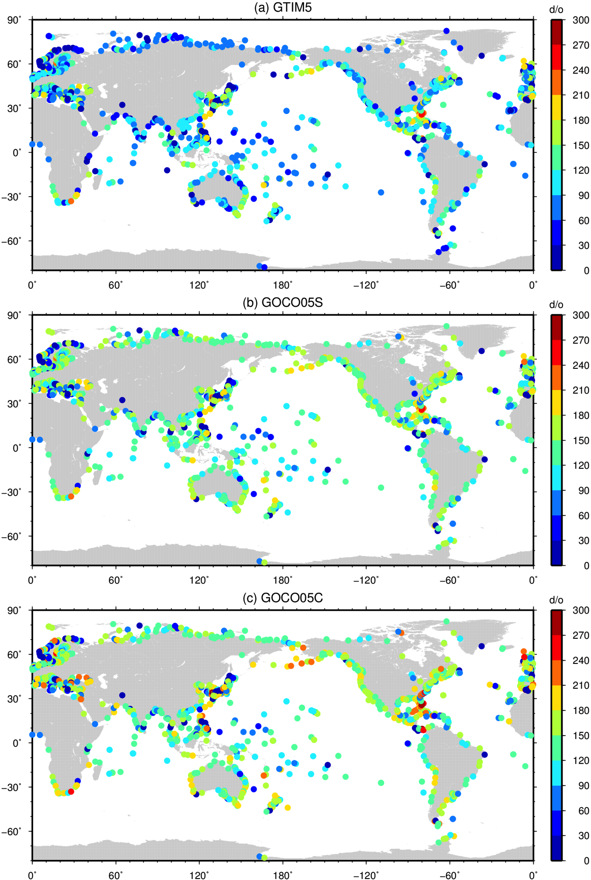
Figure 34. The degree and order at which the formal geoid commission error exceeds the MDT omission error for (a) GTIM5, (b) GOCO05S and (c) GOCO05C.

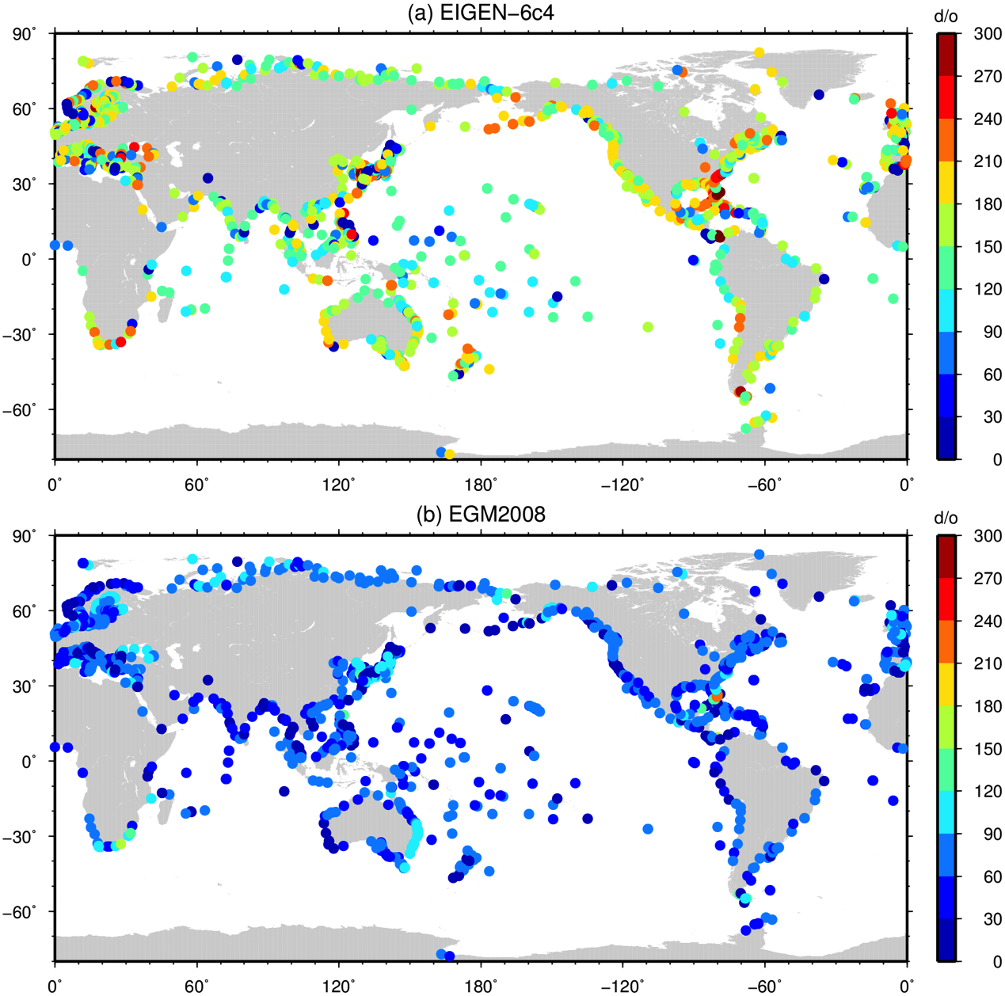

Figure 35. The degree and order at which the formal geoid commission error exceeds the MDT omission error for (a) EIGEN-6c4 and (b) EGM2008.
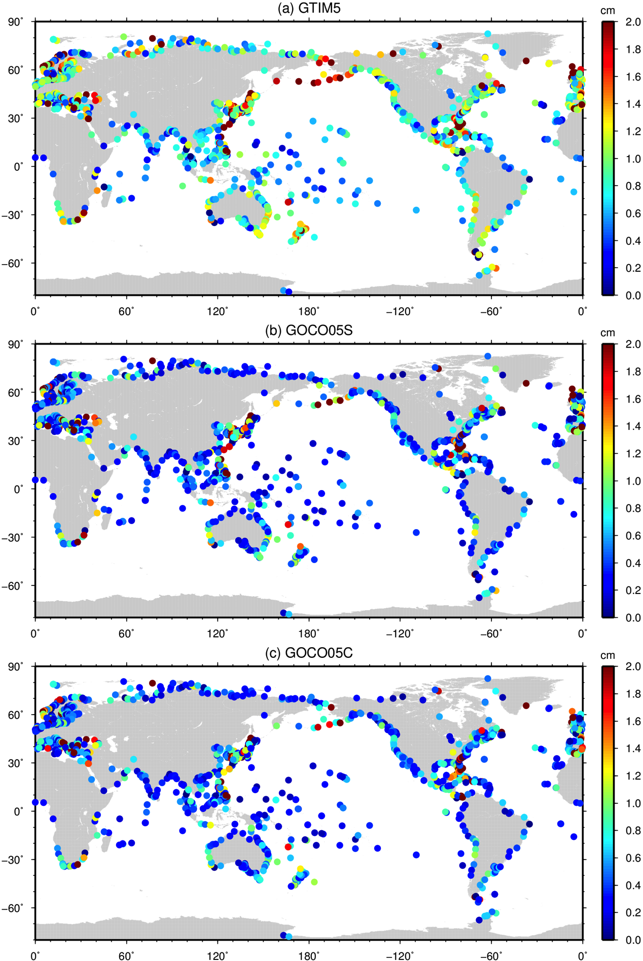
Figure 36. The MDT omission error (or geoid commission error) at the degree and order at which the formal geoid commission error exceeds the MDT omission error for (a) GTIM5, (b) GOCO05S and (c) GOCO05C.

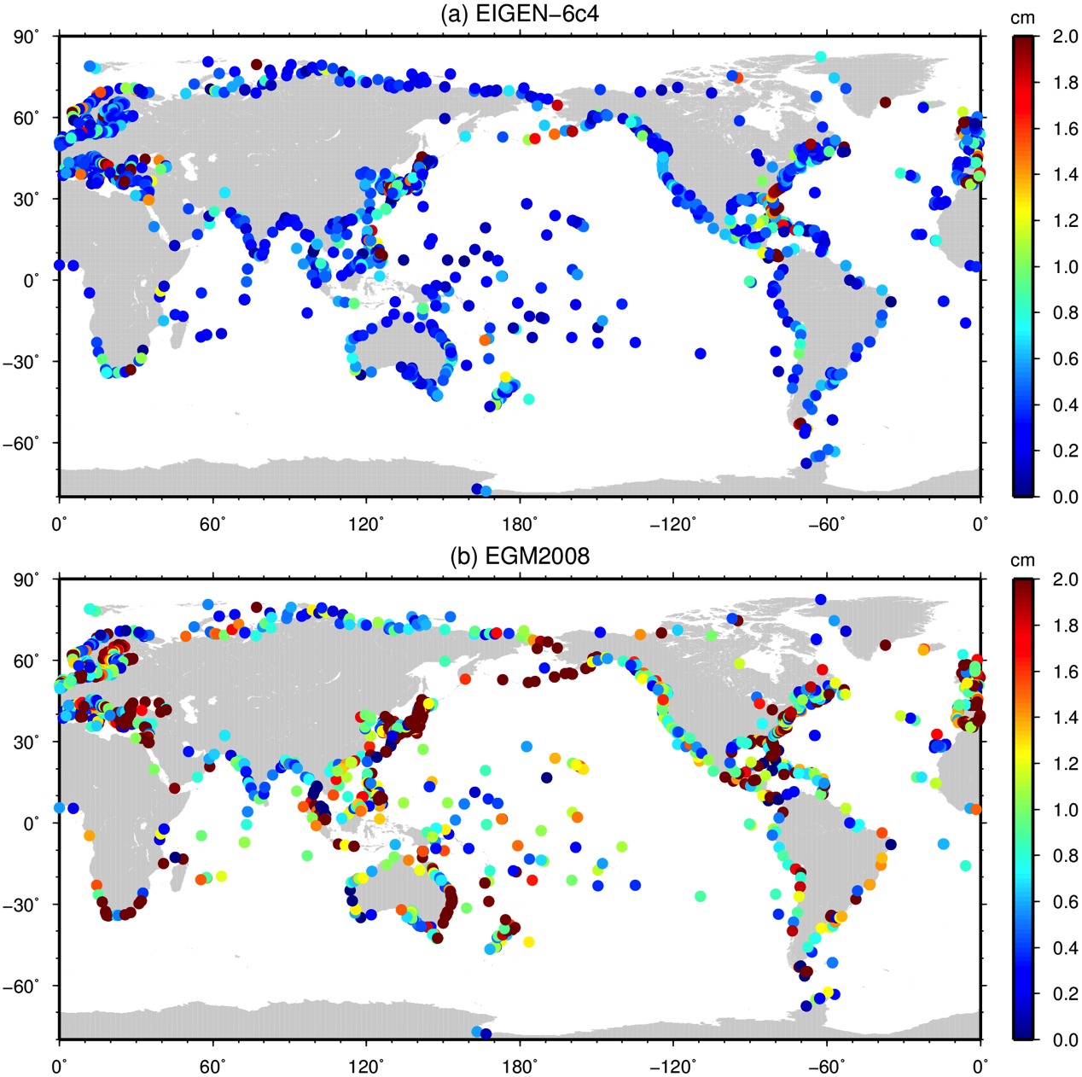

Figure 37. The MDT omission error (or geoid commission error) at the degree and order at which the formal geoid commission error exceeds the MDT omission error for (a) EIGEN-6c4 and (b) EGM2008.

These results apparently demonstrate the true differences between the EGMs as they pertain to the MDT calculation, showing the limit of their resolution and information content and the likely error at that limit. The results suggest that EIGEN-6C4 should provide the best estimate of the CMDT and EGM2008 the worst. However, it worth reiterating that the validity of these conclusions depend on the reliability of the formal error estimates. They also depend on how well the OCCAM model represents the spectral content of the MDT. However, this is likely to of minor importance compared to the correction specification of the formal errors. Nonetheless other models should be investigated.

By “true’’ in the above sentence we mean in contradistinction to the false, or apparent, difference, as far as recovery of the MDT signal is concerned, that arises through the power of the higher d/o models to reduce geoid omission error. While reducing this source of error undoubtedly leads to an improvement in the MDT (computed by the point-wise approach, as must be done for the GPS-TG approach), this improvement comes through the reduction in noise rather than increased signal content. It obscures the more fundamental balance between the MOE and GCE that places the true upper limit on the signal that can be recovered by the geodetic (or GPS) approach. To go beyond this limit, as discussed above, would require a filtering method that can be employed to dampen the GCE to a level below the MOE, without attenuating the small residual MDT signal.

Suppose our estimates of the MOE and GCE are accurate, then the above analysis places an upper bound on the CMDT signal content that can be derived from the geodetic approach. However, we must also take into account MSS error. In fact, the combined MSS error and GCE, together with residual numerical error, can be thought of as the MDT commission error (MCE). This error, being greater than the GCE only, must exceed the MOE for lower d/o than the GCE only. Thus, the cross-over points and errors, presented above may, all other things being equal, be optimistic. The extent to which they are optimistic depends on the magnitude of the MSS error at the spatial scales corresponding the relatively large spatial scales at which the MOE/GCE cross-overs tend to occur.

The formal errors for the DTU15 MSS at the TG locations is shown in Figure 38. The errors are generally in the range 2-4 cm. It is difficult to express these as a function of d/o, to assess their impact on a spectral MDT at a particular d/o. But supposing they remain a constant fraction of the signal and considering the rate at which the MSS signal grows with increasing d/o then is reasonable to suppose they would converge asymptotically rather rapidly such that they have relatively constant values close to the plotted values beyond some d/o greater than say d/o=100. In this case, these MSS errors will therefore be the dominant source of CMDT error at the MOE and GCE cross-over points and the true cross-over points may be lower than those presented above. If, on the other hand, the MSS errors only grow rapidly at spatial scales less than those corresponding to d/o=300, which could well be true, then the MOE/GCE cross-over points as presented above will be closer to what can achieved in practice.

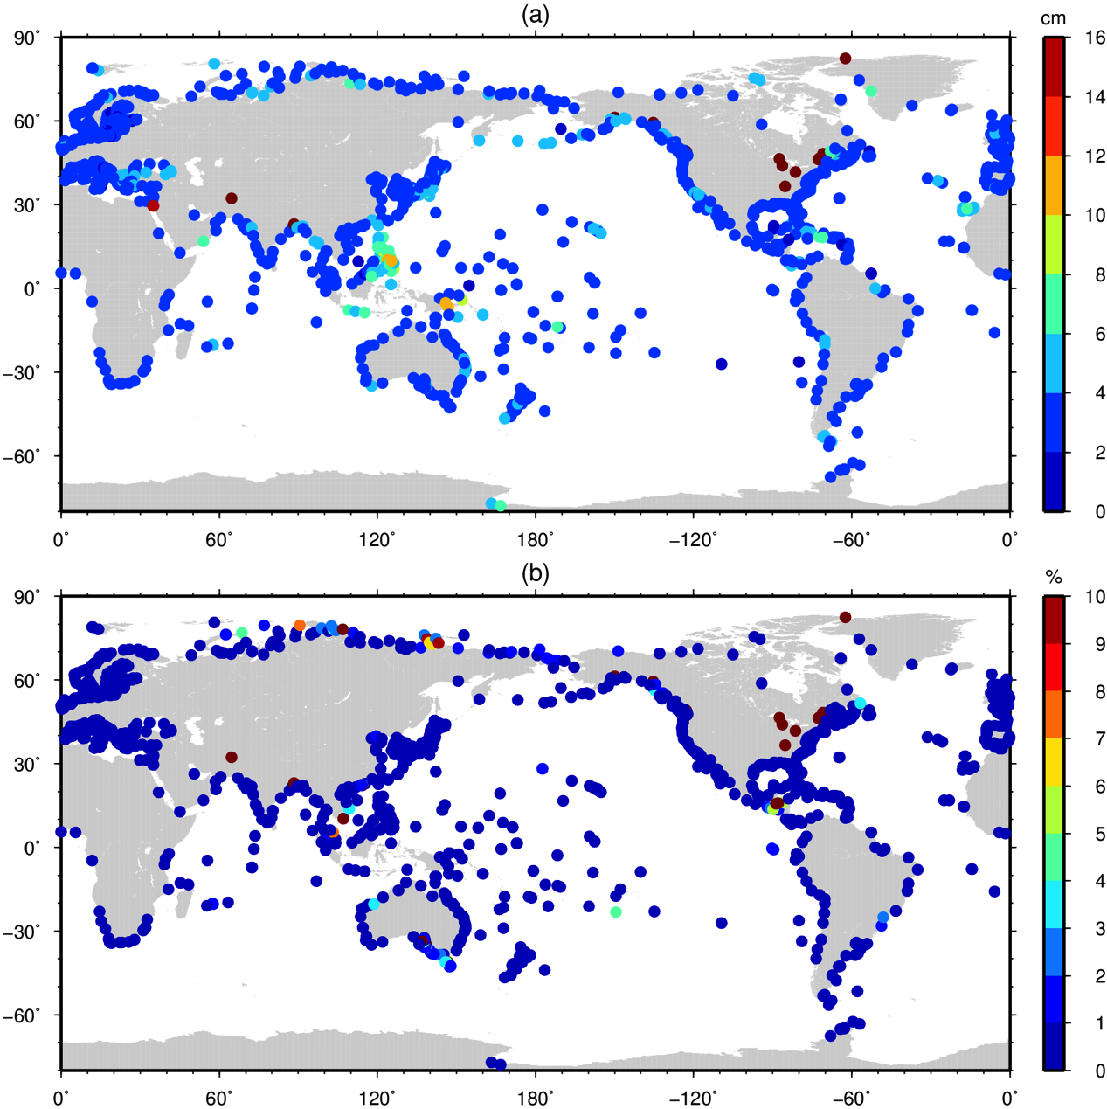
Figure 38. (a) DTU15 MSS errors at tide gauge locations. (b) Errors expressed relative to signal magnitude.

3.2.3. Geodetic coastal MDT

The MDT at the 1600 TG locations where calculated by the spectral approach using the DTU15 MSS and the five EGMs described above. The MSS was first reduced from 1 minute resolution to 1/12th of a degree resolution from which a set of spherical harmonics to coefficients to d/o=2190 was calculated. (A subsequent calculation of the spherical harmonic coefficients directly from the 1 min grid was performed but with negligible impact on the results presented below.)

An initial assessment of the CMDT computed in this way is presented in Figure 39 which shows the RMS difference between the geodetic CMDTs and nearest ocean values in OCCAM (panel a) for all 1600 TG locations. Ignoring the minimum that occurs before d/o=50 and the other smaller minimum at d/o=140 (which can be attributed to noise in the statistics) and focusing on the broad shape of the curves, the RMS difference relative to OCCAM reaches a minimum around d/o=200 for all of the models, with RMS differences growing at different rates beyond this. In line with expectations from the formal errors plotted in Figure 32, the RMS differences for the satellite only solutions grow much more rapidly than is the case for the combined solutions. Also in-line with expectations from the formal errors is that up to a certain d/o the errors for the GOCE-only GTIM5 solution are somewhat greater than the combined satellite solution GOCO05S. For the combined solutions, as expected from the formal errors, the RMS difference for GOCO05C is less than the two satellite only solutions but greater than for EIGEN-6C4. However, the RMS curve for EGM2008 goes against expectations, suggesting true errors that are lower than all the other models including EIGEN-6C4. This suggests that the formal errors from EGM2008 are too pessimistic and the difference in terms of the calculated MDT between the EIGEN-6C4 and EGM2008 is not as great as suggested by the GCE vs. MOE error analysis presented above.

Figure 39b presents a similar analysis but with RMS differences calculated relative to the GPS-CMDT estimate at the 303 GPS-TG locations. With the exception of the of the EIGEN-6C4 and EGM2008 models the ordering of the RMS differences is preserved. GTIM5 and GOCO05S again reach minimum values around d/o=200, with the RMS difference for the former model slightly greater, before growing much faster that the combined models. The combined models reach minima somewhat latter: d/o=308 for GOCO05C and EGM2008 and 374 for EIGEN-6C4. Although the EIGEN-6C4 RMS is less than EGM2008 for d/o>250, EGM2008 still has the lowest RMS difference (albeit marginally so) for d/o<250 and has the second lowest RMS for d/o>250. This again suggests that the EGM2008 formal errors are too pessimistic. This is further supported by the fact that the GPS estimate is based on the EIGEN-6C4 geoid, which may explain why the RMS difference is lower than EGM2008.

The RMS difference minima in Figure 39, particularly those in Figure 39b, are broadly in line with those suggested by the MOE/GCE cross-over analysis. Also, as one would expect the geodetic MDTs are in better agreement with the GPS-MDT than with the model MDT. For this analysis neither the geodetic CMDT values or the OCCAM MDT have been adjusted to the common 2003-2007 time period. However, the RMS difference between OCCAM and the GPS-MDT of 17 cm at d/o>100 suggests that it is noise in the geodetic MDTs that make the largest contribution to the RMS differences in both cases.

Figures 40 and 41 present a further comparison between the geodetic MDT estimates and the OCCAM (left panels) and GPS (right panels) CMDT estimates at the TG locations. For the OCCAM comparisons the geodetic MDTs have been truncated at d/o=200 as suggested by the RMS difference minima shown in Figure 39a, while for the GPS-MDT comparisons they have been truncated at d/=200 for GTIM5 and GOCO05S, d/o=308 for GOCO05C and EGM2008 and d/o=374 for EIGEN-6C4 as suggested by the RMS difference minima of Figure 39b. The comparisons with OCCAM show there is little to separate the EGMs, with the “worst” performing model (GOCO05S) having an r-squared value of 0.53 and a residual standard error (RSE) of 29.0 cm compared with values of 0.6 and 27.7 cm for the “best” performing model (EGM2008). The similarity of the distribution of points, suggest a common source of error in the geodetic MDTs, namely the DTU15 MSS.

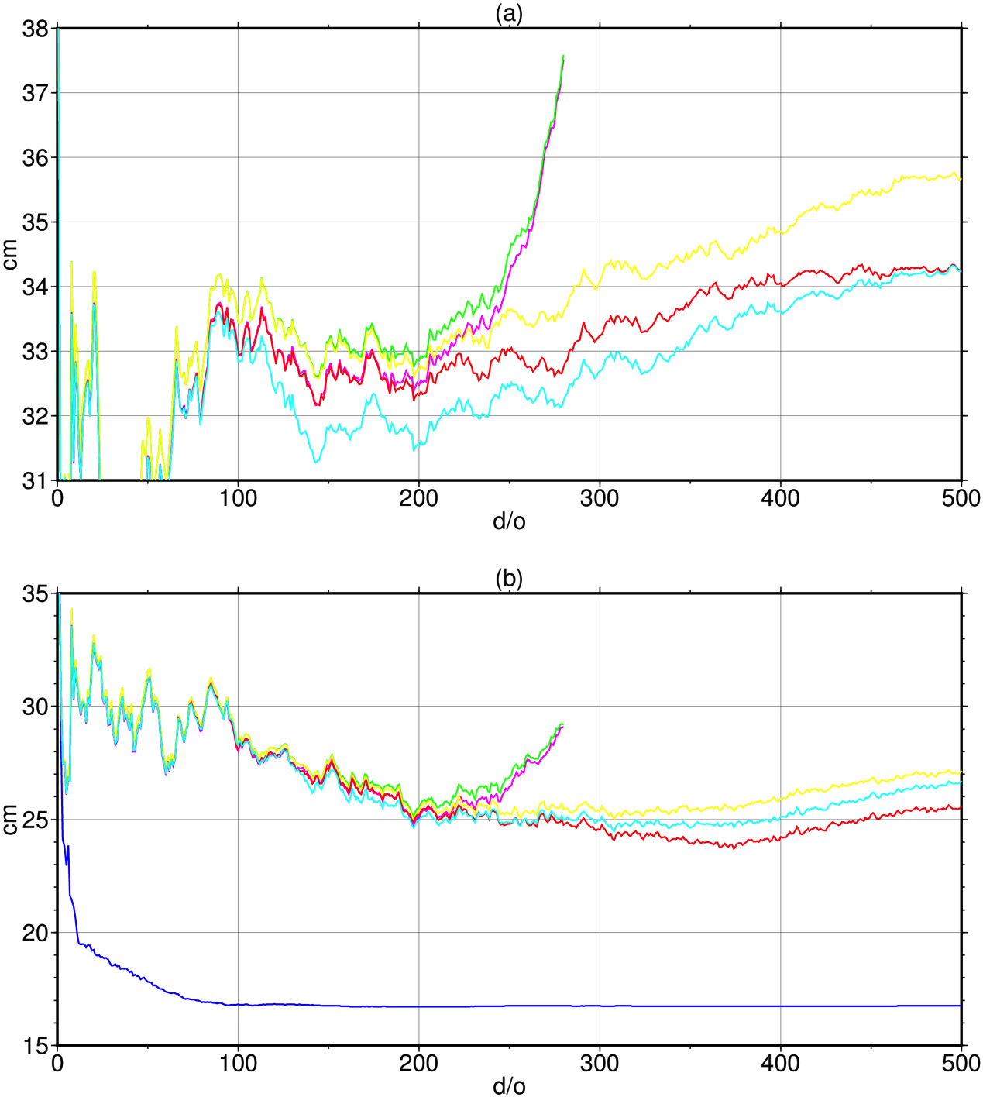
Figure 39. (a) The RMS difference calculated over the 1600 tide gauge location between geodetic MDTs and the OCC12 MDT with the geodetic MDTs calculated using the DTU15 MSS and the GTIM5 (green), GOCO05S (magenta), GOCO05C (yellow), EIGEN-6c4 (red) and EGM2008 (cyan) gravity models. (b) Repeating (a) but with RMS differences relative to the GPS-EIGEN_6c4 MDT and also including the RMS difference with OCC12 (blue).
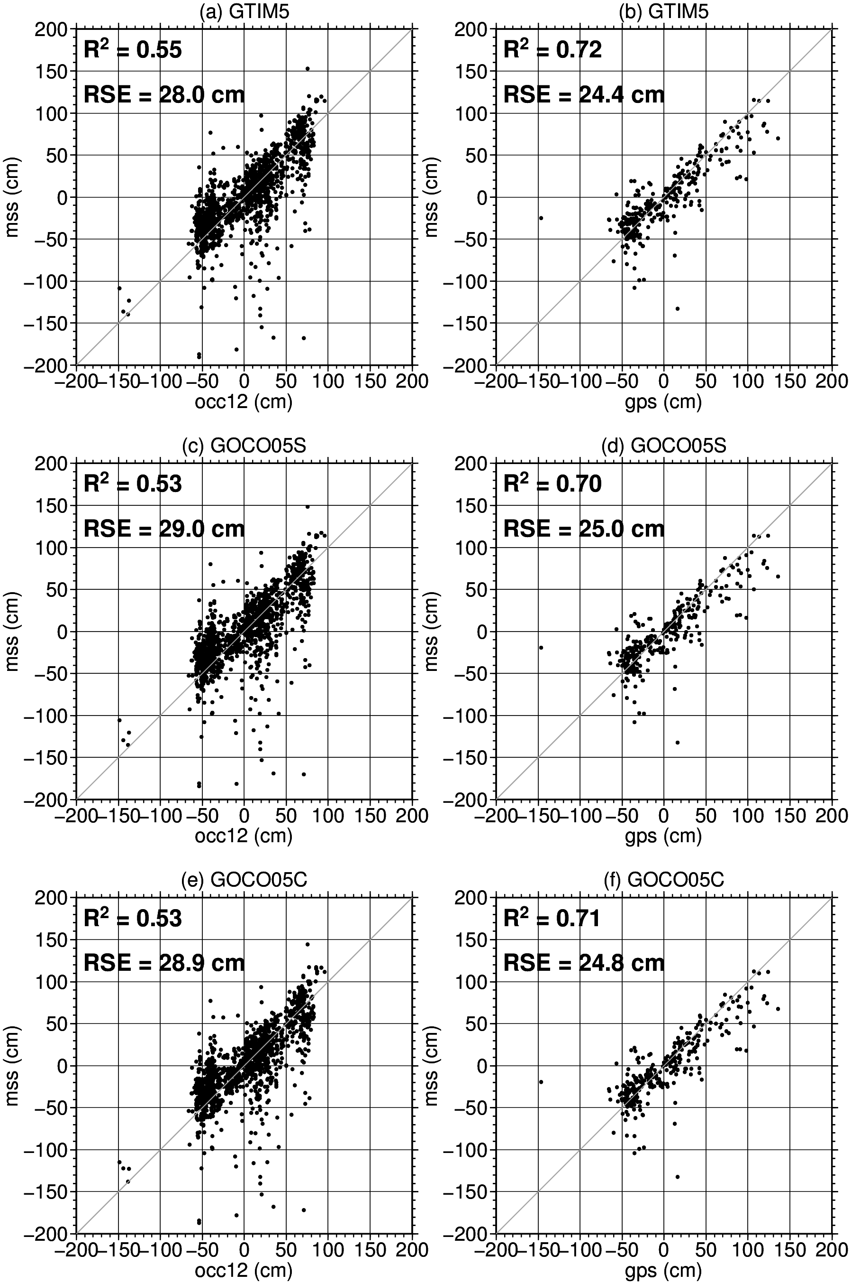
Figure 40. Scatter plots of the geodetic MDT values (y-axes) against (left) OCC12 at the 1600 tide gauge locations and (right) the GPS-MDT ad the 303 GPS tide gauge locations for (a, b) GTIM5 (d/o=200), (c, d) GOCO05S (d/o=200), (e, f) GOCO05C (d/o=200, 308).
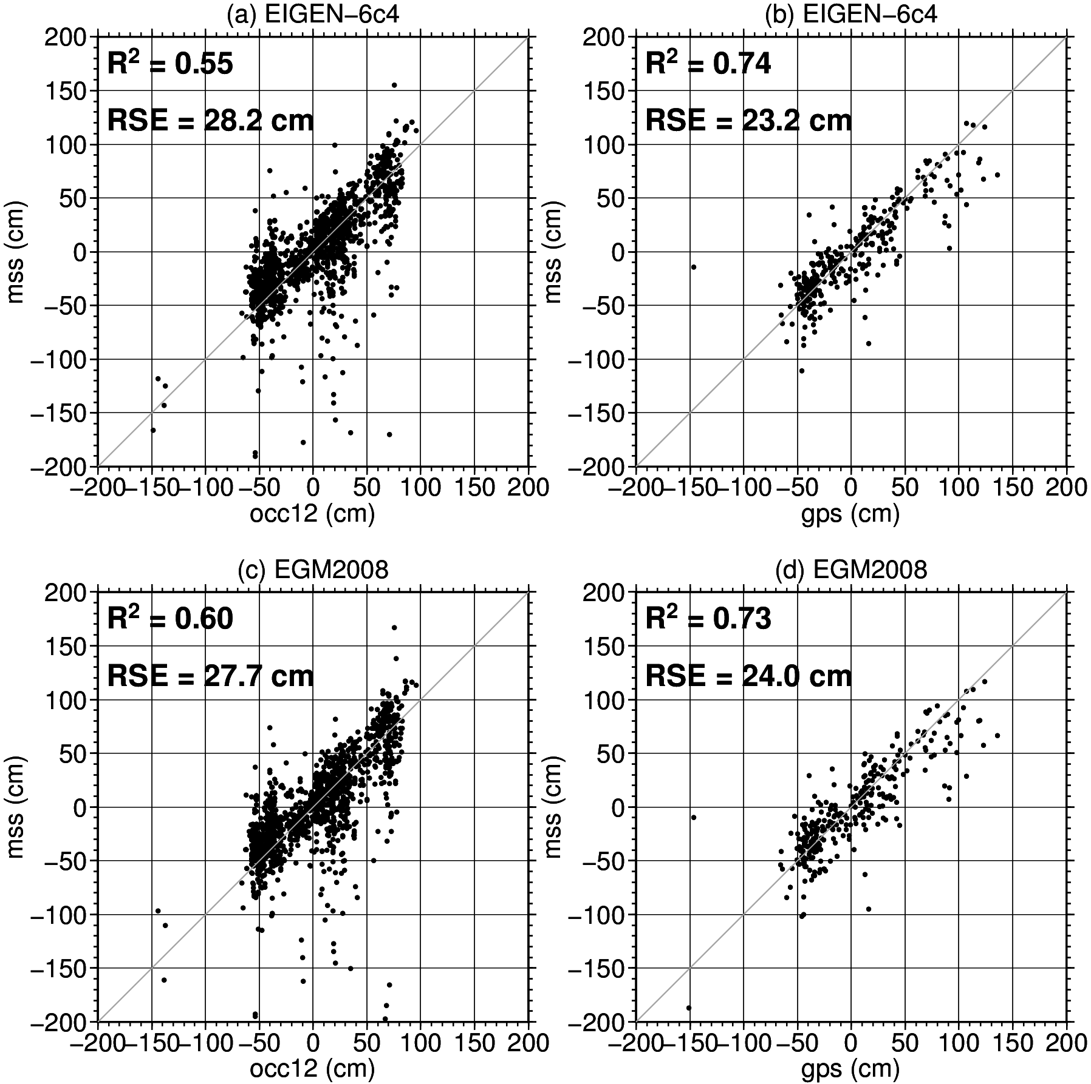
Figure 41. Scatter plots of the geodetic MDT values (y-axes) against (left) OCC12 at the 1600 tide gauge locations and (right) the GPS-MDT ad the 303 GPS tide gauge locations for (a, b) EIGEN-6c4 (d/o=200, 374) and (c, d) EGM2008 (d/o=200, 308).

Confirming Figure 39b there is better agreement with the GPS-MDTs, with r-squared values ranging from 0.70 for GOCO05S to 0.74 for EIGEN-6C4 and RSE’s ranging from 25 cm for GOCO05S to 23.2 cm for EIGEN-6C4. Again the distribution of points suggest a common source of noise in the geodetic MDT estimates.

Finally, Figure 42 shows the relatively good agreement between the OCCAM MDT and the GPS-MDT, confirming the geodetic MDTs are the primary contributors to the RMS differences and residual square errors.

Figure 42. A comparison between the GPS-EIGEN64C and OCCAM12 MDT estimates.

Thus far the analysis has only considered raw, unfiltered geodetic CMDT values. However, the above analysis demonstrates that some form of filtering is required to improve the geodetic CMDT. Filtering presents a number of challenges, especially in the coastal zone. Firstly, one must try to minimise signal attenuation. For the coastal zone this is particularly important for regions where a narrow boundary current is present just off shore. Here filtering can smear the MDT height on the ocean side of the current onto the coast resulting in an over (or under) estimate of the true MDT height. It can also blur step changes and features that may be of particular oceanographic interest. A second problem is that in the MSS the land-sea boundary is blurred and not clearly identified. An error estimate that flags pure geoid values is provided. However, some of that information will be lost if reducing the MSS to a coarser grid. This makes identifying true MDT values and excluding “almost-geoid minus geoid” values (≈0) when filtering difficult. Third, effective filtering in the coastal zone is hampered by the fact that the filter window will not be symmetrical around the coastal point in at least one direction. For these reasons simple filtering is often not effective at removing noise while preserving signal in the coastal zone. Noise can be removed but at the expense of signal resolution.

In attempt to address some of these issues a two-stage filtering method was developed. The first stage involves screening the geodetic MDT for outliers and replacing them with suitable values. This is done globally. The second stage applies a filter to the screened MDT values to obtain an estimate of the MDT at a given coastal location.
For this initial analysis geodetic MDTs where calculated on same 1/12th of a degree grid as the OCCAM MDT. Screening for outliers was performed as follows:

- For each point of the global grid a mean height is calculated within a window of a suitable radius around that point. Here suitable is defined as the radius required to reduce the difference between the mean height from the geodetic MDT and the mean height from the OCCAM MDT calculated in the same radius window below some threshold value (40 cm).
- The window mean value is then subtracted from all of the GMDT values within the window.
- These anomalous values are then screened for outliers by comparing with a range distribution estimated using (for now) the OCCAM model (Figure 43 and Figure 44b). Any values that exceed the expected range for that sized box by one standard deviation are considered to be outliers and are replaced by the mean value within that window. This could be refined by using a wider range of models the estimate the expected range for a given window size.
- Finally at each coastal (TG) location a filtered MDT estimate is obtained by filtering the screened global MDT in a window of a particular radius around the point. Here the filter radius is determined by modelling the attenuation of the filter using the OCCAM MDT and choosing the filter radius such that the attenuation does not exceed some threshold value (1 cm). This radius is illustrated in Figure 44a.

For this initial analysis no attempt was made to use knowledge of the formal errors and the GMDTs were not computed to an optimum d/o but this could easily be implemented. Also at this state the additional information and constraint provided by the GPS-MDT has not being used. This could also be incorporated into a refined approach.

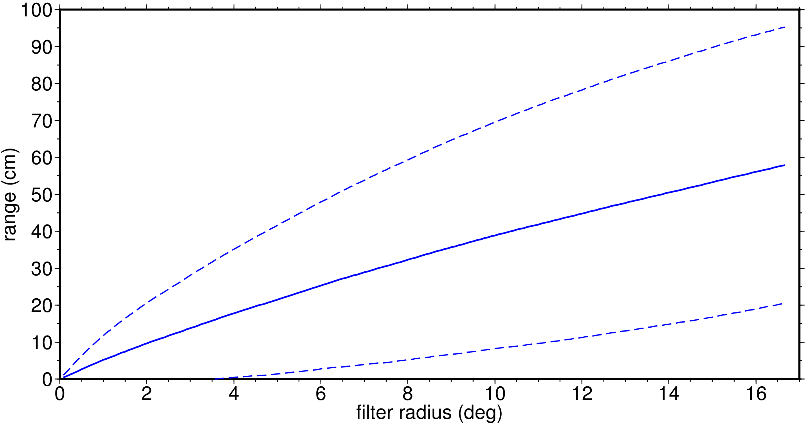
Figure 43. The mean maximum departure from the tide gauge MDT as a function of box radius surrounding the TG point. Dashed lines represent one standard deviation. Values based on the OCC12 MDT.

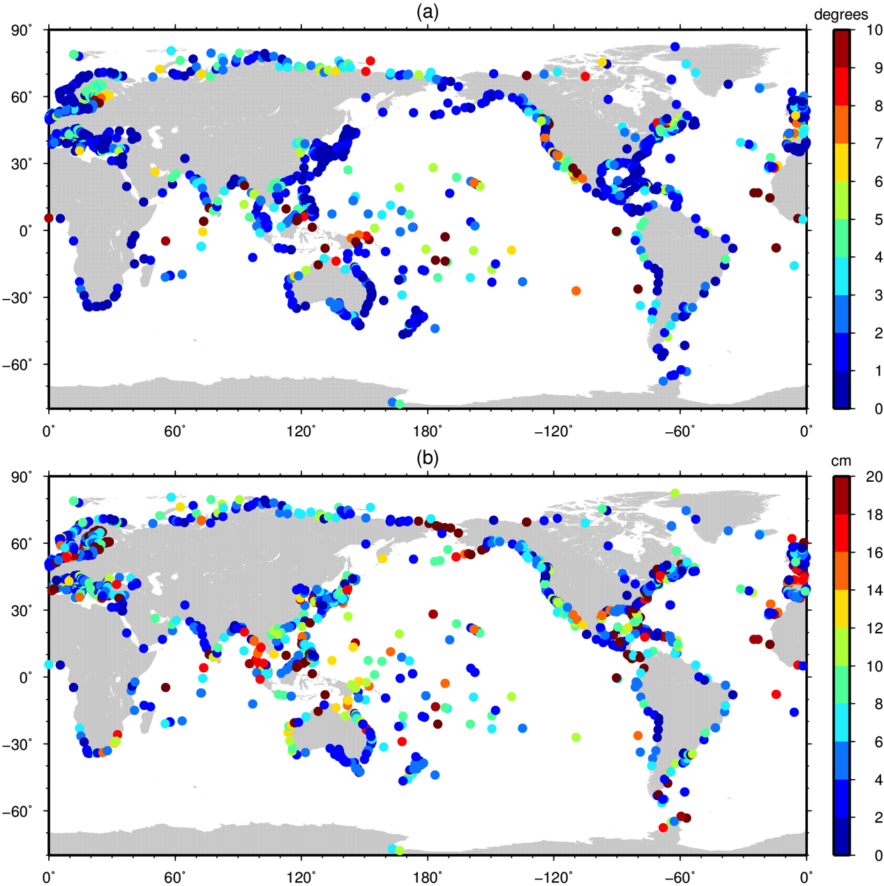
Figure 44. (a) Box-car filter radius that attenuates the MDT by 1 cm. (b) The maximum departure from the tide gauge MDT in a box of radius 5 degrees surrounding the TG point. Values based on the OCC12 MDT.

In spite of the limitations of the filtering method, it is quite successful at reducing the noise in the GMDT estimates and improving the fit with the model and GPS-MDTs. Figures 45 and 46 show scatter plots of the TG MDT estimates from the geodetic MDTs against the GPS-MDT values before (left panels) and after (right panels) screening and filtering. In this case the GMDTs have been computed to the maximum d/o of the EGM (hence the unfiltered values are somewhat different than for the earlier plots). R-squared values have now improved from around 0.7 to around 0.9 and the RSE has reduced from around 26 cm to 16 cm. The best performing model is GOCO05C with an r-squared value of 0.89 and the RSE of 15.4 cm. However, there is very little to separate the models, with the worst performers – the two satellite only EMGs – having r-squared values of 0.87 and RSE’s of 16.4 cm. These could potentially be improved by taking account of the MOE/GCE cross-over points to avoid the introduction of additional noise. The similarity of the RSE values with those from the GPS/OCCAM comparison shown in Figure 42, points to noise in the GPS solution now being the limiting factor in this analysis.

Figures 47 and 48, provide a comparison with OCCAM over the 1600 TG locations. Again there is a marked improvement with r-squared values increasing from around 0.55 to 0.77 and the RSE values decreasing from around 28 cm to about 20 cm. There is once again little to separate the models but with the GOCO05C being marginally the best performer with an r-squared value of 0.78 and an RSE of 19.7 cm.

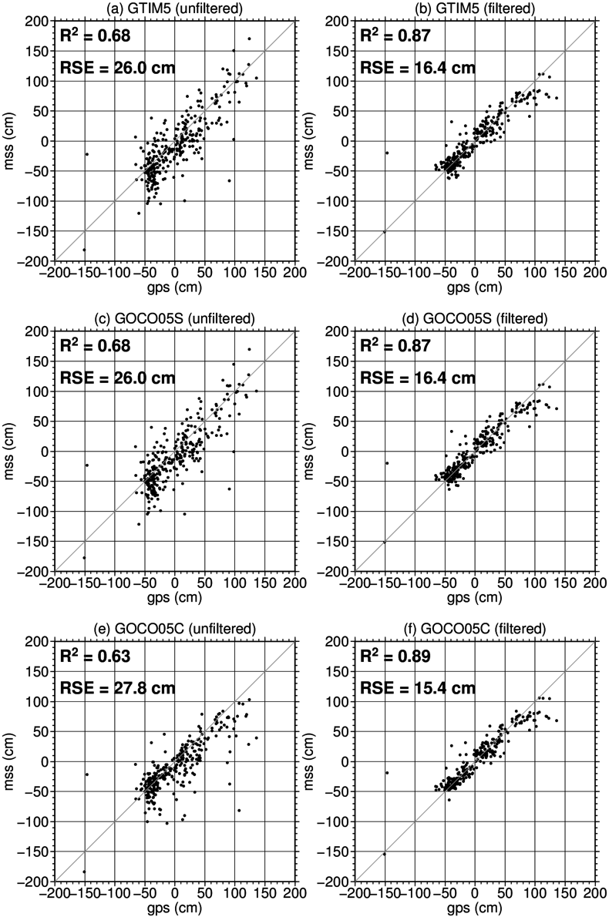
Figure 45. A comparison between the GPS-EIGEN64C and DTU15-geoid MDT estimates. (a) GOCE-TIM5 (d/o=280) with no filtering. (b) As in (a) but with filtering. (c, d) Repeating (a, b) for GOCO05S (d/o=280). (e, f) Repeating (a, b) for GOCO05C (d/o=720).

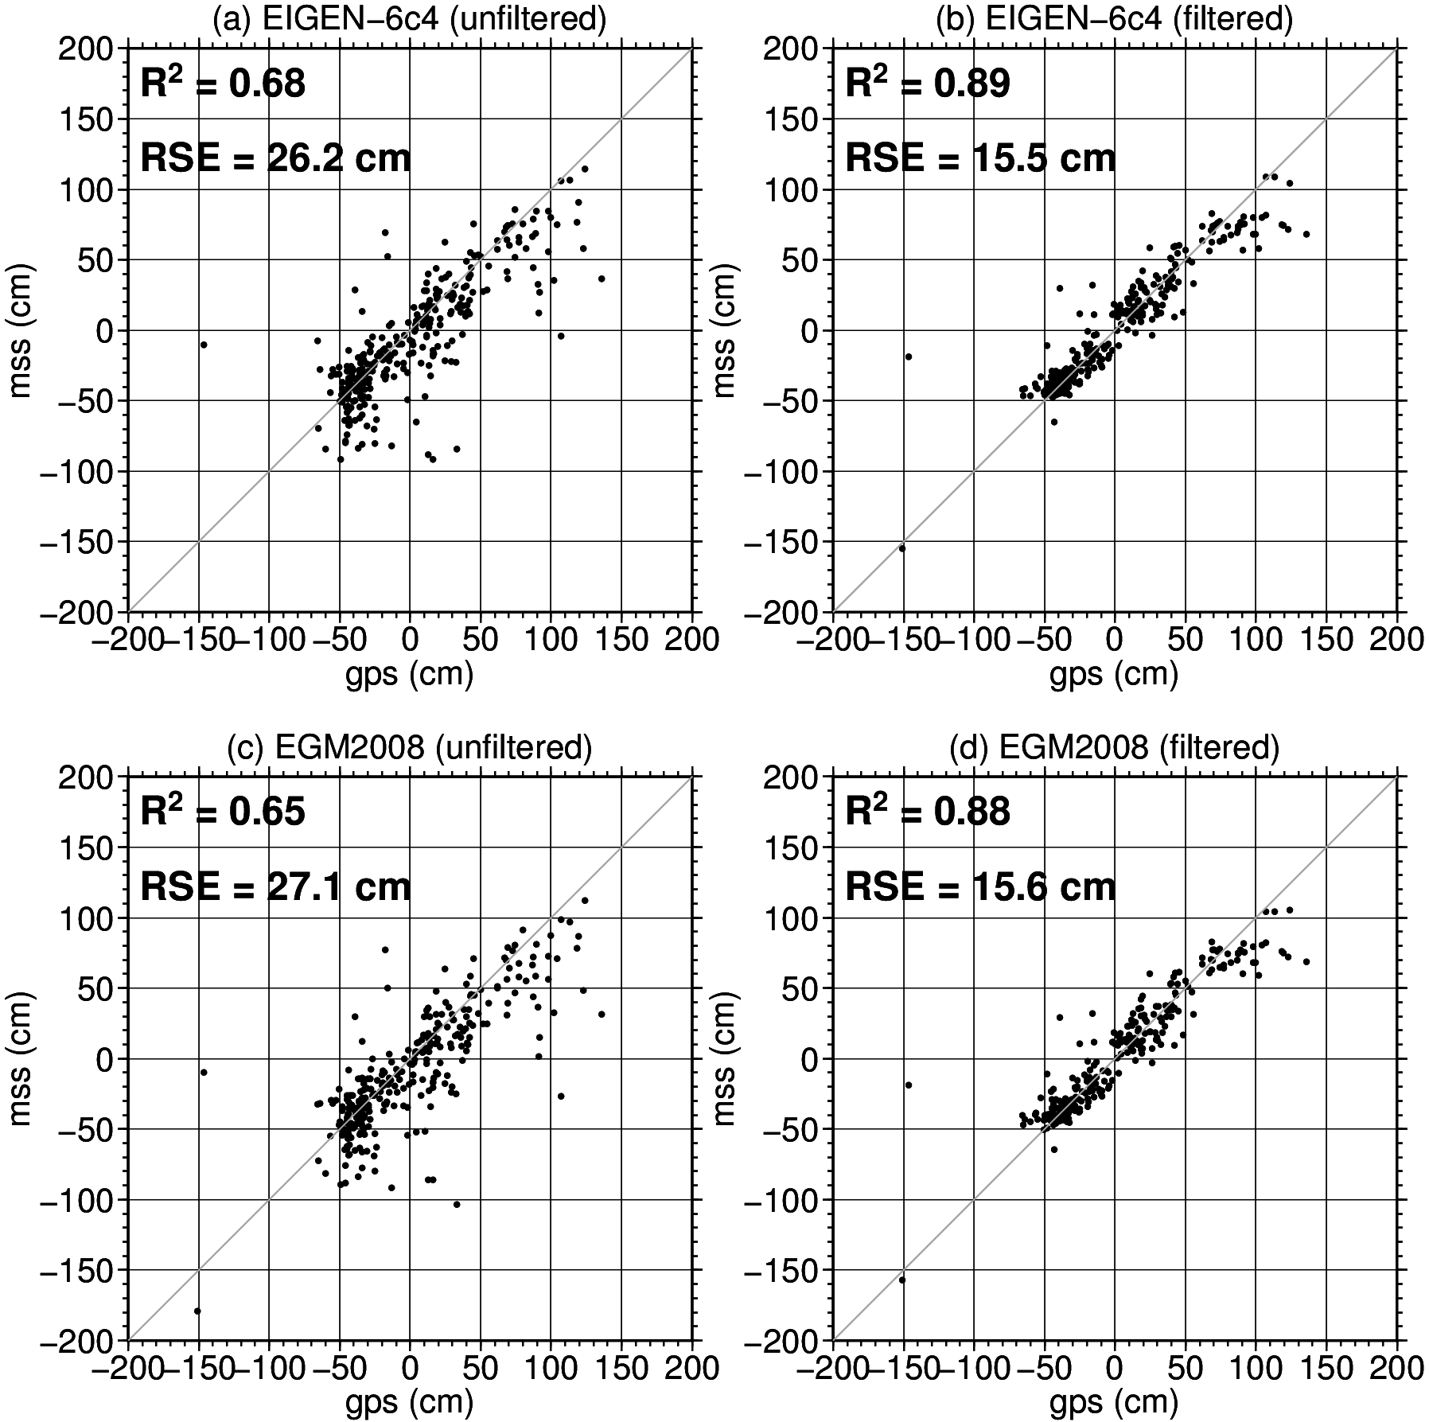
Figure 46. A comparison between the GPS-EIGEN64C and DTU15-geoid MDT estimates. (a) EIGEN-6c4 (d/o=2190) with no filtering. (b) As in (a) but with filtering. (c, d) Repeating (a, b) for EGM2008 (d/o=2190).

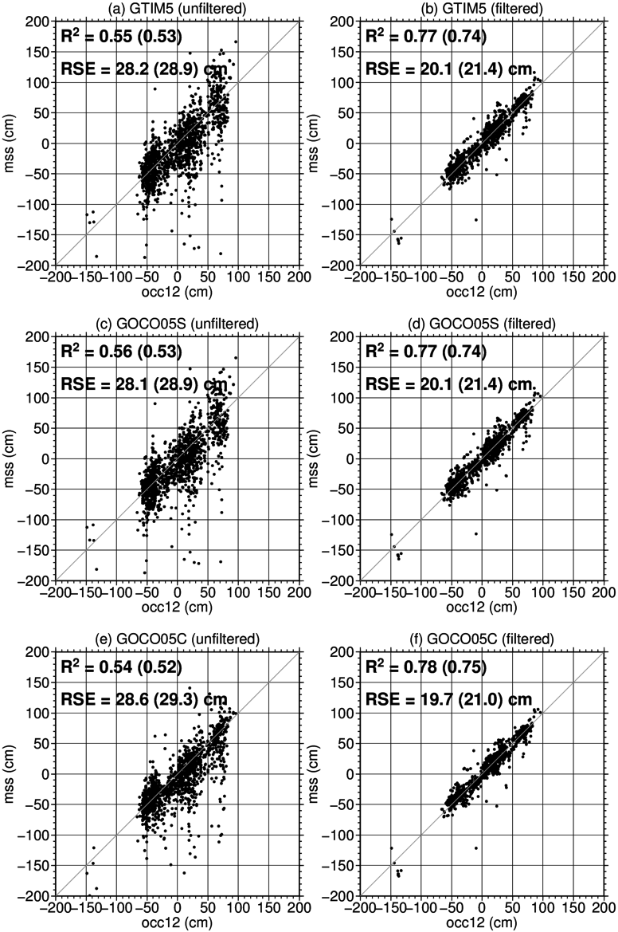
Figure 47. A comparison between OCCAM12 and DTU15-geoid MDT estimates. (a) GOCE-TIM5 (d/o=280) with no filtering. (b) As in (a) but with filtering. (c, d) Repeating (a, b) for GOCO05S (d/o=280). (e, f) Repeating (a, b) for GOCO05C (d/o=720). Values in parenthesis are calculated for GPS locations only.

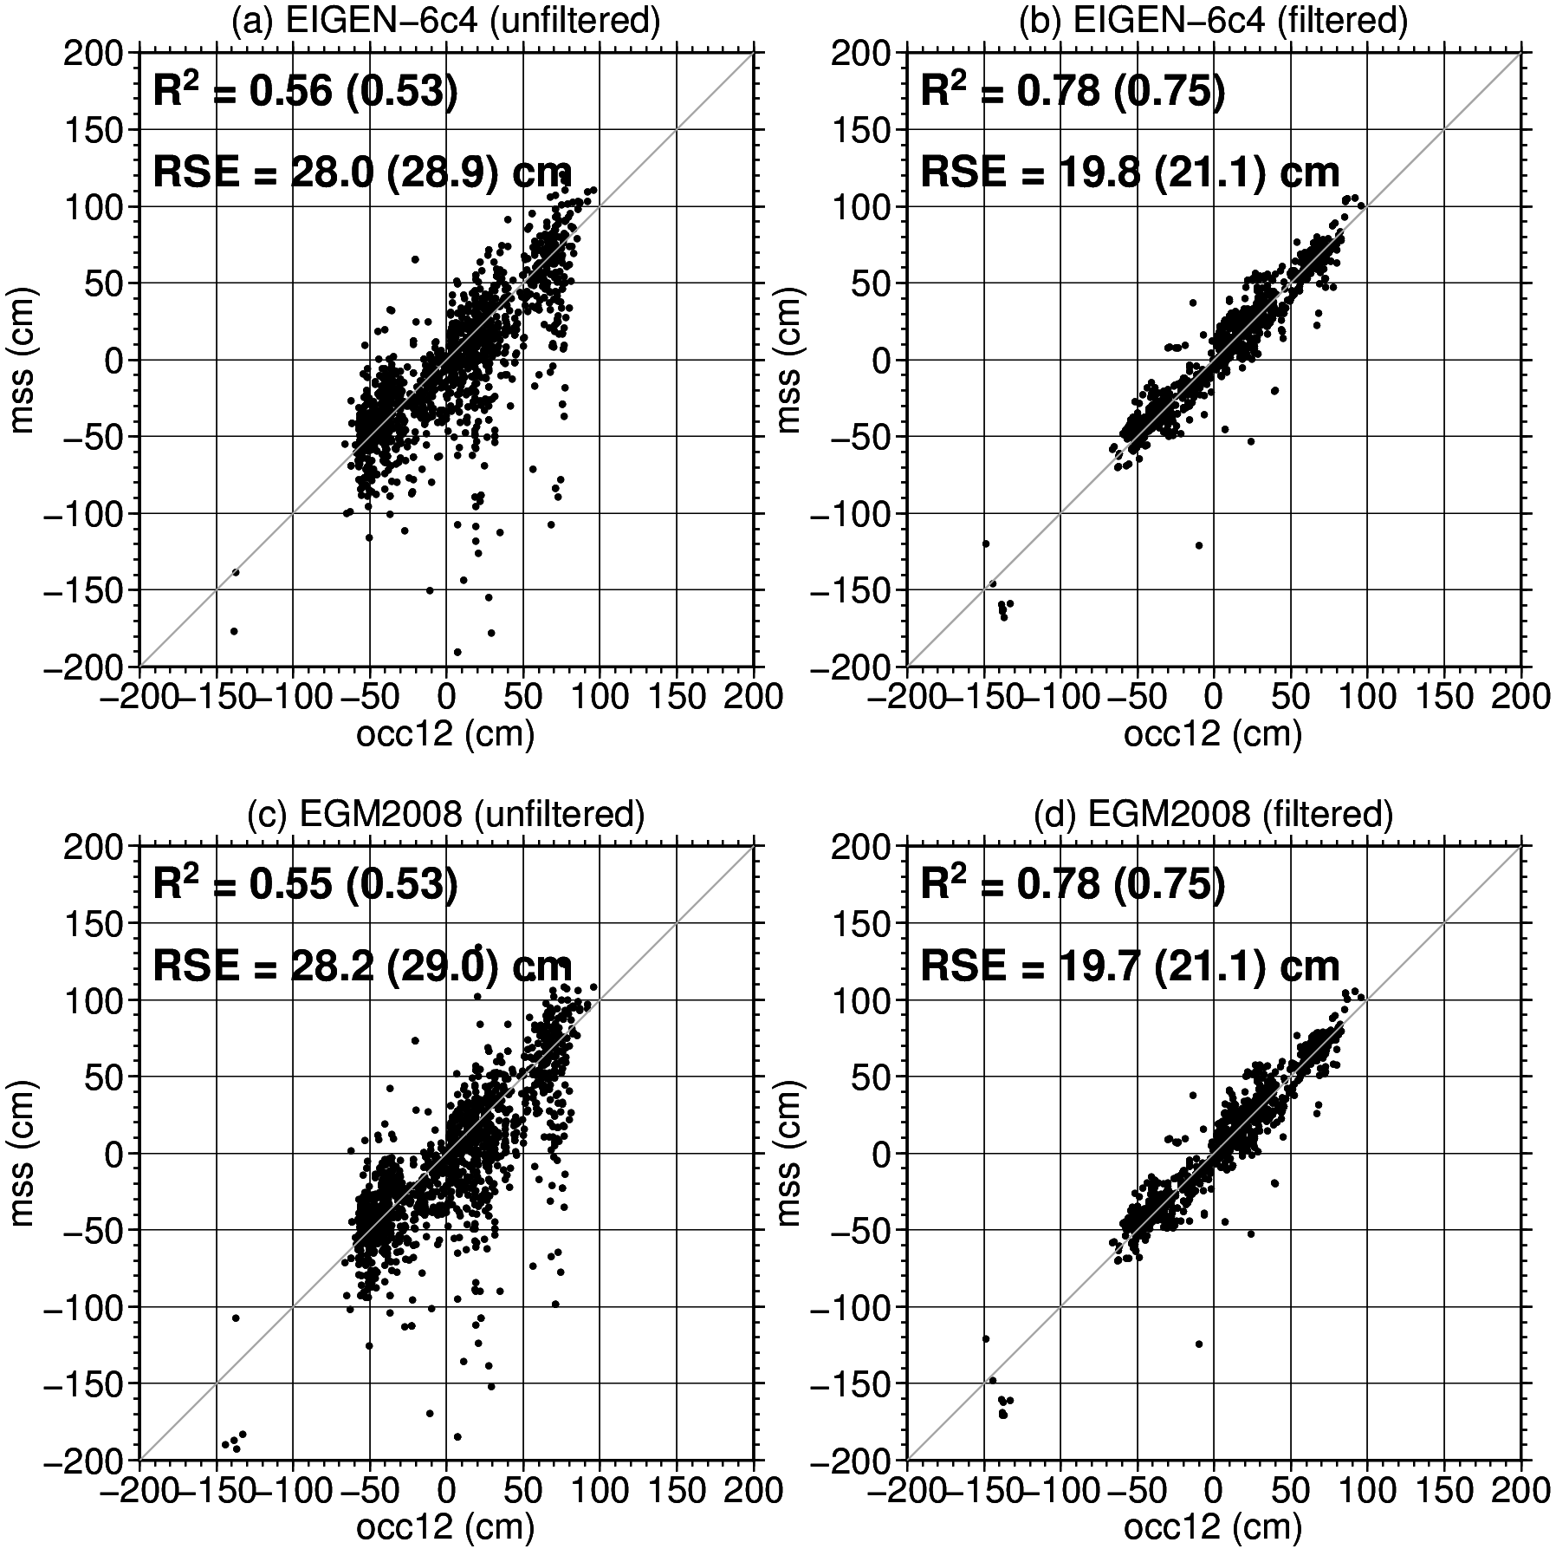
Figure 48. A comparison between OCCAM12 and DTU15-geoid MDT estimates. (a) EIGEN-6c4 (d/o=2190) with no filtering. (b) As in (a) but with filtering. (c, d) Repeating (a, b) for EGM2008 (d/o=2190). Values in parenthesis are calculated for GPS locations only.

Finally, we examine the ability of this approach to estimate a continuous CMDT along several stretches of coastline. The analysis is again conducted on the 1/12th of a degree OCCAM grid, with the coastline being defined by this model. Ultimately, however, the analysis will be conducted on the native 1 min MSS grid with the coastlines defined using e.g. GEBCO. (This work is on-going but it was not possible to complete it with the timeframe of this deliverable.)

Figure 49 shows estimates of the CMDT for Australia, traced clockwise from the north, from the for the five EGMs for a range of truncations. For comparison the OCCAM MDT is also shown. The unfiltered versions illustrate the problem of noise in the geodetic CMDT estimates, the need for some form of filtering and the challenge of removing this noise while preserving the signal. The noise grows with increasing d/o but remains relatively similar across models, pointing the DTU15 MSS as the common dominant error source. The noise is of comparable magnitude to the signal and is thus difficult to remove while preserving the signal. The right hand panels show that after applying the screening and filtering approach outlined above the noise is much reduced and a CMDT quite similar to that from OCCAM is obtained, including the step across the Torres Strait, which is somewhat more pronounced than it is in OCCAM. An interesting difference is revealed down the eastern Australian coast, where instead of the smoothly declining CMDT seen in the model, the observations suggest a more stepwise decline with a plateau followed by a sharp drop with a subsequent smaller plateau and a further drop. Inspection of the full MDT suggests this to be a reflection of true oceanographic differences between the model and the observations rather than observational error. The solutions for d/o=720 and 2190 after filtering are generally smoother than those at lower truncations, but some residual noise remains. This can be removed by changing the filter parameters. However this is at the expense of resolving the sharp feature in the CMDT. The GPS-MDT values plotted in black are in broad agreement with the geodetic and model CMDTs, although several along the north Australian coast seem too high. More generally the noise in the GPS values appears greater than that in the filtered geodetic MDTs.

Figure 50 shows the CMDT around the coast of Southern Africa. Again, after filtering the, the geodetic and model estimates are in broad agreement. However the observations suggest a sharp drop in sea level not seen to the same extent in the model. Inspection suggest that this is also a true oceanographic difference related to a sharper transition than is seen in the model between the warm water of the Indian Ocean and the cool waters from the south Atlantic that leak around the cape to where the Agulhas Current separates from the coast. The two GPS heights from this regions support this sharp transition.

Figure 51 shows the CMDT for the coast of South America. This coast is traced from the equatorial western Atlantic, down to Drake Passage and up to the equatorial eastern pacific. This coast shows the greatest difference between the model and the geodetic CMDTs. Most notably the model shows a peak around grid point 1500. In the model this peak corresponds to a small region of elevated MDT along the western Patagonian coast that is not seen in the observations. However, this is a region of elevated noise and a very convoluted and broken coast line and the opposing drop in the geodetic CMDTs centred on grid point 1500 is likely error also. More work is required to improve this screening and filtering in this region. Better agreement is found with regard to the increasing CMDT over the remainder of the section travelling northwards along the coast of Chile.

Finally, for interest, in figure 52 the South American CMDT shown in figure 51 is continued around the entire Pacific and Indian Ocean basins and into the Atlantic basin (encompassing the section shown in figure 50). With the exception of the some isolated spikes the agreement between the model and the geodetic CMDTs is good. However, more work (on-going) is required to improve the noise removal while preserve the interesting features of the CMDT.

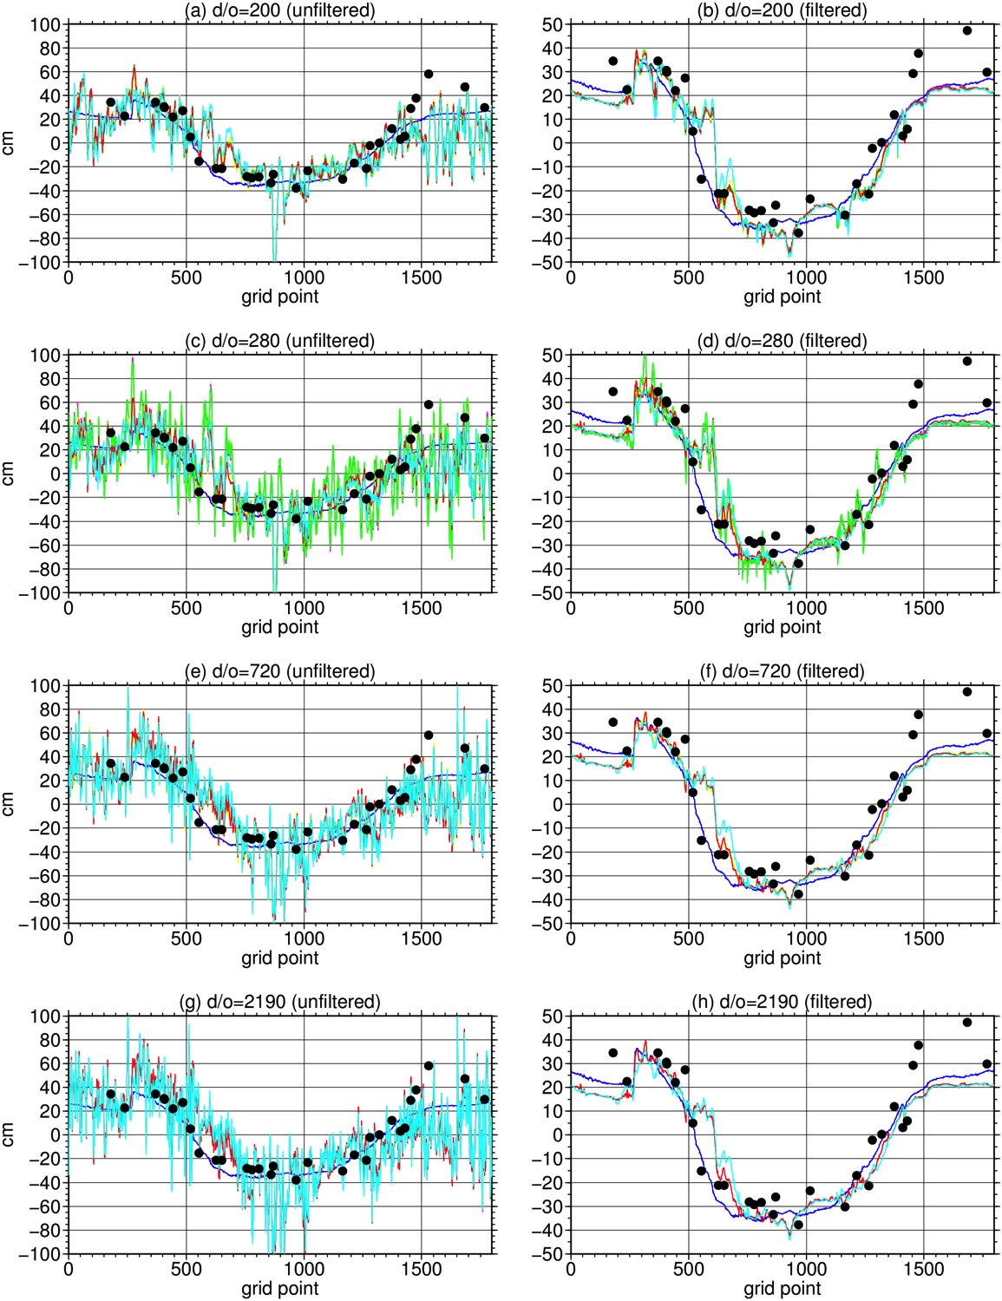
Figure 49. The Australian coastal MDT determined from the DTU15 MSS and a range of gravity models over a range of truncations: GOCE-TIM5 (black), GOCE-DIR5 (green), GOCO05S (blue), GOCO05C (magenta), EIGEN-64C (cyan) and EGM2008 (yellow). The OCCAM coastal MDT is shown in red and the black dots represent the GPS-EIGEN64C MDT. The unfiltered and filtered MSS-geoid MDTs are shown in the left and right panels respectively.

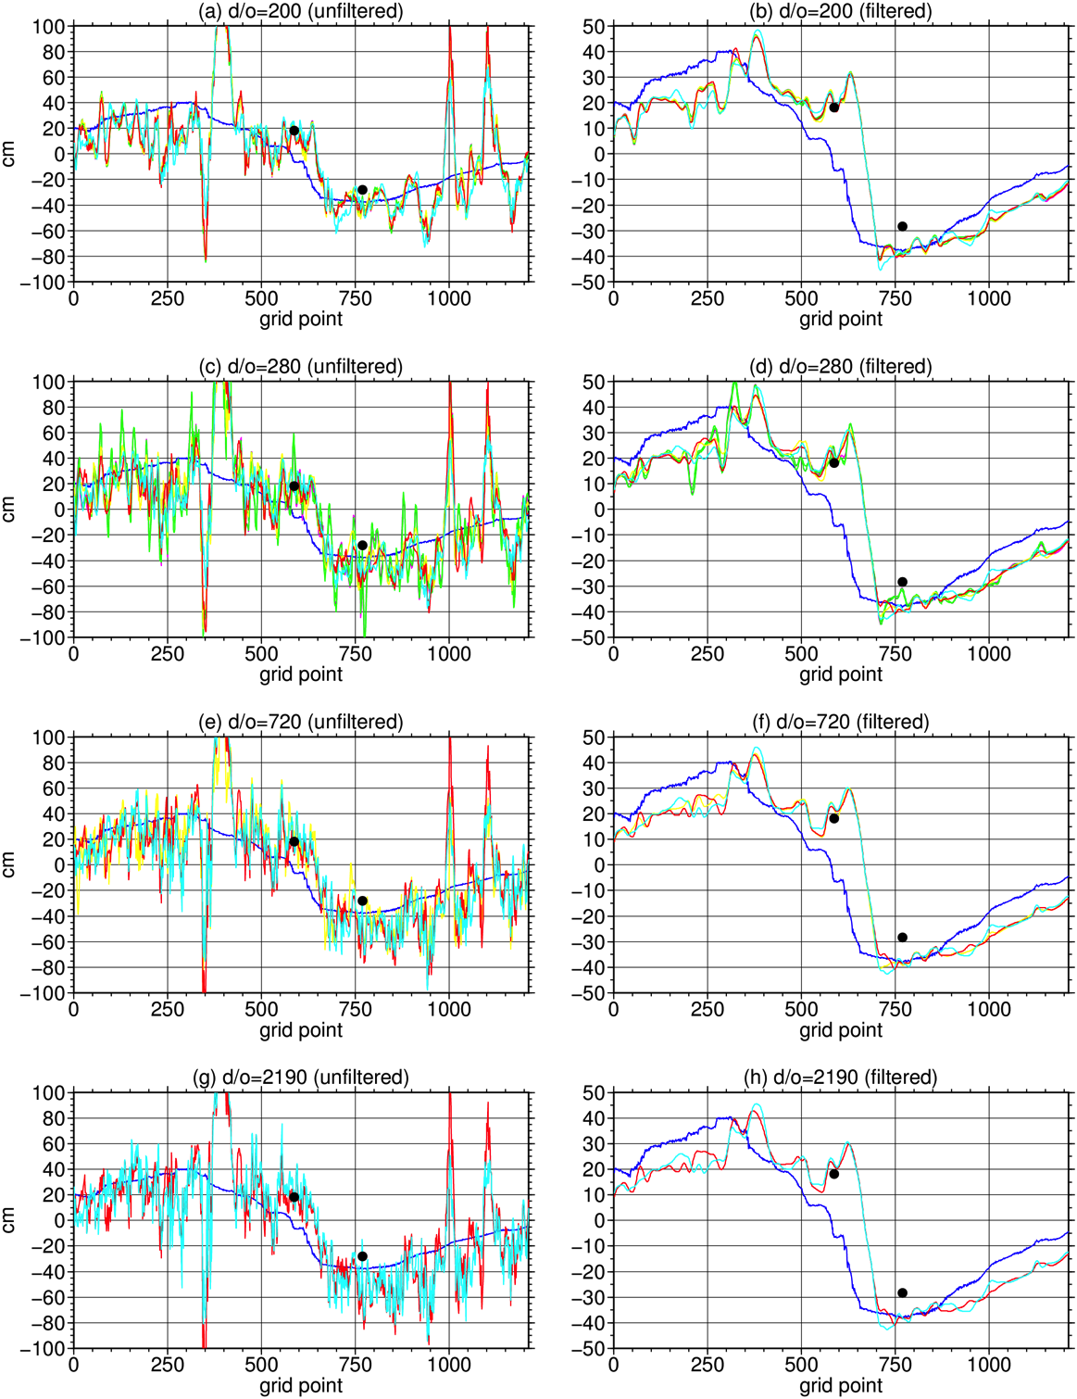
Figure 50. The Southern African coastal MDT determined from the DTU15 MSS and a range of gravity models over a range of truncations: GOCE-TIM5 (black), GOCE-DIR5 (green), GOCO05S (blue), GOCO05C (magenta), EIGEN-64C (cyan) and EGM2008 (yellow). The OCCAM coastal MDT is shown in red and the black dots represent the GPS-EIGEN64C MDT. The unfiltered and filtered MSS-geoid MDTs are shown in the left and right panels respectively.

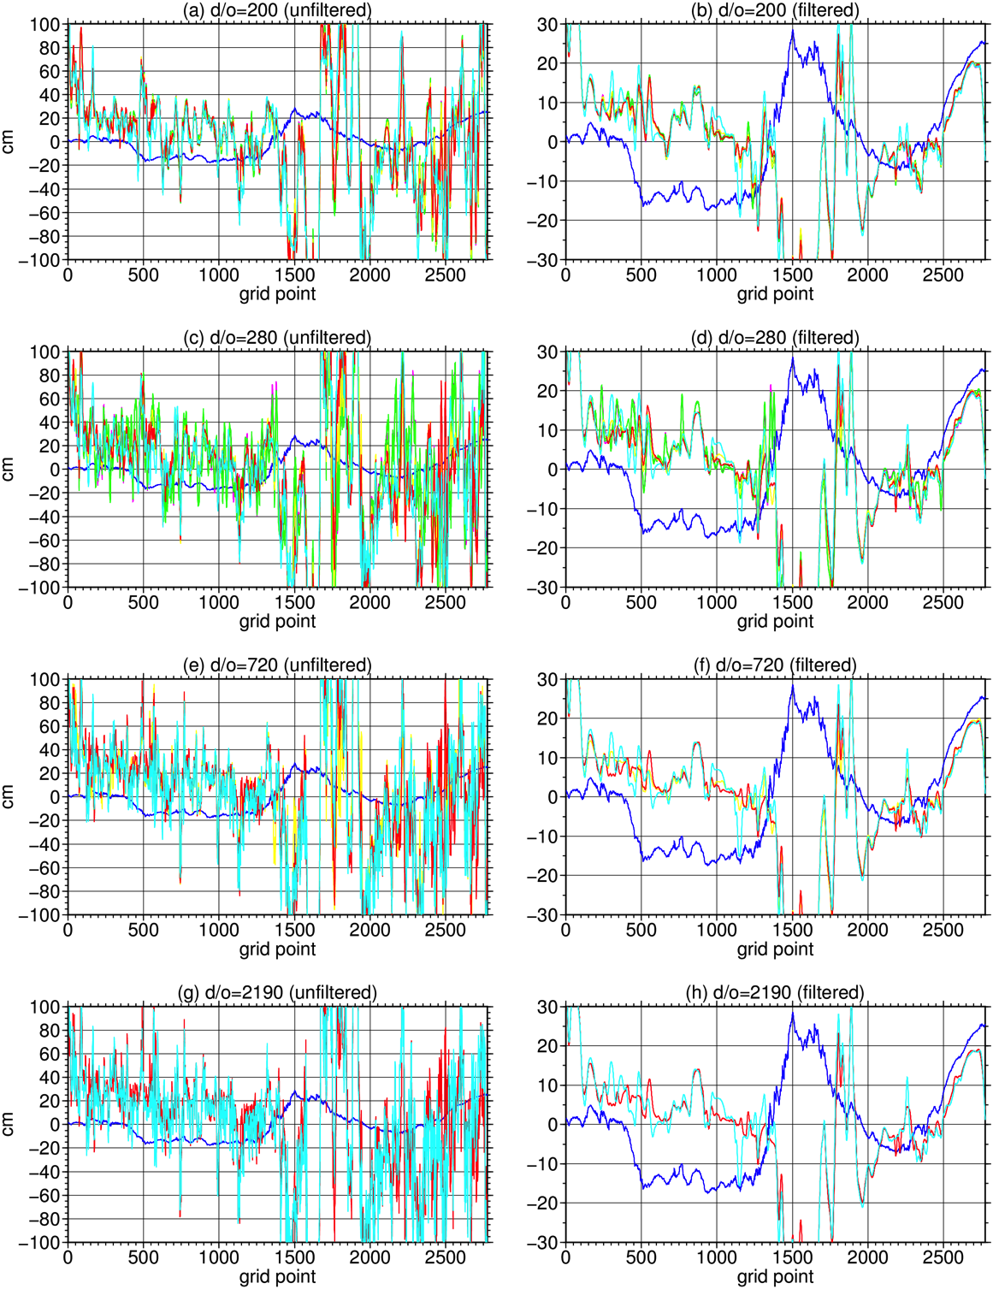
Figure 51. The South American coastal MDT determined from the DTU15 MSS and a range of gravity models over a range of truncations: GOCE-TIM5 (black), GOCE-DIR5 (green), GOCO05S (blue), GOCO05C (magenta), EIGEN-64C (cyan) and EGM2008 (yellow). The OCCAM coastal MDT is shown in red. The unfiltered and filtered MSS-geoid MDTs are shown in the left and right panels respectively.

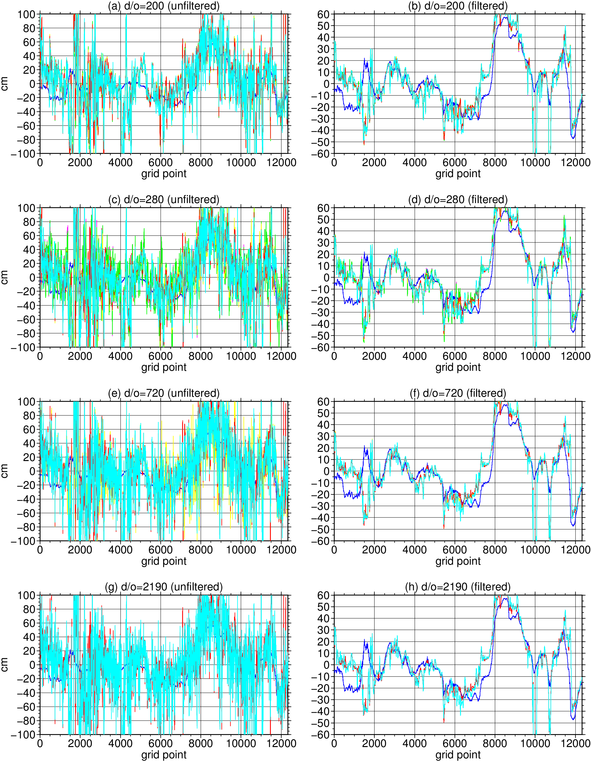
Figure 52. The South Atlantic (east coast), Pacific, Indian and South Atlantic (west coast) coastal MDT determined from the DTU15 MSS and a range of gravity models over a range of truncations: GOCE-TIM5 (black), GOCE-DIR5 (green), GOCO05S (blue), GOCO05C (magenta), EIGEN-64C (cyan) and EGM2008 (yellow). The OCCAM coastal MDT is shown in red. The unfiltered and filtered MSS-geoid MDTs are shown in the left and right panels respectively.

WP3300 Coastal Altimetry and MSS accuracy

The aim of this section is two fold.
Initially to assess the accuracy of current state of the art MSS models (DTU13MSS) in the 10 km coastal zone. Here a particular effort is put to study the influence of tidal residuals on MSS determination and its effect on degradation of MSS near coast.
(DTU Space Lead)

The Second aim is to investigate the effect of the SAR altimetry selected at distance smaller than 150 Kilometers from the coast.
UBonn and DTU Space.

3.3.1 Comparative assessment of coastal and geodetic MDT along the coast of Norway.

This investigation has been carried as an extension to the work by Vegard Ophaug (NMBU, Norway ). K. Breili (Statens Kartwerk, Norway) and C. Gerlach (Bavarian Academy of sciences, TUM, Munich, Germany) in close corporation with Martina Ivanowisz (NMBU, Norway) during a sabattical at DTU Space where the work was extended to include DTU13/DTU15 model and Cryosat-2 altimetry in the coastal zone.

The reason for preferring the Norwegian coastal zone to some of the other test regions in the project is the availability of a high resolution coastal model and high quality tide gauge information at a rate of 10 minutes along with sea level pressure information at all tide gauges during the 2010-2016 period that Cryosat-2 has been operating. This was not readily available in any other region.

In this comparative study various geoids were assessed in a combination with ocean and geodetic MDT models listed and detailed in Table 3.3.1.1. The ocean models were provided for the study by C. Hughes and the MSS model provided by O. Andersen.

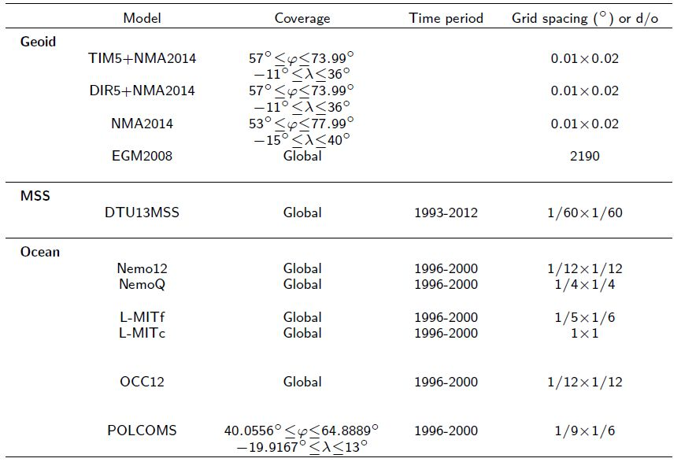

Table 3.3.1.1 Details and specification of the geoids, MSS and ocean models assessed in the Norwegial coastal study.

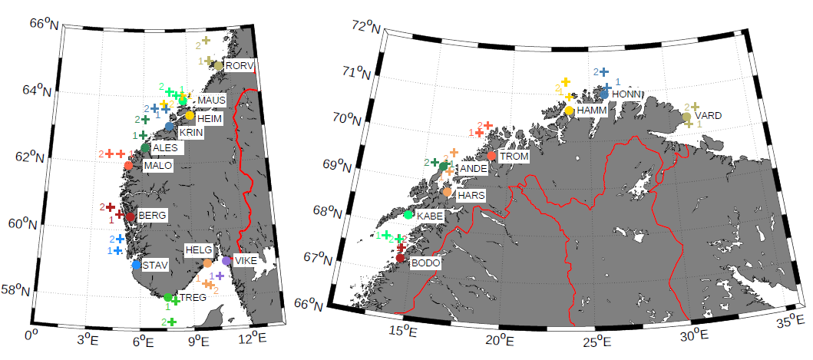

Figure 3.3.1.1. The location of the tide gauges and the closest altimetry points used for the comparison of MDT models. The figure to left shows the tide gauges within the coverage of the TOPEX/POSEIDON-JASON coverage and the figure to the right the tide gauges outside the coverage of T/P-JASON.

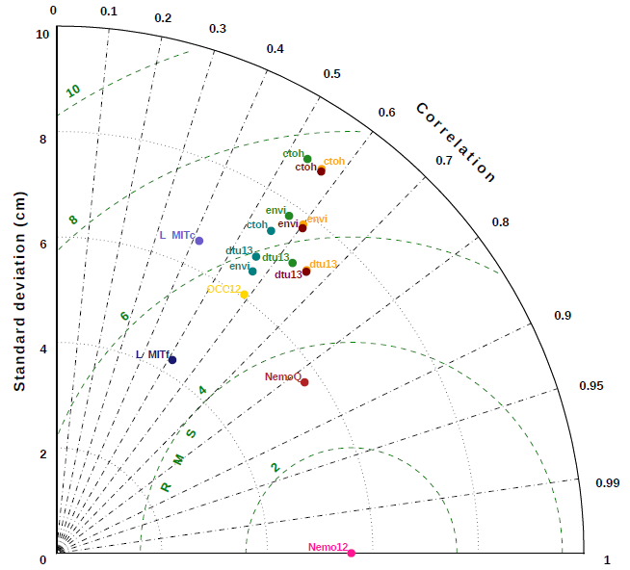

Figure 3.3.1.2 Taylor diagrams showing the standard deviation versus the Nemo12 model for all 23 tide gauges along the Norwegian coast

The Taylor diagrams in Figure 3.3.1.2 uses the MDT from Nemo12 (1/12 degree resolution) as the reference model against which all other MDTs are compared. It was chosen because, on average, it is the best-performing ocean model in comparison with tide gauges.
The model standard deviations are represented as radial distances from the origin, the centered RMS differences are proportional to the distances between reference and test models, and correlations are represented as the azimuthal angle

The comparison for the geodetic MDT based on DTU13MSS perform well in all regions. One of the reasons for the good performance of DTU13MSS could be that the extrapolation towards the tide gauges and points works well when values at equally spaced grid points are estimated from irregularly distributed data through spatiotemporal interpolation. Thus, DTU13MSS may well be more similar to the ocean models, which are also smooth surfaces not only due to their initial model physics and grids but also due to resampling and in general the agreement is within 5 cm. On average the DTU13MSS compares superior to retracked producs like those available through CTOH performance which is interesting but demonstrate the quality of this MSS.

The important conclusion from this study with respect to GOCE ++ is the fact that the agreement between ocean models and geodetic MDT is on average around 5 cm in terms of standard deviation for this very well surveyed region.

3.3.2 Enhanced coastal MDT using Cryosat-2 SARin in Norway

Due to the availability of data as described in the previous section, this study was again carried out in the Norwegian coastal region. This time in close corporation with Martina Ivanowisz and Ophaug Vegard from NMBU to evaluate the potential of Cryosat-2 in improving coastal MDT models.
In the study the Cryosat-2 SARin data were used as Norway is measured under the SARin mast of Cryosat-2. However, the data were treated as SAR data ignoring the possible cross-track SARin correction.

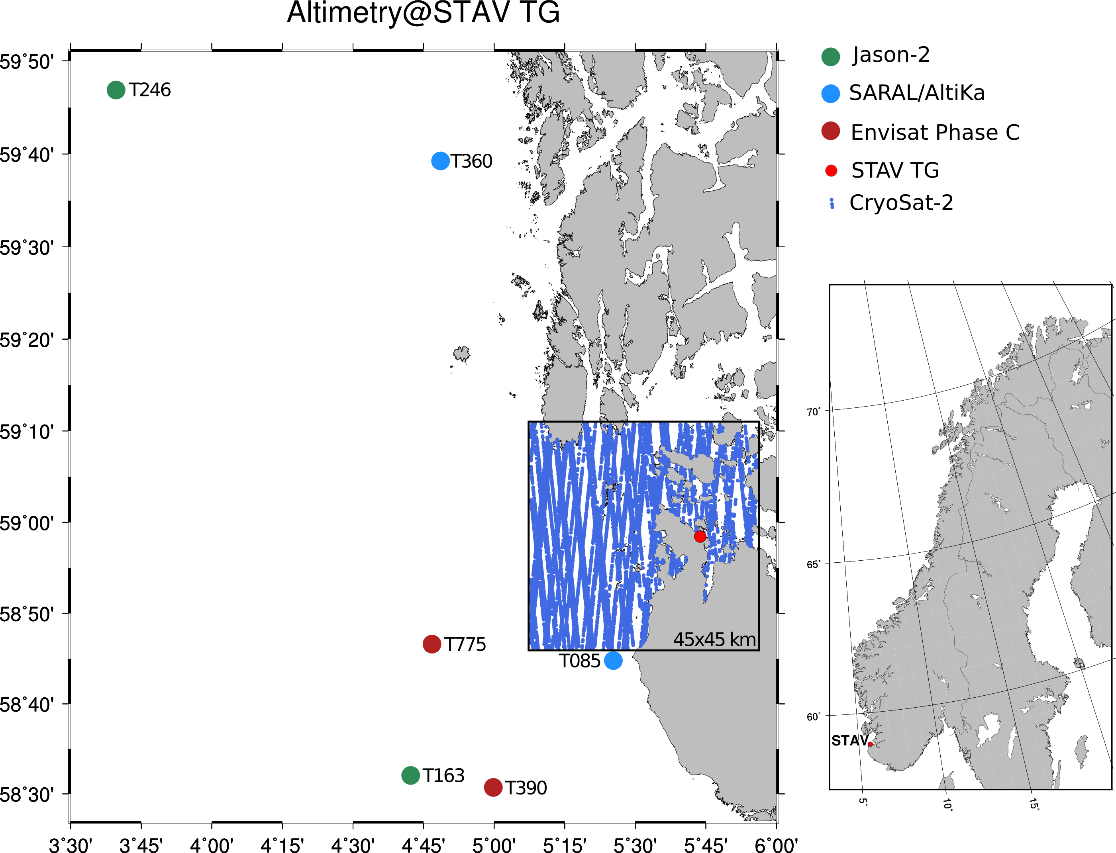

Figure 3.3.2.1 The location of the Cryosat-2 20 Hz altimetry close to the tide gauge at Stavanger in Norway along with the location of the nearby con-temporary altimetric observations by SARAL/AltiKa, Envisat (Phase C) and Jason-2

The importance of the SAR altimetry in the coastal zone is demonstrated in Figure 3.3.2.1 where the location of the Cryosat-2 20 Hz altimetry close to the tide gauge at Stavanger in Norway along with the location of the nearby con-temporary altimetric observations by SARAL/AltiKa, Envisat (Phase C) and Jason-2.
The coast of Norway is complicated with numerous fjords which largely prevents conventional altimetry in the coastal zone and it is seen that Cryosat-2 provides far more data in the near-coastal zone.

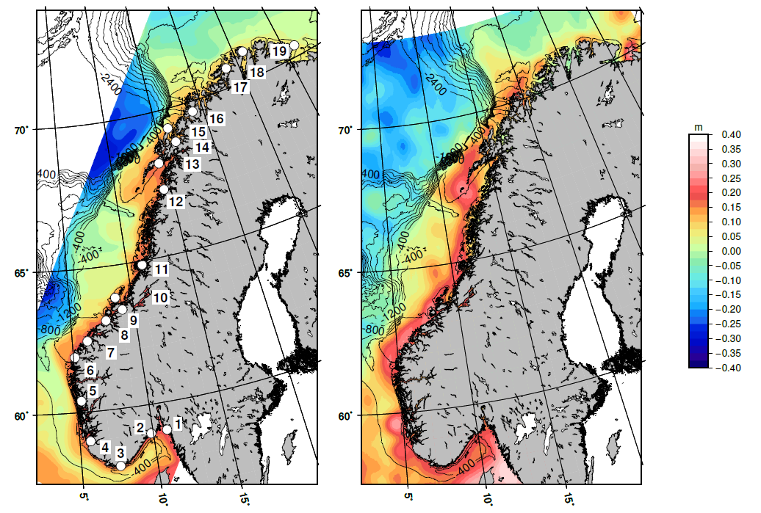
Figure 3.3.2.2 The MDT derived from the Norwegian Nordkyst model (left panel) and from Cryosat-2 altimetry (right panel). Values are given in meters.

We used the Cryosat-2 SARin from 2010-2016 augmented with LRM and SAR data away from the coast to derive an initial MSS. We then converted this into a geodetic MDT for the coastal region of Norway by subtracting the best know local geoid the NKG (Nordic commission of Geodesy) geoid for Scandinatia. This MDT is shown in the right panel of Figure 3.3.2.2. The MDT derived from the Norwegian Nordkyst model (800 meters) is shown in the left panel.

The slope of the Mean dynamic topography were derived using the slopes of the MDT and it illustrate better the quality of the derived MDT from Cryosat-2.
The Norwegian Coast current (NCC) flows northwards along Norway is very narrow and follows the bathymetry as a barotropic slope current (NwASC) the NCC also has a barotropic slope branch. Here we simply aim to compare the Cryosat-2 derived MDTs with NorKyst 800meters resolution coastal hydrodynamic model assuming that the flow follows a pattern to a geostrophically balanced flow for simplicity.

The geostrophic currents were derived from the Norwegian Nordkyst model (left panel) and from Cryosat-2 altimetry are given in Figur 3.3.2.3.

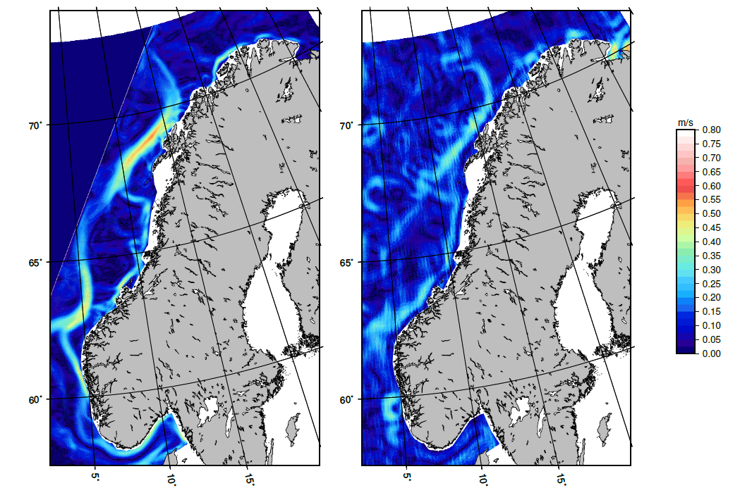
Figure 3.3.2.3 The geostrophic currents derived from the Norwegian Nordkyst model (left panel) and from Cryosat-2 altimetry (right panel). Values are given in meters/second.

3.3.3 Enhanced coastal MDT using Cryosat-2 LRM data in Australia

A detailed evaluation of DTU13MSS in coastal regions as a consequence of the possible degradation of the range and geophysical corrections was carried out in the GOCE++ test region of Australia.

The investigation was a consequence of the results presented internally to the GOCE++ consortium of a detailed comparison between 32 Australian tide gauges are currently submitted and in press by M. Filmer and W Featherstone (Curtain University) and C. Hughes comparing the similar models to the investigation in Norway. The set of Austraian tide gauges is shown in Figure 3.3.3.1

As the investigation in Australia is currently in press we are not allowed to reproduce and present them here. However their overall conclusions were similar to the comparison above by Vegard et al., 2016) where agreement on the sub-decimeter level is found.

The comparison between the DTU13 Mean sea surface and the Australian tide gauges revealed that a few tide gauges stood out beyond the 1 decimeter level as presented in Figure 3.3.3.1 (here only the fraction of the Australian tide gauges along the south coast of Australia from Melbourne to Perth corresponding to (tide gauge index 1 to 12).

The MDT derived using the DTU13MSS is shown with a black triangle in the figure 3.3.3.1 (blue arrow). It is revealed that DTU13MSS yields an MDT which is roughly 10 cm lower than the MDT derived at the Adelaide tide gauge based on tide gauge sea surface height observations combined with a local geoid model.

We subsequently carried out if this misfit can be associated with degradation in any of the range and geophysical corrections applied to the satellite range observations applied in derivation of DTU13MSS.

The data available to derive the DTU13MSS are shown in the left panel of Figure 3.3.3.2.
A very regular pattern of missing data close to the coast is seen. This is associated with the ocean tide model used to derive DTU13MSS. For DTU13MSS the state of the art model at the time of deriving it was GOT4.8 from Richar Ray at Goddard Flight Space Center. This model is based on an altimetric correction to the FES95 ocean tide model, This underlying hydrodynamic model FES95 is given on 0.5 degrees spatial resolution. Hence GOT4.8 is also only available at this resolution. It is clear that the land mask in this model can be seen to prevent the interpolation of the ocean tide signal in the coastal zone. Consesquently, the ocean tide correction becomes un-available and the data are rejected in the RADS processing.

It must be noted that the situation is not as severe in all coastal regions of the model. It largely depend on the local information that was available of the time when the FES95 ocean tide model was developed by LEGOS.

The consequence is that there will be no altimetric data available in the coastal zone up to half a cell width in the GOT4.8 model corresponding to 25 km of the coast.

Under such conditions the DTU13MSS was developed to extrapolate follow the long wavelength signal in the DTU13MSS model.

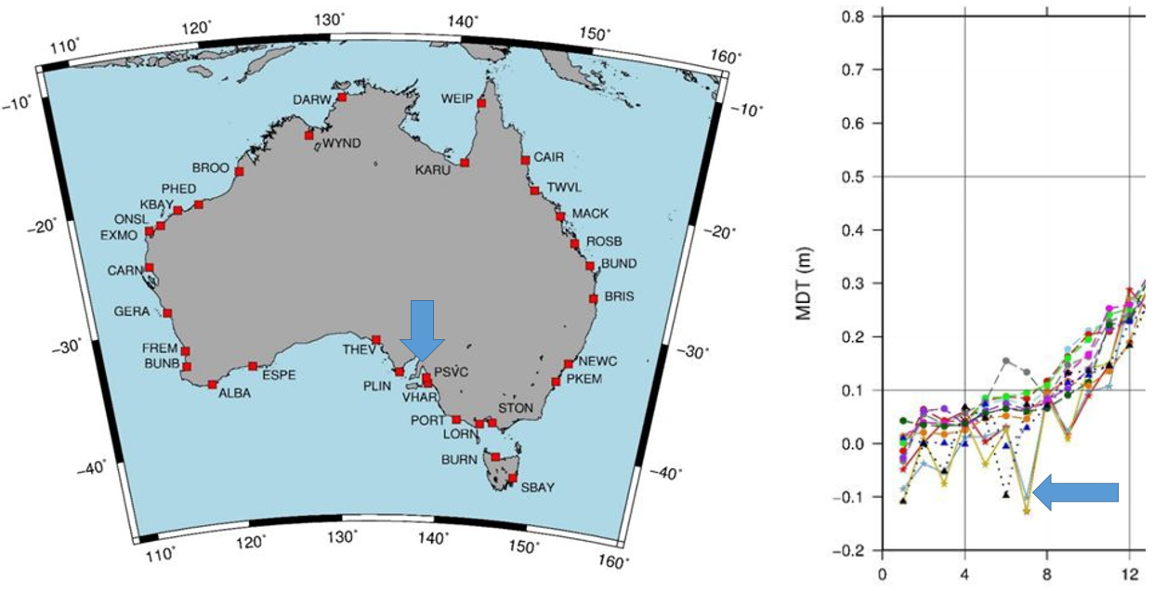

Figure 3.3.3.1 Australian tide gauges. The MDT at the tide gauges along the south coast of Australia is shown in the right figure between Melbourne and Perth corresponding to tide index 1 to 12 (Courtesy to Filmer et al., in press, 2017).

DTU13MSS is specifically developed WITHOUT using and underlying geoid model in order to provide an INDEPENDENT estimate of the mean sea surface not affected by possible errors in the geoid model. This appraoch is different to the CLS sequence of models which are developed by a remove/restore technique with respect to a geoid model)

In order to investigate the effect of the missing ocean tide correction and consequently missing data in the coastal zone we did an investigation of replacing the ocean tide correction with a more recent ocean tide correction. Namely the FES2014 ocean tide model.

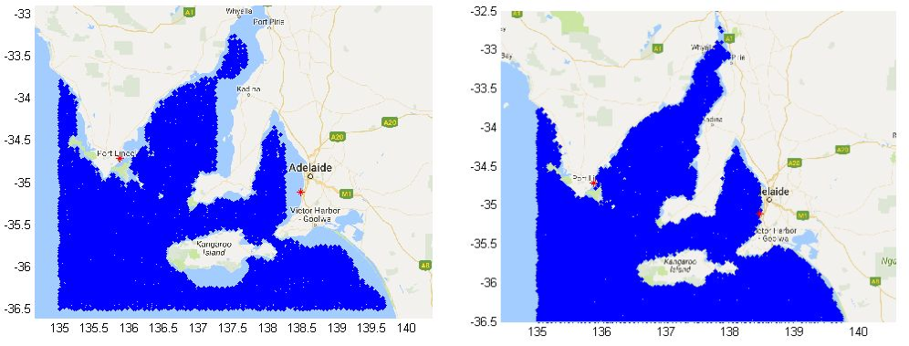
Figure 3.3.3.2 Left panel: The data available (dark blue) in the development of DTU13MSS using the GOT4.8 ocean tide model. Right panel: The data available using the FES2012 ocean tide model.

The number of data available for MSS computation using satellite altimetry processed using the FES2014 model is shown in the right panel of Figure 3.3.3.2. It is obvious that the increased resolution of the FES 2012 model increases the number of data significantly in this particular zone. Particularly the number of Cryosat-2 data increases in the coastal zone very close to the coast.

The DTU13 MSS was consequently updated using 6 years of Cryosat-2 applying the FES2012 by just computing the wavelength shorter than 100 km for each track.
The reason for only updating short wavelength is to avoid that longer wavelength of oceanographic or climatic origin in the Cryosat-2 SSH observations would ruin the investigation. The most obvious error would be that Cryosat-2 observed during 2010-2016 whereas the reference period for DTU13 is 1993-2012 with a midpoint of 2003. As sea level trend is an average of 3 mm per year will cause the sea level to increase by 3 cm between 2013 and 2013 which is the mid point of the Cryosat-2 time series.
The result of the computation is shown in Figure 3.3.3.3 which shows the coastal correction to the DTU13MSS in centimeters. It indicate that the corrected MSS should actually be 10-15 cm higher than DTU13MSS and consequently the MDT should be 10-15 cm higher and in much better agreement with the Tide gauge data in Figure 3.3.3.1.

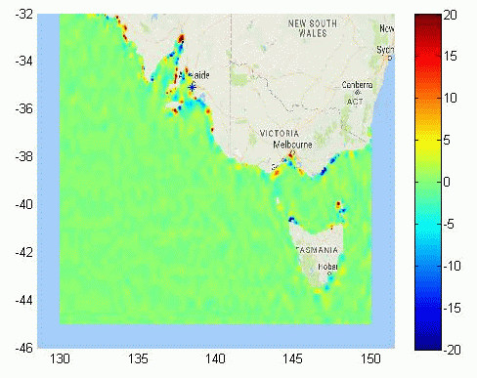
Figure 3.3.3.3 Short wavelength MSS coastal correction computed from 6 years of Cryosat-2 altimetry. The values are given in centimeters.

3.3.4 Comparative assessment of coastal and open ocean SAR and PLRM Altimetry from CryoSat-2.

This investigation is an extension of the work performed for the German Bight region (Fenoglio-Marc et al., 2015, 2015a and Dinardo et al., submitted) within the ESA Project Sea Level Climate Change Initiative (SLCCI). For the GOCE++dycot project we first consider this same region and further on extended it to include the North Eastern Atlantic coast (NEA). Moreover we analyse the Bay of Bengal region.

The regions have been selected based on the relevance for this project and on data availability.
The German Bight region offers a high-resolution coastal model and high quality 1-minute tide gauge during the complete CryoSat-2 mission 2010-2017 (see GEC region in Figure 3.3.4.1). This was not readily available in any other region.
The North-Eastern Atlantic is our first well-surveyed region (Fenoglio-Marc, 2016) and is completely covered by CryoSat-2 in SAR mode as well (Figure 3.3.4.10). Australia, our second well-surveyed region, is in LRM mode. Finally the Golf of Bengal is part of the South Eastern Asia poor-surveyed region and was covered by CryoSat-2 in SAR mode between October 2012 and March 2016. SAR coverage re-started in February 2017 (Figure 3.3.4.7).

The Synthetic Aperture Radar (SAR) mode in CryoSat-2 is expected to provide in coastal zone higher resolution long-track and more accurate altimeter-derived parameters, thanks to the reduced along-track footprint. In the study we regionally quantify the skills of CryoSat-2 SAR altimetry at different time and special scales by comparing SAR altimetry and conventional altimetry in the coastal zone, defined as the locations having distances to coast smaller than 10 km, and in open ocean. The validated geophysical altimeter parameter is sea surface ellipsoidal height (SSH).

All SAR data used have been made available by the GPOD service. They originate from the two different processing chain summarized in Table 3.3.4.1 that can be both selected by the users by choosing between different options available in the ESA-ESRIN GPOD service “SAR Versatile Altimetric Toolkit for Ocean Research & Exploitation“ (SARvatore).

We call the first “GPOD Open Ocean Processing (GPODO)” and the second “GPOD Coastal Processing (GPODC)”. GPDOC is more suitable for coastal applications. The Delay-doppler processing and the retracking methodology in GPODO and GPODC are partially different. The differences concerning delay-doppler processing are related to (1) the extension of the radar receiving window (128 range bins were used in GPODO, 256 in GPODC) and (2) the estimation of the waveform noise floor using the portions of the stack data (L1b-S) that are not affected by land reflections. The retracker model are SAMOSA2 in GPODO and SAMOSA+ in GPODC. The main differences between the SAMOSA+ and the SAMOSA2 algorithms are in the selection of the first guess epoch and the treatment of the land contaminated waveforms (see Dinardo et al., submitted for details).
The corrections in GPOD data are from the FBR cryosat products. The ocean tide TPXO8-ATLAS (http://volkov.oce.orst.edu/tides/tpxo8_atlas.html, Egbert et al., 2002) is additionally included. The geoid EGM2008 is in the data, use of the more recent geoid model EIGEN-6C4 is suggested. We substitute the standard wet tropo with the regionally improved GNSS-derived Path Delay Plus (GPD+) wet tropospheric correction (Fernandes and Lázaro, 2016)

GPODO/SAM2 | Common options in GPOD | GPODC/SAM+
 | 20 Hz
 | Hamming in coastal only
 | Exact beam forming approximated
 | FFT Zero-Padding
128 range bins  (radar receiving window) |  | 256 range bins  (radar receiving window)
 | No antenna path correction
 | LUT
SAMOSA2 |  | SAMOSA+
Table 3.3.4.1: GPOD options used in GPODO and GPODC

Simultaneous operations in SAR and pulse-limited (LRM) mode are not possible, and SAR is generally compared to a proxy of LRM, the Reduced-SAR (RDSAR) or Pseudo-LRM (PLRM) (Scharroo et al., 2016). The PLRM waveforms are here generated by processing the SAR burst data in the pulse-limited sense (Fenoglio-Marc et al., 2015) and retracked by the coastal TALES retracker, an adaptation to CryoSat-2 of the ALES sub-waveform retracker (Passaro et al., 2014). TALES is based on a numerical Brown-based model (SINC2, Buchhaupt et al., submitted).

In this study we first cross-compare altimetric GPODC/SAR and PLRM SSHs and model data, perform an in-situ validation along the coasts and investigate both instantaneous and seasonal behaviour. We finally analyse the GPOCO/SAR to investigate the differences in castal regions with respect to the optimal dataset GPODO.

The cross-validation between PLRM and GPODC/SAR proves the good consistency between PLRM and SAR sea level anomalies in the coastal zone. In the German Bight with bias, standard deviation of the differences and correlation of 2 cm, 52 cm and 0.78 respectively (Figure 3.3.4.2).

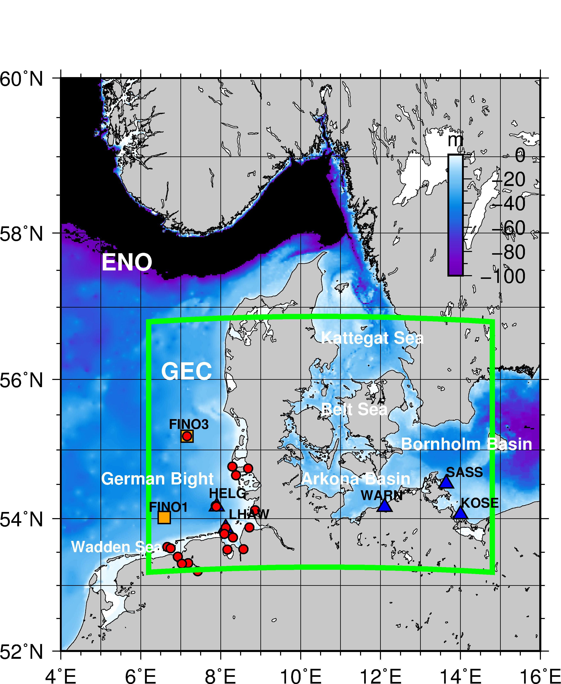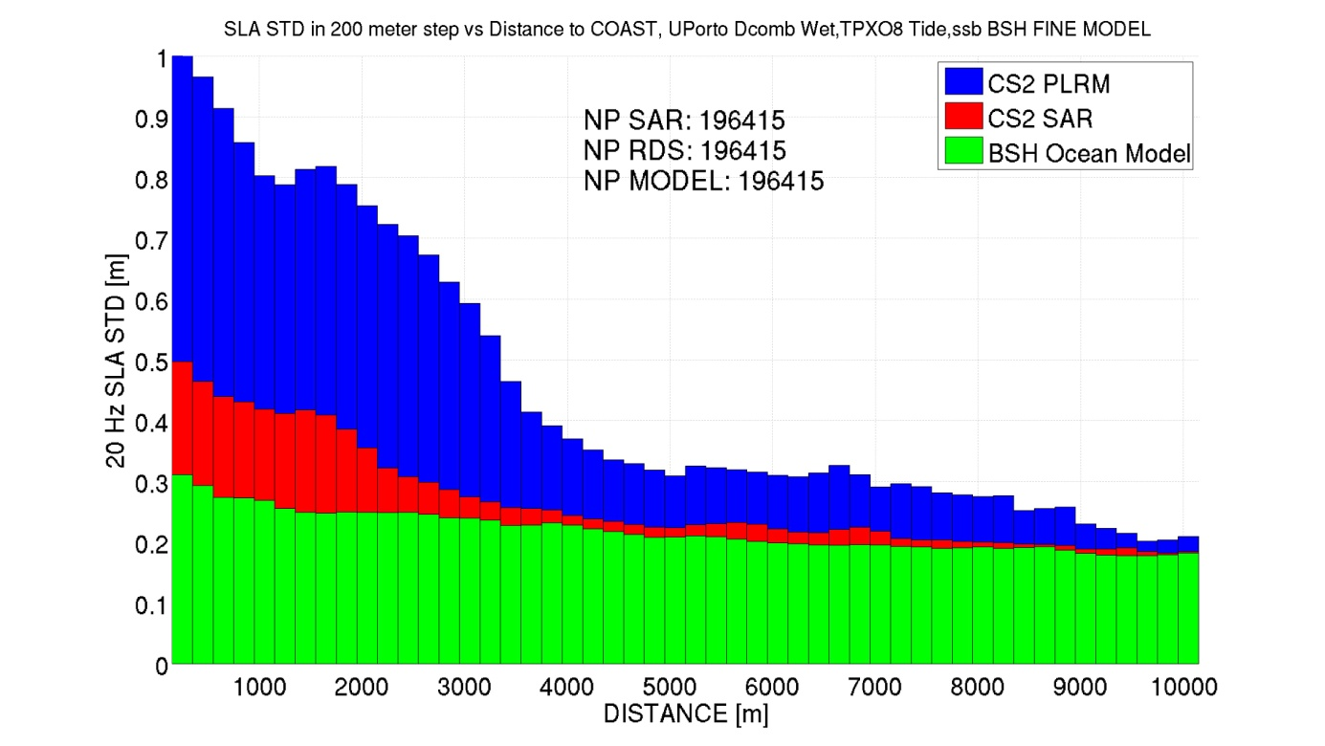
Figure 3.3.4.1: German Eastern Coast (GEC, green box) and GPODC. Corresponding diagram representing standard deviation of SLA in 200 meter bins of distance to coast for SAR, PLRM and BSH Model

The regional ocean model (BSH) shows the highest agreement with the SAR instantaneous dynamic ocean topography (DOTi) above the EIGEN-6C4 geoid. The standard deviation of the differences (stdd) is 24 cm whereas the BSH uncorrected sea level has a stdd of 55 cm with PLRM. The slope with the model is 0.96 for both altimeter products (Figure 3.3.4.2). In Figure 3.3.4.3 we have applied and ocean model correction to both the BSH model and the altimeter data

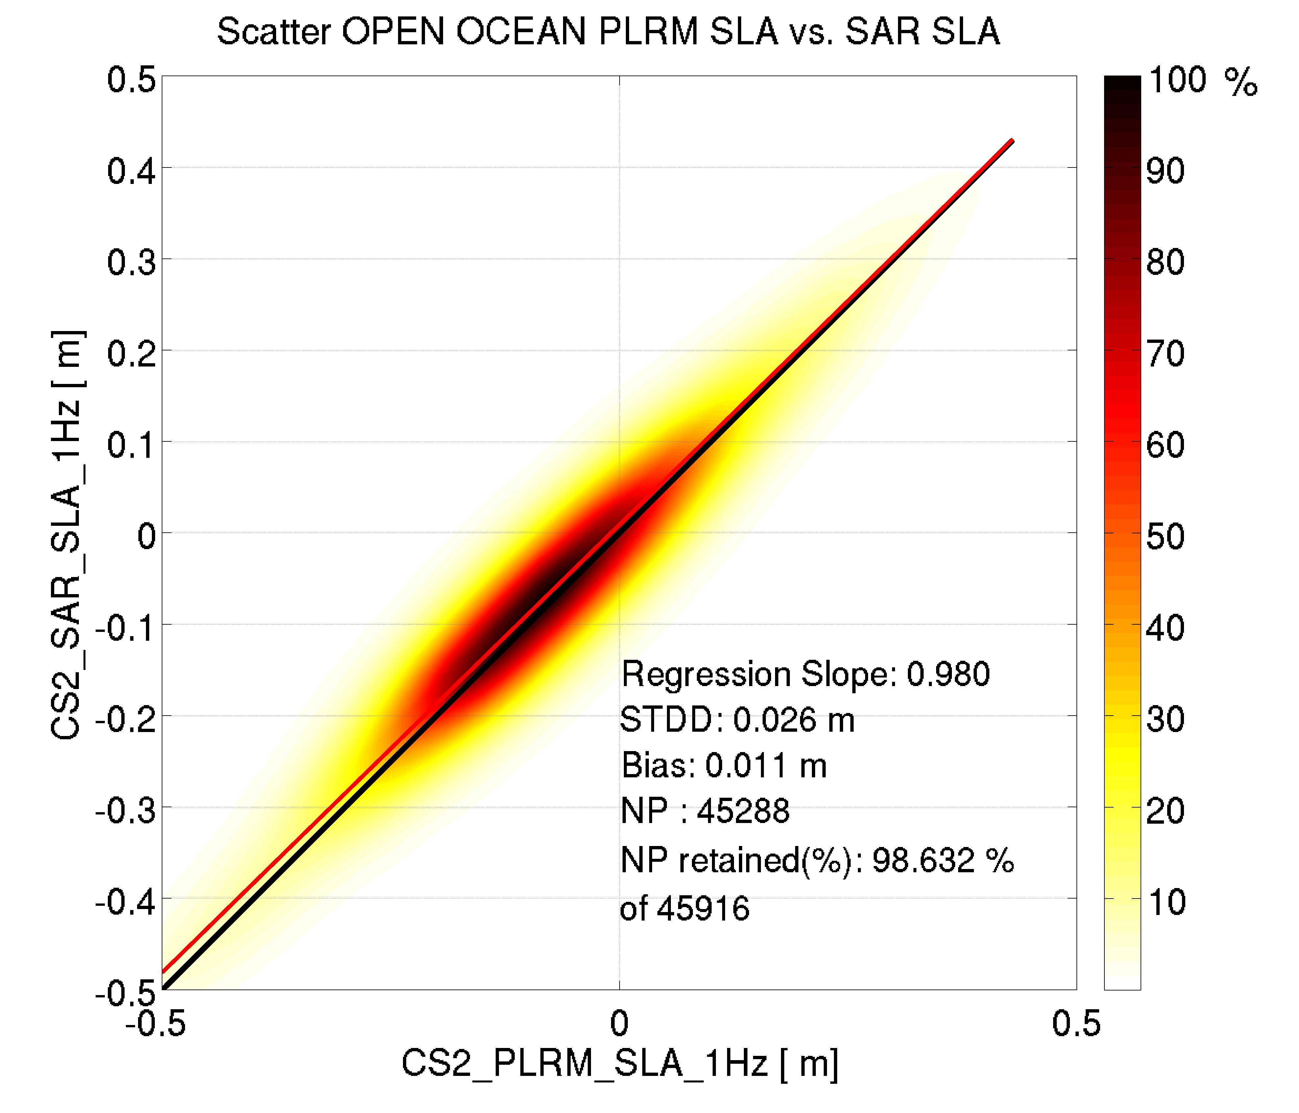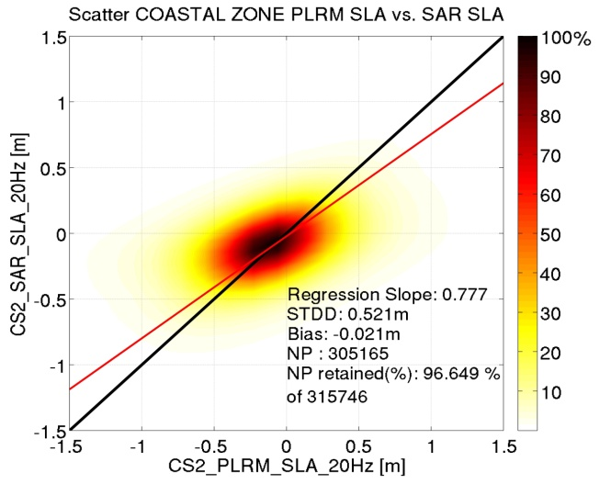
Figure 3.3.4.2. GEC and GPODC: Scatter Plot in open sea at 1 Hz (left) and in coastal zone at 20 Hz between SAR SLA & PLRM SLA (STD3D 2.6 cm, 52 cm)

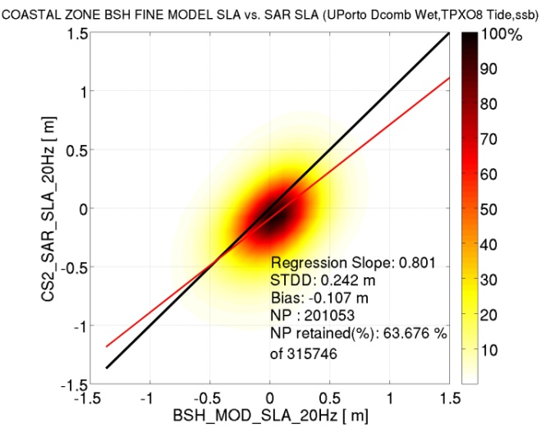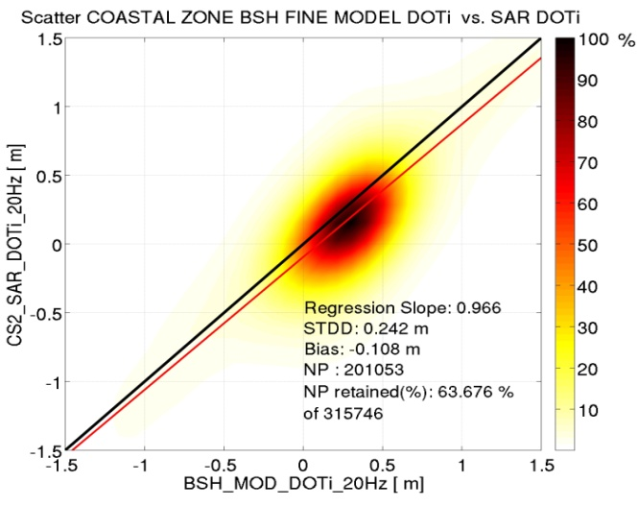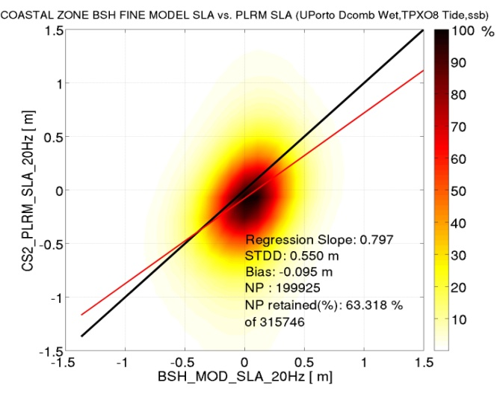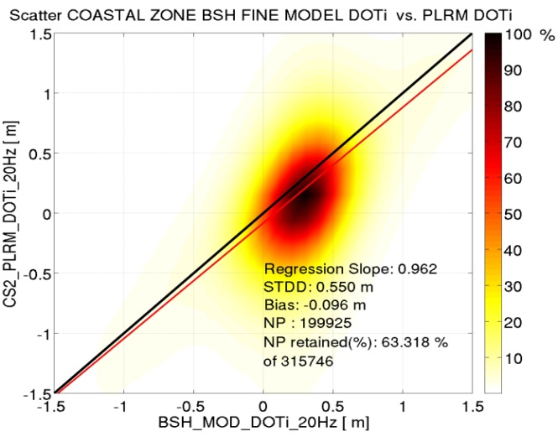
Figure 3.3.4.3. GEC and GPODC: Coastal Cross-val between SAR and BSH Model (left) and PLRM and BSH Model (right) for DOTi (top) and SLA (bottom). SLA (STD3D 24 cm, 55 cm)
We have computed the standard deviation of the measurements averaged as function of distance to coast in bands of 200 meters. Figure 3.3.4.3 shows that sea level anomalies are affected by land contamination starting at 2 km from coast in SAR and at 3.5 kilometres in PLRM TALES (Fig. 3.3.4.3).
The analysis of monthly mean time-series shows the capacity of SAR Altimetry to measure the sea level annual cycle in the coastal zone during the mission time more accurately than PLRM (Figure 3.3.4.4). Also the in situ cross-comparison exercise proves the higher accuracy of SAR SAMOSA+ compared to PLRM TALES in the coastal zone with average SLA stdd of 5.7 cm and 7.5 cm respectively. A similar conclusion holds for the in situ cross-comparison with open ocean altimeter data, with average stdd of 3.9 cm and 4.6 cm respectively in SLA retrieved from SAR and PLRM TALES.

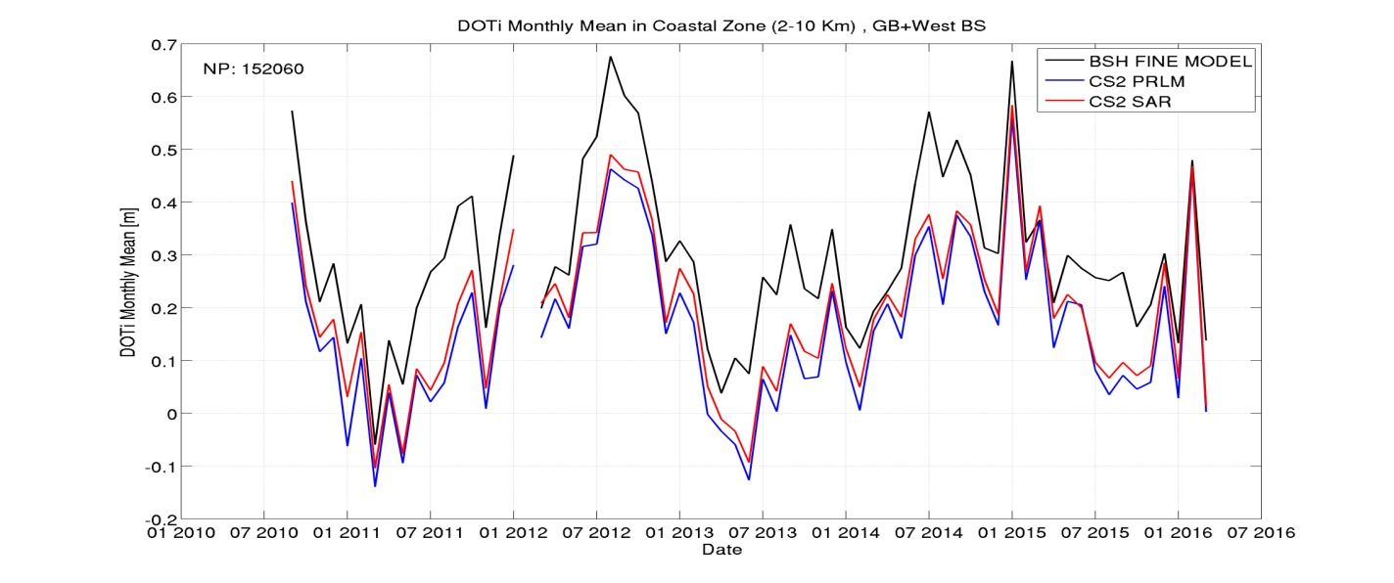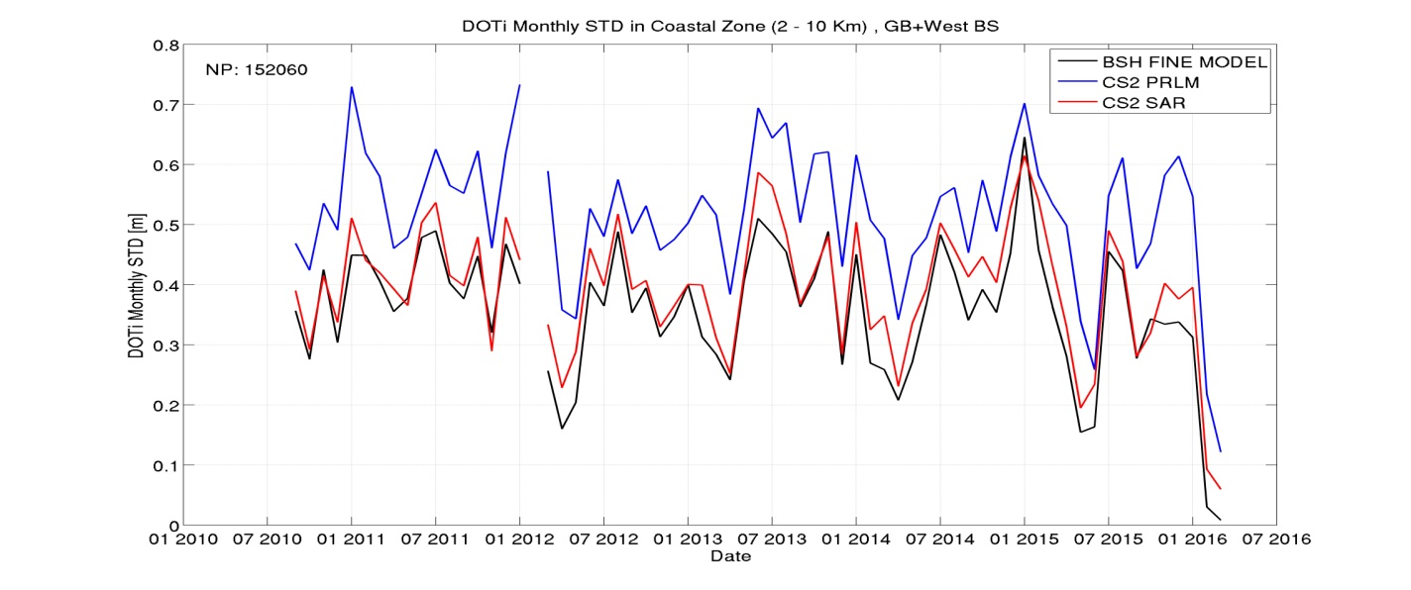

Figure 3.3.4.4. GEC and GPODC. Monthly mean (top) and standard deviation (bottom) of 20 Hz DOTi in coastal zone (2-10 km) for SAR, PLRM and BSH Model

Similar results are obtained for the cross-validations of GPODC/SAR and PLRM in the Bay of Bengal, where the mean, standard deviation of the differences and correlation between SAR and PLRM in coastal zone are 3 cm, 61 cm and 0.98 respectively (Figure 3.3.4.5). The higher standard deviation of the differences and correlation of the SLAs could indicate deficiencies in the tide ocean correction used, TPX0 in this case. The cross-validation with the year 2014 of the Numerical Ocean Circulation Model from the Institute of Water Modelling (IWM) of Bangladesh show better agreement of the model with SAR than with PLRM. Also in this region land contamination begins to affect sea level and wave measurements at 3 km from the coast in SAR and at 4 kilometres in PLRM TALES (Fig. 3.3.4.7). The noise due to contamination after 3 km is at the same level in SAR and PLRM, which was not the case in the German Bight. We also observe a higher level of variability in the ocean model in this region.

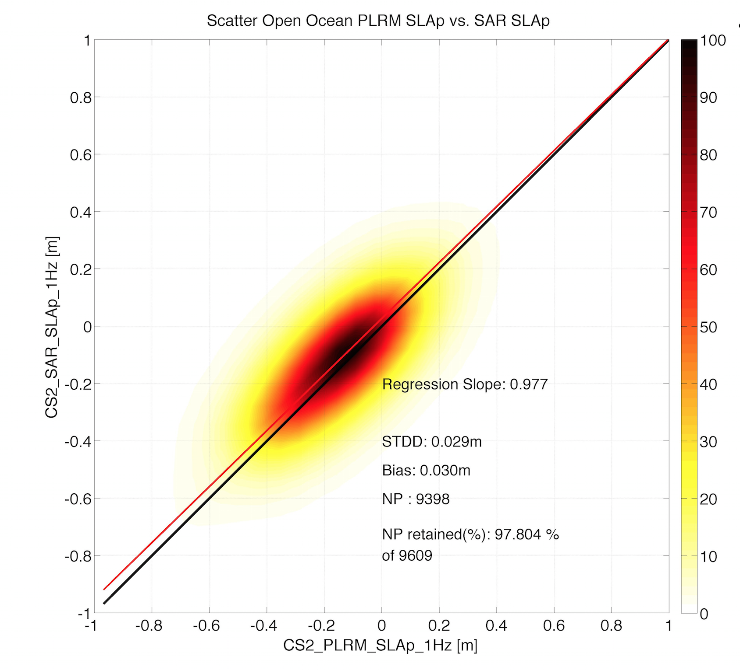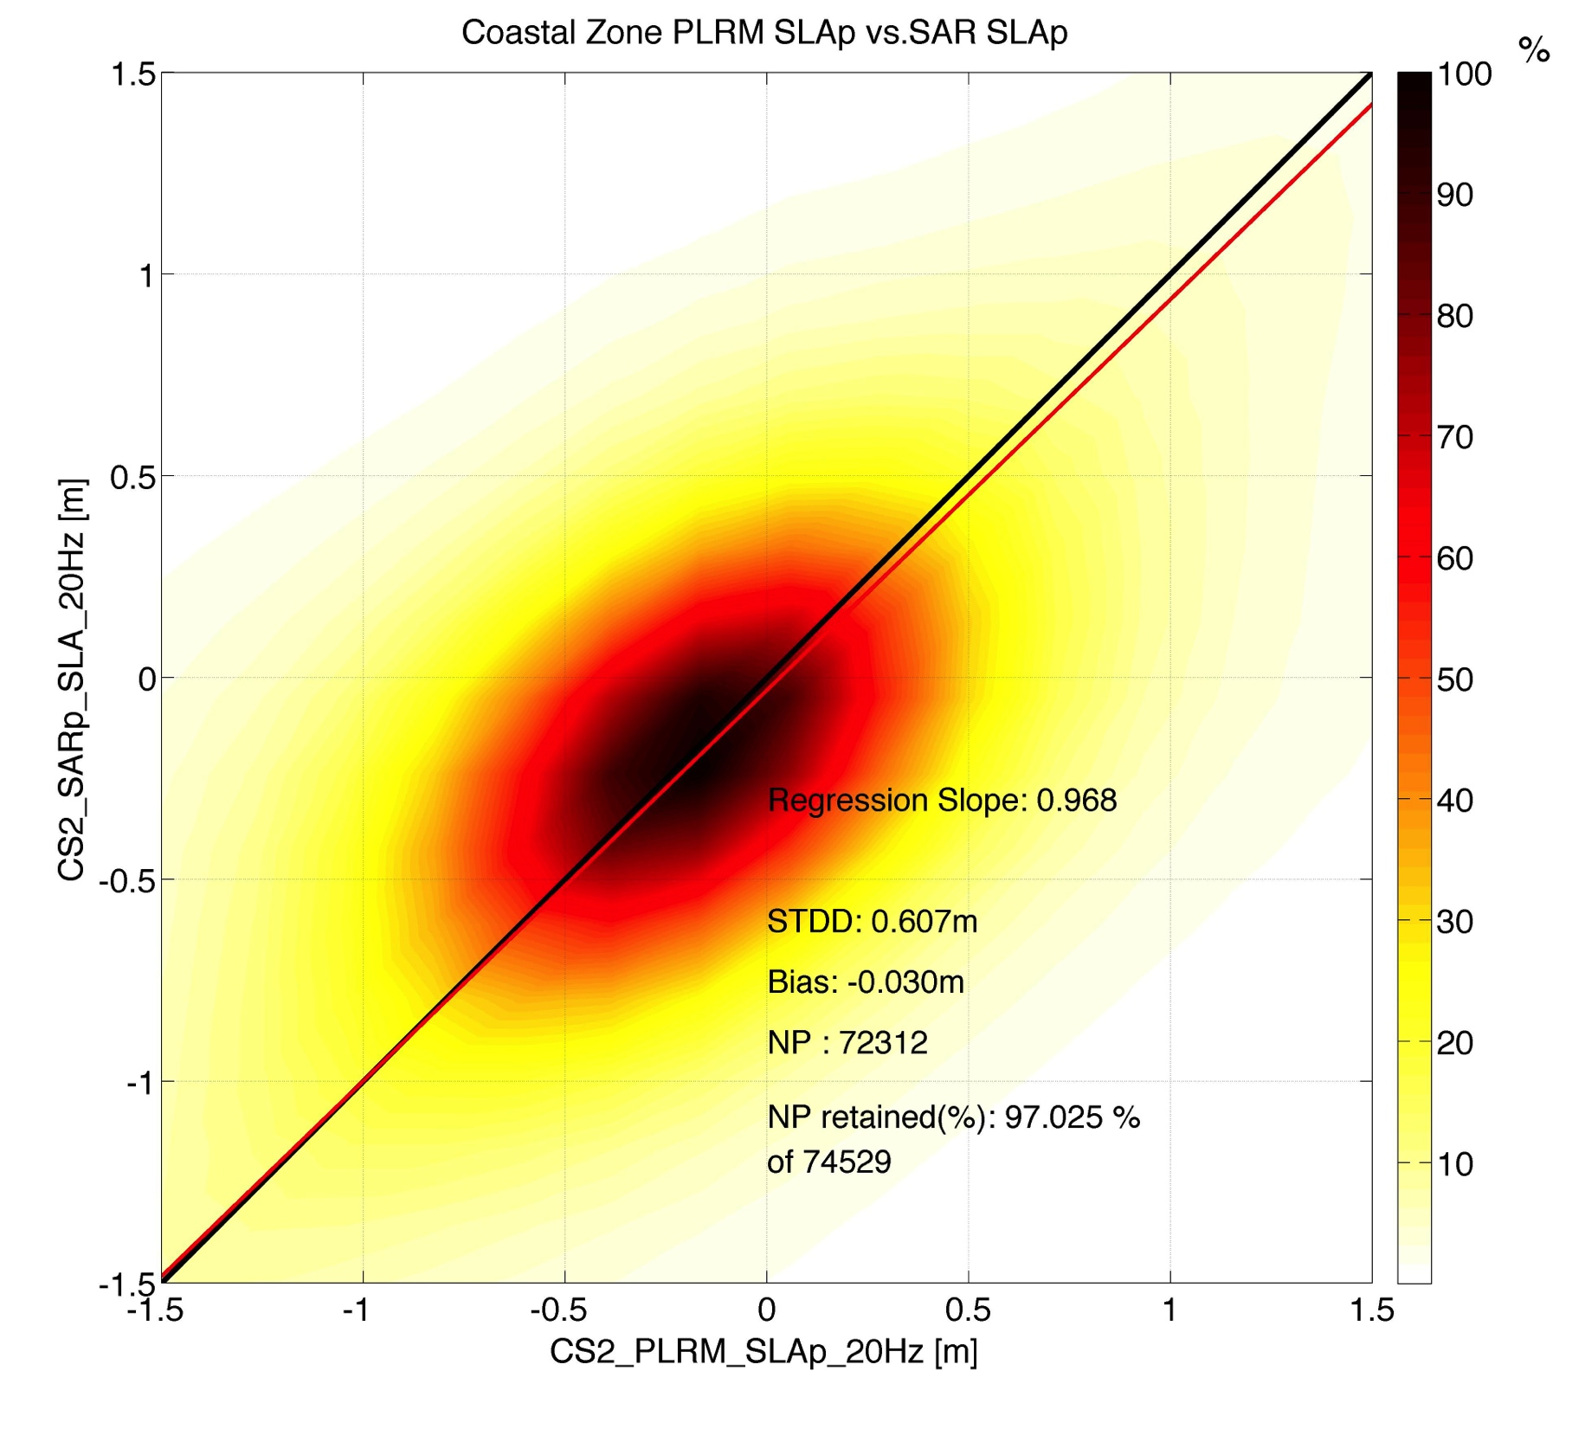
Figure 3.3.4.5. BoB and GPODC : Cross-val in open ocean (1Hz) and coastal zone (20Hz) between SAR SLA & PLRM SLA; correspond to Fig. 1 for GEC (STD3D 3 cm, 60 cm)

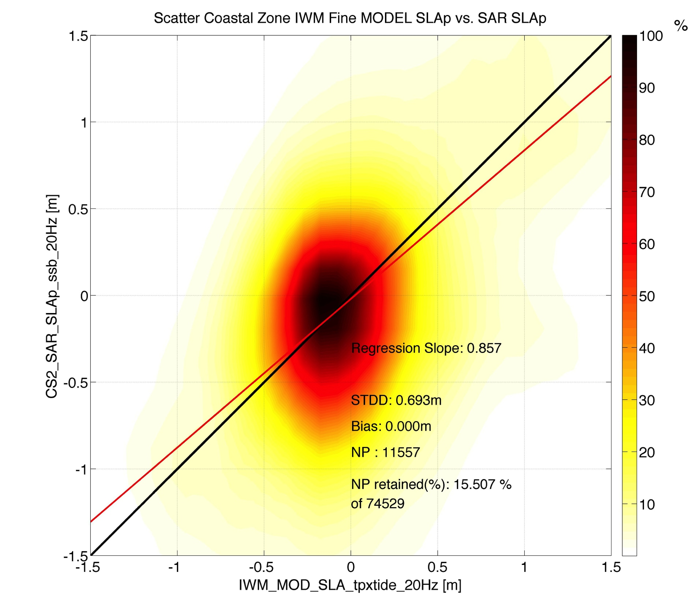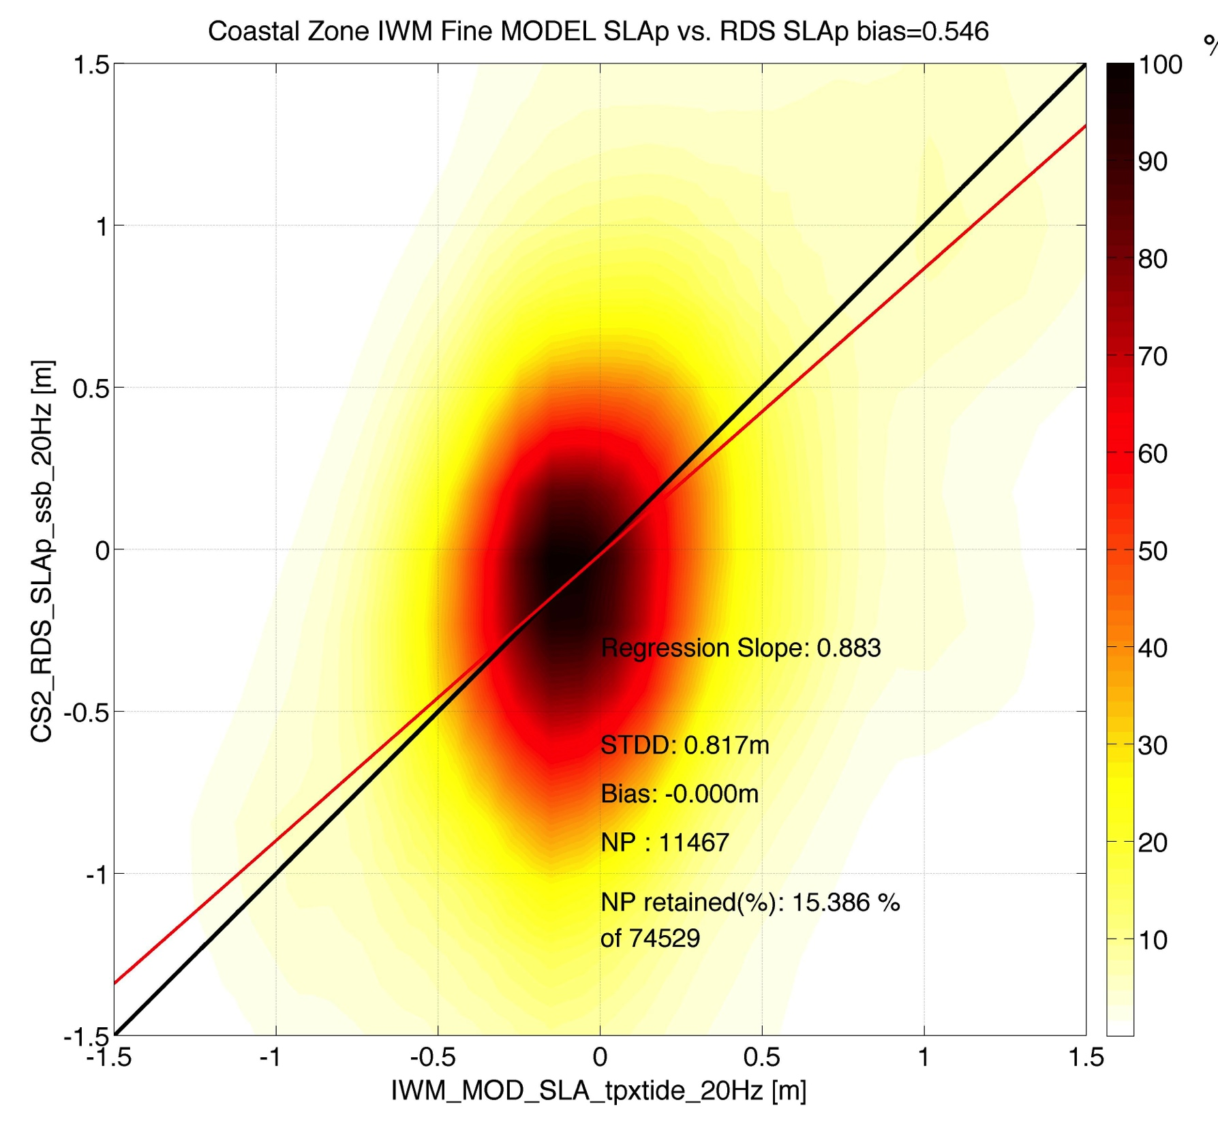
Figure 3.3.4.6: Bay of Bengal and GPODC : Cross-val in coastal zone between SAR and BSH Model (left) and PLRM and IWM Model (right) for SLA (STDD 69 cm , 82 cm).
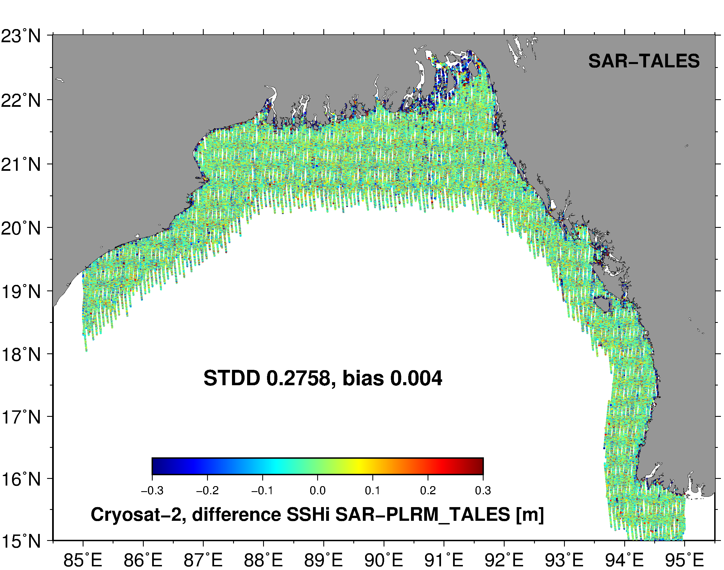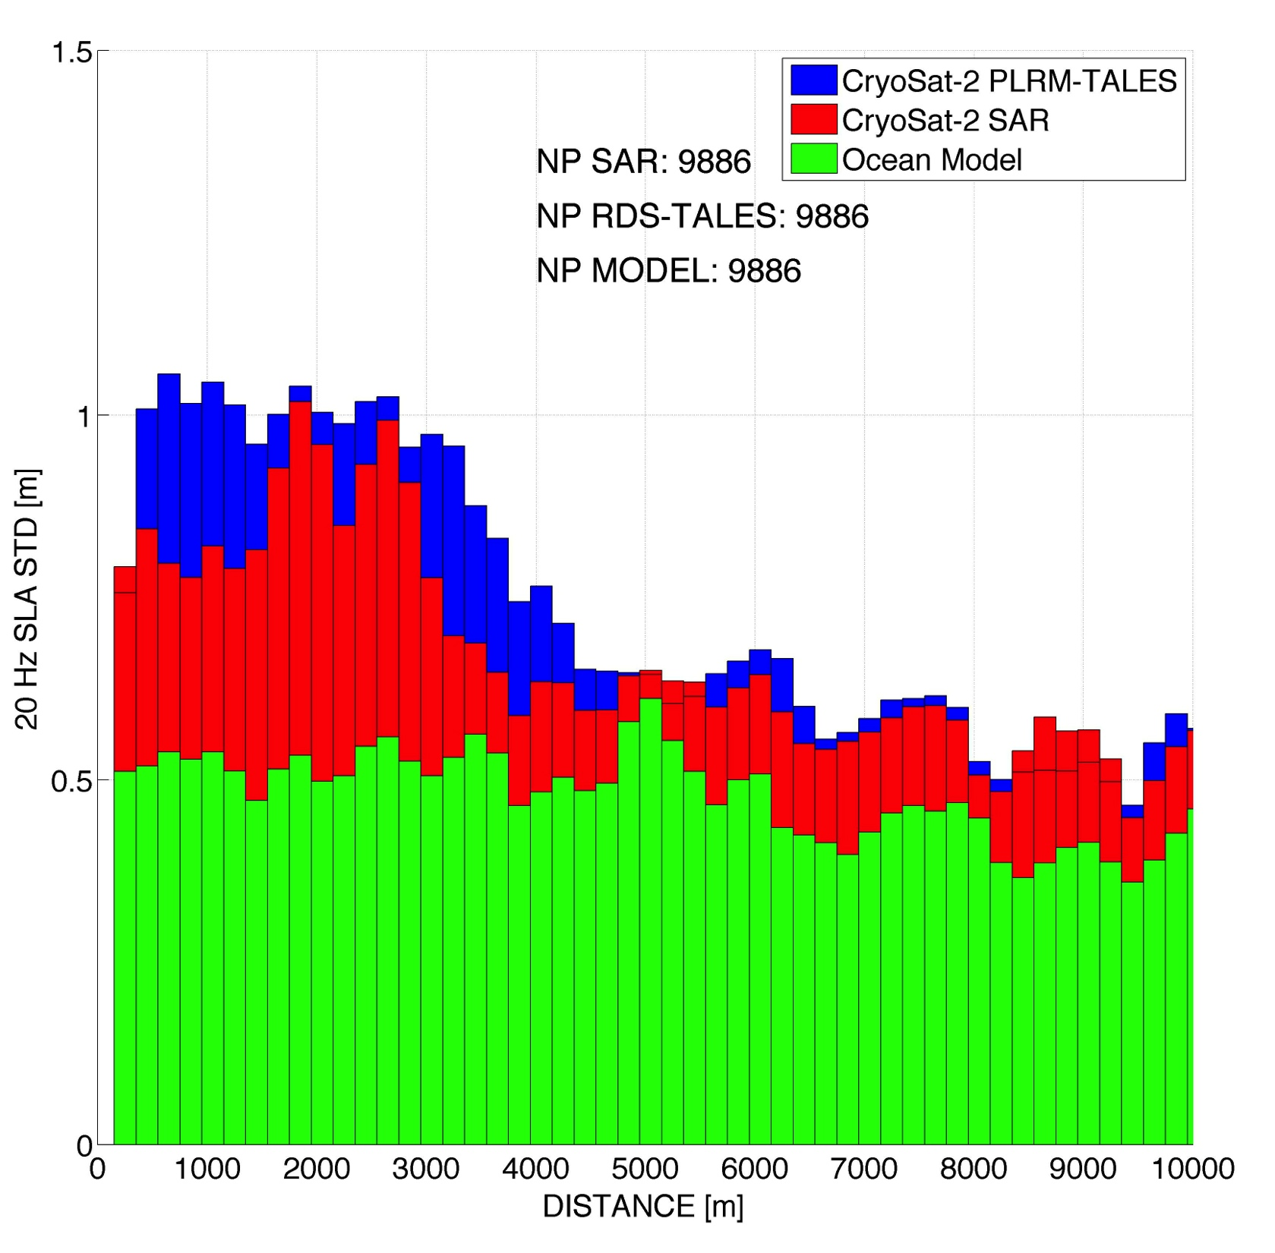
Figure 3.3.4.7. BOB and GPODC : with SAR minus TALES instantaneous heights (left) and corresponding diagram representing standard deviation of SLA in 200 meter bins of distance to coast for SAR, PLRM and IWM Model (right)
In third part of our analysis we have evaluated the differences between the data processed using GPODO and GPODC receipts in the GEC region and we have comparaed PLRM and GPODO in the NEA region. Figure 3.3.4.8 shows that in the GEC region the results of the GPDO processor are more affected than GPODC by land contamination, which starts already at 3 km from coast. The difference between GPODC and GPODO data is smaller in open sea than in coastal zone as expected (stdd of the difference is 5 cm and 22 cm respectively, see Figure 3.3.4.9). The analysis, repeated for the set of regions in Figure 3.3.4.10, gives similar results for the comparison of PLRM and GPODO in each of the four regions. We expect that GPODC is less contaminated that GPODO in the complete NEA region.

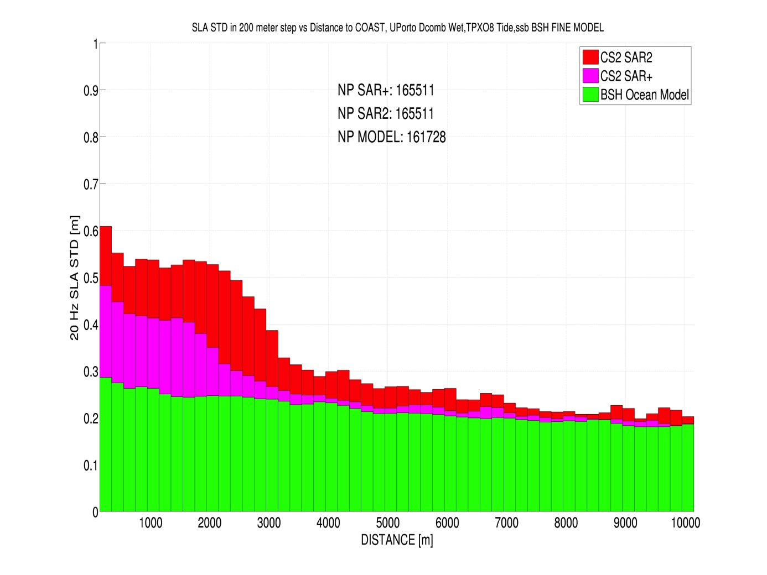
Figure 3.3.4.8. GEC with GPODC and GPODO: diagram representing the standard deviation of SLA in 200 meter bins of distance to coast for SAR, PLRM and BSH Model, 2011-2015.
The values of validation skills (mean, correlation, standard deviation of residuals) are summarized in Table 3.3.4.2. They show that in coastal zone SAR altimetry is twice more accurate that PLRM. The STDD of difference with model is 22 and 55 cm for GPODC/SAR and PLRM respectively. A significant reduction of errors in sea level anomalies is therefore possible with SAR.

The Table also indicate that SAR processing options need to be selected with care, as the STDD differences in coastal zone between different SAR processing chains can amount to 24 cm and cannot be neglected. It is therefore very important to select the more accurate SAR altimetry coastal processing for further analysis. The new limit for use of SAR altimetry data is 2-3 kilometres from coast.

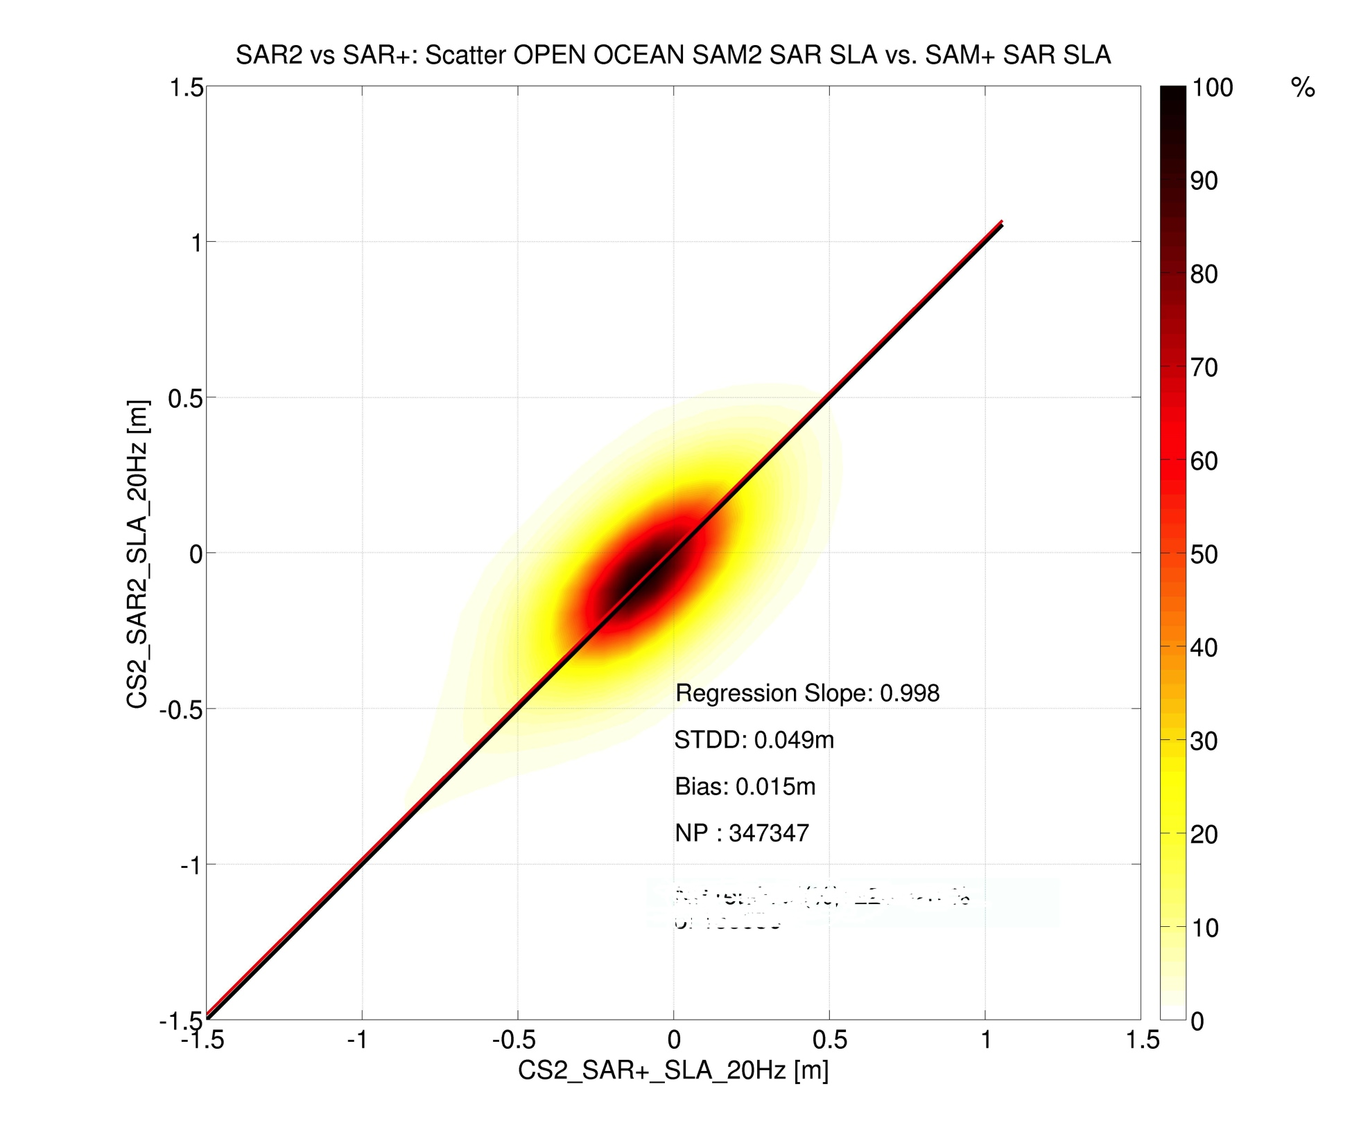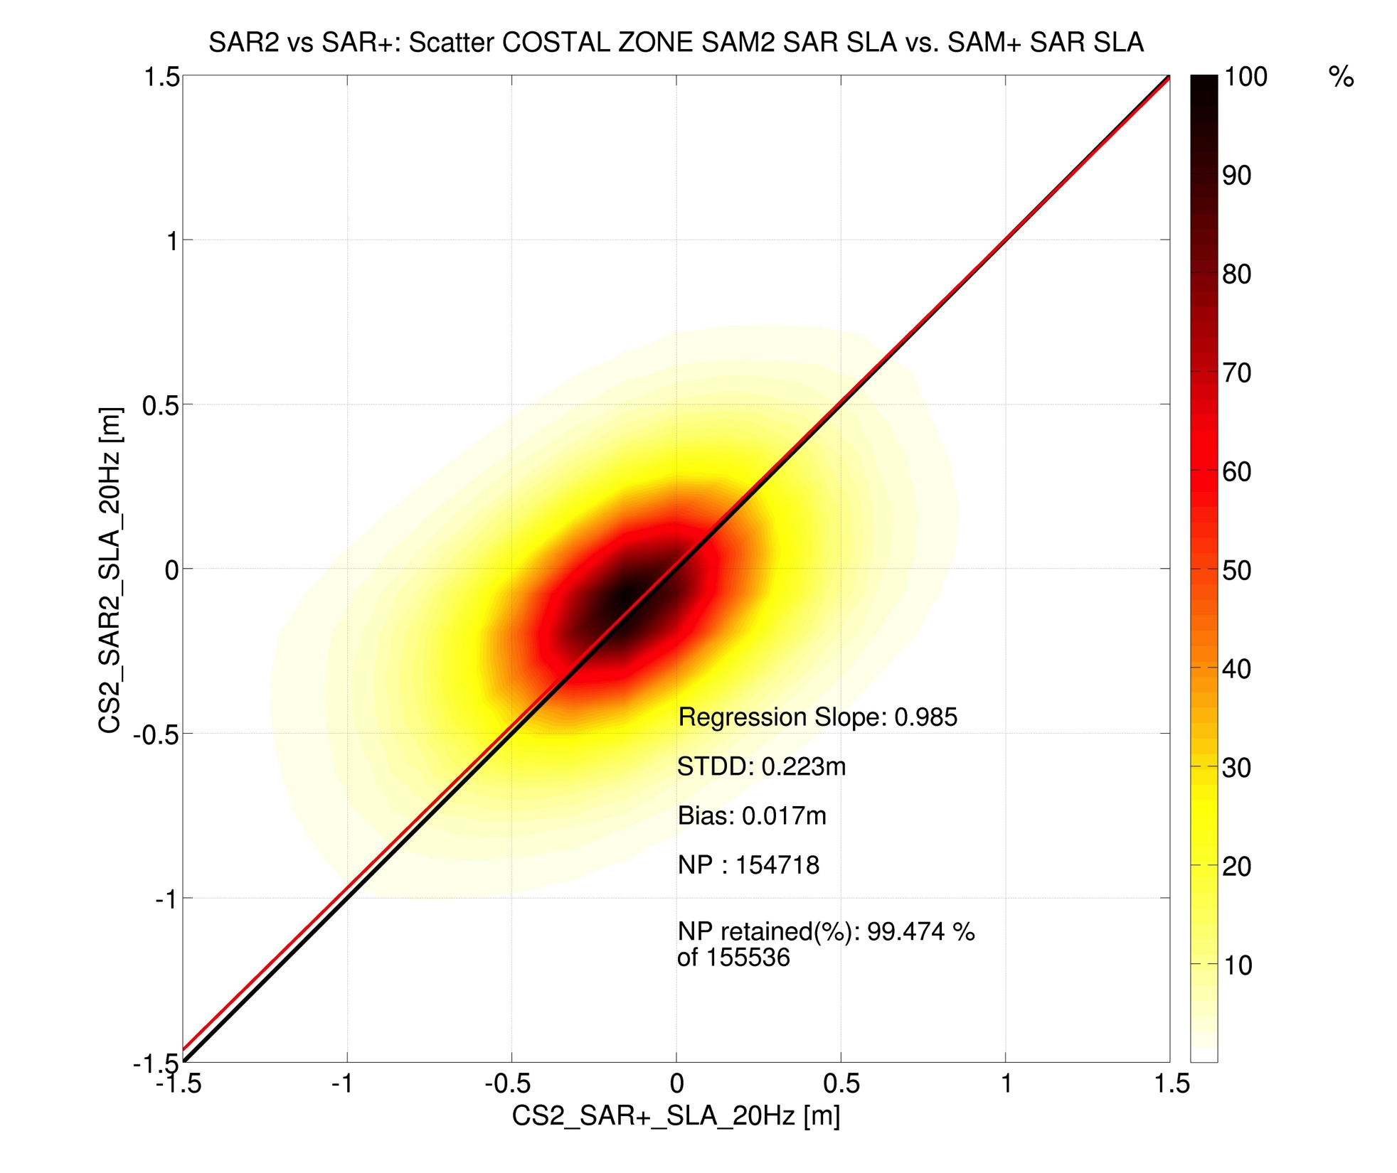

Figure 3.3.4.9: GEC, GPODC and GPODO: scatterplots of sea level anomalies SLA corresponding to the GPODO and GPODC processing for open sea (left) and coastal zone (right). 2011-2015, (STDD 5 cm , 22.3 cm).
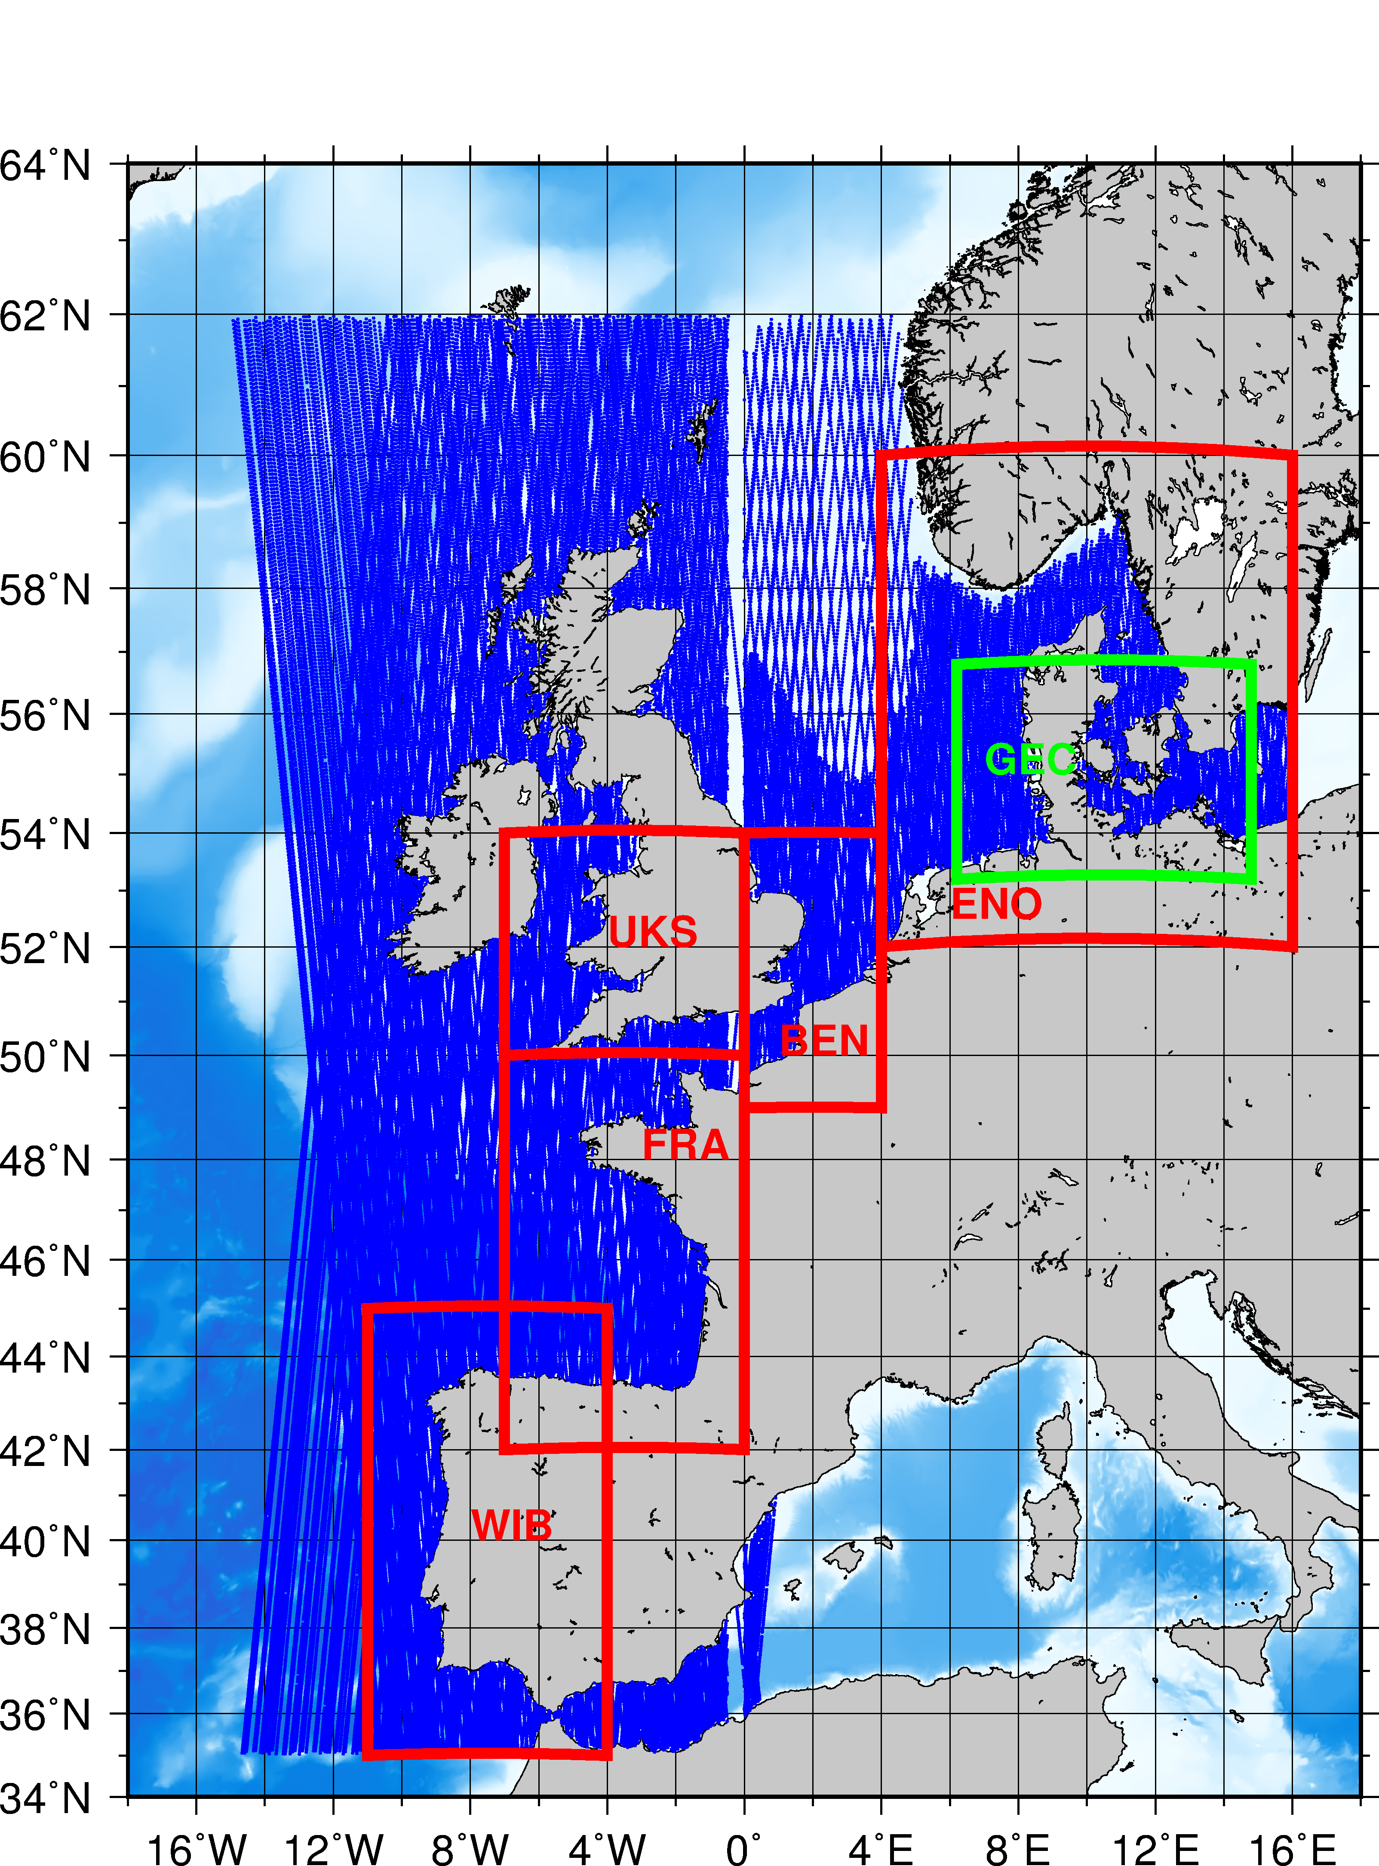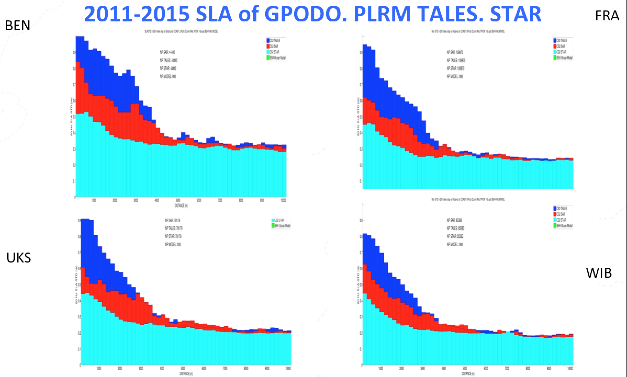
Figure 3.3.4.10. GPODO in the Eastern North Atlantic: Region (left) and corresponding diagram of SLA standard deviation in 200 meter bins of distance to coast for SAR, PLRM, Interval 2011-2015 in the 4 selected regions (right).

 | Open sea (1Hz)  PLRM/GPODC  SLA | Coastal (20Hz)  PLRM/GPODC  SLA | Coastal (20Hz)  GPODC/BSH SLA | Coastal (20Hz)  PLRM/BSH SLA | Open sea (1Hz)  GPODC/GPODO  SLA | Coastal (1Hz)  GPODC/GPODO SLA
GEC SLA  2010-2015 | 0.98, 0.026, 0.01 | 0.78, 0.52, -0.02 | 0.80, 0.24, 0.11 | 0.80, 0.55, -0.1 | 1, 0.049,  0.015 | 0.98, 0.223, 0.017
GEC DOTi  2010-2015 |  |  | 0.97, 0.24, 0.11 | 0.96, 0.55, -0.1
BoB SLA  2012-2015 | 0.98, 0.029, 0.03 | 0.97, 0.61, -0.03 | 0.86, 0.69, 0.0 | 0.88, 0.817, 0.0
Table 3.3.4.2: Summary of statistics

References

Buchhaupt C., Fenoglio-Marc L., Dinardo S. Retracking CryoSat-2 data with pulse limited processing, AdSR special session CryoSat-2, submitted January 2017

Dinardo S., Fenoglio-Marc L. Buchhaupt C., Becker M., Scharroo R., Fernandez J., Benveniste J. CryoSat-2 performance along the german coasts, AdSR special session CryoSat-2, submitted January 2017

Featherstone, W. E., J. F. Kirby, C. Hirt, M. S. Filmer, S. J. Claessens, N. J. Brown, G. Hu, and G. M. Johnston (2011), The AUSGeoid09 model of the Australian Height Datum, J. Geod., 85(3), 133-150, doi:
870 10.1007/s00190-010-0422-2.

Fecher. T., R. Pail, and T. Gruber (2015), Global gravity field modeling based on GOCE and complementary gravity data, Int. J. Appl. Earth. Obs. Geoinf., 35, 120–127. doi:10.1016/j.jag.2013.10.005

Fenoglio-Marc, L., S. Dinardo, R. Scharroo, A. Roland, M. Dutour Sikiric, B. Lucas, M. Becker, J. Benveniste, R. Weiss (2015). The German Bight: A validation of CryoSat-2 altimeter data in SAR mode, Advances in Space Research, 55, 11, 2641-2656, 2015. http://dx.doi.org/10.1016/j.asr.2015.02.014

Egbert G. and Erofeeva S. (2002). Efficient Inverse Modeling of Barotropic Ocean Tides. J. Atmos. Oceanic Technol., 19, 183204,

Fenoglio-Marc L., R. Scharroo, A. Annunziato, L. Mendoza, M. Becker, and J. Lillibridge (2015a). Cyclone Xaver seen by geodetic observations, Geophys. Res. Lett., 42, 9925–9932, http://dx.doi.org/10.1002/2015GL065989.

Fenoglio-Marc L. (2016). WP1300 Technical Report: report on selection and justification of test area GOCE++ Dynamic Topography at the coast and tide gauge unification GOCE ++ DYCOT, ESTEC

Fernandes M. J., Lázaro C. GPD+ Wet Tropospheric Corrections for CryoSat-2 and GFO Altimetry Missions, Remote Sensing 2016, 8(10), 851, 2016. http://dx.doi.org/10.3390/rs8100851

Filmer, M. E., C. W. Hughes, P. L. Woodworth, W. E. Featherstone and R. J. Bingham, 2017: Comparison of oceanographically and geodetically derived ocean mean dynamic topography at Australian tide gauges. J. Geophys. Res. (Oceans), submitted.

Passaro, M. et al., ALES: A multi-mission adaptive subwaveform retracker for coastal and Remote Sensing of Environment, 4 April, pp. 173-189, 2014.

Pavlis, N. K., S. A. Holmes, S. C. Kenyon, and J. F. Factor (2012), The development and evaluation of Earth Gravitational Model (EGM2008), J. Geophys. Res., 117, B04406, doi: 10.1029/2011JB008916.

Pavlis NK, Holmes SA, Kenyon SC, Factor JK (2013) Correction to “The development and evaluation of the Earth Gravitational Model 2008 (EGM2008)”, J. Geophys. Res. - Solid Earth 118(5): 2633, doi:
948 10.1029/jgrb.50167.

SARvatore Software Prototype Wiki User Manual Page, 2016, http://wiki.services.eoportal.org/tiki-index.php?page=GPOD+CryoSat-2+SARvatore+Software+Prototype+User+Manual

Scharroo, R., RADS RDSAR Algorithm Theoretical Basis Document, Version0.3, CP4O Project Report, 2014 - updated May 2016. URL: http://www.satoc.eu/projects/CP4O/docs/tud_rdsar_atbd.pdf

