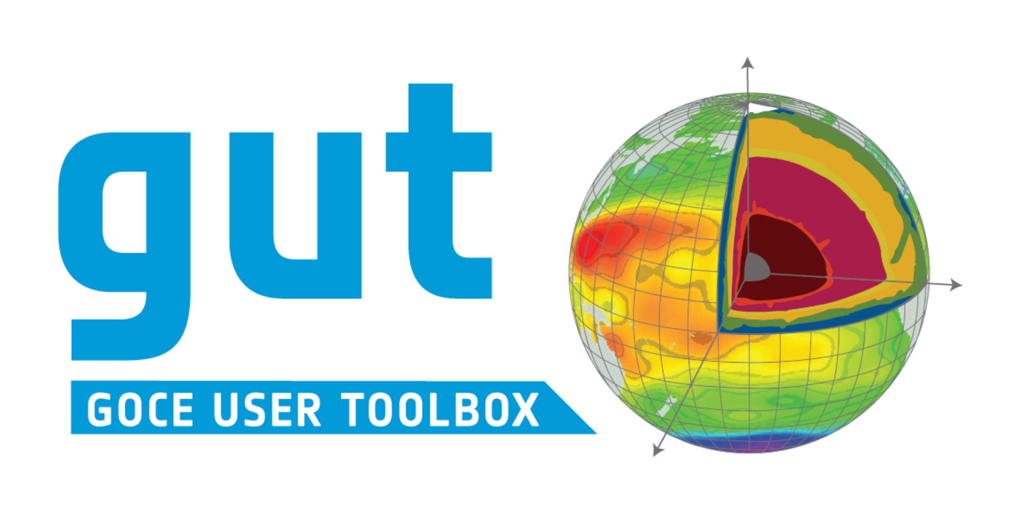

WP2200 Deliverable:

Toolbox Verification and Validation Report
Version: 1; 26 August 2016

GUT 3
VERSION 3 OF THE GOCE USER TOOLBOX

Ref:
ESA/XGCE-DTEX-EOPS-SW-09-0001 “GUTS Phase 3: GUT Development and Supporting Scientific Studies”
Coordinator: Per Knudsen (DNSC)

WP2400: “Validation and Verification of GUT v3” Responsible partner: National Oceanography Centre Prepared by: Helen Snaith

DOCUMENT CHANGE LOG
Rev. | Date | Sections modified |  | Comments | Changed by
0 | 14 March 2016 |  |  | Initial Draft for ESA
1 | 26 August 2016 | All |  | ESA Release | HMS

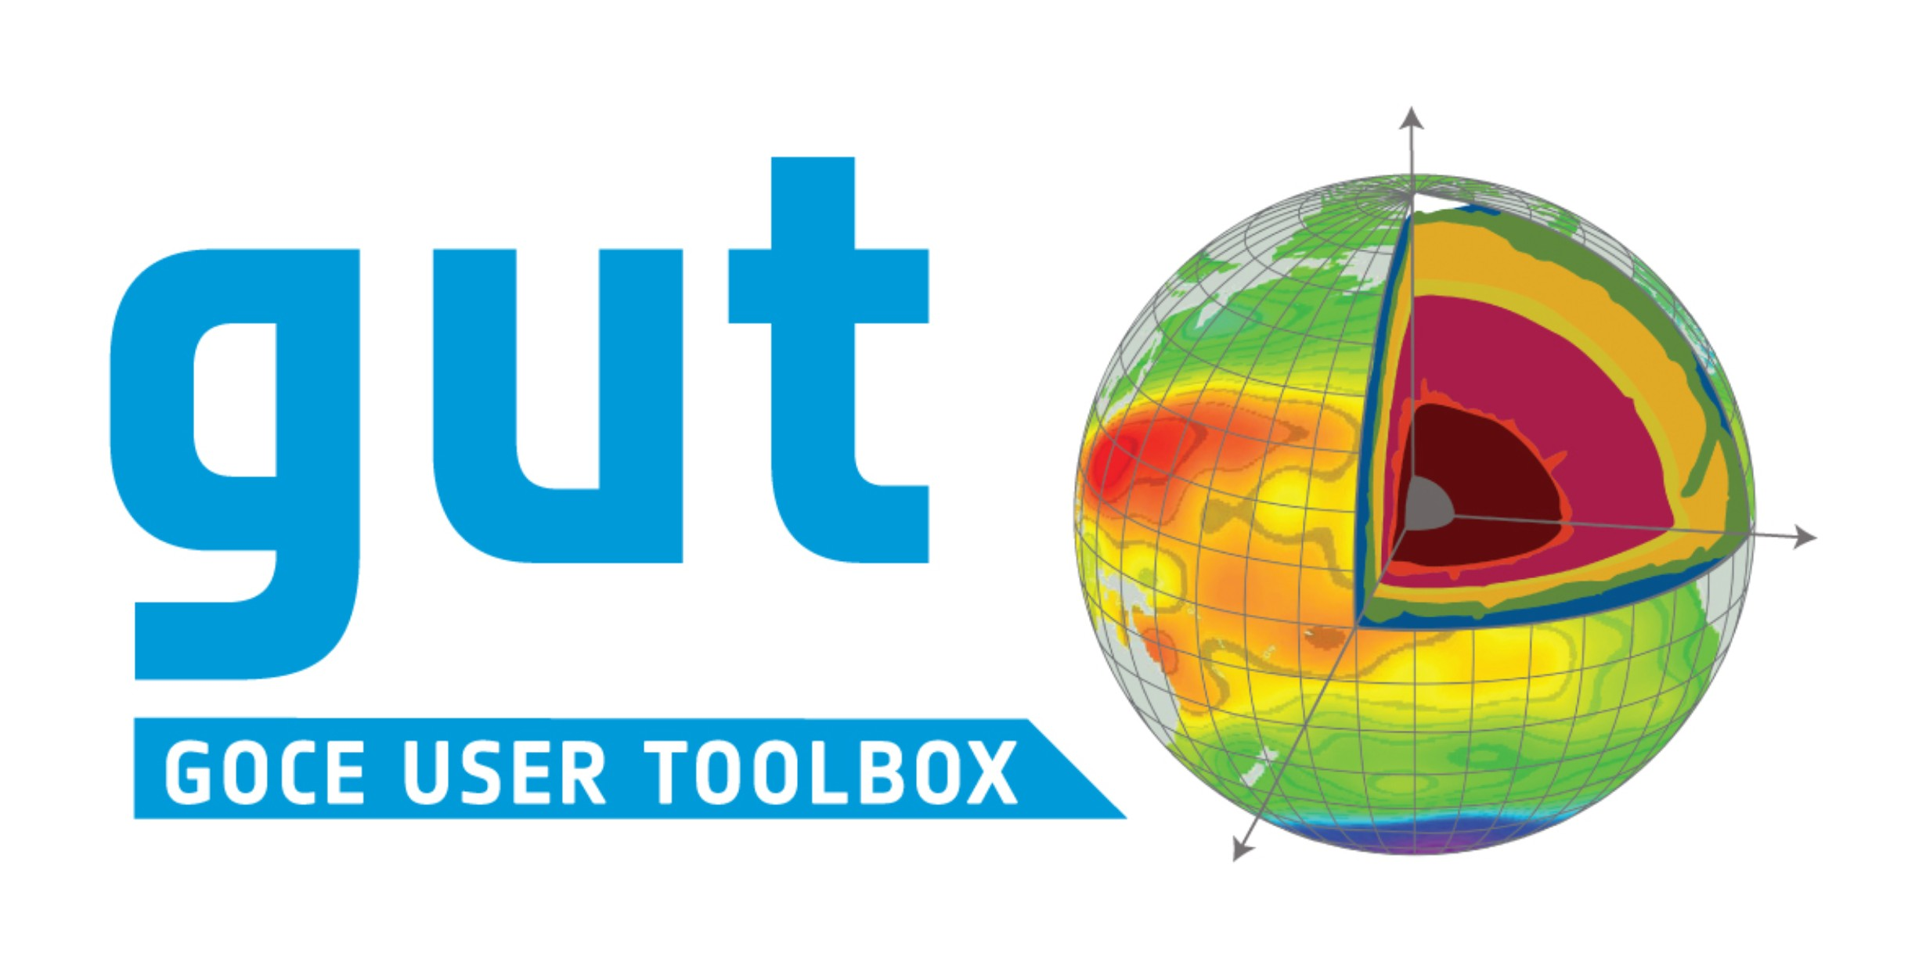 | GUTv2  Toolbox Verification and Validation Report | Ref: GUT2 Validation Report  Version : 1 Date : 26 August 2016

Table of Contents
Table of Contents i
Applicable and Reference Documents iii
Abbreviations iii
- Introduction 1
- Software Test Plan 1
- Validation Testing Protocols 2
  - Enhanced grid and track Manipulation 3
    - Compute point-wise multiplication or division or square root of two Grid or two Track functions 3
    - Generate a subset Grid Function without Interpolation 4
    - Generate meridional or zonal statistics 5
    - Diffusive Anisotropic Filter 6
  - Gravity Potential Gradient Functions 12
    - Compute a Grid Function of the Gravity Potential Gradients in LNOF from a Spherical Harmonic representation of the Gravitational Potential Field and Reference Gravity. 12
  - New Gravity Anomaly Computations 19
    - Compute a Grid Function of Free-Air Gravity Anomalies from a Spherical Harmonic representation of the Gravitational Potential Field and Reference Gravity. 20
    - Compute a Grid Function of Gravity Disturbance from an Altitude Grid Function, a Spherical Harmonic representation of the Gravitational Potential Field and Reference Gravity. 22
    - Compute a Grid Function of the Simple Bouguer effect (slab correction) 25
    - Compute a Grid Function of the Airy Isostatic Root from a pre-computed set of Spherical Harmonic Coefficients 29
    - Compute a Grid Function of the Bouguer effect (slab correction) from a pre- computed set of Spherical Harmonic Coefficients 35
  - Enhanced Oceanographic Computations 39
    - Compute the Ocean Kinetic Energy 39
    - Compute the vertical component of the Relative Vorticity from a Mean Dynamic Topography 43
- Evaluation of Documentation 44
- Current Limitations and Suggestions for Enhancement 46
i

Ref: GUT2 Validation Report Version : 1  Date : 26 August 2016 | GUTv2  Toolbox Verification and Validation Report | 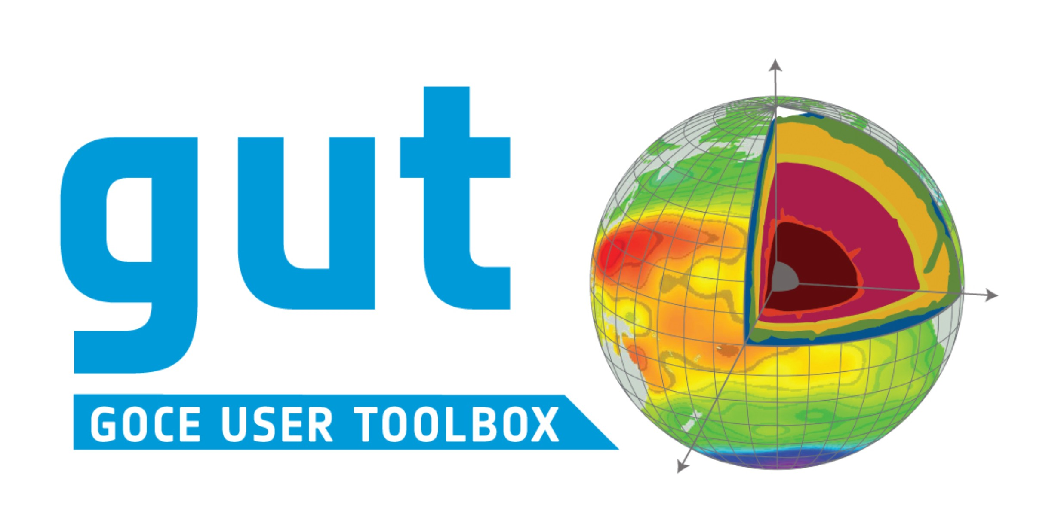
  - Statistics and data reporting 46
    - Limitation 46
    - Possible future development 46
  - Time 46
    - Limitation 46
    - Possible future development 46
  - Single Workflows to generate east and north components 46
    - Limitation 46
    - Possible future development 47
  - Working with multi-parameter files 47
    - Limitation 47
    - Possible future development 47
  - History attributes 47
    - Limitation 47
    - Possible future development 47
  - Grid adaptation 48
    - Limitation 48
    - Possible future development 48
  - Support for Alternative Standard File Formats 48
    - Limitation 48
    - Possible future development 48

 | GUTv2  Toolbox Verification and Validation Report | Ref: GUT2 Validation Report  Version : 1 Date : 26 August 2016

Applicable and Reference Documents
AD1 XGCE-DTEX-EOPS-SW-12-0001: “GOCE USER TOOLBOX, Maintenance, Evolution,
Scientific Studies and Product Validation (GUT3)", 5 November 2012.
AD2 [ESA-GUT2-SAD-001] “GUT2 Technical Specification and Architectural Design”, Version 1.1, 21-September-2010.
AD3 [ESA-GUT3-SAD-001] “GUT3 Technical Specification and Architectural Design”, Version 1.7, 19-December-2014
AD4 ESA-GUT3-WSAD-001. GUT3: GUI Technical Specification and Architectural Design. v1.0, 11 March 2015.

RD1 “GOCE High level processing facility – GOCE Level 2 Data Handbook”, GO-MA- HPF- GS-0110, iss. 4.1, 23-June-2010
RD2 ESA-GUT3-TP-001. GUT3 Software Test Plan v1.4, 11 Mar 2015.
RD3 “GUT User Guide and Algorithm Descriptions”, ESA-GUT-AD-001, v2.2, 25 Apr 2014
RD4 “GUT Installation Guide”, v3.0, 30 Jun 2015

Abbreviations
ADT Absolute Dynamic Topography
CLS Collecte Localisation Satellites
DO Degree and Order
GOCE Gravity and Ocean steady-state Circulation Explorer GUT GOCE User Toolbox
HPF High level Processing Facility
MDT Mean Dynamic Topography
MSS Mean Sea Surface
NOC National Oceanography Centre
S&T Science and Technology, Delft
SPH Spherical Harmonic Potential
SLA Sea Level Anomaly

iii

 | GUTv2  Toolbox Verification and Validation Report | Ref: GUT2 Validation Report  Version : 1 Date : 26 August 2016

Introduction
This document presents the results of the GUT v3 testing and validation carried out under WP2400. The testing and validation was carried out in order to evaluate the ability of the toolbox to:
▪▪ Reproduce the validated results generated by the v2 release of the software using v3 of the software.
▪▪ Validate the results generated by the new options available in the v3 release, as specified in [AD3], in particular:
- Compute the point-wise multiplication or division of two Grid or two Track functions.
- Compute the square root of a Grid or Track Function
- Create a subset Grid Function within specified latitude and longitude limits without interpolation
- Generate meridional or zonal statistics specified by latitude and longitude bounds and a step value
- Apply a diffusive/gradient anisotropic filter to a Grid Function defined by a diffusion mode, sensitivity value and number of iterations
- Compute a Grid Function of the Gravity Potential Gradients in LNOF from a Spherical Harmonic representation of the Gravitational Potential Field and Reference Gravity.
- Compute a Grid Function of Free-Air Gravity Anomalies from a Spherical Harmonic representation of the Gravitational Potential Field and Reference Gravity.
- Compute a Grid Function of Gravity Disturbance from an Altitude Grid Function, a Spherical Harmonic representation of the Gravitational Potential Field and Reference Gravity.
- Compute a Grid Function of the Airy Isostatic Root from a pre-computed set of Spherical Harmonic Coefficients
- Compute a Grid Function of the Bouguer effect (slab correction) from a pre- computed set of Spherical Harmonic Coefficients
- Compute the Ocean Kinetic Energy from a Mean Dynamic Topography
- Compute the vertical component of the Relative Vorticity from a Mean Dynamic Topography
▪▪ Ensure the operation of the GUI and ensure that result produced within the GUI environment replicate those generated by the command line tool.
The correctness and completeness of the toolbox documentation was also assessed.

Software Test Plan
The software was released with a software test plan [RD2], included as Annex A in this report.
This test plan was specified by S&T and conformance with the test plan ensures that the toolbox release conforms to those aspects of the technical specification and architectural design document [AD3] that were specified as requiring a specific test to be implemented.

Ref: GUT2 Validation Report Version : 1  Date : 26 August 2016 | GUTv2  Toolbox Verification and Validation Report

The current release of the software has passed all tests on the following platforms:
  - Mac OS X (10.10) using source distribution
  - Linux (Ubuntu) using source and binary distributions
  - Linux (SUSE Enterprise Desktop 10) using source distribution
  - Windows XP using Windows32 binary distribution
  - Linux Debian (4.0) using src distribution (development system)
The final testing of v3.0 raised some issues with the anisotropic filters that were resolved in v3.1.
No remaining issues were identified by the formal testing.

Validation Testing Protocols
The GUT is required to provide a scientific research tool that can be used to generate geophysical products. The approach taken for validation of v3 of the toolbox was the same as that used for v1 and v2: to use the toolbox to generate results that were comparable to those generated using existing software, currently in use in the research community, from datasets similar to those to be used within the toolbox. In the first instance, the toolbox is expected to reproduce the specific gridded products released by the HPF, in particular the geoid height, gravity anomaly and vertical deflections of gravity provided in the GOCE L2 products. Additional test datasets and workflows used in the validation were designed to allow the recreation of results equivalent to those presented in the GUT tutorial [AD5]. All data provided for testing in ASCII or binary format were first translated to NetCDF format using MATLAB and then to a GUT compliant NetCDF format using the appropriate GUT import workflow, for use in the validation process. The resultant files were read into MATLAB to confirm that the GUT import function had retained the original data values.
Where single workflows are provided with the GUT distribution to carry out a specific activity, these have been used in generation of the validation report. In other cases, workflows have been used in sequence to generate an equivalent product.
The following sections present the results of the validation exercise for a number of required activities. The results obtained, and comparisons to results generated using existing software, will be presented.

 | GUTv2  Toolbox Verification and Validation Report | Ref: GUT2 Validation Report  Version : 1 Date : 26 August 2016

Enhanced grid and track Manipulation

Compute point-wise multiplication or division or square root of two Grid or two Track functions
An additional functionality in GUT v3 is the point-wise multiplication or division of two grid or track functions. This was extended to the specific determination of the point-wise square-root of a grid or track function. The essential functionality of the new workflows multiply_gf, divide_gf and sqrt_gf were tested in the test plan. This functionality was validated by carrying out the same functions within MATLAB and comparing the results with those from the toolbox.
Input files: MSSCLS01_EIGENGL04S_fg400_grid.nc,
MSSCLS01_EIGENGL04S_fg400_point.nc

Workflow:
gut multiply_gf -InFileLhs ./input/MSSCLS01_EIGENGL04S_fg400_grid.nc
-InFileRhs ./input/MSSCLS01_EIGENGL04S_fg400_grid.nc
-OutFile MDT_multiplied.nc
gut divide_gf -InFileLhs ./MDT_multiplied.nc
-InFileRhs ./input/MSSCLS01_EIGENGL04S_fg400_grid.nc -OutFile MDT.nc gut sqrt_gf -InFile ./MDT_multiplied.nc -OutFile MDT_sqrt.nc
gut multiply_tf -InFileLhs ./input/MSSCLS01_EIGENGL04S_fg400_point.nc
-InFileRhs ./input/MSSCLS01_EIGENGL04S_fg400_point.nc
-OutFile MDT_trk_multiplied.nc
gut divide_tf -InFileLhs ./MDT_trk_multiplied.nc
-InFileRhs ./input/MSSCLS01_EIGENGL04S_fg400_point.nc
-OutFile MDT_trk.nc
gut sqrt_tf -InFile ./MDT_trk_multiplied.nc -OutFile MDT_trk_sqrt.nc
Output Files: MDT_multiplied.nc, MDT.nc MDT_sqrt.nc, MDT_trk_multiplied.nc, MDT_trk.nc and MDT_trk.nc

Results
In all cases, the resultant statistics from MATLAB and the GUT generated files were either identical, or within the numerical precision of the machine being used (10-19).

Ref: GUT2 Validation Report Version : 1  Date : 26 August 2016 | GUTv2  Toolbox Verification and Validation Report

Generate a subset Grid Function without Interpolation
An additional functionality in GUT v3 is the generation of a subset grid function, which is a simple extraction of all data from an existing grid function within specified latitude / longitude bounds with no interpolation. As an example, if the latitude values of an existing grid function are at 0.25˚, 0.75˚, 1.25˚ etc., then extracting data for a region defined with latitudes 0:10 would retain these latitude values not computing latitudes at 0˚, 0.5.

Results
The statistics generated by GUT were compared with statistics generated within MATLAB. The results were identical within the rounding errors of the machines used.
However, there is a minor ‘anomaly’. GUT will extract the data points that have any part of the grid cell within the expected limits. As an example, for a grid composed of 0.25˚, 0.75˚, 1.25˚, extract_gf with limits of 0:1 would extract all three of these data points, since the grid cell with longitude
1.25 has part of its cell <1˚. This is a different behaviour than MATLAB, which would only extract points 0.25 and 0.75 as the search would only consider the latitudes and longitudes as points, rather than locators for cells.

 | GUTv2  Toolbox Verification and Validation Report | Ref: GUT2 Validation Report  Version : 1 Date : 26 August 2016

Generate meridional or zonal statistics
An additional functionality in GUT v3 is the generation of zonal or meridional statistics of a gridded data file for specified latitude and longitude bounds and step value.

Results
The statistics generated by GUT were compared with statistics generated within MATLAB. The results were identical within the rounding errors of the machines used.

Ref: GUT2 Validation Report Version : 1  Date : 26 August 2016 | GUTv2  Toolbox Verification and Validation Report

Diffusive Anisotropic Filter
Release 3 of the toolbox introduced a workflow to apply a diffusive / gradient version anisotropic filter, designed to retain real gradients whilst smoothing noise levels. The filter is an adaptation of a filter introduced by Rory Bingham and the validation is made against a filtered grid created using the original code, from the same input file, using the same filter definitions.
Input files: mdt_DTU13_GTIM5_L280_qrtd.nc
Original Output File: mdt_DTU13_GTIM5_L280_qrtd_fltrd.nc

Workflow:
gut diffusion_gf -InFile mdt_DTU13_GTIM5_L280_qrtd.nc
-DiffFunction single -Sensitivity 0.22 -Iterations 489
-OutFile diffusive_filt.nc
New Output File: diffusive_filt.nc

Results
The diffusive filter function applied was ‘single’ (1/(1+(grad/K)^2) with a sensitivity of 0.22, over 489 iterations (Figure 1) and produced virtually identical results to the original results over the ocean.
The global statistics of the difference between the two techniques appear poor, with a range of -33 -> 21.5 km and a mean and an rms of -1.4 cm and 3.8 m, respectively. However, the inspection of the differences (Figure 2) shows that these extreme values are confined to high latitudes (greater than +/- 75˚). If the values higher than +/-75˚ latitude are ignored, the range is reduced to -1.28cm -> 1.76cm, with a mean difference of -.0011 mm and an rms of
0.15 mm, respectively.

 | GUTv2  Toolbox Verification and Validation Report | Ref: GUT2 Validation Report  Version : 1 Date : 26 August 2016

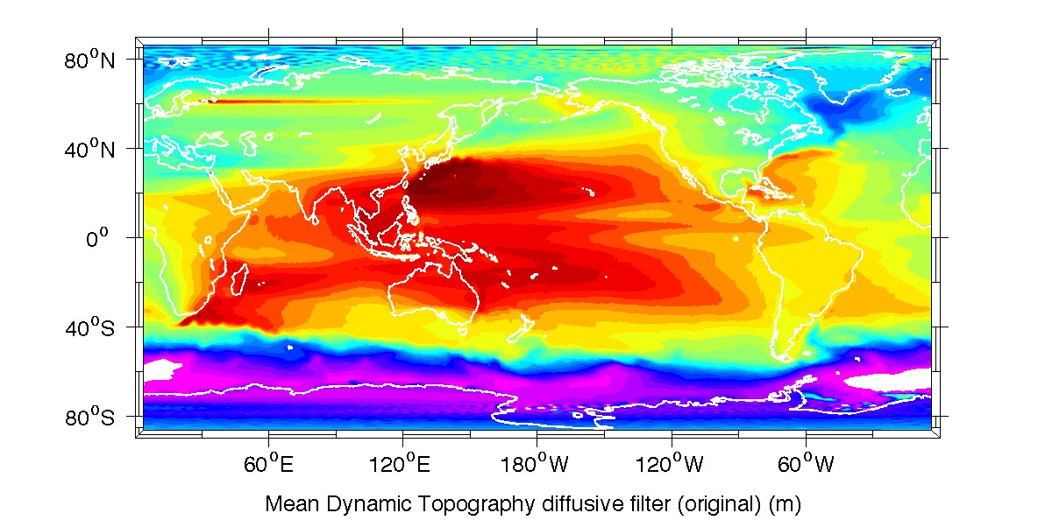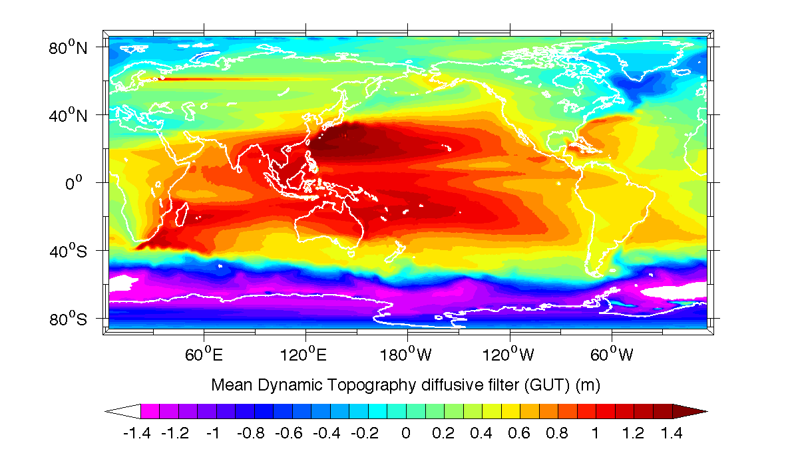

Figure 1: MDT fields filtered using a diffusive filter in the original program (top) and the same field filtered using GUT (bottom).

Ref: GUT2 Validation Report Version : 1  Date : 26 August 2016 | GUTv2  Toolbox Verification and Validation Report

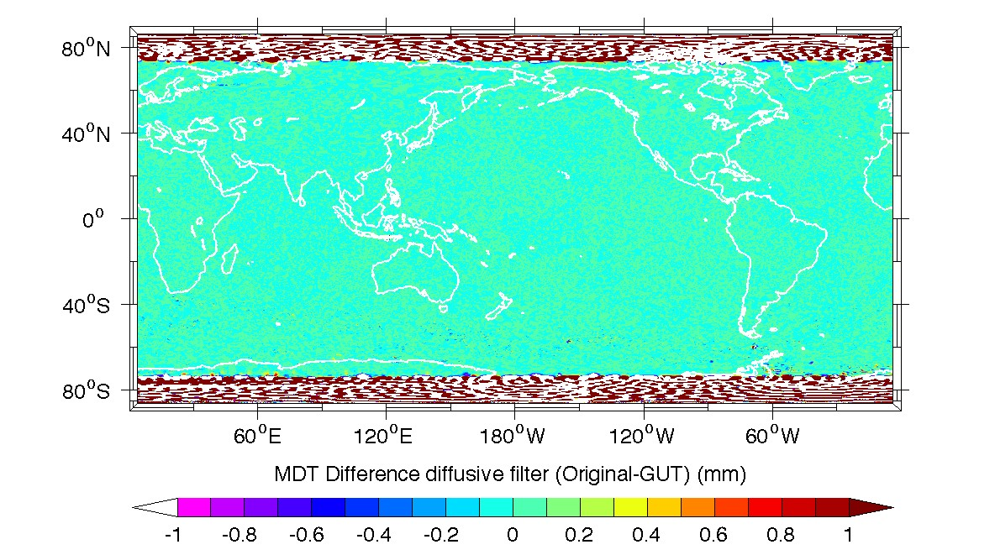
Figure 2: Difference between MDT fields filtered using a diffusive filter in the original program and the same field filtered using GUT.

However, by plotting a section of the fields from the Southern Ocean in detail (Figure 3), it appears that the filtered field from the original calculation contains spurious features south of 75˚S. These features are present in the source field, but appear to have been correctly filtered and so are not evident in the GUT calculation. Therefore, the original calculation is in error whereas the GUT filtering performs correctly.

 | GUTv2  Toolbox Verification and Validation Report | Ref: GUT2 Validation Report  Version : 1 Date : 26 August 2016

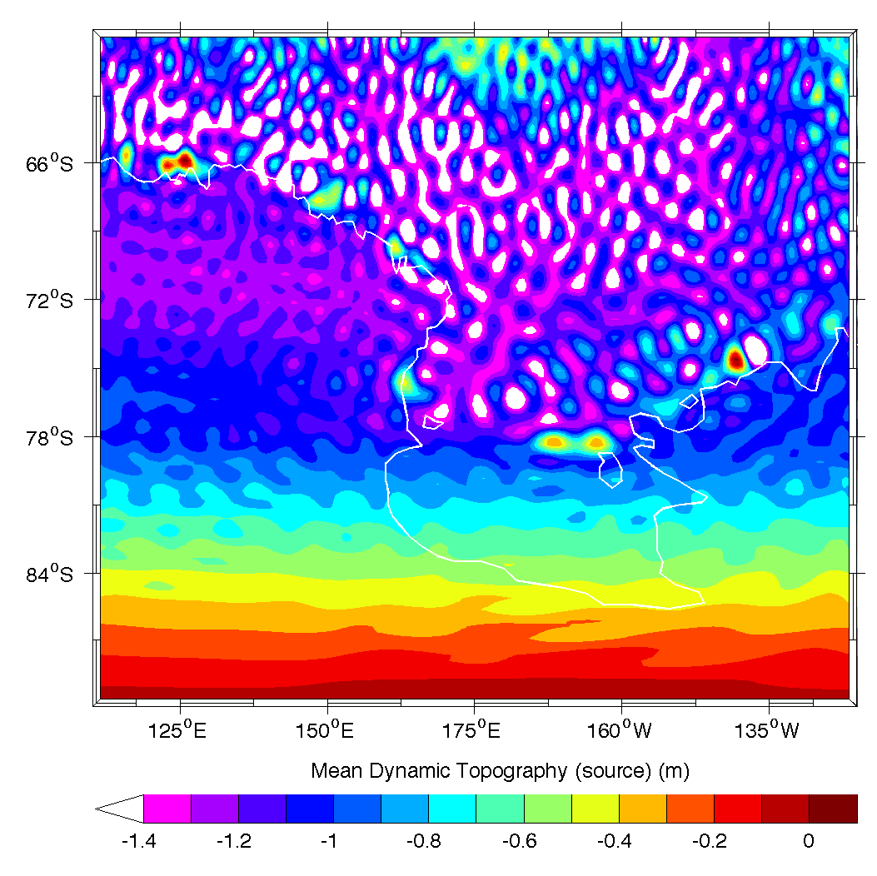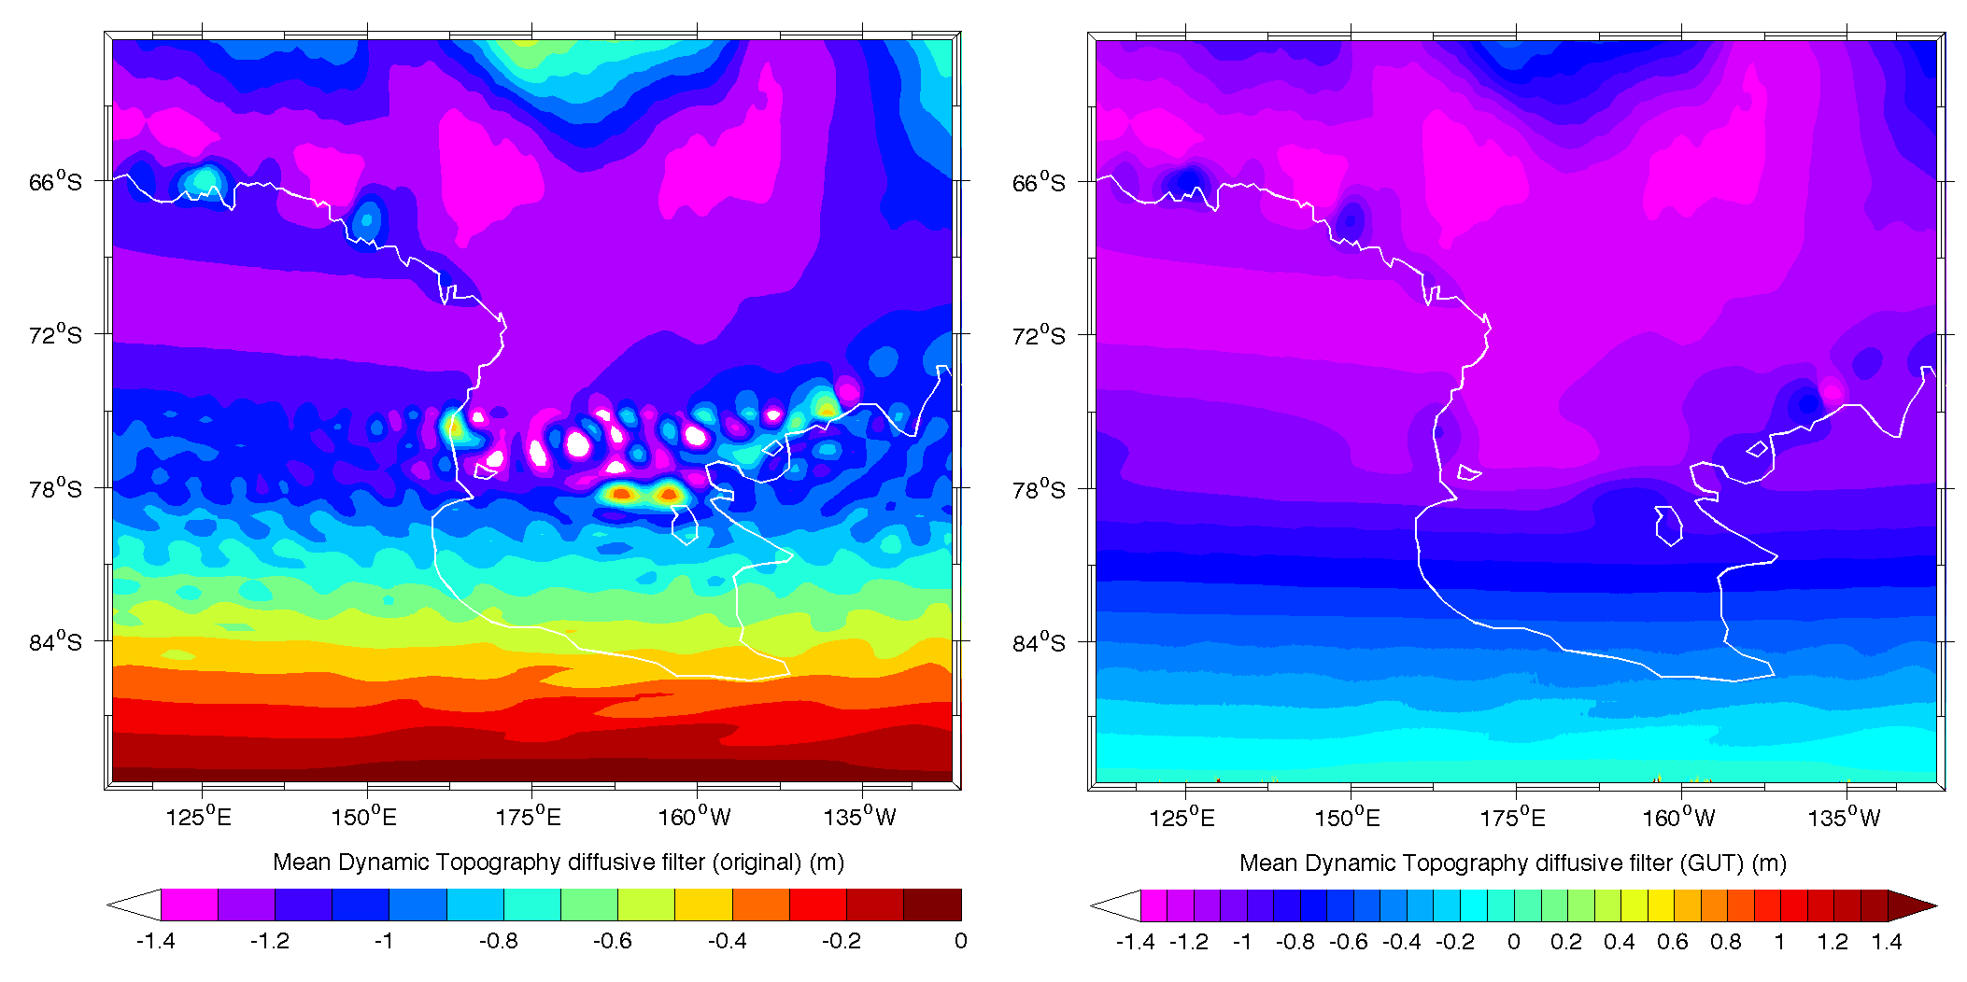
Figure 3: MDT fields for a section of the Southern Ocean, unfiltered (top), filtered using a diffusive filter in the original program (lower left) and filtered using GUT (lower right).

When comparing results away from this high latitude region, the differences are generally less than +/- 1mm (Figure 2), with the largest differences in regions of highest gradient, such as the Antarctic Circumpolar Current, as it might be expected. For a subset of the data in the Pacific, away from land areas, the two methods produce very similar results. For the region from 180 – 210˚E 6˚S – 12˚N, the difference ranges from -0.14 mm to 0.007 mm, with a mean difference of -6.246e-05 mm and an rms difference of 0.00425 mm, respectively. The differences do not have a structure related to the underlying MDT (Figure 4).

Ref: GUT2 Validation Report Version : 1  Date : 26 August 2016 | GUTv2  Toolbox Verification and Validation Report

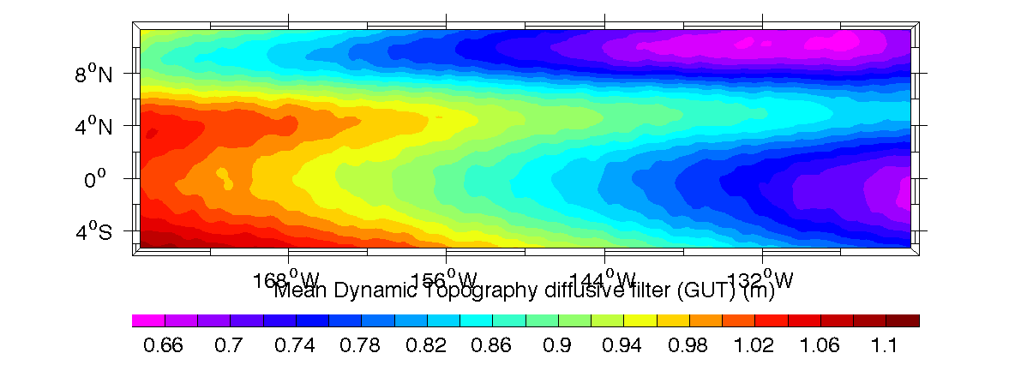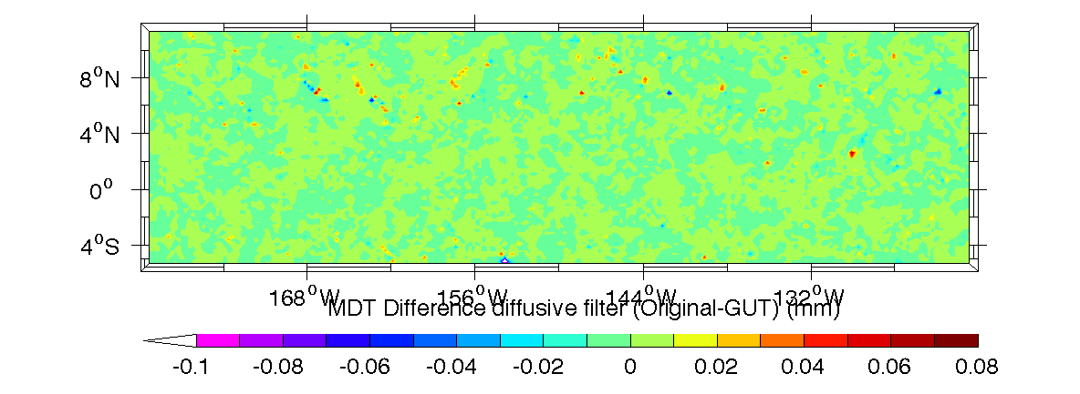

Figure 4: MDT fields in the Pacific filtered using a diffusive filter in GUT (top) and the difference between the original program and the same field filtered using GUT (bottom).

To exclude the region where the original calculation was in error, the same filter was re- run over a subset of the original MDT field, truncated at +-65˚ latitude. Again, the difference of the resulting field from the filtered MDT, determined using the original code, was computed. Comparing the two difference plots (‘original – GUT’ full field and ‘original – GUT’ subset field) for a section of the Southern Ocean at the southern limit of this subset grid (Figure 5) there are clearly edge effects present when filtering the subset field. However, these are limited to no more than two grid points from the boundary.

 | GUTv2  Toolbox Verification and Validation Report | Ref: GUT2 Validation Report  Version : 1 Date : 26 August 2016

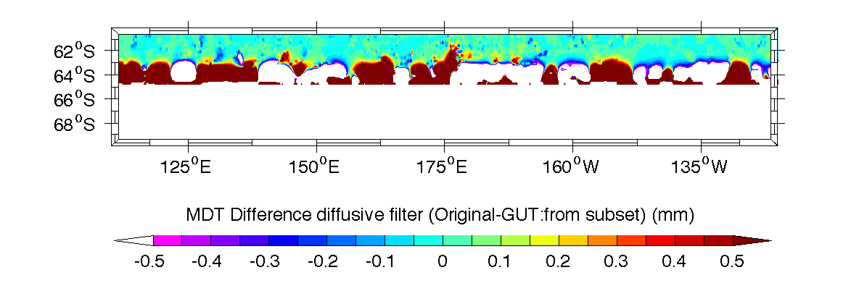
Figure 5: Difference between MDT fields filtered using a diffusive filter in the original program and the same field filtered in GUT in a section of the Southern Ocean, using the full field for filtering (top) and a subset restricted to latitude <65˚ (bottom).

Ref: GUT2 Validation Report Version : 1  Date : 26 August 2016 | GUTv2  Toolbox Verification and Validation Report

Gravity Potential Gradient Functions

Compute a Grid Function of the Gravity Potential Gradients in LNOF from a Spherical Harmonic representation of the Gravitational Potential Field and Reference Gravity.
To validate the Gravity Potential Gradients workflow introduced in v3 of GUT, the results of the new gravitypotentialgradient_gf workflow were compared with results obtained using both the GeoCol and the GrafLab software packages. The GeoCol and GrafLab grid output files were converted to a GUT compliant NetCDF in MATLAB and used to define the grid function to use for the calculation. Two sets of gradient calculation were carried out, using the same region of Europe (30 – 60˚N, 10˚W – 40˚E), but with two different grid resolutions (0.5˚ and 0.2˚). The appropriate GeoCol derived XX gradient grid file (GOCEeuTim4Txx and GOCEeuTim4Txx2.nc) was used to define the grid function for all the GUT calculations.
It is important to note that there is a difference in the definition of x and y coordinate directions between GUT and GrafLab (which uses the LNOF coordinate system) and GeoCol (which uses the ENU coordinate system). Hence for all comparisons, the relationship used is:

GUT Tyy | = | GeoCol XX
GUT Txx | = | GeoCol YY
GUT Tzz | = | GeoCol ZZ
GUT Txy | = | -GeoCol XY
GUT Tyz | = | -GeoCol XZ
GUT Txz. | = | GeoCol YZ
Input files: go_cons_gcf_2_dir_r4.gfc, GUT_ACE2_5m.nc (GUT apriori DEM)
Original Output Files: GOCEeuTim4Txx.nc, GOCEeuTim4Tyy.nc, GOCEeuTim4Tzz.nc, GOCEeuTim4Txy.nc, GOCEeuTim4Txz.nc, GOCEeuTim4Tyz.nc (from GeoCol) and Europe_DisturbingTensor.nc (GrafLab)

Workflow:
gut gravitypotentialgradient_gf -Gradient XX
-InFile go_cons_gcf_2_tim_r4.gfc -InDemFile GUT_ACE2_5M.nc
-Gf output_original/GOCEeuTim4Txx[2].nc -OutFile gut_GG_Txx[2].nc
gut gravitypotentialgradient_gf -Gradient YY
-InFile go_cons_gcf_2_tim_r4.gfc -InDemFile GUT_ACE2_5M.nc
-Gf output_original/GOCEeuTim4Txx[2].nc -OutFile gut_GG_Tyy[2].nc
gut gravitypotentialgradient_gf -Gradient ZZ
-InFile go_cons_gcf_2_tim_r4.gfc -InDemFile GUT_ACE2_5M.nc
-Gf output_original/GOCEeuTim4Txx[2].nc -OutFile gut_GG_Tzz[2].nc
gut gravitypotentialgradient_gf -Gradient XY
-InFile go_cons_gcf_2_tim_r4.gfc -InDemFile GUT_ACE2_5M.nc
-Gf output_original/GOCEeuTim4Txx[2].nc -OutFile gut_GG_Txy[2].nc

 | GUTv2  Toolbox Verification and Validation Report | Ref: GUT2 Validation Report  Version : 1 Date : 26 August 2016

gut gravitypotentialgradient_gf -Gradient XZ
-InFile go_cons_gcf_2_tim_r4.gfc -InDemFile GUT_ACE2_5M.nc
-Gf output_original/GOCEeuTim4Txx[2].nc -OutFile gut_GG_Txz[2].nc
gut gravitypotentialgradient_gf -Gradient YZ
-InFile go_cons_gcf_2_tim_r4.gfc -InDemFile GUT_ACE2_5M.nc
-Gf output_original/GOCEeuTim4Txx[2].nc -OutFile gut_GG_Tyz[2].nc
New Output Files: gut_GG_Txx.nc, gut_GG_Tyy.nc, gut_GG_Tzz.nc, gut_GG_Txy.nc, gut_GG_Txz.nc, gut_GG_Tyz.nc (for region 1) and gut_GG_Txx2.nc, gut_GG_Tyy2.nc, gut_GG_Tzz2.nc, gut_GG_Txy2.nc, gut_GG_Txz2.nc, gut_GG_Tyz2.nc (for region 2).

Results
The fields produced for the xx gradient for the coarse resolution are shown in Figure 6, those for the yz gradient at fine resolution are in Figure 7. Also plotted are the difference fields between the three calculations (GrafLab, GeoCol and GUT) for the coarse resolution grid, and between the GeoCol and GUT fields for the fine resolution grid. As can be seen, the resultant fields are very similar in terms of features, and almost identical by eye. However, it is clear that GUT has much greater differences from the other fields than the difference between the GeoCol and GrafLab fields.
The statistics for comparisons of all the gradient components for the two regions are given in the following tables. The GeoCol and GrafLab results are virtually identical, within 5*1e-4 eotvos (1e-9 s-1).
Over the majority of the region, where gravity gradients are small, the difference between the fields is very small in all cases. However, in the regions where the change in gradient is very large, the difference in fields is correspondingly large. This is demonstrated in Figure 8, which shows a very small section of the Alps, where there is a very strong short-scale change in the gravity gradients. As can be seen, the differences between the fields are greatest in this region, in particular, where there is both a strong north-south gradient and a strong east-west gradient in the basic field. It is possible these differences are caused by a minor difference in the included longitudinal gradient vectors when calculating the gridded fields.

Ref: GUT2 Validation Report Version : 1  Date : 26 August 2016 | GUTv2  Toolbox Verification and Validation Report

Table 3-1 Statistics for gravity gradient calculations for Region 1: 30-60˚N 10˚W-40˚E, 0.5˚ grid resolution.

GeoCol | Min | Max | Mean | Std
xx | -24.497000 | 24.086200 | -0.063207 | 4.261442
yy | -19.973500 | 23.658500 | -0.077701 | 3.279643
zz | -36.684300 | 39.535200 | 0.140908 | 6.166818
xy | -12.896900 | 11.232600 | 0.028150 | 2.090114
xz | -30.613800 | 26.090900 | 0.018786 | 4.754060
yz | -25.964800 | 26.383400 | -0.009352 | 3.928498
GrafLab | Min | Max | Mean | Std
xx | -24.496866 | 24.085875 | -0.063209 | 4.261428
yy | -19.973291 | 23.658280 | -0.077703 | 3.279610
zz | -36.684017 | 39.535010 | 0.140912 | 6.166781
xy | -12.896845 | 11.232559 | 0.028150 | 2.090100
xz | -30.613685 | 26.090956 | 0.018783 | 4.754041
yz | -25.964570 | 26.383195 | -0.009352 | 3.928461
GUT | Min | Max | Mean | Std
xx | -24.051300 | 23.993400 | -0.053319 | 4.214260
yy | -19.009600 | 23.650900 | -0.072125 | 3.248170
zz | -36.672500 | 38.929400 | 0.125444 | 6.101560
xy | -12.892000 | 11.227800 | 0.028661 | 2.070750
xz | -30.597300 | 25.556000 | 0.020188 | 4.710460
yz | -25.925900 | 26.027200 | -0.009885 | 3.895440
GeoCol-GrafLab | Min | Max | Mean | Std
xx | -0.000397 | 0.000389 | 0.000002 | 0.000077
yy | -0.000247 | 0.000231 | 0.000002 | 0.000056
zz | -0.000497 | 0.000546 | -0.000004 | 0.000102
xy | -0.000207 | 0.000202 | 0.000000 | 0.000043
xz | -0.000431 | 0.000443 | 0.000003 | 0.000083
yz | -0.000318 | 0.000327 | 0.000001 | 0.000065
GeoCol-GUT | Min | Max | Mean | Std
xx | -1.379930 | 0.666177 | -0.009887 | 0.084380
yy | -1.289620 | 0.342712 | -0.005576 | 0.057998
zz | -0.675710 | 1.771270 | 0.015464 | 0.117512
xy | -0.725851 | 0.518267 | 0.000512 | 0.036895
xz | -0.934463 | 1.604630 | -0.001402 | 0.081942
yz | -0.848400 | 1.241260 | -0.000533 | 0.060525
GrafLab-GUT | Min | Max | Mean | Std
xx | -1.379700 | 0.666140 | -0.009890 | 0.084372
yy | -1.289500 | 0.342590 | -0.005579 | 0.057980
zz | -0.675630 | 1.771000 | 0.015468 | 0.117490
xy | -0.725780 | 0.518170 | -0.000511 | 0.036886
xz | -0.934400 | 1.604500 | -0.001405 | 0.081931
yz | -0.848380 | 1.241100 | 0.000533 | 0.060505

 | GUTv2  Toolbox Verification and Validation Report | Ref: GUT2 Validation Report  Version : 1 Date : 26 August 2016

Table 3-2 Statistics for gravity gradient calculations for Region 2: 30-60˚N 10˚W-40˚E, 0.2˚ grid resolution.

GeoCol | Min | Max | Mean | Std
xx | -25.090200 | 26.362500 | -0.069414 | 4.263609
yy | -20.307500 | 25.140400 | -0.085047 | 3.283410
zz | -38.578500 | 39.919700 | 0.154461 | 6.171164
xy | -13.593400 | 12.073400 | 0.027962 | 2.091341
xz | -31.003600 | 26.306700 | 0.021842 | 4.753190
yz | -26.455200 | 27.556200 | -0.015027 | 3.932246
GUT | Min | Max | Mean | Std
xx | -24.735800 | 26.253100 | -0.059982 | 4.218660
yy | -19.827000 | 25.129600 | -0.079494 | 3.252380
zz | -38.395800 | 39.439000 | 0.139476 | 6.107930
xy | -13.587000 | 11.852900 | 0.028462 | 2.072490
xz | -30.597300 | 25.556000 | 0.020188 | 4.710460
yz | -26.232400 | 27.239200 | -0.015443 | 3.899100
GeoCol-GUT | Min | Max | Mean | Std
xx | -1.388570 | 0.620396 | -0.009432 | 0.079204
yy | -1.316620 | 0.415674 | -0.005553 | 0.055961
zz | -0.734527 | 2.183050 | 0.014985 | 0.112112
xy | -0.806272 | 0.518267 | -0.000500 | 0.035428
xz | -0.988272 | 1.356840 | -0.001510 | 0.079230
yz | -1.120650 | 1.256160 | 0.000415 | 0.059782

Ref: GUT2 Validation Report Version : 1  Date : 26 August 2016 | GUTv2  Toolbox Verification and Validation Report

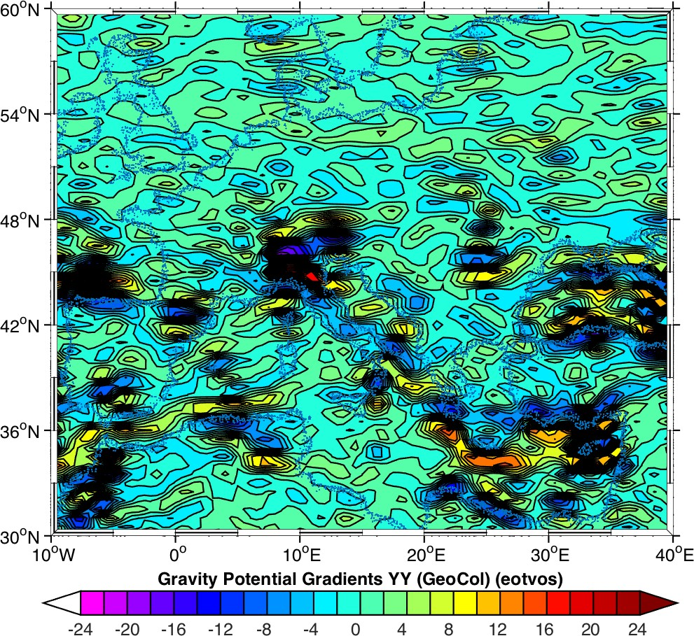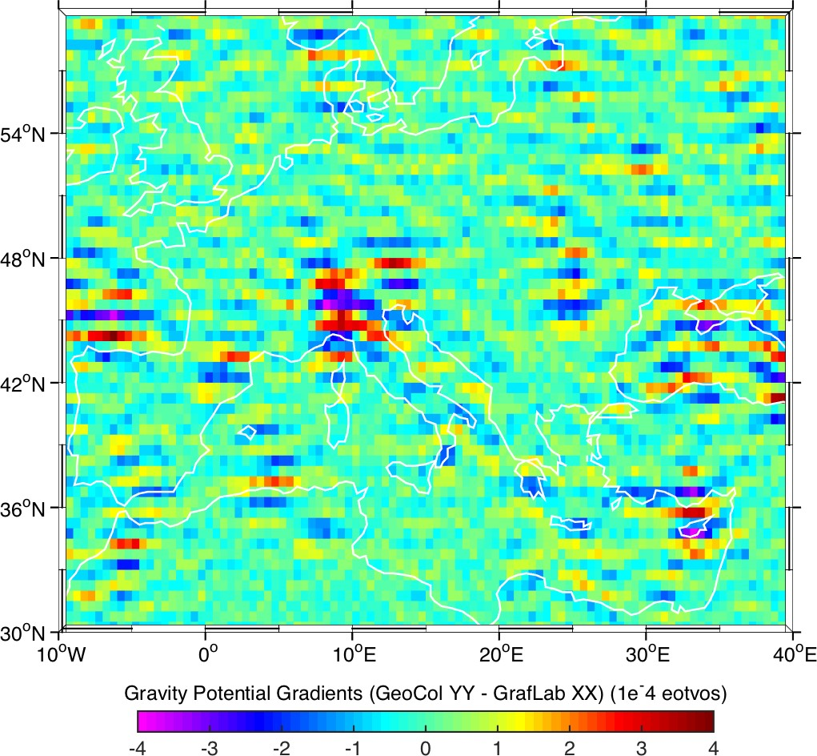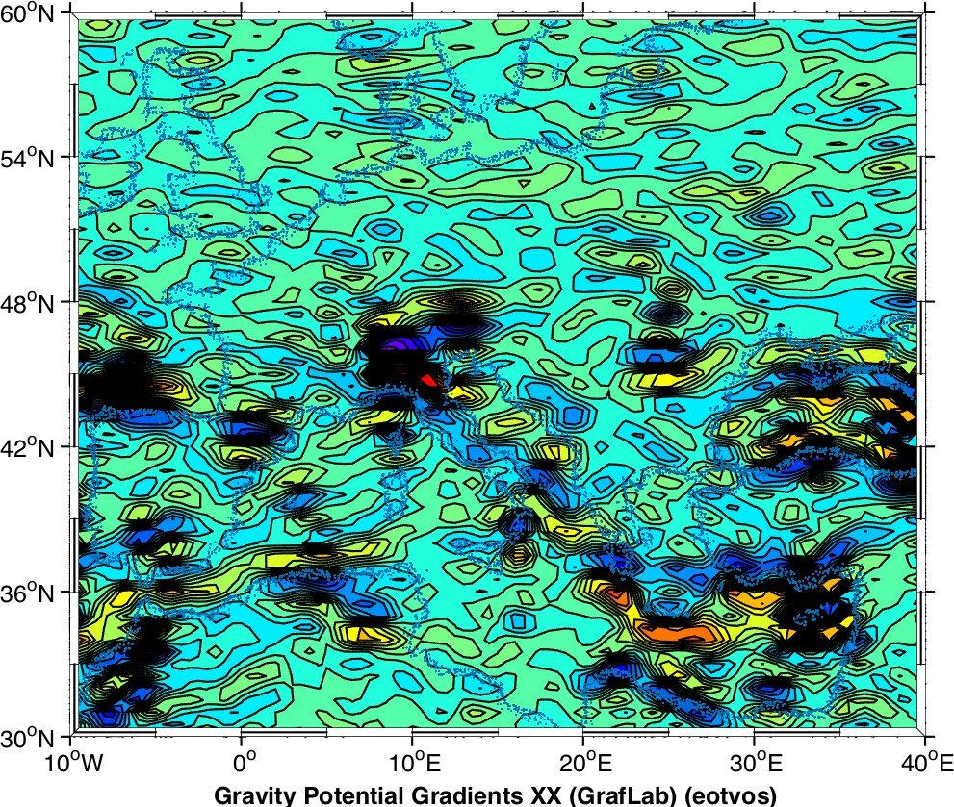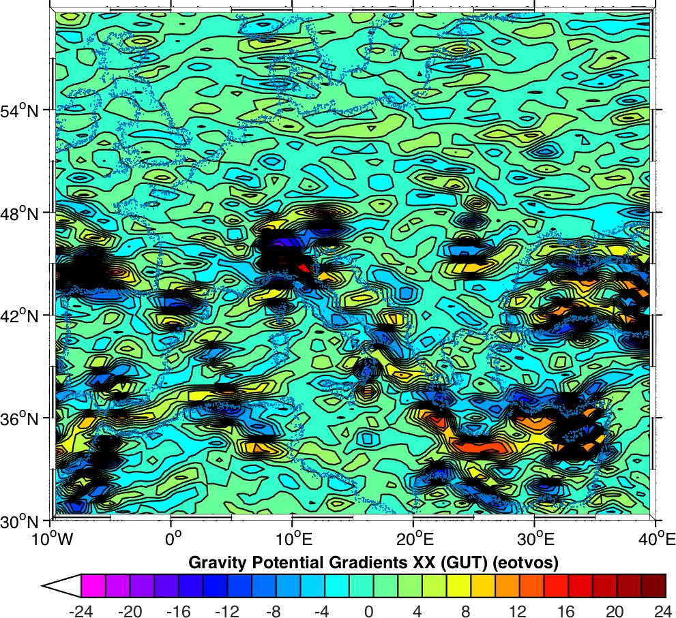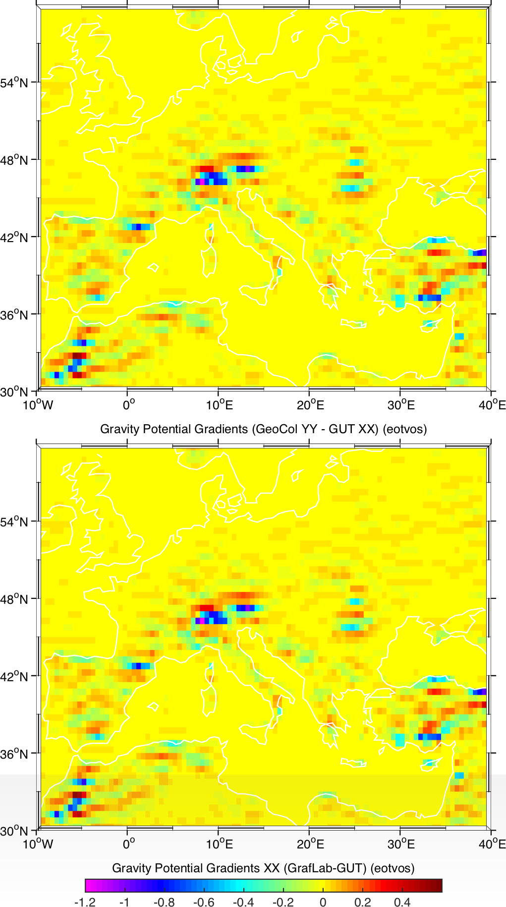

Figure 6: XX Gravity Gradients for a 0.5˚ grid over Europe (left) from GeoCol (top), GrafLab (centre) and using the GUT workflow (bottom) and the differences between them (right).

 | GUTv2  Toolbox Verification and Validation Report | Ref: GUT2 Validation Report  Version : 1 Date : 26 August 2016

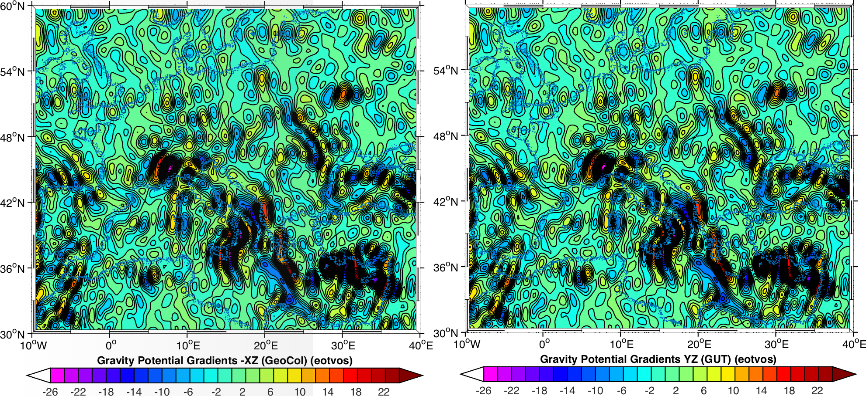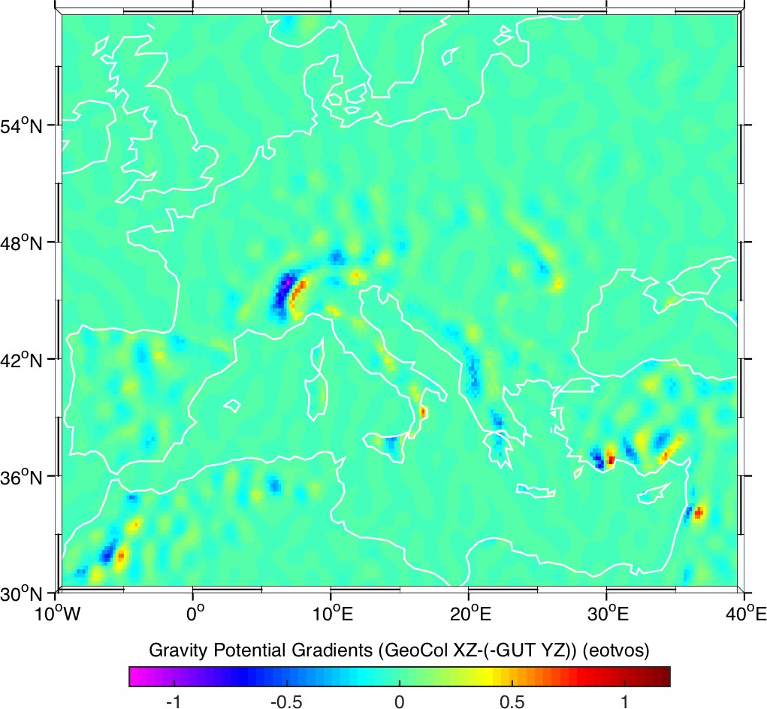
Figure 7: XZ Gravity Gradients for a 0.2˚ grid over Europe from GeoCol (top left), using the GUT workflow (top right) and the difference (below).

Ref: GUT2 Validation Report Version : 1  Date : 26 August 2016 | GUTv2  Toolbox Verification and Validation Report

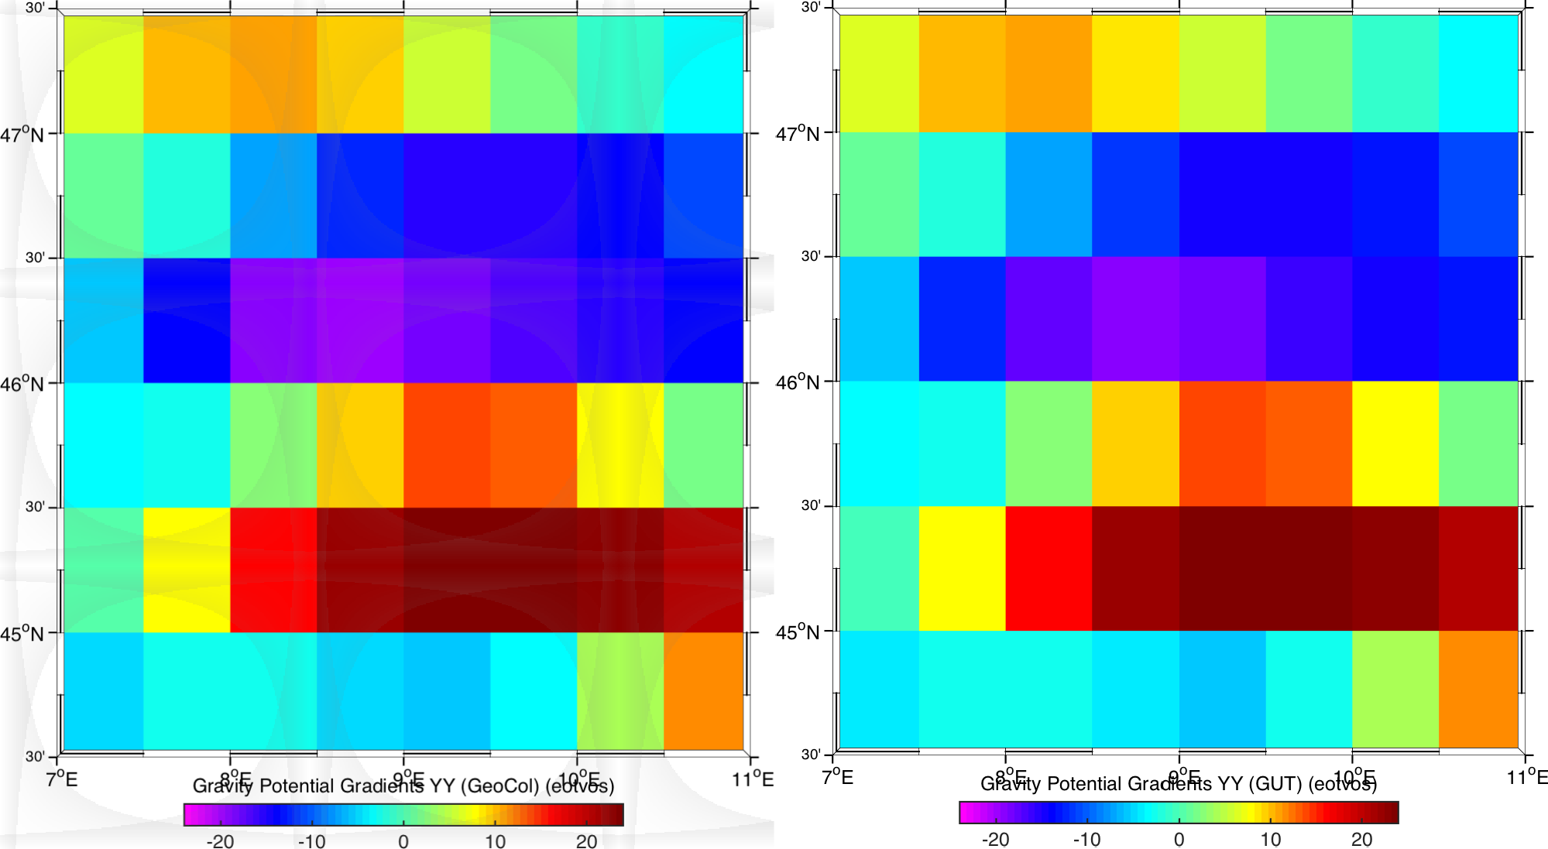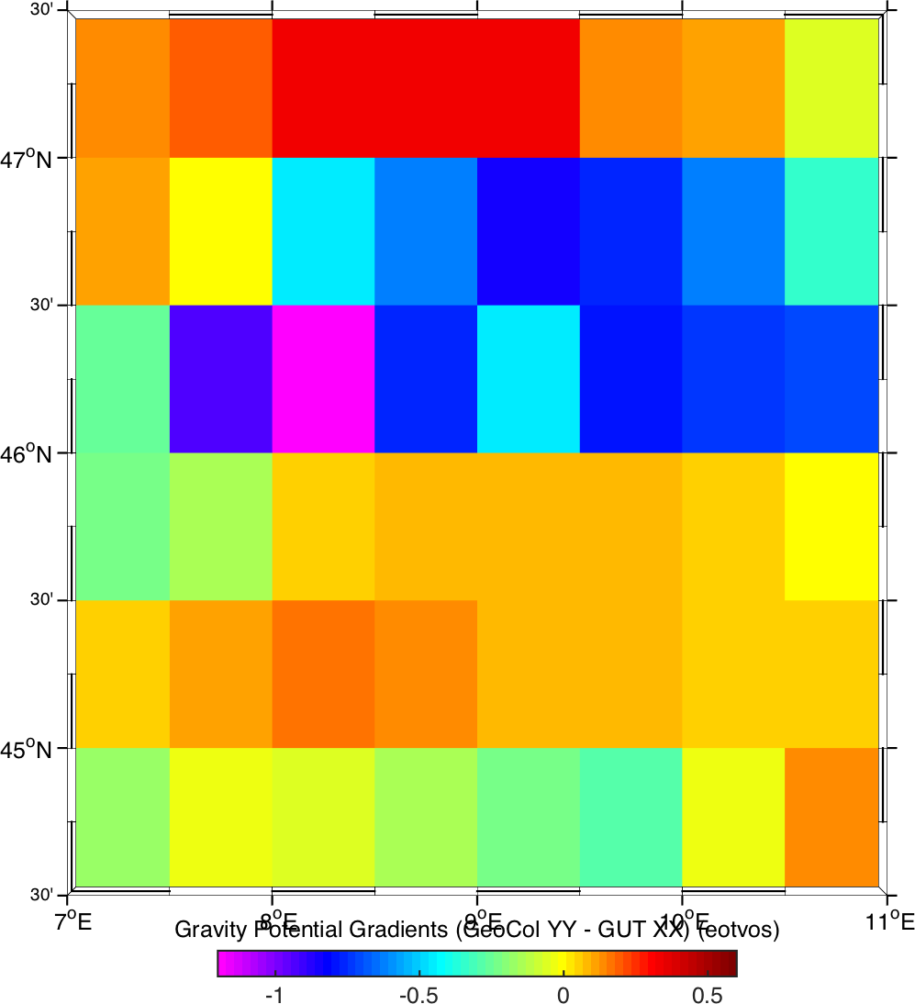
Figure 8: XX Gravity Gradients for a small section of the 0.5˚ grid over Europe from GeoCol (top left), using the GUT workflow (top right) and the difference (below).

 | GUTv2  Toolbox Verification and Validation Report | Ref: GUT2 Validation Report  Version : 1 Date : 26 August 2016

New Gravity Anomaly Computations
Two sources of data were used to test the new gravity anomaly computations. Where possible, the GUT workflows were compared with results obtained using the International Centre for Global Earth Models (ICGEM) online calculation service at http://icgem.gfz- potsdam.de/ICGEM/.
Two regions were selected to test the workflows, a predominantly oceanic area in the North Atlantic (60-15˚W, 15-40˚N) and by contrast, an area of very steep topography and varying lithosphere, covering part of South America and the South Pacific (90-70˚W, 30-0˚S).
As some of the workflows in this category (gravity disturbance, Bouguer Anomaly) require the use of a digital terrain model (DTM) the ICGEM calculation service was first used to create a DTM grid for each of these areas using the ICGEM topography, to be used in the GUT workflows, to ensure consistency as far as possible. The topography_grd functional routine was selected, as shown in Figure 9, to create DTM grids for the two regions, from the spherical harmonic expansion of the ETOPO1 1’ x 1’ grid (Ice Surface version).

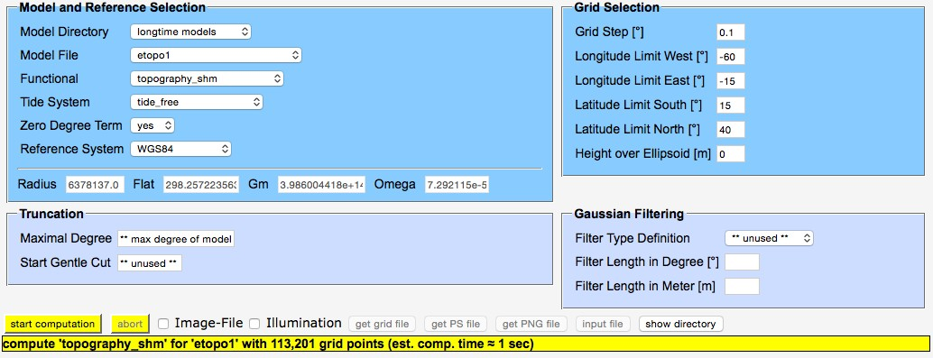
Figure 9: ICGEM calculation service input for the DTM grid calculation for the North Atlantic Region.

The output ICGEM grid (gdf) files were converted to GUT compliant NetCDF files in MATLAB. The NetCDF files could be used both as input DTM files and to define the grid functions to be used in the subsequent workflows.
For the Airy and full Bouguer workflows, there is no comparable functional in the ICGEM calculation service. In these cases, validation datasets were generated by Carla Braitenberg, using the MATLAB GrafLab functions. In this case, the test area selected included Italy and the Alps. Again, a DTM was generated in the ICGEM calculation service to define the grid function to be used for the GUT workflows.
The output GrafLab grid files were converted to GUT compliant NetCDF files in MATLAB in the same way as the ICGEM gdf files.

Ref: GUT2 Validation Report Version : 1  Date : 26 August 2016 | GUTv2  Toolbox Verification and Validation Report

Compute a Grid Function of Free-Air Gravity Anomalies from a Spherical Harmonic representation of the Gravitational Potential Field and Reference Gravity.
To validate the Free Air gravity anomaly workflow introduced in v3 of GUT, the results of the new freeairgravityanomaly_gf workflow were compared with results using the ICGEM gravity_anomaly_cl functional. The ICGEM calculation service specification used for the North Atlantic Region grid is given in Figure 10. The output ICGEM grid files were converted to a GUT compliant NetCDF in MATLAB.

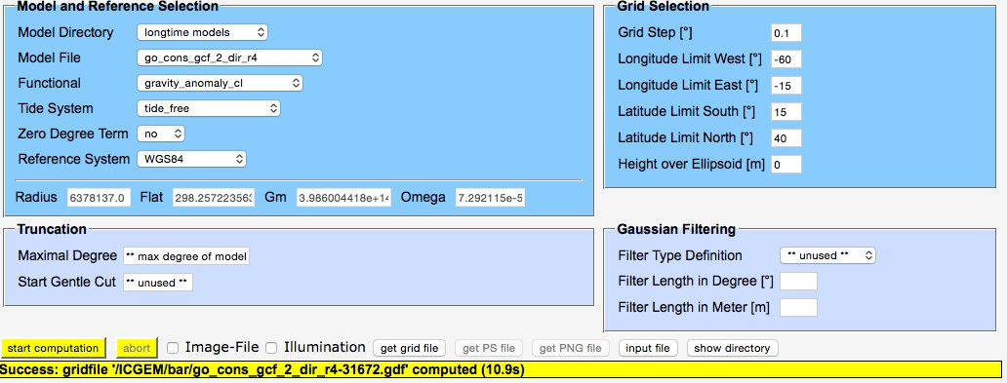
Figure 10: ICGEM calculation service input for the free air gravity anomaly grid calculation for the North Atlantic Region.

For this workflow, the DTM input files are used purely to define the grid functions.
Input files: go_cons_gcf_2_dir_r4.gfc, DTM_S_America.nc, DTM_N_Atlantic.nc
Original Output Files: gravity_anomaly_cl_N_Atlantic.nc, gravity_anomaly_cl_S_America.nc

Workflow:
gut freeairgravityanomaly_gf -InFile input/go_cons_gcf_2_dir_r4.gfc
-Gf input/DTM_S_America.nc
-OutFile freeair_gravity_anomaly_S_America.nc
gut freeairgravityanomaly_gf -InFile input/go_cons_gcf_2_dir_r4.gfc
-Gf input/DTM_N_Atlantic.nc
-OutFile freeair_gravity_anomaly_N_Atlantic.nc
New Output Files: freeair_gravity_anomaly_S_America.nc, freeair_gravity_anomaly_N_Atlantic.nc

Results
The results for the two regions are shown in Figure 11 and Figure 12. For the South Pacific region (Figure 11) the mean difference is -0.1141 mgal with an rms difference of
0.119 mgal. However, the rms difference is dominated by the differences over the highest

 | GUTv2  Toolbox Verification and Validation Report | Ref: GUT2 Validation Report  Version : 1 Date : 26 August 2016

gravity anomaly strip along the western edge of the Andes range, where the greatest difference is 0.753 mgal. The GUT calculation under-estimates the highest anomalies when compared to the ICGEM calculation. When considering a region of pure ocean (270-280˚E 30-15˚S) the mean difference is almost unchanged at -0.1446 mgal (and close to the minimum difference of -0.1447 mgal) but the rms reduces to just 0.00016304 mgal.

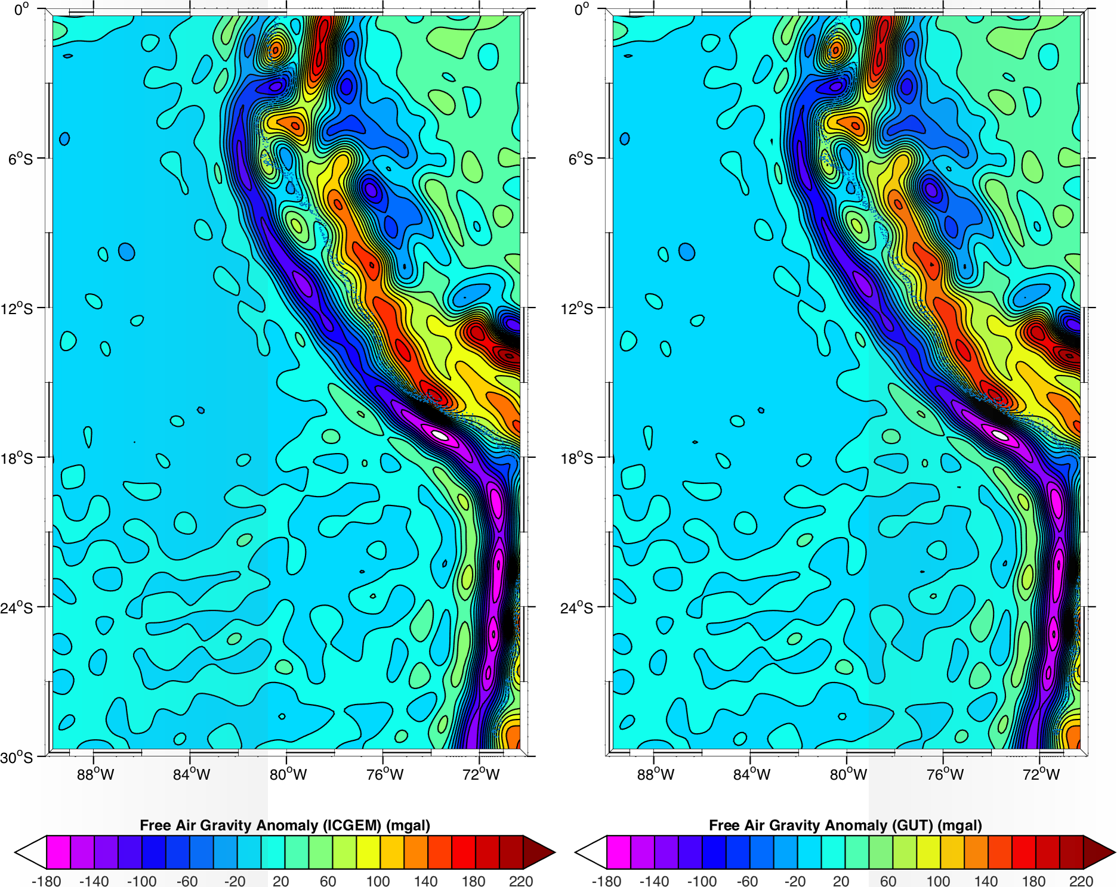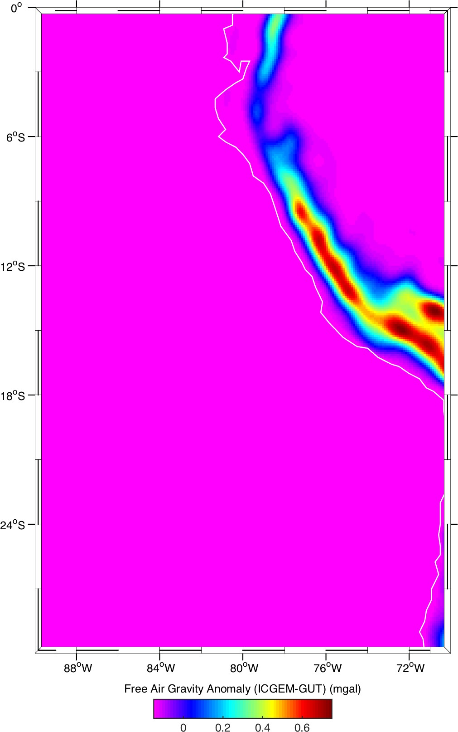
Figure 11: Free Air gravity Anomaly calculation from ICGEM (left), using the GUT workflow (middle) and the difference (right) for an area of South America and South Pacific.

For the North Atlantic (Figure 12), the mean difference is similar, at -0.1443 mgal, but the rms difference is far smaller (0.000438 mgal) and again, the differences are greatest over the areas with greatest anomalies, at seamounts and islands.

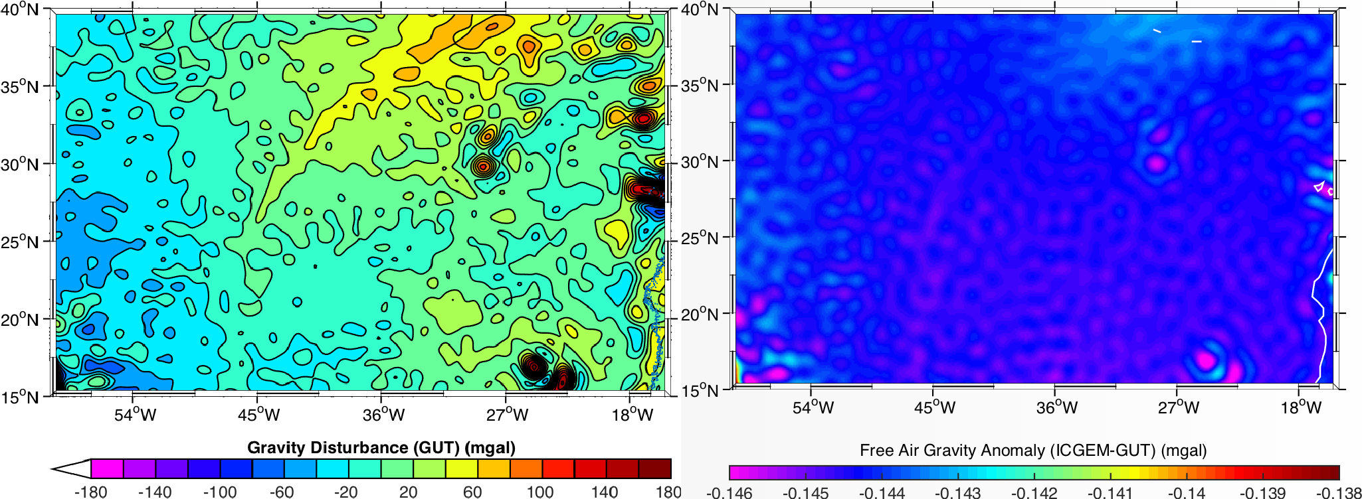
Figure 12: Free Air gravity Anomaly calculation using the GUT workflow (left), and the difference from the ICGEM calculation (right) for an area of the N Atlantic.

Ref: GUT2 Validation Report Version : 1  Date : 26 August 2016 | GUTv2  Toolbox Verification and Validation Report

3.3.2 Compute a Grid Function of Gravity Disturbance from an Altitude Grid Function, a Spherical Harmonic representation of the Gravitational Potential Field and Reference Gravity.
To validate the Gravity Disturbance workflow introduced in v3 of GUT, the results of the new gravitydisturbance_gf workflow were compared with results using the ICGEM gravity_disturbance functional.The ICGEM calculation service specification used for the North Atlantic Region grid is given in Figure 13. The output ICGEM grid files were converted to a GUT compliant NetCDF in MATLAB.

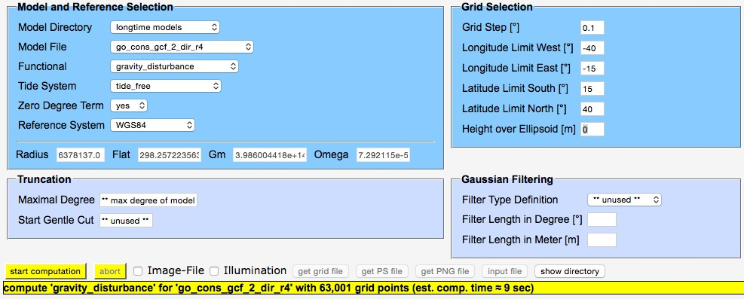
Figure 13: ICGEM calculation service input for the gravity disturbance grid calculation for the North Atlantic Region

For this workflow, the DTM input files are used to define both the surface topography and the grid function for the workflow.
Input files: go_cons_gcf_2_dir_r4.gfc, DTM_S_America.nc, DTM_N_Atlantic.nc
Original Output Files: gravity_ disturbance_S_America.nc, gravity_disturbance_N_Atlantic.nc

Workflow:
gut gravitydisturbance_gf -InFile input/go_cons_gcf_2_dir_r4.gfc - InDemFile input/DTM_N_Atlantic.nc -Gf input/DTM_N_Atlantic.nc -
OutFile gravitydisturbance_N_Atlantic.nc
gut gravitydisturbance_gf -InFile input/go_cons_gcf_2_dir_r4.gfc - InDemFile input/DTM_S_America.nc -Gf input/DTM_S_America.nc -OutFile gravitydisturbance_S_America.nc
New Output Files: gravitydisturbance_S_America.nc, gravitydisturbance_N_Atlantic.nc

 | GUTv2  Toolbox Verification and Validation Report | Ref: GUT2 Validation Report  Version : 1 Date : 26 August 2016

Results
For both regions, there was a small mean difference between the ICGEM field and the corresponding GUT field, of around 0.549 mgal (South Pacific region, Figure 14) and
0.237 mgal (North Atlantic region, Figure 15). As with the free air gravity anomaly the rms difference between the fields in the North Atlantic region is smaller than for the South Pacific (1.4 mgal and 2.99 mgal respectively), but both values are high, with a range of -10 to +19.1 mgal for the North Atlantic (Figure 15) and -10 to +36.3 mgal in the South Pacific (Figure 14). Unlike the free air gravity anomaly, where the greatest differences occurred at regions of highest gravity anomaly, the greatest differences in gravity disturbance occur at the regions of strongest gravity disturbance gradient – along the slopes of the South Pacific subduction zone, just offshore of the South American coast.

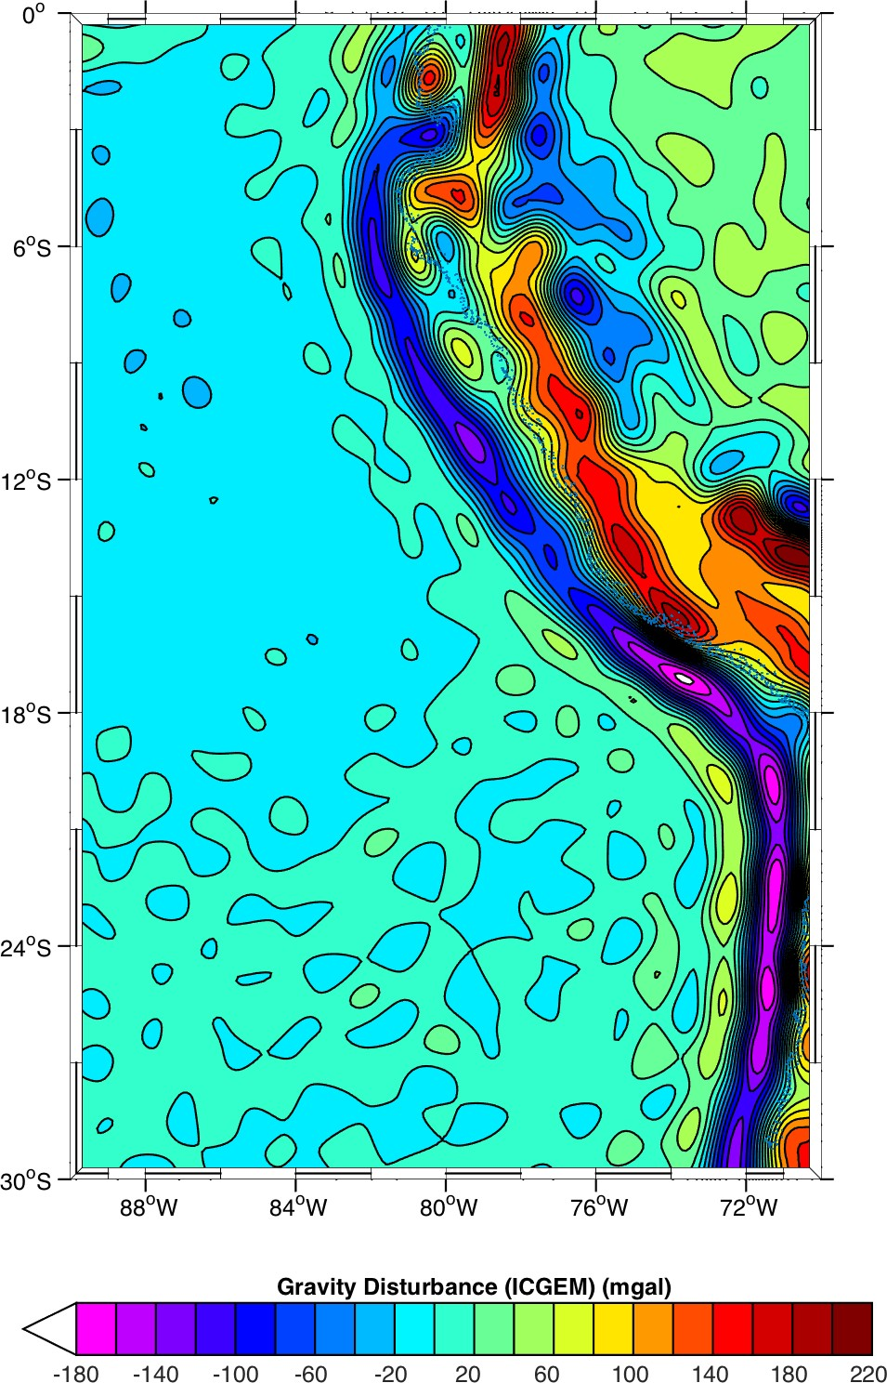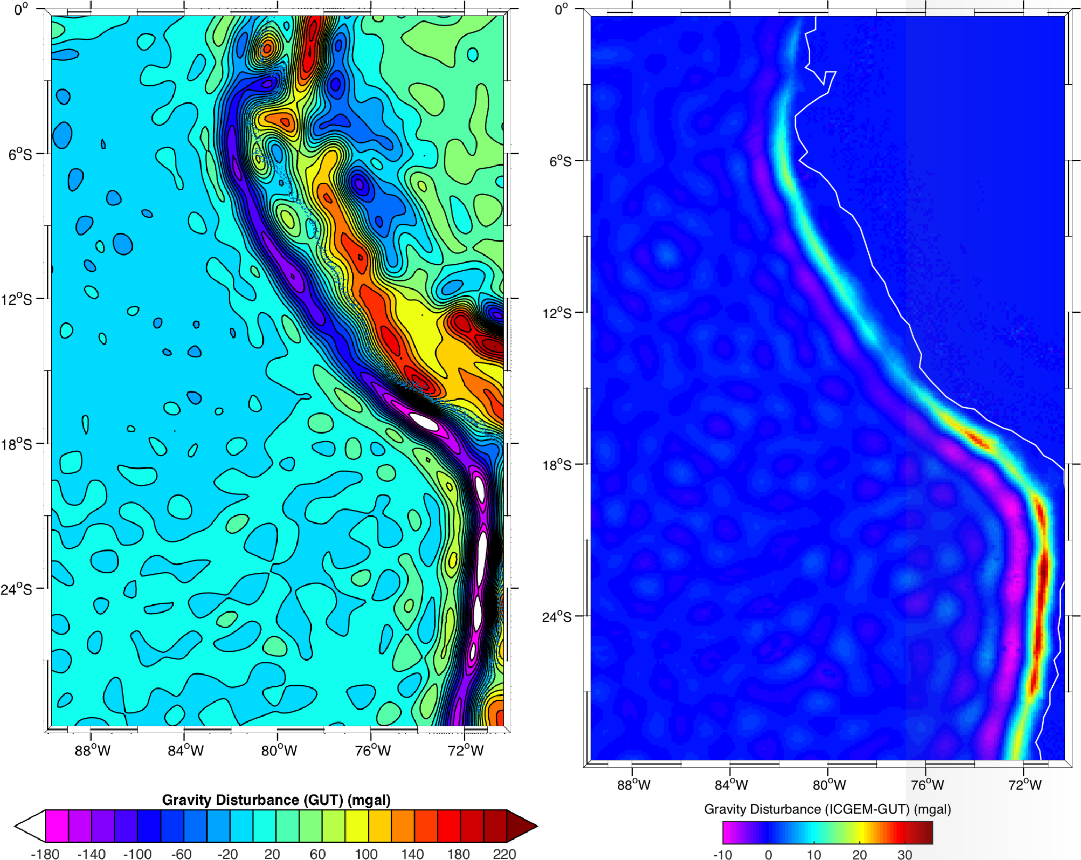
Figure 14: Gravity Disturbance calculation from ICGEM (left), using the GUT workflow (middle) and the difference (right) for an area of South America and South Pacific.

Similarly, for the North Atlantic region, the greatest differences occur at the greatest gravity disturbance slope, rather than the peak values.
These differences appear significant, and are not explained yet. Further investigation is recommended, especially as this has implications for other workflows that use this calculation: namely the Airy and Bouguer anomaly workflows.

Ref: GUT2 Validation Report Version : 1  Date : 26 August 2016 | GUTv2  Toolbox Verification and Validation Report

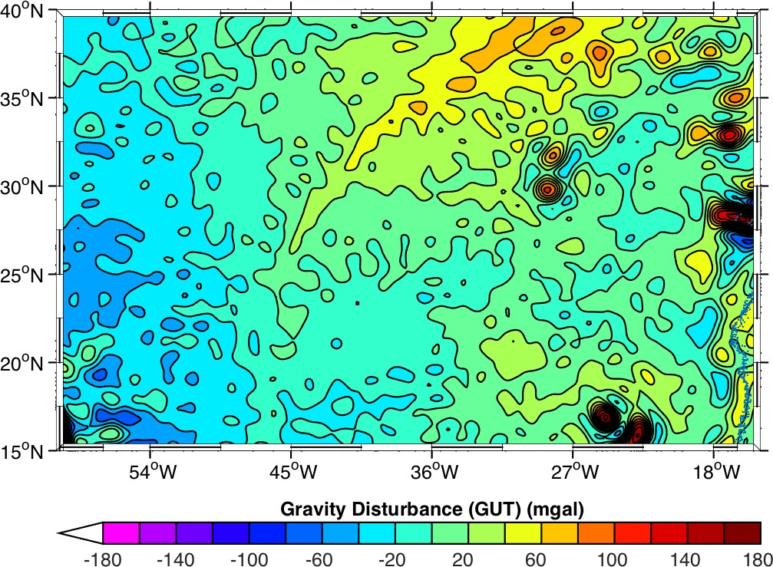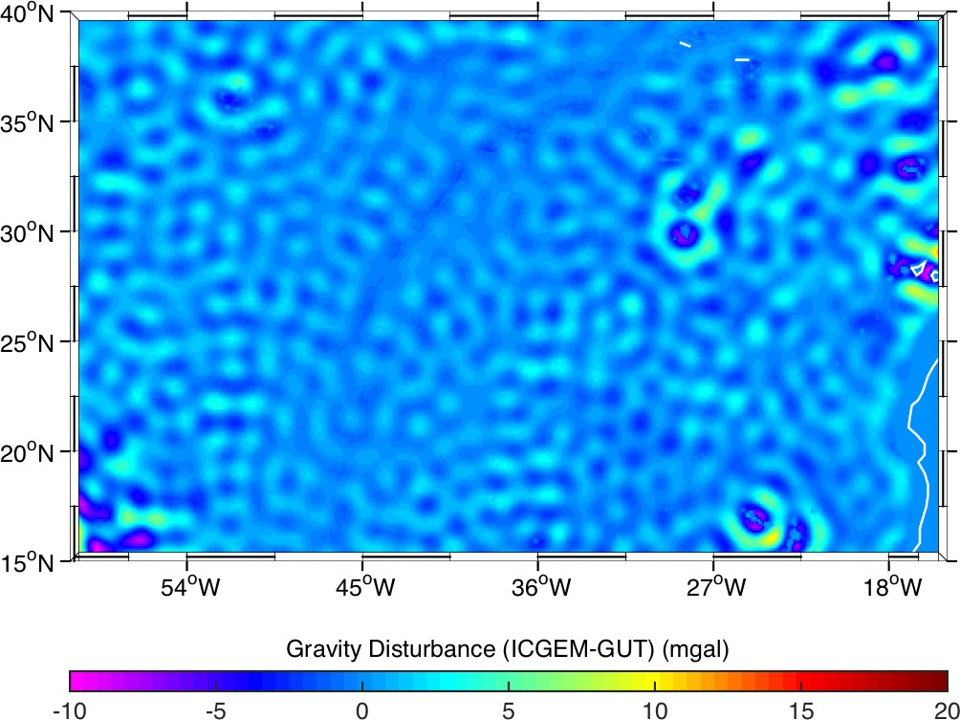
Figure 15: Gravity Disturbance calculation using the GUT workflow (left), and the difference from the ICGEM calculation (right) for an area of the North Atlantic.

 | GUTv2  Toolbox Verification and Validation Report | Ref: GUT2 Validation Report  Version : 1 Date : 26 August 2016

Compute a Grid Function of the Simple Bouguer effect (slab correction)
To validate the Simple Bouguer Anomaly workflow introduced in v2.2 of GUT, the results of the new simplebouguer_gf workflow were compared with results using the ICGEM gravity_anomaly_bg functional. The ICGEM calculation service specification used for the North Atlantic Region grid is given in Figure 16. The output ICGEM grid files were converted to a GUT compliant NetCDF in MATLAB.

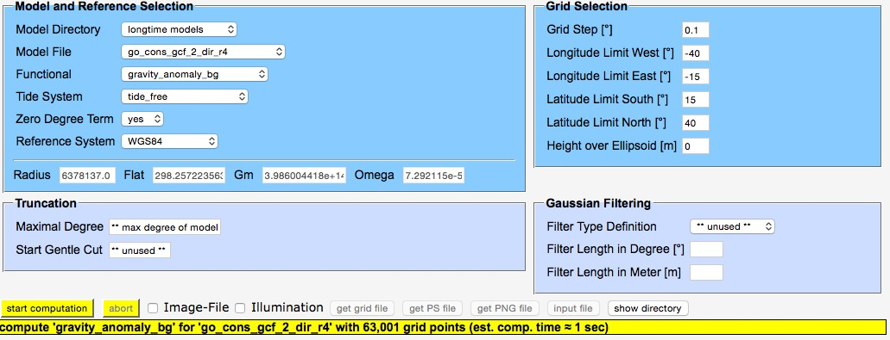
Figure 16: ICGEM calculation service input for the Bouguer gravity anomaly grid calculation for the North Atlantic Region.

For this workflow, the DTM input files are used to define both the surface topography and the grid function for the workflow.
Input files: go_cons_gcf_2_dir_r4.gfc, DTM_S_America.nc, DTM_N_Atlantic.nc
Original Output Files: gravity_anomaly_bg_S_America.nc, gravity_anomaly_bg_N_Atlantic.nc

Workflow:
gut simplebouguer_gf -InFile input/go_cons_gcf_2_dir_r4.gfc -InDemFile input/DTM_N_Atlantic.nc -Gf input/DTM_N_Atlantic.nc
-OutFile bouguer_anomaly_N_Atlantic.nc
gut simplebouguer_gf -InFile input/go_cons_gcf_2_dir_r4.gfc -InDemFile input/DTM_S_America.nc -Gf input/DTM_S_America.nc
-OutFile bouguer_anomaly_S_America.nc
New Output Files: bouguer_anomaly_S_America.nc, bouguer_anomaly_N_Atlantic.nc

Results
The results of the simple Bouguer calculations show some very significant differences. The mean difference for the South Pacific region (Figure 17) is -8.14 mgal, with an rms difference of 80.2 mgal. The range of the differences (-530 mgal to +245 mgal) is of the same order or magnitude as the anomalies themselves (-330 to +472mgal). Compared to the ICGEM calculation, the GUT workflow over-estimates the values of the negative

Ref: GUT2 Validation Report Version : 1  Date : 26 August 2016 | GUTv2  Toolbox Verification and Validation Report

anomaly over the Andes but under-estimates the positive anomaly over the South Pacific subduction area.

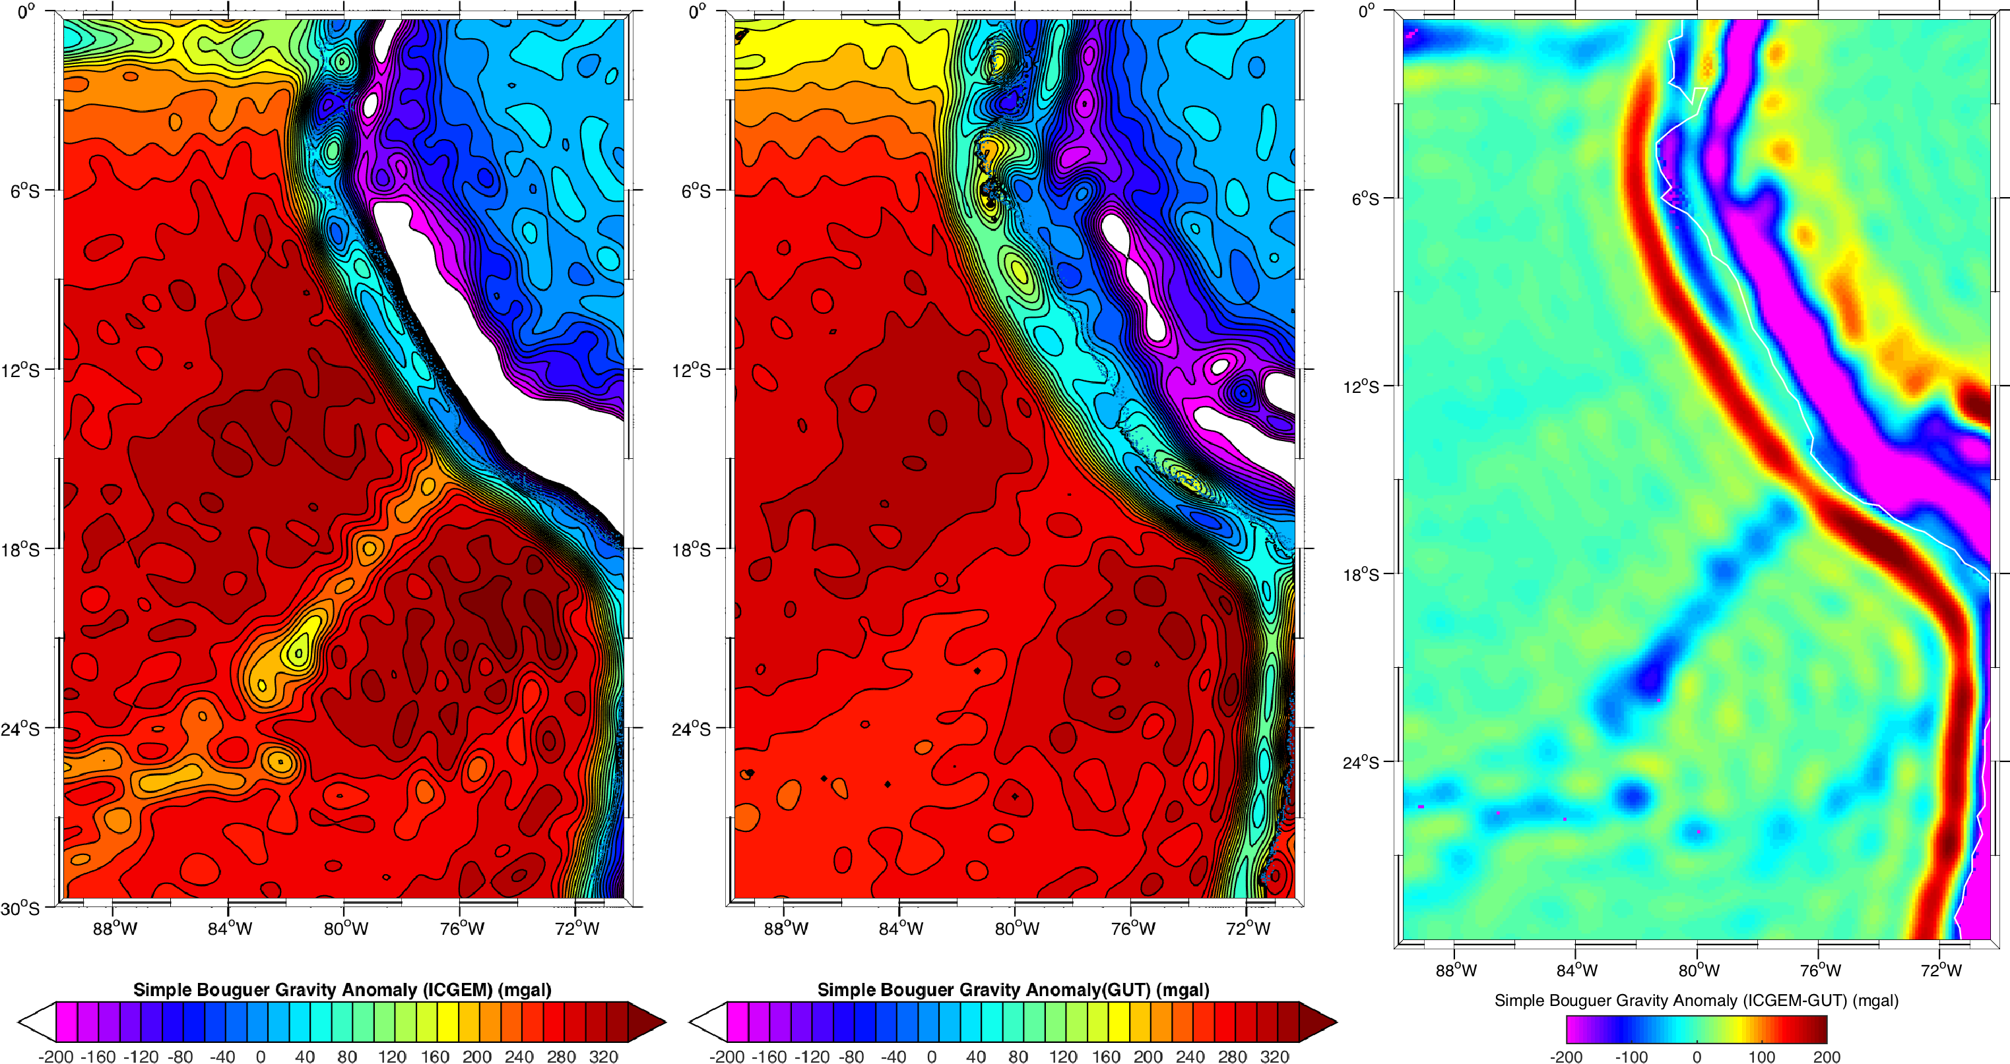
Figure 17: Simple Bouguer Anomaly calculation from ICGEM (left), using the GUT workflow (middle) and the difference (right) for an area of South America and South Pacific.

For the North Atlantic region (Figure 18), the mean difference is much smaller, at -1.85 mgal, but the rms is still very high at 25.7 mgal and the range of differences (-336 to +80.8 mgal) is, again, of the same order as the range of anomalies (+26 to 400 mgal).

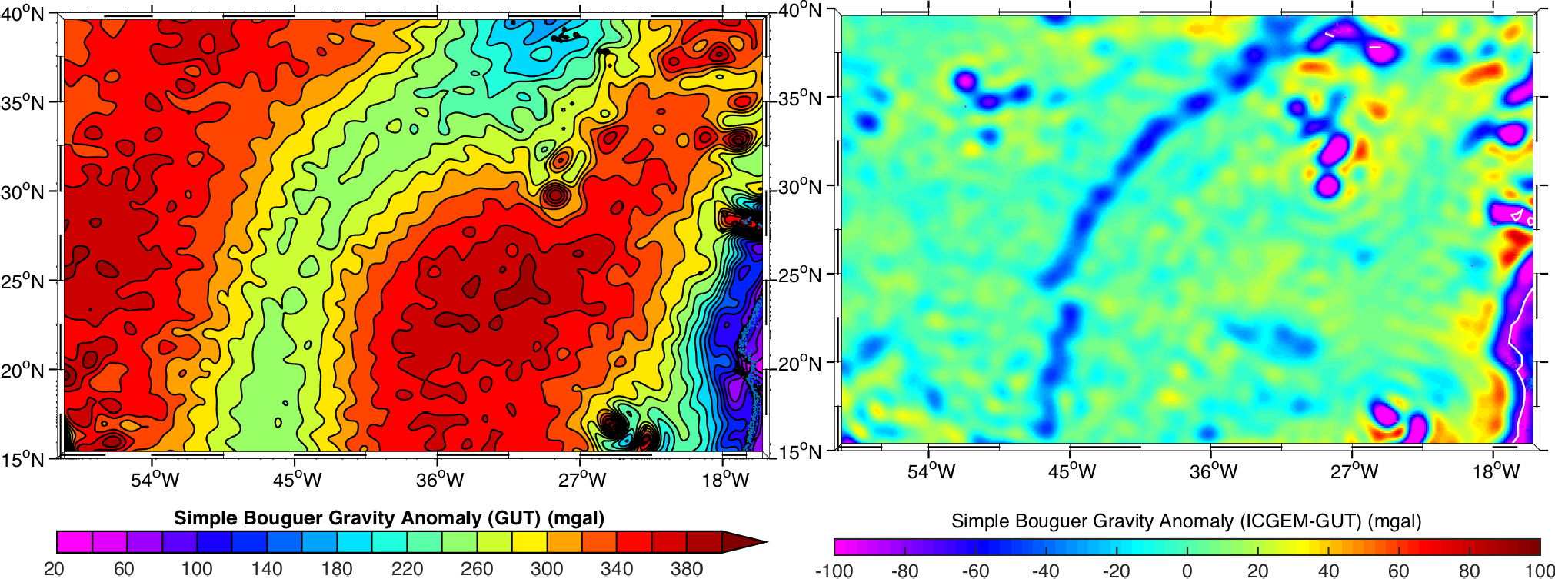
Figure 18: Simple Bouguer Anomaly calculation using the GUT workflow (left), and the difference from the ICGEM calculation (right) for an area of the North Atlantic.

There is a difference in the seawater density used in the two calculations that could cause a small, signal-related difference between the two fields. However, these discrepancies are far too large to be attributable to this cause.

 | GUTv2  Toolbox Verification and Validation Report | Ref: GUT2 Validation Report  Version : 1 Date : 26 August 2016

It appears as if the GUT calculation is far smoother than the ICGEM calculation – although no filtering has been requested in the call. This is probably a result of the Gaussian filtering of the topography within the gut workflow.
To try producing a closer match, the workflow was repeated for the North Atlantic, defining a specific filter length for both the ICGEM calculation and the GUT workflow. The definition used for the ICGEM calculation is given in Figure 19.

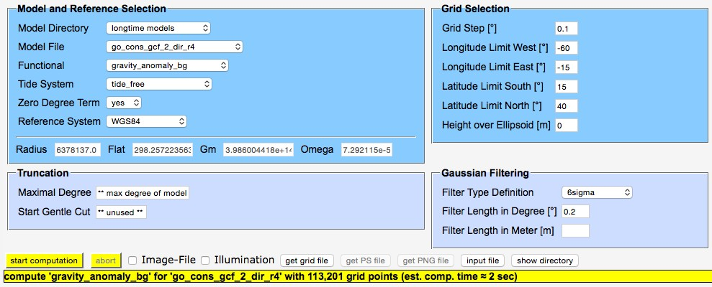
Figure 19: ICGEM calculation service input for the Bouguer gravity anomaly grid calculation for the North Atlantic Region with filtering.

Input files: go_cons_gcf_2_dir_r4.gfc, DTM_N_Atlantic.nc Original Output Files: gravity_anomaly_bg_N_Atlantic_filt.nc Workflow:
gut simplebouguer_gf -InFile input/go_cons_gcf_2_dir_r4.gfc -InDemFile input/DTM_N_Atlantic.nc -Gf input/DTM_N_Atlantic.nc –Ftg 0.2
-OutFile bouguer_anomaly_N_Atlantic_filt.nc
New Output Files: bouguer_anomaly_N_Atlantic_filt.nc

Results
The results of these filtered calculations for the North Atlantic region (Figure 20) reduce the mean difference to -1.06 mgal, with an rms difference of 7.70 mgal. The range of the differences (-112mgal to +92mgal) is also much reduced. Compared to the ICGEM calculation, the differences are now concentrated over the areas of seamounts, rather than reflecting a smoothed version of the original field. Now, the ICGEM field appears smoother than the GUT field, indicating that it is the difference in the filtering that is the cause of the differences. If an ‘exact’ match of the filters used could be created, it is expected these results would converge.

Ref: GUT2 Validation Report Version : 1  Date : 26 August 2016 | GUTv2  Toolbox Verification and Validation Report

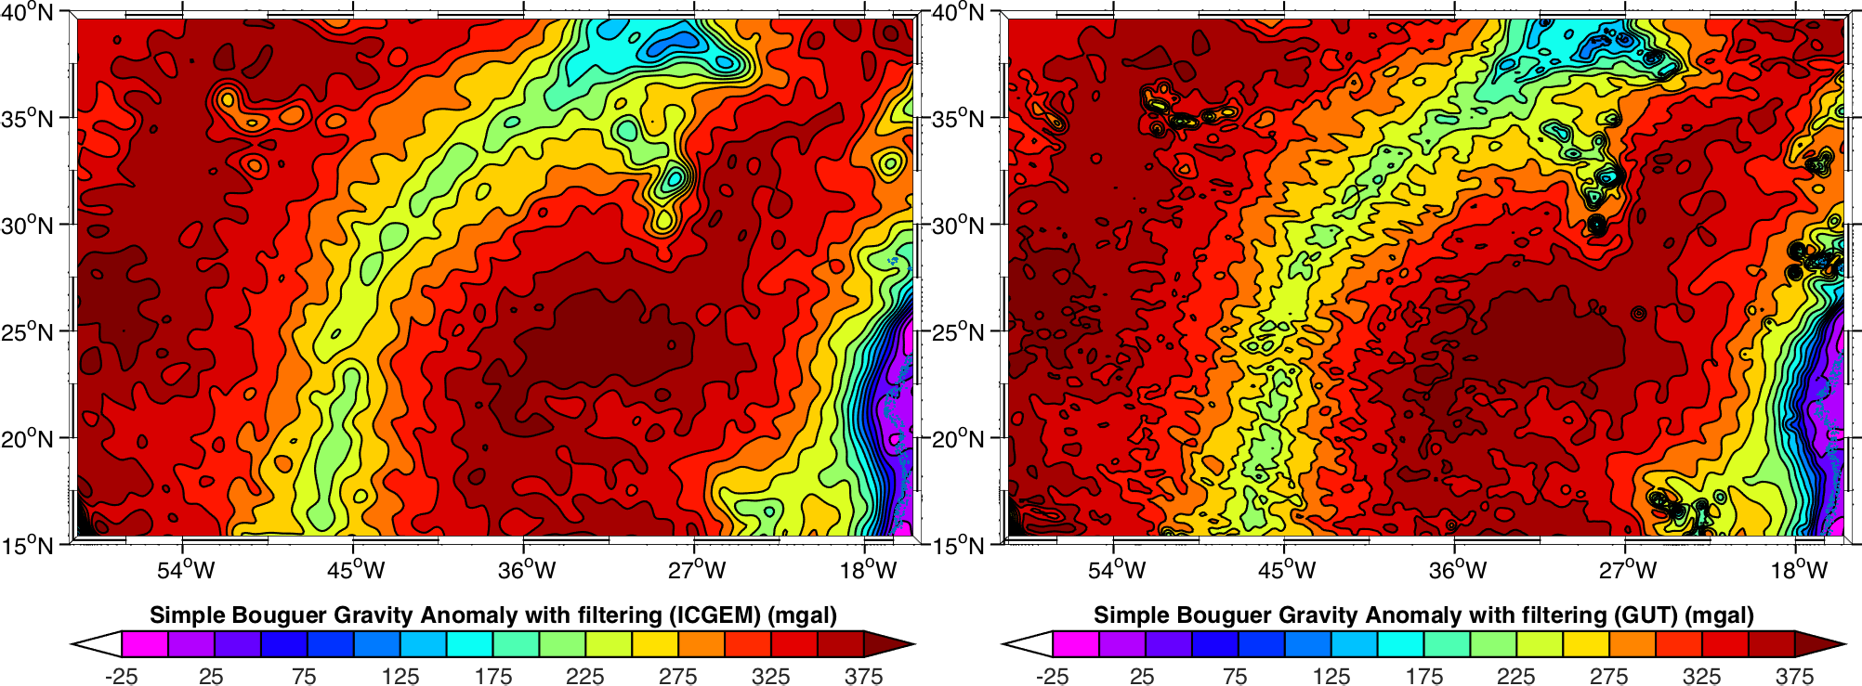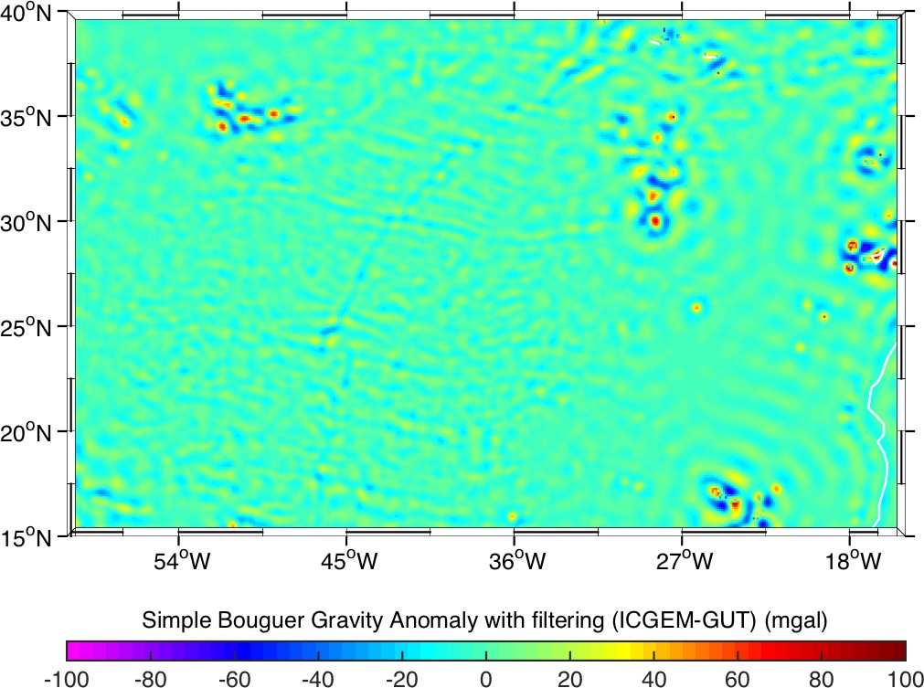
Figure 20: Simple Bouguer Anomaly calculation with filtering from ICGEM (top left), using the GUT workflow (top right), and the difference (below) for an area of the North Atlantic.

 | GUTv2  Toolbox Verification and Validation Report | Ref: GUT2 Validation Report  Version : 1 Date : 26 August 2016

Compute a Grid Function of the Airy Isostatic Root from a pre-computed set of Spherical Harmonic Coefficients
To validate the Airy anomaly workflow introduced in v3 of GUT, the results of the new airyanomaly_gf workflow were compared with results calculated using the MATLAB GrafLab 1.2 tools. The methodology was to calculate a gravity anomaly grid file from the EIGEN-6C4 spherical harmonics, and then calculate a grid file from the RWI_TOIS_2012 topographic-isostatic potential spherical harmonic expansion. The Airy anomaly is then calculated in MATLAB as the difference between these two fields. The specifications used for the two calculations are given in Figure 21. The output GrafLab grid files were converted to a GUT compliant NetCDF in MATLAB.

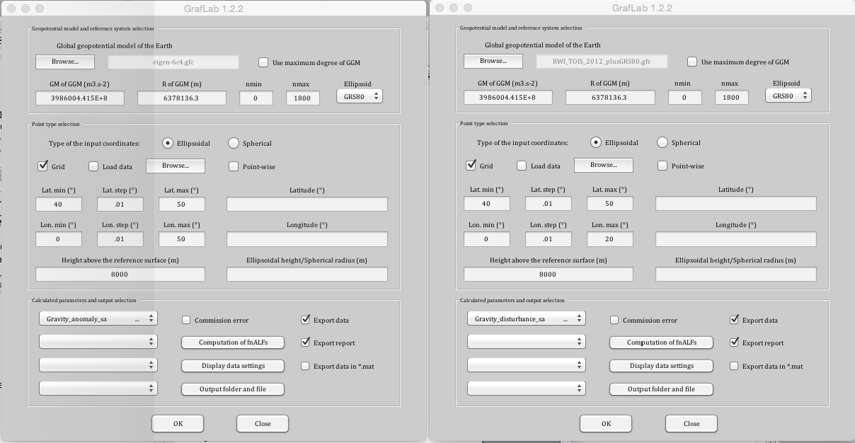
Figure 21: GrafLab calculation input for the gravity Airy anomaly grid calculations for the Alps: gravity anomaly (left) and topographic-isostatic potential (right)

For this workflow, a DTM file was generated that had a constant height of 8000m, as described in the tutorial document, to generate the correction at the same height as used in the GrafLab function (8000m). This DTM input file is used to define both the surface ‘topography’ and the grid function for the workflow.
The maximum DO is also fixed at 1800, the maximum used in the topographic-isostatic potential model expansion. Note that the “plusGRS80” version of the topographic-isostatic potential model must be used.

Ref: GUT2 Validation Report Version : 1  Date : 26 August 2016 | GUTv2  Toolbox Verification and Validation Report

Input files: eigen-6c4.gfc, RWI_TOIS_2012_plusGRS80.gfc, DTM_Italy_8000m.nc
Original Output Files: Italy_Airy_8000m_N1800.nc

Workflow:
gut airyanomaly_gf -InFile input/eigen-6c4.gfc
-InIsoFile RWI_TOIS_2012_plusGRS80.gfc
-InDemFile input/DTM_Italy_8000m.nc
-Gf input/DTM_Italy_8000m.nc –DO 1800
-OutFile airy_anomaly_Italy_8000m_N1800.nc
New Output Files: airy_anomaly_Italy_8000m_N1800.nc

Results
This GUT command took several days to run on a Mac OS X machine with 4GB memory, using the full CPU of one processor of the machine.
A second calculation was carried out, with the DO reduced to 800, which enabled the command to complete within around 12 hours.
A third run was also completed, using a subset of the initial region, covering 5-15˚E, 42-47˚N but using the full DO (1800). This final option runs in a few hours, which is still far longer than seems acceptable for the process.
For the full area, the mean difference between the GrafLab and GUT fields was -14.2 mgal (GrafLab-GUT), with a range of -16.7 to -9.97 mgal. The rms difference was just 0.97 mgal. Although these values appear high, they must be taken in the context of the differences observed for the gravity disturbance calculation between the ICGEM and GUT fields (see Figure 14). The results of this run are provided in Figure 22.
The GrafLab routines used (gravity_anomaly_sa and gravity_disturbance_sa) are spherical approximations of the full calculation – which may explain part of the difference between these fields, and also the huge difference in time to carry out the calculations: a few seconds for GrafLab vs. several days for GUT.

 | GUTv2  Toolbox Verification and Validation Report | Ref: GUT2 Validation Report  Version : 1 Date : 26 August 2016

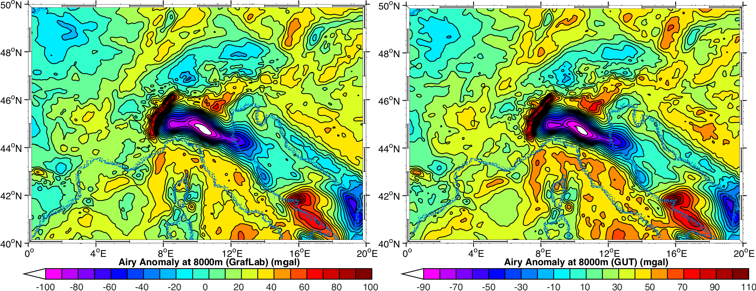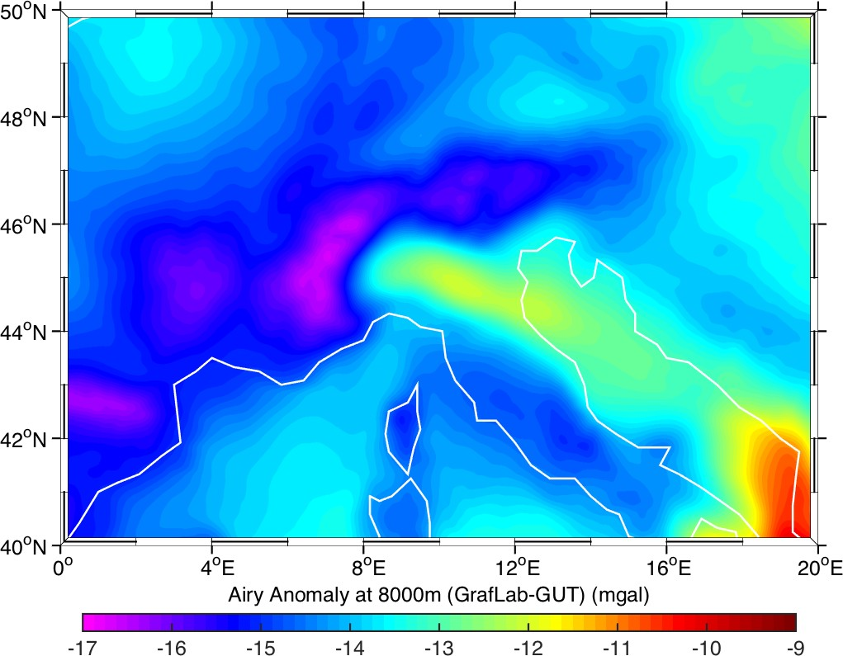
Figure 22: Airy Isostatic Root Anomaly calculation from GrafLab (left), using the GUT workflow (right) and difference (below) for the Alps.

Comparison against ICGEM values
In an attempt to produce a more appropriate validation, ICGEM calculations were used to generate source gravity disturbance and gravity anomaly files, to use in place of the GrafLab data in the calculation. The ICGEM service does not allow a 0.01˚ grid for this region, as the grid dimensions are too large. Instead, a 0.05˚ grid was generated. 3 files were used: a gravity anomaly (gravity_anomaly function) grid file from the EIGEN-6C4 spherical harmonics, a gravity disturbance (gravity_disturbance function) grid file from the RWI_TOIS_2012 topographic-isostatic potential spherical harmonic expansion and a matching DTM file. The setup for the first two of these grids is given in Figure 23, whilst the DTM file was extracted as shown in Figure 9, but using the same grid definition as the gravity fields. The grid function text files were imported into GUT compliant NetCDF using MATLAB.
An 8000m constant height value of the coarse resolution DTM file was generated, and used in the GUT workflow as the topography and grid function definition.

Ref: GUT2 Validation Report Version : 1  Date : 26 August 2016 | GUTv2  Toolbox Verification and Validation Report

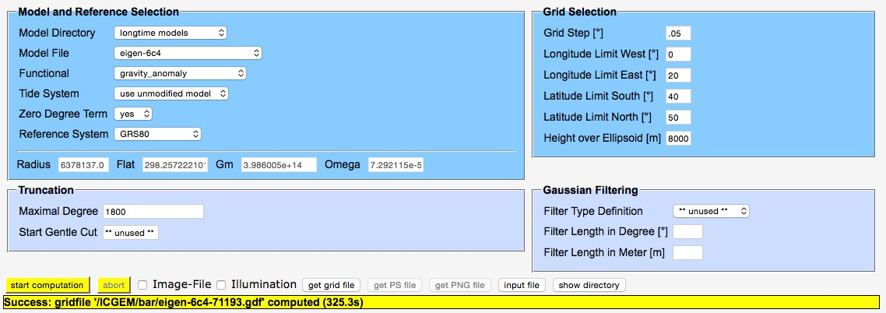

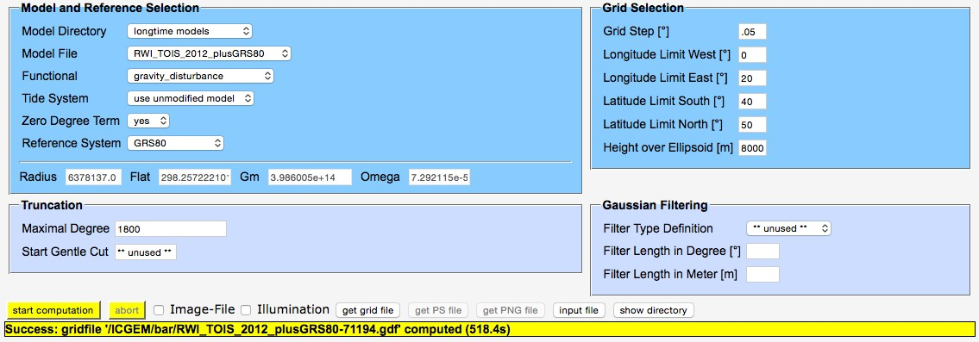

Figure 23: ICGEM calculation service input for the fields used for the Airy anomaly grid calculation for the Alps. Same grid definition used for DTM.

The ICGEM Airy anomaly was then calculated using GUT, as the difference of the two gravity files, using:
gut subtract_gf
-InFileLhs ICGEM/Italy_ga_8000m_N1800.nc
-InFileRhs ICGEM/Italy_gd_TOIS_2012_plusGRS80_8000m_N1800.nc
-OutFile Italy_Airy_coarse_8000m_N1800.nc
Input files: eigen-6c4.gfc, RWI_TOIS_2012_plusGRS80.gfc, DTM_Italy_coarse_8000m.nc
Original Output Files: ICGEM/Italy_Airy_8000m.nc

Workflow:
gut airyanomaly_gf -InFile input/eigen-6c4.gfc –DO 1800
-InIsoFile RWI_TOIS_2012_plusGRS80.gfc
-InDemFile input/DTM_Italy_coarse_8000m.nc
-Gf input/ DTM_Italy_coarse_8000m.nc
-OutFile airy_anomaly_Italy_8000m_N1800.nc
New Output Files: airy_anomaly_Italy_8000m_N1800.nc

 | GUTv2  Toolbox Verification and Validation Report | Ref: GUT2 Validation Report  Version : 1 Date : 26 August 2016

Results
This GUT command took a few hours to run on a Mac OS X machine with 4GB memory. By comparison, each of the calculations using the ICGEM calculation service took approximately 5 – 10 minutes.
The results of this run are provided in Figure 24. The mean difference between these two fields was -14.2 mgal (ICGEM-GUT), very similar to the difference between the GrafLab and GUT fields. However, the range is much greater: -53 + 48 mgal with an rms difference of
  - mgal.
Whilst very large, these differences are comparable to the differences between the gravity disturbance calculations for the two services (ICGEM and GUT) and show similar characteristics.

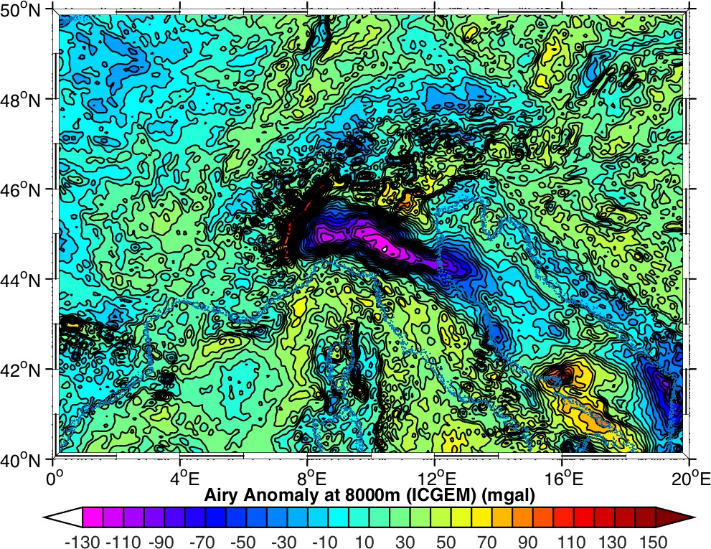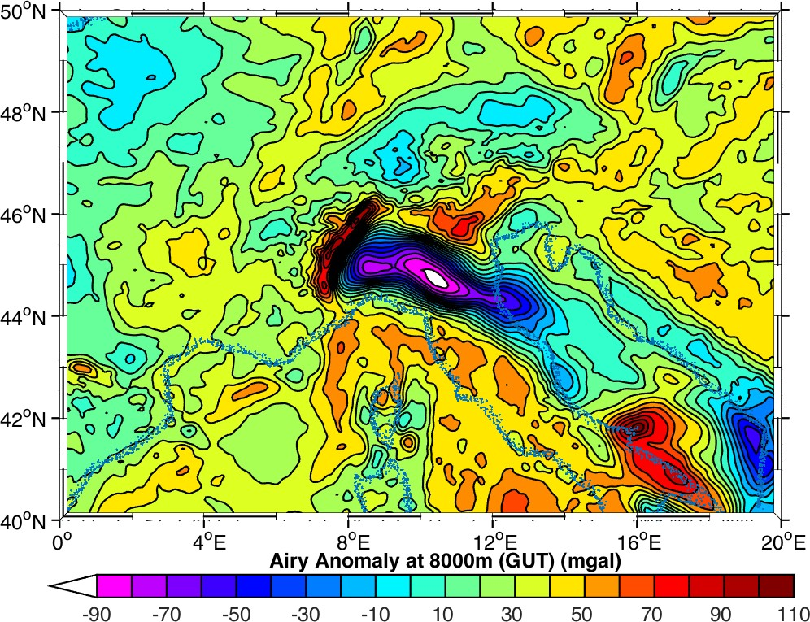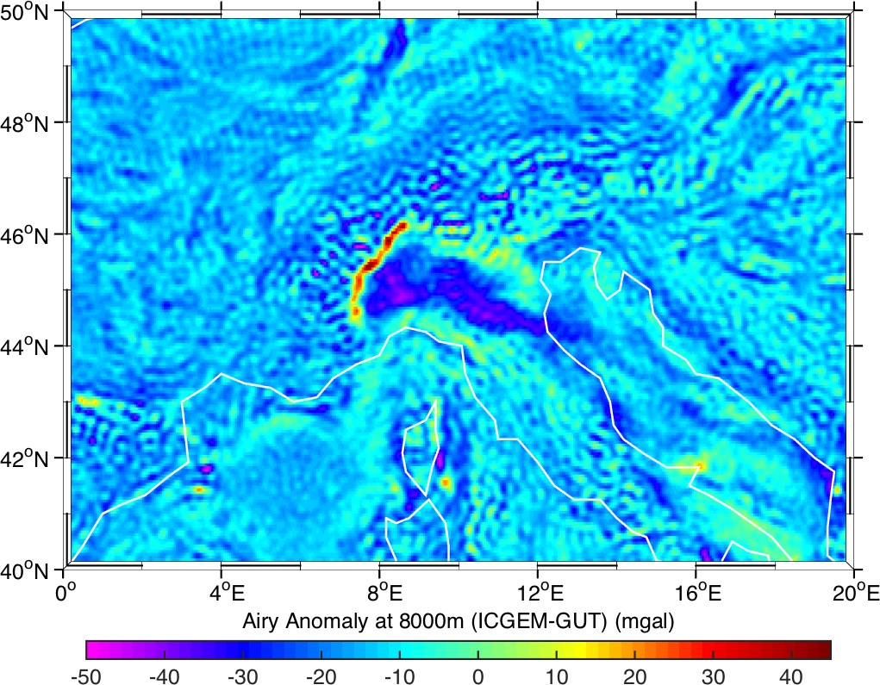
Figure 24: Airy Isostatic Root Anomaly calculation from ICGEM (left), using the GUT workflow (right) and the difference (below) for the Alps.

The large differences between these fields is still undetermined and requires further investigation. It was expected that the ICGEM results would show a close match – as both used the full, rather than spherical approximation, calculations. However, this was not the case, and the comparisons to the GrafLab calculations were far closer. Indeed, the

Ref: GUT2 Validation Report Version : 1  Date : 26 August 2016 | GUTv2  Toolbox Verification and Validation Report

difference between the ICGEM calculation and a GrafLab calculation carried out for this coarse resolution was very similar the ICGEM-GUT difference, with the exception of the mean (-0.02 mgal). The ICGEM – GrafLab field had a range of -36.5 – 64 mgal and an rms of
  - mgal.

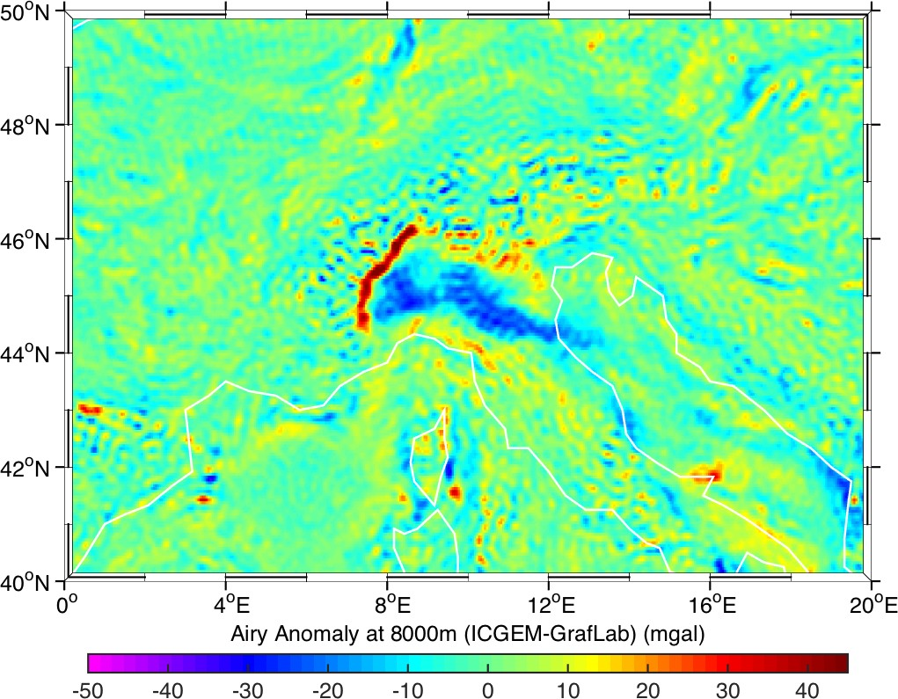
Figure 25: Difference between the Airy Isostatic Root Anomaly calculations from ICGEM and GrafLab for the Alps.

Hence, although there are large discrepancies of the GUT calculation with respect to other calculation services, they are within the bounds of differences between other services.

 | GUTv2  Toolbox Verification and Validation Report | Ref: GUT2 Validation Report  Version : 1 Date : 26 August 2016

Compute a Grid Function of the Bouguer effect (slab correction) from a pre- computed set of Spherical Harmonic Coefficients
To validate the Full Bouguer anomaly workflow introduced in v3 of GUT, the results of the new bougueranomaly_gf workflow were compared with results calculated using the MATLAB GrafLab 1.2 tools. The approach is the same as for the Airy anomaly, first calculating a gravity anomaly (using the same specification as given in Figure 21) but then calculating the topographic effect from the RWI_TOPO_2012 spherical harmonic expansion as given in Figure 26 and calculating the Bouguer anomaly as the difference of these two fields. The output GrafLab grid file was converted to a GUT compliant NetCDF in MATLAB

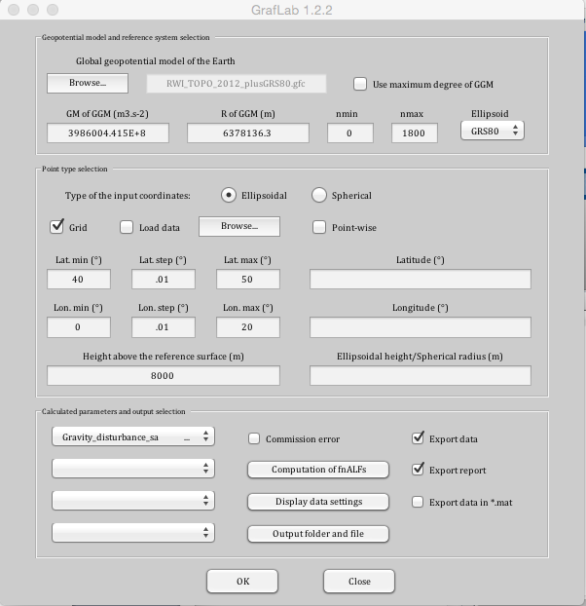
Figure 26: GrafLab calculation input for the topographic correction for calculation of the Bouguer anomaly for the Alps.

The 8000m DTM input file defined for the Airy anomaly calculation is used to define both the surface topography and the grid function for the workflow.
Input files: eigen-6c4.gfc, RWI_TOPO_2012_plusGRS80.gfc, DTM_Italy_8000m.nc
Original Output Files: Italy_Bouguer_8000m_N1800.nc

Workflow:
gut bougueranomaly_gf -InFile input/eigen-6c4.gfc
-InTopoFile RWI_TOPO_2012_plusGRS80.gfc
-InDemFile input/DTM_Italy_8000m.nc
-Gf input/DTM_Italy_8000m.nc –DO 1800
-OutFile bouguer_anomaly_Italy_8000m_N1800.nc
New Output Files: bouguer_anomaly_Italy_8000m_N1800.nc

Ref: GUT2 Validation Report Version : 1  Date : 26 August 2016 | GUTv2  Toolbox Verification and Validation Report

Results
As for the Airy calculation, this full resolution run took around 30 hours to complete Reducing the DO from 1800 to 800 allowed therun to complete within around 24 hours.
Using a subset of the initial region, covering 5-15˚E, 42-47˚N, reduced the computation time to a few hours.
Results for the reduced area are given in Figure 27, and show the fields are broadly similar. The mean difference between the fields is -14.6 mgal, consistent with the Airy calculations, with a range of just -16.9 to -12.3 mgal and an rms of 1.1 mgal.

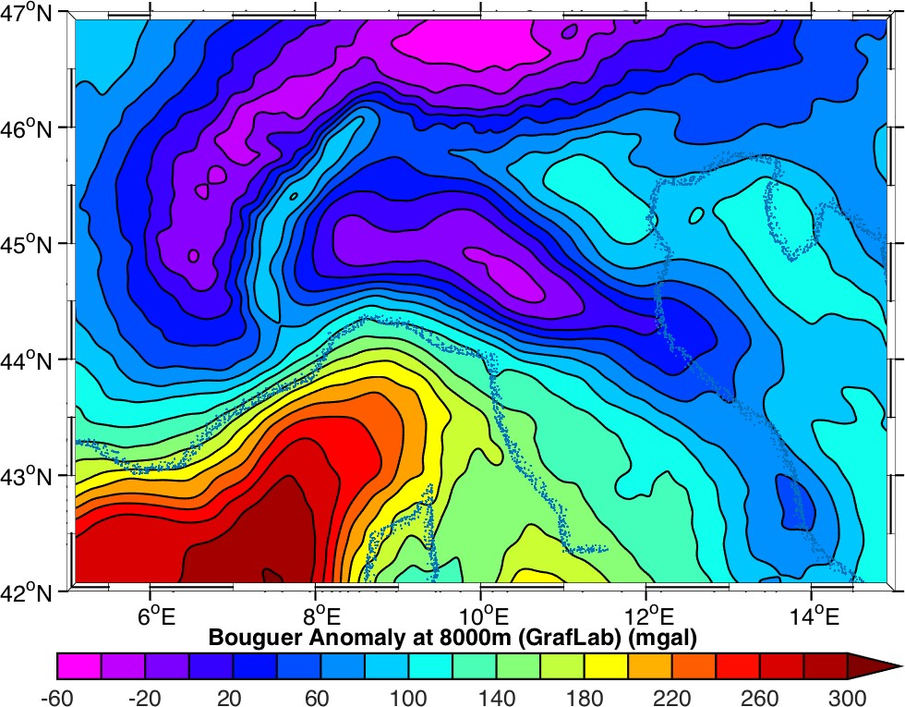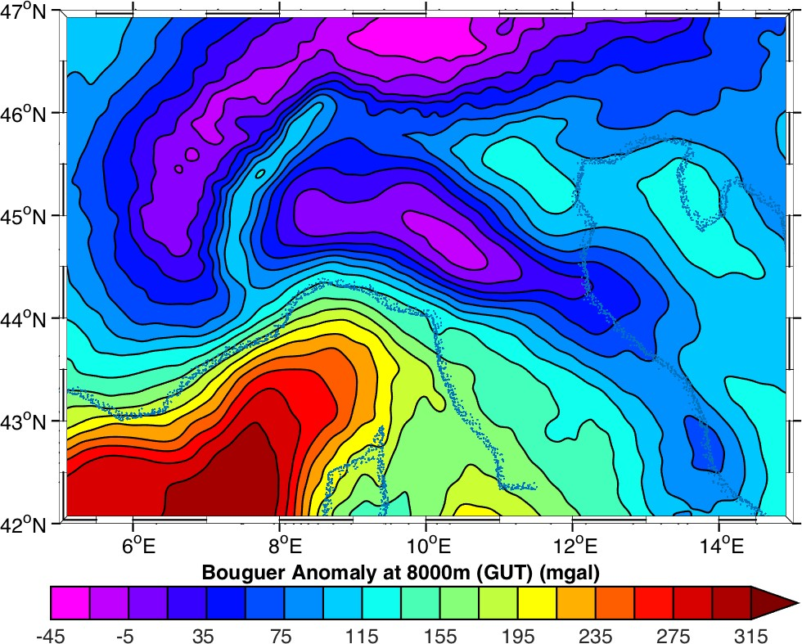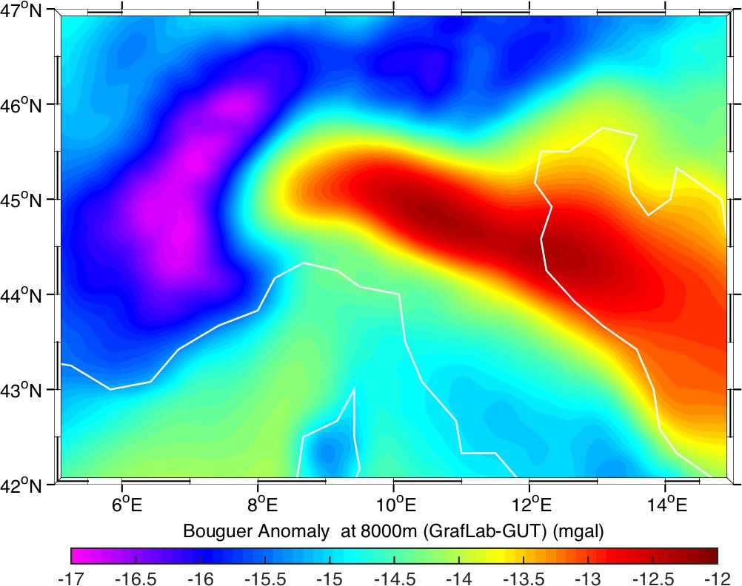
Figure 27: Bouguer Anomaly calculation from GrafLab (left), using the GUT workflow (right) and difference (below) for the Alps.

As for the Airy calculation, a coarser (0.05˚ grid) was used to calculate the Bouguer anomaly from ICGEM, GrafLab and GUT, to see how the three services compared. The same ICGEM and GrafLab gravity anomaly fields adopted for the Airy anomaly calculations were used here, with new gravity disturbance fields generated from the RWI_TOPO_2012 topographic effect spherical harmonic expansion as shown in Figure 28.

 | GUTv2  Toolbox Verification and Validation Report | Ref: GUT2 Validation Report  Version : 1 Date : 26 August 2016

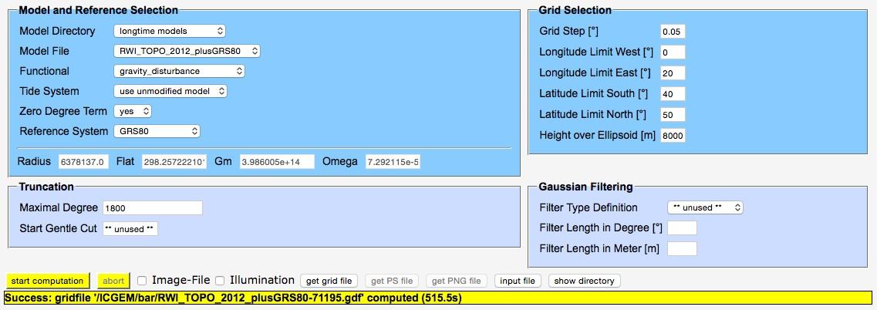

Figure 28: GrafLab and ICGEM calculation input for the topographic effect for the Alps.

Input files: eigen-6c4.gfc, RWI_TOPO_2012_plusGRS80.gfc, DTM_Italy_coarse_8000m.nc
Original Output Files: Italy_Bouguer_8000m_N1800.nc

Workflow:
gut bougueranomaly_gf -InFile input/eigen-6c4.gfc
-InTopoFile RWI_TOPO_2012_plusGRS80.gfc
-InDemFile input/DTM_Italy_coarse_8000m.nc
-Gf input/DTM_Italy_coarse_8000m.nc –DO 1800
-OutFile bouguer_anomaly_Italy_coarse_8000m_N1800.nc
New Output Files: bouguer_anomaly_Italy_coarse_8000m_N1800.nc

Results
The results from these calculations are shown in Figure 29 and are consistent with those for the Airy anomaly, namely that:

Ref: GUT2 Validation Report Version : 1  Date : 26 August 2016 | GUTv2  Toolbox Verification and Validation Report

      - There is a consistent offset of the GUT field of approximately 14.5 mgal from both the ICGEM field (-14.62 mgal) and the GrafLab field (-14.3 mgal).
      - The difference between the GrafLab calculation and that from GUT (-16.9 to -
10.3 mgal, 0.97 mgal rms) is far smaller than between the ICGEM calculation at that from GUT (-60.5 to -59.0 mgal, 9.04 mgal rms)
      - The difference between the GrafLab calculation and that from ICGEM (-47.5 to
74.5 mgal, 8.84 mgal rms) is similar to, and of the same order magnitude as, the difference between the ICGEM and GUT calculations.

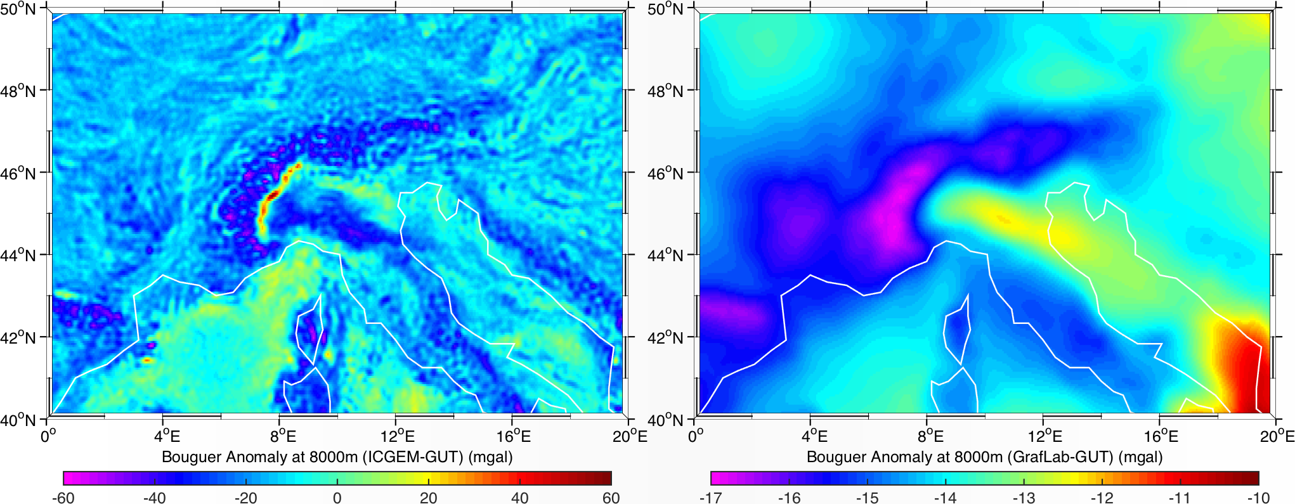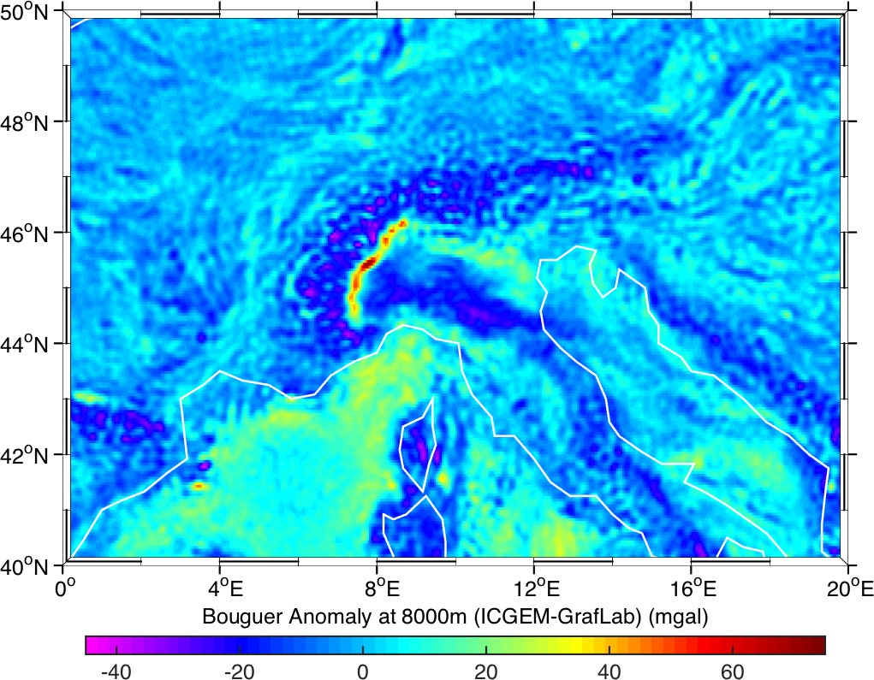
Figure 29: Differences between the Bouguer Anomaly calculations from ICGEM, GrafLab and GUT for the Alps
ICGEM-GUT (left), GrafLab-GUT (right) and ICGEM-GrafLab (below).

 | GUTv2  Toolbox Verification and Validation Report | Ref: GUT2 Validation Report  Version : 1 Date : 26 August 2016

Enhanced Oceanographic Computations

Compute the Ocean Kinetic Energy
To validate the Ocean Kinetic Energy workflow introduced in v3 of GUT, the results of the new gskineticenergy_gf workflow from an absolute dynamic topography were compared with results using the separate available workflows within GUT, and to a calculation within MATLAB. A subset of a global dynamic topography was created for the Gulf Stream Region for the calculation.
Input files: adt_mdtc_A_max.nc Workflow (direct calculation):
gut gskineticenergy_gf -InFile tmp/adt_max_gs.nc -OutFile KE.nc

Workflow (indirect calculation):
gut gsveast_gf -InFile tmp/adt_max_gs.nc -OutFile tmp/AbsGeosVel_east.nc gut gsvnorth_gf -InFile tmp/adt_max_gs.nc
-OutFile tmp/AbsGeosVel_north.nc
gut multiply_gf -InFileLhs tmp/AbsGeosVel_east.nc
-InFileRhs tmp/AbsGeosVel_east.nc -PQ ocean_kinetic_energy
-OutFile tmp/AbsGeosVel_east2.nc
gut multiply_gf -InFileLhs tmp/AbsGeosVel_north.nc -InFileRhs tmp/AbsGeosVel_north.nc -PQ ocean_kinetic_energy
-OutFile tmp/AbsGeosVel_north2.nc
gut add_gf -InFileLhs tmp/AbsGeosVel_east2.nc -InFileRhs tmp/AbsGeosVel_north2.nc -OutFile tmp/AbsGeosVel_sum2.nc
gut scale_gf -InFile tmp/AbsGeosVel_sum2.nc -Scale 0.5
-PQ0 ocean_kinetic_energy -OutFile KE_from_sum2.nc

Workflow (for MATLAB calculation):
gut import2_gf -InFile1 tmp/AbsGeosVel_east.nc
-InFile2 tmp/AbsGeosVel_north.nc -OutFile AbsGeosVel_ne.nc
New Output Files: KE.nc, KE_from_sum2.nc, AbsGeosVel_ne.nc

Results
The two GUT calculations produced identical results, as the calculation of Kinetic Energy from the velocity fields generated in MATLAB using the GUT geostrophic velocity fields did.

Ref: GUT2 Validation Report Version : 1  Date : 26 August 2016 | GUTv2  Toolbox Verification and Validation Report

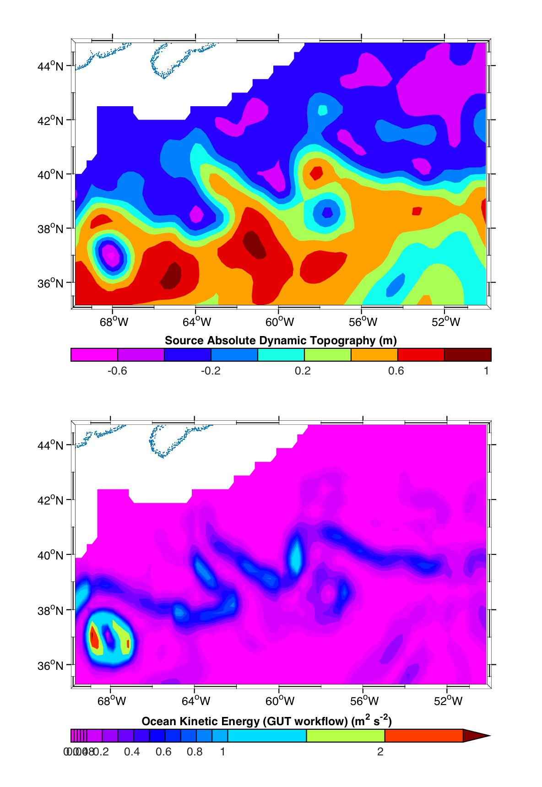
Figure 30: Regional Absolute Dynamic Topography (top) and resultant Ocean Kinetic Energy calculated using GUT workflow (bottom). The one obtained in MATLAB is identical and therefore not displayed.

The equivalent track workflow was also tested in the same fashion, using the following workflows, extracting a track function in the Southern Ocean using:
gut transect_tf -InFile input/adt_mdtc_A_max.nc -InTrack input/track.nc
-OutFile tmp/adt_max_trk.nc Input files: adt_mdtc_A_max.nc Workflow (direct calculation):
gut gskineticenergy_tf -InFile tmp/adt_max_trk.nc -OutFile KE_trk.nc

Workflow (indirect calculation):
gut gsveast_tf -InFile tmp/adt_max_trk.nc -OutFile tmp/AbsGeosVel_east_trk.nc

 | GUTv2  Toolbox Verification and Validation Report | Ref: GUT2 Validation Report  Version : 1 Date : 26 August 2016

gut gsvnorth_tf -InFile tmp/adt_max_trk.nc -OutFile tmp/AbsGeosVel_north_trk.nc
gut multiply_tf -InFileLhs tmp/AbsGeosVel_east_trk.nc
-InFileRhs tmp/AbsGeosVel_east_trk.nc -PQ ocean_kinetic_energy
-OutFile tmp/AbsGeosVel_east2_trk.nc
gut multiply_tf -InFileLhs tmp/AbsGeosVel_north_trk.nc
-InFileRhs tmp/AbsGeosVel_north_trk.nc -PQ ocean_kinetic_energy
-OutFile tmp/AbsGeosVel_north2_trk.nc
gut add_tf -InFileLhs tmp/AbsGeosVel_east2_trk.nc
-InFileRhs tmp/AbsGeosVel_north2_trk.nc
-OutFile tmp/AbsGeosVel_sum2_trk.nc
gut scale_tf -InFile tmp/AbsGeosVel_sum2_trk.nc -Scale 0.5
-OutFile tmp/KE_from_sum2_trk.nc
gut import_tf -InFile tmp/KE_from_sum2_trk.nc -PQ ocean_kinetic_energy |- OutFile KE_from_sum2_trk.nc

Workflow (for MATLAB calculation):
gut import2_tf -InFile1 tmp/AbsGeosVel_east_trk.nc -InFile2 tmp/AbsGeosVel_north_trk.nc -OutFile AbsGeosVel_ne_trk.nc
New Output Files: KE.nc, KE_from_sum2.nc, AbsGeosVel_ne.nc

Results
Note – an additional step was required in the indirect calculation as the scale_tf workflow does not accept the –PQ0 command line option to explicitly set the output physical quantity, and so the resultant file must be re-imported into GUT to set the physical quantity from ‘unknown’ to ‘ocean_kinetic_energy’.
The two GUT calculations produced identical results, as the calculation of Kinetic Energy in MATLAB from the along-track velocity transects generated using GUT did.

Ref: GUT2 Validation Report Version : 1  Date : 26 August 2016 | GUTv2  Toolbox Verification and Validation Report

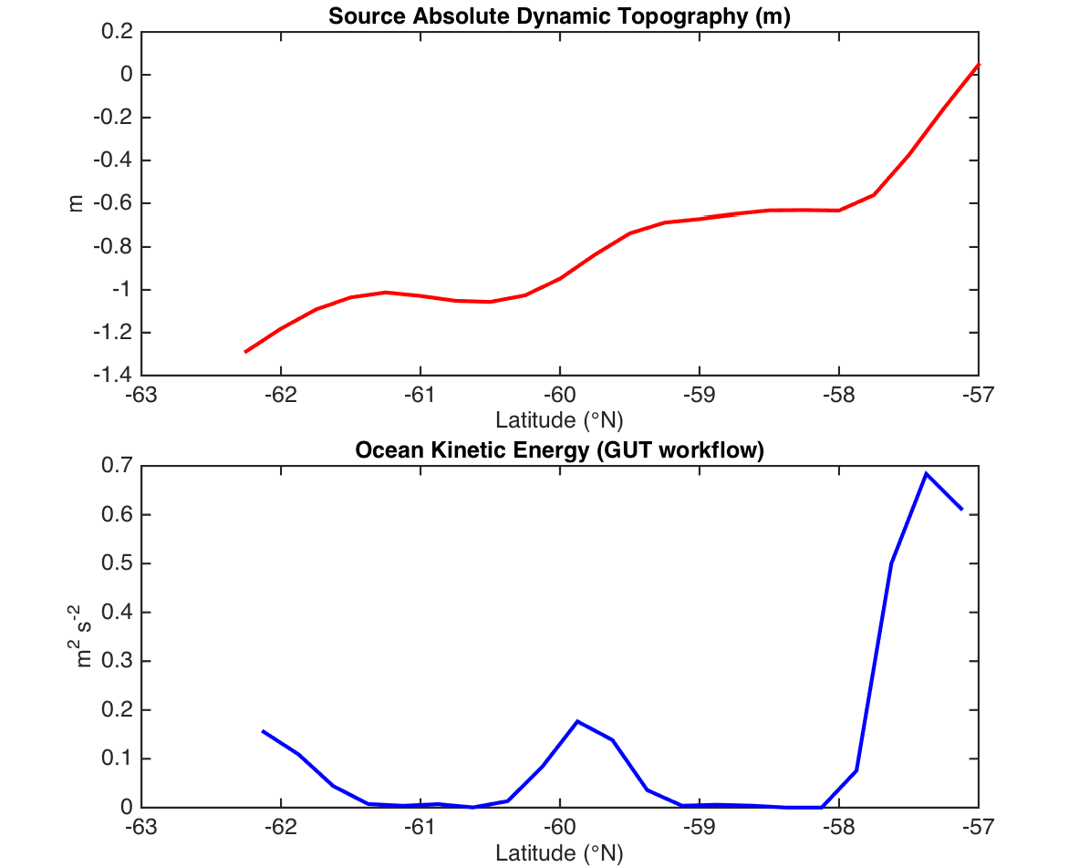
Figure 31: Along-Track Absolute Dynamic Topography (top) and resultant Ocean Kinetic Energy calculated using GUT workflow (bottom). The one obtained in MATLAB is identical and therefore not displayed.

 | GUTv2  Toolbox Verification and Validation Report | Ref: GUT2 Validation Report  Version : 1 Date : 26 August 2016

Compute the vertical component of the Relative Vorticity from a Mean Dynamic Topography
To validate the calculation of the vertical component of relative vorticity workflow introduced in v3 of GUT, the results of the new relativevorticity_gf workflow from an absolute dynamic topography were compared with results using the separate available workflows within GUT, and to a calculation within MATLAB. A subset of a global dynamic topography was created for the Gulf Stream Region for the calculation.
Note: the man entry for the workflow incorrectly reports that the workflow “Computes north component of the relative vorticity”, rather than “Computes vertical component of the relative vorticity” – this should be corrected.
Input files: adt_mdtc_A_max.nc

Workflow (direct calculation):
gut relativevorticity_gf -InFile tmp/adt_max_gs.nc -OutFile RV.nc

Workflow (for MATLAB calculation):
gut gsveast_gf -InFile tmp/adt_max_gs.nc -OutFile tmp/AbsGeosVel_east.nc gut gsvnorth_gf -InFile tmp/adt_max_gs.nc
-OutFile tmp/AbsGeosVel_north.nc
gut import2_gf -InFile1 tmp/AbsGeosVel_east.nc
-InFile2 tmp/AbsGeosVel_north.nc -OutFile AbsGeosVel_ne.nc
New Output Files: KE.nc, KE_from_sum2.nc, AbsGeosVel_ne.nc

Results
The two GUT calculations produced identical results, as did the calculation of Kinetic Energy from the velocity fields generated in MATLAB using the GUT geostrophic velocity fields.

Ref: GUT2 Validation Report Version : 1  Date : 26 August 2016 | GUTv2  Toolbox Verification and Validation Report

Evaluation of Documentation

The documentation included with the toolbox consists of:
  - Installation instructions.
  - Tutorial.
  - User Manual.
  - Workflow definitions accessible from within the toolbox using the --man option and via web pages generated from the workflows.
The installation instructions, provided as a PDF file along with the installation package, provide basic instructions on how each of the three separate distribution options (source, windows binary and linux binary) has to be installed. The instructions provide all relevant information to install a functioning version of the software, including the provided workflows and a-priori datasets. The instructions were tested as part of the software test plan on the tested platforms and provided sufficient information in all cases to install the software given a range of installation requirements.
The tutorial document [AD6] provides:
- Background information on the GOCE mission and data.
- Recommendations on the generation of a mean dynamic topography using the toolbox.
- Examples on how to use the toolbox for a range of operations, including generation of specialized workflows.
- A number of scientific use cases to highlight the potential applications of the toolbox.
The tutorial document is the essential introduction to the toolkit, recommended for all users.
The User Manual is a more technical definition of the functionality and implementation of the toolbox. It includes algorithm descriptions as well as full function descriptions and more information on how to build workflows to carry out more advanced procedures within the toolbox. The User Manual is primarily designed as a reference document for those interested in details of the algorithms implemented. It is also a resource for more advanced users, who may be interested in developing specialized workflows or even additional modules. The User Manual has been assessed and is believed to be accurate.
Description for the vertical component of relative vorticity is very sparse. When using the workflow function directly from the dynamic topography, the resultant grid is on the same grid points but with the external points absent, so the grid is 2 points smaller in each direction. This is due to the calculation creating a second derivative – from height to slope (velocity) and then to curl; as defined in the calculation of east and north velocity to maintain the slope calculations on the same grid a centred difference calculation is performed. It is assumed that a similar calculation is performed for the curl (du/dy and dv/dx components) but the method is not specified.
The workflow definitions provide the real-time reference for the toolbox in normal usage. The same information is also accessible through a web-formatted version, for browsing in parallel with the toolbox. The reliability of the included workflow information is reliant on the writer of each workflow and has only been confirmed as correct for the workflows in

 | GUTv2  Toolbox Verification and Validation Report | Ref: GUT2 Validation Report  Version : 1 Date : 26 August 2016

the initial distribution. A minor modification was made to clarify the effect of selecting only a single filter length scale.
During the anisotropic filtering testing, a minor error was noted in the documentation regarding the filter length determination. However, it was confirmed that the code uses the correct function, and the documentation has been corrected.

Ref: GUT2 Validation Report Version : 1  Date : 26 August 2016 | GUTv2  Toolbox Verification and Validation Report

Current Limitations and Suggestions for Enhancement
Most of the limitations recognised in the validation report of GUT v2, and the recommendations for enhancement, have been addressed in the current v3 release. However, a number of items were not addressed and so are reiterated in the current suggestions.

Statistics and data reporting

Limitation
The v3 toolbox allows for both enhanced statistical output and assessment of generated data, with options to limit the region geographically, and to generate zonal and meridional statistics. It is not yet possible to interrogate the values of single data points within a data file.

Possible future development
Provide upgraded statistics:
      - Provide data interrogation options – retrieval of point-wise data from an input file.

Time

Limitation
The v2 of the toolbox introduced basic interpretation of time, allowing a field to be defined as a reference (constant), as an instantaneous field or as a representative of a time period (e.g. a mean sea surface). Current gravity models are generated for a specific epoch, and some of the spherical harmonic potential coefficients have temporal correction terms. The current version of GUT can retain the information on the epoch of the coefficients, but a GUT format file will not hold the correction terms and is unable to use them to generate output fields for specific epochs.

Possible future development
- Develop the GUT format to include time-varying correction terms, specifically for gravity model coefficients.
- Calculation of gridded fields, including geoid heights and gravity anomalies, at specific epochs using time-varying correction coefficients from input gravity model coefficients.

Single Workflows to generate east and north components

Limitation
The current GUT toolbox has a workflow specifically designed to generate the geostrophic velocity, including speed and direction, in a single operation, providing a NetCDF file with both variables. To generate a single file for east and north components, or to generate a single

 | GUTv2  Toolbox Verification and Validation Report | Ref: GUT2 Validation Report  Version : 1 Date : 26 August 2016

file for east and north vertical deflections, it is still necessary to run two separate GUT workflows (egg gsveast_gf and gsvnorth_gf) and then run the appropriate ‘merging’ workflow (egg import2_gf).

Possible future development
As it is rare for a user to wish to calculate a single component (east or north) it would be useful to provide a single workflow to calculate geostrophic velocities, with an option to output data as either east and north, or speed and direction, and even an option to ONLY output speed, direction east or north component. Similarly, there could be a single workflow for deflections from the vertical. This would simplify the range of workflows available as well as the route to generate a single east / north component file.

Working with multi-parameter files

Limitation
When using functions such as adapt_gf or subtract_gf, only the first parameter, or the defined physical quantity in a file, will be exported. This behaviour is not necessary as expected, and can lead to overly-complex workflows. As an example, having generated a single file containing geostrophic speed and direction, the process to generate a subset of this file requires 3 GUT calls: adapt_gf call for speed, adapt_gf for direction and then import2_gf to re-combine these parameters.

Possible future development
For variables that GUT recognises as vectors, functions that operate on the files (including adapt_gf, subtract_gf, stats_gf) should recognise that both components should be
processed together, with appropriate warnings and error messages if the action is incompatible (e.g. differencing a file with 2 components from a file containing only one). In the case of stats_gf, it should be possible to select the parameter to generate statistics for using the – PQ option.

History attributes

Limitation
Within GUT v2, the history attribute was added, to allow the retention of the command used to generate that file. Whilst this is useful, it is still limited, and only provides a single level of history.

Possible future development
Inclusion of additional history attribute(s) within the GUT NetCDF files, which can retain a longer record of the processing history for a file, including the history of input files used in the processing.

Ref: GUT2 Validation Report Version : 1  Date : 26 August 2016 | GUTv2  Toolbox Verification and Validation Report

Grid adaptation

Limitation
The grid adaptation routines within GUT v2 offer both a bilinear and a bicubic spline interpolation scheme. This is still only a subset of the available interpolation schemes, which may be preferable in specific circumstances.

Possible future development
Provide alternative grid adaptation options using different interpolation methods.
Given that there are a large number of potential interpolation routines in existence, it is unlikely that the toolbox could ever provide all the possible options users might require. Hence, this may be best developed as an example of a plug-in module, giving a clear demonstration of how users can add their own functions to GUT and incorporate them into workflows.

Support for Alternative Standard File Formats

Limitation
GUT v3 has an enhanced, but still limited, import and export functionality. The recognised formats are NetCDF, gravsoft, GOCE HPF format for import and NetCDF or gravsoft for export. There are a range of alternative, standard formats for gravity data, and simple ASCII or binary based formats for gridded data that it would be useful to be able to import into GUT. Examples include the ICGEM XYZ ASCII formatted gridded files. Export is less of a concern, given the availability of the ncdump utility for the GUT output files.

Possible future development
Given the range of potential formats, it will not be possible to allow for input of all formats. However, as part of the tutorial, it could be possible to define a plug-in module, and demonstrate how that could be used, or modified, to read and import a different file format.

