WP 2: Sea ice freeboard heights from satellite altimetry

Recent studies have proved satellite altimetry to be used for estimating Arctic Ocean sea ice freeboard heights (Skourup (2010), Farrell et al (2009), Giles et al (2008), Kwok et al (2007, 2005, 2004), Forsberg and Skourup (2005), Peacock and Laxon (2004), Laxon et al (2003)).

In this study, we estimate freeboard heights from NASA’s Ice, Cloud and land Elevation Satellite (ICESat), which provided laser altimetry measurements of sea ice from January 2003 to October 2009. To obtain sea ice freeboard heights beyond ICESat, ESA launched the Earth explorer satellite CryoSat-2 in April 2010, dedicated to measure the cryosphere of the Earth by advanced radar altimetry. Unfortunately, there are problems with the processing of the special “sea ice mode” used in sea ice covered areas. Reprocessing of data is planned to be carried out by ESA during December 2011, and the improved data set will be available to the users in the beginning of 2012, where sea ice freeboard maps of the Arctic will be estimated accordingly. Some first results of CryoSat-2 data sea ice and related issues are presented and discussed in Poulsen (2011). The only group (Centre for Polar Observation and Modelling, University College London) having access to raw CryoSat data, have been able to process CryoSat to obtain Arctic Ocean sea ice thicknesses for January-February 2011, see appendix Arctic Ocean sea ice thickness from CryoSat measurements. Based on this study the ice thicknesses in the Baffin Bay are overestimated in the CryoSat ice thickness map.

We have used a lowest-level estimation method to derive sea ice freeboard heights (including the snow layer) for the Baffin Bay area from ICESat measurements. For a more detailed description of the procedures, see Skourup (2010). We include winter conditions (February-March) for each of the years 2003-2008, where the sea ice is close to the annual maximum (see section The sea ice in the waters around Greenland, Baffin Bay According to Baffin Bay). The maps of sea ice freeboard heights are shown in figure 2-7 with the licence areas marked by white lines. Each map represents data covering approx. 30 days of observation. ICESat measurements are obtained 40 times a second corresponding to an along-track separation of 172m. Within the 30 days observation period the track spacing is 20km at 75⁰N. Each ICESat measurement covers a surface spot-size (footprint) of approximately 70m in diameter with a vertical accuracy better than 15cm.

The sea ice freeboard height (f) to thickness (t) conversion $(t=k*f$) is debated in many papers and is highly variable depending primarily on snow conditions and to a less extent on sea ice type and settings. In previous studies of high resolution airborne laser scanner measurements of sea ice in the Baffin Bay a k-factor of 5.7 was used, based on in situ measurements (Hvidegaard et al, 2008). However, when averaging over footprint areas similar to ICESat, recent studies of the relation between freeboard heights and draft by Doble et al (2011), finds a k-value of 4.4 for level ice and 5.2 for deformed ice in the central Arctic Ocean. Thus, it is suggested to use the value of 5.2 to convert the sea ice freeboard heights of ICESat into sea ice thicknesses in the license areas.

According to definitions of the WMO (World Meteorological Organization) sea ice nomenclature the thickness of multiyear ice (MYI) is defined to be thicker than 2m and firstyear ice (FYI) thinner than 2m. This, corresponds to freeboard heights of 38 cm (using k=5.2). Thus, MYI or deformed ice is primarily found in areas with freeboard heights represented by yellow-red colours in figure 2-7, and FYI with freeboard heights represented by blue-green colours.

Visually, the distribution of MYI and FYI based on sea ice freeboard heights show good correlation with the “mode” distribution based on backscatter values from Quikscat scatterometer data, see chapter ice type from scatterometer data, except in 2005, where the MYI or deformed ice has a larger extension in the sea ice freeboard maps compared to the backscatter maps. As expected, MYI and deformed ice are primarily located along the coast of Baffin Island, and neither MYI nor deformed ice, are present in the licence areas.

The mean and standard deviation of the freeboard heights in the Baffin Bay are given below the respective plots. The minimum freeboard height of 17cm is found in 2006 and the maximum of 23cm is found in 2003. Using a k-factor of 5.2 this corresponds to an average ice thickness of 0.88m and 1.20m, respectively. This is within the average ice thickness given in section The sea ice in the waters around Greenland, Baffin Bay According to Baffin Bay, where the maximum ice thickness found in February-March is about 1.75m in the north-western Baffin Bay and gradually thinning to the south-west and the Greenland coast to about 0.70m.

ICESat freeboard distributions are plotted in figure 1 with freeboard resolution of 0.1 m. Each histogram represents one ICESat period in the Baffin Bay area. In general, the freeboard distributions have an asymmetric shape with a sharp increase in the leading edge and a long tail. This shape is characteristic for sea ice freeboard heights, drafts and thicknesses, where the long tail represents the presence of thick MYI and deformed ice due to ridging and rafting processes. The vertical black line represents the freeboard height separating FYI from MYI. As expected the major part of the sea ice in Baffin Bay are FYI, and only a minor part are MYI or deformed ice.

Figure 1: Distribution of ICESat sea ice freeboard heights (2003-2008) in Baffin Bay. To obtain ice thicknesses the freeboard height must be multiplied by a factor of approx. 5.2
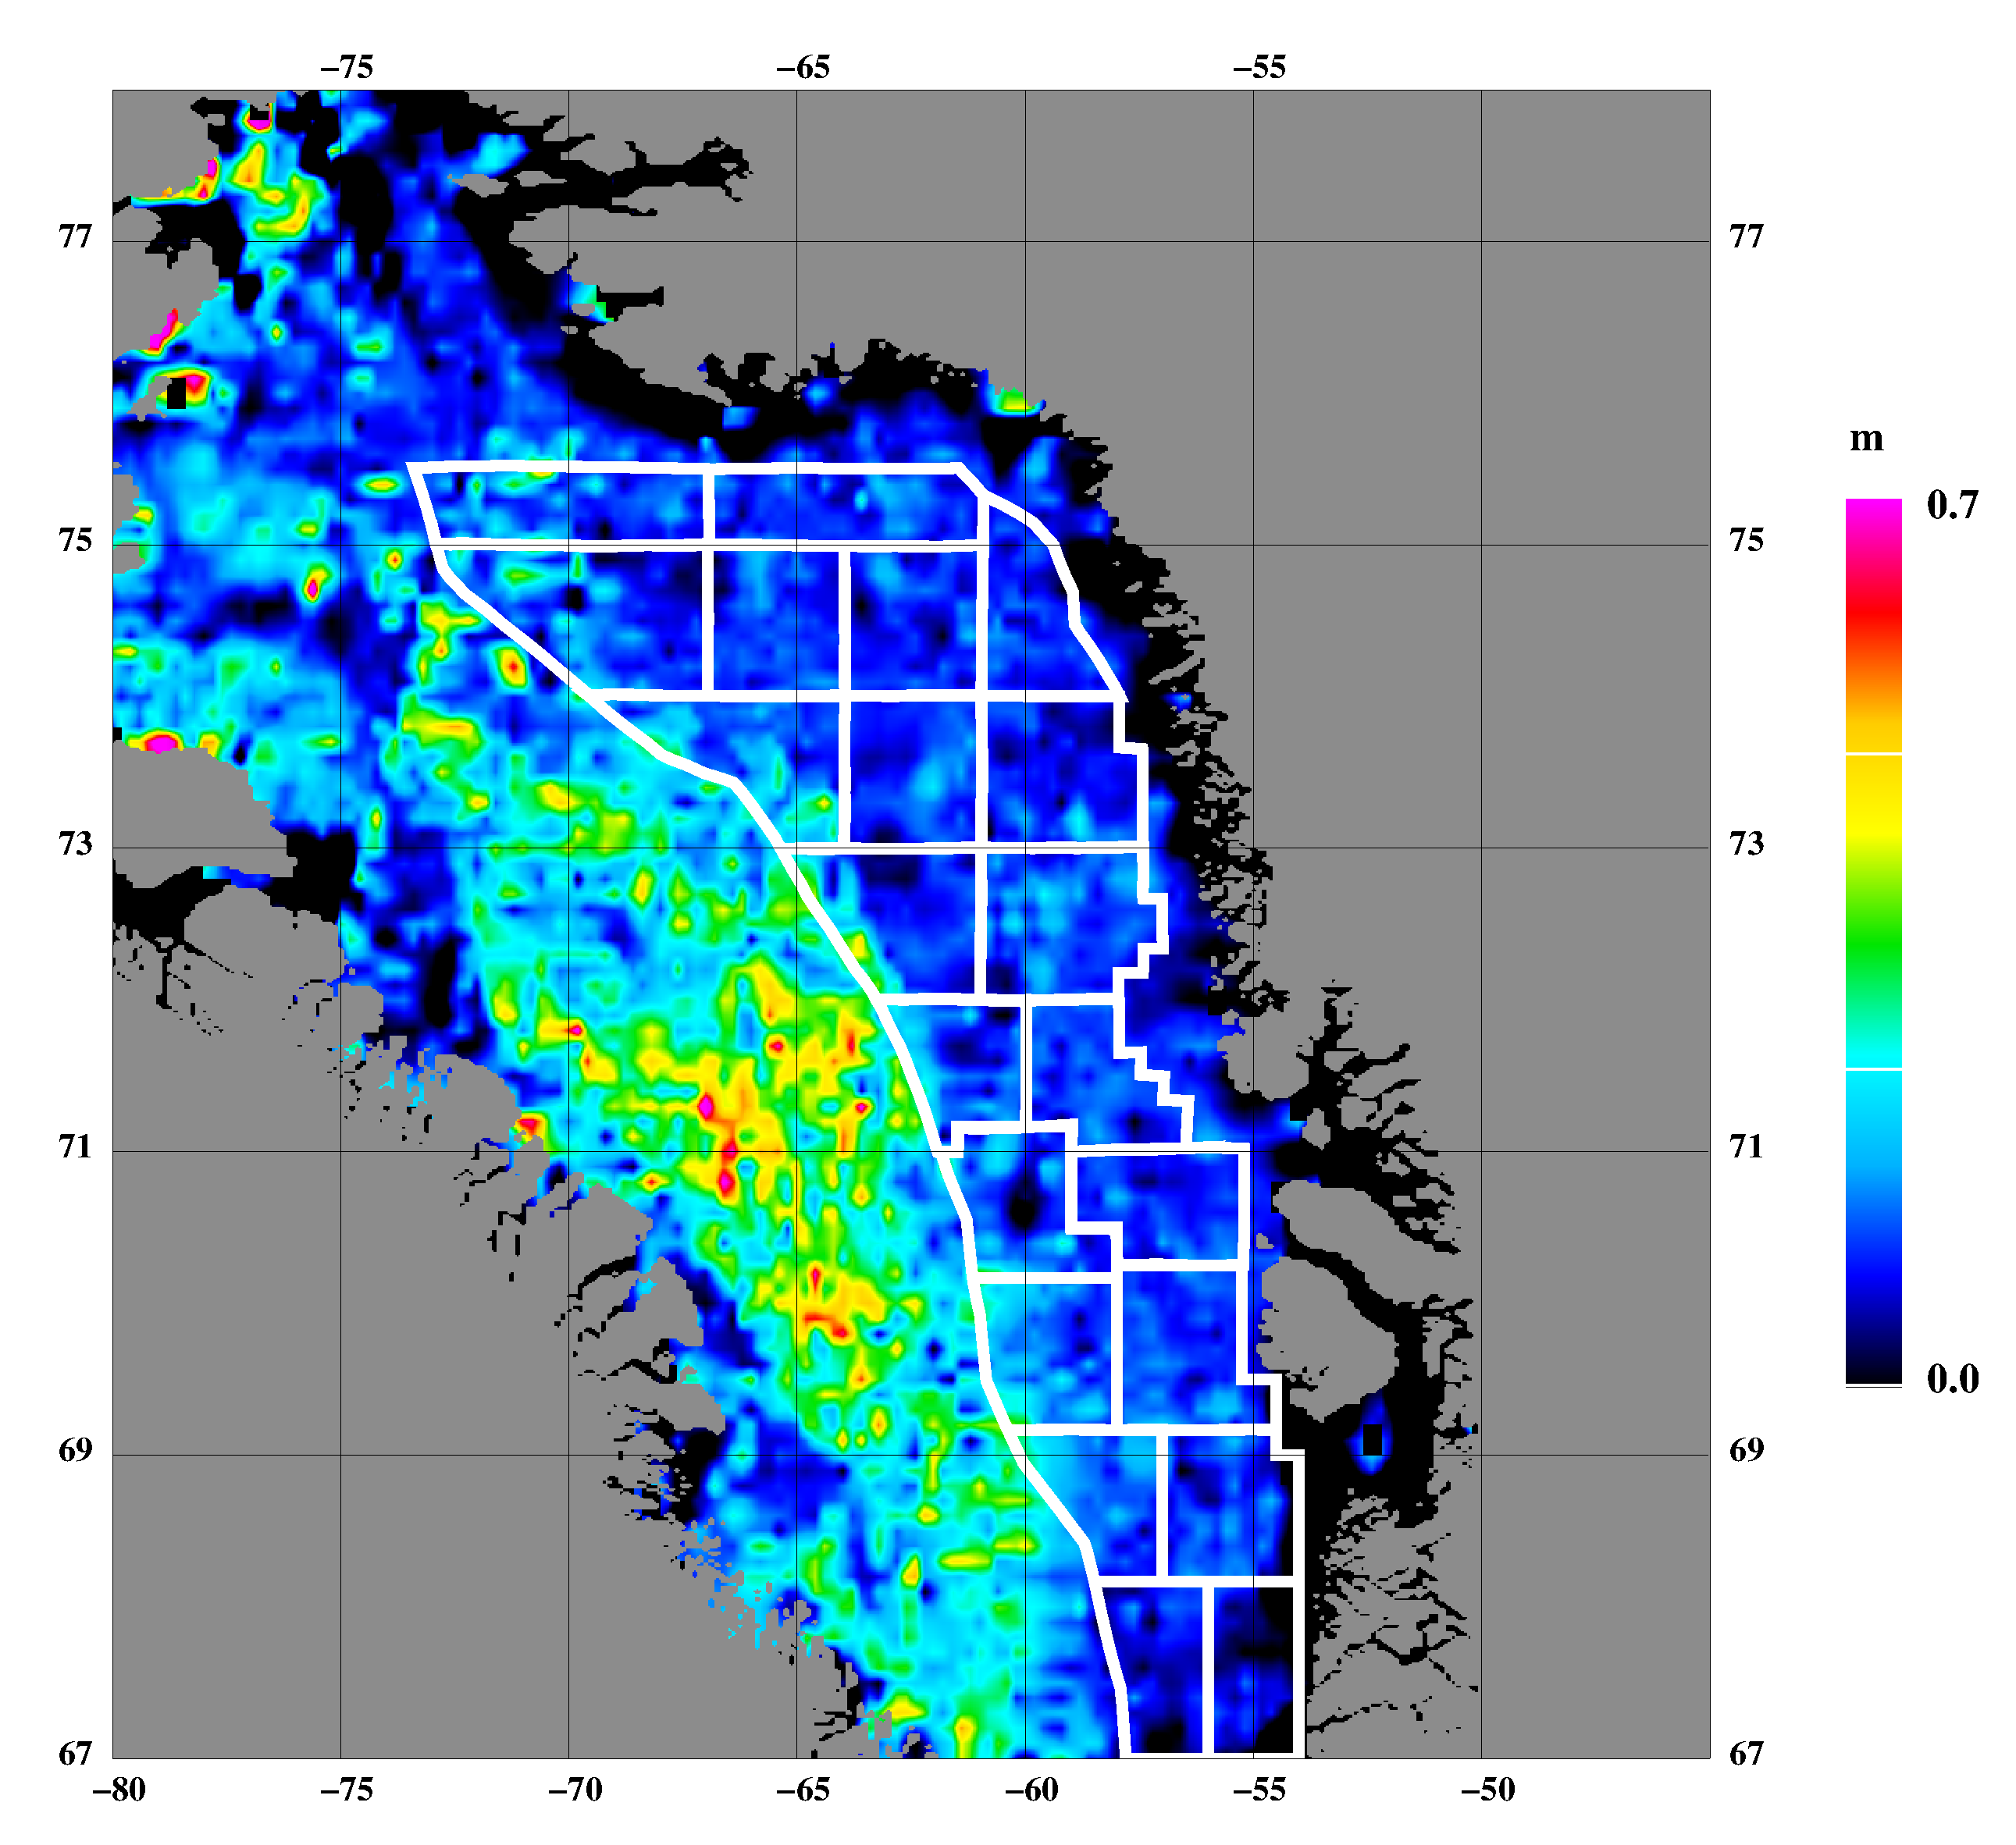
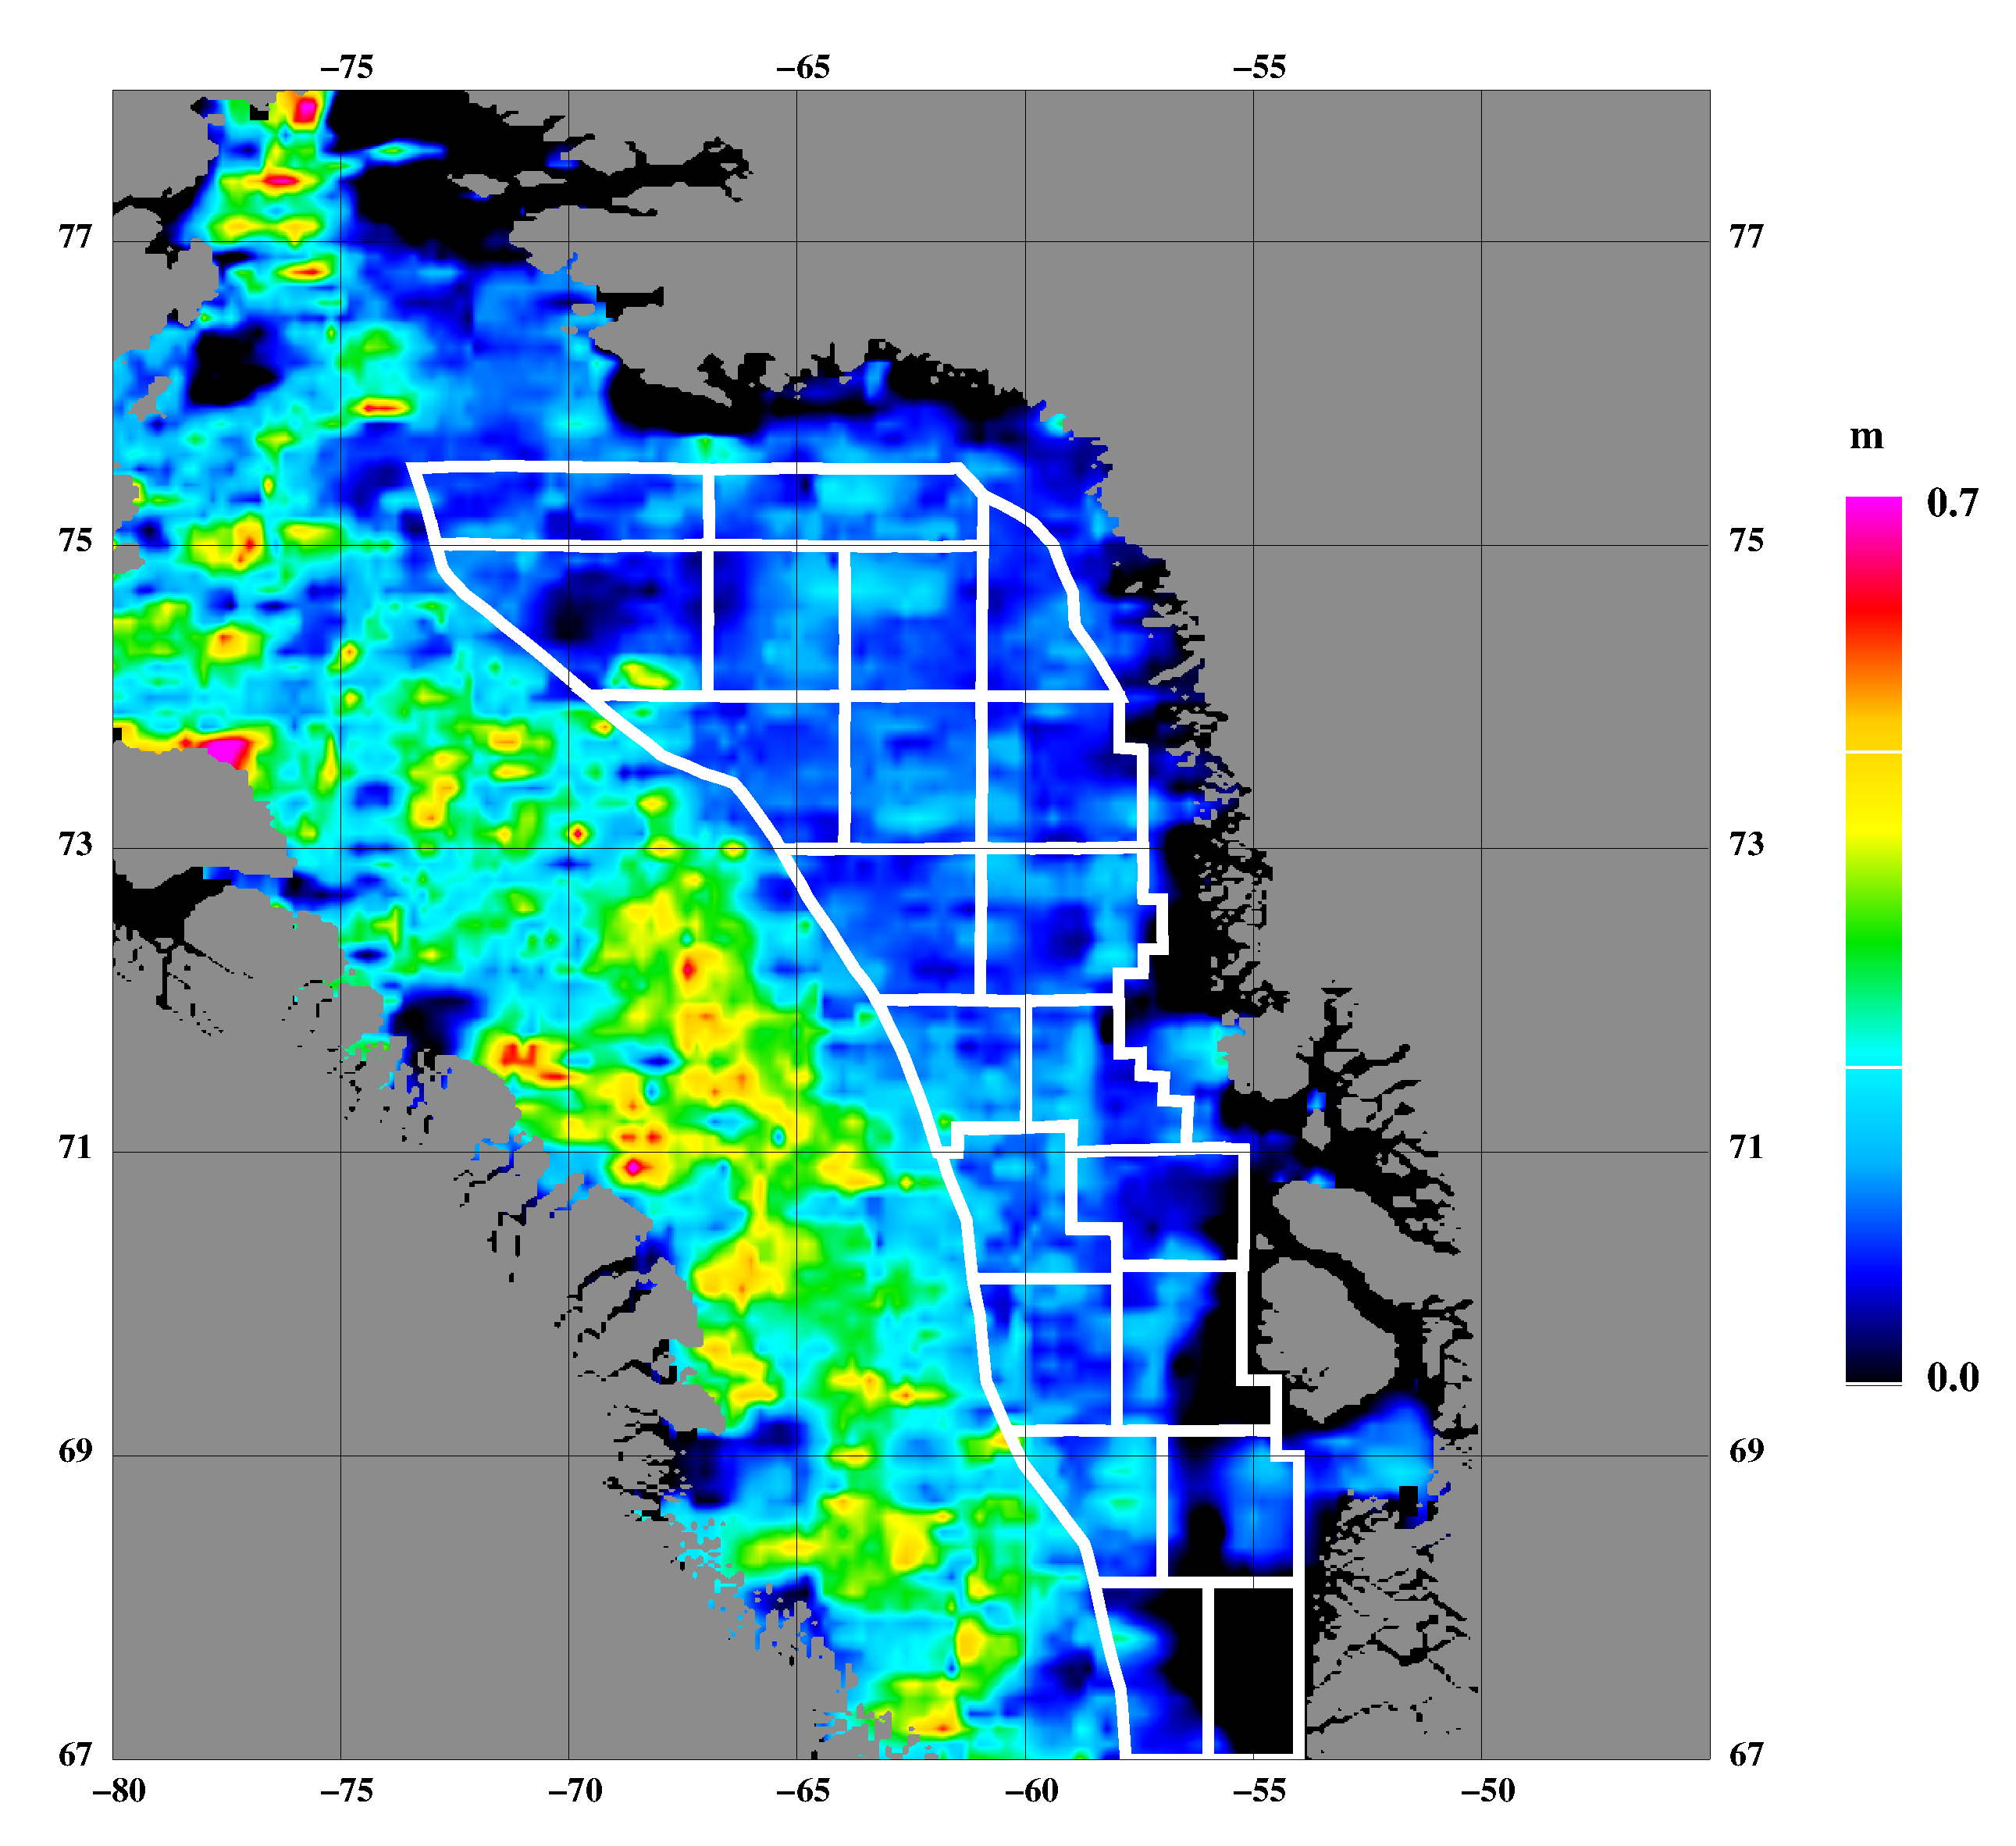
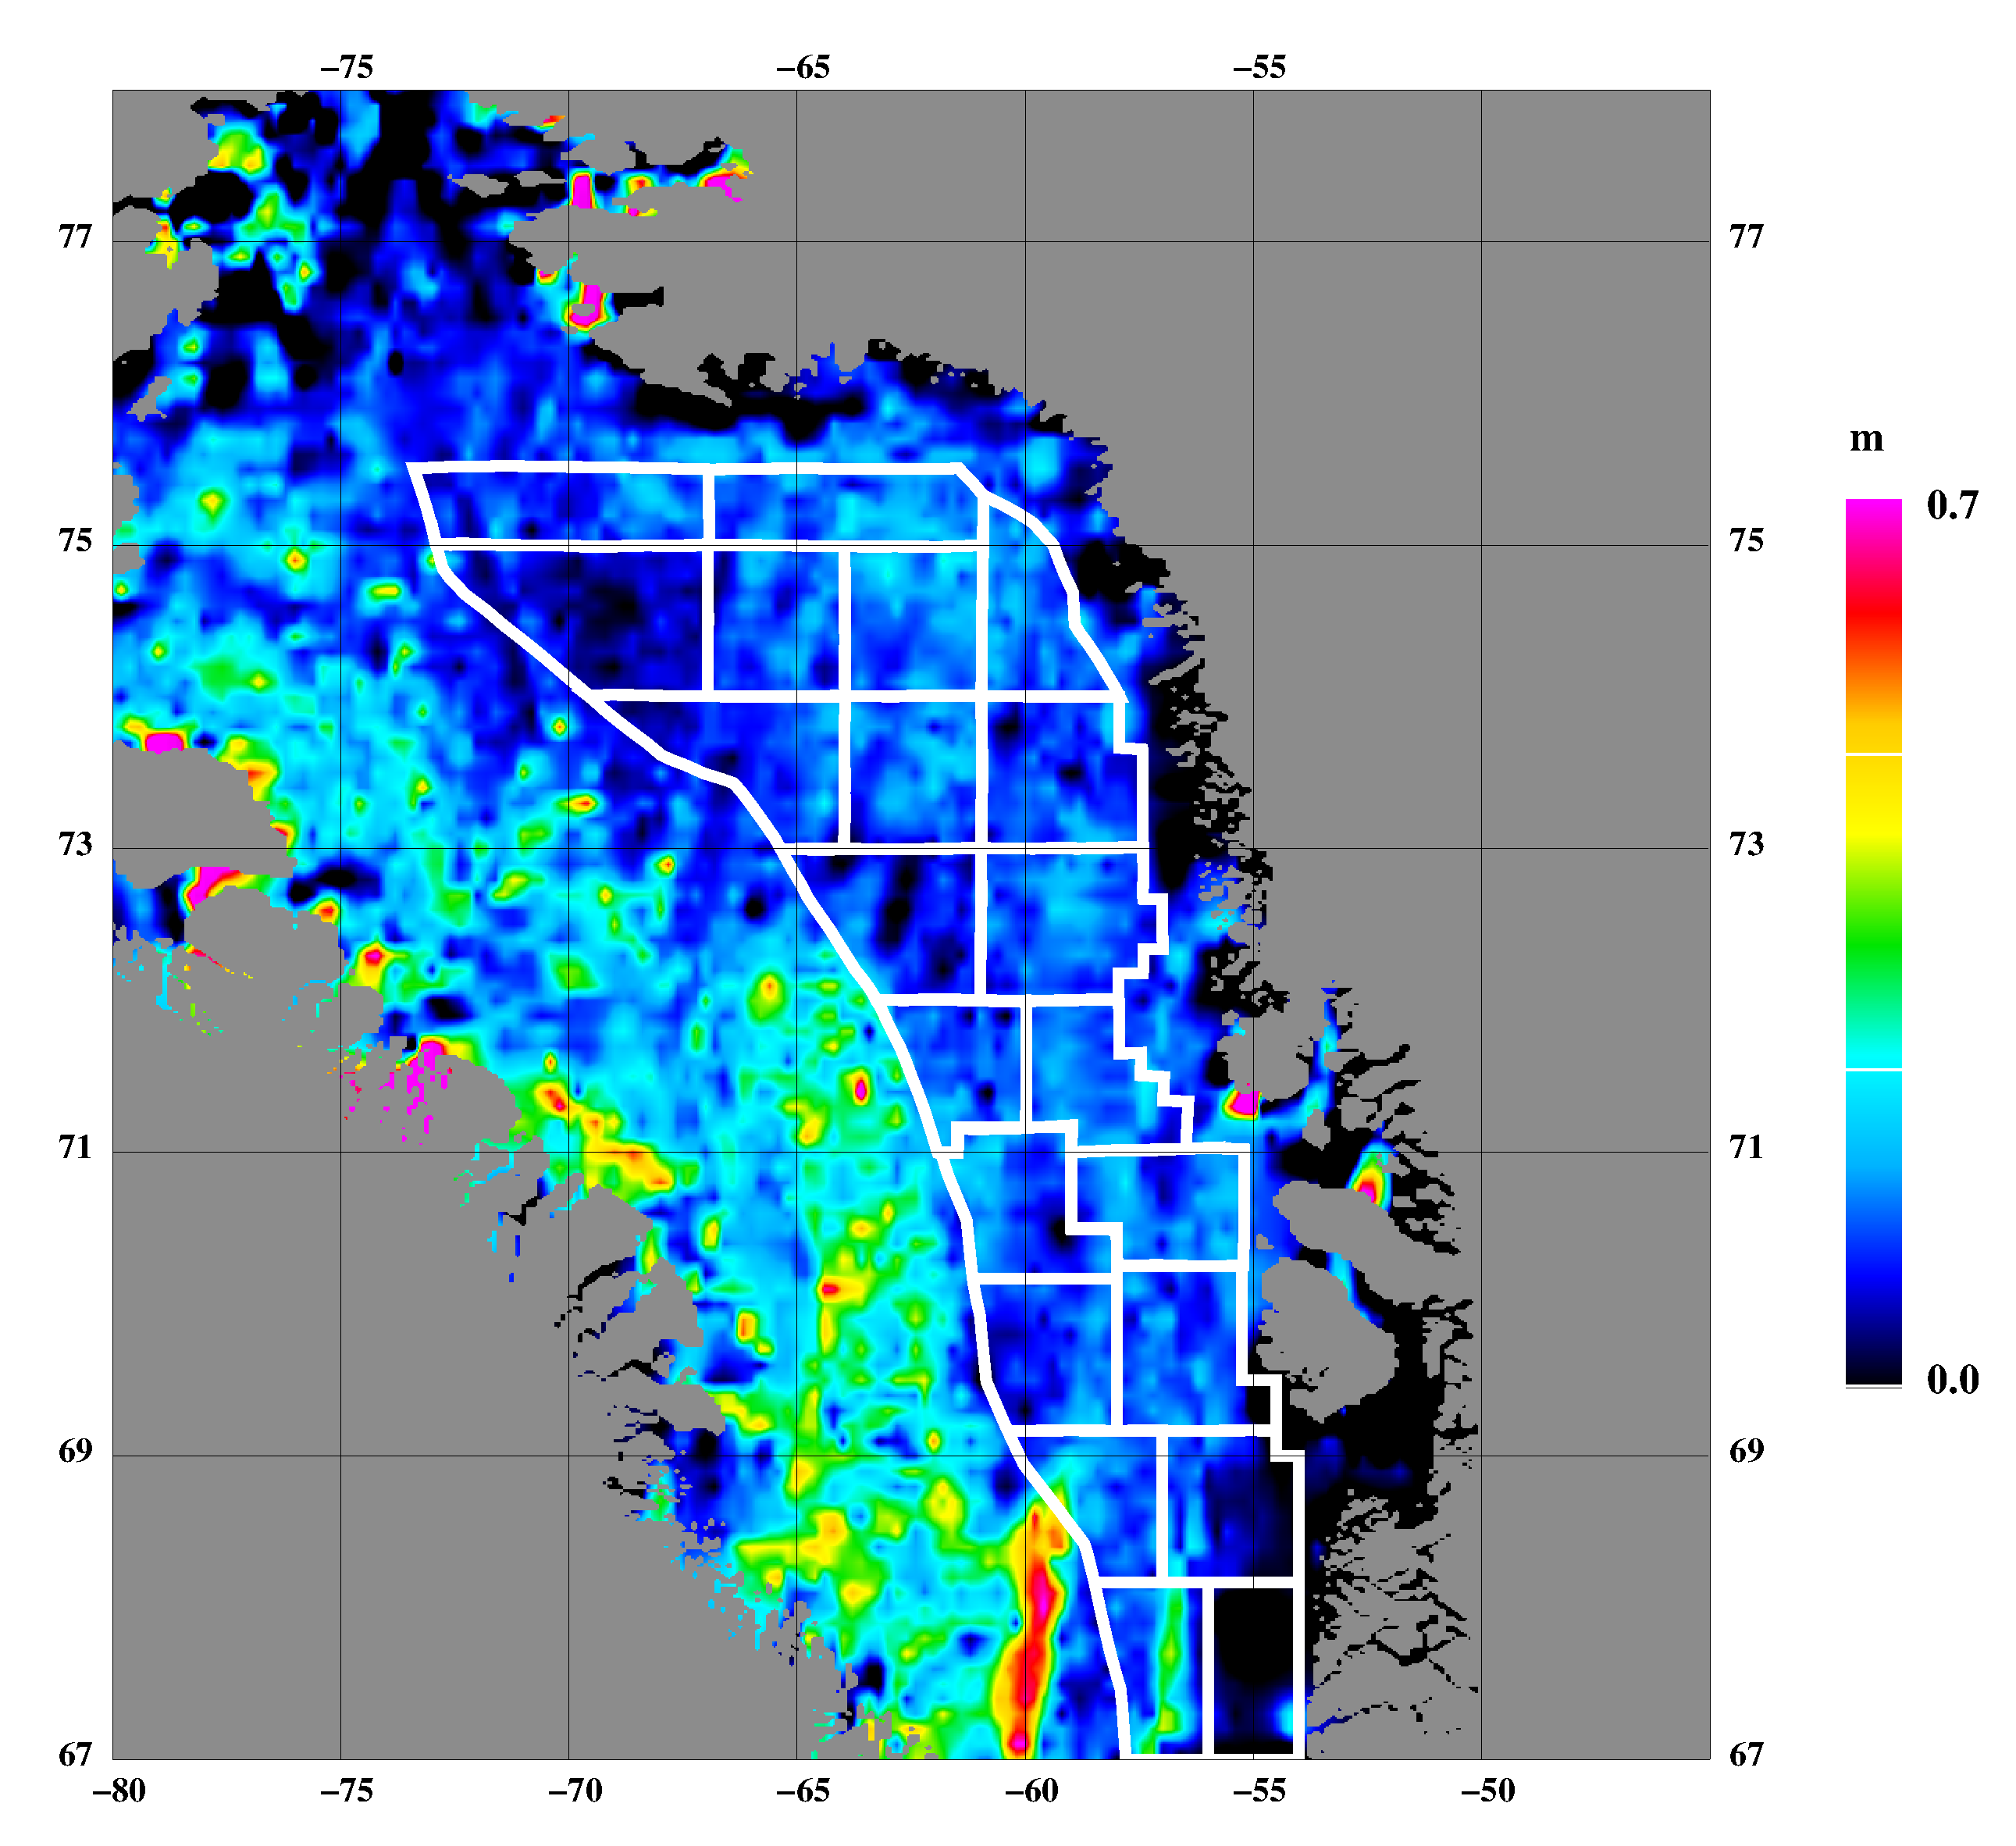
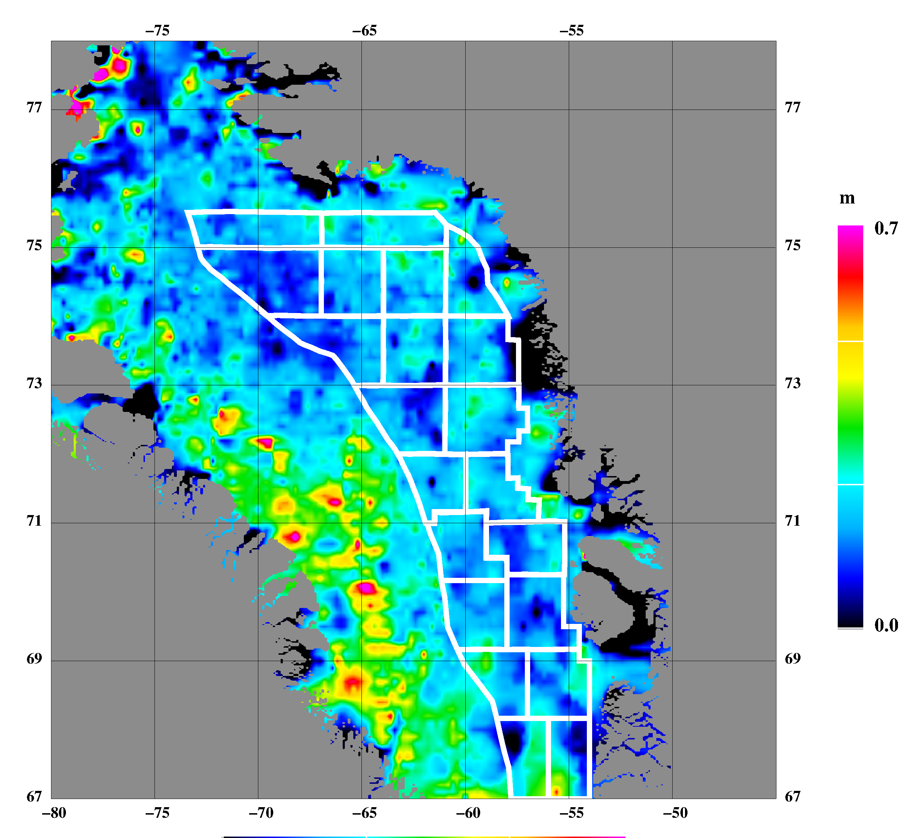
Sea ice freeboard heights FEB 17–MAR 21, 2004
Mean: 0.18m, std: 0.20m Source: ICESat
Sea ice freeboard heights FEB 20–MAR 29, 2003
Mean: 0.23m, std: 0.21m Source: ICESat
Sea ice freeboard heights FEB 22–MAR 27, 2006
Mean: 0.17m, std: 0.17m Source: ICESat
Sea ice freeboard heights FEB 17–MAR 24, 2005
Mean: 0.22m, std: 0.17m Source: ICESat
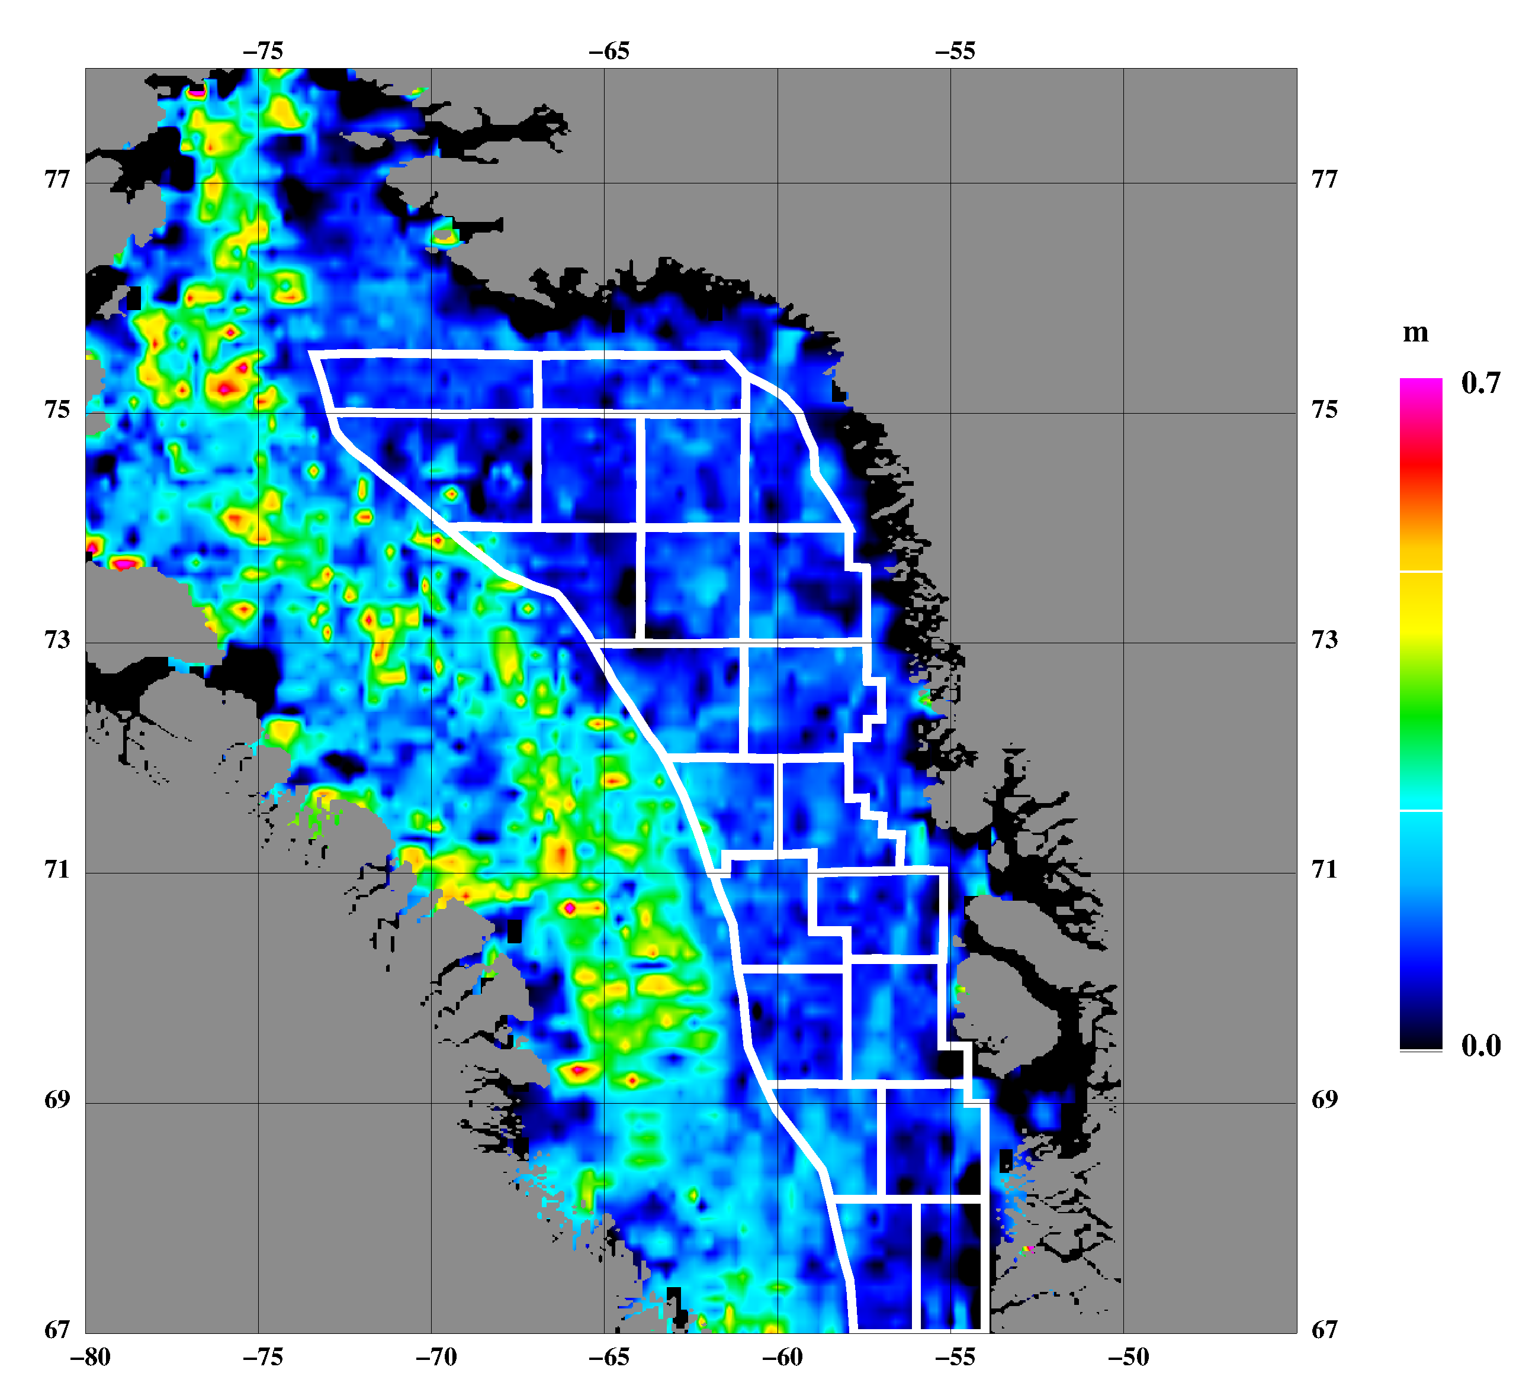
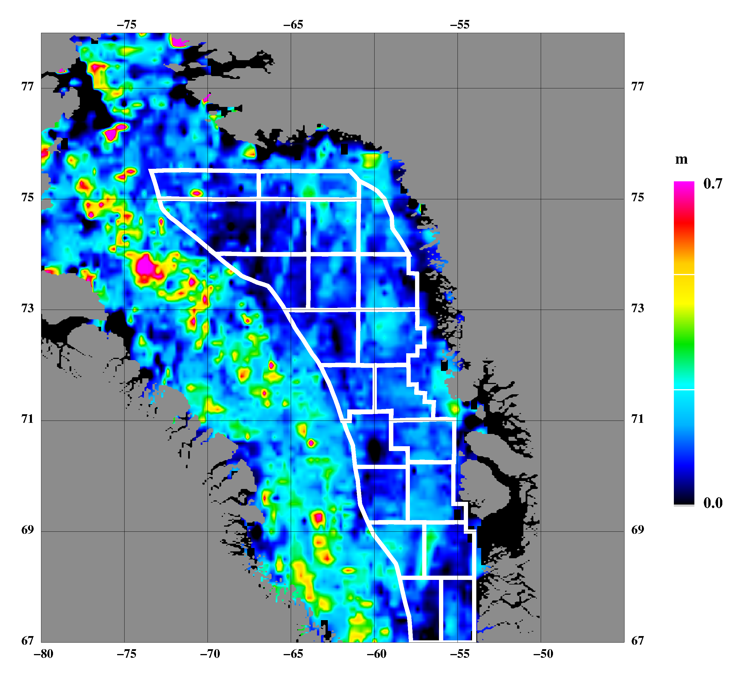
Sea ice freeboard heights MAR 12–APR 14, 2007
Mean: 0.19m, std: 0.20m Source: ICESat
Sea ice freeboard heights FEB 17–MAR 21, 2008
Mean: 0.18m, std: 0.18m Source: ICESat
References

Doble, M. J., Skourup, H., Wadhams, P., and Geiger, C.: The relation between sea ice surface elevation and draft: Results from high-resolution mapping by co-incident AUV sonar and airborne scanning laser. JGR Oceans, 2011JC007076, 2011, in press

Farrell, S. L., S. W. Laxon, D. C. McAdoo, D. Yi, and H. J. Zwally: Five years of Arctic sea ice freeboard measurements from the Ice, Cloud and land Elevation Satellite, J. Geophys. Res., 114, C04008, doi:10.1029/2008JC005074, 2009

Forsberg, R. and Skourup, H. : Arctic Ocean gravity, geoid and sea ice freeboard heights from ICESat and GRACE. Geophysical Research Letters, 32(L21502), 2005

Giles, K. A., S. W. Laxon, and A. L. Ridout: Circumpolar thinning of Arctic sea ice following the 2007 record ice extent minimum, Geophys. Res. Lett., 35, L22502, doi:10.1029/2008GL035710, 2008

Hvidegaard, S. M., R. Forsberg, S. Hanson, H. Skourup, and L. T. Pedersen: Sea ice conditions off NW and NE Greenland from satellite measurements, airborne and in-situ data. Contract report for Greenland Bureau of Minerals and Petroleum, October 2008

Kwok, R., Cunningham, G. F., Zwally, H. J., and Yi, D.: ICESat over Arctic sea ice: Interpretation of altimetric and reflectivity profiles. Journal of Geophysical Research, 111(C06006), 2006

Kwok, R., Cunningham, G. F., Zwally, H. J., and Yi, D.: Ice, Cloud, and land Elevation Satellite (ICESat) over Arctic sea ice: Retrieval of freeboard. Journal of Geophysical Research, 112(C12013), 2007

Kwok, R., Zwally, H. J., and Yi, D: ICESat observations of Arctic sea ice: A first look. Geophysical Research Letters, 31(L16401), 2004

Laxon, S., Peacock, N., and Smith, D.: High interannual variability of sea ice thickness in the Arctic region. Nature, 425:947–950, 2003

Peacock, N. R. and Laxon, S. W.: Sea surface height determination in the Arctic Ocean from ERS altimetry. Journal of Geophysical Research, 109, 2004

Poulsen, S. K., L. Stenseng, H. Skourup, L. T. Pedersen, R. Forsberg, and L. S. Sørensen: Initial results of CryoSat-2 data from the Arctic. In proceedings CryoSat Validation Workshop, Frascati, Italy, February 1-3, 2011

Skourup, H.: A study of Arctic sea ice freeboard heights, gravity anomalies and dynamic topography from ICESat measurements. PhD Thesis, University of Copenhagen, 2010

Skourup, H. and R. Forsberg: Sea ice freeboards from ICESat – A comparison to airborne lidar measurements. Arctic Sea Ice Thickness: Past, present and future, edited by P. Wadhams and G. Amanaditis. Climate Change and Natural Hazards Series, Brussels, 2006
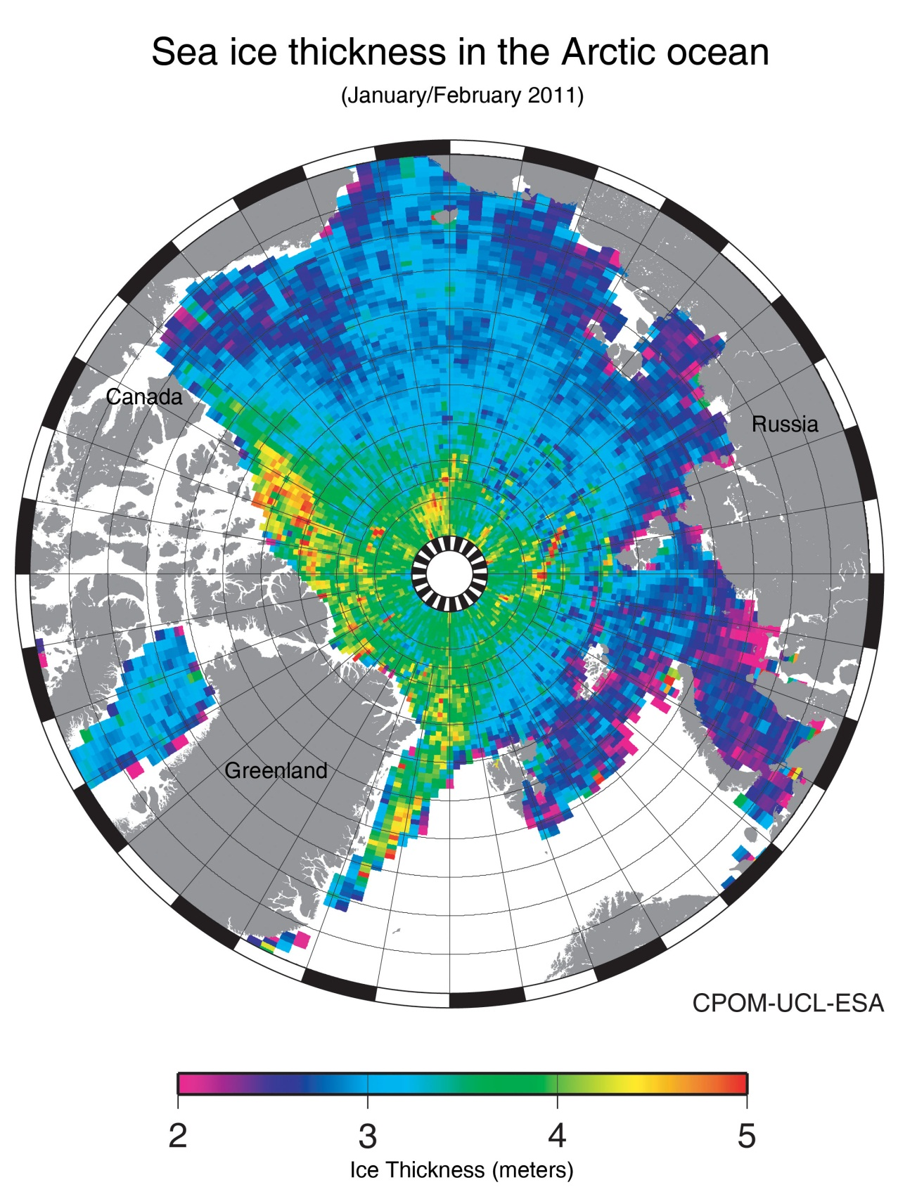
Appendix: Arctic Ocean sea ice thickness from CryoSat measurements

