WP 5: Airborne laser measurements of sea ice freeboard heights

DTU Space coordinated an airborne campaign in April 2011 to obtain high-resolution laser scanner measurements for estimation of sea ice freeboard heights in the Baffin Bay. The tracks were selected to match the southernmost flight tracks from a similar survey conducted in April 2008, see Figure 1.

The Baffin Bay campaign was carried out in connection with mobilization of ESA’s CryoSat-2 Validation Experiment (CryoVEx-2011), thus the aircraft was equipped with an advanced 13.5 GHz radar altimeter (ASIRAS), which is an airborne version of the radar altimeter carried onboard CryoSat-2. Processing of the ASIRAS data is ongoing, however, it is rather time consuming and the processed data will not be available until the beginning of 2012. To support the analysis of laser scanner and ASIRAS, vertical photography and video recordings were collected during flight.

In this study, we present sea ice freeboard heights obtained from the laser scanner measurements of the 2011 survey flights. The freeboard distributions for the east-west flight tracks for 2008 and 2006 are also presented. As the airborne laser scanner measures the surface height with higher resolution and precision, than by the use of satellite altimetry, the airborne measurements are used to validate the ICESat freeboard heights, see chapter (comparison of sea ice freeboard heights from satellite altimetry and airborne laser scanner measurements).

The planned flight tracks of the 2011 survey (blue lines) are shown in figure 1, where the two southernmost tracks (74⁰N and 72.79⁰N) are coincident with a similar survey conducted in 2008. Unfortunately, it was only possible to measure part of the planned tracks due to weather. On April 19, the eastern part of Baffin Bay (red line) was measured on the route from Qaanaaq to Kangerlussuaq. On May 8 (green line), the northernmost track at 75⁰N was surveyed, but the southernmost tracks were covered in low clouds and fog (less than 300m) preventing further measurements. Low clouds and fog, caused by a stationary low pressure system, persistently covered the Baffin Bay the following week. The airborne team was standby until midday on May 12, where the campaign had to be closed, as the extended charter period was reaching the end. As DTU Space has a formal cooperation with the NASA ICEbridge team, these were subsequently requested to fill in any data gaps in the Baffin Bay from Thule AB. At this time, collection of additional data was not possible due to time constraints and weather. However, the NASA ICEbridge airborne survey on April 28, an almost straight track from Thule AB to Upernavik located west of the track flown by DTU Space on April 19, were measured by various instruments including a laser scanner (ATM). For further information, see attached operation IceBridge Arctic 2011, preliminary science flight report, Flight F28, Baffin Bay sea ice, appendix OIB_ARC_2011_flt_rep_F28_prelim.pdf. The IceBridge data is not yet available and is therefore not included in this study.

The major part of the 2008 survey was measured on April 19 (green lines) and an additional transit flight from Thule AB to Kangerlussuaq was measured on May 7 (red line). For a more detailed description of the 2008 survey, see Hvidegaard et al (2008). In 2006 four flight tracks south of 71⁰N were measured on April 21 and 24, where only the northernmost track at 71⁰N is overlapping with 2008. Unfortunately, none of the 2011 survey has overlapping data with previous years.

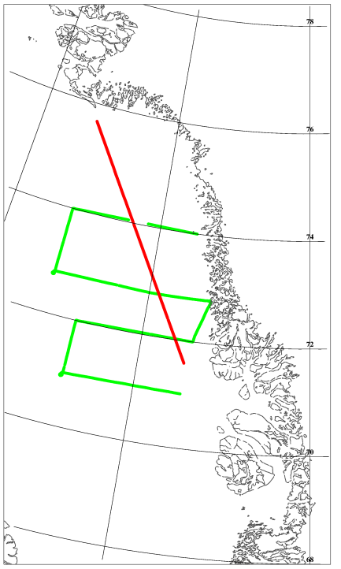
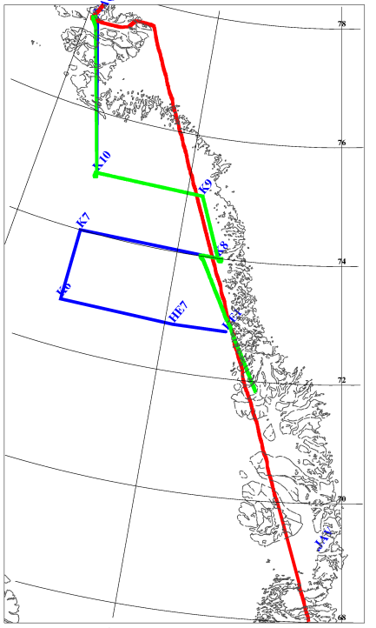
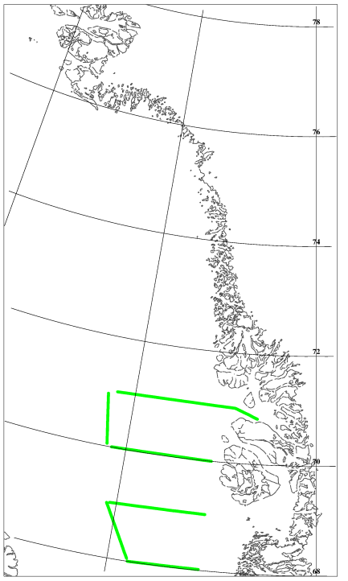
2006
2008
2011
Figure 1: Flight tracks in the Baffin Bay, 2011 (left), 2008 (middle) and 2006 (right)

The airborne laser scanner used on May 8, is the same laser scanner (Riegl LMS Q240i) as used for the 2008 survey flights. Due to problems during installation a spare laser scanner (Riegl LMS Q140i same as in 2006) was used for the first flight on April 19. The two laser scanners are almost identical measuring with a horizontal resolution of 0.75m x 1m at a flight height of 300m and a ground speed of 250 kph. The across-track swath width is roughly equal to the flight height, and the vertical accuracy is in the order of 10 – 20cm depending primarily on uncertainties in the kinematic GPS-solutions, due to long baselines (Krabill et al, 1995). For more information on the airborne instrumentation and the system setup, see Hvidegaard et al (2006).

The freeboard heights are obtained by using a lowest-level estimation method, similar to the method used for the ICESat altimeter. However, it is adapted to the higher resolution of the laser scanner system (Hvidegaard and Forsberg, 2002). An example of sea ice freeboard heights from a full resolution laser scanner swath is shown in figure 2 together with vertical photography. For consistency, we use the same freeboard to thickness conversion (k=5.7) as used in 2008 for the Baffin Bay (Hvidegaard et al, 2008).

The sea ice freeboard distribution from the laser scanner measurements along latitude 75⁰N are plotted in figure 3 (upper plot). The dominant ice has freeboard heights of 15-20cm corresponding to an ice thickness of 0.9-1.1m, which is characterized as FYI. This is consistent with the average maximum ice thickness, which according to section Sea ice around Greenland and the Arctic Ocean, Baffin Bay is about 1.75m in the north-western part of the bay gradually thinning towards the Greenland coast to about 0.7m.

In general, all flight lines in the Baffin Bay (2006-2011) have dominant ice freeboard heights of 5-20cm corresponding to 0.3-1.1m in ice thickness. The flight tracks between 69⁰N - 71⁰N are characterized by a larger amount of MYI and deformed ice, represented by the tail of freeboard distributions, as freeboard heights higher than 35cm corresponds to ice thicker than 2m (using k=5.7). This is consistent with the distribution of the ICESat sea ice freeboard heights, where the westernmost part of these tracks covers areas of thicker ice, see chapter comparison of sea ice freeboard heights from satellite altimetry and airborne laser scanner measurements.

The average ice thickness (using k=5.7) for the 2011 flight, together with the sea ice distribution of ice thicker than 80cm, are shown in Figure 6. Each value represents all data within blocks of 2 degrees longitude x 0.5 degree latitude.

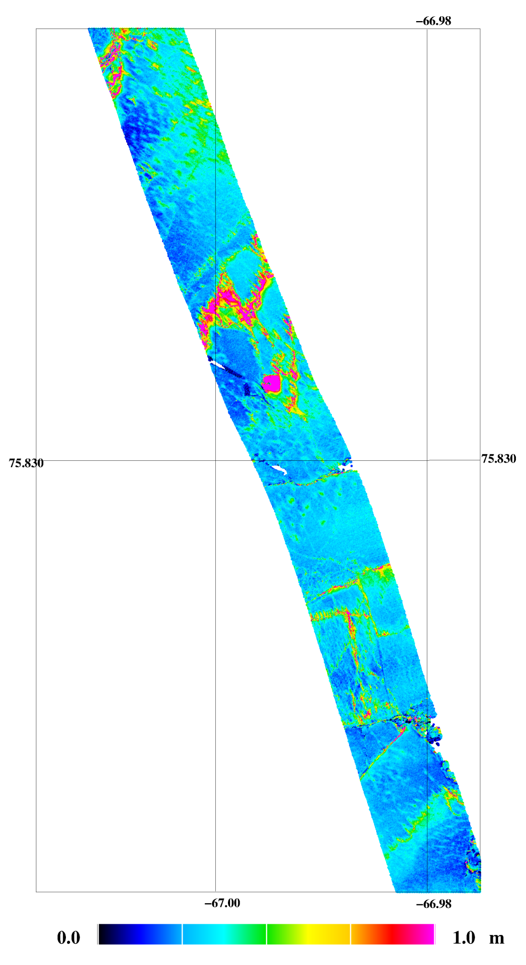
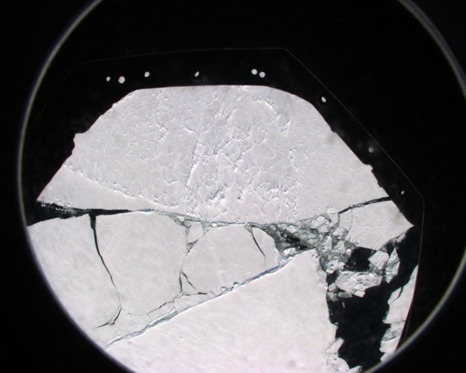
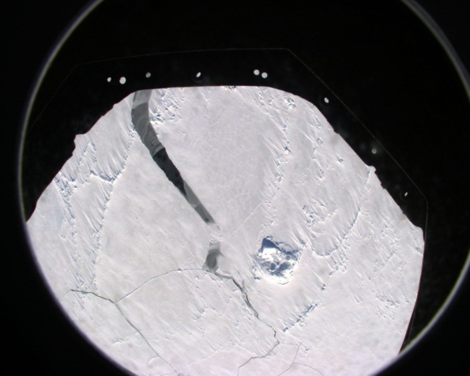
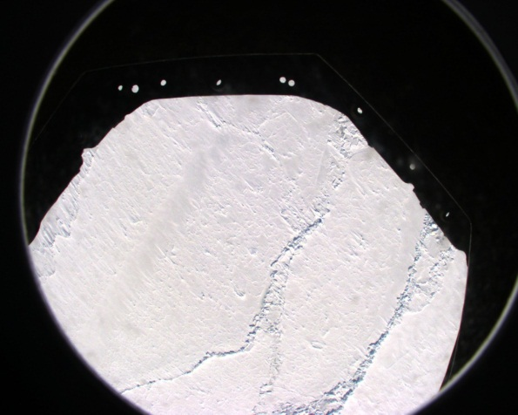
Figure 2: Full resolution sea ice freeboard heights from airborne laser scanner and vertical photography
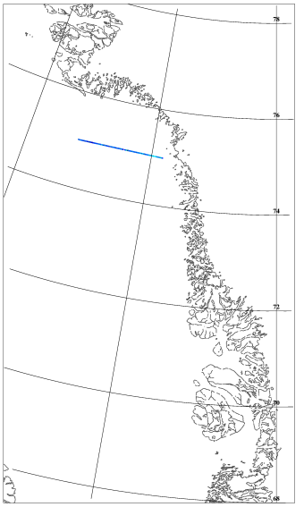
75⁰N May 8, 2011
Freeboard : 15-20cm
Thickness: 0.9-1.1m

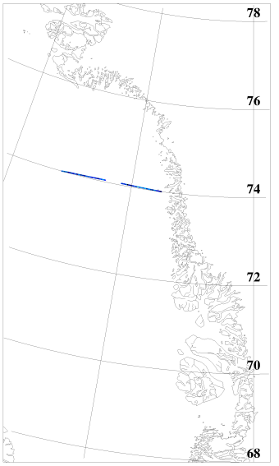
74⁰N April 19, 2008
Freeboard : 5-10cm
Thickness: 0.3-0.6m

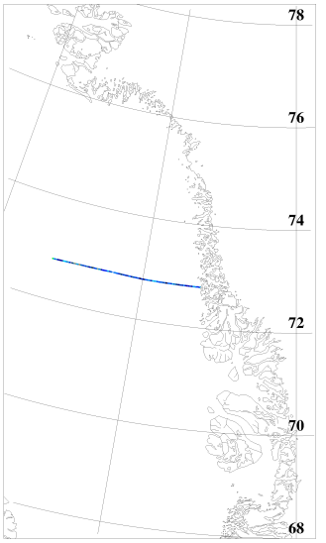
72.79⁰N April 19, 2008
Freeboard : 5-15cm
Thickness: 0.3-0.9m

Figure 3: Distribution of sea ice freeboard heights from airborne laser scanner measurements from 2011 (cyan) and 2008 (green)
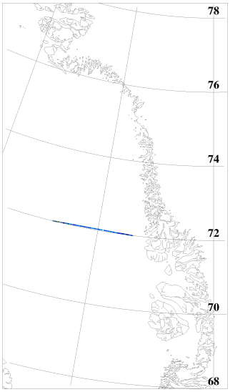
72⁰N April 19, 2008
Freeboard : 15-20cm
Thickness: 0.9-1.1m

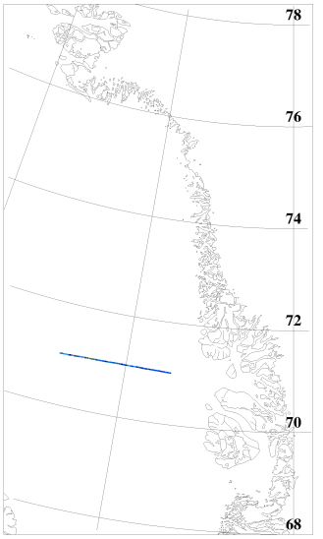
71⁰N April 19, 2008
Freeboard : 15-20cm
Thickness: 0.9-1.1m

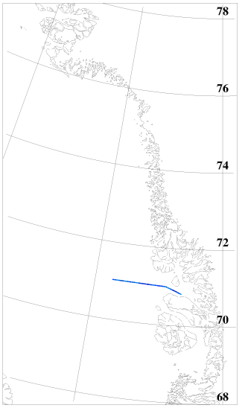
71⁰N April 24, 2006
Freeboard : 10-15cm
Thickness: 0.6-0.9m

Figure 4: Distribution of sea ice freeboard heights from airborne laser scanner measurements from 2008 (green) and 2006 (red)
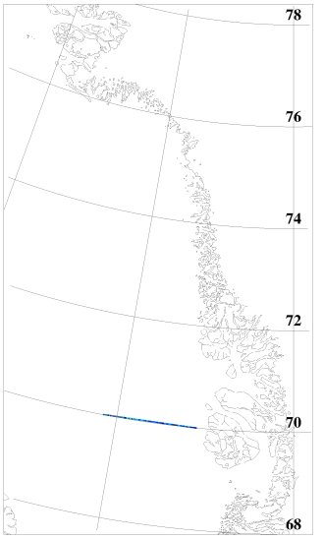
70⁰N April 24, 2006
Freeboard : 10-20cm
Thickness: 0.6-1.1m
70⁰N April 24, 2006
Freeboard : 15-20cm
Thickness: 0.9-1.1m

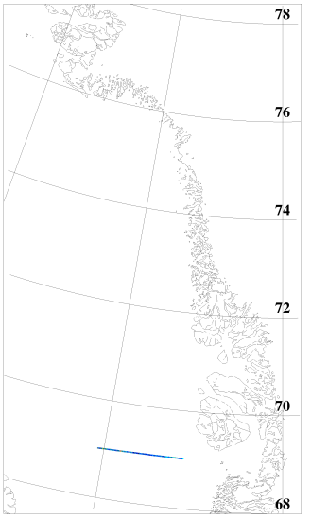
69⁰N April 21, 2006
Freeboard : 15-20cm
Thickness: 0.9-1.1m

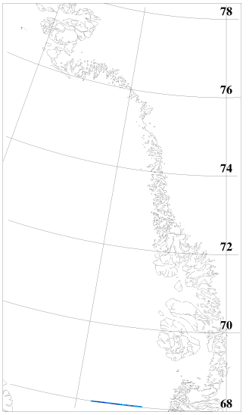
68⁰N April 21, 2006
Freeboard : 10-15cm
Thickness: 0.6-0.9m

Figure 5: Distribution of sea ice freeboard heights from airborne laser scanner measurements from 2006 (red)
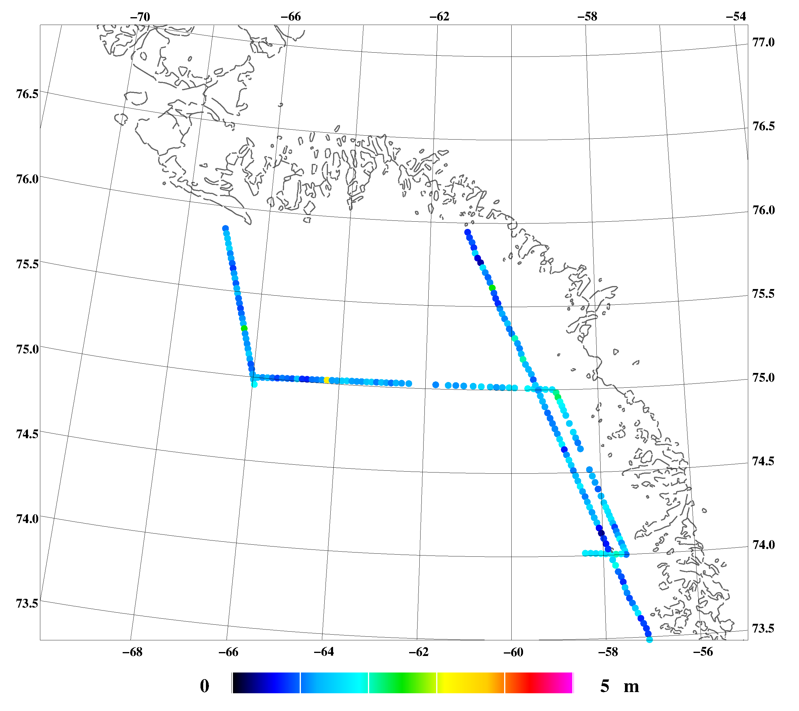
1.18 m
64%
1.22 m
74 %
1.25 m
64 %
1.24 m
72 %
1.34 m
86 %
1.30 m
75 %
1.04 m
45 %
1.30 m
71 %
1.12 m
59 %
1.40 m
80 %

Figure 6: Ice thickness in the northern Baffin Bay from lidar. Numbers show averages in 2 degree longitude x 0.5 degree latitude blocks, along with probability of ice thickness thicker than 80 cm
References

Hvidegaard, S. M., R. Forsberg, S. Hanson, H. Skourup, and L. T. Pedersen: Sea ice conditions off NW and NE Greenland from satellite measurements, airborne and in-situ data. Contract report for Greenland Bureau of Minerals and Petroleum, October 2008

Krabill, W. B., R. H. Thomas, C. F. Martin, R. N. Swift, and E. B. Frederick. Accuracy of airborne
laser altimetry over the Greenland icesheet. Int. J. Remote Sensing, 16(7):1211–1222, 1995

Hvidegaard, S.M, R. Forsberg, and H. Skourup. Sea ice thickness estimates from airborne laser
scanning. In P. Wadhams and G. Amanatidis, editors, Arctic Sea Ice Thickness: Past, Present and
Future. Climate Change and Natural Hazards Series, Brussels, 2006

Hvidegaard, S. M. and Forsberg, R. 2002: Sea-ice thickness from airborne laser altimetry over the Arctic Ocean north of Greenland. Geophysical Research Letters, 29(20):1952, 2002

