WP 6: Comparison of sea ice freeboard heights from satellite altimetry and airborne laser scanner measurements
The airborne data set from 2011 (presented in chapter Airborne laser measurements of sea ice freeboard heights) could, in principle, be compared to CryoSat-2 radar altimetry. However, the CryoSat-2 data are not ready for such comparison studies and is left for later analysis, see section Sea ice freeboard heights from satellite altimetry.
The only overlapping data sets are freeboard heights from airborne laser scanner and ICESat measurements from 2006 and 2008. The laser scanner freeboard heights are plotted on top of the respective ICESat freeboard heights in figure 1 and 2. Direct comparison is questionable, as the airborne data sets are from the end of April and beginning of May, whereas the ICESat data is from the period February – March. However, the sea ice thickness is about its annual maximum in February-March, and except for the changes due to ice drift there is not expected much changes in the sea ice distribution before the beginning of the melt season in May. The gradual decrease in sea ice freeboard heights towards the coast off Greenland are clearly seen in both plots.
The sea ice freeboard distribution of all airborne laser scanner data from 2006 (figure 1) and 2008 (figure 2), is plotted in figure 3 and 4, together with the freeboard distributions from all ICESat periods 2003-2008. The ICEsat freeboard distributions are almost identical for 2006 and 2008, and match the airborne data sets well. Peak freeboard heights are 10-20cm corresponding to sea ice thicknesses of 0.6-1.1m.
There is no evidence of biases between the freeboard heights based on the airborne and satellite measurements, not even for the tail of the distribution. This is consistent with results from a similar study made by Kurtz et al. (2008) north of Alaska (Kurtz et al, 2008) in sea ice conditions similar to those found in the Baffin Bay. Kurtz et al (2008) found ICESat freeboard heights to be underestimated by less than 2 cm, when compared to airborne laser freeboard heights, in areas of relative flat ice with many open leads.
The freeboard distribution plots of the 2011 airborne flights are plotted together with the ICESat distribution plots in figure 5. All the data used is plotted in figure 6 chapter Airborne laser measurements of sea ice freeboard heights. The 2011 freeboard distribution is best represented by the ICESat distributions of 2006 and 2008, however, there are less ice with freeboard heights higher than 35cm (>2m in thickness) in the airborne data set. This is primarily due to the fact that the 2011 airborne tracks are located in the northern part of the Baffin Bay and do not cover the thicker ice present in the western part of the Baffin Bay.
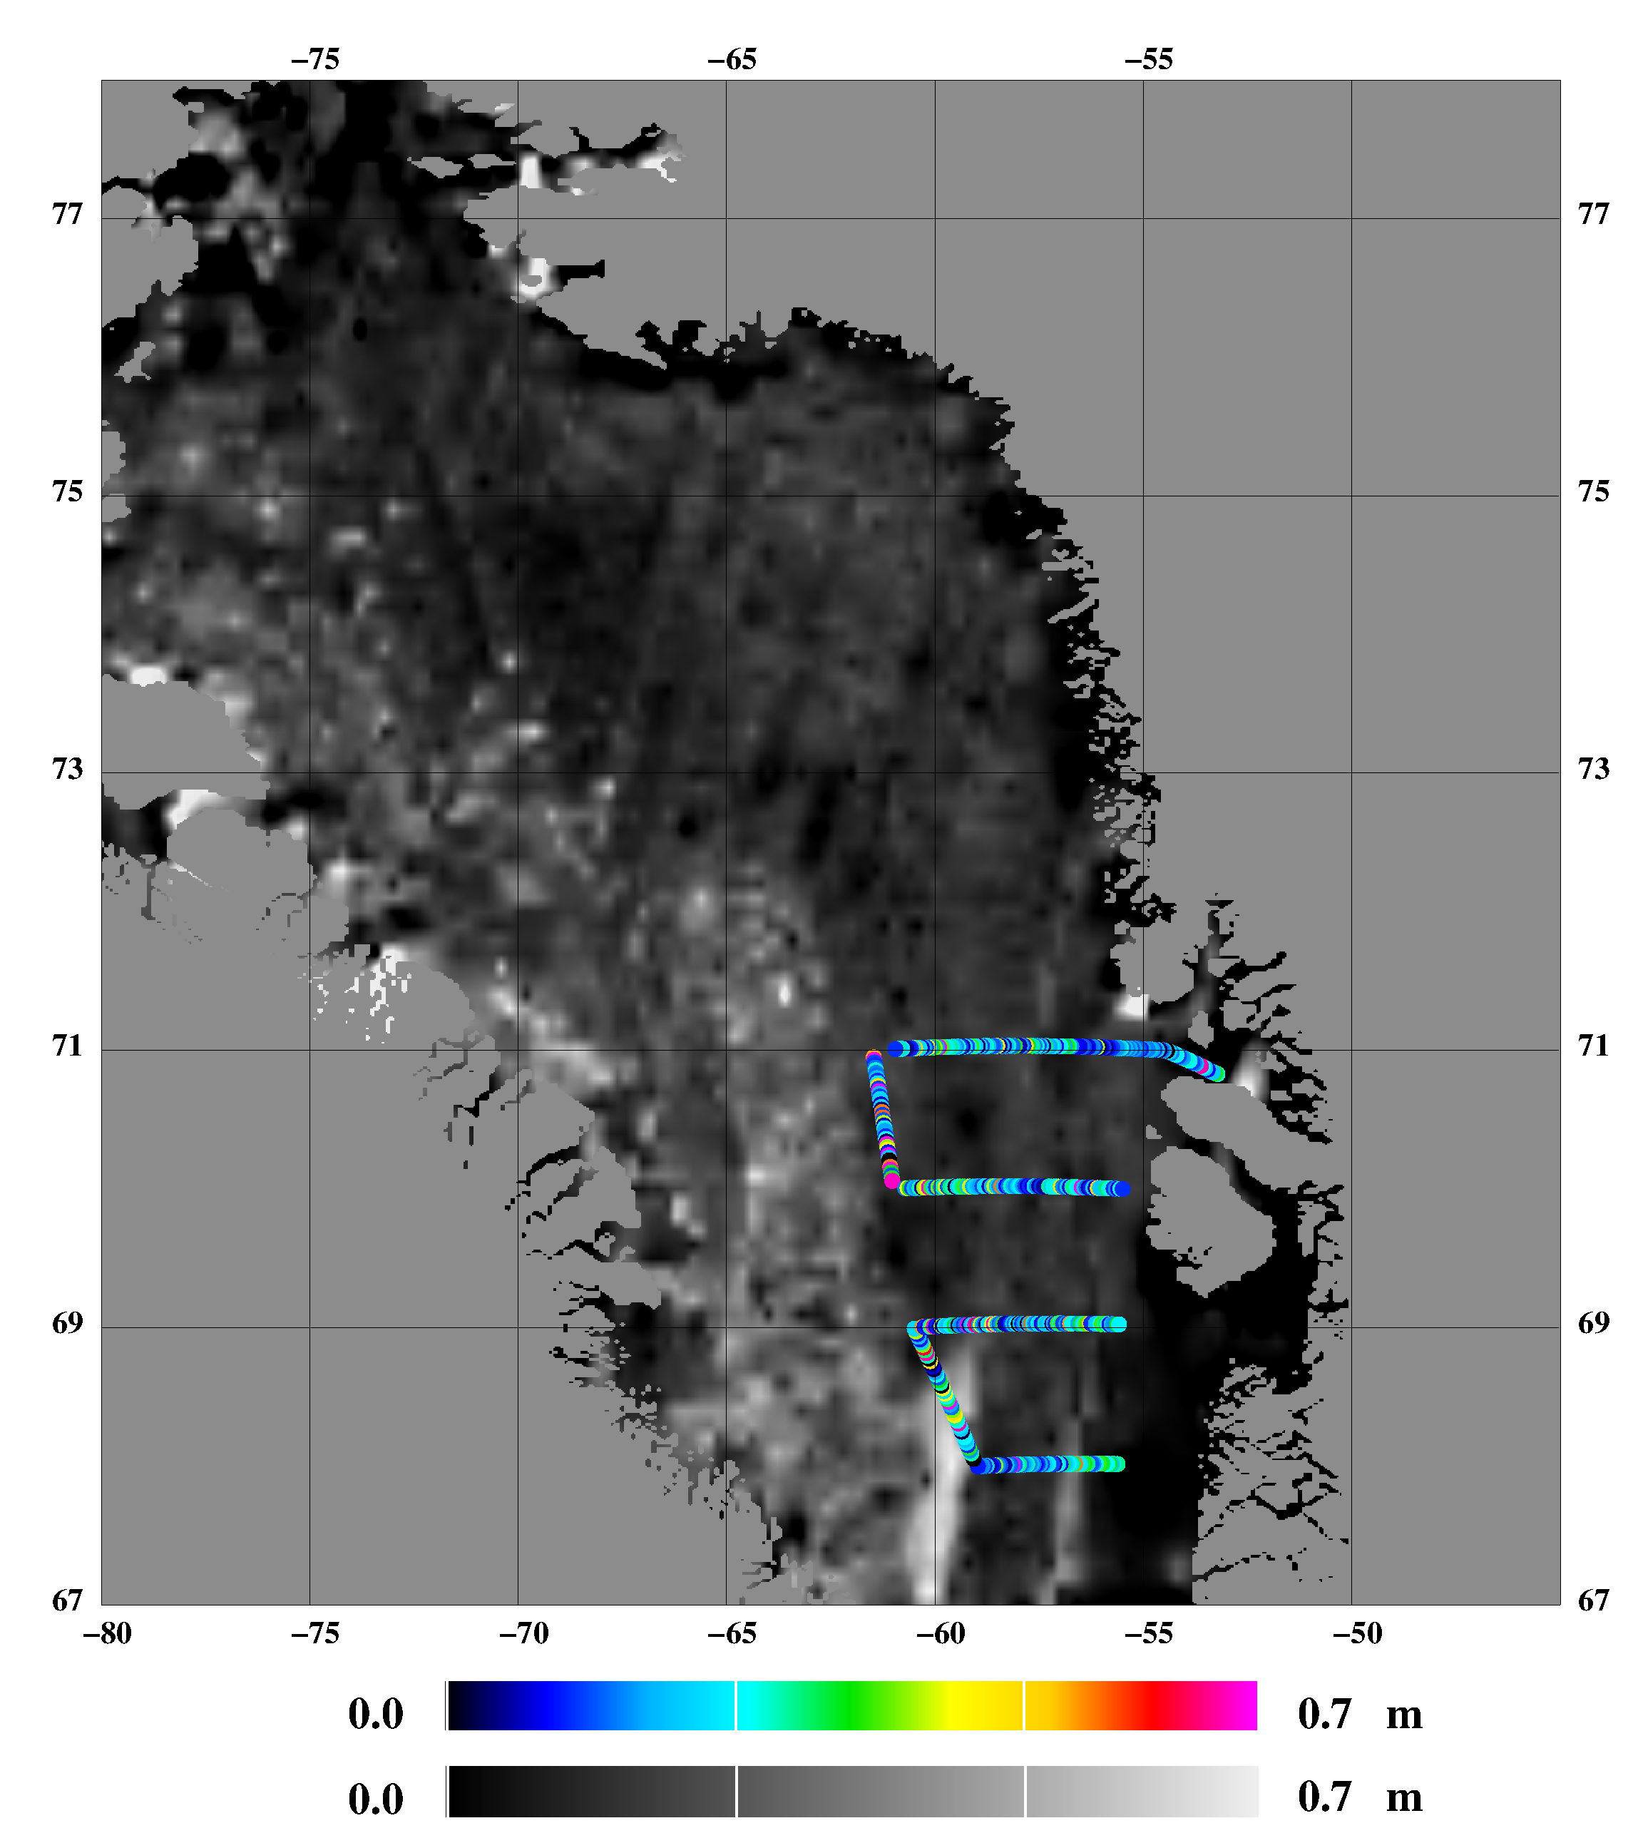
Figure 1: Freeboard heights from 2006, airborne laser scanner (April 21 and 24) overlaid ICESat freeboard heights (February 22 – March 27)

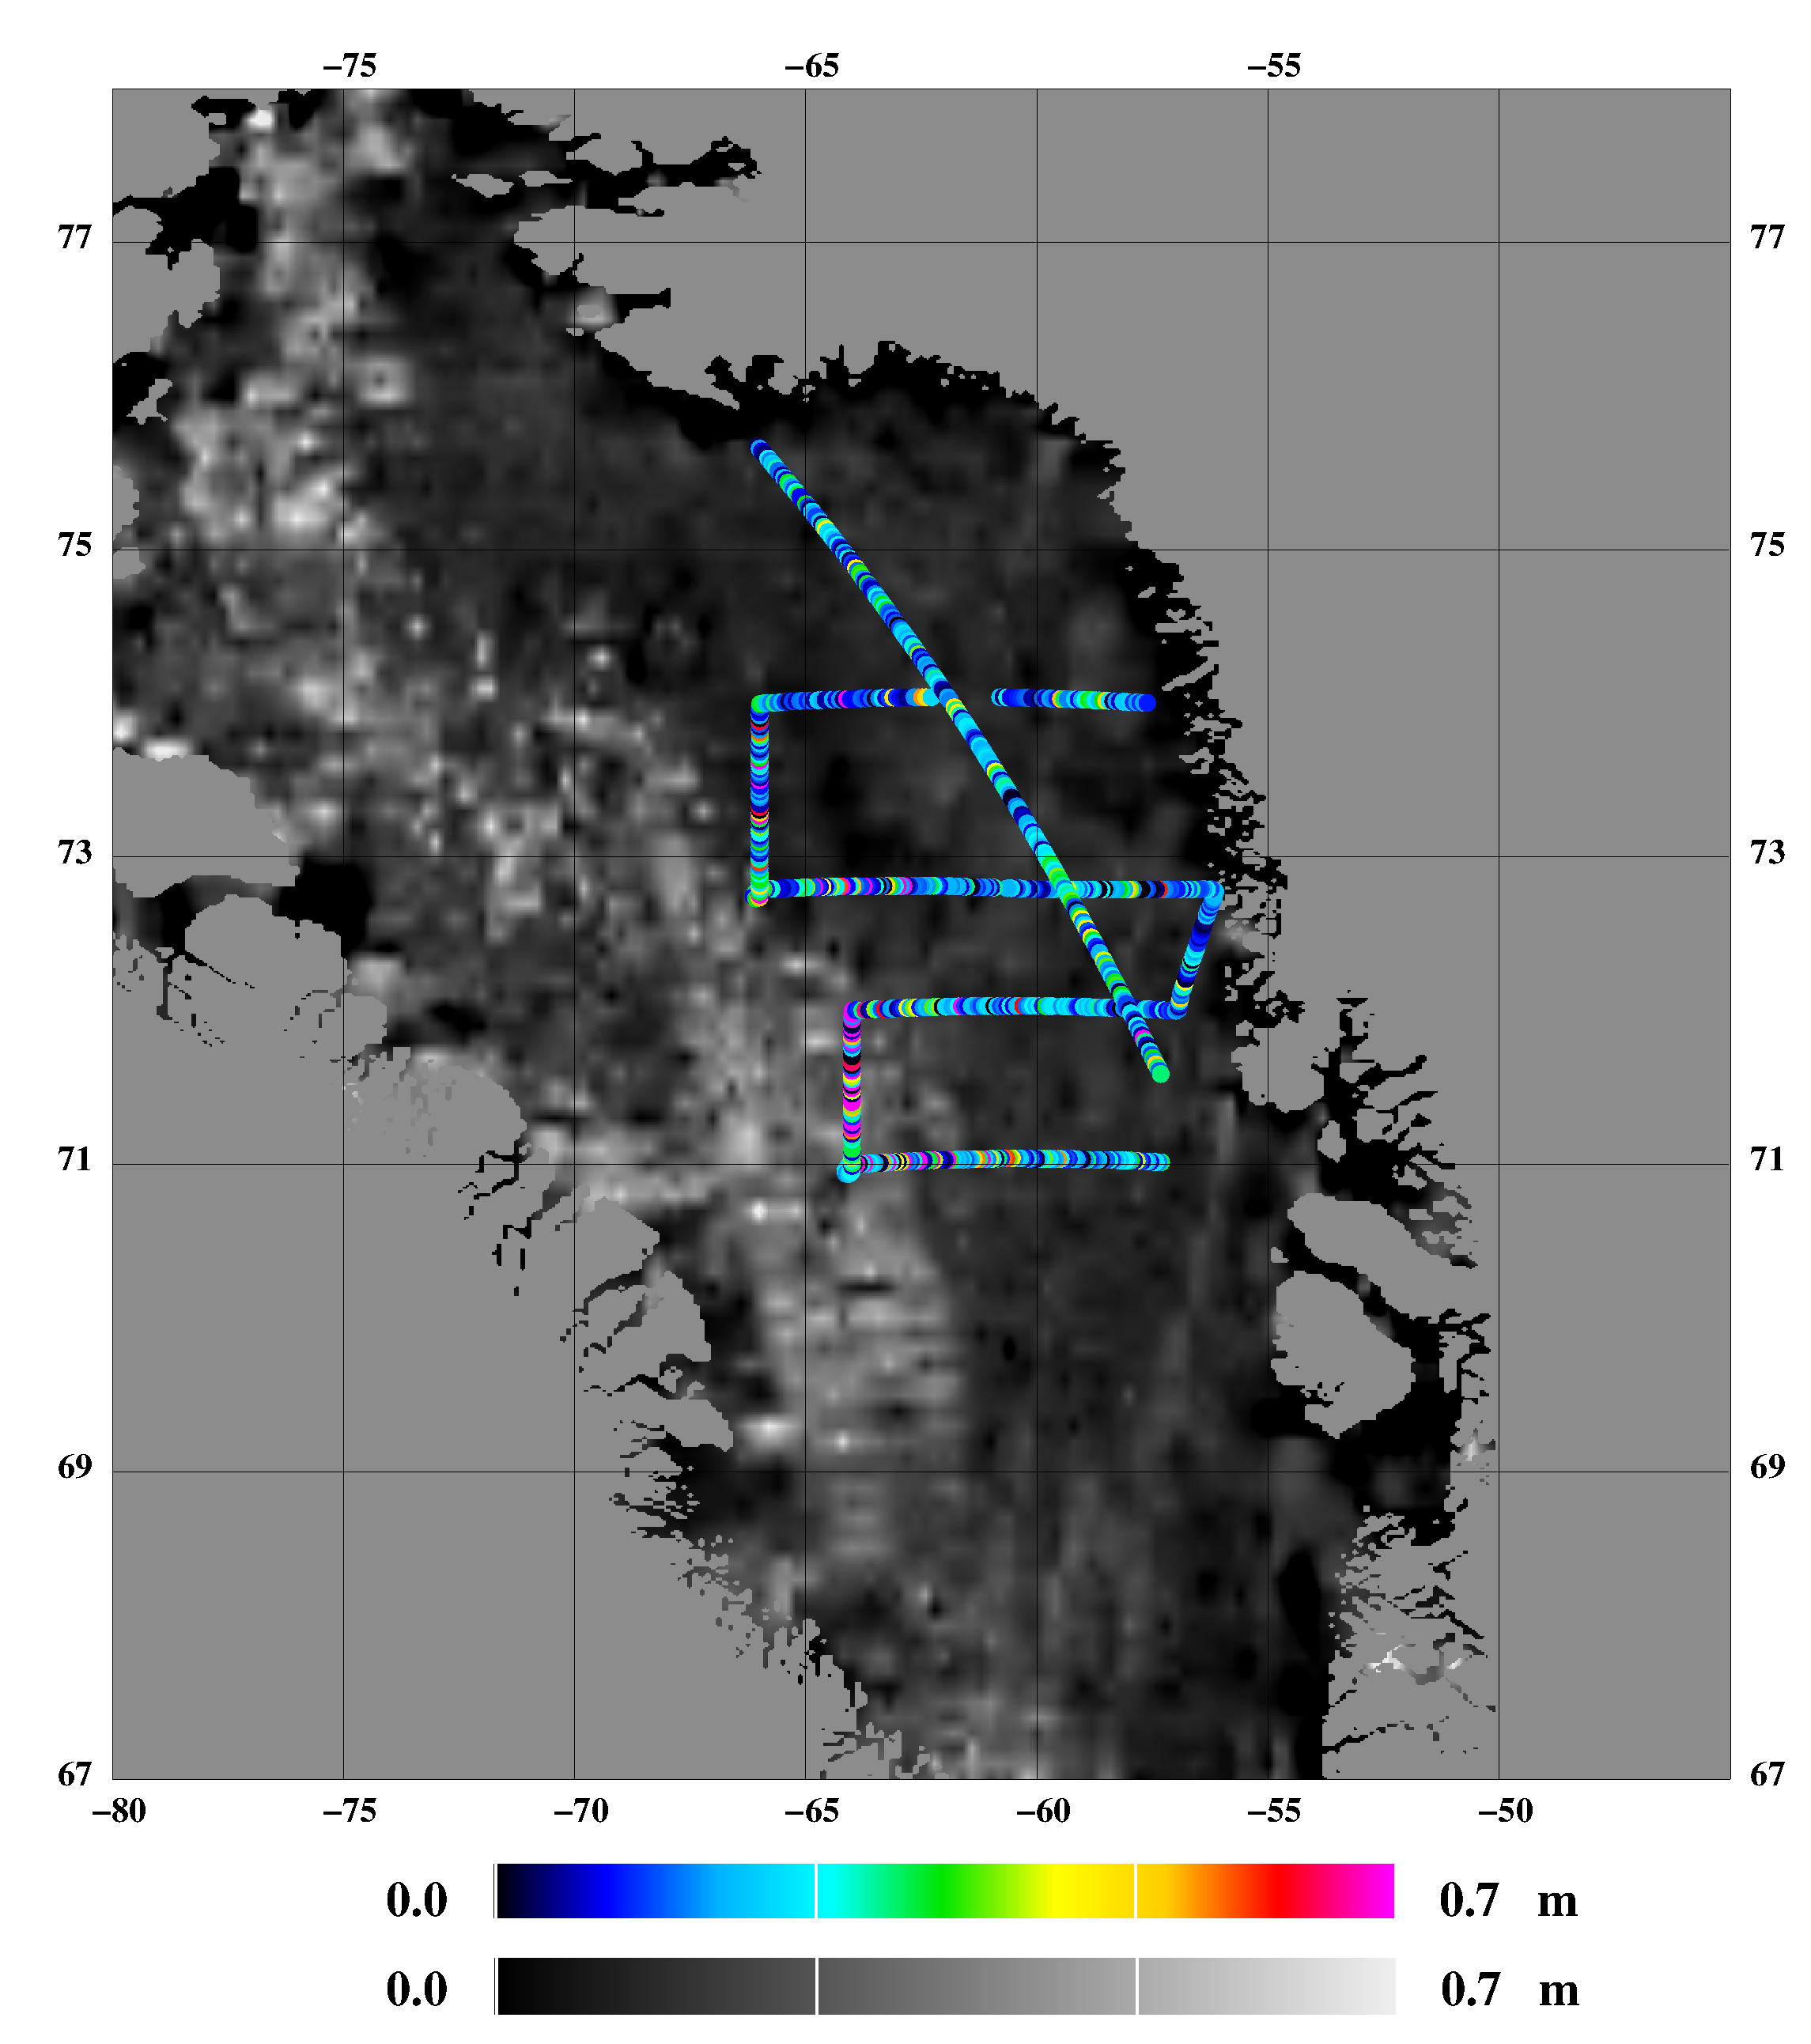
Figure 2: Freeboard heights from 2008, airborne laser scanner (April 19 and May 7) overlaid ICESat freeboard heights (February 17 – March 21)

Figure 3: Freeboard distribution from 2006 airborne laser scanner (green histogram) and 2003-2008 ICESat (lines)
Figure 4: Freeboard distribution from 2008 airborne laser scanner (cyan histogram) and 2003-2008 ICESat (lines)
Figure 5: Freeboard distribution from 2011 airborne laser scanner (cyan histogram) and 2003-2008 ICESat (lines)

References
Kurtz, N. T., Markus, T. M., Cavalieri, D. J., Krabill,W., Sonntag, J. G., and Miller, J.: Comparison of ICESat data with airborne laser altimeter measurements over Arctic sea ice. IEEE Transaction on Geoscience and Remote Sensing, 46(7):1913–1924, 2008

