Work package 2.6

Partner
DTU Space: Rene Forsberg, Stine Kildegaard Poulsen, Indriði Einarsson, Henriette Skourup
NERSC:
UHAM:

Deliverable 2.2.1 In progress
Deliverable 2.2.2 In progress
Deliverable 2.2.3 In progress
Deliverable 2.2.4 Pending results from other work packages WP 2.1 and WP 2.2

Summary of progress
Sea ice freeboard heights and dynamic topography are available for the Arctic Ocean from ICESat data, and first studies of CryoSat-2 data has been obtained. Recent studies suggest to use a R-value R = 3-3.5 for conversion of ICESat freeboard heights into thicknesses. INPUT NERSC AND UHAM

Task 2.6.1:
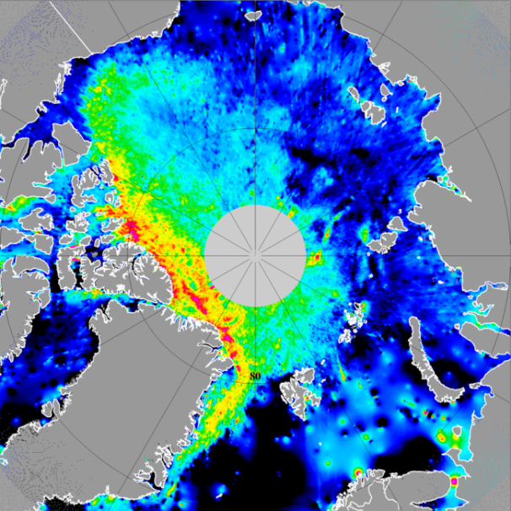
Sea ice freeboard heights and dynamic topography of the Arctic Ocean observed from ICESat altimetry 2003-2008 release 28 are available in grids of resolution 0.1°x0.2°. The procedures and results are described in Skourup (2010). Two examples are shown in the figure below from ICESat periods October-November 2005 (left) and February-March 2006 (right). The sea ice freeboard heights show good correlation with backscatter values from QuikSCAT scatterometer data (Skourup, 2010).
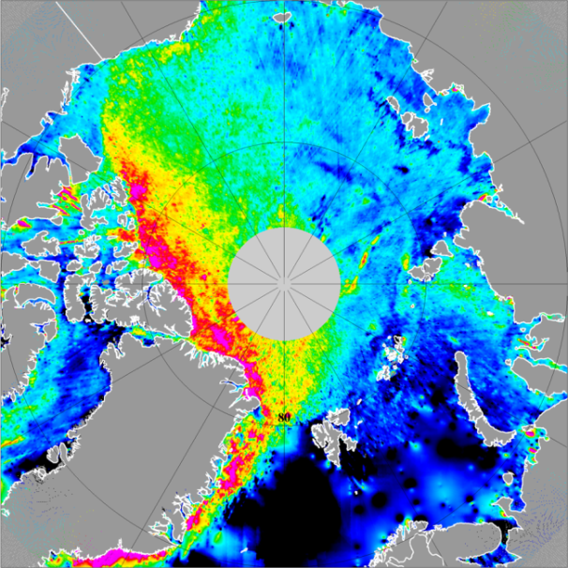

The freeboard (f) to thickness (t) conversion $(t=\left(1+R\right)*f$) is debated in many papers and is highly variable (R = 1-10) depending on sea ice type, settings and snow conditions. Recent studies of the relation between freeboard and draft by Doble et al (2011), finds a R-value of 3-3.5 for ICESat measurements. Thus, it is suggested to use these values to convert the sea ice freeboard heights of ICESat presented above into sea ice thicknesses.
CryoSat-2 was launched April 2010. The upcoming ESA calibration and validation campaign CryoVEx 2011 is the first validation campaign with direct measurements of CryoSat-2. DTU Space is involved in the airborne measurements, which include overflights of ground teams working on the sea ice and direct underflights of CryoSat-2 over the Arctic sea ice. For a more detailed description of the program, see Skourup et al (2011).
First studies of sea ice from CryoSat-2 data have been carried out in Poulsen et al. (2011). Data used is from the commissioning phase, where the SAR data still contained errors, therefore, an ice thickness analysis is too early to carry out at this stage.
Due to errors in the tropospheric correction, data used in Poulsen et al. (2011) has been reprocessed without applying this correction. As shown in Stenseng (2011), the leads can be detected by power, stack skewness and kurtosis above a certain threshold. It was also shown, that what we at first interpreted as ridges or very rough ice, was an effect of power leaking from very large magnitude of the power from the leads, due to side loops of the synthetic aperture. These side loops were misinterpreted
as height in the retracker. Fig. 1 show the height with respect to DTU10 MSS (Andersen and Knudsen 2008) derived from a 80 % beta threshold retracker (red), Stack kurtosis (green), stack skewness (black) and the return power (blue). The red dotted areas indicate detected leads, the threshold was set to 10−12 W. The figure show a large offset in the retracking height of about 8 m. This is due to instrument delays, wrong geophysical corrections and/or errors in the supplied corrections.

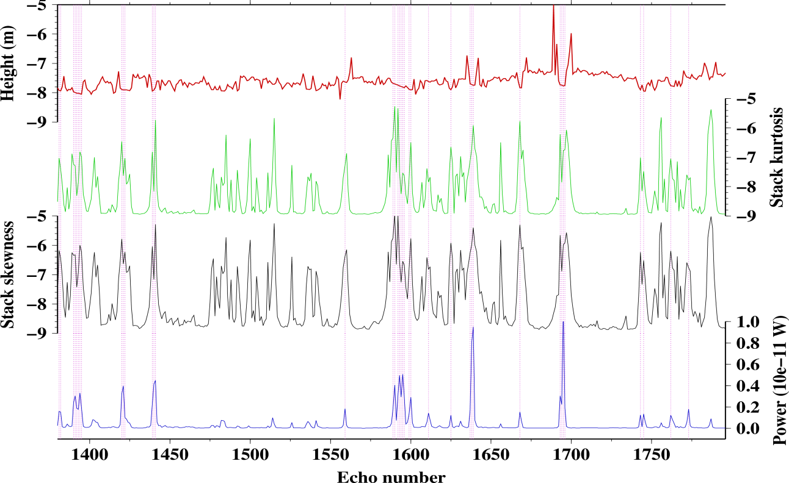

In the figure below the normalized return power is plotted on an Envisat SAR 100 m resolution image from October 8 at 19:17 UTC. There is a clear correspondence between the black areas (smooth areas probably leads or refrozen leads) and the normalized power.
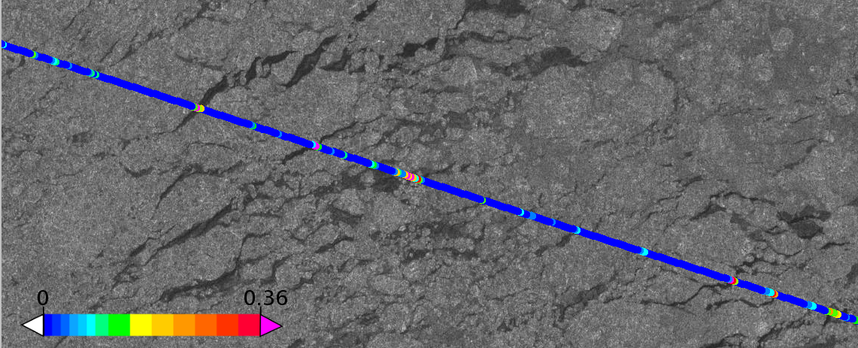
Task 2.6.2:
LEAD BENEFICIARY NERSC
The time series of sea ice thickness will be used in combination with model results and assimilation results to obtain improved estimates of sea ice volume fluxes. These fluxes represent a component of the freshwater cycle in the Arctic, where freshwater increase and decrease due to melting/freezing of sea ice and freshwater import/export to/from certain regions of the Arctic. (month 18)

Task 2.6.3:

LEAD BENEFICIARY NERSC

The fresh water fluxes will be compared to the Arctic Ocean part of the Greenland ice sheet melt, the river discharges, and merged into a freshwater flow grid, using the input of WP 2.4 and compared to the sea level time series of WP 2.2. The direct measurements of the freshwater pulse by satellite gravity (GRACE) will be exploited as part of this comparison. (month 18 and 36)

The comparison between the direct fresh water pulse obtained by altimetry (WP 2.2) and GRACE (WP 2.1), and the fresh water fluxes obtained from a combination of input from the Greenland ice sheet (WP 2.3), the river discharges (WP 1.2) and sea ice (WP 2.6) will begin as soon as results from the respective work packages are available. For the status of each of the contributions, see the respective work packages.

Impediments to progress
No comments

Outlook
RENE ?!?
Please outline the future for your activity and in particular deviations to plans to future deadlines
Resources
RENE ?!?
In particular outline and explain deviations between actual and planned person-months per work package and per beneficiary described in “Annex 1 - Description of Work”

List of related publications
Andersen, O. B. and Knudsen, P. (2008). The DTU10 global Mean sea surface and Bathymetry. In Geophysical Reasearch Abstract, volume 10. European Geophysical Union
Doble, M. J., Skourup, H., Wadhams, P., and Geiger, C. (2011). The relation between sea ice surface elevation and draft: Results from high-resolution mapping by co-incident AUV sonar and airborne scanning laser. JGR SEDNA special issue, submitted
Poulsen, S. K., Stenseng, L., Skourup, H., Pedersen, L. T., and Forsberg, R. (2011). Initial results of CryoSat-2 data from the Arctic. In proceedings, ESA CryoSat Validation Workshop, Frascati, Italy
Skourup, H. (2010). A study of Arctic sea ice freeboard heights, gravity anomalies and dynamic topography from ICESat measurements. PhD Thesis, University of Copenhagen
Skourup, H., Hanson, S., Hvidegaard, S. M., Forsberg, R., Poulsen, S. K., Morris, E. M., Sørensen, L. S., and Stenseng, L. (2011). Airborne campaigns for CryoSat prelaunch calibration and validation. In proceedings, ESA CryoSat validation workshop, Frascati, Italy
Stenseng, L. (2011). Polar Remote Sensing by CryoSat-type Radar Altimetry. PhD thesis, National Space Institute, Technical University of Denmark

