Parameter Control of j_ima_iros V. 5.1.29 with light curve extraction.
Niels Lund. DTU Space. 2017-07-18.

1.
The user can activate the light curve extraction feature by setting the parameter useIROS = “yes”.
The parameter endLevel should be set to: IMA.
The bin size for the light curves (in seconds) is specified with the parameter timeStep. The default value is 4 s.
2.
Through the use of the flag word in the user catalog the user can request output of light curves of other sources, even if these may be too weak to be identified in the standard j_ima_iros search for sources.
Setting flag = 1 for a specific source forces j_ima_iros to extract the flux and the light curve for this source, even if the source is too weak to be detected in the (full) data set. The source flux and light curve are extracted from simultaneous fits to the selected source plus the significant sources found in the current science window. The number of flag-1 sources is not limited.
Setting flag = 3 for a specific source forces j_ima_iros to extract the flux and the light curve for this source, even if the source is too weak to be detected in the (full) data set. Using this flag value forces the selected source to be present in the fits of all other sources. This is a non-standard option which must be used with care. A maximum of 3 flag-3 sources are allowed for each analysis.
This use of flag is just an extension of the logic already existing in previous versions of j_ima_iros.
3.
When useIROS is “yes”, all light-curves will be searched for burst activity.

3b.
If a significant burst is detected (a flux excursion actually, not necessarily a true X-ray or gamma-ray burst!) information about the burst will be indicated in the log file and the 512-bit of the flag word of the srcl_res file.
The ‘512’-bit will be set in the flag column for every source for which a burst is detected. See the extracted data from the srcl_res file is shown for four parameter situations.

The scw is 041100230010 in which four bursts are recorded from four different sources.

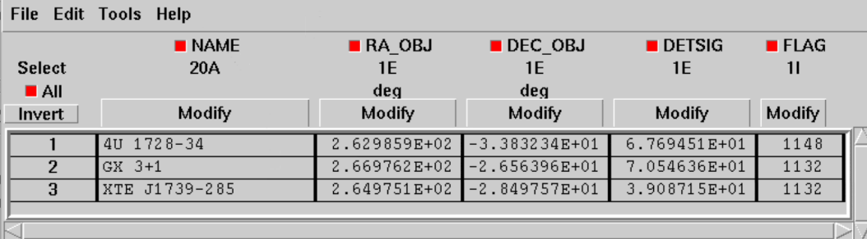

Fig. 1. No light curve extraction and no user source requests (3 sources found)
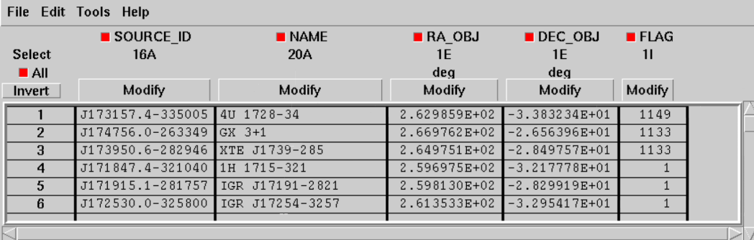

Fig.2 No light curve extraction but flag-1 request for all known burst source (3 sources found by j_ima_iros, 40 sources tested and fluxes indicated in srcl_res for this scw).

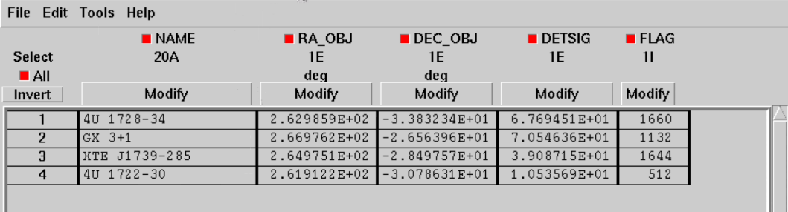

Fig. 3 Light curve extraction but no user source requests.
(3 sources found (2 also exhibiting bursts), plus one additional burst source identified from image extracted during burst peak in detector light curve).

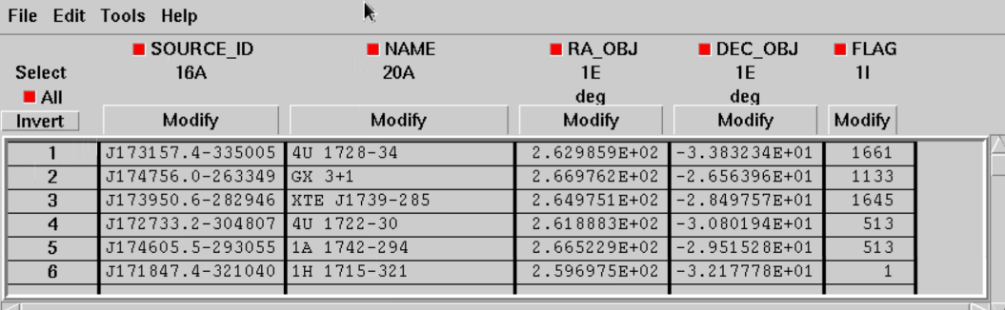

Fig. 4 Light curve extraction and flag-1 request for all known burst sources
(3 sources found, plus 2 identified from source light curves, 40 sources total in srcl_res)

